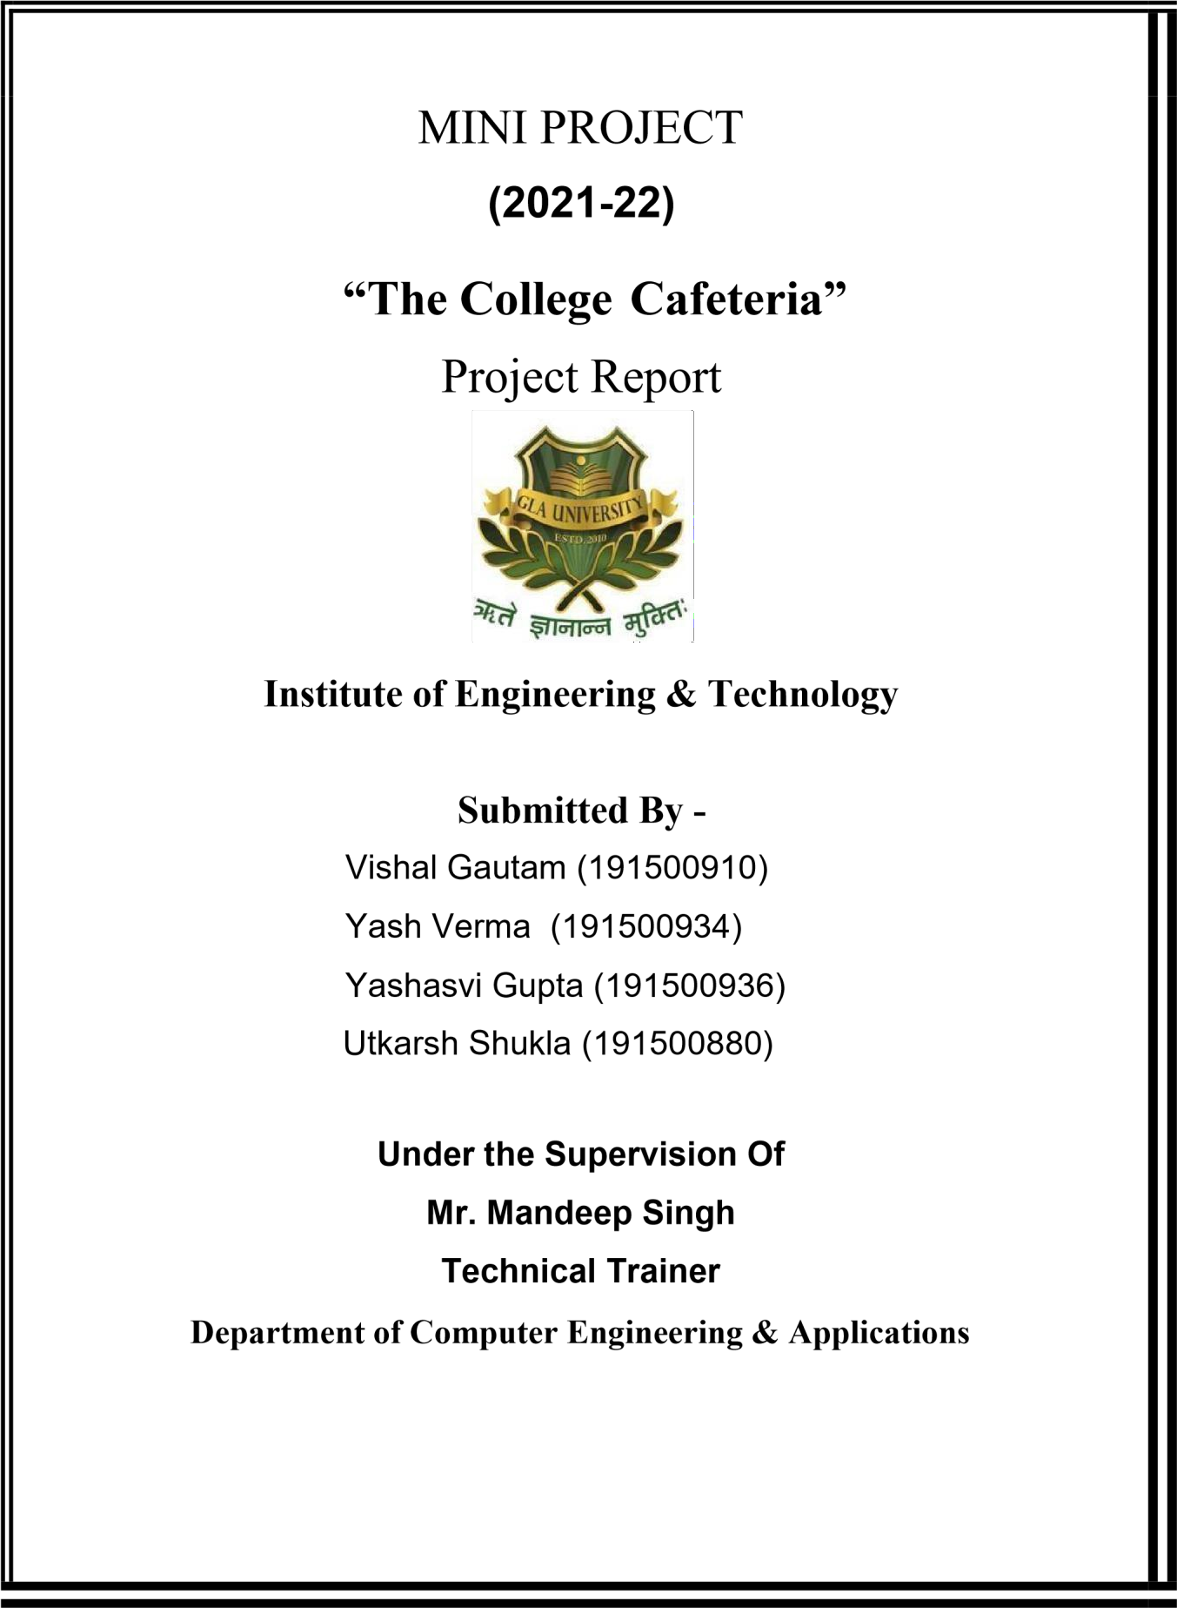

**Department of Computer Engineering and Applications**

**GLA University, 17 km. Stone NH#2, Mathura-Delhi Road, Chaumuha, Mathura – 281406 U.P (India)**

**Declaration**

I/we hereby declare that the work which is being presented in the Bachelor of technology. Project **“The College-Cafeteria”**, in partial fulfilment of the requirements for the award of the ***Bachelor of Technology*** in Computer Science and Engineering and submitted to the Department of Computer Engineering and Applications of GLA University, Mathura, is an authentic record of my/our own work carried under the supervision of **Mr. Mandeep Singh, Technical Trainer, Dept. of CEA,GLA University.**

The contents of this project report, in full or in parts, have not been submitted to any other Institute or University for the award of any degree.

**Sign**: *RishabhTiwari* **Sign**: *SakshiTiwari*

**Name of Candidate**: Rishabh Pradeep Tiwari **Name of Candidate**: Sakshi Tiwari

**University Roll No**.:201500566 **University Roll No**.:201500610

**Department of Computer Engineering and Applications GLA University, 17 km.**

**Stone NH#2, Mathura-Delhi Road, Chaumuha, Mathura – 281406 U.P (India)**

**Certificate**

This is to certify that the project entitled “The College-Cafeteria”, carried out in Mini Project – I Lab, is a bonafide work by Vishal Gautam, Yash Verma, Yashasvi Gupta, and Utkarsh Shukla and is submitted in partial fulfilment of the requirements for the award of the degree Bachelor of Technology (Computer Science & Engineering).

#### Signature of Supervisor:

**Name of Supervisor:** Mr. Mandeep Singh

#### Date:

**Department of Computer**

**Engineering and Applications GLA**

**University, 17 km. Stone NH#2, Mathura-Delhi Road, Chaumuha, Mathura – 281406 U.P (India)**

## ACKNOWLEDGEMENT

Presenting the ascribed project paper report in this very simple and official form, we would like to place my deep gratitude to GLA University for providing us the instructor Mr Mandeep Singh, our technical trainer and supervisor.

He has been helping us since Day 1 in this project. He provided us with the roadmap, the basic guidelines explaining on how to work on the project. He has been conducting regular meeting to check the progress of the project and providing us with the resources related to the project. Without his help, we wouldn’t have been able to complete this project.

And at last but not the least we would like to thank our dear parents for helping us to grab this opportunity to get trained and also my colleagues who helped me find resources during the training.

Thanking You

|  |  |
| --- | --- |
| **Sign**: *RishabhTiwari* | **Sign**: *SakshiTiwari* |
| **Name of Candidate**: Rishabh Pradeep Tiwari | **Name of Candidate**: Sakshi Tiwari |
| **University Roll No**.:201500566 | **University Roll No**.: 201500610 |

# ABSTRACT

In this project, we are creating a website , basically a college cafeteria website which we have named The College-Cafeteria. This website will provide us a platform to access the food we want to have at the ease of our fingertips. All the users will be to access the website through the internet. Any food that the user wishes to have can be seen on the website. It has been developed to override the problems prevailing in the practicing manual system. This software is supported to eliminate and in some cases reduce the hardships faced by this existing system. Moreover this system with design for the particular need of the company to carry out operations in a smooth and effective manner. The application is reduced as much as possible to avoid errors while entering the data. No formal knowledge is needed for the user to use the system. Thus by this all it proves it is user friendly. Canteen management system as described above can lead to error free, secure, reliable and fast management system. It can assist the user to concentrate on the other activities rather to concentrate on the record keeping. Every organization, whether big or small has challenges to overcome and managing the information of employee, canteen and customers.

**CONTENTS**

Cover Page i

Declaration iii

Certificate iv

Acknowledgement vii

Abstract viii

Content ix

Chapter 1Introduction 1

* 1. Context 1



* 1. Motivation 1
     + Objective 1
     + 1.4 Existing System 2
  2. Sources 2

Chapter 2 Software Requirement Analysis 3

* + - 2.1 Problem

Statement 3

* + - 2.2 Hardware and Software

Requirements 3-4

* + - 2.3 Modules and

Functionalities 4-5

Chapter 3 Technology used 6

* + - 3.1 Front-End Development 6
    - 3.2 Web Browsers(most common)… 7
    - 3.3 Tools and Technologies 8
    - 3.4 More terminology 9-10

Chapter 4 Implementation and user interface… 11

* + - 4.1 Implementation of College-Cafeteria… 11
    - 4.2 Steps to be followed to develop the website… 11
    - 4.3 Steps to be followed by the user… 12
    - 4.4 User Interface… 17

Chapter 5 Testing 18

* + - 5.1 Unit Testing 18
    - 5.2 Integration Testing 18
      * 5.3 System Testing 19
    - 5.4 Acceptance Testing 20.

Chapter 6 Conclusion 21

References 22

CHAPTER-1

INTRODUCTION

### CONTEXT

This website “The College-Cafeteria” has been submitted in partial fulfilment of the requirements for the award of the degree of Bachelor of Technology in Computer Science and Engineering at GLA University, Mathura supervised by Mr.Mandeep Singh. This project has been completed approximately three months and has been executed in modules, meetings have been organised to check the progress of the work and for instructions and guidelines.

### MOTIVATION

The motivation for designing this application came because I have seen many people involved in the fast food business and I personally do not like waiting for long in the store and placing the order. Also this covid-19 thing has made it very difficult to wait in long queues. Also, while ordering there is a lot of hustle bustle which leads to wrong orders and long delays. The Languages used to build the website would definitely help to make this system easier.

### OBJECTIVE

The main objective of this application is to create this “The College-Cafeteria” that is to make the work easier for both the management of the cafeteria as well as for the customers/users. There will be a facility to search for the menu on the website. After the search there will be list of food items and one can view about the food items of the cafeteria and can further purchase it.

This website developed can be used at a variety of places, at education hubs and have its significance. The goal of the website was to provide a way to the users to get all the information about the cafeteria and use it for saving time rather roaming on the streets and waiting in the queues.

### EXISTING SYSTEM

Whenever we implement new system it is developed to remove the shortcomings of an existing system. The computerized has more Edge over the manual system.

As we are doing a project on “The College - Cafeteria”. So firstly we will introduce the existing system, the existing system based on manual system, which takes lot of time to get performance of the test.

The Existing System doesn’t fulfilling the following activities:-

* + - Too much orders to handle at a single time.
    - Lot of confusion due to mis-communication and chaos.
    - Due to man work, lot of difficulties got increased in the work.
    - Time consuming.

### SOURCES

The source of our project (including all the project work, documentations and presentations) will is available at the following link :[- https://github.com/vishalgautam0212/-The-College-](https://github.com/vishalgautam0212/-The-College-Cafeteria-Working-Website-.git)

[Cafeteria-Working-Website-.git](https://github.com/vishalgautam0212/-The-College-Cafeteria-Working-Website-.git)

[.](https://github.com/JanviPangoriya/Book_finder_app_mini_project)

# CHAPTER -2

**SOFTWARE REQUIREMENT ANALYSIS**

### PROBLEM STATEMENT

The College-Cafeteria is a website which will allow the users to search menu on the website so that there is no need to come to the place for the order and to look for their favourite dishes. Actually this website is a static website which tells about the cafeteria but on the internet, like almost everything, for ex:- reviews, food items, details ,etc. Also there will be a feature to call directly at the cafeteria for the delivery of the food.

Though one of the common problems is to wait in the long-never-ending queues and still sometimes get the wrong order. Our website totally saves the time and eases for both the parties by just letting the users access the whole cafeteria just by some clicks.

### HARDWARE AND SOFTWARE REQUIREMENTS

**Hardware Requirement**

* + - Processor :intel i5
    - Operating System :Any Operating System
    - RAM : 8 GB (or higher)
    - Hard disk : 256GB

**Software Requirement**

* + - Software used: Visual Studio Code
    - Language used : HTML, CSS, JS.
    - User Interface Design : Front-End Development.
    - **2.3 MODULES AND FUNCTIONALITIES**
      * **Splash Screen**: The first screen with which the user interacts will be this screen containing the logo.
      * **Features Page**: This page is shows the features of the cafeteria and their functionality like the freshness of their food,etc
      * **Meals Image Page:-** Some of the favourite and mostly demanded meals will be shown on this page.
      * **Navigation Drawer**: This is the most important part of the application that provides interactivity within the app as it connects the various activities together like it is a side bar

on which Food Delivery, How it works, our cities and sign up page of the page are linked and on clicking on each you can visit the pages.

* + - * **Current cities Page :** This page comes into picture when one of the user wants to know the locations of the cafeteria they are accessing.
      * **Reviews Page**: There always is a sense of security when there are good customer reviews on the things we don’t initially trust. So, there is this page which tells you the reviews of the customers about the service and order of the food.
      * **Sign Up Page:** This page is to do the sign up/sign in to the website to access it premium features(future use).
      * **Footer Page** : This page will contain all the information that footers usually contains like

:- contact us, about us, social media handles etc.

# CHAPTER – 3 TECHNOLOGY USED

## Front-End Development

Front-end web development, also known as client-side development is the practice of producing HTML, CSS and JavaScript for a website or Web Application so that a user can see and interact with them directly. The challenge associated with front end development is that the tools and techniques used to create the frontend of a website change constantly and so the developer needs to constantly be aware of how the field is developing.

The objective of designing a site is to ensure that when the users open up the site they see the information in a format that is easy to read and relevant. This is further complicated by the fact that users now use a large variety of devices with varying screen sizes and resolutions thus forcing the designer to take into consideration these aspects when designing the site. They need to ensure that their site comes up correctly different browsers (cross-browser), different operating systems (cross-platform) and different devices (cross-device), which requires careful planning on the side of the developer.

**HTML, CSS, & JavaScript:**

A front-end developer architects and develops websites and applications using web technologies (i.e., [HTM](https://developer.mozilla.org/en-US/docs/Web/HTML)[L, CS](https://developer.mozilla.org/en-US/docs/Web/CSS)[S, DOM, a](https://developer.mozilla.org/en-US/docs/Web/API/Document_Object_Model)nd [JavaScript),](https://developer.mozilla.org/en-US/docs/Web/JavaScript) which run on the [Open Web Platform or](https://en.wikipedia.org/wiki/Open_Web_Platform) act as compilation input for non-web platform environments (i.e., [React Native).](https://facebook.github.io/react-native/)

Typically, a person enters into the field of front-end development by learning to develop HTML, CSS, and JavaScript which commonly runs in a [web browser](https://en.wikipedia.org/wiki/Web_browser) [bu](https://en.wikipedia.org/wiki/Web_browser)t can also run in a headless browser,

[WebView, o](http://developer.telerik.com/featured/what-is-a-webview/)r as compilation input for a native runtime environment. These four run times scenarios are explained below

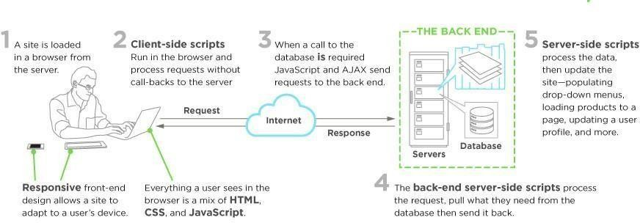

## Web Browsers (most common)

A web browser is software used to retrieve, present, and traverse information on the [WWW.](https://en.wikipedia.org/wiki/World_Wide_Web)

Typically, browsers run on a desktop or laptop computer, tablet, or phone, but as of late a browser can be found on just about anything (i.e, on a fridge, in cars, etc.). The most common web browsers are (shown in order of [most used first):](https://en.wikipedia.org/wiki/Usage_share_of_web_browsers#Summary_tables)

* + - [Chrome](http://www.google.com/chrome/)
    - [Safari](http://www.apple.com/safari/)
    - [Internet Explorer (N](https://en.wikipedia.org/wiki/Internet_Explorer)ote: not [Edge,](http://dev.modern.ie/) [r](http://dev.modern.ie/)eferring to IE 9 to IE 11)
    - [Firefox](https://www.mozilla.org/firefox/)
    - [Edge](https://www.microsoft.com/en-us/windows/microsoft-edge)

**Headless Browsers**

Headless browsers are a web browser **without** a graphical user interface that can be controlled from a command line interface programmatically for the purpose of web page automation (e.g., functional

testing, scraping, unit testing, etc.). Think of headless browsers as a browser that you can run from the command line that can retrieve and traverse web pages.

The most common headless browsers are:

* + - [Headless Chromium](https://chromium.googlesource.com/chromium/src/%2B/lkgr/headless/README.md)
    - [Zombie](https://github.com/assaf/zombie)
    - [slimerjs](http://slimerjs.org/)

## TOOLS AND TECHNOLOGIES

Tools used to build the website are:-

**VisualStudioCode**:-Visual Studio Code is [a source-code editor ma](https://en.wikipedia.org/wiki/Source-code_editor)deby [Microsoft fo](https://en.wikipedia.org/wiki/Microsoft)[r Window](https://en.wikipedia.org/wiki/Windows)[s,](https://en.wikipedia.org/wiki/Linux) [Linux an](https://en.wikipedia.org/wiki/Linux)[d mac](https://en.wikipedia.org/wiki/MacOS)[OS.](https://en.wikipedia.org/wiki/Visual_Studio_Code#cite_note-TechCrunch-9)[[9]](https://en.wikipedia.org/wiki/Visual_Studio_Code#cite_note-TechCrunch-9) [Fe](https://en.wikipedia.org/wiki/Visual_Studio_Code#cite_note-TechCrunch-9)atures include support for [debuggin](https://en.wikipedia.org/wiki/Debugging)[g, syntax highlightin](https://en.wikipedia.org/wiki/Syntax_highlighting)[g, intelligent code](https://en.wikipedia.org/wiki/Intelligent_code_completion) [completio](https://en.wikipedia.org/wiki/Intelligent_code_completion)[n, snippet](https://en.wikipedia.org/wiki/Snippet_(programming))[s, code refactoring, a](https://en.wikipedia.org/wiki/Code_refactoring)nd embedded [Git.](https://en.wikipedia.org/wiki/Git) Users can change the [them](https://en.wikipedia.org/wiki/Theme_(computing))[e, ke](https://en.wikipedia.org/wiki/Keyboard_shortcut)yboard shortcut[s,](https://en.wikipedia.org/wiki/Keyboard_shortcut) preferences, and install [extensions th](https://en.wikipedia.org/wiki/Plug-in_(computing))at add additional functionality.

Visual Studio Code combines the simplicity of a code editor with what developers need for their core edit-build-debug cycle. It provides comprehensive code editing, navigation, and understanding support along the lightweight debugging, a rich extensibility model, and lightweight integration with existing tools.

**Languages Used:-** Languages used in building a website are :-

**HTML**:- The HyperText Markup Language, or HTML is the standard markup language for documents designed to be displayed in a web browser. It can be assisted by technologies such as Cascading Style Sheets (CSS) and scripting languages such as JavaScript.

**CSS**:- CSS stands for Cascading Style Sheets. It describes how HTML elements are to be displayed on screen, paper, or in other media. It saves a lot of work. It can control the layout of multiple web pages all at once. External stylesheets are stored in CSS files.

**JAVASCRIPT**:- JavaScript often abbreviated as JS, is a programming language that conforms to the ECMAScript specification. JavaScript is high-level, often just-in-time compiled and multi- paradigm. It has dynamic typing, prototype-based object-orientation and first-class functions.

Alongside HTML and CSS, JavaScript is one of the core technologies of the World Wide Web. Over 97% of websites use it client-side for web page behavior, often incorporating third-party libraries. All major web browsers have a dedicated JavaScript engine to execute the code on the user's device.

## MORE TERMINOLOGY

#### Responsive design

As increasingly more people access the Internet from their mobile devices rather than from desktops, responsiveness is a must. Responsive design means that the web layout (including functionality and content) adjusts to the screen size and hardware. For instance, when a website is visited from a desktop computer with a big monitor, a user gets numerous columns, heavy graphics, and UI designed particularly for mouse and keyboard. On mobiles, the same website appears as a single column adjusted for touch interaction, but with the same base data. Have a look at our article on [responsiveness to](https://www.altexsoft.com/blog/mobile/making-your-ecommerce-site-mobile-friendly-and-responsive/) get a better idea.

#### Accessibility and inclusivity

Accessibility means making a website available to as many people as possible. This concept does not only include all kinds of disabilities that people have, such as visual, cognitive, hearing, or mobility impairments. It also covers matters of law, compliance standards, different mobile devices, and different

types of network connections. Our overview of [accessibility practices pr](https://www.altexsoft.com/blog/uxdesign/reach-your-audience-with-accessible-and-inclusive-design/)ovides broader awareness of the topic.

#### FRAMEWORKS

Frameworks are templates to create a website or a web application. They provide a structure (such as a skeleton or scaffolding) on which to arrange the whole project. While the framework sets the page templates, they build the structure with particular allocated areas to embed a framework code in. So, JavaScript frameworks are complete sets of tools to form and arrange a website or web application.

#### LIBRARIES

Libraries are sets of prewritten code snippets used and reused to implement core features of JavaScript. The snippet can be easily integrated into an existing project code when necessary.So, libraries are specialized tools for particular coding needs, not an all-purpose machine for grooming the whole existing project.

.

# CHAPTER – 4 IMPLEMENTATION AND USER INTERFACE

Creating a website design with layouts and technologies is the best way to communicate your vision to the web developer. Making the concept clear to the developer is probably the most important factor in successful web development. Yet it is one of the most common problems or obstacles in a web development outsourcing project.

No matter what the marketing and profit goals are or if you are outsourcing an website for your personal use, you need to fully design and document the app concept if you expect a programmer to make your vision a reality.

The two most important things to do are: A) make a comprehensive description of how the app works and what it does(functionality) and B) create a comprehensive description of what the user sees and does (look and feel).

## Implementation of College-Cafeteria :

Implementation of College-Cafeteria is taken place in various phases. Firstly we build the navigation bar of the page .i.e by the use of css and some html and then make various layouts and divs for the supporting features and connect the website with the jquery. And then finally after making the footer and remaining instances we get to display the result.

## STEPS TO BE FOLLOWED TO DEVELOP THE WEBSITE:

* + 1. Firstly we create the navigation bar with the CSS and div container tags by using HTML.
    2. After that we create the content for our website like adding animations, effects, pictures, etc
    3. And the we created the login page(future scope) which comprises of the various phases that are mentioned below:
       - Login Page: Allows user to login into the website if the user is existing one.
       - SignUp Page: If the user is new to our website then firstly he/she has to register themselves on the website.
       - Other sections:- Then we added various other sections like:- Newsletter, A feedback form, etc.
    4. The Navigation bar consists of:
       - Food Delivery
       - How it works
       - Our cities
       - Sign up
    5. Creating fragment for each of the menu item. Our items are:
       - Dashboard
       - Features
       - Pictures
       - How it works
       - Reviews
       - Footer

Now that we have created the whole website, we now try to make it look better by adding more CSS properties to it and let it shine further.

## STEPS TO BE FOLLOWED BY THE USER

* + 1. Enter the name of the site or url and open the website.
    2. Firstly, we have the frontend/ display page which will be having navigation bar which will let the user to jump to the section directly they want to go.
    3. Then the user can look at the features of the cafeteria provides by the website. And can look at the meals present in the cafeteria
    4. Then, we have the Login activity which consists of following steps:
       - Register: for new user.
       - Login: for existing as well as new user
    5. At last, the user can look at the rating and revies of the cafeteria in the reviews section as well as the users can now use the footer section to follow the social handles of the CollegeCafeteria. And can look at the blog, about, etc section of the website for more information of Cafeteria.

Hence, at last the user can now enjoy the service provided by the website!

## User Interface

#### Opening page with navigation bar

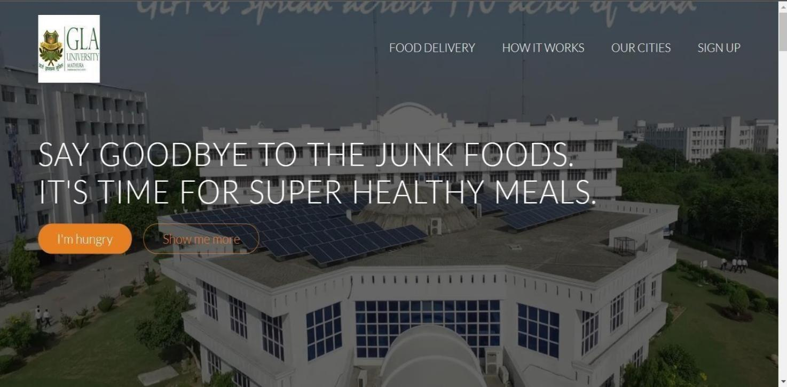

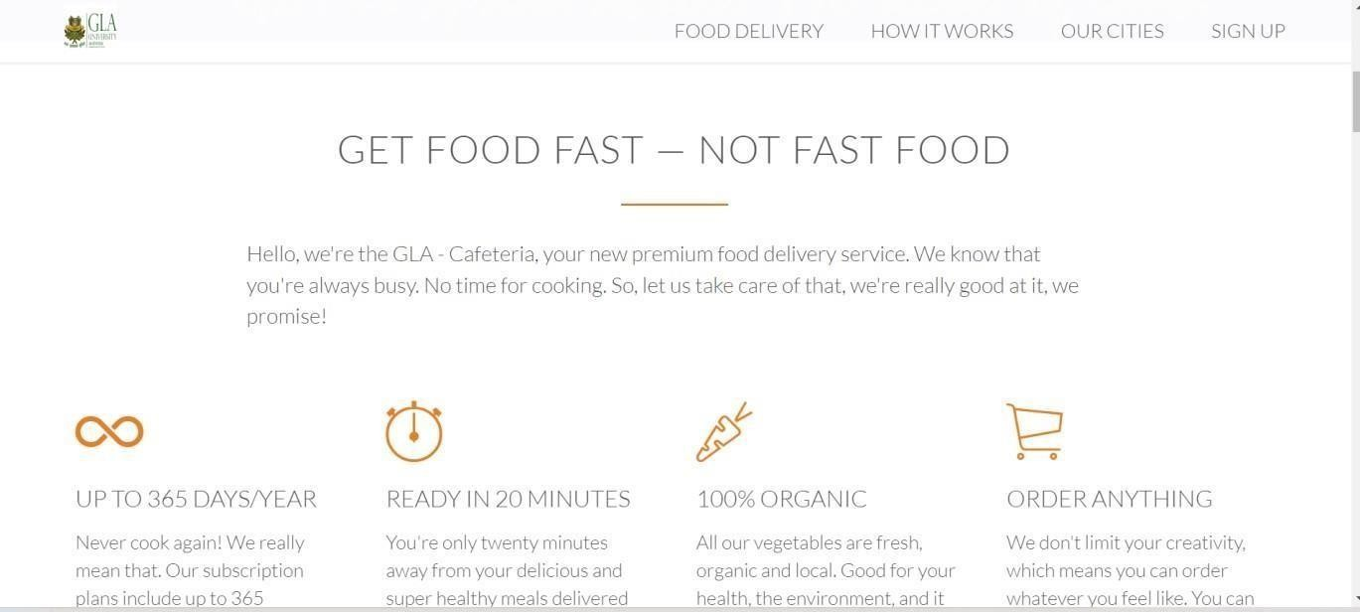**Features page :**

#### Pictures page:

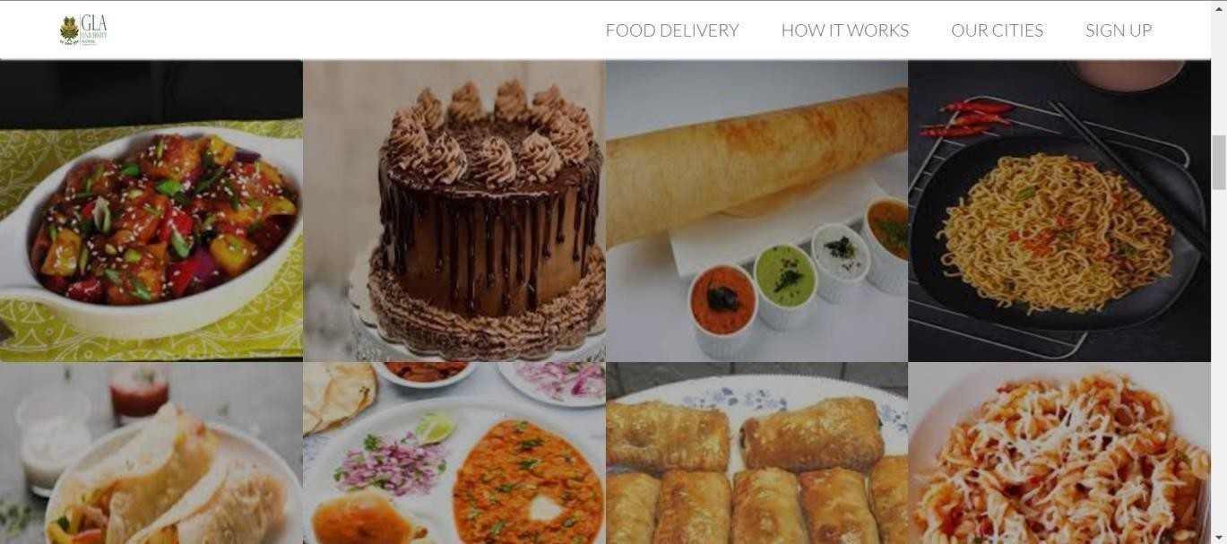

**How it works:**

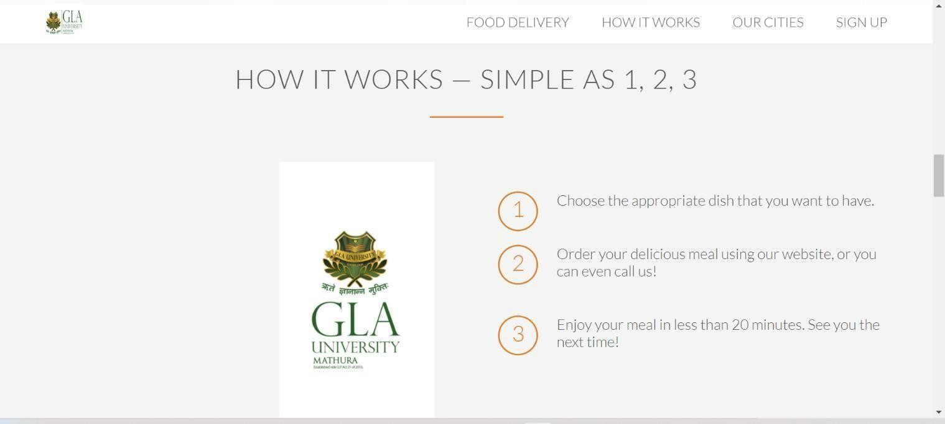

#### Current cities:

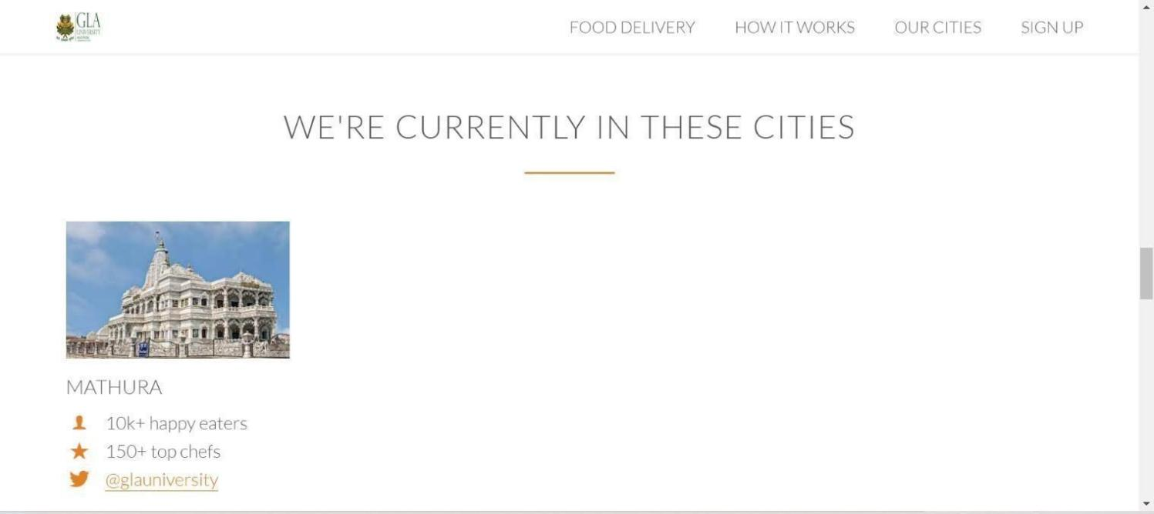

**Reviews Page:**

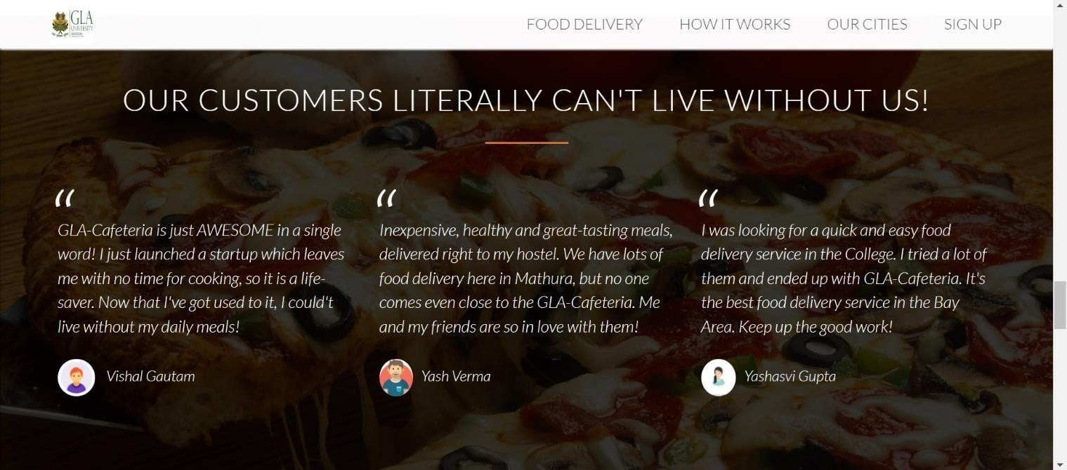

#### Sign up Page:

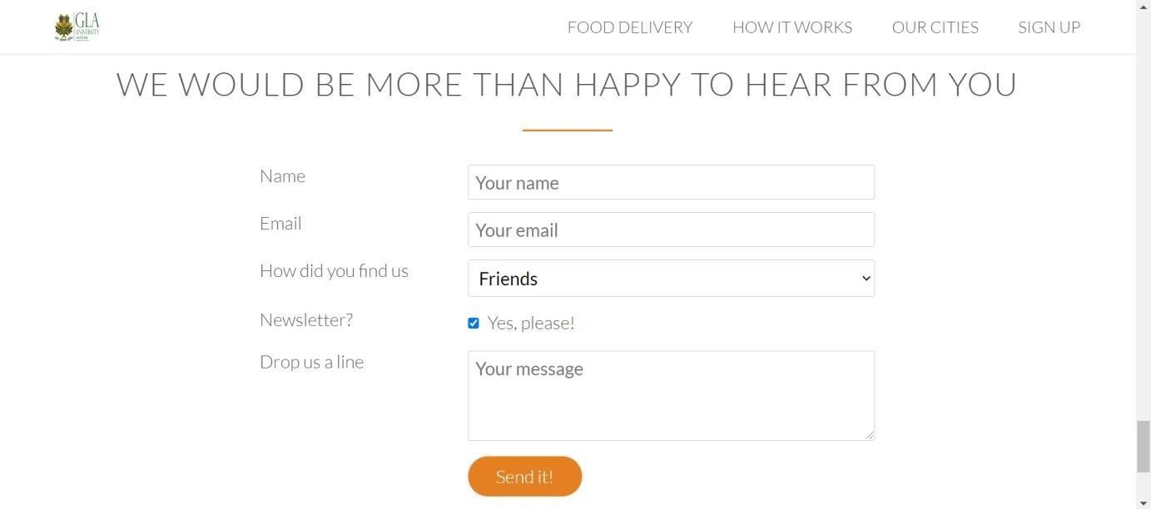

**Footer Page:**

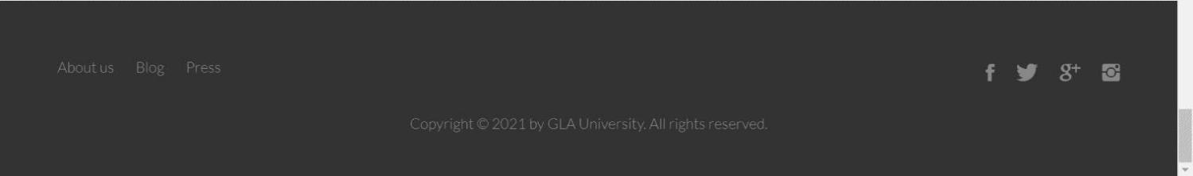

# CHAPTER – 5 TESTING

Once source code has been generated, software must be tested to uncover as many errors as possible before delivery. It is very important to work the system successfully and achieve high quality of software. Testing including designing a series of test cases that have a high likelihood of finding errors by applying software-testing techniques.

System testing makes logical assumptions that if all the parts of the system are correct, the goal will be successfully achieved. The system should be checked logically. Validations and cross checks should be there. Avoid duplications of record that cause redundancy of data.

In other Words, Testing is the process of evaluating a system or its component(s) with the intent to find whether it satisfies the specified requirements or not. It is executing a system in order to identify any gaps, errors, or missing requirements in contrary to the actual requirements.

## Unit Testing

What is unit testing? Put simply, unit testing is a method of testing the smallest pieces of code, typically individual functions, in isolation. These small pieces of code are called units. A unit can be a line of code, a class, or a method, for example. With unit testing, the smaller the parts of code you test, the better the results, as testing smaller units gives you a more detailed view of your code performance. Plus, tests run fast when dealing with small units.

## Integration Testing

While unit tests verify the behavior of isolated parts of your code, integration tests cover interactions between different parts of your application. This is the next level of software testing, as integration testing checks if different units of the software work together correctly in real life. Integration tests validate complex scenarios, so they may require more effort and additional resources, for example databases or web servers. Unit and integration tests are a great combo as they ensure that every isolated unit works correctly and that multiple units work flawlessly and as expected when integrated.

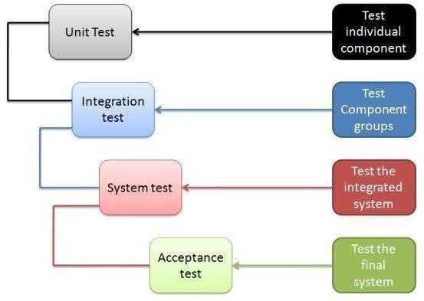

## System Testing

Once you’ve successfully completed integration testing, you can move on to system testing. This is the first level at which you test the system as a whole. System testing checks whether

all components are integrated and work correctly. For system testing, it’s crucial to create

an environment similar to the real-life environment in which the system will be deployed.

System testing verifies that the system meets functional, technical, and business requirements.

## Acceptance Testing

Acceptance testing is performed after unit, integration, and system testing. At this stage, the quality assurance team tests the application for quality by applying predefined test scenarios

and test cases. The purpose of acceptance testing is to evaluate the system’s compliance with business requirements. This is the final level of testing, and checks whether the system is ready for release.

# CHAPTER – 6 CONCLUSION

Proposed College-Cafeteria is a website that will allow users to search for the meals they want to have as well as to know more about the cafeteria. This website is developed from front-end development i.e. it includes stylish features of webpages, animations, etc. The pages includes the user-friendly features so that anyone can use them without any difficulty. It has a navigation bar which includes dashboard, how to use it, sign up page, etc. It contains the view of cafeteria but in a virtual method so that users do not have to worry about their time and can follow up the instructions of COVID-19.

This Website has wide range of scope in upcoming era. It is going to be very difficult for cafeterias to manage the wide range of public and make their orders in exact time and with less hustle-bustle. Also, with few modifications like adding database and servers, etc it can be the generalised system for the college-cafeteria.

# REFERENCES

#### W3SCHOOLS :

***[https://www.w3schools.com](https://www.w3schools.com/)***

#### For definitions :

***[https://www.wikipedia.org](https://www.wikipedia.org/)***

#### Yalantis :

***<https://yalantis.com/blog/unit-testing-for-web-software/>***

#### Stackoverflow :

***<https://stackoverflow.com/questions/547302/unit-testing-a-website>***

#### For animations:

***[https://developer.mozilla.org/en-](https://developer.mozilla.org/en-US/docs/Web/CSS/CSS_Animations/Using_CSS_animations) [US/docs/Web/CSS/CSS_Animations/Using_CSS_animations](https://developer.mozilla.org/en-US/docs/Web/CSS/CSS_Animations/Using_CSS_animations)***