**DESIGNING THE "enterchoice()" FUNCTION IN THE FILE "rlyres.c"**

The function **enterchoice()** will do the following:

1. Display the project title at the centre of the first row.

2. Below the title it will draw a line of dashes.

screen1a.png

3. It will display the list of options to the user.

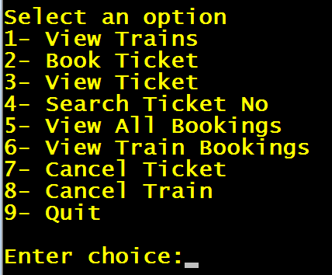

4. It will then wait for user input and return the inputted choice to the function **main().**

Here is the code for the function **enterchoice()** to be written in the file **"rlyres.c"**

***#include <stdio.h>***

***#include "conio2.h"***

***#include "rlyres.h"***

***int enterchoice( )***

***{***

***int choice,i;***

***textcolor(YELLOW);***

***gotoxy(28,1);***

***printf("RAILWAY RESERVATION SYSTEM\n");***

***for(i=1;i<=80;i++)***

***printf("-");***

***printf("\nSelect an option");***

***printf("\n1- View Trains");***

***printf("\n2- Book Ticket");***

***printf("\n3- View Ticket");***

***printf("\n4- Search Ticket No");***

***printf("\n5- View All Bookings");***

***printf("\n6- View Train Bookings");***

***printf("\n7- Cancel Ticket");***

***printf("\n8- Cancel Train");***

***printf("\n9- Quit");***

***printf("\n\nEnter choice:");***

***scanf( "%d", &choice );***

***return choice;***

***}***

**DESIGNING THE "main()" FUNCTION**

The function **main()** will do the following:

1. Run an infinite loop.

2. Call the function **enterchoice( )** and receive it's return value.

3. If the choice entered is "**quit**" then the program should terminate.

4. Otherwise a **switch-case** should run and call different functions as per the value of choice.

5. If choice is wrong then in the default part the message "**Wrong Choice! Try Again**" should be displayed in **LIGHTRED** color and again the **options screen should open**.

Here is the code for the function **main()**

***#include <stdio.h>***

***#include <stdlib.h>***

***#include "conio2.h"***

***#include "rlyres.h"***

***int main()***

***{***

***int choice;***

***while(1)***

***{***

***choice=enterchoice();***

***if(choice==9)***

***{***

***exit(0);***

***}***

***switch(choice)***

***{***

***case 1:***

***//view_trains();***

***break;***

***case 2:***

***//book_ticket();***

***break;***

***case 3:***

***//view_ticket();***

***break;***

***case 4:***

***//get_ticket_no();***

***break;***

***case 5:***

***//view_all_bookings();***

***break;***

***case 6:***

***//view_booking();***

***break;***

***case 7:***

***//cancel_ticket();***

***break;***

***case 8:***

***//cancel_train();***

***break;***

***default:***

***textcolor(LIGHTRED);***

***printf("Wrong Choice!Try again\n");***

***getch();***

***clrscr();***

***}***

***}***

***}***