***Octobud- A teaching aid for children having Down Syndrome***

Authors Details

*Abstract*—Down syndrome is a genetic disorder caused due to abnormal cell division. It can cause unique physical impairments like poor muscle tone, short neck, small stature, palmar crease, and flattened face. Though early treatment programs by therapists can treat the specific disorder of the child. This study targets to identify the root problem faced by children suffering from Down syndrome. We found that a major problem identified which hasn’t had a lot of intervention done is that of cognitive & language skills development. Thus we tried to investigate the solution of improving cognitive skills in a child having Down syndrome and presented an inexpensive soft-toy cum teaching aid for them. This toy bridge the gap between the inherent limitations of teachers/parents in teaching and the slow learning ability of children with Down syndrome.

Keywords—Down syndrome, product designing, internet of things, smart toy, teaching aid

# Introduction

People with mental and physiological disorders have a difficult time in society. These disorders are very common among children too and some of them are since birth. The disorders affect the development of the brain and body parts of the children often making them unable to perform day to day activities. Some common mental disabilities are Anxiety disorders [1], Disruptive behavior disorders [2], Eating disorders, Elimination disorders [3], Affective (mood) disorders [4], Schizophrenia [5], Tic disorders [6], Attention Deficit Hyperactivity Disorder (ADHD) [7], Down syndrome [8]. This research is focused on Down’s syndrome as the tools that help the children having Down syndrome are limited and often overlook many of the problems faced by the kids. Down syndrome is a congenital disorder that arises from a chromosome defect. It is caused by the presence of all or part of the third copy of chromosome 21 thus, it is also known as trisomy 21. It causes intellectual impairment and physical abnormalities including short stature and a broad facial profile. Some of the kids may be at an increased risk for certain health problems. Many of these associated conditions can be treated with medication, surgery, or other interventions.

Some of the conditions that occur more often among children with Down syndrome are Heart defects, Vision problems, Hearing loss, Infections, Hypothyroidism, Blood disorders, Hypotonia (poor muscle tone), problems with the upper part of the spine, Epilepsy, Mental health and emotional problems, Disrupted sleep patterns and sleep disorders, Gum disease and dental problems, Digestive disorders and Celiac disease [9][10][11][12][13]. However, each individual with Down syndrome is different, and not every person will have serious health problems.

## Treatment for down syndrome

Children, teens, and adults with Down syndrome need the same regular medical care as those without the condition, from well-baby visits and routine vaccinations as infants to reproductive counselling and cardiovascular care later in life. They get benefits from regular physical activity and social activities. The ways of treatment and to assist the kids are: Early Intervention and Educational Therapy, Treatment Therapies Drugs and Supplements and Assistive Devices.

Here, “Early intervention” refers to a range of specialised programs and resources that are provided to very young children with Down syndrome and their families by professionals. These professionals may include special educators, speech therapists, occupational therapists, physical therapists, and social workers. Early intervention is very helpful for the kids [14][15][16]. This assistance can begin shortly after birth and often continues until a child reaches age three. After that age, most children receive interventions and treatment through their local school district.

Also, there are a variety of therapies that can be used in early intervention programs and throughout a person's life to promote the greatest possible development, independence, and productivity. Some of these therapies are listed below:

1. Physical therapy includes activities and exercises that help build motor skills, increase muscle strength, and improve posture and balance [17][18]. It makes a child ready for physical challenges, such as low muscle tone, in ways that avoid long-term problems. For example, a physical therapist might help a child establish an efficient walking pattern, rather than one that might lead to foot pain.

2. Speech-language therapy helps the children improve their communication skills and use language more effectively [19][20].

3. Occupational therapy helps them find ways to adjust everyday tasks and conditions to match a person's needs and abilities [21].

4. Emotional and behavioural therapies work to find useful responses to both desirable and undesirable behaviours. During these therapies, the therapists try to understand the behaviour of the kids as sometimes the Children with Down syndrome may become frustrated because of difficulty communicating, may develop compulsive behaviours and may have Attention Deficit Hyperactivity Disorder and other mental health issues.

In some cases, medication is also used for the treatment of various symptoms of Down syndrome. Usually, amino acid supplements or drugs that affect brain activity are used [22] but it is found that some of the recent clinical trials were not controlled properly and the adverse effects from these are also revealed. There are studies about the use of drugs for treating Dementia in Down syndrome but the results have not shown clear benefits of these drugs. Similarly, studies of antioxidants for dementia in Down syndrome have shown that these supplements are safe, but not effective.

Moreover, assistive devices are also used for interventions. These assistive devices enhance learning and make the tasks easier to complete. Examples include amplification devices for hearing problems, bands that help with movement, special pencils to make writing easier, touchscreen computers, and computers with large-letter keyboards, etc. As of now, using these assistive devices seems a very effective method for helping the kids having Down syndrome. However, the functionality of these devices is limited to its use. Apart from devices, it was found that individuals with Down syndrome respond positively and effectively, with improvements in sensory-motor control, when stimulated with tasks that are complementary to conventional therapy, including therapy involving speaking skills [19][20][23]. Thus we aimed to make a product that helps the child in their overall development by using some conventional therapy and learning path.

## Related work

There are many interactive and innovative toys available in the market help children in their mental and physical skills. Melissa & Doug sells a product ‘Camo Chameleon Bean Bag’ which helps improves hand-eye coordination and gross motor skills. Hasbro sells ‘Elefun’ is ideal for kids who have trouble with their upper joints & motor skills. For kids with Down syndrome, autism or sensory processing disorders ‘Vtech Tote & Go Laptop’, ‘Rush Hour Traffic Jam Logic Game and STEM Toy’ by ThinkFun, and ‘Bilibo’ by Swiss designer Alex Hochstrasser are the leading toys. ‘Anki Vector’, ‘Dash Robot’ by Wonder Workshop, ‘Sphero Bolt’, ‘LittleBits‘, ‘Bedtime Stories’, ‘Technic Bugatti Chiron’ by Lego, ‘Luvabella Doll’ by Spin Master, ‘Hide Me Tent & Tunnel’ by Pacific Play Tents, and ‘Duplo All-in-One-Box-of-Fun’ by Lego are some of the most innovative toys in the market. Despite the availability of a vast number of toys in the market treatment of Down syndrome is still a challenge. The possible reasons are the high cost of the product which restricted the toys to an economically strong population, limited functionality, lack of adaptability, and constrained possibility of interaction channels. However, our toy is able to overcome these shortcomings and provides an inexpensive and adaptable solution, endless possibilities of adding functions, a better interface for teachers and parents and support of remote system updates.

## Design Philosophy

We aimed at customers of the higher end of the economic spectrum & for personal use i.e. teaching not done in the classroom. Specific care was taken to not completely wipe out or replace the human aspect of teaching the child since human relationships are an important aspect of the cognitive development of not just children affected by Down syndrome, but all children in general. Hence, this toy involves interaction by people around the child as well. The process involved the selection of the concept, working on form & functionality, dimensioning & ergonomics, CAD, UI and programming for the app & the electronic simulation.

# Foundational research

People with mental and physiological disorders have a difficult time in society. These disorders are very common among children too and some of them are since birth. The disorders affect the development. To understand the problem faced by children having Down syndrome we visited a school for children with disabilities, physiotherapist and general practitioner, Navjyoti School for mentally challenged, and physiotherapy center (Shree Bhasha Vikas Kendra).

## Insides of the Interviews

* English Teacher at a School for Children with disabilities

1. The children are very stubborn and need proper positive feedback in order to learn efficiently.
2. Toys like the alphabet peg board are used to motivate the children and push them towards the world of languages & alphabets.
3. All of the children have a problem in writing - not because of problems in grip, but problems in controlling the writing instrument.
4. The children get scared easily if they see even a slight amount of violence or hear any loud noise. In such cases, the primary method to get these children back to normal is through poems & music.
5. They like to sit in one place & position and do the same task for a long time. They get very attached to people, places & objects once they get used to them.
6. They love music, dance & being around fellow human beings.
7. They absolutely love colorful, bright objects & get very excited by the color red.

* Principal at a School for Children with Disabilities

1. The children love bright toys, toffees & playing games.
2. Any kind of physical activity largely motivates the children - learning through sports, especially cricket is very useful for children with Downs Syndrome.
3. However, too much physical activity cannot be done by these children since they are more prone to respiratory problems.
4. They get scared very easily & do not like loud noises or too much sudden movement.
5. They take some time to calm down & get used to new environments & people as compared to able children.
6. They love storytelling, narrations, poems, and listen very intently for hours on end to the above.
7. There is a huge need of repetition in order to explain concepts to the children & make them understand certain things.
8. For example, in order to make them learn how to use a certain toy or game - for example a peg board - they have to be shown how to use it multiple times & then they learn.
9. At some points, the students get very stubborn and hence the teachers, being human beings, tend to reach their breaking point & give up. As human beings, there’s an inherent limit to how much the teachers can give to these students. Hence there’s a major gap here where intervention through a toy can be done.

* Physiotherapist and General Practitioner (Doctor)

1. Down syndrome is generally observed when the father’s age (for the first child) is 35-40 or mother’s age is greater than 30.
2. Children with Down’s syndrome don’t suffer from any physical disability or inability to control muscles. They are merely slow learners and have to be taught the same task in multiple steps and multiple times.
3. They have cognitive problems and show slow development in motor, social and learning skills.
4. These children aren’t usually hyper, they are always smiling and don’t get irritated easily.
5. They are scared of violence.
6. They also suffer from respiratory problems, poor feeding, excessive sleepiness, and have possibility of heart diseases, RTI etc.

* Head of Bhasha Vikas Kendra

1. Their focus is to give the child proper attention and care at the same time imparting basic skills and knowledge. Therefore, they provide personal attention to each child. They use techniques such as picture cards, blocks, imitating actions to make them learn. Also they have maintained a record of what each child can do or not, and they have made goals of what they want to achieve with and for the children.
2. In order to make the children with Down syndrome do something, they have to motivate and pushed a bit, but when they start doing it, they get very involved.
3. At home, parents spend as much as time they can to communicate with the children with the help of sign language and sound (eg. clapping). The children imitate whatever their parents do & this in turn helps in developing foundation skills in them. In order to motivate them parents celebrate each small victory.
4. Children love to do activities which they find intriguing, ie. playing with toys which have lights, sound and animation. In particular, the children love animation & digital things.
5. Development in language and cognitive skills can be done up to great extent, but it requires patience from both parents and teachers side. There are many cases, one is of a girl of age.
6. 13 who can now read from a book and can also write a bit. This was only possible after continuous working of 8-9 yrs. Currently, there are no concise, affordable toys in the Indian scenario for cognitive & language development skills of children with Down syndrome.

* Navjyoti School for mentally challenged

1. The children show slow motor responses.
2. They have short attention span.
3. They love intricate things and puzzles and solve such things without being prompted to do so and are good at pattern recognition. They enjoy putting things together. It wasn’t a task for them to complete puzzles or peg boards and they did so willingly.
4. It is easier for them to learn with visual aid like pictures colours and actions. The teachers taught them different letters and sounds by attaching them to hand motions and pictures. Often when the children couldn’t remember the letter or word they would reply with hand motions.
5. These children are scared of violent activities or behaviour and are not willing to accept any sudden changes in their daily life. If a child is used to sitting in one place then he/she would sit there for all 8 hours.
6. They are fascinated by lights, squishy toys and interesting textures. They kept playing with the texture on our bags and refused to leave the light lava ball they were playing with. They are also attached to certain objects and keep searching for them in the form of rewards.
7. Children suffer from cognitive and language impairment. They feel uneasy around new people but once they get use to them, they are extremely friendly.
8. They also suffer from speech impairment. They have difficulty pronouncing words or even forming words in some cases.
9. Learn through repetition. They had to be taught how to throw a ball multiple times and couldn’t leave the ball. It took them around 10-12 tries to throw it and not place it on the floor.
10. Stories and music have a positive impact on their learning abilities. They really enjoy singing, dancing and listening to music.
11. It was easier for them to make straight lines and curves than complex shapes like triangles, angles and so on. They kept drawing spirals even when repeated attempts were made to make an angle, they were unable to stop and redraw. Connecting the starting point with the ending point.
12. They like bright colors, sweets and crunchy food.

## Empathy Mapping

After spending time with & understanding the children affected by Down syndrome first hand, the team was able to empathize with them and understand their needs, wants, motivations & fears. Hence, the team mapped out the understanding in relation to the personality of the children specifically in the Fig. 1 depicted below. This emphatic understanding will enable the team to come up with better solutions to the problem identified.

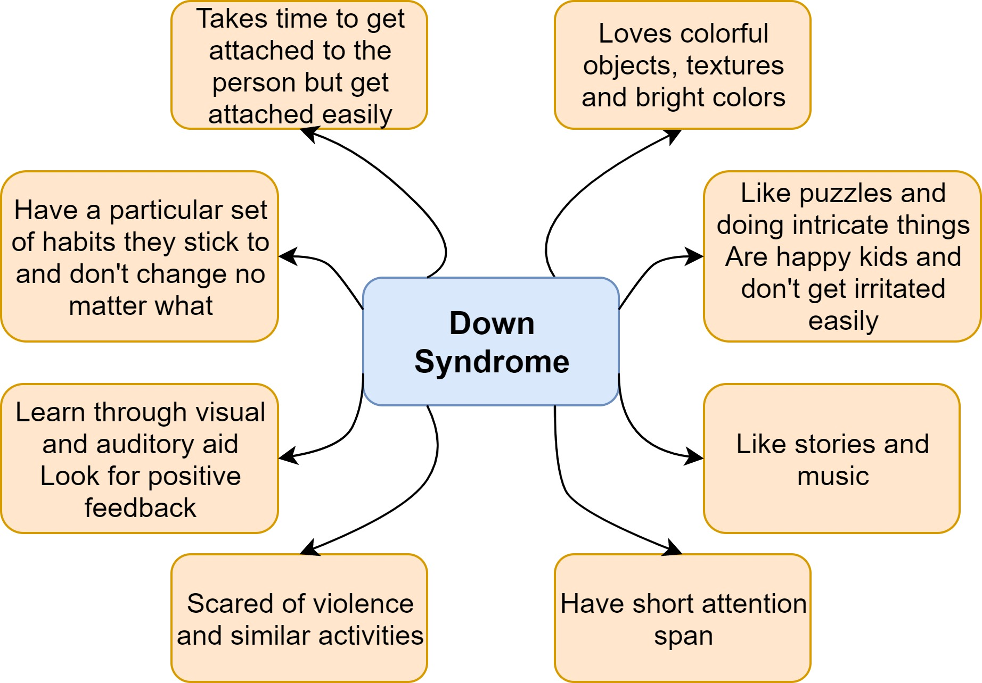

Fig. 1 Behavior of children having Down syndrome

# Methods

To provide a robust solution to the problem of improving cognitive and language skills in children we developed a toy ‘Octobud’. It consists of a soft toy linked with an app on the android mobile phone of the parents of children with Down syndrome. It is a balance between a cuddly companion for the child and teacher. Its relevance is as follows –

## Key points

* Targets the issue of lack of cognitive & language development that exists with the children suffering from Down syndrome.
* Children with Down syndrome love having companions & get much attached to toys that give feedback and develop constantly.
* This toy has a place for a temporary screen (i.e. a phone screen) and is linked with an app that can be downloaded by the parents. This app is linked with the tentacles of the Octopus. Each tentacle is linked to one skill. Pressing the respective tentacle will trigger that skill when the phone is placed inside the phone holder of the toy. The app teaches the child the specific skill as per different levels of difficulty based on the ability of the child.
* The skill is taught through audio visuals.
* To prevent phone addiction & eye damage, once the skill to be taught is selected, the phone screen becomes unresponsive to touch & the app automatically shuts off after use for 20 minutes.
* It cannot be reused unless there’s a gap of at least 3 hours.
* The toy has been ergonomically designed and the tentacles thickness has been formulated as per anthropometric dimensions measured of the children so that it is easy for them to press the toy.
* The phone holder is attached to a box placed inside the toy which can be accessed by removing the strips below the toy.
* This box contains all of the engineering components of the toy. The box can be removed & charged by the parents by removing the strip below the octopus.
* The form of an octopus has been selected since its 8 tentacles align well with the 8 skills being taught. Also, it’s a cute creature relevant to toys.
* These skills are related to language development.
* The skills being taught through this toy are as follows - Alphabets, words, sentences, poems, colours, manners, numbers and a specific special edition pack that gets updated with the app.
* The toy records the voice of the child repeating after what is being said in the app and if the child says something correctly, feedback of clapping & colourful lights is given. The toy also comes with an attachment of starfish that light up on applying pressure. These can be given to the kids by the parents if the kids do a good job in learning and repeating correctly.
* This feedback will ensure that the kid enjoys the toy & learns well.
* The idea of using the phone for a screen was to reduce the cost a bit & to look at the phone not as an interactive interface for the child but as a temporary screen that can be removed from the phone to prevent any kind of addictions.
* Children who have Down syndrome are very calm and do not throw toys around. However, in an extreme case, if a child does end up throwing the Octobud, the toy has enough protection & the phone is placed very inside hence there will be no issue related to damage of parts.

## Mechanical design

The toy has two parts: inner and outer. Inner part is made from Aluminium alloy 6061. It is light in weight, provides structure of the toy and safely contains the electronic components. The inner part is covered with a water proof, insulated layer. On the other hand, the outer part is made from felt and cotton which makes the toy soft and cuddly. Cad model, rendered model and final model are shown in Fig. 2.

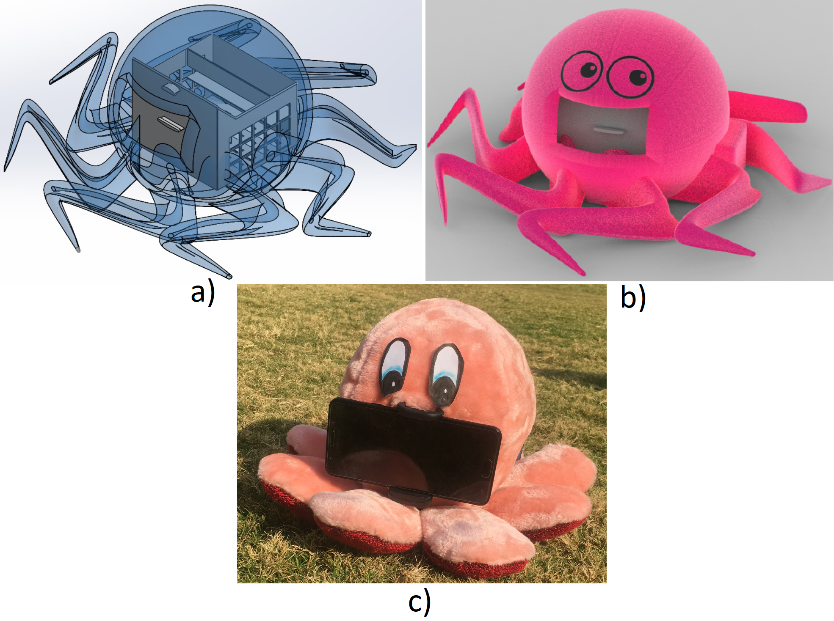

Fig. 2 a) Isometric view of translucent CAD model, b) Rendered CAD model with model properties, c) Final toy with phone attached

## Software development

Keeping in mind the feasibility and as an attempt to make the toy economical, mobile screens were an appropriate solution as a replacement for the permanently, potentially breakable screen. Thus, an android application is developed that can be installed in the parent/guardian’s phone and can be plugged in for 15-20 minutes so the child to learn. Android phones are common in most households and the application runs on API 21 and higher thus targeting more than 96 per cent of Android users. The phone can be removed from the toy and used as usual. The main objective of the application is to provide visual and audio aid. Android Studio IDE is used for developing the whole application. The application can be used for multiple children as well. Since internet connection in schools is not always available, this application is offline and needs the internet only once, while installing it. It contains a login page which takes username and password as input to provide authentication to the app that is only the registered users or the parents/guardians can access the features of the app and also kids should not access the app. There is a registration page also for the first time users to register themselves for starting the app for their kids. This page takes the name, email address and password as input and store these in the database and later they are used in the login page to check whether the user is registered or not. The app is compatible with Android version 4.0 and above. SQLite database is used for storing the data. Database model contains an ID column, a name column, an email address column, a column for a password, one for child’s name, one for product serial number and seven for storing the level kid reached in each of the learning feature provided by pressing the tentacles of the Octobud. Java classes are used for each activity like activity_alphabets, activity_colors, activity_manners etc. and corresponding XML layouts are made with colours and fonts based on our research with Down syndrome kids. Suitable java classes and XML layout files are made for instructions pages, pages to set the difficulty for each learning activity, login page and register page. Also, android tools like AppCompatActivity, RelativeLayout, etc. are used to make the application visually appealing and easy to use.

In the application, first the child’s name is asked once the login is done and used in later stages of the app to address the kid. Levels are initialised to one and continuously updated as the kid proceed to higher levels by learning. Once this is done, a page appears showing seven options each for an activity for learning alphabets, words, sentences, poems, colours, manners or numbers and an extra option for the special edition marine package. On applying pressure on a tentacle, the activity will start corresponding to that tentacle. Some videos and study material is shown to the child. Each material corresponds to a certain difficulty level. The level that can be perceived by the child is to be determined by the warden and the default setting will be EASY. With the help of videos and quirky animations, the app will have a visual impact on the child thus enabling him/her to retain information and have fun exploring new content and singing along to fun activities. There is a time limit, after which the user or child cannot use the app so that kids do not get addicted to the mobile. The flow diagram of the application is shown in Fig. 3 and flow of signals between app and Octobud is shown in Fig. 4.

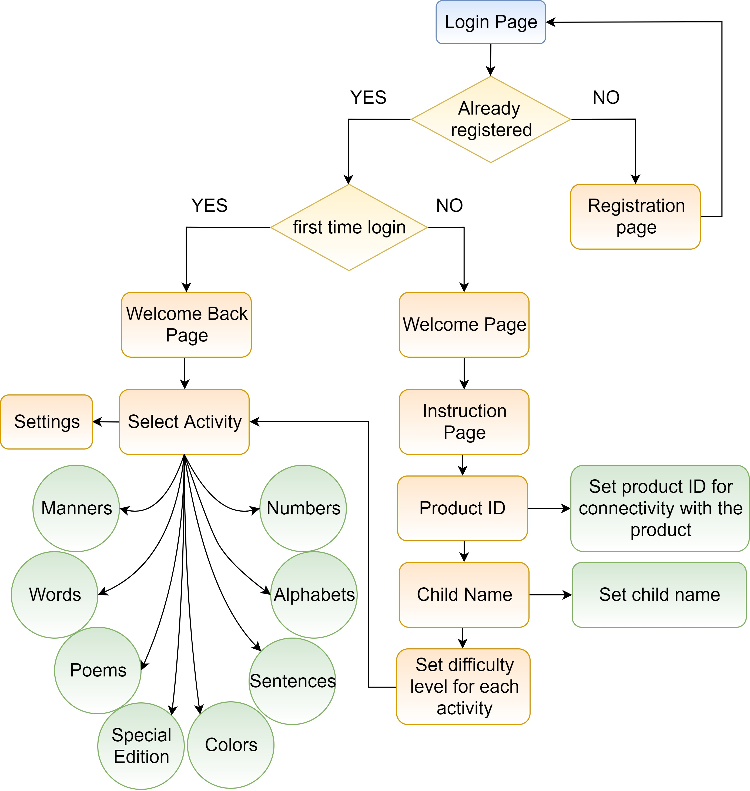

Fig. 3 Control flow diagram of the application

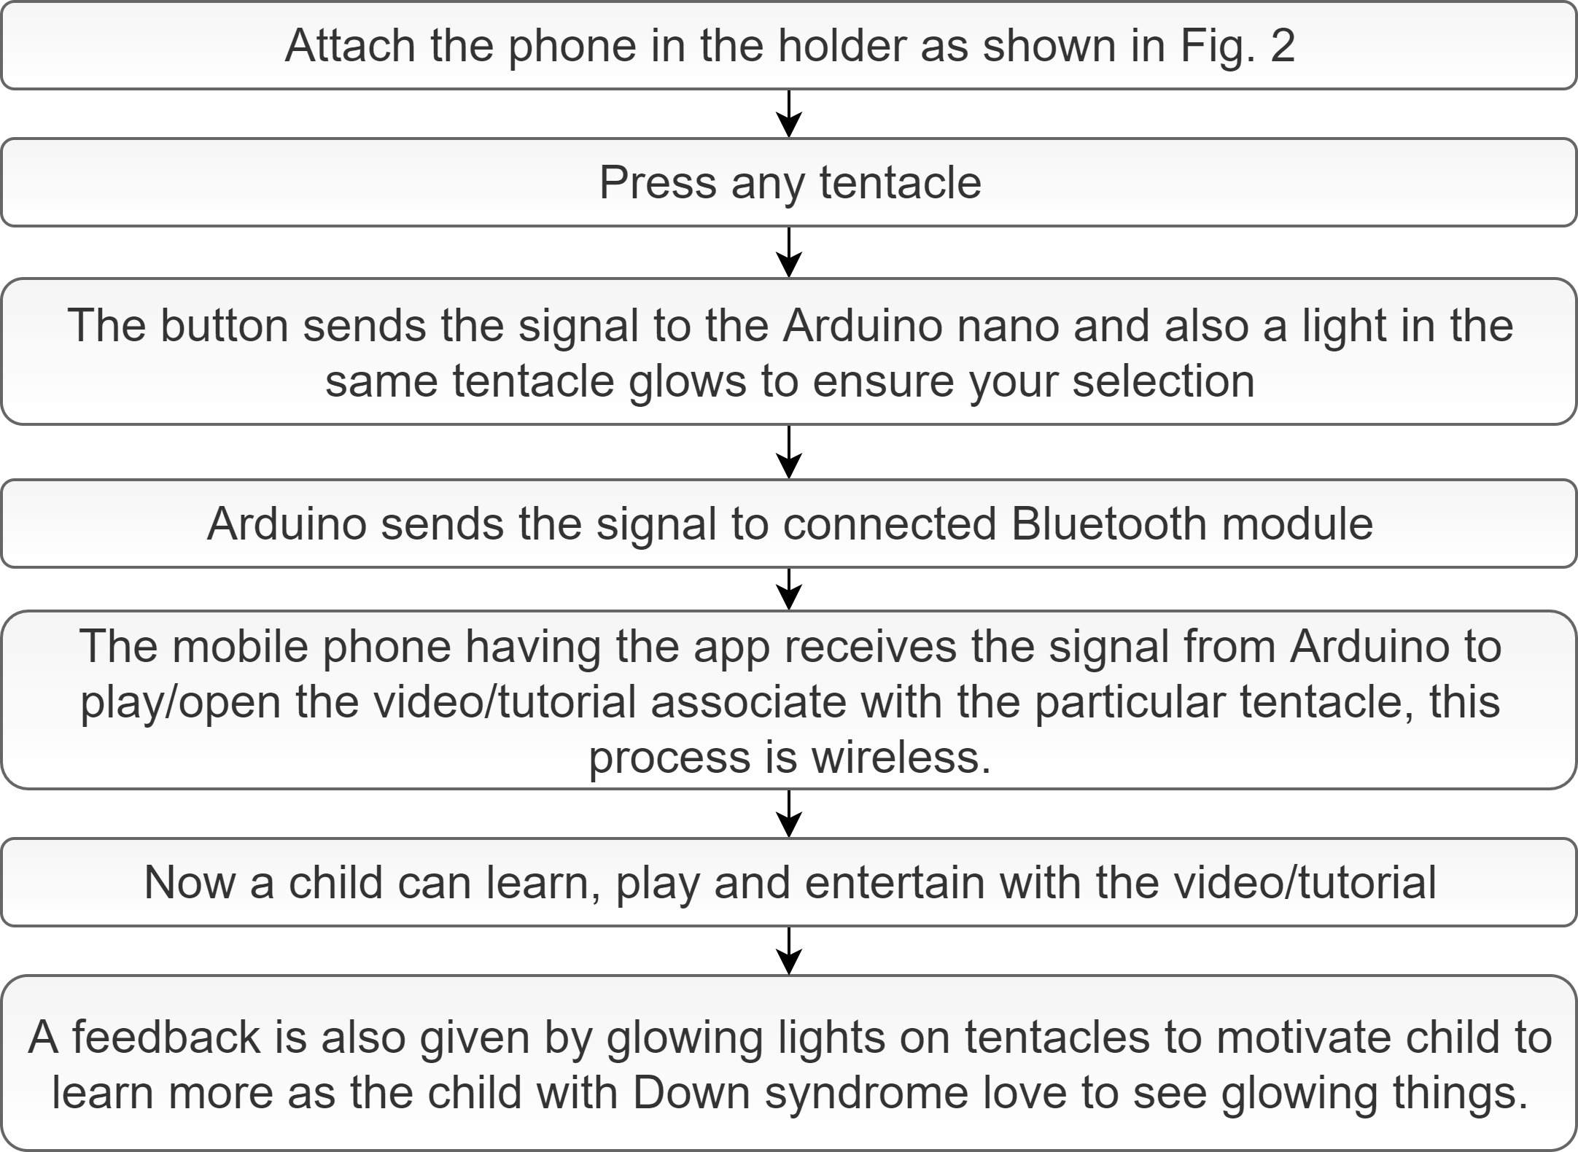

Fig. 4 Communication between Octobud and its App

# Results and Discussion

# future work

# Acknowledgment

[].

##### References

1. Kendall, P.C., 1994. Treating anxiety disorders in children: results of a randomized clinical trial. Journal of consulting and clinical psychology, 62(1), p.100.
2. Kutcher, S., Aman, M., Brooks, S.J., Buitelaar, J., Van Daalen, E., Fegert, J., Findling, R.L., Fisman, S., Greenhill, L.L., Huss, M. and Kusumakar, V., 2004. International consensus statement on attention-deficit/hyperactivity disorder (ADHD) and disruptive behaviour disorders (DBDs): clinical implications and treatment practice suggestions. European Neuropsychopharmacology, 14(1), pp.11-28.
3. Bryant‐Waugh, R. and Lask, B., 1995. Annotation: Eating disorders in children. Journal of Child Psychology and Psychiatry, 36(2), pp.191-202.
4. Chambers, W.J., Puig-Antich, J., Hirsch, M., Paez, P., Ambrosini, P.J., Tabrizi, M.A. and Davies, M., 1985. The assessment of affective disorders in children and adolescents by semistructured interview: test-retest reliability of the Schedule for Affective Disorders and Schizophrenia for School-Age Children, Present Episode Version. Archives of general psychiatry, 42(7), pp.696-702.
5. Potter, H.W., 1933. Schizophrenia in children. American Journal of Psychiatry, 89(6), pp.1253-1270.
6. Scahill, L., Sukhodolsky, D.G., Williams, S.K. and Leckman, J.F., 2005. Public health significance of tic disorders. Behav Neurol Mov Disord, 96, p.240.
7. ATTENTION-DEFICIT, S.O. and DISORDER, H., 2011. ADHD: clinical practice guideline for the diagnosis, evaluation, and treatment of attention-deficit/hyperactivity disorder in children and adolescents. Pediatrics, 128(5), p.1007.
8. Chapman, R.S., 1997. Language development in children and adolescents with Down syndrome. Mental Retardation and Developmental Disabilities Research Reviews, 3(4), pp.307-312.
9. Turner, S., Sloper, P., Cunningham, C. and Knussen, C., 1990. Health problems in children with Down's syndrome. Child: care, health and development, 16(2), pp.83-97.
10. Smith, D.S., 2001. Health care management of adults with Down syndrome. American family physician, 64(6), p.1031.
11. Määttä, T., Kaski, M., Taanila, A., Keinänen-Kiukaanniemi, S. and Iivanainen, M., 2006. Sensory impairments and health concerns related to the degree of intellectual disability in people with Down syndrome. Down Syndrome Research and Practice, 11(2), pp.78-83.
12. Bull, M.J., 2011. Health supervision for children with Down syndrome.
13. Esbensen, A.J., Seltzer, M.M. and Krauss, M.W., 2008. Stability and change in health, functional abilities, and behavior problems among adults with and without Down syndrome. American Journal on Mental Retardation, 113(4), pp.263-277.
14. Barnhart, R.C. and Connolly, B., 2007. Aging and Down syndrome: implications for physical therapy. Physical therapy, 87(10), pp.1399-1406.
15. Gardiner, K., Herault, Y., Lott, I.T., Antonarakis, S.E., Reeves, R.H. and Dierssen, M., 2010. Down syndrome: from understanding the neurobiology to therapy. Journal of Neuroscience, 30(45), pp.14943-14945.
16. Uyanik, M., Bumin, G. and KAYİHAN, H., 2003. Comparison of different therapy approaches in children with Down syndrome. Pediatrics international, 45(1), pp.68-73.
17. Wang, W.Y. and Ju, Y.H., 2002. Promoting balance and jumping skills in children with Down syndrome. Perceptual and motor skills, 94(2), pp.443-448.
18. Shumway-Cook, A. and Woollacott, M.H., 1985. Dynamics of postural control in the child with Down syndrome. Physical Therapy, 65(9), pp.1315-1322.
19. Prèvost, L., 2002. Speech and language therapy for children with Down syndrome. Down Syndrome News and Update, 2(2), pp.70-76.
20. Chapman, R.S., Schwartz, S.E. and Bird, E.K.R., 1991. Language skills of children and adolescents with Down syndrome: I. Comprehension. Journal of Speech, Language, and Hearing Research, 34(5), pp.1106-1120.
21. Daunhauer, L.A. and Fidler, D.J., 2011. The Down syndrome behavioral phenotype: Implications for practice and research in occupational therapy. Occupational Therapy in Health Care, 25(1), pp.7-25.
22. Share, J.B., 1976. Review of drug treatment for Down's syndrome persons. American journal of mental deficiency.
23. Hsieh, H.C., 2008. Effects of ordinary and adaptive toys on pre-school children with developmental disabilities. Research in Developmental Disabilities, 29(5), pp.459-46