F1 Race Telemetry Analytics and Visualization Platform - Synopsis
Reg No: U03MS23S0182
Name: Rishabh Das

Table of Contents
Sl. No | Topic Name | Page No
1 | Background and Need for the Project | 3
2 | Existing System | 4
3 | Proposed System | 4
4 | System Flowchart | 5
5 | Proposed System (Continued) | 6
6 | Hardware and Software Requirements | 7
7 | Limitations and Future Enhancements | 7

Background Context and Need for the Project
Formula 1 racing generates a large amount of telemetry and performance data during race sessions. This data includes information such as lap times, vehicle speed, throttle usage, braking behavior, tire strategy, and driver performance metrics. Analyzing this data helps teams, engineers, and analysts understand race strategies and driver performance.
However, most available race data platforms present information in a limited or static format, making it difficult for users to analyze the data interactively. There is a need for a system that retrieves formula 1 telemetry data and presents it in a visually intuitive and analytical format.
The proposed project aims to develop a web-based analytics platform that processes race telemetry data and presents it through interactive dashboards and visualizations. The system will allow users to explore race sessions, compare driver performance, and analyze race strategies through graphical representations.
This project demonstrates the integration of frontend development, backend data processing, and database management to create a scalable analytics system.

Existing System
Currently, race telemetry and performance data are available through official Formula 1 timing systems and some third-party websites. These platforms mainly provide basic race statistics such as lap times, race positions, and timing information.
However, these systems often lack interactive analytics tools and detailed telemetry visualizations that allow deeper insights into driver performance and race strategies. Most systems present the data in static formats without allowing detailed comparisons between drivers or sessions.
Due to these limitations, there is a need for an improved system that provides interactive analysis and visualization of Formula 1 telemetry data.

Proposed system
The proposed system is a web-based analytics platform that retrieves Formula 1 race data and provides interactive visualizations for analysis. The system will allow users to select a race season, Grand Prix event, and session type to retrieve telemetry and performance data.
The application will process the data using backend services and present it through graphical dashboards such as lap time charts, speed traces, and strategy visualizations. Users will also be able to compare driver performances and analyze race strategies through visual analytics.
The system will consist of a frontend interface for user interaction, a backend API for data processing, and a database for storing processed data and improving system performance.

System Flowchart
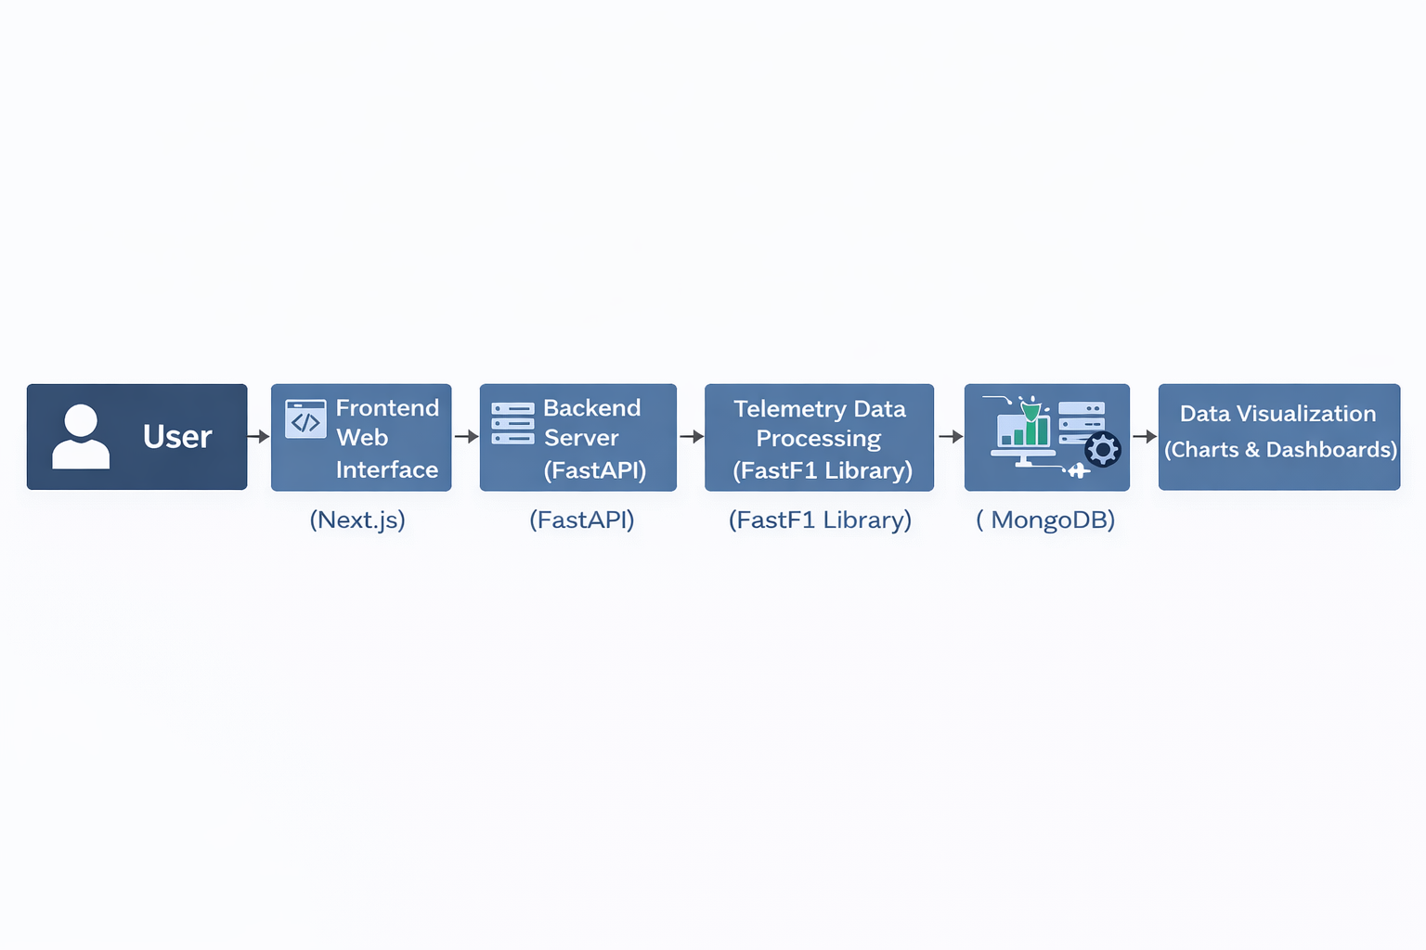

ER Diagram
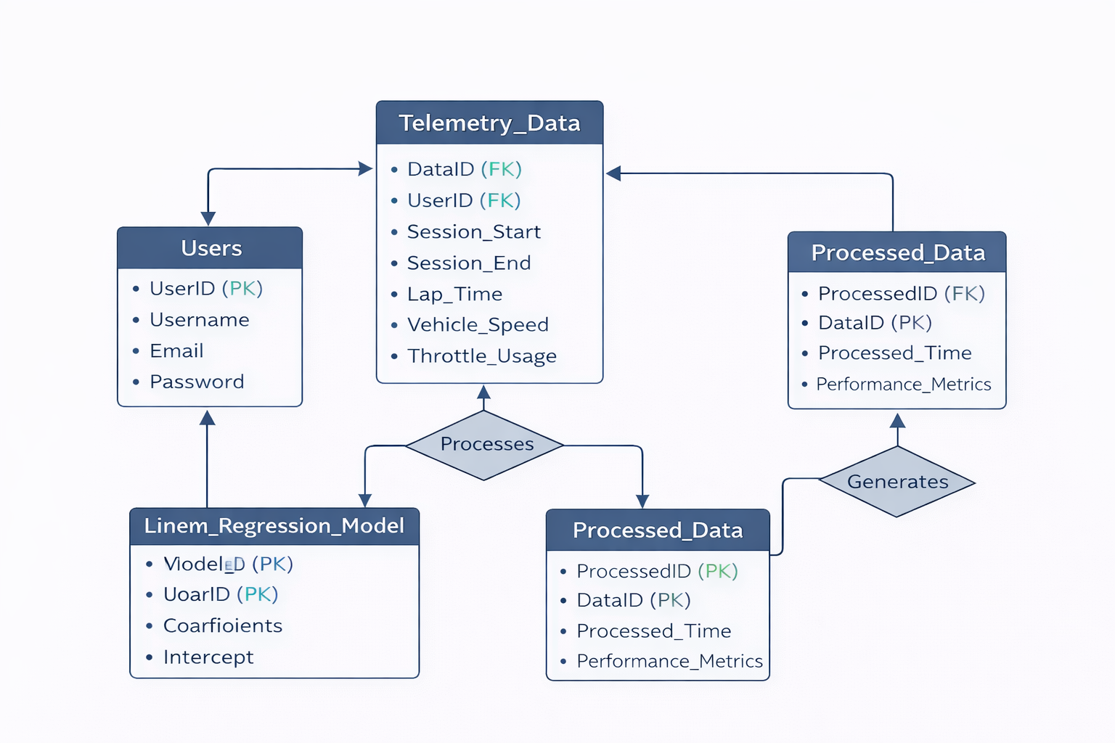

Proposed system
The system architecture follows a client-server model. The frontend interface will be developed using next.js and typescript, providing a responsive and interactive user interface. The backend will be developed using fastapi in python, which will retrieve telemetry data using the fastf1 library and process it for visualization.
The backend will expose restful apis that deliver processed data to the frontend. The frontend will use charts and visualization tools to display telemetry information such as lap times, speed variations, and race strategies.
Mongodb atlas will be used as the cloud database to store cached telemetry data and processed results. This improves performance by removing repeated data retrieval operations, and indexing from the fastf1 library.
The system will provide the following key functionalities:
- Selection of Formula 1 seasons and race sessions
- Retrieval of race telemetry and performance data
- Visualization of lap times and driver performance
- Driver comparison analytics
- Tire strategy and pit stop analysis
- Interactive dashboards for race analysis
This architecture ensures modular development and scalability of the system

Minimum Hardware and Software Requirements
Hardware Requirements:
- Laptop or Desktop Computer
- Tablet or Mobile Device

Software Requirements
Client Side:
- Web Browser (Google Chrome / Mozilla Firefox / Microsoft Edge / Safari)
Development Environment:
- Node.js
- Python
- Visual Studio Code
Frameworks and Libraries:
- Next.js
- fastapi
- fastf1
Database:
- mongodb Atlas (Cloud Database)

Limitations and Future Enhancements
Limitations:
- The system depends on publicly available Formula 1 telemetry datasets.
- Real-time race data streaming is not included in the current system.
- Data availability may vary for different race seasons.
Future Enhancements:
- Integration of real-time race telemetry.
- Advanced driver performance analytics.
- Predictive race strategy analysis using machine learning.
- Enhanced interactive race replay visualization.

