Consider the Figure below:  
Point A is rotated from an angle ϴ to an angle ϴ'.

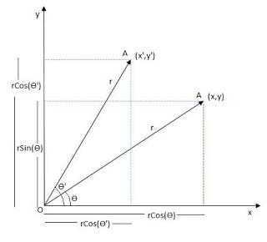

Hence,  
x=rCos(ϴ) & y=rSin(ϴ)  
And  
x'=rCos(ϴ+ϴ') & y'=rSin(ϴ+ϴ')  
Thus,  
x'=rCos(ϴ)Cos(ϴ')-rSin(ϴ)Sin(ϴ')  
x'=xCos(ϴ')-ySin(ϴ')  
  
y'=rSin(ϴ)Cos(ϴ')+rCos(ϴ)Sin(ϴ')  
y'=yCos(ϴ')+xSin(ϴ')  
Thus,  
***x'=xCos(ϴ')-ySin(ϴ')***  
***y'=yCos(ϴ')+xSin(ϴ')***  
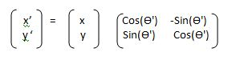

This is the matrix obtained when we want to rotate an Image about Origin. If we want to rotate an Image about any other point say(p,q), Then the equation would be,  
***x'=(x-p)Cos(ϴ')-(y-q)Sin(ϴ')+p***  
***y'=(y-q)Cos(ϴ')+(x-p)Sin(ϴ')+q***  
Hence the Matrix would be,

