**Price Estimation of Used Cars**

END TERM REPORT

***By***

**Rishabh Sen-55**

**Garvit joshi-51**

**Parth Sharma-59**

**Mridul Pal-52**

K18KY



Department of Intelligent Systems

School of Computer Science Engineering

Lovely Professional University, Jalandhar

April-2020

**Student Declaration**

This is to declare that this report has been written by me/us. No part of the report is copied from other sources. All information included from other sources have been duly acknowledged. I/We aver that if any part of the report is found to be copied, I/we are shall take full responsibility for it.

Rishabh Sen

Roll Number: 55

Parth Sharma

Roll Number: 59

Garvit joshi

Roll Number: 51

Mridul Pal

Roll Number:52

Jalandhar, Punjab

06/04/2020

**TABLE OF CONTENTS**

|  |  |
| --- | --- |
| **TITLE** | **Page No.** |
| 1. Bonafide Certificate | 4 |
| 1. The Introduction | 5 |
| 1. The Background | 5 |
| 1. The Motivation | 5 |
| 1. Outcomes and Goals | 5 |
| 1. DESCRIPTION OF PROJECT | 6-9 |
| * 1. The Problem | 6 |
| * 1. The Data | 6 |
| * 1. The Algorithm | 7 |
| * 1. Output | 8 |
| 1. WORK DIVISION | 10 |
| 1. SWOT Analysis | 10 |

**BONAFIDE CERTIFICATE**

Certified that this project report Price Estimation of used Cars is the bonafide work of Rishabh Sen,Garvit joshi, Parth Sharma, Mridul Pal who carried out the project work under my supervision.

Miss Shabnam Sajwan

Assistant Professor

25660

Department of Intelligent System

School of computer Science and Engineering

**The Introduction**

The Project was made for price estimation of used cars. The project uses many aspects to find the right price of a car for second hand purposes, it uses fuel type, car body,, door numb, car body, wheelbase, engine located, car length, stroke, fuel system, compression, horse power and many more.

**The Background**

The code in made in such a way that we can look at the aspects of a car in the form if visuals we used a dataframe to collect data from a .csv file. This will help us to understand our data better and give us some clue about pattern in data.

**The Motivation**

We came to know there is always a need for second-hand cars, for those who cannot afford a new can, so to get rid of the problem we created this model to make a good prediction of a second hand cars, we have seen every aspect of a car and then used our model to make a good prediction of used cars.

**Outcomes and Goals**

The Goal of the algorithm is used to determine good predication of second hand cars. The algorithm incorporates a number of techniques, aimed to improve the efficiency of the search operation. The non-rigid soft constraints i.e. optimization objectives for the search operation should also be effectively handled. Given the generality of the algorithm operation, it can further be adapted to more specific scenarios. The most interesting future direction in the development of the algorithm lies in its extension to constraint propagation. When there is a value assigned to a variable, such assignment can be propagated to unassigned variables to prohibit all values which come into conflict with the current assignments. The information about such prohibited values can be propagated as well.

**DESCRIPTION OF PROJECT**

**The Problem**

The prices of new cars in the industry is fixed by the manufacturer with some additional costs incurred by the Government in the form of taxes. So, customers buying a new car can be assured of the money they invest to be worthy. But due to the increased price of new cars and the incapability of customers to buy new cars due to the lack of funds, used cars sales are on a global increase. There is a need for a used car price prediction system to effectively determine the worthiness of the car using a variety of features. Even though there are websites that offers this service, their prediction method may not be the best. Besides, different models and systems may contribute on predicting power for a used car’s actual market value. It is important to know their actual market value while both buying and selling.

**The Data**

The Data Used in This Project was taken from github.com, due to lack of .csv files. I altered the data so that I can test my program with different set of data.

There Were Many Factors that include for price estimation of used cars. We kept the factors in mind a developed the source code, which takes in mind all aspects of a car, such as dents, paint, volume, occupancy and many more.

The Data Is Present in “CarPrice_Assignement.csv”.

**The Algorithm**

1. Adding all Dependencies.
2. Processing the data into a data-frame.
3. Using numpy and pandas see the characteristics of data and find useful constraints.
4. **1+1 evolutionary strategy (hard constraints)**  
   This is the phase of the algorithm were we generate an arbitrary number of schedules that try to optimize for hard constraints, hence this is shotgun hill-climbing. They way we do this for each of these schedules is: Firstly, we generate a completely random result. Then, we use the 1+1 evolutionary strategy to improve out solution. The way in which find a neighbouring solution (one that we compare with the current one) is by using a mutation operator. As part of the mutation, we search for all cars that violate some hard constraint (with any resource) and we randomly choose one of them.
5. **1+1 evolutionary strategy (soft constraints)**  
   In this phase we optimize for soft constraints only, but we are wary of not violating any hard constraints in the process. The way we do this is similar as in the previous step. We run 15000 iterations of 1+1 evolutionary strategy on the previously obtained results. The difference compared to the previous step is that we use a different cost function.
6. After Applying All the constraints we can now calculate the estimated price of all the cars that were in the csv file

**Outputs:**

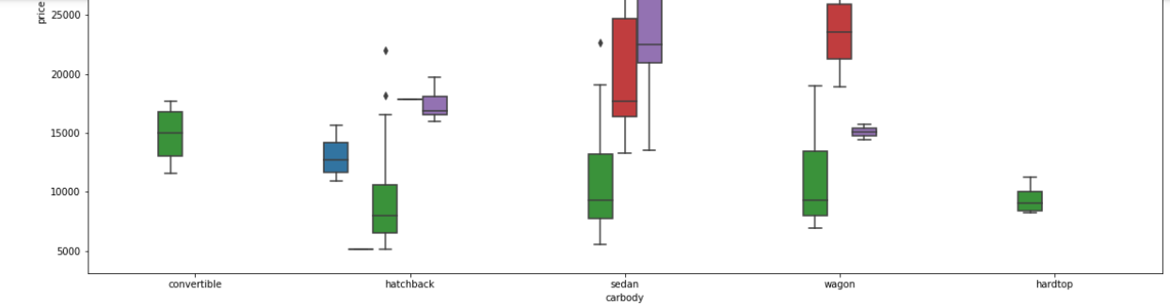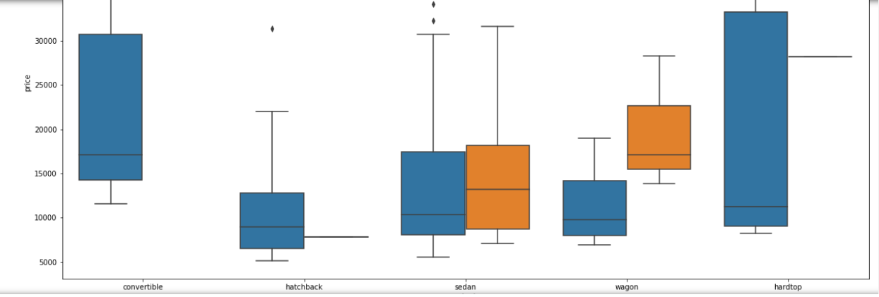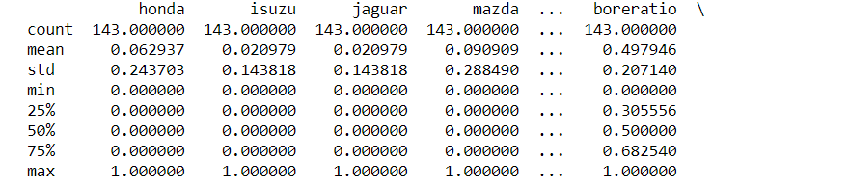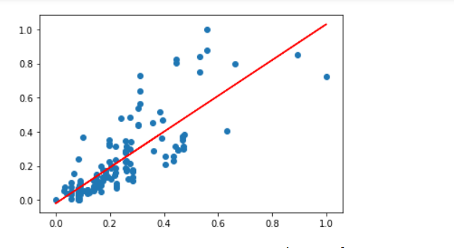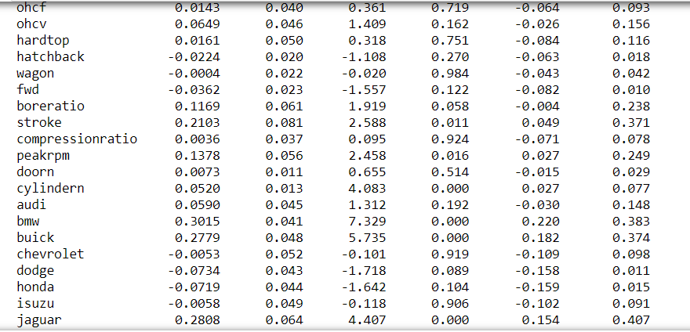

**WORK DIVISION**

**CONTRIBUTION IN PROJECT:**

|  |  |
| --- | --- |
| **Name** | **Contribution** |
| 1. Garvit Joshi | Made Modules and Added them altogether |
| 1. Rishabh Sen | Made A Formulae, some Modules and Studied about the factors that contribute in price of used cars |
| 1. Parth Sharma | Added data File and made test cases |
| 1. Mridul Pal | Contributed in making data usable with all aspects. |

**SWOT ANALYSIS**

As the previous methods of price estimation of used cars were very tideous process of assigning a person for price estimation of used cars and the person would manually check the car, this model will be helpful as it will give result in short span of time.