* This project is to reinvigorate the software that is used in automatic ticket vending machine.
* My aim regarding this project was to create software that had the ability to be independent of any human support and can issue tickets for the users, with a simple interface, some composite libraries with packages and use of graphical animations; I was able to achieve it.
* The user is supposed to select the station which will be his/her destination.
* The software is smart enough to perform the payments for the tickets by two methods - cash or smart card, which is chosen by the user. The software prints the ticket as per the preferences of the user.
* The software also has a database management system that enables it to store the account information of every user who wishes to open an account using the ticket kiosk.
* 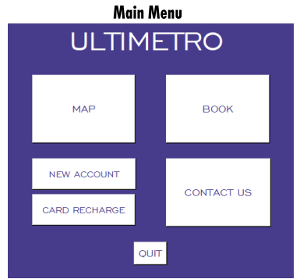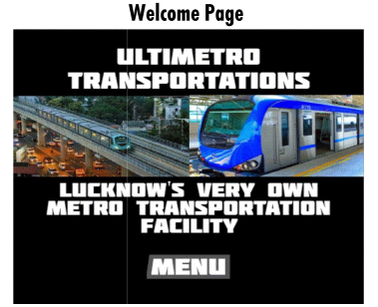The software is also capable of creating accounts for first time users or who desire to. This section of the software will be requiring the basic information of the user. This will result in the final account creation for the user.

