Supplementary Material
Shortcuts and Temporal Leakage in the Bangalore EEG Epilepsy Dataset: a Provenance Audit and Leakage-Aware Benchmark of Lightweight Seizure-Type Classifiers
This document contains extended tables, additional figures, hyper-parameter grids, full per-fold results and the additional analyses (Section S7). Supplementary File S1 is the accompanying code-and-results archive: the core pipeline (run_all.py, src/, results/, figures/, analysis.ipynb) and the additional analyses (extended_analyses/). All values were generated by that code.

S1 Hyper-parameter grids and selected values
Table S1. Hyper-parameter search grids (inner three-fold CV, macro-F1)
Model | Grid | Fixed settings
Majority | – | –
LR | C ∈ [0.01, 0.1, 1, 10, 100] | –
kNN | n_neighbors ∈ [1, 5, 15, 31]; weights ∈ ['uniform', 'distance'] | –
SVM-RBF | C ∈ [1, 10, 100]; gamma ∈ ['scale', 0.01] | –
RF | max_features ∈ ['sqrt', 0.3]; min_samples_leaf ∈ [1, 5] | n_estimators=300
XGBoost | max_depth ∈ [3, 6]; learning_rate ∈ [0.05, 0.2] | colsample_bytree=0.8; n_estimators=300; subsample=0.8
LightGBM | num_leaves ∈ [15, 63]; learning_rate ∈ [0.05, 0.2] | colsample_bytree=0.8; n_estimators=300; subsample=0.8
MLP | lr ∈ {0.001, 0.003}; width × {0.5, 1, 2}; dropout ∈ {0, 0.2} | AdamW, weight decay 1e-4, batch 128, ≤100 epochs, patience 15 (fixed defaults: lr 0.002, ≤60 epochs, patience 8, no grid)
1D-CNN | lr ∈ {0.001, 0.003}; width × {0.5, 1, 2}; dropout ∈ {0, 0.2} | AdamW, weight decay 1e-4, batch 128, ≤100 epochs, patience 15 (fixed defaults: lr 0.002, ≤60 epochs, patience 8, no grid)
BiLSTM | lr ∈ {0.001, 0.003}; width × {0.5, 1, 2}; dropout ∈ {0, 0.2} | AdamW, weight decay 1e-4, batch 128, ≤100 epochs, patience 15 (fixed defaults: lr 0.002, ≤60 epochs, patience 8, no grid)
Transformer | lr ∈ {0.001, 0.003}; width × {0.5, 1, 2}; dropout ∈ {0, 0.2} | AdamW, weight decay 1e-4, batch 128, ≤100 epochs, patience 15 (fixed defaults: lr 0.002, ≤60 epochs, patience 8, no grid)
Classical models: inner three-fold CV following the outer protocol. Deep models (blocked protocol): single purged blocked inner hold-out (80/20 of the outer-training groups); see Section S7.7. Fixed defaults were used under the random protocol and in Tables S3, S6 and S8–S11.
Table S2. Hyper-parameters selected on the development set for each hold-out run
Task | Protocol | Features | Model | Selected
4class | random | raw | LR | {logisticregression__C: 0.01}
4class | random | raw | kNN | {kneighborsclassifier__n_neighbors: 1, kneighborsclassifier__weights: uniform}
4class | random | raw | SVM-RBF | {svc__C: 100, svc__gamma: scale}
4class | random | raw | RF | {max_features: sqrt, min_samples_leaf: 1}
4class | random | raw | XGBoost | {learning_rate: 0.2, max_depth: 6}
4class | random | raw | LightGBM | {learning_rate: 0.2, num_leaves: 63}
4class | random | eng | LR | {logisticregression__C: 10}
4class | random | eng | kNN | {kneighborsclassifier__n_neighbors: 1, kneighborsclassifier__weights: uniform}
4class | random | eng | SVM-RBF | {svc__C: 100, svc__gamma: scale}
4class | random | eng | RF | {max_features: 0.3, min_samples_leaf: 1}
4class | random | eng | XGBoost | {learning_rate: 0.2, max_depth: 6}
4class | random | eng | LightGBM | {learning_rate: 0.05, num_leaves: 63}
4class | random | raw+eng | LR | {logisticregression__C: 100}
4class | random | raw+eng | kNN | {kneighborsclassifier__n_neighbors: 1, kneighborsclassifier__weights: uniform}
4class | random | raw+eng | SVM-RBF | {svc__C: 100, svc__gamma: scale}
4class | random | raw+eng | RF | {max_features: 0.3, min_samples_leaf: 1}
4class | random | raw+eng | XGBoost | {learning_rate: 0.2, max_depth: 6}
4class | random | raw+eng | LightGBM | {learning_rate: 0.05, num_leaves: 63}
4class | blocked | raw | LR | {logisticregression__C: 100}
4class | blocked | raw | kNN | {kneighborsclassifier__n_neighbors: 5, kneighborsclassifier__weights: uniform}
4class | blocked | raw | SVM-RBF | {svc__C: 100, svc__gamma: scale}
4class | blocked | raw | RF | {max_features: sqrt, min_samples_leaf: 1}
4class | blocked | raw | XGBoost | {learning_rate: 0.2, max_depth: 3}
4class | blocked | raw | LightGBM | {learning_rate: 0.05, num_leaves: 15}
4class | blocked | eng | LR | {logisticregression__C: 100}
4class | blocked | eng | kNN | {kneighborsclassifier__n_neighbors: 15, kneighborsclassifier__weights: distance}
4class | blocked | eng | SVM-RBF | {svc__C: 100, svc__gamma: 0.01}
4class | blocked | eng | RF | {max_features: sqrt, min_samples_leaf: 1}
4class | blocked | eng | XGBoost | {learning_rate: 0.2, max_depth: 3}
4class | blocked | eng | LightGBM | {learning_rate: 0.2, num_leaves: 15}
4class | blocked | raw+eng | LR | {logisticregression__C: 100}
4class | blocked | raw+eng | kNN | {kneighborsclassifier__n_neighbors: 15, kneighborsclassifier__weights: distance}
4class | blocked | raw+eng | SVM-RBF | {svc__C: 10, svc__gamma: scale}
4class | blocked | raw+eng | RF | {max_features: 0.3, min_samples_leaf: 1}
4class | blocked | raw+eng | XGBoost | {learning_rate: 0.2, max_depth: 3}
4class | blocked | raw+eng | LightGBM | {learning_rate: 0.2, num_leaves: 15}
binary | random | raw+eng | LR | {logisticregression__C: 1}
binary | random | raw+eng | kNN | {kneighborsclassifier__n_neighbors: 1, kneighborsclassifier__weights: uniform}
binary | random | raw+eng | SVM-RBF | {svc__C: 1, svc__gamma: scale}
binary | random | raw+eng | RF | {max_features: sqrt, min_samples_leaf: 1}
binary | random | raw+eng | XGBoost | {learning_rate: 0.05, max_depth: 3}
binary | random | raw+eng | LightGBM | {learning_rate: 0.05, num_leaves: 15}
binary | blocked | raw+eng | LR | {logisticregression__C: 10}
binary | blocked | raw+eng | kNN | {kneighborsclassifier__n_neighbors: 5, kneighborsclassifier__weights: uniform}
binary | blocked | raw+eng | SVM-RBF | {svc__C: 10, svc__gamma: 0.01}
binary | blocked | raw+eng | RF | {max_features: sqrt, min_samples_leaf: 1}
binary | blocked | raw+eng | XGBoost | {learning_rate: 0.05, max_depth: 3}
binary | blocked | raw+eng | LightGBM | {learning_rate: 0.05, num_leaves: 15}
3class | random | raw+eng | LR | {logisticregression__C: 100}
3class | random | raw+eng | kNN | {kneighborsclassifier__n_neighbors: 1, kneighborsclassifier__weights: uniform}
3class | random | raw+eng | SVM-RBF | {svc__C: 100, svc__gamma: scale}
3class | random | raw+eng | RF | {max_features: 0.3, min_samples_leaf: 1}
3class | random | raw+eng | XGBoost | {learning_rate: 0.2, max_depth: 6}
3class | random | raw+eng | LightGBM | {learning_rate: 0.05, num_leaves: 63}
3class | blocked | raw+eng | LR | {logisticregression__C: 1}
3class | blocked | raw+eng | kNN | {kneighborsclassifier__n_neighbors: 15, kneighborsclassifier__weights: uniform}
3class | blocked | raw+eng | SVM-RBF | {svc__C: 10, svc__gamma: 0.01}
3class | blocked | raw+eng | RF | {max_features: 0.3, min_samples_leaf: 1}
3class | blocked | raw+eng | XGBoost | {learning_rate: 0.2, max_depth: 3}
3class | blocked | raw+eng | LightGBM | {learning_rate: 0.2, num_leaves: 15}
Hold-out runs of Tables S3 and S6. Deep models in these runs used fixed default hyper-parameters (no selection).

S2 Extended hold-out results
Table S3. Four-class hold-out results for all models and feature sets
Protocol | Features | Model | Accuracy | Macro-F1 | Kappa | AUC | Brier | ECE | Fit (s)
random | eng | LightGBM | 0.916 | 0.916 | 0.888 | 0.988 | 0.128 | 0.025 | 10.9
random | eng | XGBoost | 0.909 | 0.909 | 0.878 | 0.985 | 0.140 | 0.019 | 8.8
random | eng | kNN | 0.902 | 0.903 | 0.870 | 0.935 | 0.195 | 0.098 | 0.4
random | eng | SVM-RBF | 0.889 | 0.890 | 0.853 | 0.979 | 0.165 | 0.034 | 14.5
random | eng | RF | 0.871 | 0.871 | 0.828 | 0.978 | 0.212 | 0.114 | 24.3
random | eng | LR | 0.749 | 0.749 | 0.666 | 0.925 | 0.323 | 0.033 | 4.3
random | eng | Majority | 0.250 | 0.100 | 0.000 | 0.500 | 0.750 | 0.000 | 0.0
random | raw | kNN | 0.986 | 0.986 | 0.982 | 0.991 | 0.028 | 0.014 | 0.2
random | raw | LightGBM | 0.986 | 0.986 | 0.981 | 0.999 | 0.025 | 0.010 | 3.4
random | raw | XGBoost | 0.976 | 0.976 | 0.968 | 0.999 | 0.035 | 0.009 | 2.5
random | raw | RF | 0.964 | 0.964 | 0.953 | 0.998 | 0.096 | 0.133 | 7.5
random | raw | 1D-CNN | 0.956 | 0.956 | 0.941 | 0.997 | 0.066 | 0.015 | 9.0
random | raw | MLP | 0.932 | 0.933 | 0.910 | 0.994 | 0.091 | 0.029 | 7.1
random | raw | Transformer | 0.921 | 0.921 | 0.895 | 0.988 | 0.121 | 0.018 | 32.5
random | raw | SVM-RBF | 0.903 | 0.903 | 0.871 | 0.983 | 0.145 | 0.027 | 6.7
random | raw | BiLSTM | 0.706 | 0.697 | 0.607 | 0.893 | 0.374 | 0.029 | 9.0
random | raw | LR | 0.477 | 0.483 | 0.302 | 0.657 | 0.680 | 0.127 | 2.8
random | raw | Majority | 0.250 | 0.100 | 0.000 | 0.500 | 0.750 | 0.000 | 0.0
random | raw+eng | LightGBM | 0.973 | 0.973 | 0.964 | 0.999 | 0.039 | 0.010 | 14.8
random | raw+eng | XGBoost | 0.962 | 0.962 | 0.949 | 0.997 | 0.053 | 0.009 | 9.1
random | raw+eng | RF | 0.943 | 0.943 | 0.924 | 0.994 | 0.135 | 0.136 | 28.3
random | raw+eng | SVM-RBF | 0.928 | 0.928 | 0.904 | 0.990 | 0.111 | 0.036 | 13.6
random | raw+eng | kNN | 0.926 | 0.926 | 0.902 | 0.951 | 0.147 | 0.074 | 0.4
random | raw+eng | LR | 0.761 | 0.760 | 0.681 | 0.931 | 0.311 | 0.030 | 15.8
random | raw+eng | Majority | 0.250 | 0.100 | 0.000 | 0.500 | 0.750 | 0.000 | 0.0
blocked | eng | LR | 0.707 | 0.705 | 0.609 | 0.909 | 0.357 | 0.054 | 5.8
blocked | eng | SVM-RBF | 0.702 | 0.697 | 0.603 | 0.891 | 0.426 | 0.124 | 10.7
blocked | eng | LightGBM | 0.699 | 0.690 | 0.599 | 0.889 | 0.497 | 0.208 | 7.0
blocked | eng | XGBoost | 0.695 | 0.686 | 0.593 | 0.894 | 0.419 | 0.129 | 5.9
blocked | eng | RF | 0.686 | 0.664 | 0.581 | 0.882 | 0.393 | 0.029 | 15.6
blocked | eng | kNN | 0.649 | 0.631 | 0.532 | 0.847 | 0.462 | 0.094 | 0.3
blocked | eng | Majority | 0.250 | 0.100 | 0.000 | 0.500 | 0.750 | 0.007 | 0.0
blocked | raw | SVM-RBF | 0.844 | 0.842 | 0.792 | 0.962 | 0.238 | 0.053 | 5.4
blocked | raw | LightGBM | 0.816 | 0.810 | 0.755 | 0.949 | 0.276 | 0.077 | 2.9
blocked | raw | XGBoost | 0.805 | 0.798 | 0.740 | 0.946 | 0.293 | 0.094 | 1.8
blocked | raw | RF | 0.803 | 0.795 | 0.737 | 0.942 | 0.287 | 0.077 | 6.6
blocked | raw | MLP | 0.779 | 0.772 | 0.705 | 0.949 | 0.309 | 0.076 | 2.4
blocked | raw | Transformer | 0.752 | 0.746 | 0.669 | 0.938 | 0.335 | 0.096 | 11.6
blocked | raw | 1D-CNN | 0.725 | 0.722 | 0.633 | 0.926 | 0.373 | 0.132 | 3.6
blocked | raw | kNN | 0.709 | 0.710 | 0.611 | 0.861 | 0.443 | 0.160 | 0.2
blocked | raw | BiLSTM | 0.520 | 0.468 | 0.360 | 0.771 | 0.546 | 0.093 | 2.2
blocked | raw | LR | 0.440 | 0.436 | 0.253 | 0.666 | 0.674 | 0.087 | 0.5
blocked | raw | Majority | 0.250 | 0.100 | 0.000 | 0.500 | 0.750 | 0.007 | 0.0
blocked | raw+eng | LightGBM | 0.807 | 0.799 | 0.742 | 0.942 | 0.341 | 0.148 | 8.4
blocked | raw+eng | XGBoost | 0.790 | 0.784 | 0.720 | 0.940 | 0.310 | 0.096 | 6.6
blocked | raw+eng | RF | 0.768 | 0.755 | 0.691 | 0.919 | 0.329 | 0.033 | 25.9
blocked | raw+eng | LR | 0.724 | 0.724 | 0.631 | 0.915 | 0.350 | 0.058 | 12.1
blocked | raw+eng | SVM-RBF | 0.728 | 0.719 | 0.637 | 0.912 | 0.378 | 0.103 | 8.7
blocked | raw+eng | kNN | 0.656 | 0.633 | 0.541 | 0.863 | 0.435 | 0.082 | 0.4
blocked | raw+eng | Majority | 0.250 | 0.100 | 0.000 | 0.500 | 0.750 | 0.007 | 0.0
Deep models here use fixed default hyper-parameters (tuned deep models: Table S30). Fit time includes nested hyper-parameter search on 8 CPU cores. Single final-20% hold-out; not the primary estimate (Tables S23–S24).
Table S4. Row-level versus cluster bootstrap 95% confidence intervals (four-class)
Protocol | Features | Model | Macro-F1 | Row CI | Cluster CI | Accuracy | Row CI | Cluster CI
random | raw | kNN | 0.986 | 0.981–0.992 | 0.980–0.992 | 0.986 | 0.981–0.992 | 0.980–0.992
random | raw | LightGBM | 0.986 | 0.979–0.991 | 0.979–0.992 | 0.986 | 0.979–0.991 | 0.979–0.992
random | raw | XGBoost | 0.976 | 0.969–0.984 | 0.968–0.983 | 0.976 | 0.969–0.984 | 0.968–0.984
random | raw+eng | LightGBM | 0.973 | 0.966–0.981 | 0.964–0.982 | 0.973 | 0.966–0.981 | 0.964–0.982
random | raw | RF | 0.964 | 0.956–0.974 | 0.953–0.974 | 0.964 | 0.956–0.974 | 0.953–0.974
random | raw+eng | XGBoost | 0.962 | 0.953–0.971 | 0.951–0.972 | 0.962 | 0.953–0.971 | 0.950–0.972
random | raw | 1D-CNN | 0.956 | 0.945–0.966 | 0.945–0.966 | 0.956 | 0.945–0.966 | 0.945–0.966
random | raw+eng | RF | 0.943 | 0.931–0.954 | 0.929–0.956 | 0.943 | 0.931–0.954 | 0.929–0.956
random | raw | MLP | 0.933 | 0.921–0.945 | 0.916–0.949 | 0.932 | 0.920–0.945 | 0.915–0.949
random | raw+eng | SVM-RBF | 0.928 | 0.916–0.941 | 0.913–0.944 | 0.928 | 0.915–0.941 | 0.912–0.944
random | raw+eng | kNN | 0.926 | 0.914–0.938 | 0.912–0.939 | 0.926 | 0.914–0.938 | 0.912–0.939
random | raw | Transformer | 0.921 | 0.908–0.933 | 0.901–0.939 | 0.921 | 0.909–0.933 | 0.902–0.939
random | raw | SVM-RBF | 0.903 | 0.888–0.918 | 0.880–0.924 | 0.903 | 0.888–0.917 | 0.879–0.924
random | raw+eng | LR | 0.760 | 0.740–0.780 | 0.736–0.786 | 0.761 | 0.741–0.781 | 0.735–0.787
random | raw | BiLSTM | 0.697 | 0.677–0.717 | 0.664–0.730 | 0.706 | 0.687–0.725 | 0.671–0.741
random | raw | LR | 0.483 | 0.460–0.506 | 0.444–0.518 | 0.477 | 0.454–0.501 | 0.438–0.513
blocked | raw | SVM-RBF | 0.842 | 0.824–0.859 | 0.800–0.880 | 0.844 | 0.827–0.861 | 0.802–0.882
blocked | raw | LightGBM | 0.810 | 0.791–0.827 | 0.771–0.845 | 0.816 | 0.799–0.832 | 0.779–0.850
blocked | raw+eng | LightGBM | 0.799 | 0.781–0.817 | 0.754–0.843 | 0.807 | 0.790–0.824 | 0.766–0.847
blocked | raw | XGBoost | 0.798 | 0.780–0.816 | 0.755–0.838 | 0.805 | 0.788–0.822 | 0.764–0.842
blocked | raw | RF | 0.795 | 0.777–0.813 | 0.736–0.848 | 0.803 | 0.786–0.821 | 0.750–0.853
blocked | raw+eng | XGBoost | 0.784 | 0.765–0.801 | 0.740–0.826 | 0.790 | 0.772–0.807 | 0.748–0.830
blocked | raw | MLP | 0.772 | 0.752–0.790 | 0.720–0.820 | 0.779 | 0.761–0.796 | 0.730–0.825
blocked | raw+eng | RF | 0.755 | 0.737–0.774 | 0.702–0.806 | 0.768 | 0.751–0.786 | 0.725–0.812
blocked | raw | Transformer | 0.746 | 0.726–0.765 | 0.699–0.790 | 0.752 | 0.732–0.770 | 0.708–0.794
blocked | raw+eng | LR | 0.724 | 0.705–0.744 | 0.672–0.775 | 0.724 | 0.704–0.744 | 0.673–0.775
blocked | raw | 1D-CNN | 0.722 | 0.701–0.742 | 0.674–0.765 | 0.725 | 0.705–0.744 | 0.680–0.767
blocked | raw+eng | SVM-RBF | 0.719 | 0.699–0.738 | 0.674–0.769 | 0.728 | 0.710–0.747 | 0.686–0.774
blocked | raw | kNN | 0.710 | 0.690–0.731 | 0.667–0.750 | 0.709 | 0.688–0.729 | 0.667–0.746
blocked | raw+eng | kNN | 0.633 | 0.613–0.651 | 0.601–0.668 | 0.656 | 0.638–0.674 | 0.622–0.692
blocked | raw | BiLSTM | 0.468 | 0.453–0.482 | 0.410–0.526 | 0.520 | 0.503–0.536 | 0.452–0.589
blocked | raw | LR | 0.436 | 0.414–0.458 | 0.369–0.500 | 0.440 | 0.417–0.462 | 0.370–0.506
Row CI: independent resampling of test rows. Cluster CI: class-stratified resampling of Bonn segments (class 0) and 50-row chunks (classes 1–3), which respects autocorrelation. Neither interval includes the variation due to test-block position; see Table S32 for chunk-size sensitivity and rolling-origin intervals.
Table S5. Per-class precision, recall and F1 of the best hold-out model per setting
Task | Protocol | Model | Class | Precision | Recall | F1 | Support
4class | random | kNN (raw) | H | 1.000 | 0.988 | 0.994 | 400
4class | random | kNN (raw) | GS | 0.992 | 0.983 | 0.987 | 400
4class | random | kNN (raw) | FS | 0.987 | 0.975 | 0.981 | 400
4class | random | kNN (raw) | SE | 0.966 | 1.000 | 0.983 | 400
4class | blocked | SVM-RBF (raw) | H | 1.000 | 0.995 | 0.997 | 399
4class | blocked | SVM-RBF (raw) | GS | 0.799 | 0.912 | 0.852 | 400
4class | blocked | SVM-RBF (raw) | FS | 0.809 | 0.802 | 0.806 | 400
4class | blocked | SVM-RBF (raw) | SE | 0.764 | 0.665 | 0.711 | 400
3class | random | kNN (raw) | GS | 0.995 | 0.985 | 0.990 | 400
3class | random | kNN (raw) | FS | 0.990 | 0.985 | 0.987 | 400
3class | random | kNN (raw) | SE | 0.985 | 1.000 | 0.993 | 400
3class | blocked | SVM-RBF (raw) | GS | 0.760 | 0.925 | 0.834 | 400
3class | blocked | SVM-RBF (raw) | FS | 0.824 | 0.807 | 0.816 | 400
3class | blocked | SVM-RBF (raw) | SE | 0.760 | 0.610 | 0.677 | 400
Best model of Tables S3 and S6 on each hold-out set (selected on the test set; descriptive only). Confusion matrices of the pre-specified primary model (LightGBM, raw): Figure S14.
Table S6. Binary and three-class hold-out results
Task | Protocol | Features | Model | Accuracy | Macro-F1 | Cluster CI | Kappa | AUC | ECE
binary | random | raw | 1D-CNN | 1.000 | 1.000 | 1.000–1.000 | 1.000 | 1.000 | 0.003
binary | random | raw+eng | XGBoost | 0.999 | 0.999 | 0.997–1.000 | 0.998 | 1.000 | 0.001
binary | random | raw+eng | LR | 0.999 | 0.999 | 0.997–1.000 | 0.998 | 1.000 | 0.001
binary | random | raw+eng | RF | 0.999 | 0.999 | 0.997–1.000 | 0.998 | 1.000 | 0.001
binary | random | raw+eng | SVM-RBF | 0.999 | 0.998 | 0.996–1.000 | 0.997 | 1.000 | 0.001
binary | random | raw+eng | LightGBM | 0.999 | 0.998 | 0.996–1.000 | 0.997 | 1.000 | 0.001
binary | random | raw+eng | kNN | 0.999 | 0.998 | 0.996–1.000 | 0.997 | 0.998 | 0.001
binary | random | raw | MLP | 0.998 | 0.997 | 0.994–1.000 | 0.995 | 1.000 | 0.001
binary | random | raw+eng | Majority | 0.750 | 0.429 | 0.422–0.434 | 0.000 | 0.500 | 0.000
binary | blocked | raw+eng | LR | 0.999 | 0.999 | 0.997–1.000 | 0.998 | 1.000 | 0.001
binary | blocked | raw | 1D-CNN | 0.999 | 0.999 | 0.997–1.000 | 0.998 | 1.000 | 0.001
binary | blocked | raw+eng | SVM-RBF | 0.999 | 0.999 | 0.997–1.000 | 0.998 | 1.000 | 0.001
binary | blocked | raw+eng | RF | 0.999 | 0.999 | 0.997–1.000 | 0.998 | 1.000 | 0.002
binary | blocked | raw+eng | LightGBM | 0.999 | 0.999 | 0.997–1.000 | 0.998 | 1.000 | 0.001
binary | blocked | raw+eng | XGBoost | 0.999 | 0.998 | 0.996–1.000 | 0.997 | 1.000 | 0.001
binary | blocked | raw+eng | kNN | 0.999 | 0.998 | 0.995–1.000 | 0.997 | 0.999 | 0.001
binary | blocked | raw | MLP | 0.996 | 0.995 | 0.989–0.999 | 0.990 | 1.000 | 0.010
binary | blocked | raw+eng | Majority | 0.750 | 0.429 | 0.426–0.431 | 0.000 | 0.500 | 0.007
3class | random | raw | kNN | 0.990 | 0.990 | 0.980–0.997 | 0.985 | 0.993 | 0.010
3class | random | raw | LightGBM | 0.968 | 0.968 | 0.954–0.980 | 0.951 | 0.997 | 0.012
3class | random | raw | SVM-RBF | 0.964 | 0.964 | 0.950–0.977 | 0.946 | 0.996 | 0.025
3class | random | raw+eng | LightGBM | 0.960 | 0.960 | 0.944–0.974 | 0.940 | 0.996 | 0.014
3class | random | raw+eng | kNN | 0.959 | 0.959 | 0.946–0.971 | 0.939 | 0.969 | 0.041
3class | random | raw | XGBoost | 0.958 | 0.958 | 0.945–0.971 | 0.938 | 0.995 | 0.009
3class | random | raw+eng | XGBoost | 0.956 | 0.956 | 0.939–0.971 | 0.934 | 0.994 | 0.010
3class | random | raw+eng | SVM-RBF | 0.955 | 0.955 | 0.941–0.968 | 0.932 | 0.993 | 0.015
3class | random | raw | RF | 0.948 | 0.948 | 0.930–0.963 | 0.921 | 0.995 | 0.151
3class | random | raw | MLP | 0.944 | 0.944 | 0.926–0.962 | 0.916 | 0.992 | 0.022
3class | random | raw | 1D-CNN | 0.931 | 0.931 | 0.914–0.948 | 0.896 | 0.989 | 0.027
3class | random | raw+eng | RF | 0.924 | 0.924 | 0.903–0.944 | 0.886 | 0.987 | 0.174
3class | random | raw+eng | LR | 0.721 | 0.719 | 0.681–0.753 | 0.581 | 0.875 | 0.032
3class | random | raw | LR | 0.491 | 0.489 | 0.446–0.533 | 0.236 | 0.663 | 0.045
3class | random | raw+eng | Majority | 0.333 | 0.167 | 0.158–0.175 | 0.000 | 0.500 | 0.000
3class | random | raw | Majority | 0.333 | 0.167 | 0.158–0.175 | 0.000 | 0.500 | 0.000
3class | blocked | raw | SVM-RBF | 0.781 | 0.776 | 0.712–0.832 | 0.671 | 0.923 | 0.093
3class | blocked | raw | MLP | 0.776 | 0.770 | 0.705–0.830 | 0.664 | 0.925 | 0.075
3class | blocked | raw | LightGBM | 0.762 | 0.752 | 0.694–0.806 | 0.644 | 0.903 | 0.179
3class | blocked | raw | XGBoost | 0.742 | 0.728 | 0.670–0.779 | 0.613 | 0.898 | 0.163
3class | blocked | raw+eng | LightGBM | 0.734 | 0.722 | 0.662–0.776 | 0.601 | 0.888 | 0.200
3class | blocked | raw | RF | 0.730 | 0.718 | 0.644–0.779 | 0.595 | 0.889 | 0.089
3class | blocked | raw+eng | XGBoost | 0.719 | 0.711 | 0.650–0.766 | 0.579 | 0.874 | 0.137
3class | blocked | raw | 1D-CNN | 0.714 | 0.706 | 0.657–0.749 | 0.571 | 0.878 | 0.127
3class | blocked | raw+eng | RF | 0.679 | 0.661 | 0.581–0.732 | 0.519 | 0.840 | 0.035
3class | blocked | raw+eng | SVM-RBF | 0.675 | 0.657 | 0.610–0.701 | 0.512 | 0.850 | 0.183
3class | blocked | raw | kNN | 0.647 | 0.646 | 0.577–0.706 | 0.470 | 0.820 | 0.091
3class | blocked | raw+eng | LR | 0.637 | 0.637 | 0.564–0.704 | 0.456 | 0.832 | 0.063
3class | blocked | raw+eng | kNN | 0.603 | 0.574 | 0.530–0.617 | 0.404 | 0.776 | 0.089
3class | blocked | raw | LR | 0.441 | 0.438 | 0.355–0.514 | 0.161 | 0.630 | 0.066
3class | blocked | raw+eng | Majority | 0.333 | 0.167 | 0.167–0.167 | 0.000 | 0.500 | 0.000
3class | blocked | raw | Majority | 0.333 | 0.167 | 0.167–0.167 | 0.000 | 0.500 | 0.000
Deep models here use fixed default hyper-parameters (tuned three-class deep models: Table S30).
Table S7. Single-feature, single-threshold classifiers for healthy versus seizure
Protocol | Feature | Threshold | Accuracy | Macro-F1
random | t_lag1_ac | 0.372 | 0.997 | 0.996
random | t_std | 21.434 | 0.943 | 0.922
random | f_low_high_ratio | 1.749 | 0.996 | 0.995
random | t_zc_mean | 4.500 | 0.985 | 0.980
blocked | t_lag1_ac | 0.369 | 0.997 | 0.997
blocked | t_std | 21.568 | 0.955 | 0.939
blocked | f_low_high_ratio | 1.450 | 0.993 | 0.991
blocked | t_zc_mean | 4.500 | 0.984 | 0.978
Depth-1 decision tree trained on the development set; evaluated on the hold-out test set.

S3 Cross-validation, statistics and leakage diagnostics
Table S8. Per-fold macro-F1, nested 5 × 2 CV, four classes, random protocol
Fold | 1D-CNN | LR | LightGBM | MLP | RF | SVM-RBF | XGBoost | kNN
1 | 0.938 | 0.768 | 0.963 | 0.916 | 0.934 | 0.901 | 0.955 | 0.894
2 | 0.951 | 0.761 | 0.967 | 0.946 | 0.946 | 0.917 | 0.959 | 0.899
3 | 0.921 | 0.776 | 0.967 | 0.906 | 0.927 | 0.915 | 0.956 | 0.898
4 | 0.902 | 0.768 | 0.967 | 0.926 | 0.932 | 0.910 | 0.968 | 0.894
5 | 0.930 | 0.791 | 0.969 | 0.924 | 0.944 | 0.920 | 0.965 | 0.912
6 | 0.946 | 0.772 | 0.970 | 0.910 | 0.942 | 0.916 | 0.961 | 0.891
7 | 0.930 | 0.756 | 0.956 | 0.921 | 0.910 | 0.897 | 0.949 | 0.906
8 | 0.939 | 0.796 | 0.968 | 0.938 | 0.945 | 0.928 | 0.961 | 0.914
9 | 0.934 | 0.782 | 0.964 | 0.909 | 0.945 | 0.919 | 0.955 | 0.907
10 | 0.946 | 0.775 | 0.962 | 0.934 | 0.928 | 0.906 | 0.961 | 0.914
Mean | 0.934 | 0.775 | 0.965 | 0.923 | 0.935 | 0.913 | 0.959 | 0.903
Classical models on raw+engineered features; MLP and 1D-CNN on raw values with fixed default hyper-parameters. All configurations, including raw-value models and tuned deep models: Tables S25 and S33.
Table S9. Per-fold macro-F1, nested 5 × 2 CV, four classes, blocked protocol
Fold | 1D-CNN | LR | LightGBM | MLP | RF | SVM-RBF | XGBoost | kNN
1 | 0.669 | 0.611 | 0.657 | 0.646 | 0.644 | 0.617 | 0.660 | 0.583
2 | 0.735 | 0.611 | 0.750 | 0.632 | 0.686 | 0.625 | 0.723 | 0.624
3 | 0.711 | 0.665 | 0.791 | 0.771 | 0.760 | 0.668 | 0.785 | 0.620
4 | 0.684 | 0.611 | 0.765 | 0.683 | 0.698 | 0.608 | 0.747 | 0.582
5 | 0.775 | 0.680 | 0.819 | 0.804 | 0.772 | 0.679 | 0.813 | 0.649
6 | 0.739 | 0.646 | 0.768 | 0.780 | 0.736 | 0.648 | 0.760 | 0.635
7 | 0.752 | 0.679 | 0.803 | 0.804 | 0.731 | 0.745 | 0.804 | 0.680
8 | 0.717 | 0.656 | 0.699 | 0.739 | 0.655 | 0.642 | 0.717 | 0.604
9 | 0.824 | 0.722 | 0.852 | 0.798 | 0.799 | 0.753 | 0.833 | 0.688
10 | 0.723 | 0.654 | 0.762 | 0.785 | 0.757 | 0.660 | 0.766 | 0.627
Mean | 0.733 | 0.653 | 0.767 | 0.744 | 0.724 | 0.665 | 0.761 | 0.629
Classical models on raw+engineered features; MLP and 1D-CNN on raw values with fixed default hyper-parameters. All configurations, including raw-value models and tuned deep models: Tables S25 and S33.
Table S10. Per-fold macro-F1, nested 5 × 2 CV, three seizure types, random protocol
Fold | 1D-CNN | LR | LightGBM | MLP | RF | SVM-RBF | XGBoost | kNN
1 | 0.927 | 0.684 | 0.956 | 0.918 | 0.905 | 0.932 | 0.944 | 0.926
2 | 0.941 | 0.701 | 0.961 | 0.942 | 0.915 | 0.947 | 0.955 | 0.932
3 | 0.933 | 0.712 | 0.966 | 0.944 | 0.921 | 0.945 | 0.951 | 0.933
4 | 0.915 | 0.675 | 0.950 | 0.933 | 0.909 | 0.949 | 0.943 | 0.944
5 | 0.937 | 0.702 | 0.969 | 0.957 | 0.934 | 0.950 | 0.959 | 0.948
6 | 0.929 | 0.703 | 0.952 | 0.927 | 0.907 | 0.944 | 0.938 | 0.942
7 | 0.915 | 0.699 | 0.964 | 0.937 | 0.937 | 0.944 | 0.954 | 0.937
8 | 0.937 | 0.693 | 0.952 | 0.936 | 0.924 | 0.942 | 0.951 | 0.936
9 | 0.948 | 0.691 | 0.965 | 0.946 | 0.917 | 0.938 | 0.954 | 0.933
10 | 0.915 | 0.683 | 0.955 | 0.938 | 0.916 | 0.948 | 0.942 | 0.943
Mean | 0.930 | 0.694 | 0.959 | 0.938 | 0.918 | 0.944 | 0.949 | 0.937
Classical models on raw+engineered features; MLP and 1D-CNN on raw values with fixed default hyper-parameters. All configurations, including raw-value models and tuned deep models: Tables S25 and S33.
Table S11. Per-fold macro-F1, nested 5 × 2 CV, three seizure types, blocked protocol
Fold | 1D-CNN | LR | LightGBM | MLP | RF | SVM-RBF | XGBoost | kNN
1 | 0.537 | 0.484 | 0.635 | 0.521 | 0.568 | 0.543 | 0.643 | 0.517
2 | 0.597 | 0.574 | 0.661 | 0.671 | 0.585 | 0.645 | 0.666 | 0.573
3 | 0.674 | 0.515 | 0.696 | 0.573 | 0.659 | 0.665 | 0.696 | 0.581
4 | 0.684 | 0.586 | 0.721 | 0.687 | 0.679 | 0.623 | 0.709 | 0.518
5 | 0.731 | 0.566 | 0.737 | 0.751 | 0.608 | 0.613 | 0.752 | 0.534
6 | 0.578 | 0.459 | 0.690 | 0.611 | 0.583 | 0.482 | 0.640 | 0.458
7 | 0.544 | 0.449 | 0.560 | 0.581 | 0.504 | 0.485 | 0.529 | 0.474
8 | 0.718 | 0.592 | 0.737 | 0.724 | 0.650 | 0.599 | 0.732 | 0.560
9 | 0.833 | 0.628 | 0.848 | 0.843 | 0.805 | 0.780 | 0.849 | 0.708
10 | 0.562 | 0.590 | 0.677 | 0.643 | 0.602 | 0.583 | 0.698 | 0.539
Mean | 0.646 | 0.544 | 0.696 | 0.661 | 0.624 | 0.602 | 0.692 | 0.546
Classical models on raw+engineered features; MLP and 1D-CNN on raw values with fixed default hyper-parameters. All configurations, including raw-value models and tuned deep models: Tables S25 and S33.
Table S12. Friedman tests and mean ranks (Nemenyi critical difference)
Task | Protocol | χ² | p | CD | Mean ranks
3class | blocked | 55.50 | 1.19e-09 | 3.32 | LightGBM 1.80; XGBoost 1.80; MLP 3.20; 1D-CNN 4.40; RF 4.80; SVM-RBF 5.30; LR 7.20; kNN 7.50
3class | random | 60.40 | 1.26e-10 | 3.32 | LightGBM 1.00; XGBoost 2.60; SVM-RBF 3.00; kNN 4.60; MLP 4.80; 1D-CNN 5.20; RF 6.80; LR 8.00
4class | blocked | 57.23 | 5.37e-10 | 3.32 | LightGBM 2.00; XGBoost 2.10; MLP 3.00; 1D-CNN 3.50; RF 4.60; SVM-RBF 6.20; LR 6.80; kNN 7.80
4class | random | 64.73 | 1.70e-11 | 3.32 | LightGBM 1.10; XGBoost 1.90; 1D-CNN 3.70; RF 3.80; MLP 4.90; SVM-RBF 5.80; kNN 6.80; LR 8.00
Configurations of the per-fold tables above. Folds of repeated CV share training data and are not independent, so Friedman/Nemenyi results are anti-conservative and descriptive only.
Table S13. Nearest training neighbour of random-split test rows
Class | Same class | Within 1 row | Within 5 rows | Median distance (rows)
0 | 0.988 | 0.000 | 0.007 | 643
1 | 0.983 | 0.922 | 0.975 | 1
2 | 0.975 | 0.877 | 0.932 | 1
3 | 1.000 | 0.953 | 0.995 | 1
Table S14. Block-size curve: five-fold CV macro-F1 by contiguous block size
Model | Block size | Purge gap | Macro-F1 | Accuracy
1-NN (raw) | 1 | 0 | 0.990 ± 0.003 | 0.990
1-NN (raw) | 5 | 0 | 0.917 ± 0.010 | 0.916
1-NN (raw) | 5 | 50 | 0.402 ± 0.057 | 0.505
1-NN (raw) | 25 | 0 | 0.783 ± 0.020 | 0.783
1-NN (raw) | 25 | 50 | 0.685 ± 0.040 | 0.691
1-NN (raw) | 100 | 0 | 0.731 ± 0.032 | 0.735
1-NN (raw) | 100 | 50 | 0.705 ± 0.027 | 0.712
1-NN (raw) | 200 | 0 | 0.718 ± 0.024 | 0.720
1-NN (raw) | 200 | 50 | 0.703 ± 0.022 | 0.706
1-NN (raw) | 400 | 0 | 0.684 ± 0.052 | 0.690
1-NN (raw) | 400 | 50 | 0.674 ± 0.056 | 0.681
LightGBM (raw+eng) | 1 | 0 | 0.976 ± 0.003 | 0.976
LightGBM (raw+eng) | 5 | 0 | 0.907 ± 0.006 | 0.907
LightGBM (raw+eng) | 5 | 50 | 0.411 ± 0.057 | 0.514
LightGBM (raw+eng) | 25 | 0 | 0.840 ± 0.015 | 0.842
LightGBM (raw+eng) | 25 | 50 | 0.724 ± 0.023 | 0.734
LightGBM (raw+eng) | 100 | 0 | 0.800 ± 0.034 | 0.807
LightGBM (raw+eng) | 100 | 50 | 0.760 ± 0.048 | 0.773
LightGBM (raw+eng) | 200 | 0 | 0.780 ± 0.054 | 0.786
LightGBM (raw+eng) | 200 | 50 | 0.759 ± 0.045 | 0.766
LightGBM (raw+eng) | 400 | 0 | 0.750 ± 0.065 | 0.757
LightGBM (raw+eng) | 400 | 50 | 0.733 ± 0.079 | 0.742
Block size 5 with a 50-row purge leaves very little training data for classes 1–3; this setting is not interpretable.

S4 Ablation and feature definitions
Table S15. Feature-group ablation with LightGBM
Task | Protocol | Configuration | Features | CV macro-F1 | Test macro-F1
4class | random | all (raw+eng) | 73 | 0.968 ± 0.005 | 0.975
4class | random | raw only | 16 | 0.974 ± 0.004 | 0.982
4class | random | engineered only | 57 | 0.901 ± 0.008 | 0.916
4class | random | only time | 24 | 0.807 ± 0.019 | 0.817
4class | random | eng minus time | 33 | 0.875 ± 0.014 | 0.878
4class | random | only freq | 14 | 0.776 ± 0.018 | 0.773
4class | random | eng minus freq | 43 | 0.861 ± 0.009 | 0.878
4class | random | only nonlinear | 7 | 0.602 ± 0.009 | 0.596
4class | random | eng minus nonlinear | 50 | 0.897 ± 0.005 | 0.907
4class | random | only wavelet | 12 | 0.760 ± 0.007 | 0.777
4class | random | eng minus wavelet | 45 | 0.881 ± 0.011 | 0.886
4class | blocked | all (raw+eng) | 73 | 0.753 ± 0.066 | 0.798
4class | blocked | raw only | 16 | 0.763 ± 0.054 | 0.807
4class | blocked | engineered only | 57 | 0.634 ± 0.048 | 0.681
4class | blocked | only time | 24 | 0.604 ± 0.032 | 0.636
4class | blocked | eng minus time | 33 | 0.645 ± 0.043 | 0.682
4class | blocked | only freq | 14 | 0.592 ± 0.028 | 0.613
4class | blocked | eng minus freq | 43 | 0.622 ± 0.034 | 0.661
4class | blocked | only nonlinear | 7 | 0.527 ± 0.025 | 0.516
4class | blocked | eng minus nonlinear | 50 | 0.642 ± 0.046 | 0.699
4class | blocked | only wavelet | 12 | 0.597 ± 0.029 | 0.646
4class | blocked | eng minus wavelet | 45 | 0.603 ± 0.044 | 0.656
3class | random | all (raw+eng) | 73 | 0.959 ± 0.006 | 0.963
3class | random | raw only | 16 | 0.967 ± 0.007 | 0.968
3class | random | engineered only | 57 | 0.864 ± 0.012 | 0.879
3class | random | only time | 24 | 0.739 ± 0.014 | 0.755
3class | random | eng minus time | 33 | 0.825 ± 0.009 | 0.827
3class | random | only freq | 14 | 0.692 ± 0.013 | 0.690
3class | random | eng minus freq | 43 | 0.816 ± 0.019 | 0.822
3class | random | only nonlinear | 7 | 0.454 ± 0.014 | 0.480
3class | random | eng minus nonlinear | 50 | 0.862 ± 0.012 | 0.860
3class | random | only wavelet | 12 | 0.675 ± 0.014 | 0.697
3class | random | eng minus wavelet | 45 | 0.839 ± 0.012 | 0.840
3class | blocked | all (raw+eng) | 73 | 0.696 ± 0.035 | 0.724
3class | blocked | raw only | 16 | 0.724 ± 0.030 | 0.750
3class | blocked | engineered only | 57 | 0.561 ± 0.047 | 0.592
3class | blocked | only time | 24 | 0.490 ± 0.033 | 0.505
3class | blocked | eng minus time | 33 | 0.548 ± 0.050 | 0.574
3class | blocked | only freq | 14 | 0.476 ± 0.047 | 0.482
3class | blocked | eng minus freq | 43 | 0.525 ± 0.030 | 0.555
3class | blocked | only nonlinear | 7 | 0.360 ± 0.019 | 0.362
3class | blocked | eng minus nonlinear | 50 | 0.549 ± 0.044 | 0.592
3class | blocked | only wavelet | 12 | 0.481 ± 0.033 | 0.527
3class | blocked | eng minus wavelet | 45 | 0.530 ± 0.060 | 0.535
LightGBM with fixed default hyper-parameters (31 leaves, learning rate 0.1).
Table S16. Engineered feature names by group
Group | Count | Features
time | 24 | t_mean, t_std, t_min, t_max, t_range, t_median, t_iqr, t_skew, t_kurt, t_rms, t_meanabs, t_logenergy, t_hjorth_act, t_hjorth_mob, t_hjorth_comp, t_linelength, t_mad1, t_mad2, t_maxabsdiff, t_zc_mean, t_zc_raw, t_n_extrema, t_lag1_ac, t_norm_ll
freq | 14 | f_bin1, f_bin2, f_bin3, f_bin4, f_bin5, f_bin6, f_bin7, f_bin8, f_logpower, f_spec_entropy, f_centroid, f_edge80, f_peak_bin, f_low_high_ratio
nonlinear | 7 | n_perm_entropy, n_sample_entropy, n_app_entropy, n_svd_entropy, n_petrosian_fd, n_katz_fd, n_higuchi_fd
wavelet | 12 | w_A2_logenergy, w_A2_relenergy, w_A2_std, w_A2_meanabs, w_D2_logenergy, w_D2_relenergy, w_D2_std, w_D2_meanabs, w_D1_logenergy, w_D1_relenergy, w_D1_std, w_D1_meanabs
Table S17. Top-20 features by mean |SHAP|, three-class task, blocked protocol
Feature | GS | FS | SE | mean_abs_shap | gain_importance
X11 | 1.926 | 1.193 | 0.122 | 1.080 | 2962.821
X8 | 0.377 | 0.757 | 1.416 | 0.850 | 3290.217
X15 | 0.206 | 1.085 | 0.117 | 0.469 | 1331.376
X12 | 0.302 | 0.685 | 0.290 | 0.425 | 1319.484
X6 | 0.566 | 0.465 | 0.205 | 0.412 | 1507.080
X5 | 0.505 | 0.484 | 0.138 | 0.376 | 1754.900
t_hjorth_comp | 0.151 | 0.145 | 0.783 | 0.360 | 1041.043
w_D1_std | 0.405 | 0.580 | 0.044 | 0.343 | 2552.991
X9 | 0.151 | 0.408 | 0.462 | 0.340 | 1767.332
X3 | 0.626 | 0.272 | 0.106 | 0.335 | 860.559
X16 | 0.554 | 0.163 | 0.229 | 0.316 | 898.128
X1 | 0.237 | 0.143 | 0.522 | 0.301 | 1268.298
t_hjorth_mob | 0.660 | 0.163 | 0.071 | 0.298 | 738.214
X4 | 0.324 | 0.445 | 0.120 | 0.296 | 1116.365
X14 | 0.383 | 0.327 | 0.148 | 0.286 | 745.136
X7 | 0.452 | 0.146 | 0.178 | 0.259 | 1014.838
X2 | 0.337 | 0.188 | 0.193 | 0.239 | 690.598
t_iqr | 0.457 | 0.157 | 0.076 | 0.230 | 2559.147
X10 | 0.183 | 0.318 | 0.146 | 0.215 | 916.069
n_katz_fd | 0.289 | 0.101 | 0.249 | 0.213 | 753.938
Descriptive LightGBM on raw+engineered features with fixed default hyper-parameters; not the primary model.

S5 Additional figures
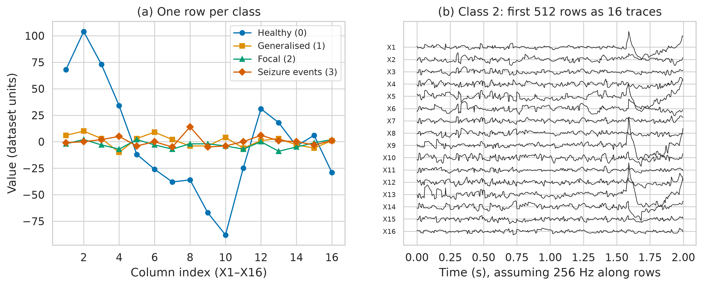
Figure S1. Example rows per class and class-2 rows displayed as 16 traces. (a) One row of each class plotted against column index. (b) The first 512 rows of class 2 plotted as 16 channels over time (2 s at 256 Hz), showing smooth evolution across rows, in contrast with class 0.
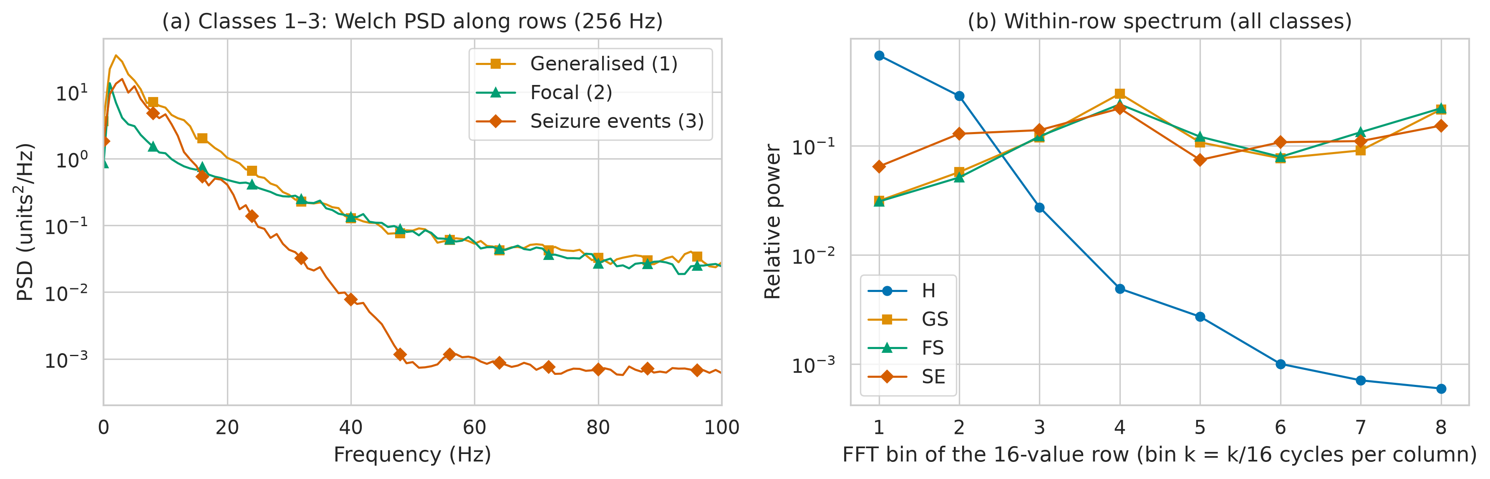
Figure S2. Spectral content of the BEED classes. (a) Welch power spectral density along rows for classes 1–3 (assuming 256 Hz), averaged over channels. (b) Relative power in the eight non-DC bins of the 16-value within-row FFT for all classes.
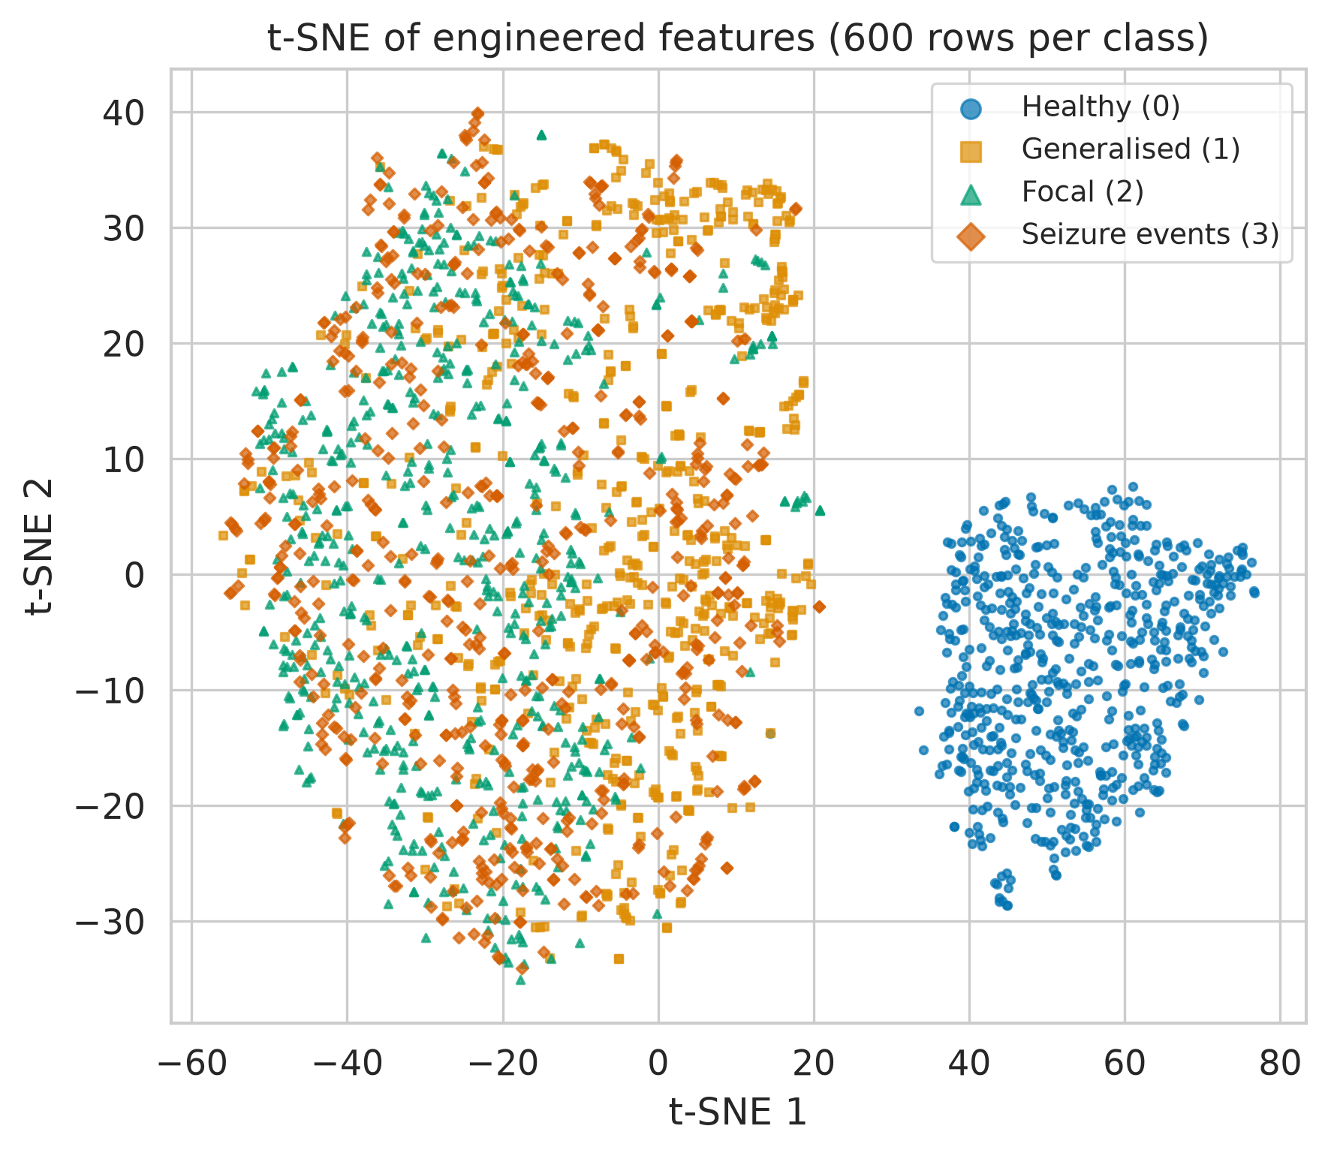
Figure S3. t-SNE embedding of engineered features. 600 randomly selected rows per class; class 0 forms a separate cluster, consistent with its different source.
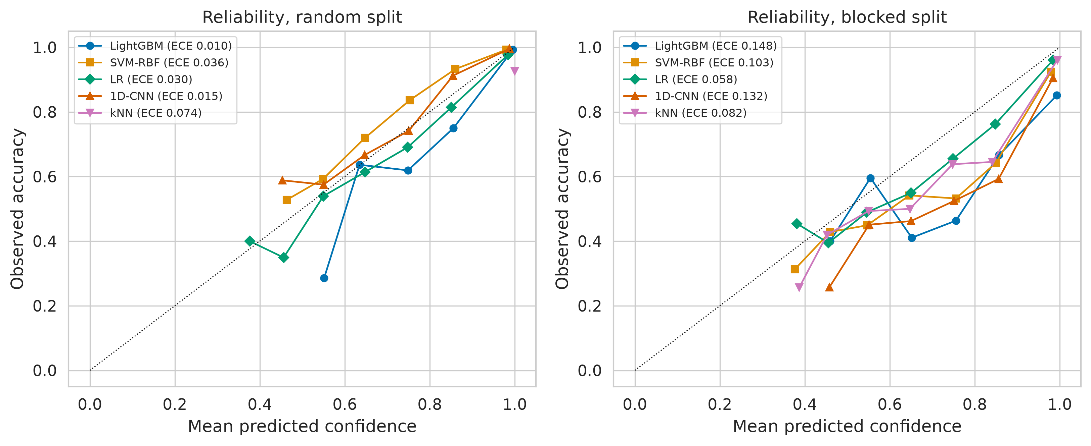
Figure S4. Reliability diagrams on the four-class hold-out test sets. Models of Table S3 (raw+engineered features for classical models). Observed accuracy versus mean confidence in ten bins (bins with fewer than ten samples omitted); legend gives ECE.
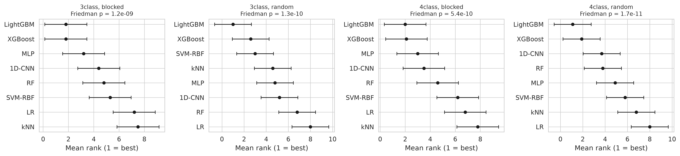
Figure S5. Mean ranks of models across repeated cross-validation folds. Error bars span the Nemenyi critical difference. Because folds of repeated CV are not independent, this test is anti-conservative and the ranks are descriptive only.
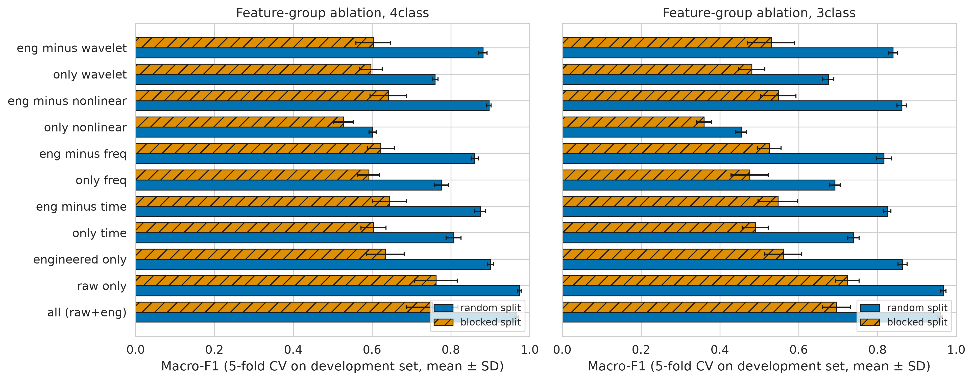
Figure S6. Feature-group ablation under random and blocked protocols. LightGBM with fixed hyper-parameters; five-fold CV on the development set (mean ± SD).
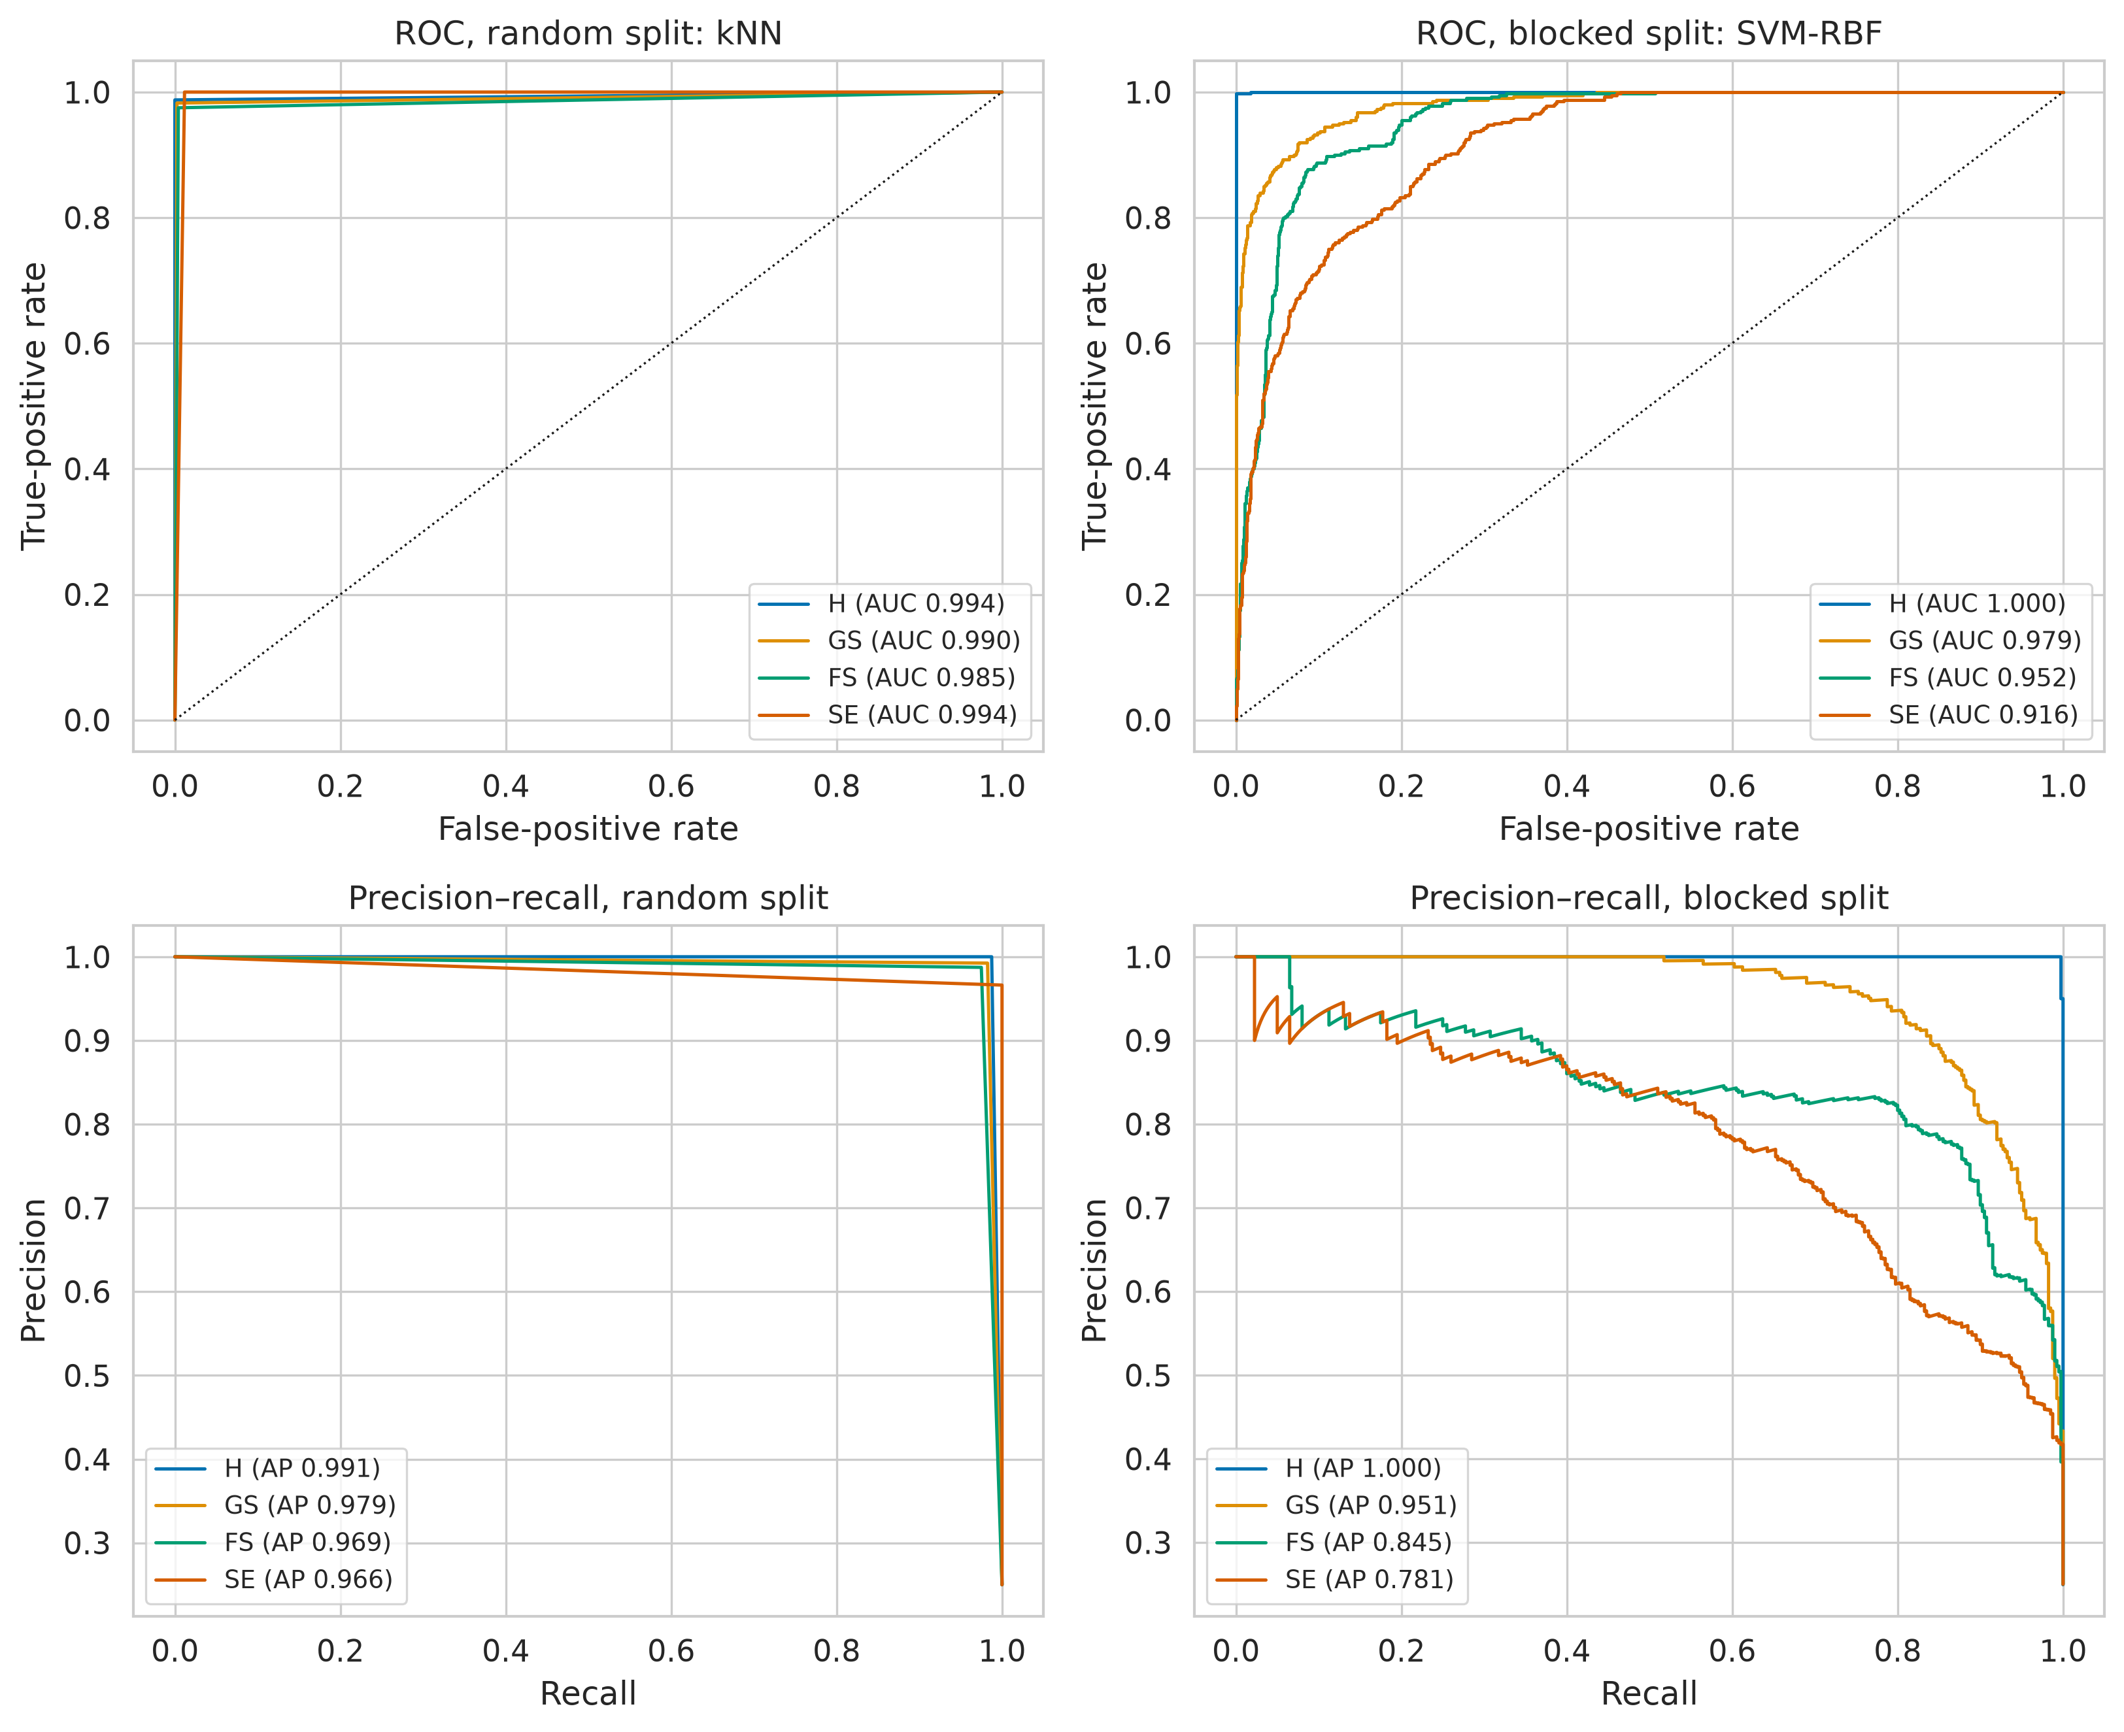
Figure S7. One-vs-rest ROC and precision–recall curves of the best four-class hold-out models. Left: random protocol; right: blocked protocol. AUC, area under the curve; AP, average precision.
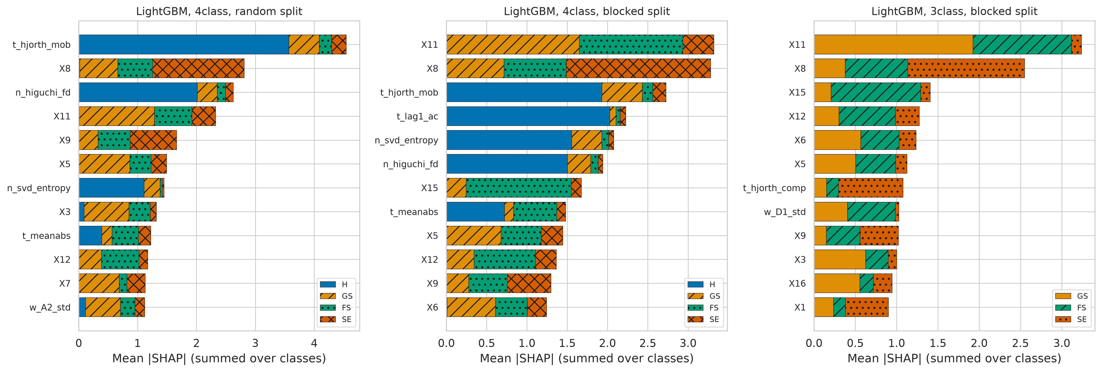
Figure S8. Mean absolute SHAP values of the leading LightGBM features. Twelve most influential features (raw+engineered set; LightGBM with fixed default hyper-parameters, 31 leaves, learning rate 0.1; a descriptive model, not the primary model), stacked by class, for the four-class task under random and blocked protocols and for the three-class task under the blocked protocol. X1–X16 are raw column values; prefixes t_, f_, n_ and w_ denote time, frequency, nonlinear and wavelet features. The healthy class is separated mainly by smoothness descriptors (Hjorth mobility, Higuchi fractal dimension, lag-1 autocorrelation); the seizure classes by raw values of particular columns (notably X11, X8 and X15).
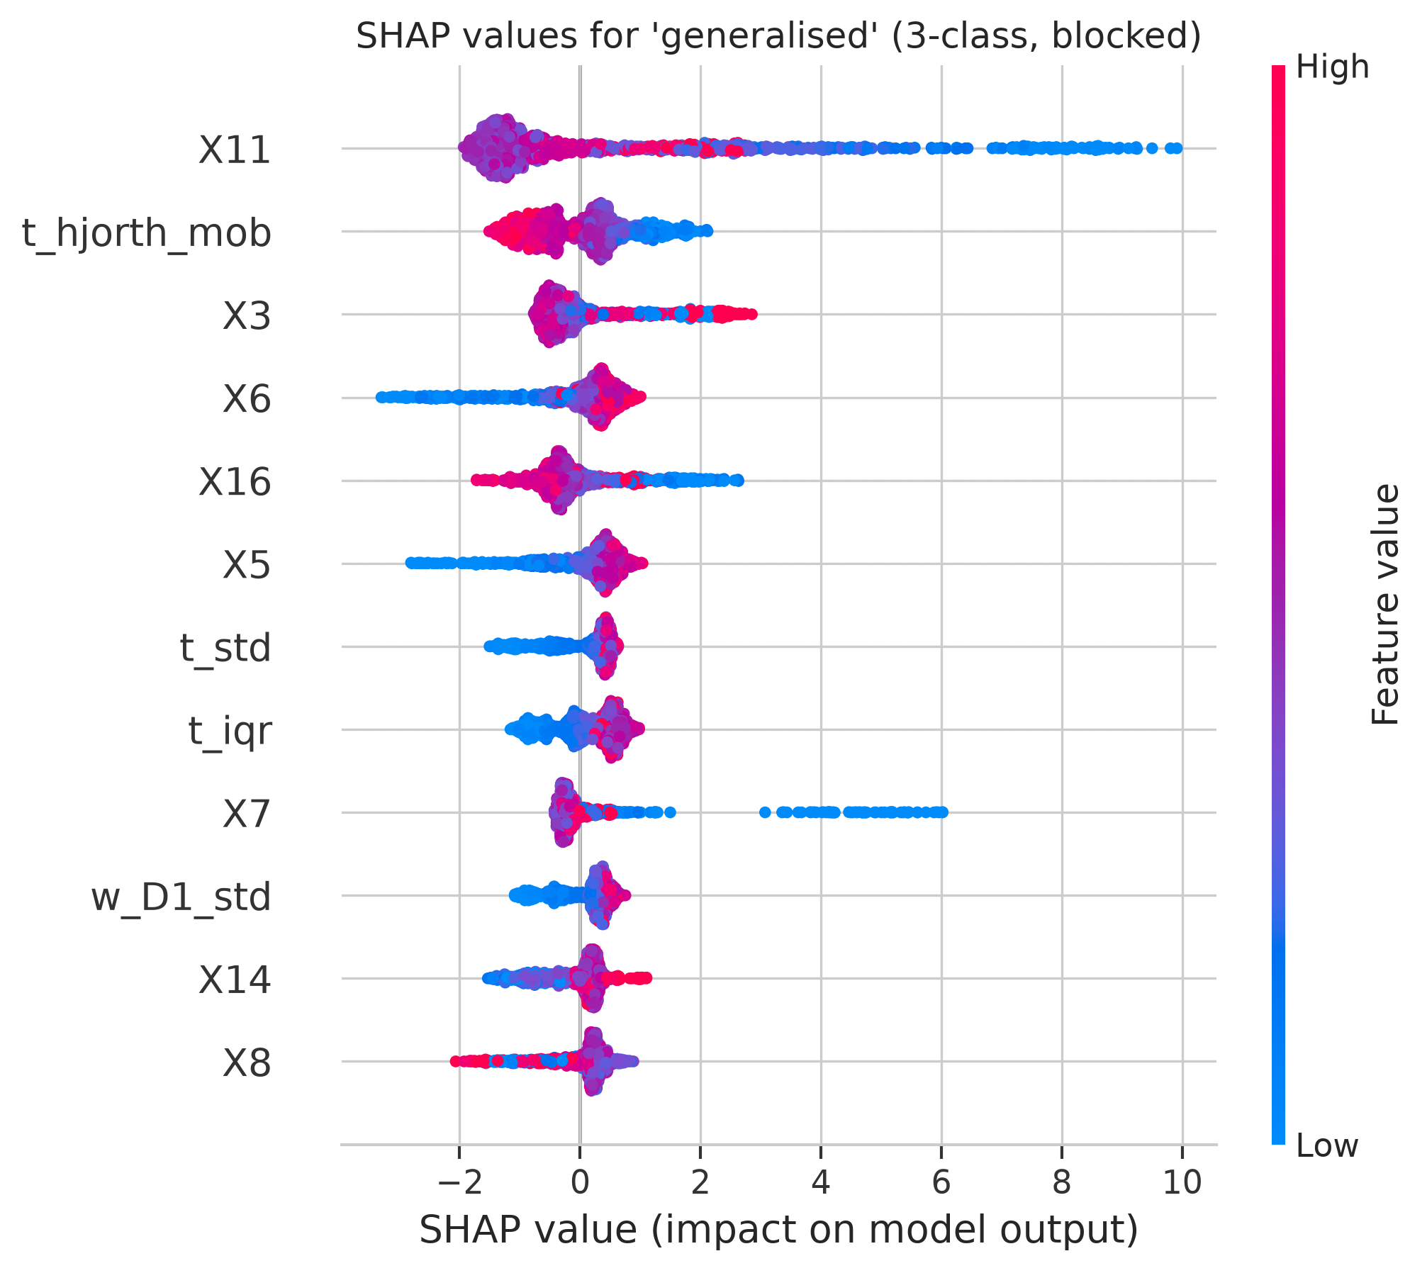
Figure S9. SHAP beeswarm for the generalised-seizure output (three-class, blocked). Each point is one test row; colour encodes feature value (red high, blue low). Descriptive LightGBM with default hyper-parameters.
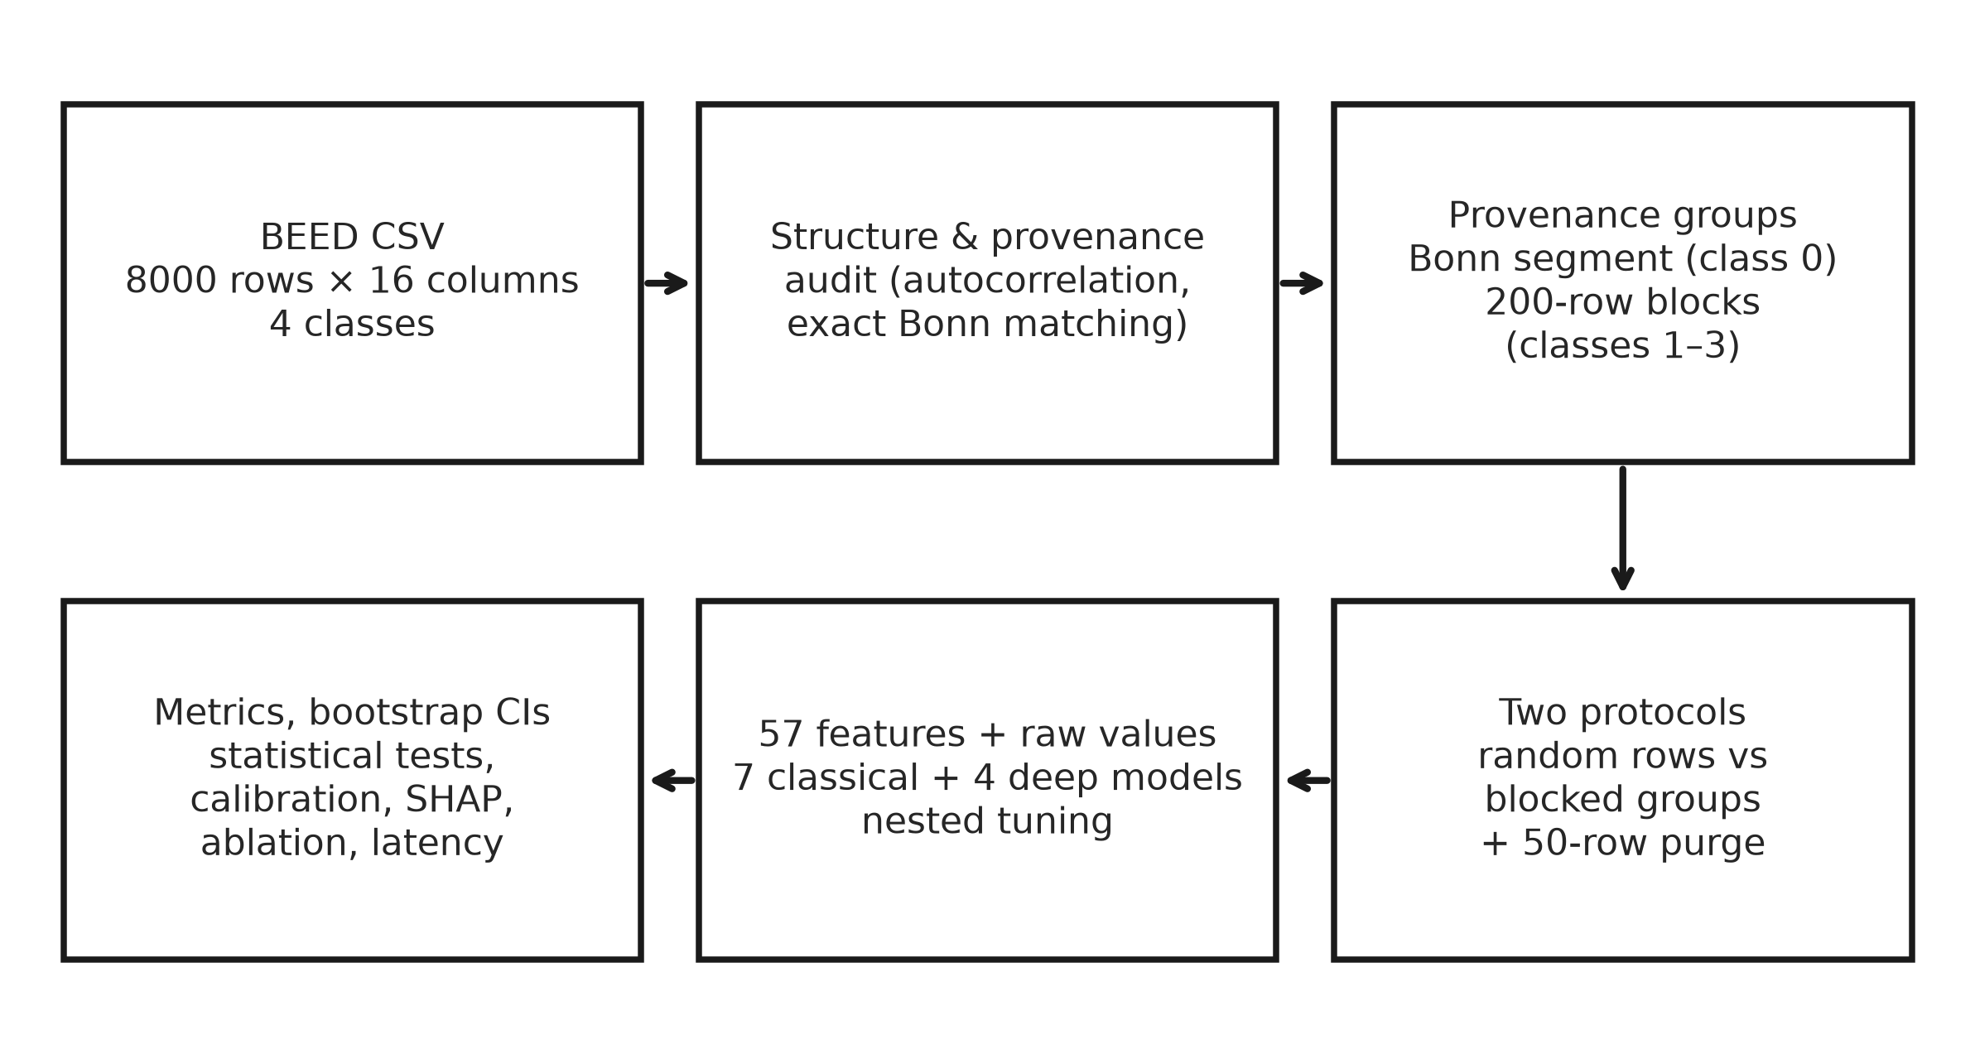
Figure S10. Overview of the audit and leakage-aware evaluation pipeline. Rows are grouped by provenance (Bonn segment for class 0; contiguous 200-row blocks for classes 1–3) before any split. Both protocols use the same features, models, nested tuning and metrics; the rolling-origin evaluation and the fingerprint baselines (Section S7) use the same grouping.
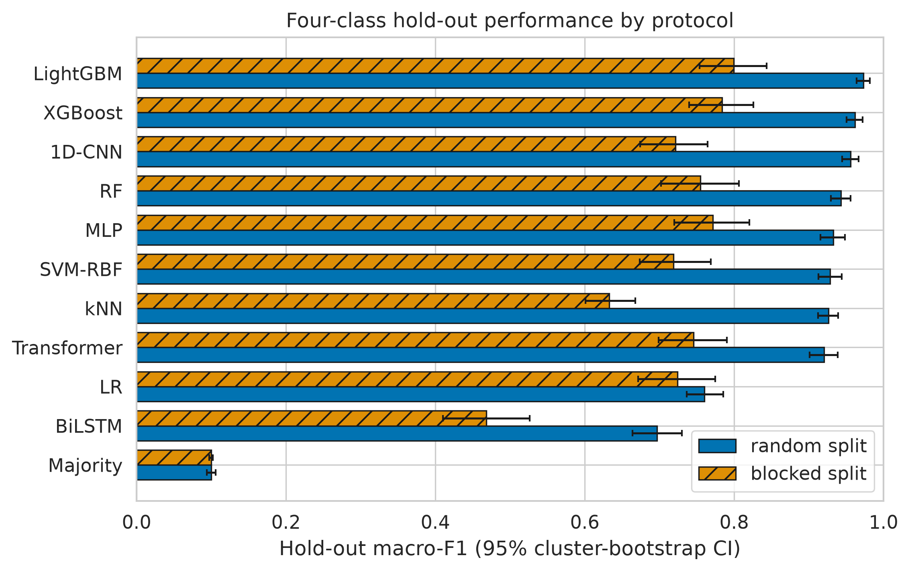
Figure S11. Four-class hold-out macro-F1 under random and blocked protocols. Classical models on raw+engineered features; deep models (fixed default hyper-parameters) on raw values. Error bars: 95% cluster-bootstrap CIs. Hatched bars: blocked protocol. The same values are tabulated in Table S3.

S6 Published and further BEED reports
Table S18. Published BEED studies: data described, task, evaluation protocol as implemented, and result
Study | Data described / used | Task | Evaluation protocol (as implemented) | Reported result
Najmusseher, Nizar Banu, Azar & Kamal [15] (dataset creators) | BEED and Bonn. The accessible abstract does not describe the BEED file used | Seizure vs healthy (AdaBoost on time, frequency and time–frequency features); seizure onset vs seizure events; seizure types (Gaussian NB) | Not stated in the accessible abstract (full text paywalled); described as sample-level evaluation by [13] | Accuracy 99% (BEED, seizure vs healthy); 91% (seizure onset vs seizure events)
Najmusseher & Nizar Banu [8] (SeqBoostNet; dataset creators) | 2000 rows per class × 16 values, consistent with the public CSV; each task uses a 4000 × 16 matrix. Described as 16 channels, 256 Hz, 20-s recordings | Six pairwise binary tasks A1–A6; no 4-class task | UMAP (3-D) and FFT features computed on all 4000 rows of each task, then a row-level train/test split (ratio not reported) | Per-task accuracy 91.16–99.83%; generalised vs focal 95.91%; 96.71% is the unweighted mean of the six tasks
Paneru [10] | Public UCI CSV (8000 × 16, 4 classes) | 4-class | Standard scaling + UMAP + FFT features; row-level hold-out (ratio not stated in the text); 10-fold nested CV | Accuracy 97.06% (hold-out); 91.51% ± 1.62% (nested CV)
Nandatama [11] | Public UCI CSV | 4-class | Stratified random 80/20 row split; hyper-parameters tuned by 10-fold stratified CV on the training rows | Weighted F1 0.9831 (tuned LightGBM, hold-out)
Sajid et al. [12] (PaperNet) | Public UCI CSV. Each row is treated as one 16-electrode time point with no subject or recording identifiers | 4-class | Stratified random 70/15/15 sample-level split (the abstract calls this “subject-independent”) | Macro-F1 0.9576; accuracy 0.9575
Obaido & Esenogho [13] | Described as 10 subjects, 19 channels (10–20), 256 Hz, 1-s windows (256 samples), 3750 seizure + 3750 non-seizure segments, with subject IDs. The data statement cites the UCI page, whose only file matches none of these | Binary (seizure vs non-seizure) | 10-fold GroupKFold by subject, tuning inside training folds, out-of-fold metrics (the abstract says “without out-of-fold evaluation”) | TabPFN accuracy 0.997, macro-F1 0.995; XGBoost accuracy 0.888 (F1 0.886)
Heba & Atya [14] (EpilepsyFormer) | Described as 80 adults aged 21–55 (UCI narrative), 14 channels, 256 Hz, 20-s segments (5120 samples). Such segments cannot be formed from the public CSV (2000 rows per class) | Binary seizure detection | 5-fold subject-independent CV (paper). The authors' public code uses a stratified random 80/20 split of segments and leaves subject grouping to an unreleased preprocessing step | Accuracy 98.3%; precision/recall/F1 98.2%; AUROC 0.991
Shah & Toma [16] | Kaggle copy of the public CSV (same file name and size, 404,412 bytes). Class 3 dropped (6000 rows); labels 1 and 2 described as focal and generalised (UCI lists them the other way round) | Binary (healthy vs seizure) | “Patient-aware” 70/15/15 split (42/9/9) of 60 pseudo-patients. The IDs were constructed by assuming each subject contributed 100 rows | Test accuracy 97.56% (16 channels); 97.11% (12 channels)
Abbreviations: UMAP, uniform manifold approximation and projection; FFT, fast Fourier transform; NB, naive Bayes; CV, cross-validation; AUROC, area under the ROC curve. “Public UCI CSV” means BEED_Data.csv (8000 rows × 16 integer columns + label y ∈ {0,1,2,3}, 2000 rows per class, no subject or recording identifiers; doi:10.24432/C5K33B). Protocols are as implemented in each paper's methods section or code, which sometimes differs from how the abstract describes them. Numbers in brackets refer to the reference list of the paper. For [15] only the abstract was accessible, and for [14] only the abstract, indexed excerpts and the authors' code; entries for these studies are limited to what those sources state. Further 2024–2026 BEED reports: Table S19.
Table S19. Further BEED reports found by a structured 2024–2026 search
Study | Task | Protocol (as far as reported) | Reported result
Najmusseher, Nizar Banu, Azar, Kamal, Alzahrani 2024, Business Intelligence and IT (BIIT 2023), SIST vol. 394, pp. 99–113, doi:10.1007/978-981-97-3980-6_9 (dataset creators) | Seizure vs healthy, BEED + Bonn; spectral (CFFT/RFFT), t-SNE analysis | Not reported in abstract | No headline metric in abstract
Najmusseher, Nizar Banu, Janardhan 2024 (reference [17] of the paper) | BEED, Bonn, CHB-MIT | Not reported in abstract | Accuracy 96.16% (BEED)
Gökşenli & Tümay 2026, J. Techniques 8(2):37–47, doi:10.51173/jt.v8i2.2848 (full text read) | 4-class, 16 columns (described as 20-s segment summaries) | Row-level split with 70% for training (workflow figure) plus internal CV (MATLAB); the paper notes that splitting by segment gives optimistic bias | Test accuracy 99.3% (subspace-kNN ensemble)
Kocarık Gacar 2025, Pamukkale Univ. J. Soc. Sci. Inst. no. 71, pp. 21–40, doi:10.30794/pausbed.1775480 (in Turkish) | 4-class; LR/SVM/XGBoost with and without PCA | 10-fold CV and hold-out test sets of several sizes | XGBoost best (no numbers in abstract)
Sunitha & Ramamoorthy 2025, IEEE ACEPE, pp. 1–8, doi:10.1109/ACEPE67873.2025.11405557 | 4-class + binary alarm | Not reported in abstract | Macro-AUC 0.999 (ANN); binary AUC 1.000, F1 0.99
Gaso, Mekuria, Kerimalieva 2026, CompSysTech, pp. 1–6, doi:10.1109/CompSysTech69798.2026.11683020 | 4-class | Not reported in abstract | ACWF accuracy 95.1% (macro-F1 0.9513); 6-model ensemble 98.1% (macro-F1 0.9807)
Gurrala, Satish, Reddy 2026, ICISC, pp. 1378–1383, doi:10.1109/ICISC69558.2026.11681206 | 4-class (CNN-BiLSTM + MASFNet) | 5-fold CV (unit not stated) | Accuracy 98.19%, F1 98.19%
Pawar, Prasad, Paliwal, Upadhyaya 2026, ICAISET, pp. 1–7, doi:10.1109/ICAISET66439.2026.11541307 | Binary seizure vs non-seizure | Not reported in abstract | AUC-ROC 98–99.6% (SVM, RF); “nearly perfect” MLP and CNN-BiLSTM
Reshi, Kaur, Singh 2026, CICN, pp. 980–984, doi:10.1109/CICN70047.2026.11594322 | 4-class | Not reported in abstract | RF accuracy 96.69%, macro-F1 0.97
Yahyati, Lamaakal, El Makkaoui, Ouahbi 2026, Discover Internet of Things 6(1), doi:10.1007/s43926-026-00514-4 | Auxiliary BEED experiments (main work uses CHB-MIT) | “Dataset-specific protocols” | Not given for BEED in abstract
Ganga Bhavani & Aparna 2026, Zenodo preprint, doi:10.5281/zenodo.19924235 | 4-class; describes the BEED classes as eyes open / eyes closed / pre-ictal / ictal, which does not match the dataset documentation | Not reported in abstract | Not used
Search on 8 October 2026 for “Bangalore EEG Epilepsy Dataset”, “BEED EEG”, “BEED epilepsy” and “BEED seizure classification” (2024 onwards) in OpenAlex full-text search, Semantic Scholar, Crossref and the web; Google Scholar could not be queried programmatically. Unless marked, details come from abstracts only and were not verified against the full text. Four further index hits in which use of BEED could not be confirmed were excluded (Tsoulos et al. 2025, Symmetry 17:1567; Quadrio & Candelieri 2025, arXiv 2512.09530; Su et al. 2026, arXiv 2607.16685; Dhriti et al. 2026, Procedia Comput. Sci. 290:176–183).

S7 Additional analyses
The analyses in this section use the same data file, seeds, grids and 50-row purge as the main analyses unless stated otherwise; every value is read from the result files in Supplementary File S1 (extended_analyses/).
S7.1 UCI documentation compared with the public file
The UCI dataset page (https://archive.ics.uci.edu/dataset/1134, doi:10.24432/C5K33B) and its public metadata were retrieved on 8 October 2026 and are quoted verbatim below. The dataset creators were not contacted.
Table S20. UCI documentation of BEED compared with the public file
Documentation states (verbatim) | The public file (BEED_Data.csv)
“BEED contains 16,000 segments of 20-second EEG recordings” | 8000 rows of 16 integers; the same page also states “Instances: 8,000 (2,000 per category)”
“a binary label (y) indicating seizure presence (1) or absence (0)” | y takes four values (0, 1, 2, 3); the variable-information field also lists four classes
“Each category includes data from 20 adult subjects (ages 21-55)”; “Subjects: 80 individuals (20 per file across four folders)” | No subject identifier column. 2000 rows per class at “200 time points per subject” would be 10 subjects per class, not 20
“Time Points: 200 per subject” | 80 × 200 = 16,000, matching the “segments” figure, of which the file holds exactly half; no larger steps or lower spatial correlation at 200- or 100-row boundaries in classes 1–3 (Tables S21–S22)
“256 Hz sampling rate”; “16 EEG channels (X1-X16) corresponding to different brain regions” | Class-0 rows are identical to 16-sample excerpts of the single-channel Bonn set-B recordings (173.61 Hz) (paper, Section 4.2)
“20-second” segments | A 20-s segment at 256 Hz has 5120 samples; 2000 rows per class at 256 Hz is 7.8 s if each row is one time point
BEED_Data.csv, md5 490e221cea201e7af385897aa6dd91dc, 8000 rows × 17 columns. Other page fields: “Instances: 8,000”, “Features: 16 (EEG channels)”, “Feature Type: Integer”, “No missing Values”; last updated 25 July 2025. Raw page and API responses are archived in Supplementary File S1.
S7.2 Change-point and splice analysis of the seizure classes
For each seizure class (2000 rows × 16 channels) we listed all row-to-row steps whose Euclidean norm exceeded eight times the class median; ran exact penalised kernel change-point detection (ruptures KernelCPD with PELT pruning) on the z-scored signal (linear kernel, i.e. an l2 cost on the mean) and on its first differences (linear and radial-basis kernels), with penalties of 1, 2, 5, 10 and 20 × d·ln n and a minimum segment of 20 rows; and compared steps at 100- and 200-row boundaries with all other steps (step-size percentile, 2000-draw random-placement null, row-to-row spatial correlation). A hypergeometric test asked whether discontinuities (spatial r < 0.30, alone or combined with a step above 4 or 8 times the median) were enriched on 100-row boundaries.
Table S21. Change points detected by penalised kernel segmentation in each seizure class
Class | Series, kernel | 1× | 2× | 5× | 10× | 20× | Positions at 10× | On 100-row boundary (all penalties)
1 | Signal, linear | 51 | 24 | 11 | 1 | 0 | 307 | 3
 | First differences, linear | 0 | 0 | 0 | 0 | 0 | – | 0
 | First differences, RBF | 0 | 0 | 0 | 0 | 0 | – | 0
2 | Signal, linear | 41 | 14 | 3 | 3 | 0 | 418, 488, 599 | 2
 | First differences, linear | 0 | 0 | 0 | 0 | 0 | – | 0
 | First differences, RBF | 2 | 0 | 0 | 0 | 0 | – | 0
3 | Signal, linear | 50 | 33 | 9 | 0 | 0 | – | 0
 | First differences, linear | 12 | 7 | 0 | 0 | 0 | – | 0
 | First differences, RBF | 2 | 2 | 0 | 0 | 0 | – | 0
Number of change points at penalties of 1–20 × d·ln n (d = 16, n = 2000). Positions are row indices within the class. Steps larger than eight times the class median: 21, 4 and 0 in classes 1–3 (all positions in Supplementary File S1, R2_large_jumps.csv). On first differences, change points occurred only at the two lowest penalties (classes 2 and 3) and none at 5× or above.
Table S22. Steps and spatial correlation at 100- and 200-row boundaries
Class | Block (rows) | Boundaries | Mean step percentile | Random-placement p | Mean r at boundary | Min r at boundary | Median r, all steps | Discontinuities on boundary / all; enrichment p
1 | 100 | 19 | 0.34 | 0.99 | 0.864 | -0.620 | 0.985 | 2/62; p = 0.12 (200, 1900)
1 | 200 | 9 | 0.31 | 0.97 | 0.909 | 0.238 | 0.985 | –
2 | 100 | 19 | 0.45 | 0.76 | 0.855 | -0.281 | 0.965 | 2/106; p = 0.27 (1200, 1500)
2 | 200 | 9 | 0.37 | 0.91 | 0.886 | 0.232 | 0.965 | –
3 | 100 | 19 | 0.52 | 0.33 | 0.977 | 0.942 | 0.985 | 0/0; p = 1.00
3 | 200 | 9 | 0.51 | 0.41 | 0.979 | 0.948 | 0.985 | –
Step percentile: rank of the boundary step among all 1999 steps in the class (0.5 = ordinary). Random-placement p: probability under 2000 random boundary placements that boundary steps are at least as large. r: row-to-row spatial correlation across the step. Discontinuity: r < 0.30 and step > 4 × median; enrichment by hypergeometric test.
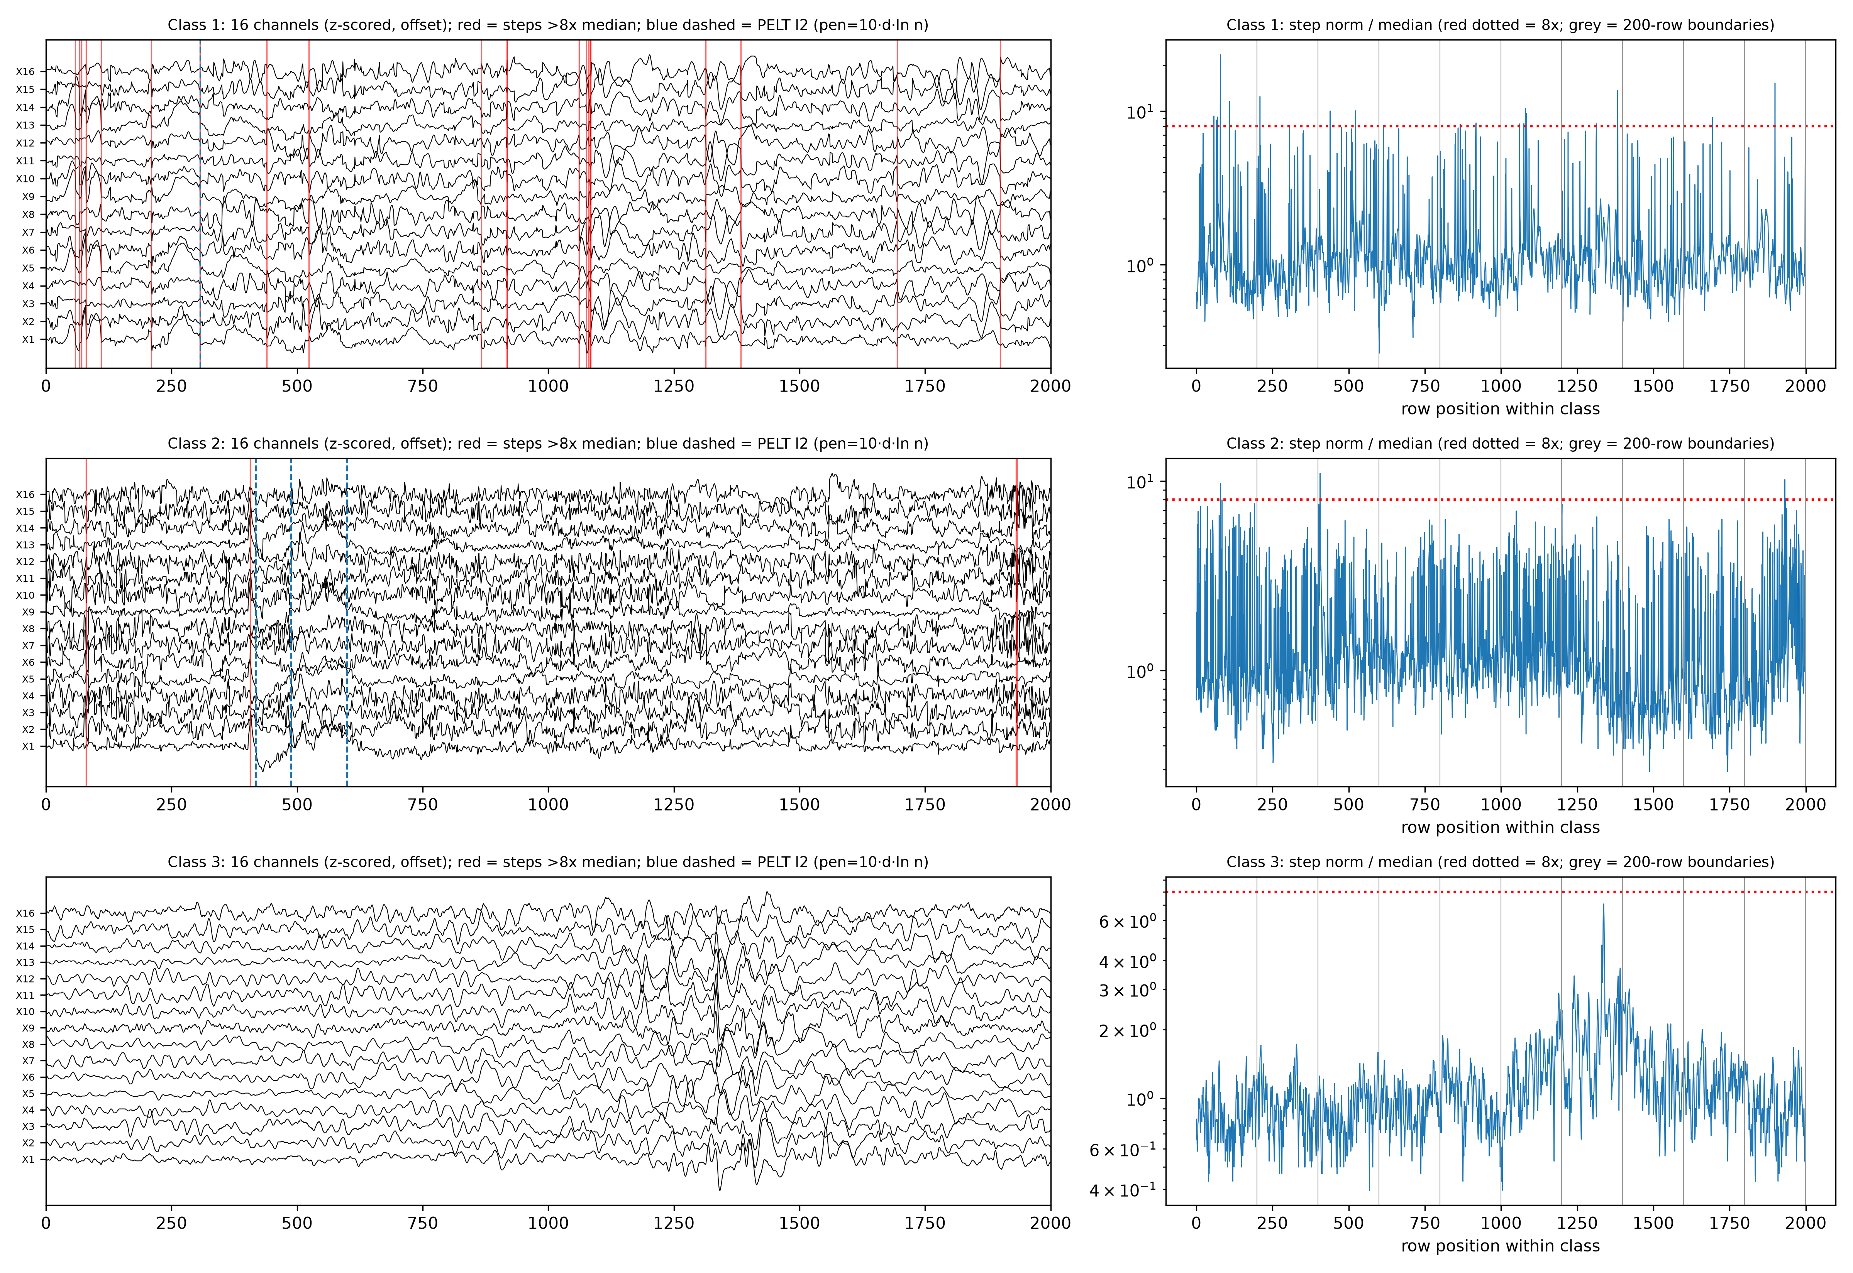
Figure S12. Change-point analysis of the three seizure classes. Left: the 16 channels of each seizure class (z-scored and offset for display) with steps larger than eight times the class median (red lines) and signal-level change points from penalised kernel segmentation at 10 × d·ln n (blue dashed lines). Right: row-to-row step norm divided by the class median (log scale), with the 8 × threshold (red dotted) and 200-row boundaries (grey). No boundary is systematically associated with larger steps; the strongest single candidate discontinuity is class 1, row 1900.
S7.3 Pre-specified primary model and rolling-origin evaluation
Table S23. Selection of the primary model and fully nested selection check
Task | Primary model | Blocked CV | Runner-up (blocked CV) | Nested choice per rolling fold | Nested F1 per fold | Nested mean ± SD
Four classes | LightGBM (raw) | 0.777 ± 0.048 | MLP (raw) 0.774 | LightGBM(raw), LightGBM(raw), LightGBM(raw), LightGBM(raw), XGBoost(raw) | 0.631, 0.742, 0.839, 0.722, 0.800 | 0.747 ± 0.080
Three seizure types | LightGBM (raw) | 0.720 ± 0.053 | XGBoost (raw) 0.716 | XGBoost(raw), LightGBM(raw), XGBoost(raw), SVM-RBF(raw), XGBoost(raw) | 0.528, 0.630, 0.803, 0.637, 0.728 | 0.665 ± 0.105
Rule: highest mean macro-F1 in nested purged blocked 5 × 2 CV on the development data; the test block is never used. Nested check: in each rolling-origin fold, the classical configuration with the best inner-CV score on that fold's training data was selected and tested.
Table S24. Rolling-origin macro-F1 per test block for all configurations
Model (features) | Rows 0–399 | 400–799 | 800–1199 | 1200–1599 | 1600–1999 | Mean ± SD | t-interval | Range
Four classes
SVM-RBF (raw) | 0.654 | 0.759 | 0.836 | 0.681 | 0.838 | 0.754 ± 0.085 | 0.648–0.860 | 0.654–0.838
LightGBM (raw) | 0.631 | 0.742 | 0.839 | 0.722 | 0.803 | 0.748 ± 0.080 | 0.648–0.847 | 0.631–0.839
Transformer (raw) | 0.621 | 0.728 | 0.851 | 0.726 | 0.807 | 0.747 ± 0.088 | 0.637–0.856 | 0.621–0.851
XGBoost (raw) | 0.638 | 0.735 | 0.819 | 0.702 | 0.800 | 0.739 ± 0.074 | 0.647–0.830 | 0.638–0.819
MLP (raw) | 0.646 | 0.609 | 0.818 | 0.776 | 0.844 | 0.739 ± 0.105 | 0.608–0.869 | 0.609–0.844
XGBoost (raw+eng) | 0.615 | 0.707 | 0.828 | 0.715 | 0.790 | 0.731 ± 0.082 | 0.628–0.833 | 0.615–0.828
LightGBM (raw+eng) | 0.624 | 0.710 | 0.833 | 0.688 | 0.797 | 0.730 ± 0.084 | 0.625–0.835 | 0.624–0.833
RF (raw) | 0.610 | 0.706 | 0.838 | 0.701 | 0.793 | 0.730 ± 0.089 | 0.619–0.840 | 0.610–0.838
RF (raw+eng) | 0.593 | 0.668 | 0.792 | 0.636 | 0.742 | 0.686 ± 0.080 | 0.586–0.786 | 0.593–0.792
kNN (raw) | 0.570 | 0.700 | 0.748 | 0.690 | 0.716 | 0.685 ± 0.068 | 0.600–0.769 | 0.570–0.748
1D-CNN (raw) | 0.599 | 0.627 | 0.739 | 0.665 | 0.760 | 0.678 ± 0.070 | 0.592–0.764 | 0.599–0.760
SVM-RBF (raw+eng) | 0.563 | 0.643 | 0.732 | 0.644 | 0.719 | 0.660 ± 0.068 | 0.575–0.745 | 0.563–0.732
LR (raw+eng) | 0.583 | 0.653 | 0.718 | 0.603 | 0.724 | 0.656 ± 0.064 | 0.577–0.736 | 0.583–0.724
BiLSTM (raw) | 0.619 | 0.528 | 0.714 | 0.600 | 0.741 | 0.640 ± 0.087 | 0.532–0.748 | 0.528–0.741
LR (eng) | 0.564 | 0.655 | 0.712 | 0.558 | 0.708 | 0.639 ± 0.075 | 0.546–0.732 | 0.558–0.712
LightGBM (eng) | 0.571 | 0.627 | 0.701 | 0.576 | 0.694 | 0.634 ± 0.062 | 0.557–0.711 | 0.571–0.701
XGBoost (eng) | 0.562 | 0.639 | 0.707 | 0.566 | 0.685 | 0.632 ± 0.066 | 0.550–0.714 | 0.562–0.707
SVM-RBF (eng) | 0.567 | 0.614 | 0.705 | 0.565 | 0.697 | 0.629 ± 0.068 | 0.545–0.714 | 0.565–0.705
RF (eng) | 0.535 | 0.608 | 0.694 | 0.577 | 0.658 | 0.614 ± 0.063 | 0.536–0.693 | 0.535–0.694
kNN (raw+eng) | 0.502 | 0.600 | 0.697 | 0.591 | 0.635 | 0.605 ± 0.071 | 0.517–0.693 | 0.502–0.697
kNN (eng) | 0.516 | 0.579 | 0.659 | 0.572 | 0.629 | 0.591 ± 0.055 | 0.522–0.660 | 0.516–0.659
LR (raw) | 0.509 | 0.383 | 0.414 | 0.352 | 0.440 | 0.420 ± 0.060 | 0.345–0.494 | 0.352–0.509
Three seizure types
MLP (raw) | 0.524 | 0.635 | 0.774 | 0.729 | 0.804 | 0.693 ± 0.114 | 0.551–0.835 | 0.524–0.804
SVM-RBF (raw) | 0.563 | 0.704 | 0.767 | 0.637 | 0.776 | 0.689 ± 0.090 | 0.578–0.801 | 0.563–0.776
Transformer (raw) | 0.513 | 0.640 | 0.818 | 0.676 | 0.787 | 0.687 ± 0.122 | 0.535–0.839 | 0.513–0.818
LightGBM (raw) | 0.534 | 0.630 | 0.798 | 0.669 | 0.752 | 0.677 ± 0.104 | 0.548–0.805 | 0.534–0.798
XGBoost (raw) | 0.528 | 0.658 | 0.803 | 0.655 | 0.728 | 0.674 ± 0.102 | 0.548–0.800 | 0.528–0.803
LightGBM (raw+eng) | 0.502 | 0.610 | 0.776 | 0.652 | 0.722 | 0.652 ± 0.105 | 0.521–0.783 | 0.502–0.776
RF (raw) | 0.491 | 0.598 | 0.788 | 0.617 | 0.718 | 0.642 ± 0.115 | 0.500–0.785 | 0.491–0.788
XGBoost (raw+eng) | 0.464 | 0.587 | 0.757 | 0.643 | 0.711 | 0.633 ± 0.114 | 0.490–0.775 | 0.464–0.757
kNN (raw) | 0.426 | 0.605 | 0.677 | 0.644 | 0.646 | 0.600 ± 0.100 | 0.475–0.724 | 0.426–0.677
1D-CNN (raw) | 0.407 | 0.546 | 0.752 | 0.576 | 0.691 | 0.594 ± 0.134 | 0.427–0.761 | 0.407–0.752
RF (raw+eng) | 0.451 | 0.554 | 0.717 | 0.515 | 0.661 | 0.580 ± 0.108 | 0.445–0.714 | 0.451–0.717
SVM-RBF (raw+eng) | 0.443 | 0.533 | 0.669 | 0.585 | 0.657 | 0.577 ± 0.093 | 0.461–0.693 | 0.443–0.669
LR (raw+eng) | 0.442 | 0.537 | 0.622 | 0.464 | 0.637 | 0.541 ± 0.089 | 0.430–0.651 | 0.442–0.637
kNN (raw+eng) | 0.352 | 0.501 | 0.659 | 0.532 | 0.574 | 0.524 ± 0.113 | 0.384–0.664 | 0.352–0.659
BiLSTM (raw) | 0.410 | 0.345 | 0.496 | 0.508 | 0.400 | 0.432 ± 0.069 | 0.346–0.518 | 0.345–0.508
LR (raw) | 0.472 | 0.454 | 0.393 | 0.357 | 0.438 | 0.423 ± 0.047 | 0.365–0.482 | 0.357–0.472
Each fold tests the given 400 rows of every seizure class plus a fixed fifth of the Bonn segments, with a 50-row purge on both sides. t-interval: mean ± t₄·SD/√5. Deep models tuned as in Section S7.7.
Table S25. Macro-F1 of all configurations: repeated CV, rolling origin, hold-out and corrected tests
Model (features) | Random 5 × 2 CV | Blocked 5 × 2 CV | Rolling origin | Blocked hold-out | p (Holm), blocked CV
Four classes
LightGBM (raw) | 0.972 ± 0.004 | 0.777 ± 0.048 | 0.748 ± 0.080 | 0.810 | ref.
MLP (raw)† | 0.931 ± 0.011 | 0.774 ± 0.054 | 0.739 ± 0.105 | 0.843 | 1.000
XGBoost (raw) | 0.965 ± 0.006 | 0.773 ± 0.048 | 0.739 ± 0.074 | 0.798 | 1.000
LightGBM (raw+eng) | 0.965 ± 0.004 | 0.767 ± 0.057 | 0.730 ± 0.084 | 0.799 | 1.000
RF (raw) | 0.956 ± 0.008 | 0.763 ± 0.050 | 0.730 ± 0.089 | 0.795 | 1.000
XGBoost (raw+eng) | 0.959 ± 0.006 | 0.761 ± 0.052 | 0.731 ± 0.082 | 0.784 | 0.832
SVM-RBF (raw) | 0.894 ± 0.011 | 0.755 ± 0.046 | 0.754 ± 0.085 | 0.842 | 0.938
Transformer (raw)† | 0.920 ± 0.009 | 0.749 ± 0.048 | 0.747 ± 0.088 | 0.861 | 1.000
1D-CNN (raw)† | 0.948 ± 0.008 | 0.739 ± 0.047 | 0.678 ± 0.070 | 0.775 | 1.000
RF (raw+eng) | 0.935 ± 0.012 | 0.724 ± 0.051 | 0.686 ± 0.080 | 0.755 | 0.133
kNN (raw) | 0.984 ± 0.004 | 0.697 ± 0.030 | 0.685 ± 0.068 | 0.710 | 0.155
SVM-RBF (raw+eng) | 0.913 ± 0.010 | 0.665 ± 0.050 | 0.660 ± 0.068 | 0.719 | 0.001
LR (raw+eng) | 0.775 ± 0.012 | 0.653 ± 0.036 | 0.656 ± 0.064 | 0.724 | < 0.001
SVM-RBF (eng) | 0.874 ± 0.012 | 0.651 ± 0.050 | 0.629 ± 0.068 | 0.697 | 0.010
LR (eng) | 0.751 ± 0.013 | 0.650 ± 0.046 | 0.639 ± 0.075 | 0.705 | < 0.001
XGBoost (eng) | 0.893 ± 0.010 | 0.650 ± 0.046 | 0.632 ± 0.066 | 0.686 | 0.002
LightGBM (eng) | 0.903 ± 0.012 | 0.648 ± 0.050 | 0.634 ± 0.062 | 0.690 | 0.002
RF (eng) | 0.870 ± 0.007 | 0.634 ± 0.049 | 0.614 ± 0.063 | 0.664 | 0.001
kNN (raw+eng) | 0.903 ± 0.009 | 0.629 ± 0.036 | 0.605 ± 0.071 | 0.633 | < 0.001
kNN (eng) | 0.883 ± 0.010 | 0.622 ± 0.047 | 0.591 ± 0.055 | 0.631 | < 0.001
BiLSTM (raw)† | 0.730 ± 0.081 | 0.590 ± 0.038 | 0.640 ± 0.087 | 0.650 | < 0.001
LR (raw) | 0.498 ± 0.012 | 0.352 ± 0.047 | 0.420 ± 0.060 | 0.436 | < 0.001
Three seizure types
LightGBM (raw) | 0.968 ± 0.005 | 0.720 ± 0.053 | 0.677 ± 0.104 | 0.752 | ref.
XGBoost (raw) | 0.959 ± 0.007 | 0.716 ± 0.049 | 0.674 ± 0.102 | 0.728 | 1.000
Transformer (raw)† | 0.903 ± 0.011 | 0.705 ± 0.058 | 0.687 ± 0.122 | 0.787 | 1.000
LightGBM (raw+eng) | 0.959 ± 0.007 | 0.696 ± 0.075 | 0.652 ± 0.105 | 0.722 | 1.000
RF (raw) | 0.949 ± 0.007 | 0.693 ± 0.066 | 0.642 ± 0.115 | 0.718 | 1.000
XGBoost (raw+eng) | 0.949 ± 0.007 | 0.692 ± 0.083 | 0.633 ± 0.114 | 0.711 | 1.000
SVM-RBF (raw) | 0.955 ± 0.007 | 0.685 ± 0.073 | 0.689 ± 0.090 | 0.776 | 1.000
MLP (raw)† | 0.940 ± 0.013 | 0.665 ± 0.074 | 0.693 ± 0.114 | 0.756 | 1.000
1D-CNN (raw)† | 0.941 ± 0.010 | 0.645 ± 0.099 | 0.594 ± 0.134 | 0.660 | 1.000
RF (raw+eng) | 0.918 ± 0.011 | 0.624 ± 0.081 | 0.580 ± 0.108 | 0.661 | 0.035
kNN (raw) | 0.983 ± 0.006 | 0.624 ± 0.072 | 0.600 ± 0.100 | 0.646 | 0.028
SVM-RBF (raw+eng) | 0.944 ± 0.005 | 0.602 ± 0.088 | 0.577 ± 0.093 | 0.657 | 0.103
kNN (raw+eng) | 0.937 ± 0.007 | 0.546 ± 0.069 | 0.524 ± 0.113 | 0.574 | 0.003
LR (raw+eng) | 0.694 ± 0.011 | 0.544 ± 0.063 | 0.541 ± 0.089 | 0.637 | 0.002
BiLSTM (raw)† | 0.887 ± 0.011 | 0.525 ± 0.111 | 0.432 ± 0.069 | 0.629 | 0.213
LR (raw) | 0.479 ± 0.012 | 0.389 ± 0.054 | 0.423 ± 0.047 | 0.438 | 0.002
Mean ± SD over 10 outer CV folds or 5 rolling-origin folds; hold-out is the single final-20% test block. Rows sorted by blocked CV. p: Nadeau–Bengio corrected resampled t-test against LightGBM (raw), the best model in blocked CV (ref.), Holm-adjusted across all 72 comparisons in the four task × protocol settings. †Deep models: tuned by an inner purged blocked hold-out under the blocked protocol; fixed default hyper-parameters under the random protocol. All tests: Table S33.
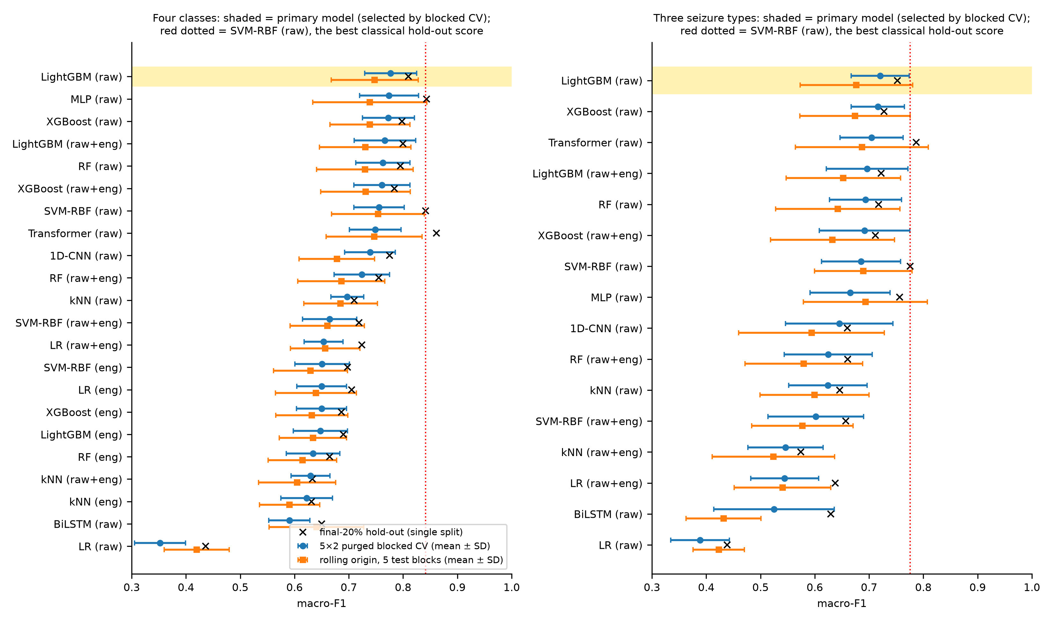
Figure S13. Leakage-aware macro-F1 of every configuration under three evaluation schemes. For each model and feature set: purged blocked 5 × 2 CV (circles, mean ± SD), five-fold rolling origin (squares, mean ± SD) and the single final-20% hold-out (crosses). Left: four classes; right: three seizure types. The shaded row is the primary model selected by blocked CV; the dotted vertical line marks SVM-RBF (raw), the best classical hold-out score (selected on the test block). Hold-out scores lie towards the upper end of the rolling-origin spread for most models.
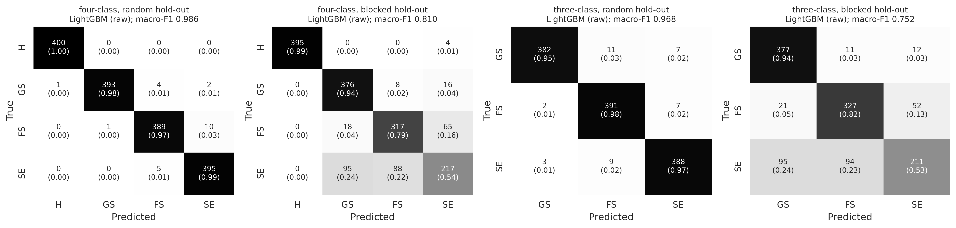
Figure S14. Confusion matrices of the primary model on the hold-out sets. LightGBM on raw values. Counts with row-normalised proportions in parentheses. From left: four-class random, four-class blocked, three-class random and three-class blocked hold-out. Grey intensity encodes the proportion; numbers are printed. Errors under the blocked protocol are concentrated among the three seizure classes.
S7.4 Recording-fingerprint and normalisation baselines
Table S26. All fingerprint and normalisation baselines (macro-F1)
Model (input) | Rolling origin | Blocked CV | Blocked hold-out | Random CV | Random hold-out | Share of primary above chance (rolling)
Four classes
LightGBM (raw) | 0.748 ± 0.080 | 0.777 ± 0.048 | 0.810 | 0.972 ± 0.004 | 0.986 | 100.0%
SVM-RBF (raw) | 0.754 ± 0.085 | 0.755 ± 0.046 | 0.842 | 0.894 ± 0.011 | 0.903 | 101.2%
LightGBM (raw+eng) | 0.730 ± 0.084 | 0.767 ± 0.057 | 0.799 | 0.965 ± 0.004 | 0.973 | 96.5%
LR (per-channel |x|) | 0.702 ± 0.104 | 0.723 ± 0.059 | 0.775 | 0.777 ± 0.013 | 0.779 | 90.8%
LightGBM (per-channel |x|) | 0.720 ± 0.074 | 0.737 ± 0.049 | 0.778 | 0.929 ± 0.007 | 0.936 | 94.5%
LR (row SD) | 0.568 ± 0.092 | 0.529 ± 0.089 | 0.647 | 0.573 ± 0.017 | 0.575 | 63.8%
LightGBM (row SD) | 0.519 ± 0.053 | 0.508 ± 0.041 | 0.563 | 0.560 ± 0.014 | 0.561 | 54.1%
LR (row mean) | 0.364 ± 0.040 | 0.218 ± 0.128 | 0.402 | 0.387 ± 0.006 | 0.385 | 22.9%
LightGBM (row mean) | 0.449 ± 0.030 | 0.434 ± 0.030 | 0.490 | 0.471 ± 0.013 | 0.480 | 39.9%
LR (row statistics) | 0.573 ± 0.099 | 0.571 ± 0.057 | 0.644 | 0.612 ± 0.015 | 0.616 | 65.0%
LightGBM (row statistics) | 0.535 ± 0.061 | 0.546 ± 0.028 | 0.609 | 0.655 ± 0.013 | 0.659 | 57.3%
LR (per-recording z-score) | 0.228 ± 0.033 | 0.220 ± 0.038 | 0.208 | – | 0.272 | -4.4%
kNN (per-recording z-score) | 0.552 ± 0.034 | 0.578 ± 0.027 | 0.573 | – | 0.984 | 60.6%
SVM-RBF (per-recording z-score) | 0.674 ± 0.032 | 0.704 ± 0.065 | 0.687 | – | 0.981 | 85.1%
LightGBM (per-recording z-score) | 0.605 ± 0.034 | 0.638 ± 0.038 | 0.650 | – | 0.972 | 71.3%
LR (per-row normalisation) | 0.372 ± 0.022 | 0.373 ± 0.041 | 0.391 | – | 0.390 | 24.4%
kNN (per-row normalisation) | 0.695 ± 0.075 | 0.730 ± 0.034 | 0.749 | – | 0.994 | 89.5%
SVM-RBF (per-row normalisation) | 0.743 ± 0.062 | 0.764 ± 0.028 | 0.801 | – | 0.984 | 99.1%
LightGBM (per-row normalisation) | 0.767 ± 0.044 | 0.784 ± 0.024 | 0.808 | – | 0.964 | 104.0%
Three seizure types
LightGBM (raw) | 0.677 ± 0.104 | 0.720 ± 0.053 | 0.752 | 0.968 ± 0.005 | 0.968 | 100.0%
SVM-RBF (raw) | 0.689 ± 0.090 | 0.685 ± 0.073 | 0.776 | 0.955 ± 0.007 | 0.964 | 103.7%
LightGBM (raw+eng) | 0.652 ± 0.105 | 0.696 ± 0.075 | 0.722 | 0.959 ± 0.007 | 0.960 | 92.9%
LR (per-channel |x|) | 0.627 ± 0.124 | 0.669 ± 0.050 | 0.727 | 0.722 ± 0.013 | 0.733 | 85.5%
LightGBM (per-channel |x|) | 0.648 ± 0.094 | 0.685 ± 0.054 | 0.726 | 0.912 ± 0.010 | 0.910 | 91.6%
LR (row SD) | 0.490 ± 0.116 | 0.470 ± 0.105 | 0.588 | 0.496 ± 0.023 | 0.488 | 45.5%
LightGBM (row SD) | 0.427 ± 0.041 | 0.446 ± 0.050 | 0.457 | 0.486 ± 0.013 | 0.471 | 27.4%
LR (row mean) | 0.339 ± 0.034 | 0.290 ± 0.050 | 0.365 | 0.338 ± 0.011 | 0.322 | 1.7%
LightGBM (row mean) | 0.367 ± 0.043 | 0.372 ± 0.027 | 0.389 | 0.415 ± 0.012 | 0.405 | 9.8%
LR (row statistics) | 0.477 ± 0.125 | 0.491 ± 0.104 | 0.557 | 0.521 ± 0.018 | 0.519 | 41.7%
LightGBM (row statistics) | 0.431 ± 0.057 | 0.443 ± 0.042 | 0.496 | 0.574 ± 0.020 | 0.544 | 28.5%
LR (per-recording z-score) | 0.256 ± 0.057 | 0.261 ± 0.055 | 0.300 | – | 0.312 | -22.6%
kNN (per-recording z-score) | 0.434 ± 0.039 | 0.459 ± 0.045 | 0.446 | – | 0.980 | 29.2%
SVM-RBF (per-recording z-score) | 0.572 ± 0.042 | 0.587 ± 0.050 | 0.587 | – | 0.988 | 69.5%
LightGBM (per-recording z-score) | 0.478 ± 0.045 | 0.526 ± 0.057 | 0.517 | – | 0.962 | 42.1%
LR (per-row normalisation) | 0.407 ± 0.056 | 0.381 ± 0.042 | 0.402 | – | 0.439 | 21.3%
kNN (per-row normalisation) | 0.594 ± 0.094 | 0.612 ± 0.051 | 0.681 | – | 0.988 | 75.8%
SVM-RBF (per-row normalisation) | 0.662 ± 0.081 | 0.665 ± 0.053 | 0.714 | – | 0.973 | 95.8%
LightGBM (per-row normalisation) | 0.703 ± 0.049 | 0.705 ± 0.031 | 0.748 | – | 0.941 | 107.6%
Mean ± SD over 5 rolling-origin blocks or 10 CV folds. Share: (F1 − chance)/(F1 of LightGBM raw − chance), rolling origin. Normalised inputs were de-quantised with U(−0.5, 0.5) noise (fixed seed) before normalisation: without it, per-recording z-scoring of integer data puts each class on its own value lattice, which tree models exploit (these non-de-quantised runs are documented in Supplementary File S1 but are not valid results and are not reported). Per-recording z-scoring uses the class label and is a diagnostic, not a deployable model. –, not run under the random protocol.
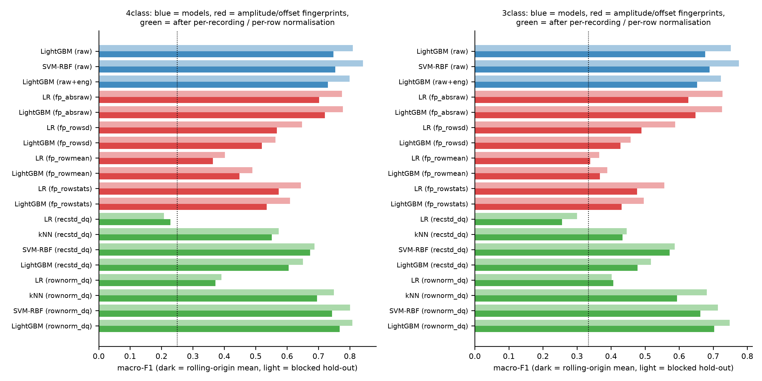
Figure S15. Amplitude fingerprints recover most of the leakage-aware performance. Macro-F1 of the main models (blue), amplitude/offset fingerprint baselines (red) and models after per-recording channel-wise z-scoring (recstd_dq) or per-row normalisation (rownorm_dq) (green); dark bars, rolling-origin mean; light bars, blocked hold-out. fp_absraw, per-channel |x|; fp_rowsd, row SD; fp_rowmean, row mean; fp_rowstats, row mean, SD, range and mean |x|. Dotted line: chance. Left: four classes; right: three seizure types.
Table S27. Pre-specified tests: primary model versus logistic regression on per-channel |x|
Task | Scheme | Primary F1 | LR(|x|) F1 | Difference | Folds | t (corrected) | p | p (Holm, 4 tests)
4class | cv blocked | 0.777 | 0.723 | +0.054 | 10 | 2.21 | 0.054 | 0.163
4class | rolling origin | 0.748 | 0.702 | +0.046 | 5 | 2.07 | 0.108 | 0.163
3class | cv blocked | 0.720 | 0.669 | +0.052 | 10 | 2.00 | 0.077 | 0.163
3class | rolling origin | 0.677 | 0.627 | +0.050 | 5 | 3.06 | 0.038 | 0.151
Nadeau–Bengio corrected resampled t-test; Holm correction over the pre-specified family of four tests. None is significant after correction.
S7.5 Search of CHB-MIT for the source of classes 1–3
Corpus: CHB-MIT Scalp EEG Database v1.0.0 (PhysioNet open-access mirror; 686 EDF files), streamed file by file with the 141 seizure-containing records first. Queries: for each of classes 1–3, rows 900–1099 (200 rows), first-differenced and z-scored per channel, which makes the scan insensitive to unknown gain and offset. Statistic: exact normalised cross-correlation (NCC) at every lag against every 256 Hz signal of each file. The permutation-robust score is the mean over the 16 BEED channels of the maximum over file channels; the same-order score uses the first 16 (double-banana) CHB-MIT channels in order, for three query windows per class (rows 300, 900 and 1500). Peaks were re-verified in double precision; windows with first-difference SD below 0.5 digital units were excluded to avoid numerical artefacts from flat segments. Candidate threshold: 0.80. The scan was time-limited and stopped after 246 of 686 files (281.7 h, all 24 subjects, 136 of 141 seizure-containing records; five seizure records chb06_01, chb06_04, chb06_10, chb06_24 and chb07_12 were not completed, and the other 110 scanned files are seizure-free).
Table S28. CHB-MIT scan: peak normalised cross-correlation per BEED seizure class
Class | Files | Median, permutation-robust | Maximum, permutation-robust (file) | Maximum, same order | Positive control, own query | Positive control, other queries
1 | 246 | 0.32 | 0.38 (chb12_27.edf) | 0.22 | 1.000 (lag exact) | 0.21–0.39
2 | 246 | 0.22 | 0.26 (chb15_15.edf) | 0.22 | 1.000 (lag exact) | 0.33–0.39
3 | 246 | 0.35 | 0.42 (chb06_09.edf) | 0.31 | 1.000 (lag exact) | 0.21–0.33
Threshold for a candidate match: 0.80; no file reached it. Positive control: the BEED rows of each class were injected into chb01_03 with gain × 7, offset +13 and a random channel permutation. Not tested: resampled, filtered, re-referenced or re-montaged derivatives; the 440 unscanned files; other corpora (TUSZ, Siena, Helsinki neonatal). The search is therefore partial and its negative result does not exclude CHB-MIT.
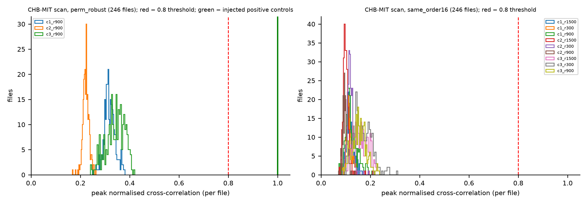
Figure S16. Distribution of per-file peak cross-correlation in the CHB-MIT scan. Left: permutation-robust score for the three row-900 queries across 246 files; the red dashed line is the 0.80 candidate threshold and the green line the injected positive controls (1.00). Right: same-order scores for nine query windows (three per class). All scanned files lie far below the threshold.
S7.6 Windowed multichannel analysis on the same splits as single rows
Three-class task. Windows of W ∈ {32, 64} rows (0.125 or 0.25 s at 256 Hz) were described by per-channel Welch band powers (delta to gamma) and line length (16 × 6 features) and classified by a standardised logistic regression; W and C ∈ {0.01, 0.1, 1, 10} were chosen by an inner three-fold purged blocked CV on the training windows. Splits: the same final-20% hold-out as single rows (test windows lie entirely in rows ≥ 1600; training windows more than 50 rows from any test row) and the same 5 × 2 purged blocked CV over 200-row blocks. Paired comparator: SVM-RBF on single rows, trained on exactly the rows covered by the training windows and tested on exactly the rows covered by the test windows, scored per row and as a window vote (argmax of the mean row probability).
Table S29. Windowed logistic regression versus single-row SVM-RBF on identical rows (three classes)
Split | W (rows) | C | Training windows | Test windows | Windowed LR | Single-row SVM, row level | Single-row SVM, window vote
Hold-out | 32 | 0.1 | 144 | 36 | 0.972 | 0.767 | 0.886
CV fold 1 | 64 | 0.1 | 44 | 19 | 1.000 | 0.656 | 0.785
CV fold 2 | 64 | 0.01 | 44 | 17 | 0.700 | 0.588 | 0.736
CV fold 3 | 64 | 0.01 | 44 | 19 | 0.850 | 0.582 | 0.744
CV fold 4 | 32 | 0.01 | 117 | 17 | 1.000 | 0.667 | 0.759
CV fold 5 | 32 | 1 | 113 | 19 | 1.000 | 0.741 | 0.842
CV fold 6 | 32 | 0.1 | 86 | 38 | 0.865 | 0.608 | 0.641
CV fold 7 | 32 | 1 | 93 | 35 | 0.908 | 0.575 | 0.712
CV fold 8 | 64 | 10 | 46 | 18 | 0.944 | 0.703 | 0.886
CV fold 9 | 32 | 0.01 | 117 | 17 | 0.927 | 0.801 | 0.927
CV fold 10 | 64 | 10 | 59 | 8 | 1.000 | 0.742 | 0.722
CV mean ± SD |  |  |  |  | 0.919 ± 0.096 | 0.666 ± 0.079 | 0.775 ± 0.087
Macro-F1. Hold-out 95% CIs: windowed LR [0.915, 1.0] (window bootstrap) and [0.899, 1.0] (100-row clusters); single-row SVM row level [0.699, 0.825] (50-row clusters); window vote [0.766, 0.972]. Windowed minus window vote: hold-out paired CI [-0.028, 0.211] (100-row clusters [-0.033, 0.217]); in CV +0.144 ± 0.107, corrected t-test p = 0.055. Windowed minus single row: CV +0.253 ± 0.080, p = 0.0006. Windows come from the same single recording per class; this is within-recording temporal extrapolation and is not comparable with single-row results.
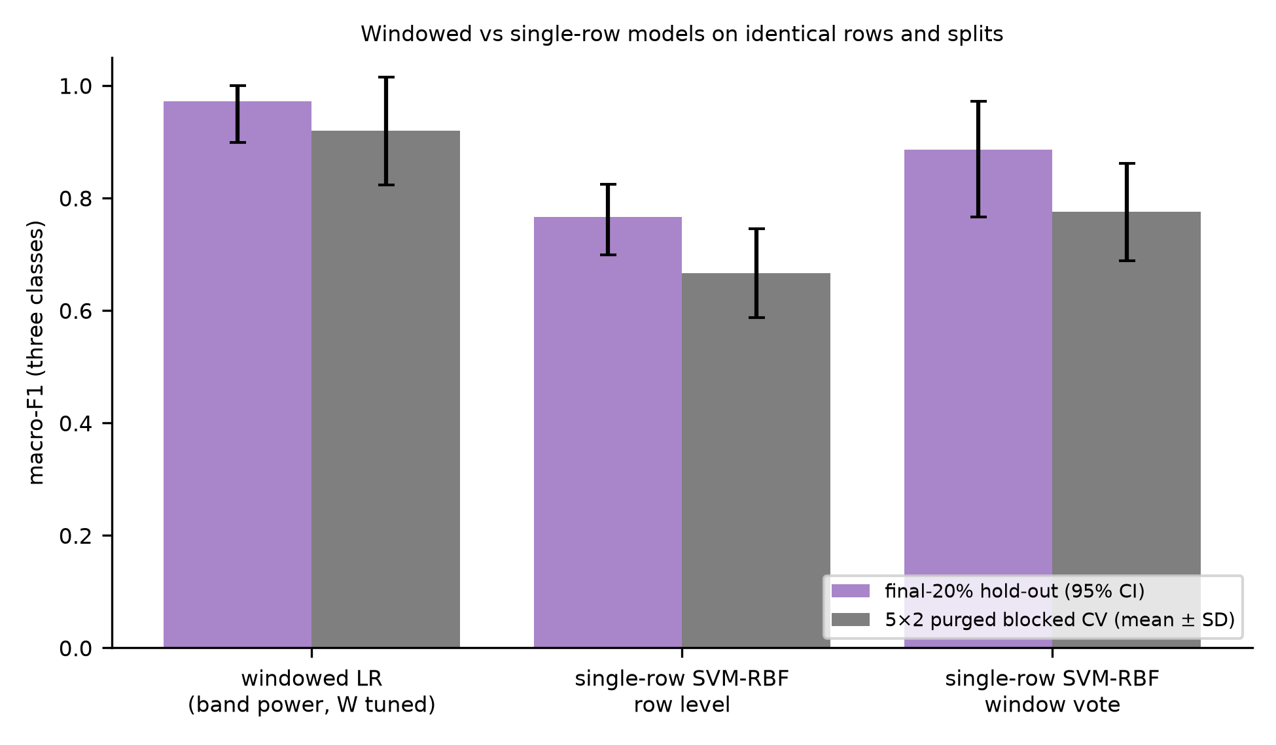
Figure S17. Windowed versus single-row models on identical rows and splits. Three-class macro-F1 of the windowed logistic regression, the single-row SVM-RBF scored per row, and the single-row SVM-RBF averaged per window. Purple: final-20% hold-out with 95% CI; grey: purged blocked 5 × 2 CV, mean ± SD.
S7.7 Tuned deep models
Grid (12 points): learning rate ∈ {0.001, 0.003} × width multiplier ∈ {0.5, 1, 2} × dropout ∈ {0, 0.2}, with the same topologies; AdamW, up to 100 epochs, early stopping with patience 15. In every blocked outer fold (5 × 2 CV, rolling origin, hold-out) each grid point was trained on 80% of the outer-training 200-row blocks and Bonn segments (class-stratified, 50-row purge) and scored on the remaining 20%; the best point was refitted on the whole outer-training set. Two compute shortcuts apply: (i) the inner loop is a single purged blocked hold-out rather than the three-fold inner CV used for classical models; (ii) random-protocol CV for the deep models used fixed default hyper-parameters (learning rate 0.002, ≤ 60 epochs, patience 8), not the grid.
Table S30. Deep models: tuned versus fixed default hyper-parameters (blocked protocol, macro-F1)
Task | Model | Tuned blocked CV | Tuned rolling origin | Tuned hold-out | Default hold-out | Default blocked CV | Mean epochs | Parameters (range)
4class | MLP | 0.774 ± 0.054 | 0.739 ± 0.105 | 0.843 | 0.772 | 0.744 ± 0.066 | 34.2 | 3492–38532
4class | 1D-CNN | 0.739 ± 0.047 | 0.678 ± 0.070 | 0.775 | 0.722 | 0.733 ± 0.044 | 26.0 | 5156–75908
4class | BiLSTM | 0.590 ± 0.038 | 0.640 ± 0.087 | 0.650 | 0.468 | not run | 35.8 | 5572–77572
4class | Transformer | 0.749 ± 0.048 | 0.747 ± 0.088 | 0.861 | 0.746 | not run | 37.5 | 4804–68356
3class | MLP | 0.665 ± 0.074 | 0.693 ± 0.114 | 0.756 | 0.770 | 0.661 ± 0.096 | 33.8 | 3459–38403
3class | 1D-CNN | 0.645 ± 0.099 | 0.594 ± 0.134 | 0.660 | 0.706 | 0.646 ± 0.098 | 29.6 | 5091–75651
3class | BiLSTM | 0.525 ± 0.111 | 0.432 ± 0.069 | 0.629 | not run | not run | 31.4 | 5475–77187
3class | Transformer | 0.705 ± 0.058 | 0.687 ± 0.122 | 0.787 | not run | not run | 47.8 | 4787–68291
Mean ± SD over 10 CV folds or 5 rolling-origin folds. Default: fixed hyper-parameters (learning rate 0.002, ≤ 60 epochs, patience 8). The chosen configuration varied between folds, consistent with a flat optimum (per-fold choices in Supplementary File S1). Holm-adjusted comparisons with LightGBM (raw): Table S33. Under the random protocol the deep models used the default settings.
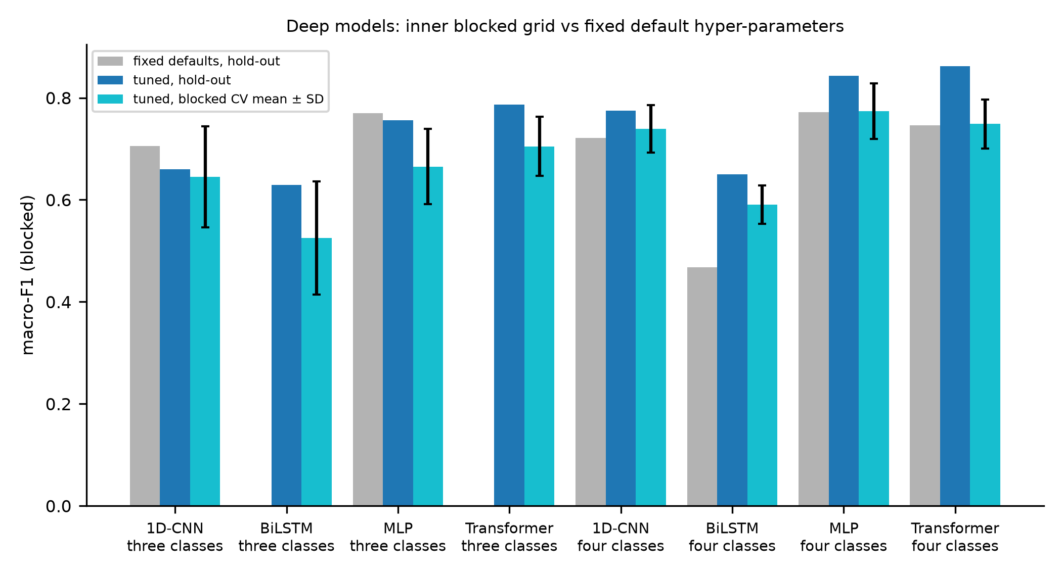
Figure S18. Deep models with an inner blocked grid versus fixed default hyper-parameters. Blocked-protocol macro-F1 of each deep model: fixed defaults on the hold-out (grey; not run for the three-class BiLSTM and transformer), tuned on the hold-out (dark blue) and tuned in purged blocked 5 × 2 CV (light blue, mean ± SD).
S7.8 Computational footprint on a server CPU
Table S31. Computational footprint of all profiled models (one server CPU thread)
Model | Hyper-parameters | Parameters / nodes | Native size (kB) | ONNX (kB) | Feature extraction (ms) | Inference, Python, median / p95 (ms) | ONNX Runtime (ms) | Total, Python (ms) | ONNX agreement | Hold-out F1
LightGBM (tuned) | {learning_rate: 0.2, num_leaves: 15} | 28658 tree nodes | 1,767.7 (joblib); 1,765.6 (text) | 1,062.3 | 3.476 | 0.498 / 0.653 | 0.019 | 3.974 | 100.0% | 0.799
LightGBM (default) | {num_leaves: 31, learning_rate: 0.1} | 62720 tree nodes | 3,619.4 (joblib); 3,617.3 (text) | 2,320.4 | 3.476 | 0.736 / 0.861 | 0.020 | 4.212 | 99.9% | 0.794
MLP (tuned) | {lr: 0.003, w: 0.5, p: 0.0} | 3492 parameters | 18.9 (state_dict) | 15.9 | 0.001 | 0.054 / 0.114 | 0.017 | 0.054 | 100.0% | 0.843
MLP (default) | {lr: 0.002, w: 1.0, p: 0.2} | 11076 parameters | 49.3 (state_dict) | 46.3 | 0.001 | 0.090 / 0.110 | 0.018 | 0.090 | 100.0% | 0.770
1D-CNN (tuned) | {lr: 0.003, w: 1.0, p: 0.0} | 19524 parameters | 83.4 (state_dict) | 76.9 | 0.001 | 0.200 / 0.233 | 0.038 | 0.200 | 100.0% | 0.775
1D-CNN (default) | {lr: 0.002, w: 1.0, p: 0.2} | 19524 parameters | 83.4 (state_dict) | 76.9 | 0.001 | 0.199 / 0.242 | 0.038 | 0.199 | 100.0% | 0.714
BiLSTM (tuned) | {lr: 0.003, w: 2.0, p: 0.0} | 77572 parameters | 306.3 (state_dict) | 305.6 | 0.001 | 0.396 / 0.521 | 0.077 | 0.396 | 100.0% | 0.650
BiLSTM (default) | {lr: 0.002, w: 1.0, p: 0.2} | 20356 parameters | 82.7 (state_dict) | 82.1 | 0.001 | 0.374 / 0.433 | 0.066 | 0.374 | 100.0% | 0.467
Transformer (tuned) | {lr: 0.001, w: 1.0, p: 0.2} | 17796 parameters | 77.4 (state_dict) | 116.6 | 0.001 | 0.186 / 0.233 | 0.092 | 0.186 | 100.0% | 0.861
Transformer (default) | {lr: 0.002, w: 1.0, p: 0.1} | 17796 parameters | 77.4 (state_dict) | 116.6 | 0.001 | 0.183 / 0.222 | 0.092 | 0.183 | 100.0% | 0.745
Intel Xeon virtual CPU (8-vCPU VM), one thread, Python 3.13.5; medians of 500 single-sample calls (300 for feature extraction) after 30 warm-up calls. LightGBM uses 73 features (16 raw + 57 engineered); batched feature extraction costs 0.51 ms per row. Deep-model feature extraction is standardisation only. Hold-out F1: four-class blocked hold-out (single split). ONNX agreement: share of test predictions identical to the native model. No wearable or embedded hardware was used.
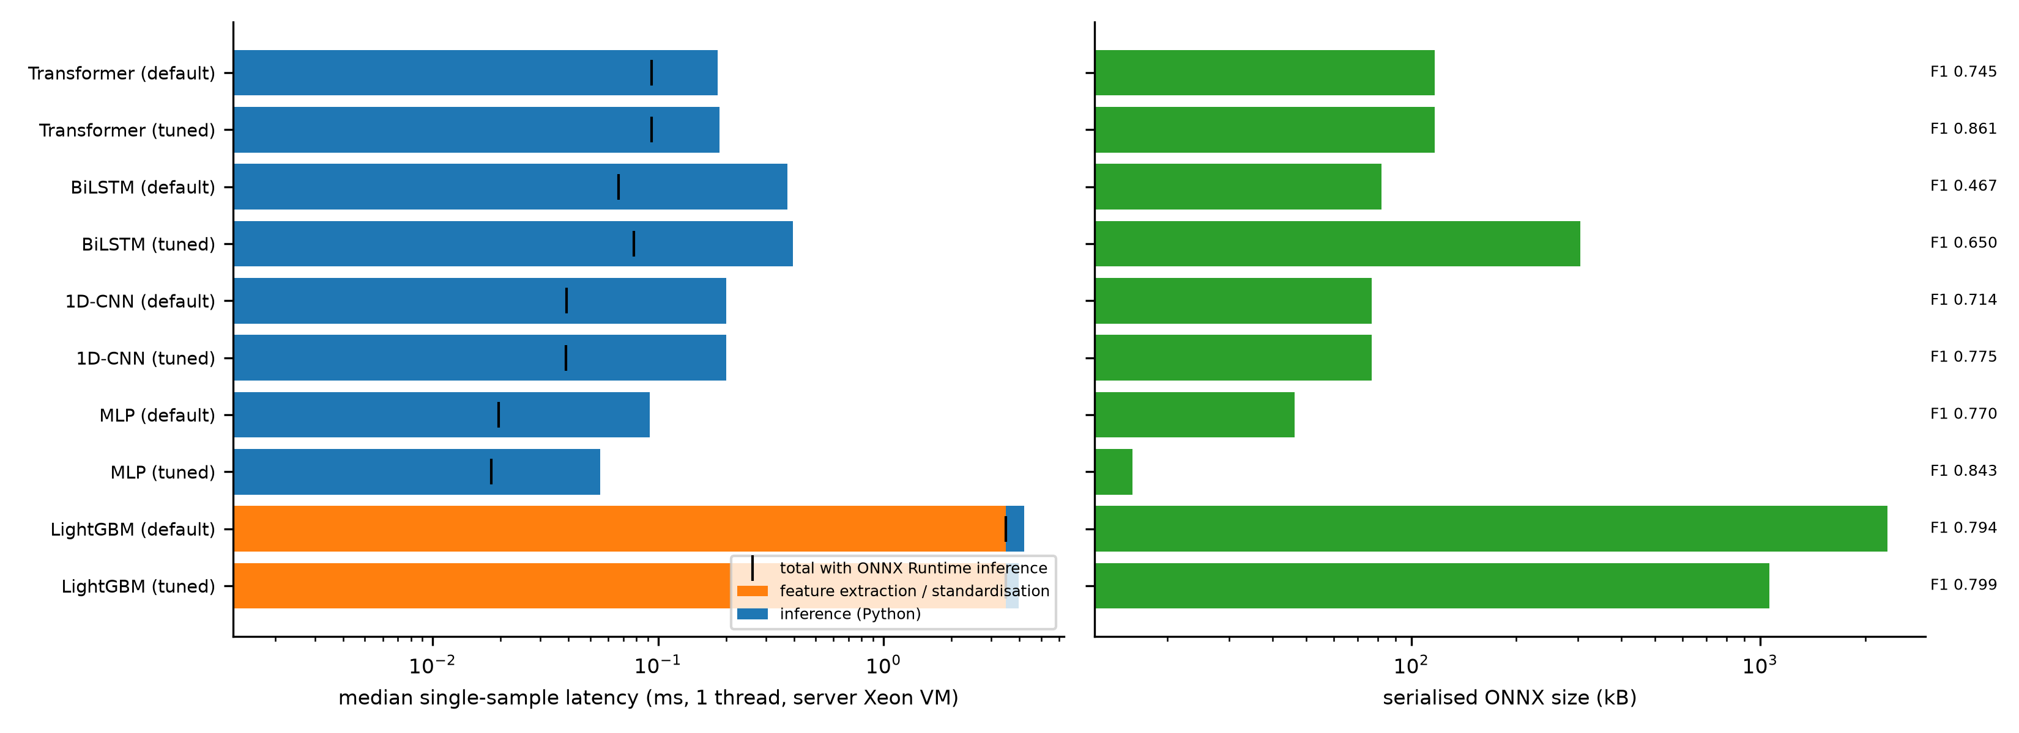
Figure S19. Single-sample latency and serialised size of the profiled models. Left: median single-sample latency on one server CPU thread (log scale), split into feature extraction or standardisation (orange) and Python inference (blue); black ticks give the total with ONNX Runtime inference. Right: serialised ONNX size (log scale), with the four-class blocked hold-out macro-F1 of each model. “Default” denotes fixed default hyper-parameters.
S7.9 Uncertainty: interval sensitivity and multiplicity
Table S32. Hold-out confidence intervals by bootstrap cluster size and rolling-origin intervals
Task | Model | Role | Hold-out F1 | Naive row CI | Cluster 25 | Cluster 50 | Cluster 100 | Rolling mean (t-interval) | Rolling range
4class | LightGBM (raw) | primary (selected by blocked CV) | 0.810 | 0.791–0.827 | 0.764–0.854 | 0.771–0.845 | 0.769–0.848 | 0.748 (0.648–0.847) | 0.631–0.839
4class | SVM-RBF (raw) | best classical hold-out (test-selected) | 0.842 | 0.824–0.859 | 0.799–0.881 | 0.800–0.880 | 0.794–0.884 | 0.754 (0.648–0.860) | 0.654–0.838
4class | LightGBM (raw+eng) | raw+engineered comparator | 0.799 | 0.781–0.817 | 0.754–0.846 | 0.754–0.843 | 0.751–0.843 | 0.730 (0.625–0.835) | 0.624–0.833
4class | LR (fp_absraw) | amplitude fingerprint baseline | 0.775 | 0.754–0.795 | 0.729–0.818 | 0.716–0.826 | 0.710–0.825 | 0.702 (0.573–0.831) | 0.535–0.800
3class | LightGBM (raw) | primary (selected by blocked CV) | 0.752 | 0.729–0.776 | 0.692–0.805 | 0.694–0.806 | 0.689–0.806 | 0.677 (0.548–0.805) | 0.534–0.798
3class | SVM-RBF (raw) | best classical hold-out (test-selected) | 0.776 | 0.753–0.799 | 0.712–0.833 | 0.712–0.832 | 0.705–0.835 | 0.689 (0.578–0.801) | 0.563–0.776
3class | LightGBM (raw+eng) | raw+engineered comparator | 0.722 | 0.698–0.747 | 0.662–0.775 | 0.662–0.776 | 0.651–0.786 | 0.652 (0.521–0.783) | 0.502–0.776
3class | LR (fp_absraw) | amplitude fingerprint baseline | 0.727 | 0.702–0.752 | 0.667–0.786 | 0.651–0.792 | 0.646–0.793 | 0.627 (0.473–0.781) | 0.445–0.754
Blocked protocol. Cluster bootstrap: 2000 class-stratified resamples of 25-, 50- or 100-row chunks (16, 8 or 4 clusters per seizure class; class 0 by Bonn segment). Rolling: mean ± t₄·SD/√5 and min–max over the five test blocks. Every hold-out interval lies in the upper part of the rolling-origin range.
Table S33. Corrected resampled t-tests with Holm correction across all settings
Task | Protocol | Best | Other | F1 best | F1 other | t | p | p (Holm, within) | p (Holm, all 72)
3class | blocked | LightGBM (raw) | 1D-CNN (raw) | 0.720 | 0.645 | 1.87 | 0.0939 | 0.6240 | 1.0000
3class | blocked | LightGBM (raw) | BiLSTM (raw) | 0.720 | 0.525 | 3.11 | 0.0125 | 0.1128 | 0.2131
3class | blocked | LightGBM (raw) | LR (raw) | 0.720 | 0.389 | 7.42 | 0.0000 | 0.0006 | 0.0016
3class | blocked | LightGBM (raw) | LR (raw+eng) | 0.720 | 0.544 | 7.55 | 0.0000 | 0.0005 | 0.0015
3class | blocked | LightGBM (raw) | LightGBM (raw+eng) | 0.720 | 0.696 | 1.61 | 0.1412 | 0.7059 | 1.0000
3class | blocked | LightGBM (raw) | MLP (raw) | 0.720 | 0.665 | 1.99 | 0.0779 | 0.6233 | 1.0000
3class | blocked | LightGBM (raw) | RF (raw) | 0.720 | 0.693 | 1.91 | 0.0891 | 0.6240 | 1.0000
3class | blocked | LightGBM (raw) | RF (raw+eng) | 0.720 | 0.624 | 4.46 | 0.0016 | 0.0174 | 0.0348
3class | blocked | LightGBM (raw) | SVM-RBF (raw) | 0.720 | 0.685 | 1.29 | 0.2289 | 0.8168 | 1.0000
3class | blocked | LightGBM (raw) | SVM-RBF (raw+eng) | 0.720 | 0.602 | 3.67 | 0.0051 | 0.0513 | 0.1026
3class | blocked | LightGBM (raw) | Transformer (raw) | 0.720 | 0.705 | 0.92 | 0.3823 | 0.8168 | 1.0000
3class | blocked | LightGBM (raw) | XGBoost (raw) | 0.720 | 0.716 | 0.42 | 0.6849 | 0.8168 | 1.0000
3class | blocked | LightGBM (raw) | XGBoost (raw+eng) | 0.720 | 0.692 | 1.37 | 0.2042 | 0.8168 | 1.0000
3class | blocked | LightGBM (raw) | kNN (raw) | 0.720 | 0.624 | 4.67 | 0.0012 | 0.0141 | 0.0282
3class | blocked | LightGBM (raw) | kNN (raw+eng) | 0.720 | 0.546 | 6.91 | 0.0001 | 0.0009 | 0.0026
3class | random | kNN (raw) | 1D-CNN (raw) | 0.983 | 0.941 | 6.47 | 0.0001 | 0.0006 | 0.0038
3class | random | kNN (raw) | BiLSTM (raw) | 0.983 | 0.887 | 13.51 | 0.0000 | 0.0000 | 0.0000
3class | random | kNN (raw) | LR (raw) | 0.983 | 0.479 | 65.91 | 0.0000 | 0.0000 | 0.0000
3class | random | kNN (raw) | LR (raw+eng) | 0.983 | 0.694 | 39.37 | 0.0000 | 0.0000 | 0.0000
3class | random | kNN (raw) | LightGBM (raw) | 0.983 | 0.968 | 5.36 | 0.0005 | 0.0009 | 0.0118
3class | random | kNN (raw) | LightGBM (raw+eng) | 0.983 | 0.959 | 4.49 | 0.0015 | 0.0015 | 0.0348
3class | random | kNN (raw) | MLP (raw) | 0.983 | 0.940 | 6.18 | 0.0002 | 0.0006 | 0.0050
3class | random | kNN (raw) | RF (raw) | 0.983 | 0.949 | 7.25 | 0.0000 | 0.0003 | 0.0019
3class | random | kNN (raw) | RF (raw+eng) | 0.983 | 0.918 | 11.57 | 0.0000 | 0.0000 | 0.0001
3class | random | kNN (raw) | SVM-RBF (raw) | 0.983 | 0.955 | 8.41 | 0.0000 | 0.0001 | 0.0007
3class | random | kNN (raw) | SVM-RBF (raw+eng) | 0.983 | 0.944 | 15.65 | 0.0000 | 0.0000 | 0.0000
3class | random | kNN (raw) | Transformer (raw) | 0.983 | 0.903 | 15.60 | 0.0000 | 0.0000 | 0.0000
3class | random | kNN (raw) | XGBoost (raw) | 0.983 | 0.959 | 6.34 | 0.0001 | 0.0006 | 0.0043
3class | random | kNN (raw) | XGBoost (raw+eng) | 0.983 | 0.949 | 7.11 | 0.0001 | 0.0003 | 0.0021
3class | random | kNN (raw) | kNN (raw+eng) | 0.983 | 0.937 | 15.66 | 0.0000 | 0.0000 | 0.0000
4class | blocked | LightGBM (raw) | 1D-CNN (raw) | 0.777 | 0.739 | 1.76 | 0.1120 | 0.6719 | 1.0000
4class | blocked | LightGBM (raw) | BiLSTM (raw) | 0.777 | 0.590 | 12.54 | 0.0000 | 0.0000 | 0.0000
4class | blocked | LightGBM (raw) | LR (eng) | 0.777 | 0.650 | 8.75 | 0.0000 | 0.0002 | 0.0005
4class | blocked | LightGBM (raw) | LR (raw) | 0.777 | 0.352 | 9.63 | 0.0000 | 0.0001 | 0.0003
4class | blocked | LightGBM (raw) | LR (raw+eng) | 0.777 | 0.653 | 9.27 | 0.0000 | 0.0001 | 0.0003
4class | blocked | LightGBM (raw) | LightGBM (eng) | 0.777 | 0.648 | 7.45 | 0.0000 | 0.0005 | 0.0016
4class | blocked | LightGBM (raw) | LightGBM (raw+eng) | 0.777 | 0.767 | 0.90 | 0.3914 | 1.0000 | 1.0000
4class | blocked | LightGBM (raw) | MLP (raw) | 0.777 | 0.774 | 0.16 | 0.8751 | 1.0000 | 1.0000
4class | blocked | LightGBM (raw) | RF (eng) | 0.777 | 0.634 | 7.91 | 0.0000 | 0.0004 | 0.0011
4class | blocked | LightGBM (raw) | RF (raw) | 0.777 | 0.763 | 1.28 | 0.2313 | 1.0000 | 1.0000
4class | blocked | LightGBM (raw) | RF (raw+eng) | 0.777 | 0.724 | 3.47 | 0.0070 | 0.0701 | 0.1332
4class | blocked | LightGBM (raw) | SVM-RBF (eng) | 0.777 | 0.651 | 5.49 | 0.0004 | 0.0042 | 0.0104
4class | blocked | LightGBM (raw) | SVM-RBF (raw) | 0.777 | 0.755 | 2.13 | 0.0625 | 0.4376 | 0.9377
4class | blocked | LightGBM (raw) | SVM-RBF (raw+eng) | 0.777 | 0.665 | 7.77 | 0.0000 | 0.0004 | 0.0012
4class | blocked | LightGBM (raw) | Transformer (raw) | 0.777 | 0.749 | 1.09 | 0.3047 | 1.0000 | 1.0000
4class | blocked | LightGBM (raw) | XGBoost (eng) | 0.777 | 0.650 | 7.51 | 0.0000 | 0.0005 | 0.0015
4class | blocked | LightGBM (raw) | XGBoost (raw) | 0.777 | 0.773 | 0.59 | 0.5710 | 1.0000 | 1.0000
4class | blocked | LightGBM (raw) | XGBoost (raw+eng) | 0.777 | 0.761 | 2.24 | 0.0520 | 0.4160 | 0.8320
4class | blocked | LightGBM (raw) | kNN (eng) | 0.777 | 0.622 | 13.84 | 0.0000 | 0.0000 | 0.0000
4class | blocked | LightGBM (raw) | kNN (raw) | 0.777 | 0.697 | 3.34 | 0.0086 | 0.0774 | 0.1548
4class | blocked | LightGBM (raw) | kNN (raw+eng) | 0.777 | 0.629 | 11.39 | 0.0000 | 0.0000 | 0.0001
4class | random | kNN (raw) | 1D-CNN (raw) | 0.984 | 0.948 | 6.50 | 0.0001 | 0.0007 | 0.0038
4class | random | kNN (raw) | BiLSTM (raw) | 0.984 | 0.730 | 5.20 | 0.0006 | 0.0011 | 0.0140
4class | random | kNN (raw) | LR (eng) | 0.984 | 0.751 | 25.55 | 0.0000 | 0.0000 | 0.0000
4class | random | kNN (raw) | LR (raw) | 0.984 | 0.498 | 60.44 | 0.0000 | 0.0000 | 0.0000
4class | random | kNN (raw) | LR (raw+eng) | 0.984 | 0.775 | 24.37 | 0.0000 | 0.0000 | 0.0000
4class | random | kNN (raw) | LightGBM (eng) | 0.984 | 0.903 | 11.66 | 0.0000 | 0.0000 | 0.0001
4class | random | kNN (raw) | LightGBM (raw) | 0.984 | 0.972 | 4.37 | 0.0018 | 0.0018 | 0.0376
4class | random | kNN (raw) | LightGBM (raw+eng) | 0.984 | 0.965 | 5.89 | 0.0002 | 0.0010 | 0.0067
4class | random | kNN (raw) | MLP (raw) | 0.984 | 0.931 | 8.61 | 0.0000 | 0.0001 | 0.0006
4class | random | kNN (raw) | RF (eng) | 0.984 | 0.870 | 24.13 | 0.0000 | 0.0000 | 0.0000
4class | random | kNN (raw) | RF (raw) | 0.984 | 0.956 | 6.01 | 0.0002 | 0.0010 | 0.0060
4class | random | kNN (raw) | RF (raw+eng) | 0.984 | 0.935 | 6.81 | 0.0001 | 0.0006 | 0.0027
4class | random | kNN (raw) | SVM-RBF (eng) | 0.984 | 0.874 | 13.26 | 0.0000 | 0.0000 | 0.0000
4class | random | kNN (raw) | SVM-RBF (raw) | 0.984 | 0.894 | 13.49 | 0.0000 | 0.0000 | 0.0000
4class | random | kNN (raw) | SVM-RBF (raw+eng) | 0.984 | 0.913 | 11.41 | 0.0000 | 0.0000 | 0.0001
4class | random | kNN (raw) | Transformer (raw) | 0.984 | 0.920 | 9.17 | 0.0000 | 0.0001 | 0.0004
4class | random | kNN (raw) | XGBoost (eng) | 0.984 | 0.893 | 14.09 | 0.0000 | 0.0000 | 0.0000
4class | random | kNN (raw) | XGBoost (raw) | 0.984 | 0.965 | 5.52 | 0.0004 | 0.0011 | 0.0104
4class | random | kNN (raw) | XGBoost (raw+eng) | 0.984 | 0.959 | 6.89 | 0.0001 | 0.0006 | 0.0026
4class | random | kNN (raw) | kNN (eng) | 0.984 | 0.883 | 13.88 | 0.0000 | 0.0000 | 0.0000
4class | random | kNN (raw) | kNN (raw+eng) | 0.984 | 0.903 | 12.72 | 0.0000 | 0.0000 | 0.0000
Nadeau–Bengio corrected resampled t-test on the 10 outer folds of 5 × 2 CV against the best model in each task × protocol setting (all configurations of Table S25). Holm correction within each setting and across all 72 comparisons.
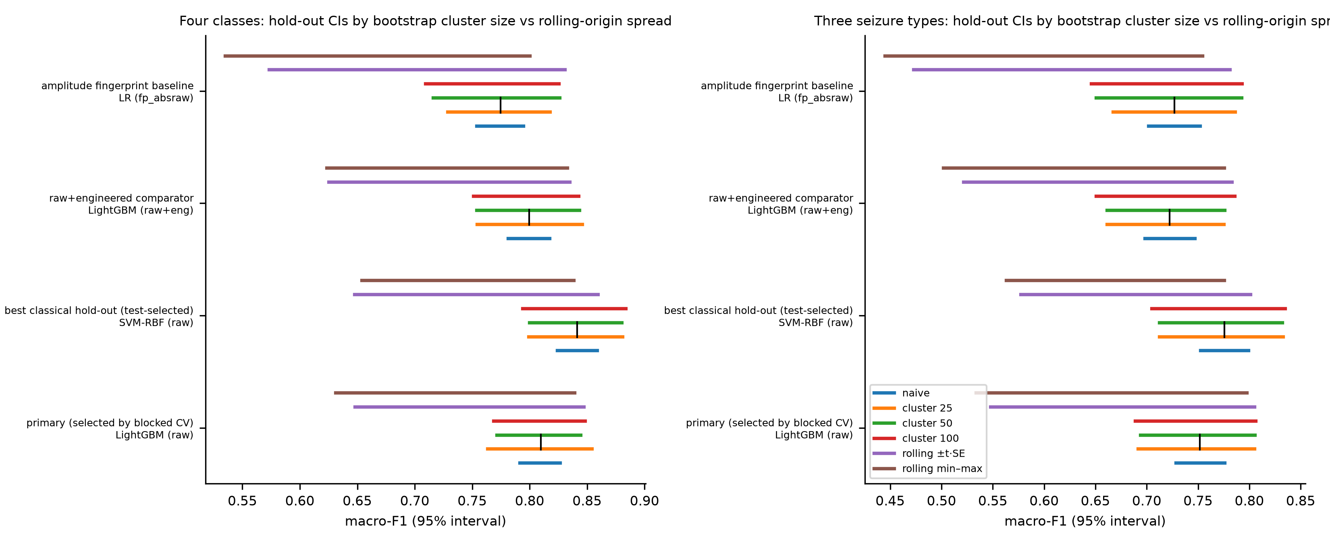
Figure S20. Hold-out confidence intervals versus rolling-origin spread. For four models per task (the primary LightGBM raw; SVM-RBF raw, the best classical hold-out score; LightGBM on raw+engineered features; and the LR(|x|) amplitude fingerprint), naive row-level and cluster-bootstrap 95% intervals (25-, 50- and 100-row chunks) on the final-20% hold-out, and the rolling-origin t-interval and min–max range. Left: four classes; right: three seizure types.

