Our cancer-type study, explained simply
A plain-language note on the Pan-Cancer paper: what we did, what we found and why it matters. Written so it can be retold to friends, family or visitors at a poster.

What is this about?
When someone has cancer, doctors need to know where in the body it started, because that guides treatment. Usually this is clear, but sometimes a cancer is found after it has spread and its starting point is unknown. One idea is to let a computer guess the starting point from the tumour's genes.
A small, free-to-download collection of tumour data has become a popular test for such computer programs. Many groups report that their programs get about 98 to 100 out of 100 right on it. We asked: what do those near-perfect scores really tell us, and what do they not? The short answer: the task in this collection is so easy that almost any sensible method scores near the top, so the scores cannot show which method is better.

What is gene activity, and what is RNA sequencing?
- Genes are the instructions inside our cells. Each type of tissue (breast, lung, kidney and so on) switches on a different mix of genes.
- RNA sequencing is a lab test that measures how active each gene is in a sample. The result is one number per gene: a big number means the gene is busy, a small number means it is quiet.
- Why it helps: because each tissue has its own pattern of busy and quiet genes, a tumour often still carries the pattern of the tissue it came from.

What data did we use?
The collection is kept by the University of California, Irvine (UCI) in a public library of datasets. It was taken from a large international cancer project called The Cancer Genome Atlas (TCGA). It is one table with 801 tumours (rows) and 20,531 genes (columns). Each tumour is labelled with one of five cancer types:
- Breast cancer (300 tumours)
- Kidney cancer (146)
- Lung cancer of the adenocarcinoma type (141)
- Prostate cancer (136)
- Bowel (colon) cancer (78)
One important detail: the gene names have been replaced by codes (gene_0, gene_1, …). So we cannot say which real genes matter, and we deliberately make no claims about biology.

How did we test the programs?
We tried seven kinds of computer programs that learn from examples (called “models”), from very simple to more modern ones, plus a “guess the most common type” baseline for comparison.
Testing a model is like a school exam: it practises on some tumours and is then tested on tumours it has not seen. We did this fifty times, each time with a different fifth of the tumours held back as the exam (ten rounds of five exams, a method called repeated cross-validation). This gives a fairer average than a single exam.
The models do not use all 20,531 genes; first the 100 genes that differ most between cancer types are picked out. A classic mistake is to pick those genes using all tumours, including the exam tumours. That lets the exam answers leak into the practice, a problem called “leakage”, and it can make scores look better than they are. We always picked the genes using only the practice tumours, and we also ran the mistaken version on purpose to measure how much it matters.

What did we find?
Finding 1: on this collection, the classic leakage mistake barely changes the score.
With all 801 tumours, picking genes the wrong way changed the score by at most 0.29 out of 100 when 20 or more genes were used. For our main model with 100 genes it was 99.50 out of 100 with the mistake and 99.48 without. The mistake only showed clearly in a trick test: when we shuffled the cancer labels at random, so there was nothing real to learn, and used just 60 tumours, the mistaken method still scored 68.2 out of 100 against 19.9 for the correct one, where pure guessing gives about 20. In other words, leakage is real, but on this easy collection it hides behind the near-perfect score instead of creating it.
Finding 2: no model is better than the others.
All seven models scored between 98.9 and 99.8 out of 100 (using a score that treats the five cancer types equally). Proper statistical tests found no pair of models that differed by more than chance would explain. More than that, for 10 of the 15 pairs that did not involve the weakest model (naive Bayes), we could show the two were practically the same, within one point out of 100. The remaining pairs were undecided, not different. Our main model made 42 mistakes in 8,010 exam answers, and they all came from a handful of unusual tumours, so a “winning” model on this collection usually wins by a few tumours.
Finding 3: the model can be made to say “I am not sure”, which removes most remaining mistakes.
Besides naming a cancer type, the models give a confidence, for example “97% sure”. We checked whether these confidences can be trusted (called “calibration”). They are close, but not perfect: the average gap between confidence and actual correctness was 0.47 out of 100, against about 0.14 expected for a perfectly honest model. The gap is small and probably real, and it sits in the few cases where the model was unsure: the 80 answers given with less than 93% confidence held all 42 mistakes.
We then used a method called conformal prediction. Instead of always giving one answer, it gives a short list of possible cancer types that contains the right one with a promised probability, here 99 out of 100. If the list has just one type, the model answers; if not, it abstains and says “ask a human”. The model answered alone for 99.4% of tumours and abstained on the rest. Among the answers it gave, the mistake rate fell from 0.51 to 0.18 out of 100. Honestly, a simple “answer only when very confident” rule did about as well (0.26 out of 100); what conformal prediction adds is a principled way to set that confidence bar with a stated guarantee. Three particularly unusual lung tumours were flagged as uncertain in 18 of their 30 appearances, so about half the time.
Finding 4: very little data is needed.
Trained on only 3 tumours of each type, our main model already scored 98.1 out of 100, and with 10 of each type 99.4 (naive Bayes, the weakest model, needed far more). This also explains Finding 1: the leakage mistake inflated scores on shuffled labels by 65 points with 30 tumours but only 14 points with 390 tumours, and with the real labels it made almost no difference, because the real task is solved with a few examples anyway. Other researchers had described this pattern before in simulations; we confirm it on real data.
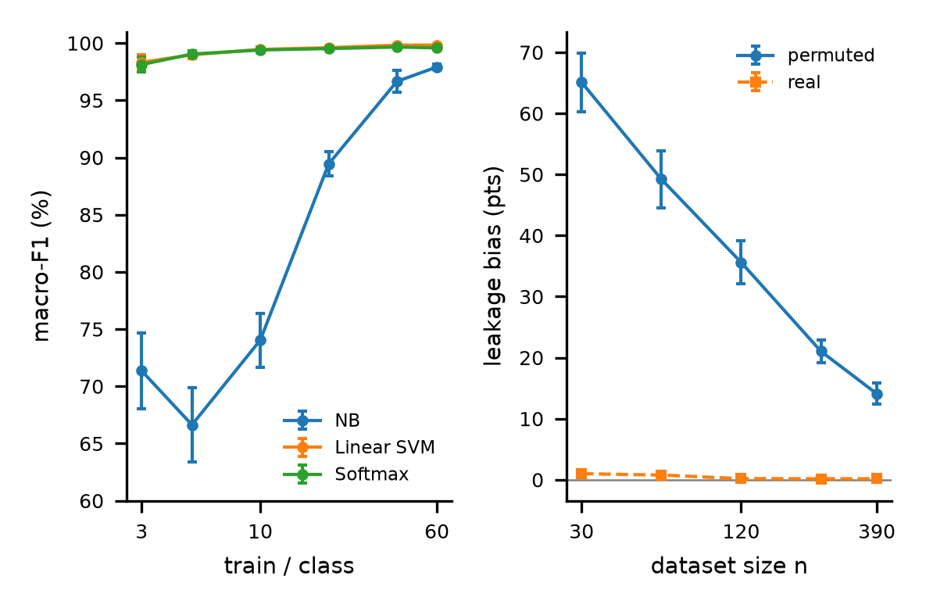
Picture. Left: score against the number of training tumours per cancer type; two of the three models are near the top with only a few examples. Right: how much the leakage mistake inflates the score on shuffled labels (blue) and real labels (orange) as the number of tumours grows.

What the study does NOT show
- It does not show that any one model is the best. On this collection they are effectively tied.
- It does not show that a near-perfect score proves a method is free of leakage. Leaky and careful methods score the same here.
- It does not identify cancer genes. The gene names are hidden codes, so we make no biological claims.
- It does not show that the models would work in a hospital, on patients from other centres, or on cancers that have spread.
- We do not propose a new model.

Limitations
- Small and from one source: 801 tumours, all from TCGA, and only five cancer types that are easy to tell apart.
- No extra information about patients or how the samples were handled. Even simple overall summaries of each tumour's gene numbers guessed the cancer type 52.7% of the time (20% by chance), so some differences may come from sample handling rather than biology.
- The promise of conformal prediction holds only for tumours like those in this collection, and with about 160 tumours used to set the bar, the bar moves a lot from one exam to the next.
- Real clinical use would need testing on new hospitals, the full set of 33 TCGA cancer types, and cancers that have spread.

Why does it matter?
Many papers celebrate near-perfect scores on this collection. Our study shows that such scores are the norm, that they cannot separate good methods from slightly worse ones or careful methods from careless ones, and that honest testing tools (shuffled-label checks, tests that show when two models are practically the same, and the option to say “I am not sure”) tell us much more. All our code is shared, and rerunning it reproduces every number.

Quick Q&A
Q: So are the earlier near-perfect results wrong?
A: Probably not by much: on this collection, careless and careful methods give almost the same score. The issue is what the score is taken to prove, not the score itself.
Q: Which model should I use?
A: Any of the simple ones. They are practically tied, and the simplest is easiest to check.
Q: Can this be used in a hospital?
A: No. It was not tested on new patients or other hospitals. It is a research study about testing methods.
Q: What would make the data better?
A: Real gene names, information about each patient and sample, more cancer types, and tumours from other hospitals.

