Supplementary Material
What Near-Perfect Accuracy Does and Does Not Show on the UCI TCGA Pan-Cancer RNA-Seq Dataset: Leakage, Equivalence, Conformal Reliability and Data Efficiency
Contents: S1 Software, settings and data integrity; S2 Per-class performance and pooled errors; S3 Feature-count ablation; S4 All-gene benchmark; S5 All pairwise comparisons; S6 Leakage audit; S7 Misclassified samples and quality metrics; S8 Top-ranked genes and selection stability; S9 Computational footprint and fold-level distributions; S10 Reproducing the results (Supplementary File S1); S11 Calibration and conformal prediction (robustness checks, all models); S12 Learning curves and leakage by sample size, with 95% CIs.

S1 Software, settings and data integrity
All analyses were run with Python 3.13.5 on a 8-vCPU Linux virtual machine (x86-64), using scikit-learn 1.9.1, LightGBM 4.7.0, NumPy 2.5.4, pandas 3.0.6, SciPy 1.18.1 and Matplotlib 3.11.2 and joblib 1.6.0 (pinned in requirements.txt). The main benchmark took 18 min; the revision analyses (leakage audit, all-gene benchmark) run in parallel and add about 1 h on 8 vCPUs, mostly LightGBM on all genes; the extension and robustness analyses add about 5 min. The dataset was downloaded from the UCI repository (dataset 401) on 16 October 2026; SHA-256 checksums: data.csv e3e7eff51f4a5fe5f121fb183c09786c767c755ef10d1c7b3ce3c193a7082ca9, labels.csv e1653ccf5a630deb3b953ccac5a8b331b89adc5433e5d2d3444c1fc01d79e7aa.
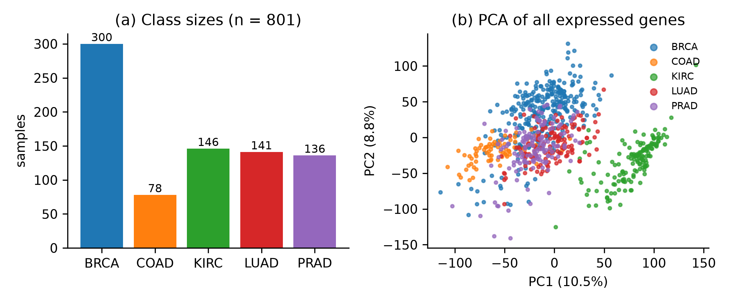
Figure S1. Dataset overview. (a) Samples per cancer type. (b) First two principal components of the standardised expression of all non-constant genes, fitted on all 801 samples for visualisation only.
Table S1. Fixed settings (no hyperparameter tuning)
Component | Setting
Majority baseline | most frequent class (BRCA)
Softmax (multinomial LR) | L2 penalty, C = 1, lbfgs, max_iter 5000
Ridge classifier | α = 10; one-vs-rest least squares
Linear SVM | LinearSVC, C = 1, squared hinge, one-vs-rest, max_iter 20000
Gaussian naive Bayes | default variance smoothing 10⁻⁹
Random forest | 500 trees, Gini, √p features per split, seed 2026
LightGBM | 200 trees, learning rate 0.05, 15 leaves, seed 2026
MLP | one hidden layer, 64 ReLU units, Adam, L2 10⁻³, max 1000 epochs, seed 2026
Pipeline (all) | zero-variance filter → ANOVA-F top-k (k = 100) → z-scoring → classifier; refitted per fold
Cross-validation | RepeatedStratifiedKFold, 5 folds × 10 repeats, seed 2026; identical splits for all models

S2 Per-class performance
Table S2. Per-class F1 and balanced accuracy
Model | BRCA | COAD | KIRC | LUAD | PRAD | Balanced acc., % [95% CI]
Softmax (multinomial LR) | 0.994 | 0.995 | 0.998 | 0.988 | 1.000 | 99.32 [98.48, 100.00]
Ridge classifier | 0.996 | 1.000 | 1.000 | 0.991 | 1.000 | 99.63 [99.07, 100.00]
Linear SVM | 0.998 | 0.998 | 1.000 | 0.995 | 1.000 | 99.75 [99.21, 100.00]
Gaussian naive Bayes | 0.993 | 0.987 | 0.993 | 0.972 | 1.000 | 98.93 [98.14, 99.73]
Random forest | 0.996 | 0.994 | 0.998 | 0.989 | 1.000 | 99.38 [98.59, 100.00]
LightGBM | 0.995 | 0.993 | 0.999 | 0.987 | 0.996 | 99.32 [98.53, 100.00]
MLP (64 hidden units) | 0.995 | 0.993 | 0.997 | 0.988 | 1.000 | 99.28 [98.41, 100.00]
Per-class F1 from the confusion matrix summed over 10×801 out-of-fold predictions; balanced accuracy: mean over 50 folds with corrected 95% CI. k = 100.
Table S3. Pooled error rates
Model | Errors | Error rate, % [Wilson 95% CI] | Perfect folds, %
Majority baseline | 5010 | 62.55 [61.48, 63.60] | 0
Softmax (multinomial LR) | 42 | 0.52 [0.39, 0.71] | 48
Ridge classifier | 26 | 0.32 [0.22, 0.48] | 62
Linear SVM | 15 | 0.19 [0.11, 0.31] | 76
Gaussian naive Bayes | 82 | 1.02 [0.83, 1.27] | 16
Random forest | 36 | 0.45 [0.32, 0.62] | 52
LightGBM | 45 | 0.56 [0.42, 0.75] | 42
MLP (64 hidden units) | 43 | 0.54 [0.40, 0.72] | 46
Pooled counts treat repeated predictions of the same sample as separate trials, so the Wilson intervals are too narrow; descriptive only.
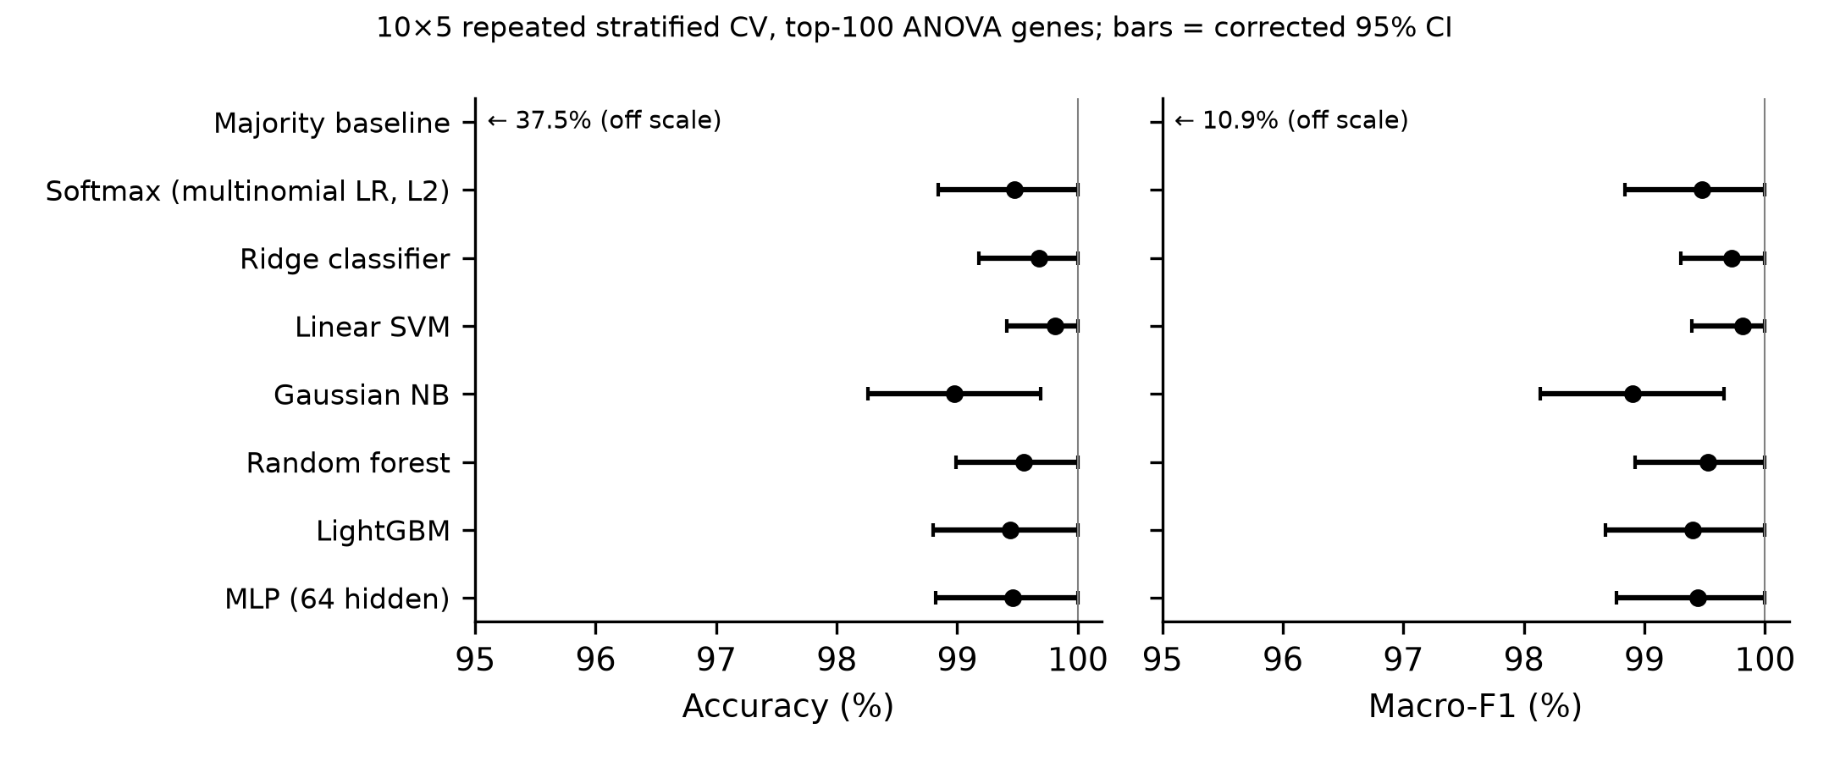
Figure S2. Accuracy and macro-F1 with corrected 95% confidence intervals. Mean over 50 folds of 10×5 repeated stratified CV; Nadeau–Bengio corrected 95% CI. Majority baseline off the axis.

S3 Feature-count ablation
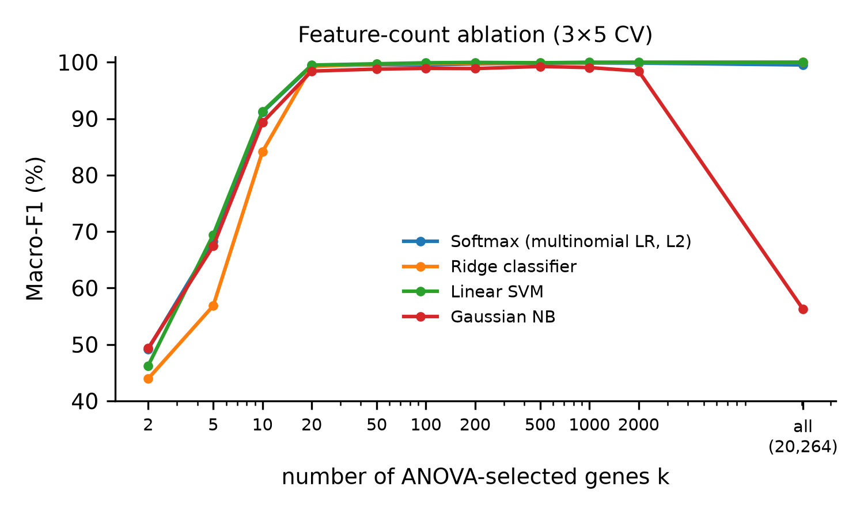
Figure S3. Macro-F1 as a function of the number of selected genes. Selection, scaling and classifier refitted inside every training fold; 3×5 repeated CV; log-scaled x-axis.
Table S4. Performance by number of selected genes, 3×5 repeated CV
Model | k | Accuracy, % (mean ± SD) | Macro-F1, % (mean ± SD) | Errors per repeat | Fit, ms
Softmax (multinomial LR) | 2 | 63.80 ± 6.82 | 49.16 ± 6.42 | 290.0 | 416
Ridge classifier | 2 | 61.22 ± 8.53 | 43.94 ± 8.52 | 310.7 | 367
Linear SVM | 2 | 62.17 ± 8.02 | 46.24 ± 7.09 | 303.0 | 376
Gaussian naive Bayes | 2 | 59.09 ± 10.26 | 49.32 ± 6.89 | 327.7 | 385
Softmax (multinomial LR) | 5 | 75.86 ± 1.67 | 68.31 ± 3.41 | 193.3 | 412
Ridge classifier | 5 | 72.24 ± 1.18 | 56.85 ± 2.17 | 222.3 | 387
Linear SVM | 5 | 76.07 ± 2.05 | 69.43 ± 3.93 | 191.7 | 370
Gaussian naive Bayes | 5 | 68.12 ± 3.75 | 67.43 ± 4.73 | 255.3 | 366
Softmax (multinomial LR) | 10 | 92.67 ± 5.44 | 91.13 ± 6.30 | 58.7 | 393
Ridge classifier | 10 | 89.22 ± 6.71 | 84.14 ± 9.66 | 86.3 | 397
Linear SVM | 10 | 92.55 ± 5.63 | 91.27 ± 6.49 | 59.7 | 375
Gaussian naive Bayes | 10 | 90.84 ± 7.67 | 89.32 ± 7.64 | 73.3 | 370
Softmax (multinomial LR) | 20 | 99.46 ± 0.52 | 99.37 ± 0.60 | 4.3 | 399
Ridge classifier | 20 | 99.29 ± 0.62 | 99.25 ± 0.72 | 5.7 | 382
Linear SVM | 20 | 99.54 ± 0.55 | 99.50 ± 0.64 | 3.7 | 387
Gaussian naive Bayes | 20 | 98.63 ± 0.86 | 98.43 ± 0.97 | 11.0 | 367
Softmax (multinomial LR) | 50 | 99.62 ± 0.46 | 99.56 ± 0.57 | 3.0 | 542
Ridge classifier | 50 | 99.63 ± 0.39 | 99.68 ± 0.34 | 3.0 | 384
Linear SVM | 50 | 99.79 ± 0.45 | 99.72 ± 0.58 | 1.7 | 384
Gaussian naive Bayes | 50 | 98.92 ± 0.90 | 98.79 ± 0.89 | 8.7 | 375
Softmax (multinomial LR) | 100 | 99.50 ± 0.54 | 99.51 ± 0.54 | 4.0 | 425
Ridge classifier | 100 | 99.71 ± 0.40 | 99.75 ± 0.34 | 2.3 | 398
Linear SVM | 100 | 99.88 ± 0.26 | 99.89 ± 0.22 | 1.0 | 414
Gaussian naive Bayes | 100 | 99.00 ± 0.78 | 98.91 ± 0.82 | 8.0 | 389
Softmax (multinomial LR) | 200 | 99.75 ± 0.52 | 99.73 ± 0.58 | 2.0 | 414
Ridge classifier | 200 | 99.83 ± 0.29 | 99.86 ± 0.24 | 1.3 | 391
Linear SVM | 200 | 99.96 ± 0.16 | 99.96 ± 0.14 | 0.3 | 497
Gaussian naive Bayes | 200 | 98.96 ± 0.61 | 98.88 ± 0.69 | 8.3 | 384
Softmax (multinomial LR) | 500 | 99.83 ± 0.37 | 99.86 ± 0.32 | 1.3 | 481
Ridge classifier | 500 | 99.88 ± 0.26 | 99.89 ± 0.22 | 1.0 | 432
Linear SVM | 500 | 99.88 ± 0.26 | 99.90 ± 0.21 | 1.0 | 1333
Gaussian naive Bayes | 500 | 99.46 ± 0.57 | 99.26 ± 0.80 | 4.3 | 409
Softmax (multinomial LR) | 1000 | 99.83 ± 0.37 | 99.86 ± 0.32 | 1.3 | 555
Ridge classifier | 1000 | 99.88 ± 0.26 | 99.89 ± 0.22 | 1.0 | 489
Linear SVM | 1000 | 100.00 ± 0.00 | 100.00 ± 0.00 | 0.0 | 577
Gaussian naive Bayes | 1000 | 99.33 ± 0.69 | 99.05 ± 0.91 | 5.3 | 389
Softmax (multinomial LR) | 2000 | 99.83 ± 0.29 | 99.86 ± 0.24 | 1.3 | 1131
Ridge classifier | 2000 | 99.96 ± 0.16 | 99.96 ± 0.14 | 0.3 | 563
Linear SVM | 2000 | 100.00 ± 0.00 | 100.00 ± 0.00 | 0.0 | 752
Gaussian naive Bayes | 2000 | 98.88 ± 0.72 | 98.45 ± 0.91 | 9.0 | 401
Softmax (multinomial LR) | all (≈20,264) | 99.54 ± 0.55 | 99.52 ± 0.56 | 3.7 | 1435
Ridge classifier | all (≈20,264) | 100.00 ± 0.00 | 100.00 ± 0.00 | 0.0 | 643
Linear SVM | all (≈20,264) | 100.00 ± 0.00 | 100.00 ± 0.00 | 0.0 | 5979
Gaussian naive Bayes | all (≈20,264) | 63.13 ± 3.41 | 56.28 ± 3.85 | 295.3 | 515
SD across 15 folds. 'all': every gene with non-zero variance in the training fold.

S4 All-gene benchmark
Table S5. All seven classifiers with every expressed gene, 10×5 repeated CV
Model | Accuracy, % [95% CI] | Macro-F1, % [95% CI] | Errors per repeat | Fit, s
Softmax (multinomial LR) | 99.48 [98.91, 100.00] | 99.45 [98.83, 100.00] | 4.2 | 0.76
Ridge classifier | 100.00 [100.00, 100.00] | 100.00 [100.00, 100.00] | 0.0 | 0.59
Linear SVM | 100.00 [100.00, 100.00] | 100.00 [100.00, 100.00] | 0.0 | 6.81
Gaussian naive Bayes | 63.10 [59.02, 67.18] | 56.50 [51.44, 61.56] | 295.6 | 0.55
Random forest | 99.61 [99.14, 100.00] | 99.68 [99.28, 100.00] | 3.1 | 7.84
LightGBM | 99.45 [98.81, 100.00] | 99.40 [98.69, 100.00] | 4.4 | 478.26
MLP (64 hidden units) | 99.45 [98.65, 100.00] | 99.36 [98.42, 100.00] | 4.4 | 5.89
Zero-variance filter and z-scoring fitted in-fold, no ANOVA selection; same folds as the main benchmark. Fit times measured with parallel jobs; indicative only.

S5 All pairwise comparisons
Table S6. All 21 pairwise macro-F1 comparisons
A | B | Δ (B − A), pts | p | Holm p | TOST Holm p | P(A/ROPE/B) | MDD80
Linear SVM | Gaussian naive Bayes | -0.91 | 0.031 | 0.66 | 0.890 | 0.84/0.16/0.00 | 1.2
Ridge classifier | Gaussian naive Bayes | -0.83 | 0.063 | 1.00 | 0.890 | 0.77/0.23/0.00 | 1.2
Gaussian naive Bayes | Random forest | +0.63 | 0.147 | 1.00 | 0.890 | 0.01/0.38/0.62 | 1.2
Linear SVM | MLP | -0.37 | 0.176 | 1.00 | 0.110 | 0.32/0.68/0.00 | 0.8
Softmax | Gaussian naive Bayes | -0.58 | 0.203 | 1.00 | 0.890 | 0.57/0.42/0.01 | 1.3
Softmax | Linear SVM | +0.33 | 0.207 | 1.00 | 0.074 | 0.00/0.74/0.26 | 0.7
Gaussian naive Bayes | MLP | +0.54 | 0.217 | 1.00 | 0.890 | 0.01/0.45/0.54 | 1.2
Linear SVM | LightGBM | -0.41 | 0.232 | 1.00 | 0.328 | 0.40/0.59/0.01 | 1.0
Softmax | Ridge classifier | +0.24 | 0.247 | 1.00 | 0.006 | 0.00/0.89/0.11 | 0.6
Ridge classifier | MLP | -0.28 | 0.253 | 1.00 | 0.035 | 0.19/0.81/0.00 | 0.7
Ridge classifier | LightGBM | -0.33 | 0.323 | 1.00 | 0.178 | 0.30/0.69/0.01 | 0.9
Linear SVM | Random forest | -0.29 | 0.323 | 1.00 | 0.085 | 0.23/0.76/0.00 | 0.8
Gaussian naive Bayes | LightGBM | +0.50 | 0.327 | 1.00 | 0.890 | 0.03/0.47/0.50 | 1.4
Ridge classifier | Random forest | -0.20 | 0.408 | 1.00 | 0.013 | 0.11/0.89/0.00 | 0.7
Random forest | MLP | -0.08 | 0.638 | 1.00 | < 0.001 | 0.01/0.99/0.00 | 0.5
Random forest | LightGBM | -0.13 | 0.661 | 1.00 | 0.028 | 0.10/0.88/0.02 | 0.8
Ridge classifier | Linear SVM | +0.09 | 0.680 | 1.00 | < 0.001 | 0.00/0.97/0.03 | 0.6
Softmax | LightGBM | -0.08 | 0.801 | 1.00 | 0.038 | 0.10/0.86/0.04 | 0.9
Softmax | Random forest | +0.05 | 0.802 | 1.00 | < 0.001 | 0.00/0.99/0.01 | 0.5
Softmax | MLP | -0.04 | 0.846 | 1.00 | < 0.001 | 0.01/0.98/0.00 | 0.6
LightGBM | MLP | +0.04 | 0.893 | 1.00 | 0.028 | 0.05/0.88/0.08 | 0.9
Corrected resampled t-test (Nadeau–Bengio), Holm over 21 pairs; TOST margin ±1 point; Bayesian correlated t-test, ROPE ±0.5 point; MDD80 in points. Accuracy: results/pairwise_all.csv in File S1.

S6 Leakage audit
Table S7. Leaky vs in-fold selection, real labels, n = 801
k | Model | Accuracy, % leaky / in-fold (Δ, p) | Macro-F1, % leaky / in-fold (Δ, p)
10 | Softmax | 95.22 / 92.32 (+2.89, p = 0.27) | 92.94 / 90.23 (+2.71, p = 0.40)
10 | Linear SVM | 95.37 / 92.31 (+3.06, p = 0.24) | 93.26 / 90.65 (+2.61, p = 0.39)
10 | Gaussian NB | 95.47 / 90.80 (+4.66, p = 0.20) | 93.52 / 88.98 (+4.54, p = 0.25)
20 | Softmax | 99.76 / 99.54 (+0.22, p = 0.39) | 99.65 / 99.50 (+0.16, p = 0.60)
20 | Linear SVM | 99.78 / 99.55 (+0.22, p = 0.46) | 99.68 / 99.50 (+0.19, p = 0.62)
20 | Gaussian NB | 99.00 / 98.71 (+0.29, p = 0.41) | 98.74 / 98.53 (+0.20, p = 0.65)
100 | Softmax | 99.50 / 99.48 (+0.02, p = 0.87) | 99.55 / 99.48 (+0.07, p = 0.73)
100 | Linear SVM | 99.78 / 99.81 (-0.04, p = 0.76) | 99.79 / 99.81 (-0.02, p = 0.88)
100 | Gaussian NB | 98.98 / 98.98 (+0.00, p = 1.00) | 98.90 / 98.90 (+0.00, p = 0.97)
1,000 | Softmax | 99.85 / 99.84 (+0.01, p = 0.79) | 99.87 / 99.86 (+0.01, p = 0.79)
1,000 | Linear SVM | 100.00 / 100.00 (+0.00, p = 1.00) | 100.00 / 100.00 (+0.00, p = 1.00)
1,000 | Gaussian NB | 99.21 / 99.20 (+0.01, p = 0.79) | 98.95 / 98.94 (+0.02, p = 0.72)
10×5 repeated CV, identical folds; corrected paired t-test, unadjusted.
Permuted labels, n = 801 (softmax, 100 permutations, mean ± SD of 5-fold accuracy): k = 10: leaky 38.1% ± 1.2 (max 40.9), in-fold 33.0% ± 1.4 (max 36.3); k = 100: leaky 35.9% ± 2.3 (max 42.4), in-fold 25.3% ± 1.5 (max 29.1). Small samples (n = 60, 12 per class, 50 subsamples, softmax): permuted labels, k = 10: leaky 51.2% ± 7.0, in-fold 19.7% ± 5.4; permuted labels, k = 100: leaky 68.2% ± 5.8, in-fold 19.9% ± 6.3; real labels, k = 10: leaky 92.7% ± 8.2, in-fold 90.7% ± 5.8; real labels, k = 100: leaky 99.9% ± 0.4, in-fold 99.3% ± 1.1.

S7 Misclassified samples and quality metrics
Table S8. Samples misclassified by softmax in at least one repeat, with within-class quality z-scores
Sample | True | Predicted (count) | Repeats wrong | Mean expr. z | Zero frac. z | Centroid corr. z (rank)
sample_129 | LUAD | BRCA ×9 | 9/10 | -2.4 | +1.4 | -2.5 (5/141)
sample_507 | LUAD | BRCA ×9 | 9/10 | -1.9 | +1.3 | -2.1 (9/141)
sample_599 | LUAD | BRCA ×9 | 9/10 | -3.1 | +2.1 | -3.8 (1/141)
sample_510 | COAD | LUAD ×8 | 8/10 | +0.4 | +0.1 | -1.0 (10/78)
sample_61 | KIRC | BRCA ×7 | 7/10 | +1.2 | -1.9 | -3.3 (4/146)
z-scores within the true class. Centroid correlation: Pearson correlation with the mean profile of the other samples of the class; rank 1 = least typical.
Global summary statistics alone (9 per sample) predicted the class with 52.7% balanced accuracy in 5-fold CV (chance 20%).
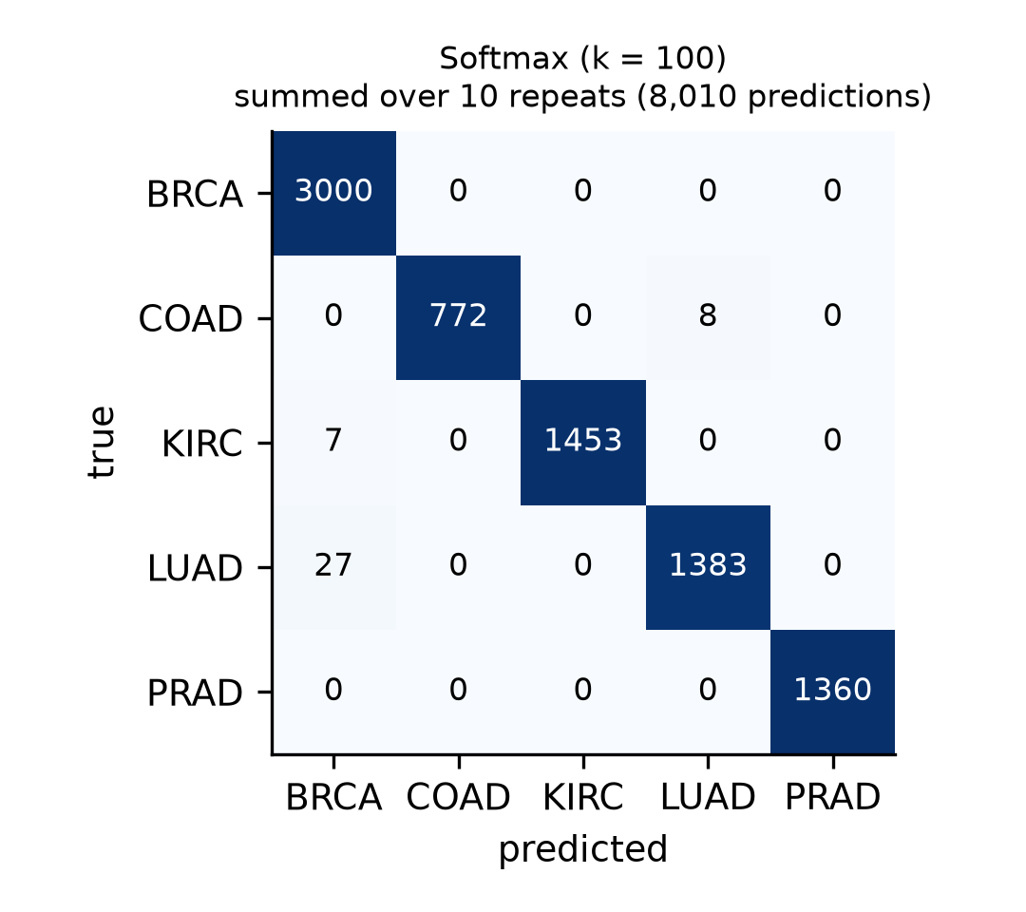
Figure S4. Confusion matrix of softmax regression. Counts summed over 10 repeats of 5-fold CV; colour: row-normalised recall.

S8 Top-ranked genes per class and selection stability
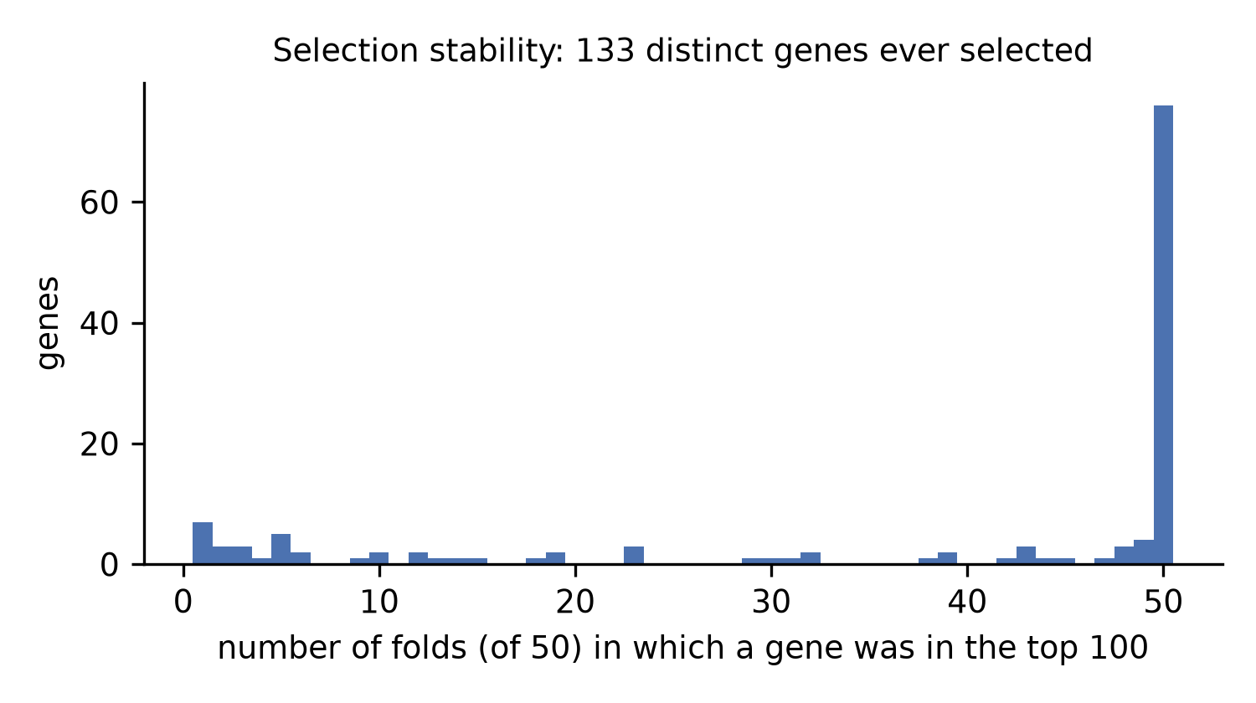
Figure S5. Stability of the top-100 ANOVA selection across folds. Number of training folds (of 50) in which each gene was among the top 100.
The genes below are the dummy names of the UCI release (gene_<index>, ordered as in the original Synapse submission syn4301332). Symbols are not distributed with the release, so the genes are not interpreted biologically.
Table S9. Five largest positive softmax coefficients per class
Class | Rank | Gene index | Coefficient | Selected in folds | Mean in class | Mean other
BRCA | 1 | gene_18746 | 0.450 | 50/50 | 12.97 | 8.17
BRCA | 2 | gene_5576 | 0.241 | 43/50 | 4.74 | 4.20
BRCA | 3 | gene_5577 | 0.198 | 48/50 | 4.04 | 3.58
BRCA | 4 | gene_17906 | 0.196 | 44/50 | 9.84 | 6.22
BRCA | 5 | gene_8348 | 0.190 | 50/50 | 9.76 | 6.78
COAD | 1 | gene_12013 | 0.322 | 50/50 | 11.35 | 1.78
COAD | 2 | gene_3523 | 0.263 | 50/50 | 11.82 | 2.13
COAD | 3 | gene_7238 | 0.250 | 50/50 | 11.79 | 2.46
COAD | 4 | gene_2037 | 0.221 | 50/50 | 6.86 | 0.29
COAD | 5 | gene_11464 | 0.199 | 39/50 | 11.23 | 3.84
KIRC | 1 | gene_3439 | 0.221 | 50/50 | 11.83 | 0.84
KIRC | 2 | gene_1858 | 0.218 | 50/50 | 10.01 | 0.71
KIRC | 3 | gene_6733 | 0.207 | 50/50 | 12.98 | 2.13
KIRC | 4 | gene_2129 | 0.161 | 49/50 | 10.51 | 3.23
KIRC | 5 | gene_13818 | 0.156 | 50/50 | 8.53 | 0.39
LUAD | 1 | gene_7964 | 0.416 | 50/50 | 8.64 | 5.10
LUAD | 2 | gene_15898 | 0.385 | 50/50 | 15.70 | 1.04
LUAD | 3 | gene_15895 | 0.375 | 50/50 | 10.45 | 0.23
LUAD | 4 | gene_11903 | 0.348 | 50/50 | 10.87 | 0.71
LUAD | 5 | gene_15894 | 0.327 | 50/50 | 10.49 | 1.06
PRAD | 1 | gene_13976 | 0.224 | 50/50 | 10.65 | 0.44
PRAD | 2 | gene_9175 | 0.197 | 50/50 | 16.75 | 1.12
PRAD | 3 | gene_9176 | 0.197 | 50/50 | 18.24 | 1.02
PRAD | 4 | gene_16358 | 0.194 | 50/50 | 14.94 | 7.42
PRAD | 5 | gene_18135 | 0.190 | 50/50 | 11.08 | 0.33
Softmax refitted on all samples (descriptive). Expression means on the released (log-scale) values.
Stability summary: 133 genes ever selected; 76 in all 50 folds; 85 in ≥ 90%; mean pairwise Jaccard 0.873 (min 0.786); 76 of the 100 genes selected on the full data were selected in every fold. Nogueira Φ = 0.931 (bootstrap 95% CI 0.929–0.937); average Kuncheva index 0.931.

S9 Computational footprint and fold-level distributions
Table S10. Computational footprint with 100 input genes (one CPU thread)
Model | Fit per fold incl. selection, ms | Prediction, ms/sample | Parameters or tree nodes | Model size, kB
Softmax (multinomial LR) | 360 | 0.178 | 505 | 2.7
Ridge classifier | 358 | 0.179 | 505 | 2.7
Linear SVM | 374 | 0.175 | 505 | 4.5
Gaussian naive Bayes | 360 | 0.176 | 1,005 | 4.5
Random forest | 1037 | 0.296 | 11,910 | 1371.3
LightGBM | 1690 | 0.221 | 21,444 | 1369.9
MLP (64 hidden units) | 518 | 0.180 | 6,789 | 114.7
Fit: mean over 50 folds (640 training samples), including ANOVA on 20,531 genes. Size: pickled classifier only. Shared virtual machine; indicative only.
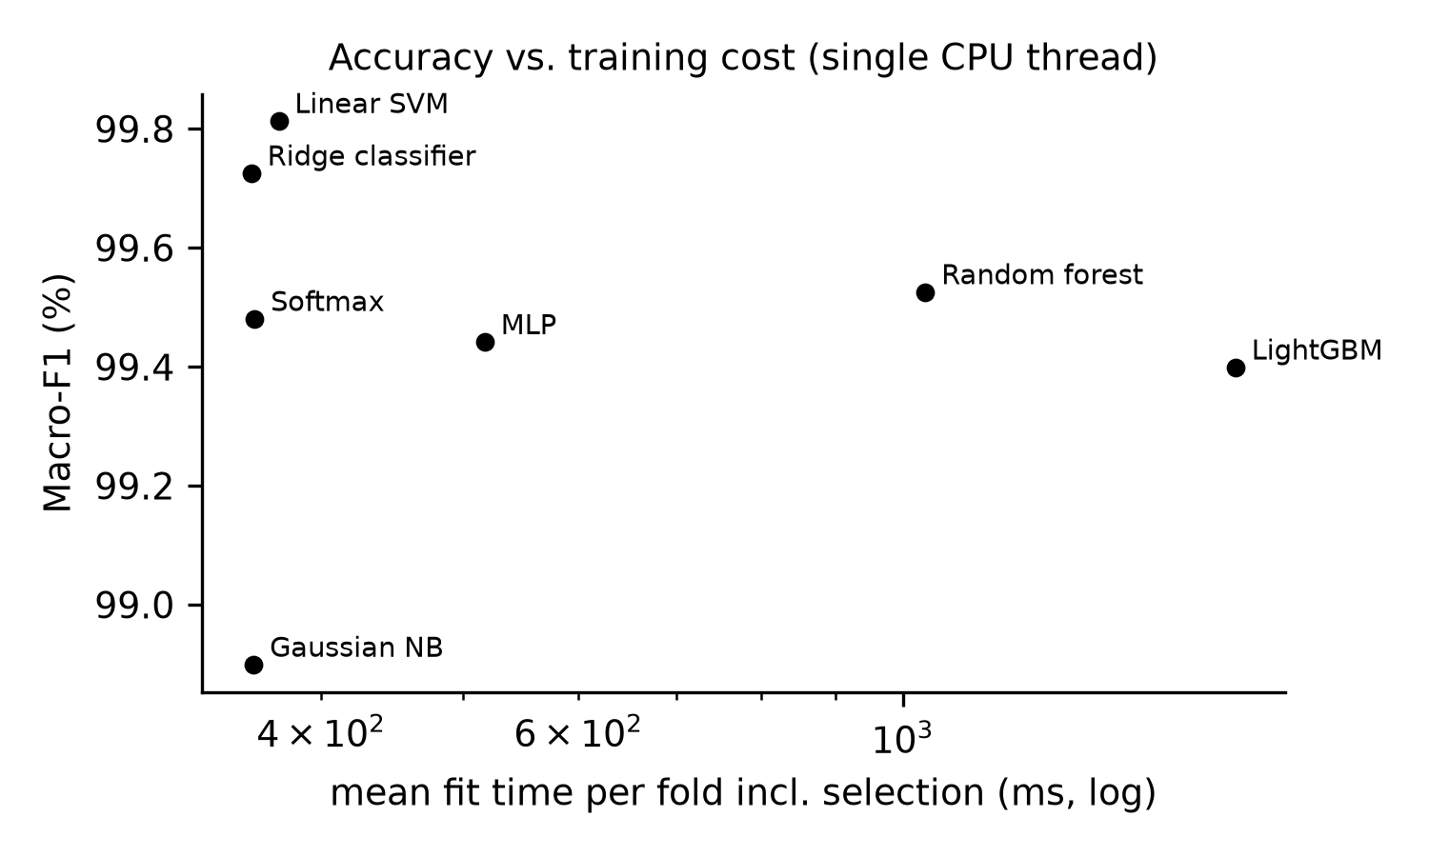
Figure S6. Macro-F1 against mean fit time per fold. Fit time includes zero-variance filtering, ANOVA on all genes and scaling (one CPU thread).
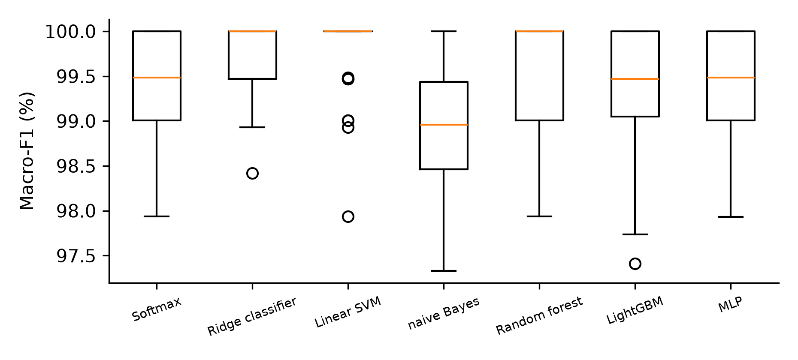
Figure S7. Distribution of fold-level macro-F1. 50 test folds per model (161 or 160 samples each).

S10 Reproducing the results
Supplementary File S1 (code zip) contains run_all.py, src/experiments.py, src/audit.py, src/novelty.py, src/robust.py, src/figures.py, requirements.txt and a README. Place data.csv and labels.csv from the UCI archive in data/ and run 'python run_all.py'; all tables in the paper and this supplement are generated from the files written to results/, and all figures to figures/ (300 dpi). 'python run_all.py --quick' runs a 2-repeat smoke test, '--revision-only' reruns only the revision analyses from saved fold results, '--revision-only --extension-only' reruns only the reliability and data-efficiency analyses, and '--jobs' sets the number of parallel workers.

S11 Calibration and conformal prediction, all models
Table S11. Calibration of pooled out-of-fold predictions (models fitted on whole training folds)
Model | Acc., % | Mean conf., % | ECE, % [95% CI] | Calibrated reference ECE, % [95% range] | Equal-mass ECE, % | Class-wise ECE, % | Log-loss | Brier
Softmax | 99.48 | 99.57 | 0.47 [0.25, 0.83] | 0.14 [0.08, 0.22] | 0.22 | 0.25 | 0.0098 | 0.0058
Naive Bayes | 98.98 | 99.99 | 1.02 [0.42, 1.69] | 0.02 [0.01, 0.03] | 1.01 | 0.41 | 0.3377 | 0.0203
Random forest | 99.55 | 96.94 | 2.72 [2.32, 3.21] | 0.40 [0.22, 0.61] | 2.61 | 1.25 | 0.0372 | 0.0110
LightGBM | 99.44 | 99.74 | 0.45 [0.17, 0.88] | 0.11 [0.07, 0.17] | 0.30 | 0.27 | 0.0237 | 0.0098
MLP | 99.46 | 99.47 | 0.35 [0.24, 0.69] | 0.17 [0.09, 0.26] | 0.19 | 0.30 | 0.0135 | 0.0068
10×801 pooled predictions; ECE with 15 equal-width bins; CI: bootstrap over the 801 tumours (2,000 resamples). Reference: labels redrawn from the predicted probabilities (consistency resampling), which treats predictions as independent, so its range is somewhat too narrow. Class-wise ECE: mean over folds.
Softmax reliability bins (confidence range: predictions, errors): 0.33–0.40: 1, 1; 0.40–0.47: 3, 0; 0.47–0.53: 7, 2; 0.53–0.60: 16, 15; 0.60–0.67: 2, 2; 0.67–0.73: 10, 9; 0.73–0.80: 9, 5; 0.80–0.87: 13, 6; 0.87–0.93: 19, 2; 0.93–1.00: 7930, 0.
Table S12. Marginal conformal prediction sets: coverage spread, tie-breaking and cross-conformal variant
Model | Variant | Nominal, % | Coverage, % | Fold range, % | Beta 5th pct, % | Size | Singleton, % | Empty, % | Error on accepted, % | LUAD cov., %
Softmax | split | 90 | 89.6 | 78.1–95.6 | 86.0 | 0.90 | 89.6 | 10.4 | 0.00 | 83.0
 |  | 95 | 94.7 | 85.0–99.4 | 92.0 | 0.95 | 94.7 | 5.3 | 0.00 | 89.9
 |  | 99 | 99.4 | 96.9–100.0 | 98.2 | 1.00 | 99.4 | 0.5 | 0.18 | 97.9
 | split, randomised | 90 | 89.5 | 78.1–95.6 | 86.0 | 0.90 | 89.5 | 10.5 | 0.00 | 82.7
 |  | 95 | 94.7 | 85.0–99.4 | 92.0 | 0.95 | 94.7 | 5.3 | 0.00 | 89.9
 |  | 99 | 98.9 | 94.4–100.0 | 98.2 | 0.99 | 99.0 | 0.9 | 0.18 | 96.8
 | cross-conformal | 90 | 90.7 | 82.0–95.0 | 86.0 | 0.91 | 90.7 | 9.3 | 0.00 | 85.3
 |  | 95 | 95.5 | 88.8–99.4 | 92.0 | 0.96 | 95.5 | 4.5 | 0.00 | 91.0
 |  | 99 | 99.1 | 96.9–100.0 | 98.2 | 0.99 | 99.2 | 0.8 | 0.03 | 96.9
Naive Bayes | split | 90 | 98.6 | 96.2–100.0 | 86.0 | 1.00 | 99.8 | 0.2 | 1.28 | 99.7
 |  | 95 | 98.6 | 96.2–100.0 | 92.0 | 1.00 | 99.8 | 0.2 | 1.28 | 99.7
 |  | 99 | 99.9 | 97.5–100.0 | 98.2 | 4.52 | 12.0 | 0.0 | 0.94 | 100.0
 | split, randomised | 90 | 90.2 | 84.4–95.6 | 86.0 | 0.91 | 91.4 | 8.6 | 1.26 | 91.1
 |  | 95 | 94.5 | 87.5–97.5 | 92.0 | 0.96 | 95.7 | 4.3 | 1.30 | 95.9
 |  | 99 | 99.0 | 96.2–100.0 | 98.2 | 2.55 | 27.8 | 0.2 | 1.35 | 99.6
Random forest | split | 90 | 90.1 | 82.6–95.6 | 86.0 | 0.90 | 90.1 | 9.9 | 0.00 | 82.9
 |  | 95 | 94.9 | 89.4–98.8 | 92.0 | 0.95 | 94.9 | 5.1 | 0.00 | 90.1
 |  | 99 | 99.3 | 96.2–100.0 | 98.2 | 1.00 | 99.1 | 0.5 | 0.15 | 98.0
 | split, randomised | 90 | 89.8 | 82.6–95.6 | 86.0 | 0.90 | 89.8 | 10.2 | 0.00 | 82.5
 |  | 95 | 94.8 | 89.4–98.1 | 92.0 | 0.95 | 94.8 | 5.2 | 0.00 | 90.1
 |  | 99 | 99.0 | 95.6–100.0 | 98.2 | 0.99 | 98.9 | 0.9 | 0.14 | 97.2
LightGBM | split | 90 | 89.5 | 78.8–95.0 | 86.0 | 0.89 | 89.5 | 10.5 | 0.00 | 83.2
 |  | 95 | 95.0 | 87.5–99.4 | 92.0 | 0.95 | 95.0 | 5.0 | 0.00 | 91.3
 |  | 99 | 99.4 | 96.9–100.0 | 98.2 | 1.01 | 98.9 | 0.4 | 0.25 | 98.5
 | split, randomised | 90 | 89.4 | 78.8–95.0 | 86.0 | 0.89 | 89.4 | 10.6 | 0.00 | 83.2
 |  | 95 | 95.0 | 87.5–99.4 | 92.0 | 0.95 | 95.0 | 5.0 | 0.00 | 91.3
 |  | 99 | 99.0 | 96.3–100.0 | 98.2 | 1.00 | 99.0 | 0.7 | 0.28 | 97.9
MLP | split | 90 | 90.0 | 80.1–96.9 | 86.0 | 0.90 | 90.0 | 10.0 | 0.00 | 84.4
 |  | 95 | 95.0 | 85.0–98.8 | 92.0 | 0.95 | 95.0 | 5.0 | 0.00 | 89.8
 |  | 99 | 99.5 | 96.9–100.0 | 98.2 | 1.00 | 99.2 | 0.4 | 0.16 | 98.5
 | split, randomised | 90 | 89.8 | 80.1–96.9 | 86.0 | 0.90 | 89.8 | 10.2 | 0.00 | 84.2
 |  | 95 | 94.9 | 85.0–98.8 | 92.0 | 0.95 | 94.9 | 5.1 | 0.00 | 89.5
 |  | 99 | 98.9 | 91.9–100.0 | 98.2 | 0.99 | 98.9 | 0.9 | 0.23 | 96.9
Split: 25% of each outer training fold for calibration (n ≈ 161). Randomised: smoothed p-values breaking ties. Cross-conformal: 5 inner folds of the whole training fold (softmax only). Beta 5th pct: 5th percentile of coverage conditional on a calibration set of this size.
Table S13. Abstention rules for softmax at the 99% level: accepted predictions and errors
Rule | Accepted | Errors | Error rate, % [bootstrap 95% CI] | Wilson 95% CI
No abstention (75% model) | 8,010 | 41 | 0.51 [0.42, 0.60] | [0.38, 0.69]
Split conformal, 99% | 7,960 | 14 | 0.18 [0.10, 0.25] | [0.10, 0.30]
Max-probability, same threshold | 7,973 | 21 | 0.26 [0.16, 0.35] | [0.17, 0.40]
Max-probability, abstention matched on calibration data | 7,957 | 23 | 0.29 [0.16, 0.43] | [0.19, 0.43]
Cross-conformal, 99% | 7,942 | 2 | 0.03 [0.00, 0.06] | [0.01, 0.09]
No abstention (cross-conformal ensemble) | 8,010 | 50 | 0.62 [0.59, 0.66] | [0.47, 0.82]
Pooled over 10×801 test predictions. Bootstrap over the 10 repeats. Paired difference split conformal − no abstention: -0.34 points [-0.47, -0.21]. Wilson intervals treat repeated predictions as independent and are too narrow.
Table S14. Split-conformal prediction sets (no tie-breaking), marginal and Mondrian, all probabilistic models
Model | Sets | Nominal, % | Coverage, % | Size | Singleton, % | Empty, % | Acc. singletons, % | Coverage BRCA/COAD/KIRC/LUAD/PRAD, %
Softmax | marginal | 90 | 89.60 | 0.90 | 89.6 | 10.4 | 100.00 | 88 / 90 / 95 / 83 / 93
 | marginal | 95 | 94.71 | 0.95 | 94.7 | 5.3 | 100.00 | 95 / 96 / 97 / 90 / 96
 | marginal | 99 | 99.36 | 1.00 | 99.4 | 0.5 | 99.82 | 100 / 99 / 99 / 98 / 100
 | mondrian | 90 | 91.15 | 0.91 | 91.1 | 8.9 | 100.00 | 90 / 95 / 89 / 92 / 93
 | mondrian | 95 | 96.28 | 1.87 | 13.4 | 0.0 | 74.45 | 95 / 100 / 97 / 96 / 97
 | mondrian | 99 | 100.00 | 5.00 | 0.0 | 0.0 | — | 100 / 100 / 100 / 100 / 100
Naive Bayes | marginal | 90 | 98.56 | 1.00 | 99.8 | 0.2 | 98.72 | 98 / 97 / 99 / 100 / 100
 | marginal | 95 | 98.56 | 1.00 | 99.8 | 0.2 | 98.72 | 98 / 97 / 99 / 100 / 100
 | marginal | 99 | 99.89 | 4.52 | 12.0 | 0.0 | 99.06 | 100 / 100 / 100 / 100 / 100
 | mondrian | 90 | 98.74 | 1.38 | 61.9 | 0.1 | 98.82 | 98 / 98 / 99 / 100 / 100
 | mondrian | 95 | 99.10 | 2.33 | 5.0 | 0.0 | 98.80 | 98 / 100 / 99 / 100 / 100
 | mondrian | 99 | 100.00 | 5.00 | 0.0 | 0.0 | — | 100 / 100 / 100 / 100 / 100
Random forest | marginal | 90 | 90.10 | 0.90 | 90.1 | 9.9 | 100.00 | 93 / 86 / 90 / 83 / 93
 | marginal | 95 | 94.87 | 0.95 | 94.9 | 5.1 | 100.00 | 97 / 95 / 93 / 90 / 97
 | marginal | 99 | 99.34 | 1.00 | 99.1 | 0.5 | 99.85 | 100 / 99 / 99 / 98 / 100
 | mondrian | 90 | 91.80 | 0.92 | 91.8 | 8.2 | 100.00 | 91 / 95 / 90 / 93 / 93
 | mondrian | 95 | 96.57 | 1.87 | 13.1 | 0.0 | 75.33 | 95 / 100 / 98 / 96 / 97
 | mondrian | 99 | 100.00 | 5.00 | 0.0 | 0.0 | — | 100 / 100 / 100 / 100 / 100
LightGBM | marginal | 90 | 89.45 | 0.89 | 89.5 | 10.5 | 100.00 | 92 / 84 / 91 / 83 / 92
 | marginal | 95 | 94.98 | 0.95 | 95.0 | 5.0 | 100.00 | 96 / 93 / 96 / 91 / 97
 | marginal | 99 | 99.35 | 1.01 | 98.9 | 0.4 | 99.75 | 100 / 99 / 100 / 99 / 99
 | mondrian | 90 | 91.41 | 0.91 | 91.4 | 8.6 | 99.99 | 90 / 95 / 90 / 92 / 92
 | mondrian | 95 | 96.14 | 1.87 | 13.4 | 0.0 | 73.63 | 95 / 100 / 96 / 96 / 96
 | mondrian | 99 | 100.00 | 5.00 | 0.0 | 0.0 | — | 100 / 100 / 100 / 100 / 100
MLP | marginal | 90 | 90.01 | 0.90 | 90.0 | 10.0 | 100.00 | 88 / 93 / 94 / 84 / 93
 | marginal | 95 | 95.01 | 0.95 | 95.0 | 5.0 | 100.00 | 96 / 97 / 96 / 90 / 97
 | marginal | 99 | 99.48 | 1.00 | 99.2 | 0.4 | 99.84 | 100 / 99 / 100 / 99 / 100
 | mondrian | 90 | 91.31 | 0.91 | 91.3 | 8.7 | 100.00 | 90 / 95 / 90 / 92 / 93
 | mondrian | 95 | 96.39 | 1.87 | 13.3 | 0.0 | 74.72 | 95 / 100 / 97 / 96 / 97
 | mondrian | 99 | 100.00 | 5.00 | 0.0 | 0.0 | — | 100 / 100 / 100 / 100 / 100
Score 1 − p(label). Naive Bayes over-covers at 90% and 95% because saturated probabilities produce tied scores (see randomised variant above). Mondrian sets need ≥ 19 (95%) or ≥ 99 (99%) calibration samples per class; available: about 60 BRCA, 29 KIRC, 28 LUAD, 27 PRAD, 16 COAD.

S12 Learning curves and leakage by sample size
Table S15. Learning curves (k = 100, in-fold), evaluated on full held-out folds
Model | Per class | Training n | Accuracy, % (± 95% CI) | Macro-F1, % (± 95% CI) | Fold SD of F1
Gaussian NB | 3 | 15 | 70.22 ± 3.66 | 71.36 ± 3.34 | 10.74
Gaussian NB | 5 | 25 | 66.18 ± 2.93 | 66.63 ± 3.23 | 11.07
Gaussian NB | 10 | 50 | 74.02 ± 2.14 | 74.04 ± 2.36 | 6.95
Gaussian NB | 20 | 100 | 88.99 ± 1.27 | 89.43 ± 1.05 | 3.98
Gaussian NB | 40 | 200 | 96.40 ± 1.01 | 96.65 ± 0.96 | 2.00
Gaussian NB | 60 | 300 | 97.72 ± 0.27 | 97.91 ± 0.26 | 1.36
Linear SVM | 3 | 15 | 98.16 ± 0.80 | 98.32 ± 0.69 | 2.20
Linear SVM | 5 | 25 | 98.94 ± 0.37 | 98.98 ± 0.34 | 1.38
Linear SVM | 10 | 50 | 99.45 ± 0.22 | 99.45 ± 0.22 | 0.58
Linear SVM | 20 | 100 | 99.58 ± 0.15 | 99.60 ± 0.15 | 0.57
Linear SVM | 40 | 200 | 99.79 ± 0.07 | 99.82 ± 0.06 | 0.31
Linear SVM | 60 | 300 | 99.80 ± 0.05 | 99.83 ± 0.04 | 0.31
Softmax | 3 | 15 | 97.94 ± 0.74 | 98.12 ± 0.67 | 2.54
Softmax | 5 | 25 | 98.91 ± 0.36 | 99.04 ± 0.29 | 1.17
Softmax | 10 | 50 | 99.36 ± 0.20 | 99.40 ± 0.20 | 0.62
Softmax | 20 | 100 | 99.48 ± 0.12 | 99.52 ± 0.12 | 0.54
Softmax | 40 | 200 | 99.63 ± 0.06 | 99.66 ± 0.06 | 0.40
Softmax | 60 | 300 | 99.58 ± 0.09 | 99.58 ± 0.07 | 0.49
Balanced random draws from each of the 50 outer training folds; 95% CI from the 10 repeat means (t interval).
Table S16. Leaky vs in-fold selection by dataset size (softmax accuracy, %)
Labels | k | n | Leaky | In-fold | Δ, points (± 95% CI)
permuted | 10 | 30 | 73.3 | 19.6 | +53.8 ± 3.6
permuted | 10 | 60 | 52.6 | 19.1 | +33.5 ± 3.4
permuted | 10 | 120 | 43.1 | 19.3 | +23.8 ± 2.4
permuted | 10 | 240 | 35.3 | 19.7 | +15.6 ± 1.4
permuted | 10 | 390 | 30.7 | 20.5 | +10.3 ± 1.4
permuted | 100 | 30 | 85.8 | 20.7 | +65.1 ± 4.8
permuted | 100 | 60 | 68.9 | 19.7 | +49.2 ± 4.7
permuted | 100 | 120 | 55.2 | 19.6 | +35.6 ± 3.5
permuted | 100 | 240 | 41.0 | 20.0 | +21.0 ± 1.8
permuted | 100 | 390 | 34.7 | 20.6 | +14.1 ± 1.7
real | 10 | 30 | 88.6 | 85.4 | +3.1 ± 2.5
real | 10 | 60 | 94.3 | 90.6 | +3.7 ± 2.0
real | 10 | 120 | 94.2 | 93.6 | +0.7 ± 1.3
real | 10 | 240 | 91.1 | 91.6 | -0.4 ± 1.5
real | 10 | 390 | 89.7 | 91.3 | -1.6 ± 0.8
real | 100 | 30 | 100.0 | 99.0 | +1.0 ± 0.7
real | 100 | 60 | 100.0 | 99.2 | +0.8 ± 0.5
real | 100 | 120 | 99.8 | 99.6 | +0.2 ± 0.1
real | 100 | 240 | 99.7 | 99.5 | +0.2 ± 0.1
real | 100 | 390 | 99.7 | 99.5 | +0.2 ± 0.1
permuted (all 801, unbalanced) | 10 | 801 | 38.1 | 33.0 | +5.1 ± 0.3
permuted (all 801, unbalanced) | 100 | 801 | 35.9 | 25.3 | +10.6 ± 0.5
Balanced subsamples: 30 per n, 5-fold CV each; CI over subsamples. At n = 390 every subsample contains all 78 COAD tumours, so subsamples overlap and the CIs are optimistic. Last rows: all 801 samples, 100 label permutations, a different design (chance 24.3% vs 20%).

