**BIOMETRIC AUTHENTICATION USING HUMAN EAR**

*A report submitted in partial fulfillment of the requirements for*

*the award of the degree of*

**B.Tech.** in

Computer Science Engineering



Submitted by: Under Guidance of:

**Natasha (160102904) Dr. Aditya Saxena**

**Vansh Mohale(1501021242) Assistant Professor in**

**Vinayak Bist(1501051108) CSE Department**

**Aakriti Nagar(1501021251)**

**COMPUTER SCIENCE AND ENGINEERING**

**DEPARTMENT**

**DIT UNIVERSITY, DEHRADUN**

**CERTIFICATE**

This is to certify that the project report entitled **“BIOMETRIC AUTHENTICATION USING HUMAN EAR”** being submitted by **“Natasha, Vansh Mohale, Vinayak Bist, Aakriti Nagar”** in partial fulfillment for the award of the Degree of Bachelor of Technology in Computer Science and Engineering to the Dehradun Institute of Technology (An Autonomous Institution of Uttarakhand Technical University) is a record of bona fide work carried out by them under my guidance and supervision.

The results embodied in this project report have not been submitted to any other University or Institute for the award of any Degree or Diploma.

Dr. Aditya Saxena Mr. Anil K. Gupta

**Assistant Professor Head of Department**

**CSE Department CSE Department**

**CANDIDATE/S DECLARATION**

I hereby certify that the work, which is being presented in the report/ project report, entitled **Biometric Authentication Using Human Ear**, in partial fulfillment of the requirement for the award of the Degree of **Bachelor of Technology** and submitted to the institution is an authentic record of my/our own work carried out during the period *January-2018* to *April-2018* under the supervision of Dr. Aditya Saxena.

Date: Signature of the Candidate

This is to certify that the above statement made by the candidate is correct to the best of my /our knowledge.

Date: Signature(s) of the Supervisor(s)

**TABLE OF CONTENTS**

Title Page No.

ABSTRACT ………………………………………………………..

ACKNOWLEDGEMENT……………………………………………

LIST OF TABLES.......................................................................................

HU LIST OF FIGURES...................................................................................................... .ix

ABBREVIATIONS……………………………………………………………………..x

NOTATIONS…………………………………………………………………...…….xi

Chapter 1 Introduction

1.1 Purpose .............................................................................................................

1.2 Objective...........................................................................................................

1.3 Motivation……………………….…………………………………………….

1.4 Definition and Overview……………………………………………………….

**CHAPTER 2 OVERALL DESCRIPTION**

2.1 Project Perspective ...................................................................................…….

2.2 Project Functions…….………..........................................................................

2.3 E-R and DFD Diagrams ……………………………………………………..

2.4 Constraints and Assumptions….......................................................................

**CHAPTER3 SYSTEM REQUIREMENTS**

3.1 External Interface Requirement.........................................................................

3.1.1 Hardware interface…………………………………………………......

3.1.2 Software Interface…………. ................................................................

3.2 Functional Requirement ...................................................................................

3.3 Non-functional Requirement..............................................................................

3.4 Hardware and Performance Requirement…………………………………….

**CHAPTER 4 CONCLUSION AND FUTURE WORK**

4.1 Conclusions ....................................................................................................

4.2 Scope for Future Work ...................................................................................

**REFERENCES** ……………………………………………………..………………

APPENDIX…………………………………………………………………………...

**ABSTRACT**

Biometrics is the science of identifying or verifying the identity of a person based on physiological or behavioral characteristics. Biometrics identification methods have proved to be very efficient, more natural and easy for users than traditional methods of human identification. In today’s world security plays a very important role in organizations and particularly computer systems .To make systems more reliable and secure, several biometric techniques that exploit physiological and behavioral traits and characteristics of people have been developed for verification and identification of the individuals. Biometric authentication systems are essentially pattern recognition systems, the physiological characteristics being fingerprint, face, hand geometry, DNA and iris recognition. The main aim of the project is to develop a biometric authentication system using the ear. The process will involve several steps from acquisition of the image to the point where a positive identification can be made using the system. The image was acquired using a digital camera. The photo is then processed, stored and used for the identification process. For every individual, there are some distinct features that can be used for identification. The portion or segment that contains these unique features is known as the Region of Interest. After the raw data is obtained, the Region of Interest (ROI) which is the area containing the ear image is chosen. Feature extraction filters the uniqueness data out of the raw data and combines them into the biometric feature The method applied for this is Edge detection. For “easy” images from the database error-free recognition was obtained. When all the external conditions such as lighting are effectively controlled and remain constant, all the system produces a perfect performance with accurate results all the time.

**ACKNOWLEDGEMENT**

First and foremost, I express my gratitude to the Almighty and the management of DIT

University for providing all the facilities needed for this project.

I express my gratitude to the Head of Department, Prof. Ajay K. Gupta, for his immense

support and encouragement.

I express my gratitude to our project coordinator, Mr Aditya Kumar Saxena, Department of

Computer Science and Engineering for his valuable suggestions and guidance.

Last but not the least, I wish to thank all the staff of Computer Science and Engineering

Department for their help and support.

**LIST OF TABLES**

Table 2.1: Amount of Blurring

**LIST OF FIGURES**

Figure 1.1: Biometrics Methods

Figure 1.2: Anatomy of the outer Ear

Figure1.3: Error possibilities in ear recognition.

Figure 2.1: Finding Objects

Figure 2.2: Original Image

Figure 2.3: Resulting Image

Figure 2.4: Scale Space

Figure 2.5: Difference of Gaussian Blurred Images

Figure 2.6: Finding Maixma and Minima

Figure 2.7: Sub Key Points

Figure 2.8: Keypoints

Figure 2.9: Orientation

Figure 2.10: Vector Recognition

Figure 2.11: Gradient and Magnitude

Figure 2.12: Genearting a Feature

Figure 5.1: General biometrics system

Figure 5.2: Enrollment Process

Figure 5.3: Discrete approximation to Gaussian Function

Figure 5.4: Gradient in the x-direction

Figure 5.4: Gradient in the y-direction

Figure 5.5: Masking Example

Figure 5.6: Ear sample showing detected edges

Figure 5.7: Sample template showing extracted features.

Figure 6.1: “Easy” Images

Figure 6.2: Perfect match Figure

6.3: False rejection due to illumination changes

Figure 6.4: Match percentage when external conditions are constant

Figure 6.5: Match percentage when external conditions are varied Figure

6.6: “Complex” Images Figure A1.1: Measurements used in Iannarelli’s system.

**ABBREVIATIONS**

ROI: Region Of Interest

CCTV: Closed Circuit Television

DVR: Digital Video Recorders

SIFT: Scale Invariant Feature Transform

LoG: Laplasian of Gaussian

DoG: Difference of Gaussian

E-R: Entity Relationship

DFD: Data Flow Diagram

**NOTATIONS**

A = B : Store value of B in A.

ABC() : Direct the control of program to function named ABC().

ABC(a,b) : Direct the control of program to function named ABC with the parameters a and b.

A – B : Subtract B from A.

A/ B : Divide A by B.

%A : Hide the line A from users which is used as a reference for developer.

A^B : Multiply A with itself, B times.

A*B : Multiply A with B.

A>B : A is greater than B.

**CHAPTER 1**

**INTRODUCTION**

* 1. **Purpose**

In proposing the ear as the basis for a new class of biometrics, there is the need to show that it is viable (i.e., Universal, unique, Permanent, Collectable). In the same way that no one can prove that fingerprints are unique, there is no absolute way to show that each human has a unique pair of ears. Instead, an assertion that this is probable can be made based on supporting evidence from two experiments conducted by Alfred Iannarelli (Appendix 2). It is obvious that the structure of the ear does not change radically over time. Medical literature reports that ear growth after the first four months of birth is proportional. It turns out that even though ear growth is proportional, gravity can cause the ear to undergo stretching in the vertical direction. The effect of this stretching is most pronounced in the lobe of the ear, and measurements show that the change is non-linear. The rate of stretching is approximately five times greater than normal during the period from four months to the age of eight, after which it is constant until around 70 when it again increases.

Since every individual has ears, it is rational to conclude that the ear is universal. The ear is also collectable using various means.

**1.2 Objective**

The main aim of the project is to develop a biometric authentication system using the ear. The process will involve several steps from acquisition of the image to the point where a positive identification can be made using the system. The image was acquired using a digital camera. The photo is then processed, stored and used for the identification process.

For every individual, there are some distinct features that can be used for identification. The portion or segment that contains these unique features is known as the Region of Interest. After the raw data is obtained, the Region of Interest (ROI) which is the area containing the ear image is chosen. Feature extraction filters the uniqueness data out of the raw data and combines them into the biometric feature

The method applied for this is Edge detection. For “easy” images from the database error-free recognition was obtained. When all the external conditions such as lighting are effectively controlled and remain constant, all the system produces a perfect performance with accurate results all the time.

* 1. **Motivation**

There were many drawbacks in human recognition using fingerprint and I scanner and other conventional methods. To overcome these drawbacks v got motivated to bring biometric authentication using human ear into existence. Those drawbacks are:

1. Direct contact or close distance of human body was required with the scanner.

2. Many breeching techniques have been developed and loopholes are found.

**1.4 Definition and Overview**

Identification is the basis of every access control system. Basically there are three different methods for verifying identity:

* Possessions, like cards, badges, keys
* Knowledge, like user id, password, Personal Identification Number (PIN)  Biometrics like fingerprint, face, ear.

Unfortunately, the first two carry within them an unavoidable weakness: they are only slightly linked to their owners. In contrast to this, biometric identification methods directly check the identifiable person.

Biometrics is the science of identifying or verifying the identity of a person based on physiological or behavioral characteristics. Physiological biometrics use algorithms and other methods to define identity in terms of data gathered from direct measurement of the human body. Finger print and finger scan, hand geometry, palm prints, Iris and retina scanning and facial geometry are all examples of physiological biometrics. Behavioral biometrics is however defined by analyzing a specific action of a person. Examples of these include voice identification, signature dynamics, keystroke dynamics and motion recognition

Generally, biometric identification techniques can be divided in two broad categories.

These are:

* **Active biometrics:** They are inherently invasive. They require the subject to participate actively in both enrolling into the system and during subsequent identification. The willing participation of the subject in the controlled environment of these systems is intrinsic to the success of the identification. Examples include all Fingerprint technologies, Hand geometry technologies, Retina scanning technologies and Signature recognition technologies.
* **Passive biometrics:** do not require a user’s active participation and can be successful without a person even knowing that they have been analyzed.

Examples include Voice recognition technologies (limited), Iris recognition technologies (limited) and Facial recognition (truly passive).

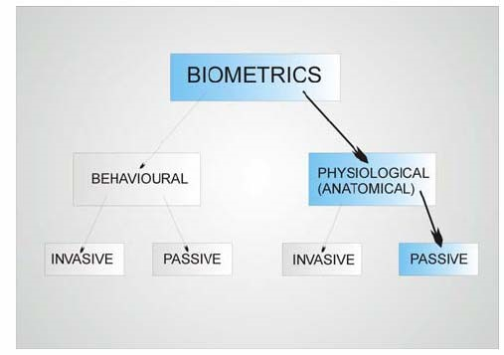

Figure 1.1: Biometrics methods

An ideal biometric should have four main qualities. It should be:

* **Universal:** Each person should possess the characteristics
* **Unique:** No two persons should share the characteristics
* **Permanent:** The characteristics should not change
* **Collectable:** They should be easily presentable to a sensor and quantifiable. It

should be possible to capture and store it easily.

**CHAPTER 2**

**OVERALL DESCRIPTION**

**2.1 Project Perspective**

Ears are a new biometric with major advantage in that they appear to maintain their structure with increasing age. Most current approaches are holistic and describe the ear by its general properties. We propose a new model-based approach, capitalizing on explicit structure and with the advantages of being robust in noise and occlusion. Our model is a constellation of generalized ear parts, which is learned off-line using an unsupervised learning algorithm over an enrolled training set of 63 ear images. The Scale Invariant Feature Transform (SIFT), is used to detect the features within the ear images. In recognition, given a profile image of the human head, the ear is enrolled and recognised from the parts selected via the model. We achieve an encouraging recognition rate, on an image database selected from the XM2VTS database. A head-to-head comparison with PCA is also presented to show the advantage derived by the use of the model in successful occlusion handling**.**

**2.2 Project Description**

**2.2.1 Introduction**

Matching features across different images in a common problem in computer vision. When all images are similar in nature (same scale, orientation, etc) [simple corner detectors](http://aishack.in/tutorials/harris-corner-detector/) can work. But when you have images of different scales and rotations, you need to use the Scale Invariant Feature Transform.

Here's an example. We're looking for these:

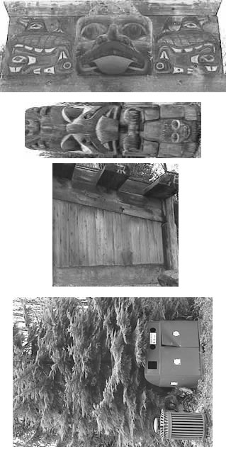

Figure 2.1: Finding Objects

And we want to find these objects in this scene:

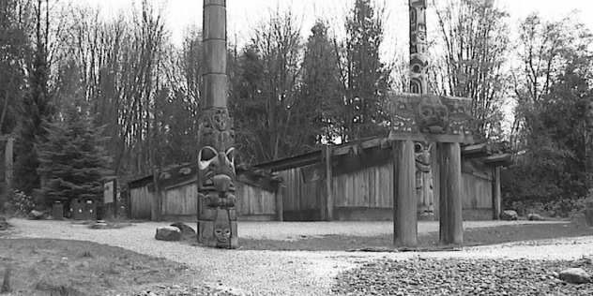

Figure 2.2: Original Image

Here's the result:

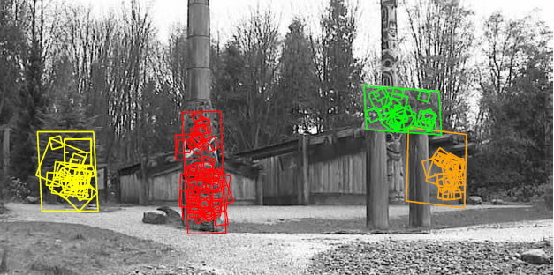

Figure 2.3: Resulting Image

## The algorithm

SIFT is quite an involved algorithm. It has a lot going on and can become confusing, So I've split up the entire algorithm into multiple parts. Here's an outline of what happens in SIFT.

1. [Constructing a scale space](http://aishack.in/tutorials/sift-scale-invariant-feature-transform-scale-space/)**:** This is the initial preparation. You create internal representations of the original image to ensure scale invariance. This is done by generating a "scale space".
2. [LoG Approximation](http://aishack.in/tutorials/sift-scale-invariant-feature-transform-log-approximation/)**:** The Laplacian of Gaussian is great for finding interesting points (or key points) in an image. But it's computationally expensive. So we cheat and approximate it using the representation created earlier.
3. [Finding keypoints](http://aishack.in/tutorials/sift-scale-invariant-feature-transform-keypoints/)**:** With the super fast approximation, we now try to find key points. These are maxima and minima in the Difference of Gaussian image we calculate in step 2.
4. [Get rid of bad key points](http://aishack.in/tutorials/sift-scale-invariant-feature-transform-eliminate-low-contrast/)**:** Edges and low contrast regions are bad keypoints. Eliminating these makes the algorithm efficient and robust. A technique similar to [the Harris Corner Detector](http://aishack.in/tutorials/interesting-windows-in-the-harris-corner-detector/) is used here.
5. [Assigning an orientation to the keypoints](http://aishack.in/tutorials/sift-scale-invariant-feature-transform-keypoint-orientation/)**:** An orientation is calculated for each key point. Any further calculations are done relative to this orientation. This effectively cancels out the effect of orientation, making it rotation invariant.
6. [Generate SIFT features](http://aishack.in/tutorials/sift-scale-invariant-feature-transform-features/)**:** Finally, with scale and rotation invariance in place, one more representation is generated. This helps uniquely identify features. Lets say you have 50,000 features. With this representation, you can easily identify the feature you're looking for (say, a particular eye, or a sign board). That was an overview of the entire algorithm.

**2.2.2 Construction of Scale Space**

SIFT takes scale spaces to the next level. You take the original image, and generate progressively blurred out images. Then, you resize the original image to half size. And you generate blurred out images again. And you keep repeating.

Here's what it would look like in SIFT:

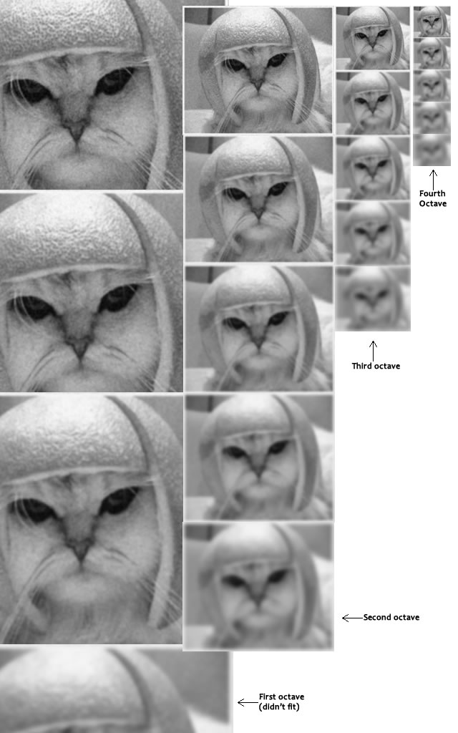

Figure 2.4: Scale Space

Images of the same size (vertical) form an octave. Above are four octaves. Each octave has 5 images. The individual images are formed because of the increasing "scale" (the amount of blur).

**Blurring**

Mathematically, "blurring" is referred to as the convolution of the gaussian operator and the image. Gaussian blur has a particular expression or "operator" that is applied to each pixel. What results is the blurred image.

http://aishack.in/static/img/tut/sift-convolution.jpg

The symbols:

* L is a blurred image
* G is the Gaussian Blur operator
* I is an image
* x,y are the location coordinates
* σ is the "scale" parameter. Think of it as the amount of blur. Greater the value, greater the blur.
* The * is the convolution operation in x and y. It "applies" gaussian blur G onto the image I.

http://aishack.in/static/img/tut/sift-gaussian-operator.jpg

This is the actual Gaussian Blur operator.

**Amount of blurring**

The amount of blurring in each image is important. It goes like this. Assume the amount of blur in a particular image is σ. Then, the amount of blur in the next image will be k*σ. Here k is whatever constant you choose.

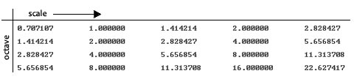

Table 2.1: Amount of Blurring

This is a table of σ's for my current example. See how each σ differs by a factor  from the previous one.

**2.2.3 LoG Approximations**

The Laplacian of Gaussian (LoG) operation goes like this. You take an image, and blur it a little. And then, you calculate second order derivatives on it (or, the "laplacian"). This locates edges and corners on the image. These edges and corners are good for finding keypoints.

But the second order derivative is extremely sensitive to noise. The blur smoothes it out the noise and stabilizes the second order derivative.

The problem is, calculating all those second order derivatives is computationally intensive. So we cheat a bit.

## The Con

To generate Laplacian of Guassian images quickly, we use the scale space. We calculate the difference between two consecutive scales. Or, the Difference of Gaussians. Here's how:

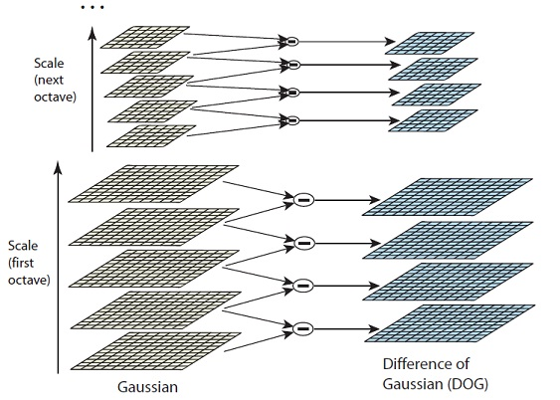

Figure 2.5: Difference of Gaussian Blurred Images

These Difference of Gaussian images are approximately equivalent to the Laplacian of Gaussian. And we've replaced a computationally intensive process with a simple subtraction (fast and efficient). Awesome!

These DoG images comes with another little goodie. These approximations are also "scale invariant".

**2.2.4 Finding Keypoints**

Finding key points is a two part process

1. Locate maxima/minima in DoG images
2. Find subpixel maxima/minima

## Locate maxima/minima in DoG images

The first step is to coarsely locate the maxima and minima. This is simple. You iterate through each pixel and check all it's neighbours. The check is done within the current image, and also the one above and below it. Something like this:

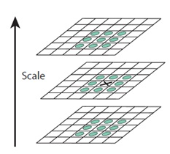

Figure 2.6: Finding Maixma and Minima

X marks the current pixel. The green circles mark the neighbours. This way, a total of 26 checks are made. **X is marked as a "key point" if it is the greatest or least of all 26 neighbours.**

Usually, a non-maxima or non-minima position won't have to go through all 26 checks. A few initial checks will usually sufficient to discard it.

Note that keypoints are not detected in the lowermost and topmost scales. There simply aren't enough neighbours to do the comparison. So simply skip them!

Once this is done, the marked points are the approximate maxima and minima. They are "approximate" because the maxima/minima almost never lies exactly on a pixel. It lies somewhere between the pixel. But we simply cannot access data "between" pixels. So, we must mathematically locate the subpixel location.

Here's what I mean:

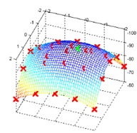

Figure 2.7: Sub Key Points

The red crosses mark pixels in the image. But the actual extreme point is the green one.

## Find subpixel maxima/minima

Using the available pixel data, subpixel values are generated. This is done by the Taylor expansion of the image around the approximate key point.

Mathematically, it's like this:

http://aishack.in/static/img/tut/sift-dog-taylor1.jpg

We can easily find the extreme points of this equation (differentiate and equate to zero). On solving, we'll get subpixel key point locations. These subpixel values increase chances of matching and stability of the algorithm.

**2.2.5 Getting rid of Bad Key Points**

## Removing low contrast features

This is simple. If the magnitude of the intensity (i.e., without sign) at the current pixel in the DoG image (that is being checked for minima/maxima) is less than a certain value, it is rejected.

Because we have subpixel keypoints (we used the Taylor expansion to refine keypoints), we again need to use the taylor expansion to get the intensity value at subpixel locations. If it's magnitude is less than a certain value, we reject the keypoint.

## Removing edges

The idea is to calculate two gradients at the keypoint. Both perpendicular to each other. Based on the image around the keypoint, three possibilities exist. The image around the keypoint can be:

* **A flat region:** If this is the case, both gradients will be small.
* **An edge:** Here, one gradient will be big (perpendicular to the edge) and the other will be small (along the edge)
* **A "corner":** Here, both gradients will be big.

Corners are great keypoints. So we want just corners. If both gradients are big enough, we let it pass as a key point. Otherwise, it is rejected.

Mathematically, this is achieved by the Hessian Matrix. Using this matrix, you can easily check if a point is a corner or not.

**2.2.7 Keypoint Orientation**

The idea is to collect gradient directions and magnitudes around each keypoint. Then we figure out the most prominent orientation(s) in that region. And we assign this orientation(s) to the keypoint.

Any later calculations are done relative to this orientation. This ensures rotation invariance.

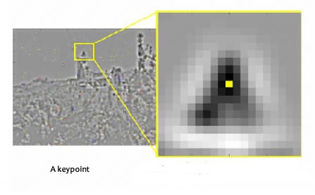

Figure 2.8: Keypoints

The size of the "orientation collection region" around the keypoint depends on it's scale. The bigger the scale, the bigger the collection region.

## The details

Now for the little details about collecting orientations.

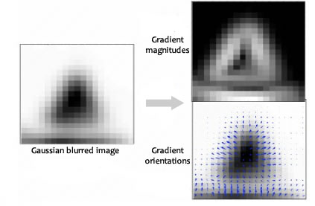

Figure 2.9: Orientation

Gradient magnitudes and orientations are calculated using these formulae:

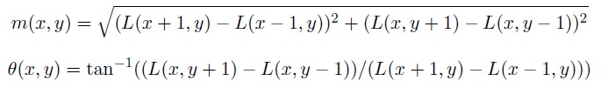

**2.2.8 Generating Features**

We want to generate a very unique fingerprint for the keypoint. It should be easy to calculate. We also want it to be relatively lenient when it is being compared against other keypoints. Things are never EXACTLY same when comparing two different images.

To do this, a 16x16 window around the keypoint. This 16x16 window is broken into sixteen 4x4 windows.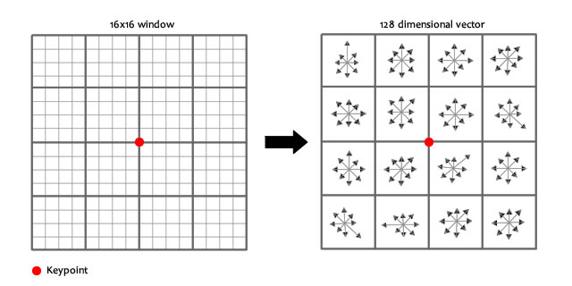

Figure 2.10: Vector Recognition

Within each 4x4 window, gradient magnitudes and orientations are calculated. These orientations are put into an 8 bin [histogram](http://aishack.in/tutorials/histograms-from-simplest-to-the-most-complex/).

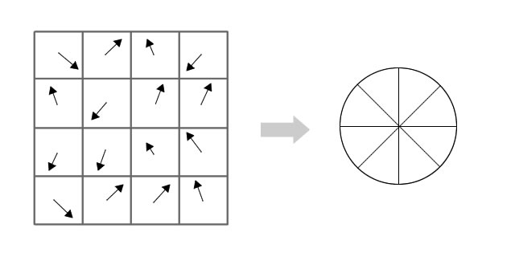

Figure 2.11: Gradient and Magnitude

Any gradient orientation in the range 0-44 degrees add to the first bin. 45-89 add to the next bin. And so on.And (as always) the amount added to the bin depends on the magnitude of the gradient.

Unlike the past, the amount added also depends on the distance from the keypoint. So gradients that are far away from the keypoint will add smaller values to the histogram.

This is done using a "gaussian weighting function". This function simply generates a gradient (it's like a 2D bell curve). You multiple it with the magnitude of orientations, and you get a weighted thingy. The farther away, the lesser the magnutide.

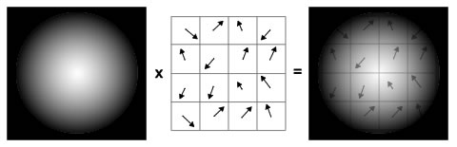

Figure 2.12: Genearting a Feature

Doing this for all 16 pixels, you would've "compiled" 16 totally random orientations into 8 predetermined bins. You do this for all sixteen 4x4 regions. So you end up with 4x4x8 = 128 numbers. Once you have all 128 numbers, you normalize them (just like you would normalize a vector in school, divide by root of sum of squares). These 128 numbers form the "feature vector". This keypoint is uniquely identified by this feature vector.

**2.3 E-R and DFD Diagrams**

**2.4 Constraints and Assumptions**

The Constraints are mostly due to improper image capture, such as improper image capture positioning, lighting, and hair that is sometimes considered as feature, while capturing the profile face, an image may include other skin parts such as neck.This makes the size of the skin area larger than the actual and leads to an incorrect resizing of the ear template and hence, it produces an erroneous ear localisation.The different of age range have no influence on the results of identification, future testing can be done at the age of the sample has been increased.

The Assumption we have taken in ear detection is that it relies on the hypothesis that the longest path in edge image is the outer boundary of the ear. It works well only when there is small background present around the ear and fails if ear detection is carried out in whole profile face image.

**CHAPTER 3**

**SYSTEM REQUIREMENTS**

**3.1 External Interface Requirement**

**3.1.1 Hardware Interface**

Image Acquisition Device: CCTV or DVR

|  |  |
| --- | --- |
| Processor | : Pentium IV or higher |
| Hard Disk | : 40GB or more |
| RAM | : 256MB or more |

**3.1.2 Software Interface**

OPERATING SYSTEM: Windows XP or higher.

DEVELOPMENT KIT : MATLAB

**3.2 Functional Requirement**

This project is intended to meet the following non functional requirements: -

1.The biometric application should identify all of its clients that it will serve, before granting them any access to the System.

2.The system should not allow an administrator to have access to other administrators data or functions to ensure independent rolls.

3.It has to be very friendly and give accurate and quick results

4.User can select image from the system, the interface should have a browsing screen so that the user can select file from different images

5.The system should validate that the captured sample is coming from aThe physical connection between the biometric devices used should be properly secured live human being.

6.The system should scan any template presented to it for known viruses and other harmful programs

7.The system should ensure the confidentiality and integrity of biometric templates and live samples

8.The system should ensure that security is enhanced or at least maintained whenever a hardware or biometric device is repaired or replaced

9.The user when compares two images, if both are similar it should display a message “Matched” otherwise “Not Matched”

10.It should be able to handle 'gif' and 'jpeg' images.

11.The system should ensure that all external communication channels are protected against any corruption

12.If one of the biometric characteristics failed to identify a user, others should be able to work properly

**3.3 Non-Functional Requirement**

This project is intended to meet the following non functional requirements: -

1.This face recognition software should be available on the Internet, to enable the users to use , download it any time.

2.The program should be platform independent.

3.It should be extremely convenient to take a photo.

4. Instructions for acquiring ear images should make users clear enough as to where they should look at when taking photos.

5.It should follow this feature -Usability , scalability , efficiently and security .

**3.4 Hardware and Performance Requirements**

Hardware and Software requirements Various Software and Hardware that are required to do this project are discussed here. Software :

1) The product requires the use of a PC running on JAVA runtime environment or java enabled browser for the web application and an android system for mobile user.

1.1) For the client side (end user) Running Window XP or later, UNIX, MAC operating system. Java runtime environment.

2. Hardware: The other part of the external interface is hardware interface, this interface describe the hardware part of the system.

2.1. Hardware requirement for the client computer RAM 1 GB, 2 GB or more recommended for fast access of the application Hard Disk: 5 GB free space to install the Client side application. Input device: Keyboard, webcam (digital camera), ear reader. Output device: Computer Monitor.

2.2 Hardware requirement for the server. RAM 2GB recommended 6GB or more for big systems this is recommended because image processing work need more memory. Hard Disk: minimum of 15 GB recommended 40GB or more to store the biometric data, we need bigger storage space for storing the image file properly. Input device: Keyboard, Webcam (digital camera), and fingerprint reader. Output device: computer monitor. External firewall if the system needs to be secure.

**CHAPTER 4**

**CONCLUSIONS AND FUTURE WORK**

**4.1 Conclusions**

This project was aimed at developing a biometric authentication system based on human ear images. An invariant geometrical method was used in order to extract features needed for classification. After the feature extraction, authentication is performed based on simple comparison between a new input image and an already existing one.

The human ear is a perfect source of data for passive person authentication in many applications. In a growing need for security in various public places, ear biometrics seem to be a good solution, since ears are visible and its images can be easily taken, even without the knowledge of the examined person. Then the robust feature extraction method can be used to determine personality of some individuals, for instance terrorists at the airports and stations. Access control to various buildings and crowd surveillance are among other possible applications. Ear biometrics can be also used to enhance effectiveness of other well-known biometrics, by its implementation in multimodal systems. Since most of the methods have some drawbacks, recently, the idea of building multimodal (hybrid) biometrics systems is gaining lot of attention. Due to its advantages, ear biometrics seems to be a good choice to support well known methods like voice, hand or face identification.

**4.2 Scope for Future Work**

The proposed work and research has been motivated by the need for a person identification system which is non-invasive and accurate. The ear biometric recognition system works well for image segmentation by employing both colour and depth information. While the system achieved results from research and experiments, from these also came new ideas and areas which could be explored in some future research and work. Feature extraction is crucial for any recognition algorithm and system. A remarkable change has been noticed in the recognition rate using preprocessing and different feature extraction. Specifically in cropping an image before it is run through a recognition system, there is still much work to be done in this area. It would be interesting to explore new techniques of preprocessing that would lead to the optimal recognition rates. In this case, fear biometrics has been used, but perhaps there are other metrics that can be combined that will lead to a more robust system. It would be interesting to see what kind of results could be achieved in a system such as this with other metrics. The system provides the template security for the biometric fuzzy vault database, but still it can be investigate for the large scale operation and integrating another biometric with the face and ear feature set.

**REFERENCES**

1. M. Abdel-Mottaleb, J. Zhou, Human Ear Recognition from Face Profile Images, *ICB 2006,* pp. 786 - 792.
2. H. M. Akkermans, T. A. M. Kevenaar, D. W. E. Schobben, Acoustic Ear Recognition for Person Identification, *Fourth IEEE Workshop on Automatic*

*Identification Advanced Technologies (AutoID'05)* pp. 219-223

1. Banafshe Arbab-Zavar, Mark S. Nixon, and David J. Hurley, “On Model-Based Analysis of Ear Biometrics”
2. M. Burge, W. Burger, *Ear biometrics in: Jain, Bolle and Pankanti (Eds.), Biometrics: Personal Identification in Networked Society,* Kluwer Academic, Dordrecht, 1998, pp. 273-286.
3. Burge, M., and Burger, W., Ear biometrics in computer vision, *Proc. ICPR 2000,* pp. 822-826, 2002
4. A. Bertillon, *La photographie judiciaire, avec un appendice sur la classification et l'identi¯cation anthropometriques,* Gauthier-Villars, Paris, 1890.
5. K. Chang, K.W. Bowyer, S. Sarkar, B. Victor, Comparison and combination of ear and face images in appearance-based biometrics, *IEEE Trans. PAMI,* 2003, vol. 25, no. 9, pp. 1160-1165.
6. H. Chen, B. Bhanu, R. Wang, Performance evaluation and prediction for 3D ear recognition, *Proc. International Conference on Audio and Video based Biometric Person Authentication,* NY, 2005.