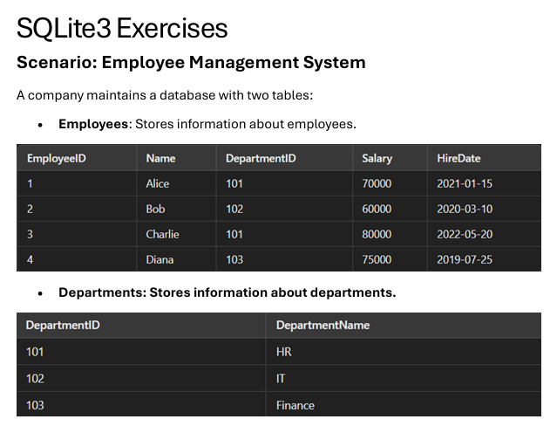

**Q1. Write a query to list the names of employees hired after January 1, 2021.**

SELECT name, hire_date

FROM Employees

WHERE hire_date > '2021-01-01'

ORDER BY hire_date;

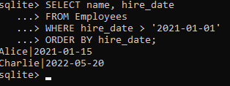

**Q2. Write a query to calculate the average salary of employees in each department.**

SELECT

d.department_name,

ROUND(AVG(e.salary), 2) as average_salary

FROM Departments d

LEFT JOIN Employees e ON d.department_id = e.department_id

GROUP BY d.department_name

ORDER BY average_salary DESC;

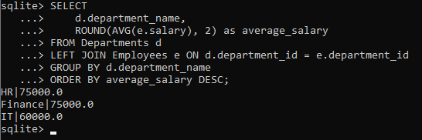

**Q3. Write a query to find the department name where the total salary is the highest.**

SELECT

d.department_name,

SUM(e.salary) as total_salary

FROM Departments d

JOIN Employees e ON d.department_id = e.department_id

GROUP BY d.department_name

ORDER BY total_salary DESC

LIMIT 1;

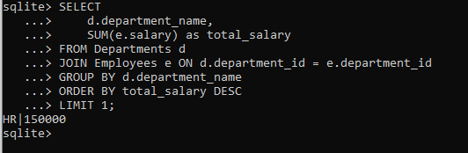

**Q4. Write a query to list all departments that currently have no employees assigned.**

SELECT department_name

FROM Departments d

LEFT JOIN Employees e ON d.department_id = e.department_id

WHERE e.employee_id IS NULL;

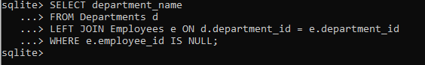

**Q5. Write a query to fetch all employee details along with their department names.**

SELECT

e.employee_id,

e.name,

e.hire_date,

e.salary,

d.department_name

FROM Employees e

JOIN Departments d ON e.department_id = d.department_id

ORDER BY e.employee_id;

