**ASSIGNMENT12:RISHABH GAUR**

**Q1.** Create series attendance.

**OUTPUT:-**

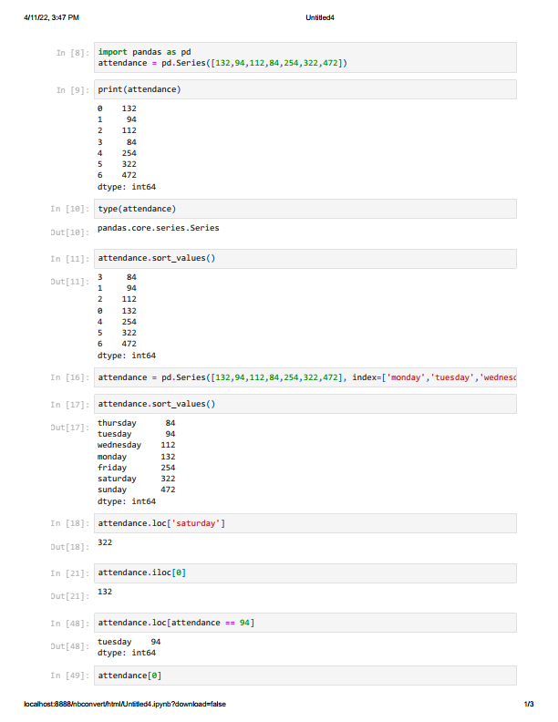

**Q2.** Create dataframe for fruits.

**OUTPUT:-**

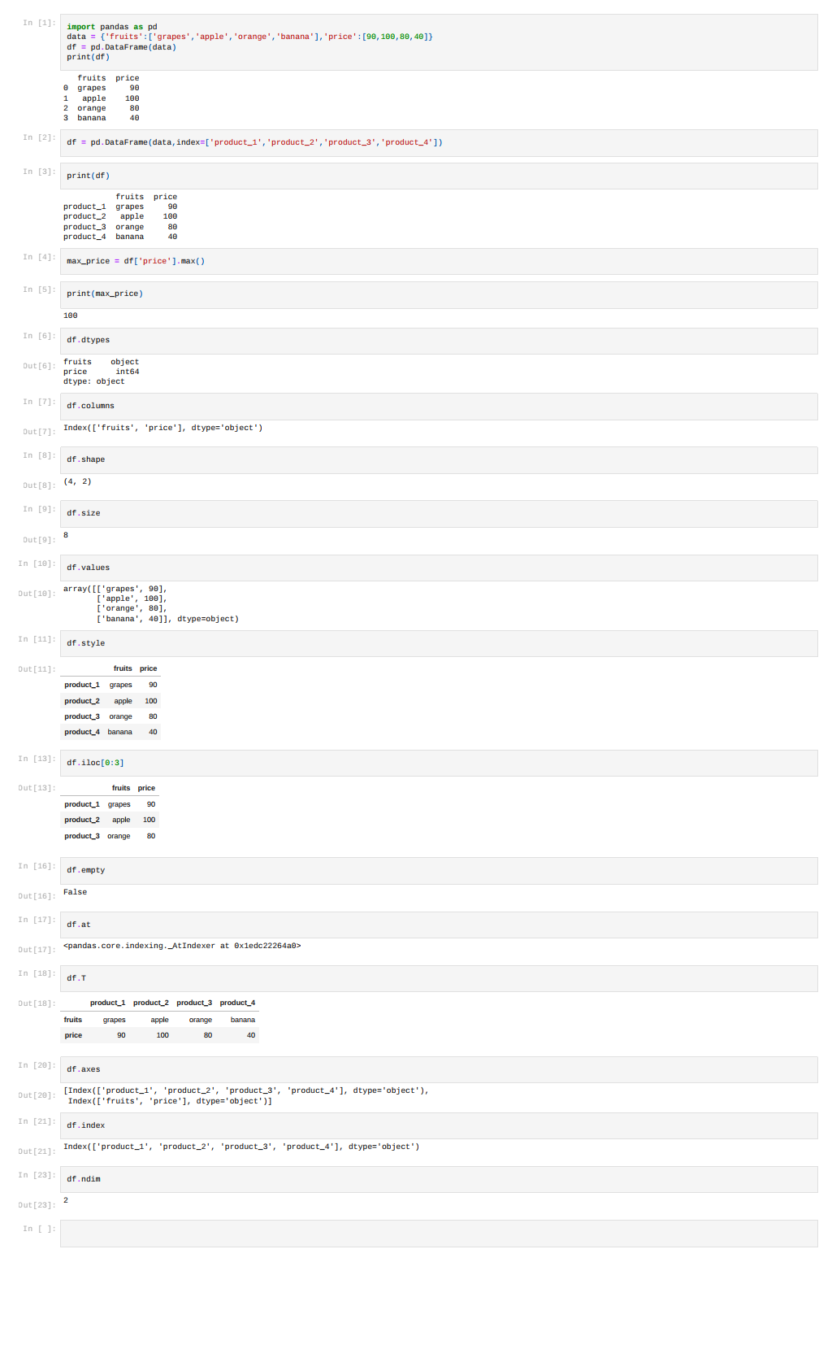

**Q3.** Analyse IMDB movie dataset.

**OUTPUT:-**

