**Experiment-4**

Name of the experiment: Time domain analysis of continuous time systems (Finding zero state response and zero input response).

Theory: There is a class of LTIC systems for which the input x (t) and the output y (t) are related by linear differential equations of the form Q(D )y(t)= P(D)x(t) ; Where the polynomials, are nth and mth order differential equations.

The response can be expressed as the sum of two components: the zero-input component and zero-state component. Therefore, Total response = zero-input response + zero-state response

The zero-input component is the system response when the input x (t) = 0, and thus it is the result of internal system conditions (such as energy storages, initial conditions) alone. It is independent of the external input x (t). In contrast, the zeros state component is the system response to the external input x (t) when the system is in zero state, the absence of all internal energy storages: that is all initial conditions are zero.

Unit impulse response:

For an LTIC system, the unit impulse response h (t) is given by, h(t)=b0*delta(t)+[P(D)Yn]*u(t) where Yn is a linear combination of the characteristic modes of the system subject to the following initial conditions: the derivatives of Y at 0 upto (n-2)th order is 0 and (n-1)th order is 1.

Result: The solutions to the questions are-

**A> 1.** 5*exp(-5*t)

**2. a>**exp(-t) + 2*exp(-3*t) **b>**3*exp(-2*t) - t*exp(-2*t) **c>**3*cos(6*t)*exp(-2*t) - (sin(6*t)*exp(-2*t))/6

**3.** 3 - 2*exp(-2*t)

**B>** **1.** -u(t)*(exp(-2*t) - 2*exp(-3*t))

**2.**  u(t)*(exp(-t) - t*exp(-t))

**C>** -u(t)*(15*exp(-t) - 30*exp(-2*t) + 15*exp(-3*t)) [Since zero input response is zero, this is total response]

All the solutions were cross-checked by differentiating the result and I was convinced that these were indeed the solutions to the differential equations for the given initial conditions

Conclusion: This experiment helped us clarify our concepts about the characteristic modes, eigenvalues, zero-input response, impulse response and zero state response of a system. While we could have solved it by finding the characteristic roots first and then assuming solutions, MATLAB’s in-built *dsolve* function helped us evaluate the results much more quickly and also we had no need to convolve the impulse response with input to get zero-state result in this case. The usage of *str2func/inline* was required which again helped us know more about MATLAB. All together, this was a very interesting experiment.

Appendix: Code to solve the questions:

clc;

close all;

clear all;

syms y(t);

res=dsolve(diff(y)+5*y==0, y(0)==5);

res=char(res);

disp(res);

f=inline(res);

plot=GraphEx4(f);

subplot(2,4,1);

stem(plot);

Dy=diff(y);

k=3;

res1=dsolve(diff(y,2)+4*diff(y)+k*y==0,y(0)==3,Dy(0)==-7);

res=char(res1);

disp(res);

f=inline(res);

subplot(2,4,2);

plot=GraphEx4(f);

stem(plot);

k=4;

res2=dsolve(diff(y,2)+4*diff(y)+k*y==0,y(0)==3,Dy(0)==-7);

res=char(res2);

disp(res);

f=inline(res);

plot=GraphEx4(f);

subplot(2,4,3);

stem(plot);

k=40;

res3=dsolve(diff(y,2)+4*diff(y)+k*y==0,y(0)==3,Dy(0)==-7);

res=char(res3);

disp(res);

f=inline(res);

plot=GraphEx4(f);

subplot(2,4,4);

stem(plot);

res4=dsolve(diff(y,2)+2*diff(y)==0,y(0)==1,Dy(0)==4);

res=char(res4);

disp(res);

f=inline(res);

plot=GraphEx4(f);

subplot(2,4,5);

stem(plot);

res5=dsolve(diff(y,2)+5*diff(y)+6*y==0,y(0)==0,Dy(0)==1);

res6=diff(res5)+res5;

res=char(res6);

f=inline(res);

plot=GraphEx4(f);

subplot(2,4,6);

stem(plot);

disp(res6*'u(t)');

res5=dsolve(diff(y,2)+2*diff(y)+y==0,y(0)==0,Dy(0)==1);

res6=diff(res5);

res=char(res6);

f=inline(res);

plot=GraphEx4(f);

subplot(2,4,7);

stem(plot);

disp(res6*'u(t)');

res5=dsolve(diff(y,2)+3*diff(y)+2*y==diff(10*exp(-3*t)),y(0)==0,Dy(0)==0);

disp(res5*'u(t)');

res=char(res5);

f=inline(res);

plot=GraphEx4(f);

subplot(2,4,8);

stem(plot);

Helper function code to plot the graphs:

function [ plot ] = GraphEx4( f )

plot=zeros(1,801);

a=1;

for i=-4:0.01:4

plot(1,a)=f(i);

a=a+1;

end;

end

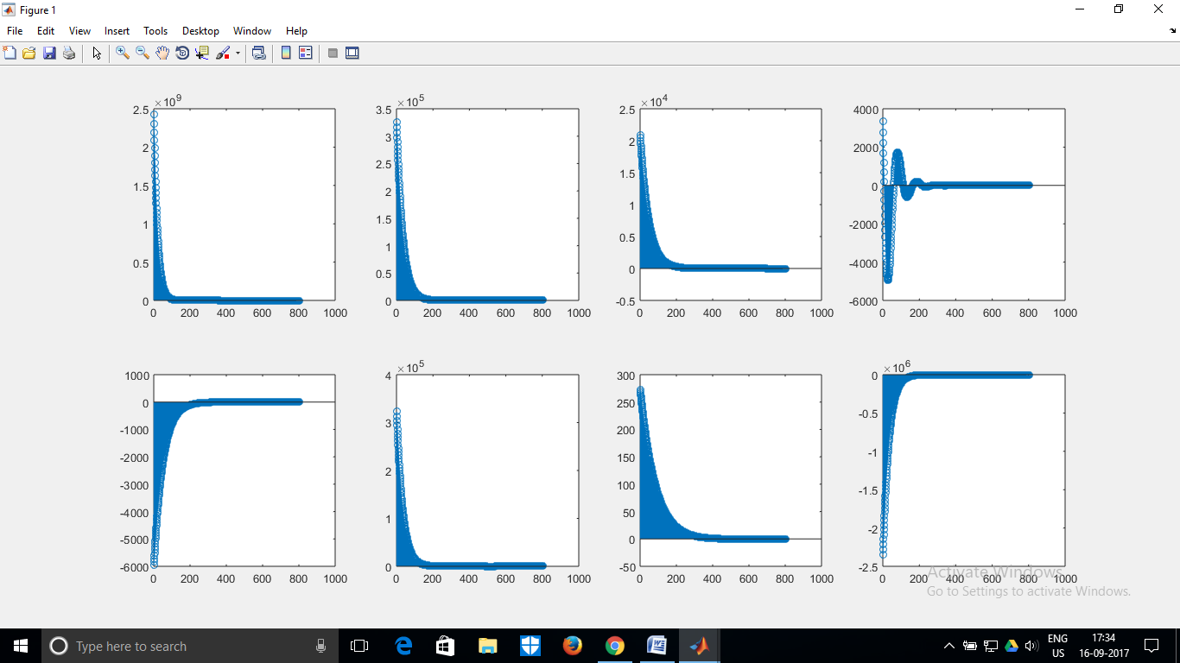

The various graphs for the solutions