**Experiment-6**

**Name of the experiment:** To study and implement trigonometric Fourier series.

**Theory:** Fourier series is an approximation process where a non-sinusoidal waveform is converted to sinusoidal such that all the periodic signals are represented in unique form.

The Continuous Time Fourier series is a good analysis tool for systems with periodic excitation. Understanding properties of Fourier series makes the work simple in calculating the Fourier series coefficients in the case when signals modified by some basic operations. Graphical representation of a periodic signal in frequency domain represents Complex Fourier Spectrum.

g(t)=a0+Sigma(n=1 to infinity)an*cos*(nwot)+ Sigma(n=1 to infinity)an*sin*(nwot)

a0=1/T*integral(g(t),0,T)

an=2/T*integral(g(t)*cos(nwot),0,T)

bn=2/T*integral(g(t)*sin(nwot),0,T)

**Exponential Fourier series (Complex Fourier Series):** The same can be expressed in terms of exponential Fourier series, g(t)=Sigma[n=-Infinity to Infinity](Cne-jW0t)

**Results and observations:** The first 9 figures show all the 9 signals with the figures showing bn, an, function as obtained by plotting and function as obtained by summing Fourier series. The a0 is written below each figure. The last 6 figures depict Cn and Theta(n).

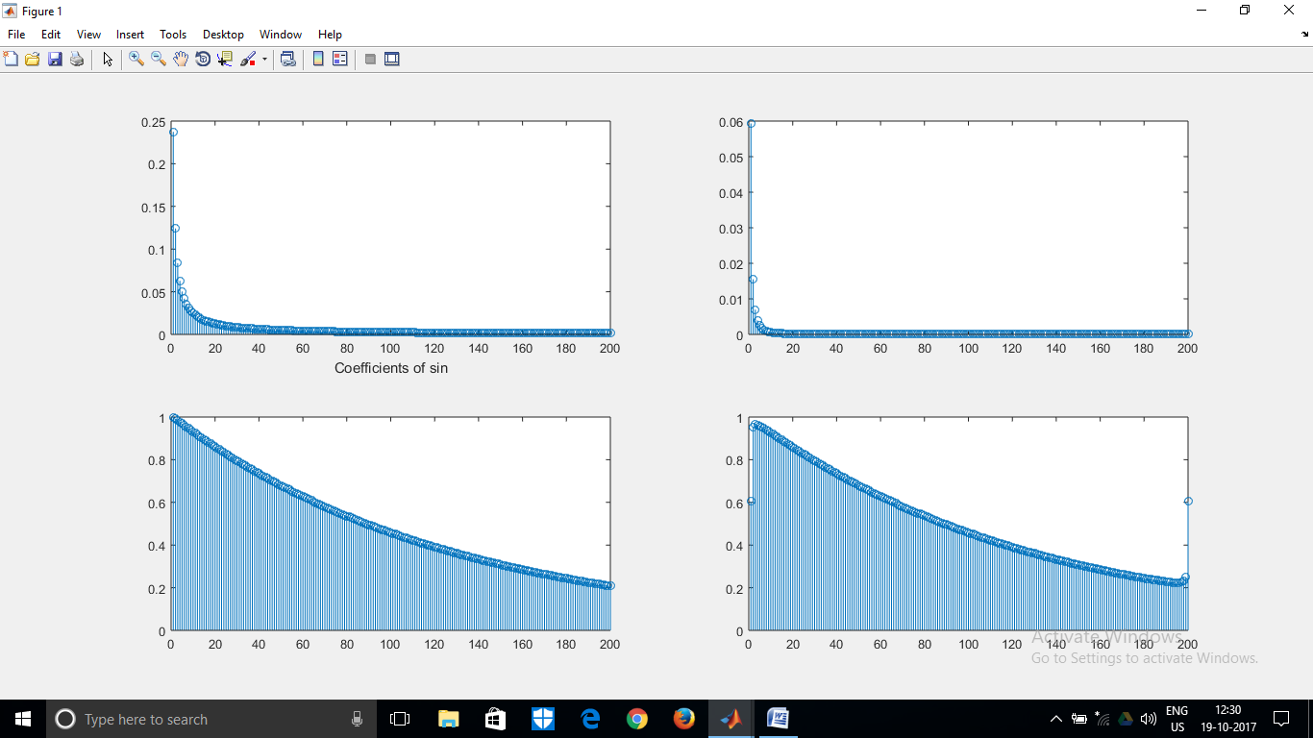

A0=0.5043

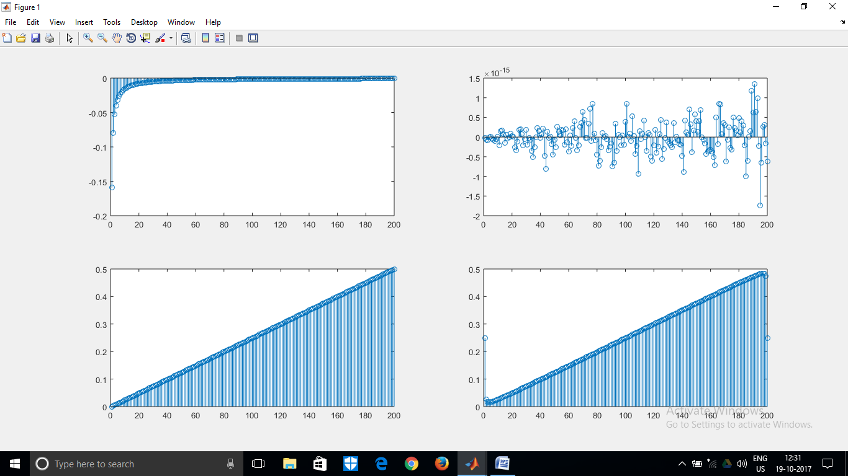

A0=0.2500

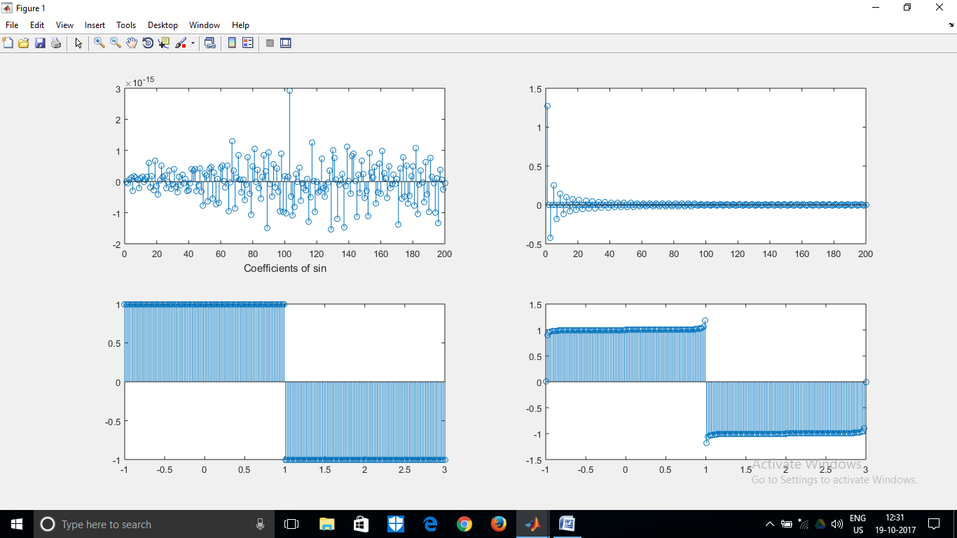

A0=0

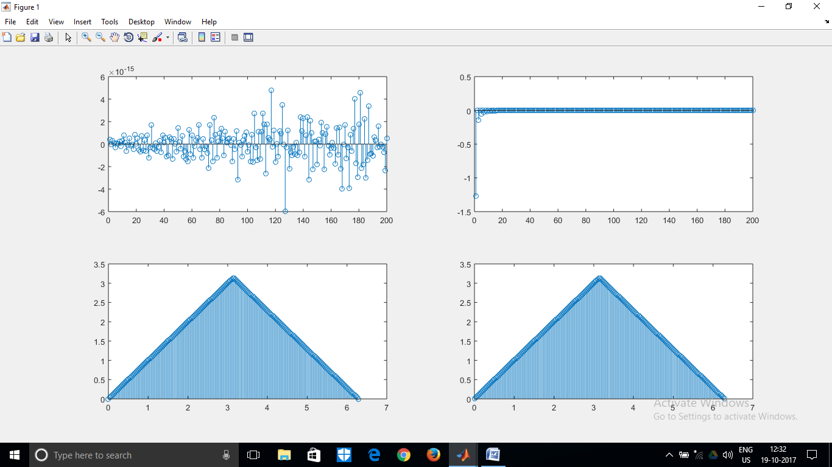

A0=1.5708

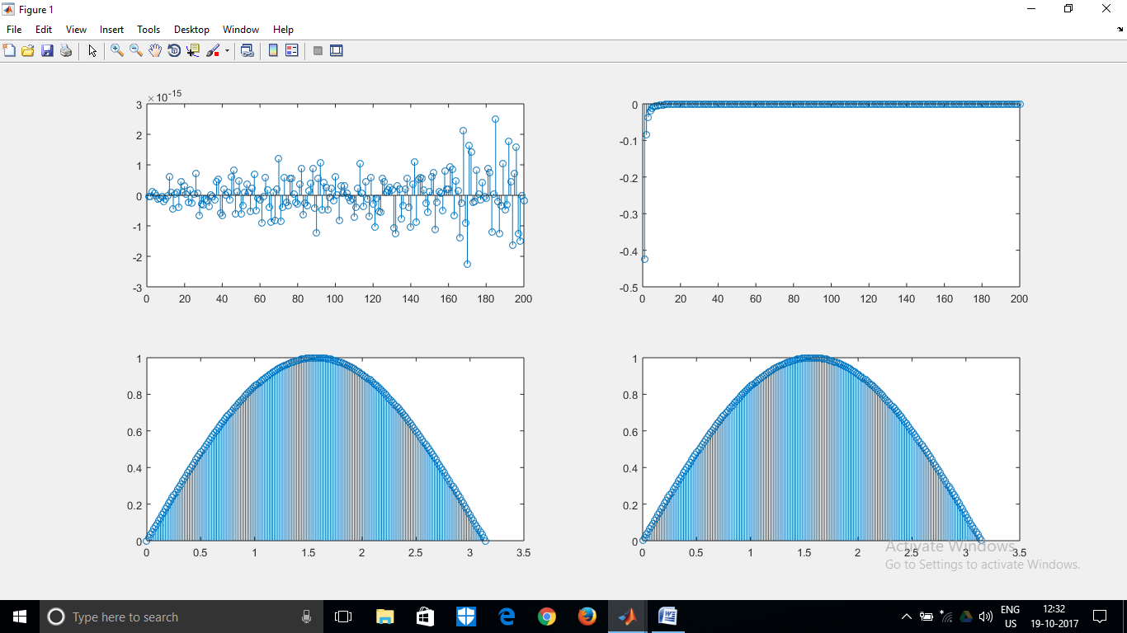

A0=0.6366

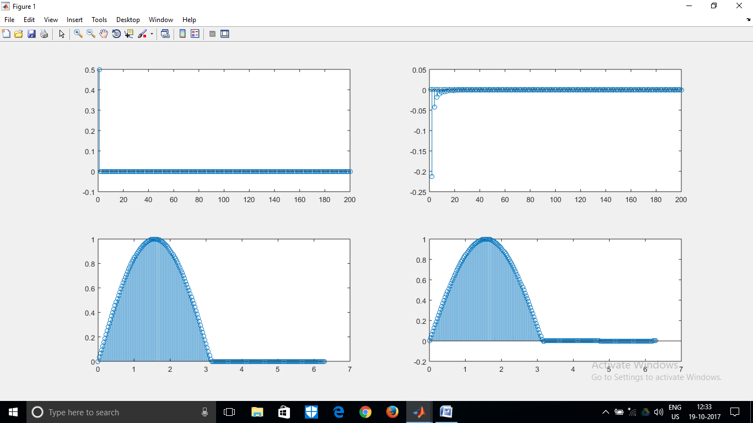

A0=0.3183

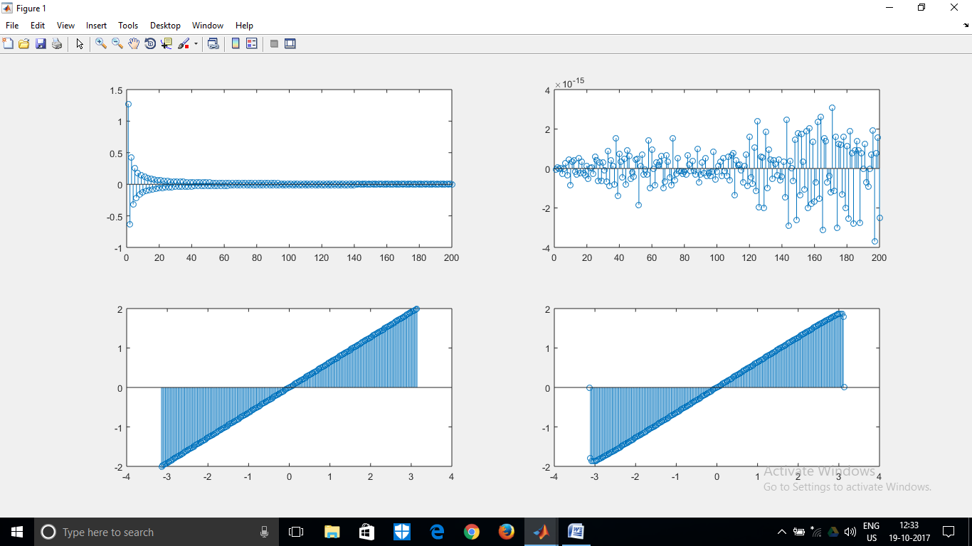

A0=1.7670e-17

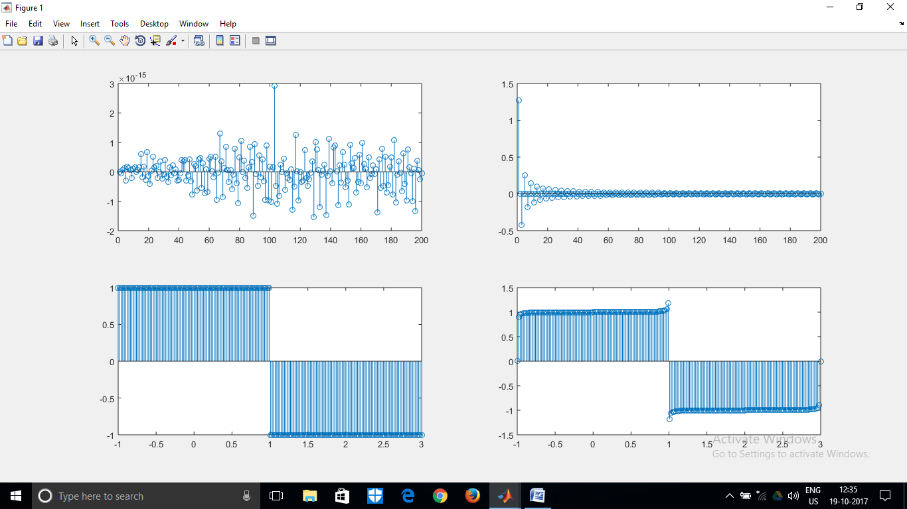

A0=0

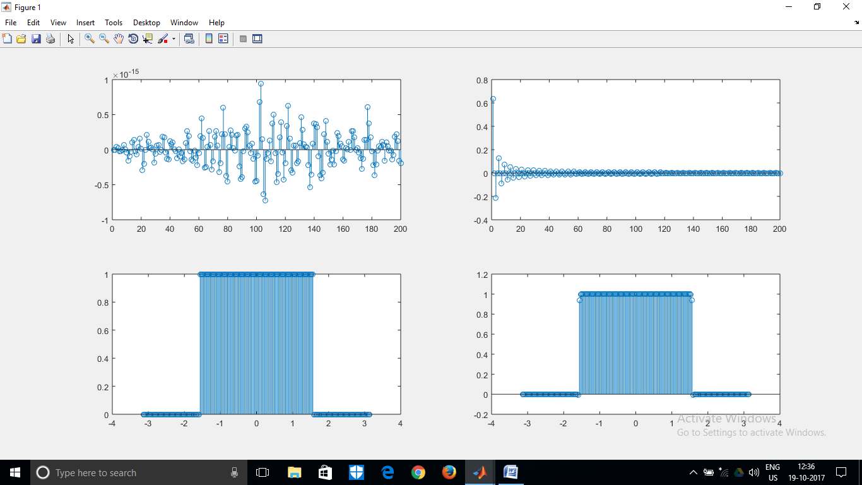

A0=0.5000

Figure 4 in terms of Cn and Theta(n), respectively:

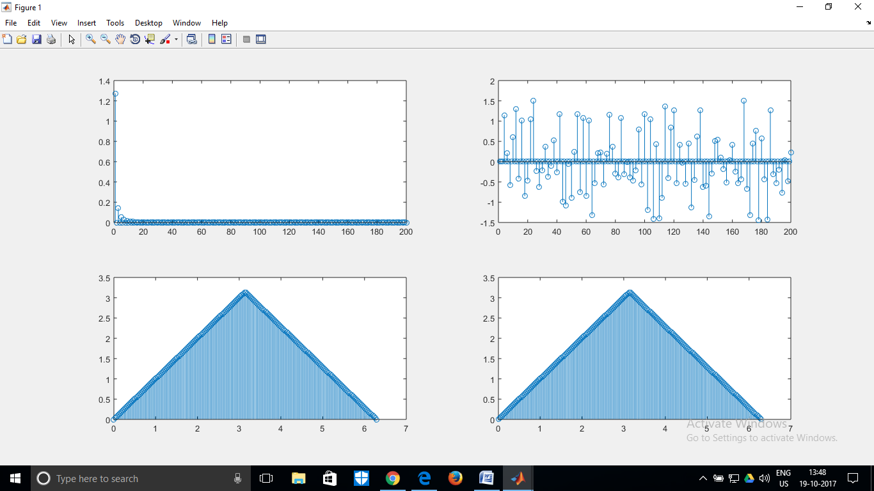

Figure 5 in terms of Cn and Theta(n), respectively:

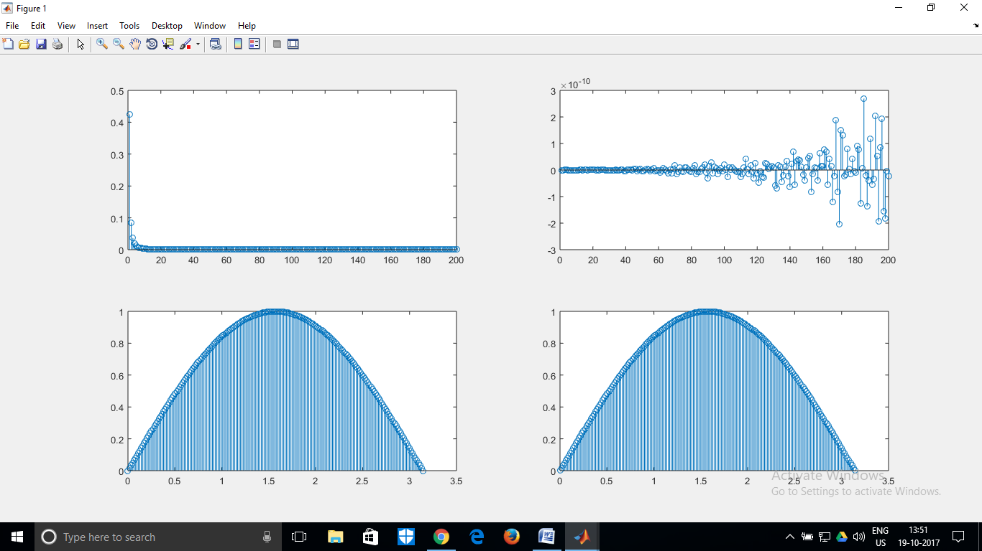

Figure 6 in terms of Cn and Theta(n), respectively:

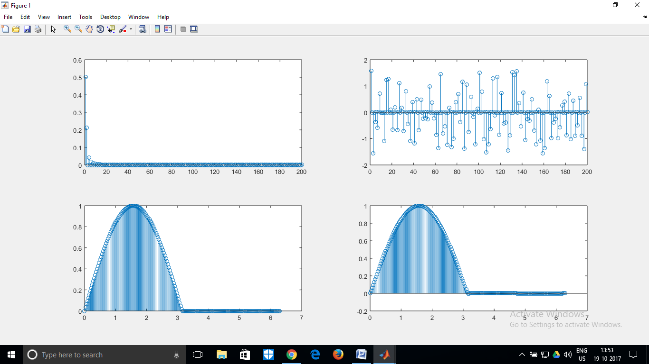

Figure 7 in terms of Cn and Theta(n), respectively:

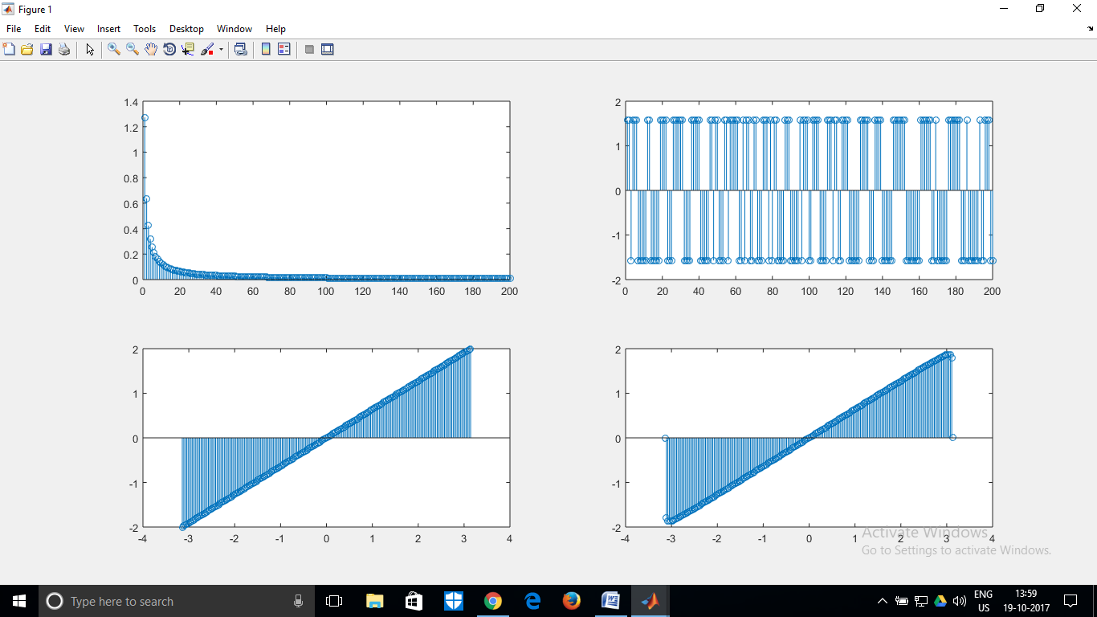

Figure 8 in terms of Cn and Theta(n), respectively:

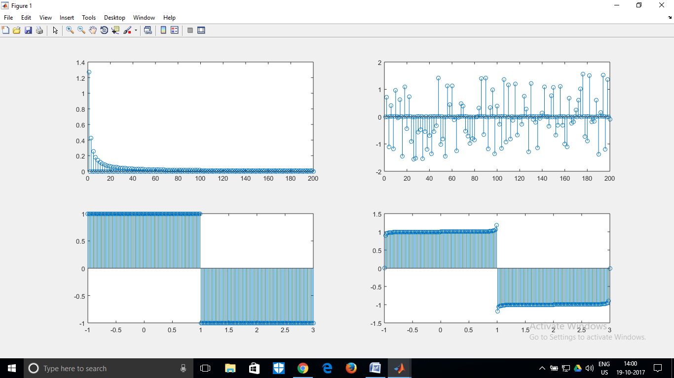

Figure 9 in terms of Cn and Theta(n), respectively:

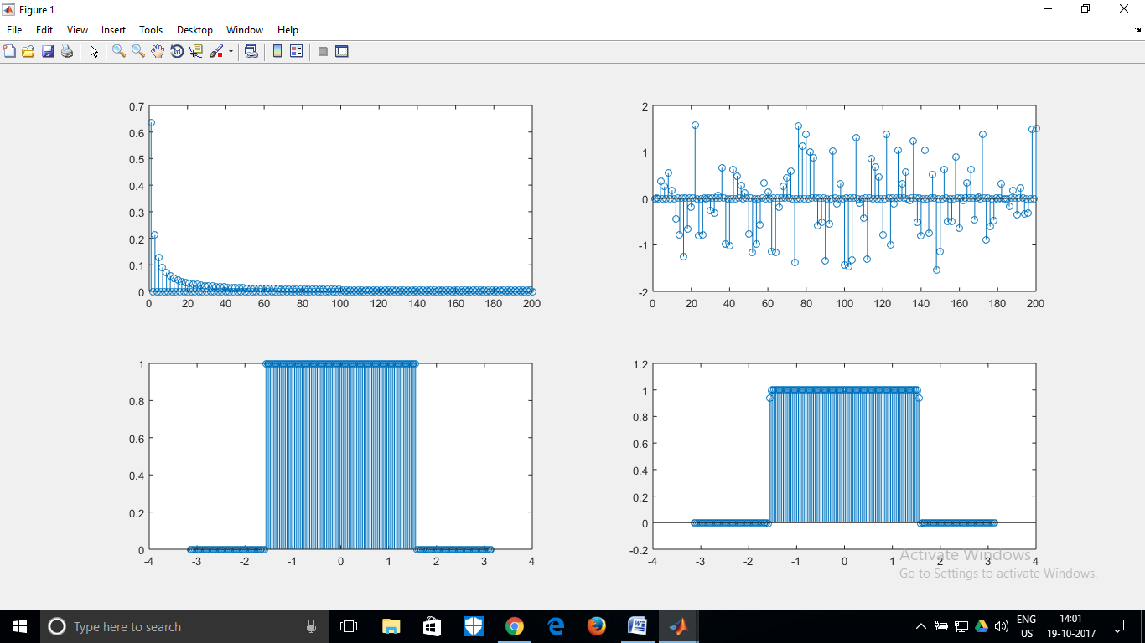

**Conclusion:** The experiment provided us a way to observe Fourier series in action. We managed to plot the Fourier spectrum and verified that the theory matched with the practical and the closer we moved towards the infinite series, the better the convergence and approximation was. However, when I tried to plot the compact trigonometric Fourier series, I faced some difficulty as blindly using the atan function to calculate the argument of the compact cosine terms doesn’t work-we need to figure out which quadrant the cosine/sine coefficients are and decide the sign accordingly. However, that could be handled with a few if/else conditions and I will try to figure out a way to design a function which decides the sign for me, such that even compact function plotting is perfect.

**Appendix: (MATLAB Code)**

clc;

clear all;

close all;

n=input('Enter choice ');

switch(n)

case 1

sig= @(t) exp(-t/2);

period=pi;

a0=integral(sig,0,pi)/pi;

disp(a0);

an=zeros(1,200);

bn=zeros(1,200);

for i=1:1:200

sign= @(t) exp(-t/2).*(sin(2*(i)*t));

an(i)=2*integral(sign,0,period)/pi;

end;

for i=1:1:200

sign= @(t) exp(-t/2).*(cos(2*(i)*t));

bn(i)=2*integral(sign,0,period)/pi;

end;

figure;

subplot(2,2,1);

stem(an);

xlabel('Coefficients of sin');

subplot(2,2,2);

stem(bn);

subplot(2,2,3);

t=linspace(0,pi,200);

stem(sig(t));

subplot(2,2,4);

g=zeros(1,200);

for i=1:1:200

for j=1:1:200

g(i)=g(i)+(an(j))*sin(2*(j)*t(i));

g(i)=g(i)+(bn(j))*cos(2*(j)*t(i));

end;

g(i)=g(i)+a0;

end;

stem(g);

case 2

sig= @(t) t/2;

period=1;

a0=integral(sig,0,1);

disp(a0);

an=zeros(1,200);

bn=zeros(1,200);

for i=1:1:200

sign= @(t) (t/2).*(sin((2*pi*i)*t));

an(i)=2*integral(sign,0,period)/1;

end;

for i=1:1:200

sign= @(t) (t/2).*(cos((2*pi*i)*t));

bn(i)=2*integral(sign,0,period)/1;

end;

subplot(2,2,1);

stem(an);

subplot(2,2,2);

xlabel('Coefficients of sin');

stem(bn);

subplot(2,2,3);

t=linspace(0,1,200);

stem(sig(t));

subplot(2,2,4);

g=zeros(1,200);

for i=1:1:200

for j=1:1:200

g(i)=g(i)+an(j)*sin((2*pi*j)*t(i));

g(i)=g(i)+bn(j)*cos((2*pi*j)*t(i));

end;

g(i)=g(i)+a0;

end;

stem(g);

sig= @(t) t/2;

case 3

sig1= @(t) (t/t);

sig2= @(t) -(t/t);

period=4;

%a0=integral(sig1,-1,-0.01)+integral(sig2,0.01,3);

a0=0;

disp(a0);

an=zeros(1,200);

bn=zeros(1,200);

for i=1:1:200

sign1= @(t) 1.*(sin((pi/2*i)*t));

sign2= @(t) -1.*(sin((pi/2*i)*t));

an(i)=2*(integral(sign1,-1,1)+integral(sign2,1,3))/4;

end;

for i=1:1:200

sign1= @(t) 1.*(cos((pi/2*i)*t));

sign2= @(t) -1.*(cos((pi/2*i)*t));

bn(i)=2*(integral(sign1,-1,1)+integral(sign2,1,3))/4;

end;

figure;

subplot(2,2,1);

stem(an);

xlabel('Coefficients of sin');

subplot(2,2,2);

stem(bn);

subplot(2,2,3);

t=linspace(-1,3,200);

%disp(t);

res=zeros(1,200);

for i=1:200

if(t(i)<=1)

res(i)=1;

else

res(i)=-1;

end;

end;

stem(t,res);

subplot(2,2,4);

g=zeros(1,200);

for i=1:1:200

for j=1:1:200

g(i)=g(i)+an(j)*sin(pi/2*(j)*t(i));

g(i)=g(i)+bn(j)*cos(pi/2*(j)*t(i));

end;

g(i)=g(i)+a0;

end;

stem(t,g);

case 4

sig1= @(t) (t);

sig2= @(t) -(t)+2*pi;

period=4;

a0=(integral(sig1,0,pi)+integral(sig2,pi,2*pi))/(2*pi);

disp(a0);

an=zeros(1,200);

bn=zeros(1,200);

cn=zeros(1,200);

tn=zeros(1,200);

for i=1:1:200

sign1= @(t) t.*(sin((i)*t));

sign2= @(t) (-t+2*pi).*(sin((i)*t));

an(i)=2*(integral(sign1,0,pi)+integral(sign2,pi,2*pi))/(2*pi);

end;

for i=1:1:200

sign1= @(t) t.*(cos((i)*t));

sign2= @(t) (-t+2*pi).*(cos((i)*t));

bn(i)=2*(integral(sign1,0,pi)+integral(sign2,pi,2*pi))/(2*pi);

end;

for i=1:1:200

cn(i)=sqrt(an(i)*an(i)+bn(i)*bn(i));

tn(i)=atan(-an(i)/bn(i));

end;

figure;

subplot(2,2,1);

%stem(an)

stem(cn);

subplot(2,2,2);

%stem(bn);

stem(tn);

subplot(2,2,3);

t=linspace(0,2*pi,200);

res=zeros(1,200);

for i=1:200

if(t(i)<=pi)

res(i)=sig1(t(i));

else

res(i)=sig2(t(i));

end;

end;

stem(t,res);

subplot(2,2,4);

g=zeros(1,200);

for i=1:1:200

for j=1:1:200

%g(i)=g(i)+an(j)*sin((j)*t(i));

%g(i)=g(i)+bn(j)*cos((j)*t(i));

g(i)=g(i)+cn(j)*cos(pi-j*t(i)+tn(j));

end;

g(i)=g(i)+a0;

end;

stem(t,g);

% stem(t(1:100),g(101:200));

% hold on;

% ax=gca;

% ax.ColorOrderIndex=1;

% stem(t(101:200),g(1:100));

% hold off;

case 5

sig1= @(t) sin(t);

period=4;

a0=(integral(sig1,0,pi))/(pi);

disp(a0);

an=zeros(1,200);

bn=zeros(1,200);

cn=zeros(1,200);

tn=zeros(1,200);

for i=1:1:200

sign1= @(t) sin(t).*(sin((2*i)*t));

an(i)=2*(integral(sign1,0,pi))/(pi);

end;

for i=1:1:200

sign1= @(t) sin(t).*(cos((2*i)*t));

bn(i)=2*(integral(sign1,0,pi))/(pi);

end;

for i=1:1:200

cn(i)=sqrt(an(i)*an(i)+bn(i)*bn(i));

tn(i)=atan(-an(i)/bn(i));

end;

figure;

subplot(2,2,1);

%stem(an);

stem(cn);

subplot(2,2,2);

%stem(bn);

stem(tn);

subplot(2,2,3);

t=linspace(0,pi,200);

stem(t,sig1(t));

subplot(2,2,4);

g=zeros(1,200);

for i=1:1:200

for j=1:1:200

%g(i)=g(i)+an(j)*sin((2*j)*t(i));

%g(i)=g(i)+bn(j)*cos((2*j)*t(i));

g(i)=g(i)+cn(j)*cos(pi-(2*j)*t(i)+tn(j));

%g(i)=-g(i);

end;

g(i)=g(i)+a0;

end;

stem(t,g);

% stem(t(101:200),g(1:100));

% hold on;

% ax=gca;

% ax.ColorOrderIndex=1;

% stem(t(1:100),g(101:200));

% hold off;

case 6

sig1= @(t) sin(t);

period=4;

a0=(integral(sig1,0,pi))/(2*pi);

disp(a0);

an=zeros(1,200);

bn=zeros(1,200);

cn=zeros(1,200);

tn=zeros(1,200);

for i=1:1:200

sign1= @(t) sin(t).*(sin((i)*t));

an(i)=2*(integral(sign1,0,pi))/(2*pi);

end;

for i=1:1:200

sign1= @(t) sin(t).*(cos((i)*t));

bn(i)=2*(integral(sign1,0,pi))/(2*pi);

end;

for i=1:1:200

cn(i)=sqrt(an(i)*an(i)+bn(i)*bn(i));

tn(i)=atan(-an(i)/bn(i));

end;

figure;

subplot(2,2,1);

%stem(an);

stem(cn);

subplot(2,2,2);

%stem(bn)

stem(tn);

subplot(2,2,3);

t=linspace(0,2*pi,200);

res=zeros(1,200);

for i=1:200

if(t(i)<=pi)

res(i)=sig1(t(i));

else

res(i)=0;

end;

end;

stem(t,res);

subplot(2,2,4);

g=zeros(1,200);

for i=1:1:200

for j=1:1:200

%g(i)=g(i)+an(j)*sin((j)*t(i));

%g(i)=g(i)+bn(j)*cos((j)*t(i));

g(i)=g(i)+cn(j)*cos(pi-(j*t(i)+tn(j)));

end;

g(i)=g(i)+a0;

end;

stem(t,g);

case 7

sig1= @(t) (2/pi)*t;

a0=(integral(sig1,-pi,pi))/(2*pi);

disp(a0);

an=zeros(1,200);

bn=zeros(1,200);

cn=zeros(1,200);

tn=zeros(1,200);

for i=1:1:200

sign1= @(t) (2/pi)*(t).*(sin((i)*t));

an(i)=2*(integral(sign1,-pi,pi))/(2*pi);

end;

for i=1:1:200

sign1= @(t) (2/pi)*(t).*(cos((i)*t));

bn(i)=2*(integral(sign1,-pi,pi))/(2*pi);

end;

for i=1:1:200

cn(i)=sqrt(an(i)*an(i)+bn(i)*bn(i));

tn(i)=atan(-an(i)/bn(i));

end;

figure;

subplot(2,2,1);

%stem(an);

stem(cn);

subplot(2,2,2);

%stem(bn);

stem(tn);

subplot(2,2,3);

t=linspace(-pi,pi,200);

res=zeros(1,200);

stem(t,sig1(t));

subplot(2,2,4);

g=zeros(1,200);

for i=1:1:200

for j=1:1:200

g(i)=g(i)+an(j)*sin((j)*t(i));

g(i)=g(i)+bn(j)*cos((j)*t(i));

%g(i)=g(i)+cn(j)*cos((j)*t(i)+tn(j));

end;

g(i)=g(i)+a0;

end;

stem(t,g);

case 8

a0=0;

disp(a0);

an=zeros(1,200);

bn=zeros(1,200);

cn=zeros(1,200);

tn=zeros(1,200);

for i=1:1:200

sign1= @(t) 1.*(sin(pi/2*(i)*t));

sign2= @(t) -1.*(sin(pi/2*i*t));

an(i)=2*(integral(sign1,-1,1)+integral(sign2,1,3))/(4);

end;

for i=1:1:200

sign1= @(t) 1.*(cos(pi/2*(i)*t));

sign2= @(t) -1.*(cos(pi/2*(i)*t));

bn(i)=2*(integral(sign1,-1,1)+integral(sign2,1,3))/(4);

end;

for i=1:1:200

cn(i)=sqrt(an(i)*an(i)+bn(i)*bn(i));

tn(i)=atan(-an(i)/bn(i));

end;

figure;

subplot(2,2,1);

stem(cn)

%stem(an);

subplot(2,2,2);

%stem(bn);

stem(tn);

subplot(2,2,3);

t=linspace(-1,3,200);

res=zeros(1,200);

for i=1:200

if(t(i)<=1)

res(i)=1;

else

res(i)=-1;

end;

end;

stem(t,res);

subplot(2,2,4);

g=zeros(1,200);

for i=1:1:200

for j=1:1:200

g(i)=g(i)+an(j)*sin(pi/2*(j)*t(i));

g(i)=g(i)+bn(j)*cos(pi/2*(j)*t(i));

%g(i)=g(i)+cn(j)*cos(j*t(i)+tn(j));

end;

g(i)=g(i)+a0;

end;

stem(t,g);

case 9

a0=0.5;

disp(a0);

an=zeros(1,200);

bn=zeros(1,200);

cn=zeros(1,200);

tn=zeros(1,200);

for i=1:1:200

sign1= @(t) 1.*(sin((i)*t));

an(i)=2*(integral(sign1,-pi/2,pi/2))/(2*pi);

end;

for i=1:1:200

sign1= @(t) 1.*(cos((i)*t));

bn(i)=2*(integral(sign1,-pi/2,pi/2))/(2*pi);

end;

for i=1:1:200

cn(i)=sqrt(an(i)*an(i)+bn(i)*bn(i));

tn(i)=atan(-an(i)/bn(i));

end;

figure;

subplot(2,2,1);

%stem(an);

stem(cn);

subplot(2,2,2);

%stem(bn);

stem(tn);

subplot(2,2,3);

t=linspace(-pi,pi,200);

res=zeros(1,200);

for i=1:200

if(t(i)<=-pi/2||t(i)>pi/2)

res(i)=0;

else

res(i)=1;

end;

end;

stem(t,res);

subplot(2,2,4);

g=zeros(1,200);

for i=1:1:200

for j=1:1:200

g(i)=g(i)+an(j)*sin((j)*t(i));

g(i)=g(i)+bn(j)*cos((j)*t(i));

%g(i)=g(i)+cn(j)*cos(j*t(i)+tn(j));

end;

g(i)=g(i)+a0;

end;

stem(t,g);

end;