

**Table of Contents**

Part 1 - Introduction

Project Summary…………………………………………………………………………Page 3

Part 2 - Database Schema

Physical Model……………………………………………………………………………Page 5

Data Dictionary…………………………………………………………………………...Page 5

Part 3 - Structure and Query Implementation

Database System Infrastructure………………………………………………………..Page 8

SQL Script for Creating Tables and Inserting Sample Data………………………...Page 8

SQL Statements for Answering Major Data Questions……………………………...Page 36

Part 4 - Interface Implementation

Forms……………………………………………………………..………………………Page 39

Reports…………………………………………………………………………………...Page 42

**PART 1 – INTRO**

**Section II: Project Summary**

The project focuses on designing an inventory fulfillment database management system for the hotel rooms in Hotel Dragonfly located in Mumbai. The hotel has 30 rooms and 10 service apartments (apartments rented out for a longer duration by the employees of the corporate firms in the vicinity). The hotel is located close to the international airport so it caters to both business as well as leisure travelers. It provides hotel lodging, banquet halls for corporate and social events and restaurant services.

Hotels require a large amount of inventory for both guest rooms and other accommodations such as restaurants and banquet halls. This makes it crucial for any company within the hospitality industry to streamline their supply chain to ensure that there is enough inventory to provide excellent service to their customers.

At present, the inventory of food supplies and other items such as toiletries, towels, etc is managed manually by maintaining excel sheets and manual bookkeeping by the purchase manager. This is insufficient and can lead to several different issues. When the inventory for the room supplies and the restaurant items reach a critical level, the purchase manager orders them by compiling a list of items required and then contacts the vendor for them to be replenished. This happens when an inventory purchase is made that contains both order line and product. As a result, the hotel is in the process of entirely digitizing their operations.

In the proposed system, the customer’s details are entered at the time of making a reservation and allotted a room depending on the group size of the customer as the hotel has a policy where they allow a maximum of three guests in a room so a reservation can include more than one room if the group size of the guests is more than three. The MealID associated with a reservation would be used to track the food items used in the complimentary breakfast and items ordered a la carte. The room number would be used to track the amount of room supplies (toiletries, towels, bedsheets, etc.) used up in a particular reservation. This data would be used by the purchase manager to compile a list of items to be purchased by checking the levels of the various items in the storage inventory to replenish the inventory for the rooms and the restaurant. The purchase manager then contacts the vendor and orders the items required.

By shifting towards a database management system for their inventory, they can eradicate several issues and get an accurate picture of the items left so that they can be replenished by the purchase manager by contacting their wholesaler. The inventory levels could be tracked in real time by different stakeholders and accordingly help them in making relevant business decisions.  This will in turn aid in the pricing analysis of the hotel rooms and in maintaining a proper supply chain so that the inventory does not run out. In the proposed system, inventory fulfillment for rooms and the restaurant will be considered, along with the purchasing of inventory when it is low, and the reservation process as well.

Users:

**Hotel Manager-** Takes care of daily administration and employee scheduling

**Sales Head-** Oversees rooms and banquet hall events and bookings

**Purchase Manager-** Manages the inventory of the food items and other hotel supplies

**Restaurant Manager-** Manages the restaurant and the cafe in the hotel

The hotel manager, sales head, restaurant manager and the purchase manager have equal access to the database.

The sales head, restaurant manager and the hotel manager are in constant touch with the purchase manager so as to communicate their daily requirements for their respective departments to him. The purchase manager then supplies them with their requirements and subsequently replenishes the items by ordering them.

**PART 2 – DATABASE SCHEMA**

**Section III: Physical Model**

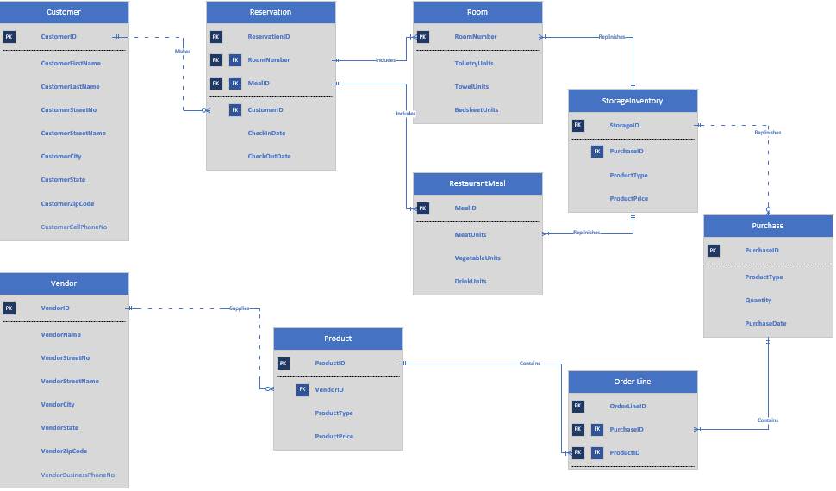

**Section IV: Data Dictionary**

1. Customer Table - Stores the information of the customers of the system.
2. Reservation Table - Stores the information of the reservations of the system.
3. Room Table - Stores the inventory levels of a particular room.
4. RestaurantMeal Table - Stores the inventory levels of a reservation’s complimentary meal.
5. StorageInventory Table - Stores all records of purchased units in storage.
6. Purchase Table - Stores the information of the purchases made.
7. Orderline Table - Tertiary entity to resolve many-to-many relationships between product and purchase tables.
8. Product Table - Stores the information of the products of the system.
9. Vendor Table - Stores the information of the vendors of the system.



**PART 3 – STRUCTURE AND QUERY IMPLEMENTATION**

**Section V: Database System Infrastructure**

We used the default infrastructure of a client-server model. Below are the tools used in detail:

1. Microsoft Visio: We used Microsoft Visio as the entity relationship diagram design tool. Microsoft Visio is a diagramming and vector graphics application developed by Microsoft. We used this software to create our physical model.
2. Microsoft SQL Server: We used Microsoft SQL Server as the database engine. Microsoft SQL Server is a relational database management system developed by Microsoft. We used this to write SQL script for creating tables and inserting sample data. We also used it for SQL statements for answering major data questions.
3. Microsoft Access: We used Microsoft Access as the interface design tool. Microsoft Access is a database management system developed by Microsoft. We used this to generate forms and reports.

**Section VI: SQL Script for Creating Tables and Inserting Sample Data.**

-- Final Project

-- Created by: Ian Ustanik and Rishabh Agarwal

-- Due Date: 12/3/2019

-- -------------------------

-- SQL Script for Creating Tables and Inserting Sample Data.

----------Tables----------

-- Created Customer Table

CREATE TABLE Customer(

CustomerID CHAR(10) NOT NULL,

CustomerFirstName VARCHAR(30) NOT NULL,

CustomerLastName VARCHAR(30) NOT NULL,

CustomerStreetNo VARCHAR(10) NOT NULL,

CustomerStreetName VARCHAR(30) NOT NULL,

CustomerCity VARCHAR(20) NOT NULL,

CustomerState VARCHAR(30) NOT NULL,

CustomerZipCode VARCHAR(10) NOT NULL,

CustomerCellPhoneNumber VARCHAR(20),

CONSTRAINT Customer_PK PRIMARY KEY (CustomerId)

);

-- Created Vendor Table

CREATE TABLE Vendor(

VendorID CHAR(10) NOT NULL,

VendorName VARCHAR(30) NOT NULL,

VendorStreetNo VARCHAR(30) NOT NULL,

VendorStreetName VARCHAR(30) NOT NULL,

VendorCity VARCHAR(30) NOT NULL,

VendorState VARCHAR(30) NOT NULL,

VendorZipCode VARCHAR(30) NOT NULL,

VendorBusinessPhoneNumber VARCHAR(30),

CONSTRAINT Vendor_PK PRIMARY KEY (VendorId)

);

-- Created Room Table

CREATE TABLE Room(

RoomNumber CHAR(10) NOT NULL,

ToiletryUnits VARCHAR(10) NOT NULL,

TowelUnits VARCHAR(10) NOT NULL,

BedsheetUnits VARCHAR(10) NOT NULL,

CONSTRAINT Room_PK PRIMARY KEY (RoomNumber)

);

-- Created RestaurantMeal Table

CREATE TABLE RestaurantMeal(

MealID CHAR(10) NOT NULL,

MeatUnits VARCHAR(20) NOT NULL,

VegetableUnits VARCHAR(20) NOT NULL,

DrinkUnits VARCHAR(20) NOT NULL,

CONSTRAINT RestaurantMeal_PK PRIMARY KEY (MealID)

);

-- Created Purchase Table

CREATE TABLE Purchase(

PurchaseID CHAR(10) NOT NULL,

ProductType VARCHAR(30) NOT NULL CHECK(ProductType IN ('Toiletry', 'Towel', 'Bedsheet', 'Meat', 'Vegetable', 'Drink')),

Quantity VARCHAR(30) NOT NULL,

PurchaseDate DATE NOT NULL,

CONSTRAINT Purchase_PK PRIMARY KEY (PurchaseID)

);

-- Created StorageInventory Table

CREATE TABLE StorageInventory(

StorageID CHAR(10) NOT NULL,

PurchaseID CHAR(10) NOT NULL,

ProductType VARCHAR(30) NOT NULL CHECK(ProductType IN ('Toiletry', 'Towel', 'Bedsheet', 'Meat', 'Vegetable', 'Drink')),

ProductPrice VARCHAR(30) NOT NULL,

CONSTRAINT StorageInventory_PK PRIMARY KEY (StorageID),

CONSTRAINT StorageInventory_FK FOREIGN KEY (PurchaseID) REFERENCES Purchase(PurchaseID)

);

-- Created Product Table

CREATE TABLE Product(

ProductID CHAR(10) NOT NULL,

VendorID CHAR(10) NOT NULL,

ProductType VARCHAR(20) NOT NULL CHECK(ProductType IN ('Toiletry', 'Towel', 'Bedsheet', 'Meat', 'Vegetable', 'Drink')),

ProductPrice VARCHAR(20) NOT NULL,

CONSTRAINT Product_PK PRIMARY KEY (ProductID),

CONSTRAINT Product_FK FOREIGN KEY (VendorID) REFERENCES Vendor(VendorID)

);

-- Created OrderLine Table

CREATE TABLE OrderLine(

OrderLineID CHAR(10) NOT NULL,

PurchaseID CHAR(10) NOT NULL,

ProductID CHAR(10) NOT NULL,

CONSTRAINT OrderLine_PK PRIMARY KEY (OrderLineID),

CONSTRAINT OrderLine_FK1 FOREIGN KEY (PurchaseID) REFERENCES Purchase(PurchaseID),

CONSTRAINT OrderLine_FK2 FOREIGN KEY (ProductID) REFERENCES Product(ProductID)

);

-- Created Reservation Table

CREATE TABLE Reservation(

ReservationID CHAR(10) NOT NULL,

RoomNumber CHAR(10) NOT NULL,

MealID CHAR(10) NOT NULL,

CustomerID CHAR(10) NOT NULL,

CheckInDate DATE NOT NULL,

CheckOutDate DATE NOT NULL,

CONSTRAINT Reservation_PK PRIMARY KEY (ReservationID, RoomNumber, MealID),

CONSTRAINT Reservation_FK1 FOREIGN KEY (RoomNumber) REFERENCES Room(RoomNumber),

CONSTRAINT Reservation_FK2 FOREIGN KEY (MealID) REFERENCES RestaurantMeal(MealID),

CONSTRAINT Reservation_FK3 FOREIGN KEY (CustomerID) REFERENCES Customer(CustomerID)

);

----------Sample Data----------

-- Inserted Customer Data

INSERT INTO Customer (CustomerID,CustomerFirstName,CustomerLastName,CustomerStreetNo,CustomerStreetName,CustomerCity,CustomerState,CustomerZipCode,CustomerCellPhoneNumber)

VALUES('1','Rohit','Sharma','112','Peddar Rd','Mumbai','Maharashtra','400003','9930023011');

INSERT INTO Customer (CustomerID,CustomerFirstName,CustomerLastName,CustomerStreetNo,CustomerStreetName,CustomerCity,CustomerState,CustomerZipCode,CustomerCellPhoneNumber)

VALUES('2','Rahul','Kapoor','1334','Nepensea Rd','Mumbai','Maharashtra','400003','9830022011');

INSERT INTO Customer (CustomerID,CustomerFirstName,CustomerLastName,CustomerStreetNo,CustomerStreetName,CustomerCity,CustomerState,CustomerZipCode,CustomerCellPhoneNumber)

VALUES('3','Chris','Pulisic','1445','Lancaster Ave','Syracuse','New York','13210','3154667777');

INSERT INTO Customer (CustomerID,CustomerFirstName,CustomerLastName,CustomerStreetNo,CustomerStreetName,CustomerCity,CustomerState,CustomerZipCode,CustomerCellPhoneNumber)

VALUES('4','Brad','Friedel','111','Ackerman Ave','Syracuse','New York','13210','3154990007');

INSERT INTO Customer (CustomerID,CustomerFirstName,CustomerLastName,CustomerStreetNo,CustomerStreetName,CustomerCity,CustomerState,CustomerZipCode,CustomerCellPhoneNumber)

VALUES('5','Michael','Scott','303','Euclid Ave','Syracuse','New York','13210', NULL);

-- Inserted Reservation Data

INSERT INTO Reservation(ReservationID,RoomNumber,MealID,CustomerID,CheckInDate,CheckOutDate)

VALUES('11','8001','600','3','10/20/2019','10/23/2019');

INSERT INTO Reservation(ReservationID,RoomNumber,MealID,CustomerID,CheckInDate,CheckOutDate)

VALUES('12','7001','601','2','08/04/2018','08/20/2018');

INSERT INTO Reservation(ReservationID,RoomNumber,MealID,CustomerID,CheckInDate,CheckOutDate)

VALUES('13','5001','602','1','09/12/2018','10/02/2018');

INSERT INTO Reservation(ReservationID,RoomNumber,MealID,CustomerID,CheckInDate,CheckOutDate)

VALUES('15','3001','603','4','09/12/2019','09/22/2019');

INSERT INTO Reservation(ReservationID,RoomNumber,MealID,CustomerID,CheckInDate,CheckOutDate)

VALUES('14','1001','604','5','03/02/2019','03/04/2019');

-- Inserted Room Data

INSERT INTO Room(RoomNumber,ToiletryUnits,TowelUnits,BedsheetUnits)

VALUES('8001','15','6','5');

INSERT INTO Room(RoomNumber,ToiletryUnits,TowelUnits,BedsheetUnits)

VALUES('1001','20','3','6');

INSERT INTO Room(RoomNumber,ToiletryUnits,TowelUnits,BedsheetUnits)

VALUES('3001','12','8','9');

INSERT INTO Room(RoomNumber,ToiletryUnits,TowelUnits,BedsheetUnits)

VALUES('5001','17','4','3');

INSERT INTO Room(RoomNumber,ToiletryUnits,TowelUnits,BedsheetUnits)

VALUES('7001','14','6','8');

-- Inserted Purchase Data

INSERT INTO Purchase(PurchaseID,ProductType,Quantity,PurchaseDate)

VALUES('999','Vegetable','30','10/22/2019');

INSERT INTO Purchase(PurchaseID,ProductType,Quantity,PurchaseDate)

VALUES('900','Meat','50','01/02/2019');

INSERT INTO Purchase(PurchaseID,ProductType,Quantity,PurchaseDate)

VALUES('909','Towel','100','01/03/2019');

INSERT INTO Purchase(PurchaseID,ProductType,Quantity,PurchaseDate)

VALUES('903','Drink','50','01/09/2019');

INSERT INTO Purchase(PurchaseID,ProductType,Quantity,PurchaseDate)

VALUES('907','Toiletry','20','01/01/2019');

INSERT INTO Purchase(PurchaseID,ProductType,Quantity,PurchaseDate)

VALUES('908','Bedsheet','60','01/10/2019');

-- Inserted RestaurantMeal Data

INSERT INTO RestaurantMeal(MealID,MeatUnits,VegetableUnits,DrinkUnits)

VALUES('600','30','20','16');

INSERT INTO RestaurantMeal(MealID,MeatUnits,VegetableUnits,DrinkUnits)

VALUES('601','15','10','17');

INSERT INTO RestaurantMeal(MealID,MeatUnits,VegetableUnits,DrinkUnits)

VALUES('602','10','20','30');

INSERT INTO RestaurantMeal(MealID,MeatUnits,VegetableUnits,DrinkUnits)

VALUES('603','20','16','19');

INSERT INTO RestaurantMeal(MealID,MeatUnits,VegetableUnits,DrinkUnits)

VALUES('604','30','20','10');

-- Inserted OrderLine Data

INSERT INTO OrderLine(OrderLineID,PurchaseID,ProductID)

VALUES('700','999','300');

INSERT INTO OrderLine(OrderLineID,PurchaseID,ProductID)

VALUES('701','900','301');

INSERT INTO OrderLine(OrderLineID,PurchaseID,ProductID)

VALUES('702','909','302');

INSERT INTO OrderLine(OrderLineID,PurchaseID,ProductID)

VALUES('703','907','303');

INSERT INTO OrderLine(OrderLineID,PurchaseID,ProductID)

VALUES('704','903','304');

-- Inserted Product Data

INSERT INTO Product(ProductID,VendorID,ProductType,ProductPrice)

VALUES('300','400','Vegetable','20');

INSERT INTO Product(ProductID,VendorID,ProductType,ProductPrice)

VALUES('301','401','Meat','30');

INSERT INTO Product(ProductID,VendorID,ProductType,ProductPrice)

VALUES('302','402','Drink','3');

INSERT INTO Product(ProductID,VendorID,ProductType,ProductPrice)

VALUES('303','403','Towel','10');

INSERT INTO Product(ProductID,VendorID,ProductType,ProductPrice)

VALUES('304','404','Toiletry','9');

-- Inserted Vendor Data

INSERT INTO Vendor(VendorID,VendorName,VendorStreetNo,VendorStreetName,VendorCity,VendorState,VendorZipCode,VendorBusinessPhoneNumber)

VALUES('400','ABC foods','1010','Colaba','Mumbai','Maharashtra','400001','9200202020');

INSERT INTO Vendor(VendorID,VendorName,VendorStreetNo,VendorStreetName,VendorCity,VendorState,VendorZipCode,VendorBusinessPhoneNumber)

VALUES('401','CBD cold storage','1403','IC colony','Mumbai','Maharashtra','400004','9892207200');

INSERT INTO Vendor(VendorID,VendorName,VendorStreetNo,VendorStreetName,VendorCity,VendorState,VendorZipCode,VendorBusinessPhoneNumber)

VALUES('402','THC beverages','1400','Orlem road','Mumbai','Maharashtra','400007','9636471777');

INSERT INTO Vendor(VendorID,VendorName,VendorStreetNo,VendorStreetName,VendorCity,VendorState,VendorZipCode,VendorBusinessPhoneNumber)

VALUES('403','CVV furnishing','100','Cuffe Parade','Mumbai','Maharashtra','400002','9930013034');

INSERT INTO Vendor(VendorID,VendorName,VendorStreetNo,VendorStreetName,VendorCity,VendorState,VendorZipCode,VendorBusinessPhoneNumber)

VALUES('404','NBC traders','101','Marine Lines','Mumbai','Maharashtra','400005', NULL);

-- Inserted StorageInventory Data (Data would not be manually entered, but inputted using an inventory scanner at delivery)

INSERT INTO StorageInventory(StorageID,PurchaseID,ProductType,ProductPrice)

VALUES('800','999','Vegetable','20');

INSERT INTO StorageInventory(StorageID,PurchaseID,ProductType,ProductPrice)

VALUES('801','900','Meat','30');

INSERT INTO StorageInventory(StorageID,PurchaseID,ProductType,ProductPrice)

VALUES('802','909','Towel','10');

INSERT INTO StorageInventory(StorageID,PurchaseID,ProductType,ProductPrice)

VALUES('803','903','Drink','3');

INSERT INTO StorageInventory(StorageID,PurchaseID,ProductType,ProductPrice)

VALUES('804','907','Toiletry','9');

INSERT INTO StorageInventory(StorageID,PurchaseID,ProductType,ProductPrice)

VALUES('805','908','Bedsheet','9');

INSERT INTO StorageInventory(StorageID,PurchaseID,ProductType,ProductPrice)

VALUES('806','908','Bedsheet','9');

INSERT INTO StorageInventory(StorageID,PurchaseID,ProductType,ProductPrice)

VALUES('807','908','Bedsheet','9');

INSERT INTO StorageInventory(StorageID,PurchaseID,ProductType,ProductPrice)

VALUES('808','908','Bedsheet','9');

INSERT INTO StorageInventory(StorageID,PurchaseID,ProductType,ProductPrice)

VALUES('809','908','Bedsheet','9');

INSERT INTO StorageInventory(StorageID,PurchaseID,ProductType,ProductPrice)

VALUES('810','908','Bedsheet','9');

INSERT INTO StorageInventory(StorageID,PurchaseID,ProductType,ProductPrice)

VALUES('811','903','Drink','3');

INSERT INTO StorageInventory(StorageID,PurchaseID,ProductType,ProductPrice)

VALUES('812','903','Drink','3');

INSERT INTO StorageInventory(StorageID,PurchaseID,ProductType,ProductPrice)

VALUES('813','903','Drink','3');

INSERT INTO StorageInventory(StorageID,PurchaseID,ProductType,ProductPrice)

VALUES('814','903','Drink','3');

INSERT INTO StorageInventory(StorageID,PurchaseID,ProductType,ProductPrice)

VALUES('815','903','Drink','3');

INSERT INTO StorageInventory(StorageID,PurchaseID,ProductType,ProductPrice)

VALUES('816','903','Drink','3');

INSERT INTO StorageInventory(StorageID,PurchaseID,ProductType,ProductPrice)

VALUES('817','903','Drink','3');

INSERT INTO StorageInventory(StorageID,PurchaseID,ProductType,ProductPrice)

VALUES('818','903','Drink','3');

INSERT INTO StorageInventory(StorageID,PurchaseID,ProductType,ProductPrice)

VALUES('819','907','Toiletry','9');

INSERT INTO StorageInventory(StorageID,PurchaseID,ProductType,ProductPrice)

VALUES('820','907','Toiletry','9');

INSERT INTO StorageInventory(StorageID,PurchaseID,ProductType,ProductPrice)

VALUES('821','907','Toiletry','9');

INSERT INTO StorageInventory(StorageID,PurchaseID,ProductType,ProductPrice)

VALUES('822','907','Toiletry','9');

INSERT INTO StorageInventory(StorageID,PurchaseID,ProductType,ProductPrice)

VALUES('823','907','Toiletry','9');

INSERT INTO StorageInventory(StorageID,PurchaseID,ProductType,ProductPrice)

VALUES('824','907','Toiletry','9');

INSERT INTO StorageInventory(StorageID,PurchaseID,ProductType,ProductPrice)

VALUES('825','907','Toiletry','9');

INSERT INTO StorageInventory(StorageID,PurchaseID,ProductType,ProductPrice)

VALUES('826','900','Meat','30');

INSERT INTO StorageInventory(StorageID,PurchaseID,ProductType,ProductPrice)

VALUES('827','900','Meat','30');

INSERT INTO StorageInventory(StorageID,PurchaseID,ProductType,ProductPrice)

VALUES('828','900','Meat','30');

INSERT INTO StorageInventory(StorageID,PurchaseID,ProductType,ProductPrice)

VALUES('829','900','Meat','30');

INSERT INTO StorageInventory(StorageID,PurchaseID,ProductType,ProductPrice)

VALUES('830','900','Meat','30');

INSERT INTO StorageInventory(StorageID,PurchaseID,ProductType,ProductPrice)

VALUES('831','900','Meat','30');

INSERT INTO StorageInventory(StorageID,PurchaseID,ProductType,ProductPrice)

VALUES('832','999','Vegetable','20');

INSERT INTO StorageInventory(StorageID,PurchaseID,ProductType,ProductPrice)

VALUES('833','999','Vegetable','20');

INSERT INTO StorageInventory(StorageID,PurchaseID,ProductType,ProductPrice)

VALUES('834','999','Vegetable','20');

INSERT INTO StorageInventory(StorageID,PurchaseID,ProductType,ProductPrice)

VALUES('835','999','Vegetable','20');

INSERT INTO StorageInventory(StorageID,PurchaseID,ProductType,ProductPrice)

VALUES('836','999','Vegetable','20');

INSERT INTO StorageInventory(StorageID,PurchaseID,ProductType,ProductPrice)

VALUES('837','999','Vegetable','20');

INSERT INTO StorageInventory(StorageID,PurchaseID,ProductType,ProductPrice)

VALUES('838','999','Vegetable','20');

INSERT INTO StorageInventory(StorageID,PurchaseID,ProductType,ProductPrice)

VALUES('839','999','Vegetable','20');

INSERT INTO StorageInventory(StorageID,PurchaseID,ProductType,ProductPrice)

VALUES('840','999','Vegetable','20');

INSERT INTO StorageInventory(StorageID,PurchaseID,ProductType,ProductPrice)

VALUES('841','999','Vegetable','20');

INSERT INTO StorageInventory(StorageID,PurchaseID,ProductType,ProductPrice)

VALUES('842','999','Vegetable','20');

INSERT INTO StorageInventory(StorageID,PurchaseID,ProductType,ProductPrice)

VALUES('843','909','Towel','10');

INSERT INTO StorageInventory(StorageID,PurchaseID,ProductType,ProductPrice)

VALUES('844','909','Towel','10');

INSERT INTO StorageInventory(StorageID,PurchaseID,ProductType,ProductPrice)

VALUES('845','909','Towel','10');

INSERT INTO StorageInventory(StorageID,PurchaseID,ProductType,ProductPrice)

VALUES('846','909','Towel','10');

INSERT INTO StorageInventory(StorageID,PurchaseID,ProductType,ProductPrice)

VALUES('847','909','Towel','10');

INSERT INTO StorageInventory(StorageID,PurchaseID,ProductType,ProductPrice)

VALUES('848','909','Towel','10');

INSERT INTO StorageInventory(StorageID,PurchaseID,ProductType,ProductPrice)

VALUES('849','909','Towel','10');

INSERT INTO StorageInventory(StorageID,PurchaseID,ProductType,ProductPrice)

VALUES('850','907','Toiletry','9');

INSERT INTO StorageInventory(StorageID,PurchaseID,ProductType,ProductPrice)

VALUES('851','907','Toiletry','9');

INSERT INTO StorageInventory(StorageID,PurchaseID,ProductType,ProductPrice)

VALUES('852','907','Toiletry','9');

INSERT INTO StorageInventory(StorageID,PurchaseID,ProductType,ProductPrice)

VALUES('853','907','Toiletry','9');

INSERT INTO StorageInventory(StorageID,PurchaseID,ProductType,ProductPrice)

VALUES('854','907','Toiletry','9');

INSERT INTO StorageInventory(StorageID,PurchaseID,ProductType,ProductPrice)

VALUES('855','907','Toiletry','9');

INSERT INTO StorageInventory(StorageID,PurchaseID,ProductType,ProductPrice)

VALUES('856','907','Toiletry','9');

INSERT INTO StorageInventory(StorageID,PurchaseID,ProductType,ProductPrice)

VALUES('857','907','Toiletry','9');

INSERT INTO StorageInventory(StorageID,PurchaseID,ProductType,ProductPrice)

VALUES('858','907','Toiletry','9');

INSERT INTO StorageInventory(StorageID,PurchaseID,ProductType,ProductPrice)

VALUES('859','907','Toiletry','9');

INSERT INTO StorageInventory(StorageID,PurchaseID,ProductType,ProductPrice)

VALUES('860','907','Toiletry','9');

INSERT INTO StorageInventory(StorageID,PurchaseID,ProductType,ProductPrice)

VALUES('861','907','Toiletry','9');

INSERT INTO StorageInventory(StorageID,PurchaseID,ProductType,ProductPrice)

VALUES('862','907','Toiletry','9');

INSERT INTO StorageInventory(StorageID,PurchaseID,ProductType,ProductPrice)

VALUES('863','907','Toiletry','9');

INSERT INTO StorageInventory(StorageID,PurchaseID,ProductType,ProductPrice)

VALUES('864','907','Toiletry','9');

INSERT INTO StorageInventory(StorageID,PurchaseID,ProductType,ProductPrice)

VALUES('865','907','Toiletry','9');

INSERT INTO StorageInventory(StorageID,PurchaseID,ProductType,ProductPrice)

VALUES('866','907','Toiletry','9');

INSERT INTO StorageInventory(StorageID,PurchaseID,ProductType,ProductPrice)

VALUES('867','907','Toiletry','9');

INSERT INTO StorageInventory(StorageID,PurchaseID,ProductType,ProductPrice)

VALUES('868','907','Toiletry','9');

INSERT INTO StorageInventory(StorageID,PurchaseID,ProductType,ProductPrice)

VALUES('869','907','Toiletry','9');

INSERT INTO StorageInventory(StorageID,PurchaseID,ProductType,ProductPrice)

VALUES('870','907','Toiletry','9');

INSERT INTO StorageInventory(StorageID,PurchaseID,ProductType,ProductPrice)

VALUES('871','907','Toiletry','9');

INSERT INTO StorageInventory(StorageID,PurchaseID,ProductType,ProductPrice)

VALUES('872','907','Toiletry','9');

INSERT INTO StorageInventory(StorageID,PurchaseID,ProductType,ProductPrice)

VALUES('873','907','Toiletry','9');

INSERT INTO StorageInventory(StorageID,PurchaseID,ProductType,ProductPrice)

VALUES('874','907','Toiletry','9');

INSERT INTO StorageInventory(StorageID,PurchaseID,ProductType,ProductPrice)

VALUES('875','907','Toiletry','9');

INSERT INTO StorageInventory(StorageID,PurchaseID,ProductType,ProductPrice)

VALUES('876','907','Toiletry','9');

INSERT INTO StorageInventory(StorageID,PurchaseID,ProductType,ProductPrice)

VALUES('877','907','Toiletry','9');

INSERT INTO StorageInventory(StorageID,PurchaseID,ProductType,ProductPrice)

VALUES('878','907','Toiletry','9');

INSERT INTO StorageInventory(StorageID,PurchaseID,ProductType,ProductPrice)

VALUES('879','907','Toiletry','9');

INSERT INTO StorageInventory(StorageID,PurchaseID,ProductType,ProductPrice)

VALUES('880','907','Toiletry','9');

INSERT INTO StorageInventory(StorageID,PurchaseID,ProductType,ProductPrice)

VALUES('881','907','Toiletry','9');

INSERT INTO StorageInventory(StorageID,PurchaseID,ProductType,ProductPrice)

VALUES('882','907','Toiletry','9');

INSERT INTO StorageInventory(StorageID,PurchaseID,ProductType,ProductPrice)

VALUES('883','907','Toiletry','9');

INSERT INTO StorageInventory(StorageID,PurchaseID,ProductType,ProductPrice)

VALUES('884','907','Toiletry','9');

INSERT INTO StorageInventory(StorageID,PurchaseID,ProductType,ProductPrice)

VALUES('885','907','Toiletry','9');

INSERT INTO StorageInventory(StorageID,PurchaseID,ProductType,ProductPrice)

VALUES('886','907','Toiletry','9');

INSERT INTO StorageInventory(StorageID,PurchaseID,ProductType,ProductPrice)

VALUES('887','907','Toiletry','9');

INSERT INTO StorageInventory(StorageID,PurchaseID,ProductType,ProductPrice)

VALUES('888','907','Toiletry','9');

INSERT INTO StorageInventory(StorageID,PurchaseID,ProductType,ProductPrice)

VALUES('889','907','Toiletry','9');

INSERT INTO StorageInventory(StorageID,PurchaseID,ProductType,ProductPrice)

VALUES('890','907','Toiletry','9');

INSERT INTO StorageInventory(StorageID,PurchaseID,ProductType,ProductPrice)

VALUES('891','907','Toiletry','9');

INSERT INTO StorageInventory(StorageID,PurchaseID,ProductType,ProductPrice)

VALUES('892','907','Toiletry','9');

INSERT INTO StorageInventory(StorageID,PurchaseID,ProductType,ProductPrice)

VALUES('893','907','Toiletry','9');

INSERT INTO StorageInventory(StorageID,PurchaseID,ProductType,ProductPrice)

VALUES('894','907','Toiletry','9');

INSERT INTO StorageInventory(StorageID,PurchaseID,ProductType,ProductPrice)

VALUES('895','907','Toiletry','9');

INSERT INTO StorageInventory(StorageID,PurchaseID,ProductType,ProductPrice)

VALUES('896','907','Toiletry','9');

INSERT INTO StorageInventory(StorageID,PurchaseID,ProductType,ProductPrice)

VALUES('897','907','Toiletry','9');

INSERT INTO StorageInventory(StorageID,PurchaseID,ProductType,ProductPrice)

VALUES('898','907','Toiletry','9');

INSERT INTO StorageInventory(StorageID,PurchaseID,ProductType,ProductPrice)

VALUES('899','907','Toiletry','9');

INSERT INTO StorageInventory(StorageID,PurchaseID,ProductType,ProductPrice)

VALUES('900','907','Toiletry','9');

INSERT INTO StorageInventory(StorageID,PurchaseID,ProductType,ProductPrice)

VALUES('901','907','Toiletry','9');

INSERT INTO StorageInventory(StorageID,PurchaseID,ProductType,ProductPrice)

VALUES('902','907','Toiletry','9');

INSERT INTO StorageInventory(StorageID,PurchaseID,ProductType,ProductPrice)

VALUES('903','907','Toiletry','9');

INSERT INTO StorageInventory(StorageID,PurchaseID,ProductType,ProductPrice)

VALUES('904','907','Toiletry','9');

INSERT INTO StorageInventory(StorageID,PurchaseID,ProductType,ProductPrice)

VALUES('905','907','Toiletry','9');

INSERT INTO StorageInventory(StorageID,PurchaseID,ProductType,ProductPrice)

VALUES('906','907','Toiletry','9');

INSERT INTO StorageInventory(StorageID,PurchaseID,ProductType,ProductPrice)

VALUES('907','907','Toiletry','9');

INSERT INTO StorageInventory(StorageID,PurchaseID,ProductType,ProductPrice)

VALUES('908','907','Toiletry','9');

INSERT INTO StorageInventory(StorageID,PurchaseID,ProductType,ProductPrice)

VALUES('909','907','Toiletry','9');

INSERT INTO StorageInventory(StorageID,PurchaseID,ProductType,ProductPrice)

VALUES('910','907','Toiletry','9');

INSERT INTO StorageInventory(StorageID,PurchaseID,ProductType,ProductPrice)

VALUES('911','907','Toiletry','9');

INSERT INTO StorageInventory(StorageID,PurchaseID,ProductType,ProductPrice)

VALUES('912','907','Toiletry','9');

INSERT INTO StorageInventory(StorageID,PurchaseID,ProductType,ProductPrice)

VALUES('913','907','Toiletry','9');

INSERT INTO StorageInventory(StorageID,PurchaseID,ProductType,ProductPrice)

VALUES('914','907','Toiletry','9');

INSERT INTO StorageInventory(StorageID,PurchaseID,ProductType,ProductPrice)

VALUES('915','907','Toiletry','9');

INSERT INTO StorageInventory(StorageID,PurchaseID,ProductType,ProductPrice)

VALUES('916','907','Toiletry','9');

INSERT INTO StorageInventory(StorageID,PurchaseID,ProductType,ProductPrice)

VALUES('917','907','Toiletry','9');

INSERT INTO StorageInventory(StorageID,PurchaseID,ProductType,ProductPrice)

VALUES('918','907','Toiletry','9');

INSERT INTO StorageInventory(StorageID,PurchaseID,ProductType,ProductPrice)

VALUES('919','907','Toiletry','9');

INSERT INTO StorageInventory(StorageID,PurchaseID,ProductType,ProductPrice)

VALUES('920','907','Toiletry','9');

INSERT INTO StorageInventory(StorageID,PurchaseID,ProductType,ProductPrice)

VALUES('921','907','Toiletry','9');

INSERT INTO StorageInventory(StorageID,PurchaseID,ProductType,ProductPrice)

VALUES('922','907','Toiletry','9');

INSERT INTO StorageInventory(StorageID,PurchaseID,ProductType,ProductPrice)

VALUES('923','907','Toiletry','9');

INSERT INTO StorageInventory(StorageID,PurchaseID,ProductType,ProductPrice)

VALUES('924','907','Toiletry','9');

INSERT INTO StorageInventory(StorageID,PurchaseID,ProductType,ProductPrice)

VALUES('925','907','Toiletry','9');

INSERT INTO StorageInventory(StorageID,PurchaseID,ProductType,ProductPrice)

VALUES('926','907','Toiletry','9');

INSERT INTO StorageInventory(StorageID,PurchaseID,ProductType,ProductPrice)

VALUES('927','907','Toiletry','9');

INSERT INTO StorageInventory(StorageID,PurchaseID,ProductType,ProductPrice)

VALUES('928','907','Toiletry','9');

INSERT INTO StorageInventory(StorageID,PurchaseID,ProductType,ProductPrice)

VALUES('929','907','Toiletry','9');

INSERT INTO StorageInventory(StorageID,PurchaseID,ProductType,ProductPrice)

VALUES('930','907','Toiletry','9');

INSERT INTO StorageInventory(StorageID,PurchaseID,ProductType,ProductPrice)

VALUES('931','907','Toiletry','9');

INSERT INTO StorageInventory(StorageID,PurchaseID,ProductType,ProductPrice)

VALUES('932','907','Toiletry','9');

INSERT INTO StorageInventory(StorageID,PurchaseID,ProductType,ProductPrice)

VALUES('933','907','Toiletry','9');

INSERT INTO StorageInventory(StorageID,PurchaseID,ProductType,ProductPrice)

VALUES('934','907','Toiletry','9');

INSERT INTO StorageInventory(StorageID,PurchaseID,ProductType,ProductPrice)

VALUES('935','907','Toiletry','9');

INSERT INTO StorageInventory(StorageID,PurchaseID,ProductType,ProductPrice)

VALUES('936','907','Toiletry','9');

INSERT INTO StorageInventory(StorageID,PurchaseID,ProductType,ProductPrice)

VALUES('937','907','Toiletry','9');

INSERT INTO StorageInventory(StorageID,PurchaseID,ProductType,ProductPrice)

VALUES('938','907','Toiletry','9');

INSERT INTO StorageInventory(StorageID,PurchaseID,ProductType,ProductPrice)

VALUES('939','907','Toiletry','9');

INSERT INTO StorageInventory(StorageID,PurchaseID,ProductType,ProductPrice)

VALUES('940','907','Toiletry','9');

INSERT INTO StorageInventory(StorageID,PurchaseID,ProductType,ProductPrice)

VALUES('941','907','Toiletry','9');

INSERT INTO StorageInventory(StorageID,PurchaseID,ProductType,ProductPrice)

VALUES('942','907','Toiletry','9');

INSERT INTO StorageInventory(StorageID,PurchaseID,ProductType,ProductPrice)

VALUES('943','907','Toiletry','9');

INSERT INTO StorageInventory(StorageID,PurchaseID,ProductType,ProductPrice)

VALUES('944','907','Toiletry','9');

INSERT INTO StorageInventory(StorageID,PurchaseID,ProductType,ProductPrice)

VALUES('945','907','Toiletry','9');

INSERT INTO StorageInventory(StorageID,PurchaseID,ProductType,ProductPrice)

VALUES('946','907','Toiletry','9');

INSERT INTO StorageInventory(StorageID,PurchaseID,ProductType,ProductPrice)

VALUES('947','907','Toiletry','9');

INSERT INTO StorageInventory(StorageID,PurchaseID,ProductType,ProductPrice)

VALUES('948','907','Toiletry','9');

INSERT INTO StorageInventory(StorageID,PurchaseID,ProductType,ProductPrice)

VALUES('949','907','Toiletry','9');

INSERT INTO StorageInventory(StorageID,PurchaseID,ProductType,ProductPrice)

VALUES('950','909','Towel','10');

INSERT INTO StorageInventory(StorageID,PurchaseID,ProductType,ProductPrice)

VALUES('951','909','Towel','10');

INSERT INTO StorageInventory(StorageID,PurchaseID,ProductType,ProductPrice)

VALUES('952','909','Towel','10');

INSERT INTO StorageInventory(StorageID,PurchaseID,ProductType,ProductPrice)

VALUES('953','909','Towel','10');

INSERT INTO StorageInventory(StorageID,PurchaseID,ProductType,ProductPrice)

VALUES('954','909','Towel','10');

INSERT INTO StorageInventory(StorageID,PurchaseID,ProductType,ProductPrice)

VALUES('955','909','Towel','10');

INSERT INTO StorageInventory(StorageID,PurchaseID,ProductType,ProductPrice)

VALUES('956','909','Towel','10');

INSERT INTO StorageInventory(StorageID,PurchaseID,ProductType,ProductPrice)

VALUES('957','909','Towel','10');

INSERT INTO StorageInventory(StorageID,PurchaseID,ProductType,ProductPrice)

VALUES('958','909','Towel','10');

INSERT INTO StorageInventory(StorageID,PurchaseID,ProductType,ProductPrice)

VALUES('959','909','Towel','10');

INSERT INTO StorageInventory(StorageID,PurchaseID,ProductType,ProductPrice)

VALUES('960','909','Towel','10');

INSERT INTO StorageInventory(StorageID,PurchaseID,ProductType,ProductPrice)

VALUES('961','909','Towel','10');

INSERT INTO StorageInventory(StorageID,PurchaseID,ProductType,ProductPrice)

VALUES('962','909','Towel','10');

INSERT INTO StorageInventory(StorageID,PurchaseID,ProductType,ProductPrice)

VALUES('963','909','Towel','10');

INSERT INTO StorageInventory(StorageID,PurchaseID,ProductType,ProductPrice)

VALUES('964','909','Towel','10');

INSERT INTO StorageInventory(StorageID,PurchaseID,ProductType,ProductPrice)

VALUES('965','909','Towel','10');

INSERT INTO StorageInventory(StorageID,PurchaseID,ProductType,ProductPrice)

VALUES('966','909','Towel','10');

INSERT INTO StorageInventory(StorageID,PurchaseID,ProductType,ProductPrice)

VALUES('967','909','Towel','10');

INSERT INTO StorageInventory(StorageID,PurchaseID,ProductType,ProductPrice)

VALUES('968','909','Towel','10');

INSERT INTO StorageInventory(StorageID,PurchaseID,ProductType,ProductPrice)

VALUES('969','909','Towel','10');

INSERT INTO StorageInventory(StorageID,PurchaseID,ProductType,ProductPrice)

VALUES('970','909','Towel','10');

INSERT INTO StorageInventory(StorageID,PurchaseID,ProductType,ProductPrice)

VALUES('971','909','Towel','10');

INSERT INTO StorageInventory(StorageID,PurchaseID,ProductType,ProductPrice)

VALUES('972','909','Towel','10');

INSERT INTO StorageInventory(StorageID,PurchaseID,ProductType,ProductPrice)

VALUES('973','909','Towel','10');

INSERT INTO StorageInventory(StorageID,PurchaseID,ProductType,ProductPrice)

VALUES('974','909','Towel','10');

INSERT INTO StorageInventory(StorageID,PurchaseID,ProductType,ProductPrice)

VALUES('975','909','Towel','10');

INSERT INTO StorageInventory(StorageID,PurchaseID,ProductType,ProductPrice)

VALUES('976','909','Towel','10');

INSERT INTO StorageInventory(StorageID,PurchaseID,ProductType,ProductPrice)

VALUES('977','909','Towel','10');

INSERT INTO StorageInventory(StorageID,PurchaseID,ProductType,ProductPrice)

VALUES('978','909','Towel','10');

INSERT INTO StorageInventory(StorageID,PurchaseID,ProductType,ProductPrice)

VALUES('979','909','Towel','10');

INSERT INTO StorageInventory(StorageID,PurchaseID,ProductType,ProductPrice)

VALUES('980','909','Towel','10');

INSERT INTO StorageInventory(StorageID,PurchaseID,ProductType,ProductPrice)

VALUES('981','909','Towel','10');

INSERT INTO StorageInventory(StorageID,PurchaseID,ProductType,ProductPrice)

VALUES('982','909','Towel','10');

INSERT INTO StorageInventory(StorageID,PurchaseID,ProductType,ProductPrice)

VALUES('983','909','Towel','10');

INSERT INTO StorageInventory(StorageID,PurchaseID,ProductType,ProductPrice)

VALUES('984','909','Towel','10');

INSERT INTO StorageInventory(StorageID,PurchaseID,ProductType,ProductPrice)

VALUES('985','909','Towel','10');

INSERT INTO StorageInventory(StorageID,PurchaseID,ProductType,ProductPrice)

VALUES('986','909','Towel','10');

INSERT INTO StorageInventory(StorageID,PurchaseID,ProductType,ProductPrice)

VALUES('987','909','Towel','10');

INSERT INTO StorageInventory(StorageID,PurchaseID,ProductType,ProductPrice)

VALUES('988','909','Towel','10');

INSERT INTO StorageInventory(StorageID,PurchaseID,ProductType,ProductPrice)

VALUES('989','909','Towel','10');

INSERT INTO StorageInventory(StorageID,PurchaseID,ProductType,ProductPrice)

VALUES('990','909','Towel','10');

INSERT INTO StorageInventory(StorageID,PurchaseID,ProductType,ProductPrice)

VALUES('991','909','Towel','10');

INSERT INTO StorageInventory(StorageID,PurchaseID,ProductType,ProductPrice)

VALUES('992','909','Towel','10');

INSERT INTO StorageInventory(StorageID,PurchaseID,ProductType,ProductPrice)

VALUES('993','909','Towel','10');

INSERT INTO StorageInventory(StorageID,PurchaseID,ProductType,ProductPrice)

VALUES('994','909','Towel','10');

INSERT INTO StorageInventory(StorageID,PurchaseID,ProductType,ProductPrice)

VALUES('995','909','Towel','10');

INSERT INTO StorageInventory(StorageID,PurchaseID,ProductType,ProductPrice)

VALUES('996','909','Towel','10');

INSERT INTO StorageInventory(StorageID,PurchaseID,ProductType,ProductPrice)

VALUES('997','909','Towel','10');

INSERT INTO StorageInventory(StorageID,PurchaseID,ProductType,ProductPrice)

VALUES('998','909','Towel','10');

INSERT INTO StorageInventory(StorageID,PurchaseID,ProductType,ProductPrice)

VALUES('999','909','Towel','10');

INSERT INTO StorageInventory(StorageID,PurchaseID,ProductType,ProductPrice)

VALUES('1000','909','Towel','10');

INSERT INTO StorageInventory(StorageID,PurchaseID,ProductType,ProductPrice)

VALUES('1001','909','Towel','10');

INSERT INTO StorageInventory(StorageID,PurchaseID,ProductType,ProductPrice)

VALUES('1002','909','Towel','10');

INSERT INTO StorageInventory(StorageID,PurchaseID,ProductType,ProductPrice)

VALUES('1003','909','Towel','10');

INSERT INTO StorageInventory(StorageID,PurchaseID,ProductType,ProductPrice)

VALUES('1004','909','Towel','10');

INSERT INTO StorageInventory(StorageID,PurchaseID,ProductType,ProductPrice)

VALUES('1005','909','Towel','10');

INSERT INTO StorageInventory(StorageID,PurchaseID,ProductType,ProductPrice)

VALUES('1006','909','Towel','10');

INSERT INTO StorageInventory(StorageID,PurchaseID,ProductType,ProductPrice)

VALUES('1007','909','Towel','10');

INSERT INTO StorageInventory(StorageID,PurchaseID,ProductType,ProductPrice)

VALUES('1008','909','Towel','10');

INSERT INTO StorageInventory(StorageID,PurchaseID,ProductType,ProductPrice)

VALUES('1009','909','Towel','10');

INSERT INTO StorageInventory(StorageID,PurchaseID,ProductType,ProductPrice)

VALUES('1010','909','Towel','10');

INSERT INTO StorageInventory(StorageID,PurchaseID,ProductType,ProductPrice)

VALUES('1011','909','Towel','10');

INSERT INTO StorageInventory(StorageID,PurchaseID,ProductType,ProductPrice)

VALUES('1012','909','Towel','10');

INSERT INTO StorageInventory(StorageID,PurchaseID,ProductType,ProductPrice)

VALUES('1013','909','Towel','10');

INSERT INTO StorageInventory(StorageID,PurchaseID,ProductType,ProductPrice)

VALUES('1014','909','Towel','10');

INSERT INTO StorageInventory(StorageID,PurchaseID,ProductType,ProductPrice)

VALUES('1015','909','Towel','10');

INSERT INTO StorageInventory(StorageID,PurchaseID,ProductType,ProductPrice)

VALUES('1016','909','Towel','10');

INSERT INTO StorageInventory(StorageID,PurchaseID,ProductType,ProductPrice)

VALUES('1017','909','Towel','10');

INSERT INTO StorageInventory(StorageID,PurchaseID,ProductType,ProductPrice)

VALUES('1018','909','Towel','10');

INSERT INTO StorageInventory(StorageID,PurchaseID,ProductType,ProductPrice)

VALUES('1019','909','Towel','10');

INSERT INTO StorageInventory(StorageID,PurchaseID,ProductType,ProductPrice)

VALUES('1020','909','Towel','10');

INSERT INTO StorageInventory(StorageID,PurchaseID,ProductType,ProductPrice)

VALUES('1021','909','Towel','10');

INSERT INTO StorageInventory(StorageID,PurchaseID,ProductType,ProductPrice)

VALUES('1022','909','Towel','10');

INSERT INTO StorageInventory(StorageID,PurchaseID,ProductType,ProductPrice)

VALUES('1023','909','Towel','10');

INSERT INTO StorageInventory(StorageID,PurchaseID,ProductType,ProductPrice)

VALUES('1024','909','Towel','10');

INSERT INTO StorageInventory(StorageID,PurchaseID,ProductType,ProductPrice)

VALUES('1025','909','Towel','10');

INSERT INTO StorageInventory(StorageID,PurchaseID,ProductType,ProductPrice)

VALUES('1026','909','Towel','10');

INSERT INTO StorageInventory(StorageID,PurchaseID,ProductType,ProductPrice)

VALUES('1027','909','Towel','10');

INSERT INTO StorageInventory(StorageID,PurchaseID,ProductType,ProductPrice)

VALUES('1028','909','Towel','10');

INSERT INTO StorageInventory(StorageID,PurchaseID,ProductType,ProductPrice)

VALUES('1029','909','Towel','10');

INSERT INTO StorageInventory(StorageID,PurchaseID,ProductType,ProductPrice)

VALUES('1030','909','Towel','10');

INSERT INTO StorageInventory(StorageID,PurchaseID,ProductType,ProductPrice)

VALUES('1031','909','Towel','10');

INSERT INTO StorageInventory(StorageID,PurchaseID,ProductType,ProductPrice)

VALUES('1032','909','Towel','10');

INSERT INTO StorageInventory(StorageID,PurchaseID,ProductType,ProductPrice)

VALUES('1033','909','Towel','10');

INSERT INTO StorageInventory(StorageID,PurchaseID,ProductType,ProductPrice)

VALUES('1034','909','Towel','10');

INSERT INTO StorageInventory(StorageID,PurchaseID,ProductType,ProductPrice)

VALUES('1035','909','Towel','10');

INSERT INTO StorageInventory(StorageID,PurchaseID,ProductType,ProductPrice)

VALUES('1036','909','Towel','10');

INSERT INTO StorageInventory(StorageID,PurchaseID,ProductType,ProductPrice)

VALUES('1037','909','Towel','10');

INSERT INTO StorageInventory(StorageID,PurchaseID,ProductType,ProductPrice)

VALUES('1038','909','Towel','10');

INSERT INTO StorageInventory(StorageID,PurchaseID,ProductType,ProductPrice)

VALUES('1039','909','Towel','10');

INSERT INTO StorageInventory(StorageID,PurchaseID,ProductType,ProductPrice)

VALUES('1040','909','Towel','10');

INSERT INTO StorageInventory(StorageID,PurchaseID,ProductType,ProductPrice)

VALUES('1041','909','Towel','10');

INSERT INTO StorageInventory(StorageID,PurchaseID,ProductType,ProductPrice)

VALUES('1042','909','Towel','10');

INSERT INTO StorageInventory(StorageID,PurchaseID,ProductType,ProductPrice)

VALUES('1043','909','Towel','10');

INSERT INTO StorageInventory(StorageID,PurchaseID,ProductType,ProductPrice)

VALUES('1044','909','Towel','10');

INSERT INTO StorageInventory(StorageID,PurchaseID,ProductType,ProductPrice)

VALUES('1045','909','Towel','10');

INSERT INTO StorageInventory(StorageID,PurchaseID,ProductType,ProductPrice)

VALUES('1046','909','Towel','10');

INSERT INTO StorageInventory(StorageID,PurchaseID,ProductType,ProductPrice)

VALUES('1047','909','Towel','10');

INSERT INTO StorageInventory(StorageID,PurchaseID,ProductType,ProductPrice)

VALUES('1048','909','Towel','10');

INSERT INTO StorageInventory(StorageID,PurchaseID,ProductType,ProductPrice)

VALUES('1049','909','Towel','10');

INSERT INTO StorageInventory(StorageID,PurchaseID,ProductType,ProductPrice)

VALUES('1050','908','Bedsheet','9');

INSERT INTO StorageInventory(StorageID,PurchaseID,ProductType,ProductPrice)

VALUES('1051','908','Bedsheet','9');

INSERT INTO StorageInventory(StorageID,PurchaseID,ProductType,ProductPrice)

VALUES('1052','908','Bedsheet','9');

INSERT INTO StorageInventory(StorageID,PurchaseID,ProductType,ProductPrice)

VALUES('1053','908','Bedsheet','9');

INSERT INTO StorageInventory(StorageID,PurchaseID,ProductType,ProductPrice)

VALUES('1054','908','Bedsheet','9');

INSERT INTO StorageInventory(StorageID,PurchaseID,ProductType,ProductPrice)

VALUES('1055','908','Bedsheet','9');

INSERT INTO StorageInventory(StorageID,PurchaseID,ProductType,ProductPrice)

VALUES('1056','908','Bedsheet','9');

INSERT INTO StorageInventory(StorageID,PurchaseID,ProductType,ProductPrice)

VALUES('1057','908','Bedsheet','9');

INSERT INTO StorageInventory(StorageID,PurchaseID,ProductType,ProductPrice)

VALUES('1058','908','Bedsheet','9');

INSERT INTO StorageInventory(StorageID,PurchaseID,ProductType,ProductPrice)

VALUES('1059','908','Bedsheet','9');

INSERT INTO StorageInventory(StorageID,PurchaseID,ProductType,ProductPrice)

VALUES('1060','908','Bedsheet','9');

INSERT INTO StorageInventory(StorageID,PurchaseID,ProductType,ProductPrice)

VALUES('1061','908','Bedsheet','9');

INSERT INTO StorageInventory(StorageID,PurchaseID,ProductType,ProductPrice)

VALUES('1062','908','Bedsheet','9');

INSERT INTO StorageInventory(StorageID,PurchaseID,ProductType,ProductPrice)

VALUES('1063','908','Bedsheet','9');

INSERT INTO StorageInventory(StorageID,PurchaseID,ProductType,ProductPrice)

VALUES('1064','908','Bedsheet','9');

INSERT INTO StorageInventory(StorageID,PurchaseID,ProductType,ProductPrice)

VALUES('1065','908','Bedsheet','9');

INSERT INTO StorageInventory(StorageID,PurchaseID,ProductType,ProductPrice)

VALUES('1066','908','Bedsheet','9');

INSERT INTO StorageInventory(StorageID,PurchaseID,ProductType,ProductPrice)

VALUES('1067','908','Bedsheet','9');

INSERT INTO StorageInventory(StorageID,PurchaseID,ProductType,ProductPrice)

VALUES('1068','908','Bedsheet','9');

INSERT INTO StorageInventory(StorageID,PurchaseID,ProductType,ProductPrice)

VALUES('1069','908','Bedsheet','9');

INSERT INTO StorageInventory(StorageID,PurchaseID,ProductType,ProductPrice)

VALUES('1070','908','Bedsheet','9');

INSERT INTO StorageInventory(StorageID,PurchaseID,ProductType,ProductPrice)

VALUES('1071','908','Bedsheet','9');

INSERT INTO StorageInventory(StorageID,PurchaseID,ProductType,ProductPrice)

VALUES('1072','908','Bedsheet','9');

INSERT INTO StorageInventory(StorageID,PurchaseID,ProductType,ProductPrice)

VALUES('1073','908','Bedsheet','9');

INSERT INTO StorageInventory(StorageID,PurchaseID,ProductType,ProductPrice)

VALUES('1074','908','Bedsheet','9');

INSERT INTO StorageInventory(StorageID,PurchaseID,ProductType,ProductPrice)

VALUES('1075','908','Bedsheet','9');

INSERT INTO StorageInventory(StorageID,PurchaseID,ProductType,ProductPrice)

VALUES('1076','908','Bedsheet','9');

INSERT INTO StorageInventory(StorageID,PurchaseID,ProductType,ProductPrice)

VALUES('1077','908','Bedsheet','9');

INSERT INTO StorageInventory(StorageID,PurchaseID,ProductType,ProductPrice)

VALUES('1078','908','Bedsheet','9');

INSERT INTO StorageInventory(StorageID,PurchaseID,ProductType,ProductPrice)

VALUES('1079','908','Bedsheet','9');

INSERT INTO StorageInventory(StorageID,PurchaseID,ProductType,ProductPrice)

VALUES('1080','908','Bedsheet','9');

INSERT INTO StorageInventory(StorageID,PurchaseID,ProductType,ProductPrice)

VALUES('1081','908','Bedsheet','9');

INSERT INTO StorageInventory(StorageID,PurchaseID,ProductType,ProductPrice)

VALUES('1082','908','Bedsheet','9');

INSERT INTO StorageInventory(StorageID,PurchaseID,ProductType,ProductPrice)

VALUES('1083','908','Bedsheet','9');

INSERT INTO StorageInventory(StorageID,PurchaseID,ProductType,ProductPrice)

VALUES('1084','908','Bedsheet','9');

INSERT INTO StorageInventory(StorageID,PurchaseID,ProductType,ProductPrice)

VALUES('1085','908','Bedsheet','9');

INSERT INTO StorageInventory(StorageID,PurchaseID,ProductType,ProductPrice)

VALUES('1086','908','Bedsheet','9');

INSERT INTO StorageInventory(StorageID,PurchaseID,ProductType,ProductPrice)

VALUES('1087','908','Bedsheet','9');

INSERT INTO StorageInventory(StorageID,PurchaseID,ProductType,ProductPrice)

VALUES('1088','908','Bedsheet','9');

INSERT INTO StorageInventory(StorageID,PurchaseID,ProductType,ProductPrice)

VALUES('1089','908','Bedsheet','9');

INSERT INTO StorageInventory(StorageID,PurchaseID,ProductType,ProductPrice)

VALUES('1090','908','Bedsheet','9');

INSERT INTO StorageInventory(StorageID,PurchaseID,ProductType,ProductPrice)

VALUES('1091','908','Bedsheet','9');

INSERT INTO StorageInventory(StorageID,PurchaseID,ProductType,ProductPrice)

VALUES('1092','908','Bedsheet','9');

INSERT INTO StorageInventory(StorageID,PurchaseID,ProductType,ProductPrice)

VALUES('1093','908','Bedsheet','9');

INSERT INTO StorageInventory(StorageID,PurchaseID,ProductType,ProductPrice)

VALUES('1094','908','Bedsheet','9');

INSERT INTO StorageInventory(StorageID,PurchaseID,ProductType,ProductPrice)

VALUES('1095','908','Bedsheet','9');

INSERT INTO StorageInventory(StorageID,PurchaseID,ProductType,ProductPrice)

VALUES('1096','908','Bedsheet','9');

INSERT INTO StorageInventory(StorageID,PurchaseID,ProductType,ProductPrice)

VALUES('1097','908','Bedsheet','9');

INSERT INTO StorageInventory(StorageID,PurchaseID,ProductType,ProductPrice)

VALUES('1098','908','Bedsheet','9');

INSERT INTO StorageInventory(StorageID,PurchaseID,ProductType,ProductPrice)

VALUES('1099','908','Bedsheet','9');

INSERT INTO StorageInventory(StorageID,PurchaseID,ProductType,ProductPrice)

VALUES('1100','908','Bedsheet','9');

INSERT INTO StorageInventory(StorageID,PurchaseID,ProductType,ProductPrice)

VALUES('1101','908','Bedsheet','9');

INSERT INTO StorageInventory(StorageID,PurchaseID,ProductType,ProductPrice)

VALUES('1102','908','Bedsheet','9');

INSERT INTO StorageInventory(StorageID,PurchaseID,ProductType,ProductPrice)

VALUES('1103','908','Bedsheet','9');

INSERT INTO StorageInventory(StorageID,PurchaseID,ProductType,ProductPrice)

VALUES('1104','908','Bedsheet','9');

INSERT INTO StorageInventory(StorageID,PurchaseID,ProductType,ProductPrice)

VALUES('1105','908','Bedsheet','9');

INSERT INTO StorageInventory(StorageID,PurchaseID,ProductType,ProductPrice)

VALUES('1106','908','Bedsheet','9');

INSERT INTO StorageInventory(StorageID,PurchaseID,ProductType,ProductPrice)

VALUES('1107','908','Bedsheet','9');

INSERT INTO StorageInventory(StorageID,PurchaseID,ProductType,ProductPrice)

VALUES('1108','908','Bedsheet','9');

INSERT INTO StorageInventory(StorageID,PurchaseID,ProductType,ProductPrice)

VALUES('1109','908','Bedsheet','9');

INSERT INTO StorageInventory(StorageID,PurchaseID,ProductType,ProductPrice)

VALUES('1110','908','Bedsheet','9');

INSERT INTO StorageInventory(StorageID,PurchaseID,ProductType,ProductPrice)

VALUES('1111','908','Bedsheet','9');

INSERT INTO StorageInventory(StorageID,PurchaseID,ProductType,ProductPrice)

VALUES('1112','908','Bedsheet','9');

INSERT INTO StorageInventory(StorageID,PurchaseID,ProductType,ProductPrice)

VALUES('1113','908','Bedsheet','9');

INSERT INTO StorageInventory(StorageID,PurchaseID,ProductType,ProductPrice)

VALUES('1114','908','Bedsheet','9');

INSERT INTO StorageInventory(StorageID,PurchaseID,ProductType,ProductPrice)

VALUES('1115','908','Bedsheet','9');

INSERT INTO StorageInventory(StorageID,PurchaseID,ProductType,ProductPrice)

VALUES('1116','908','Bedsheet','9');

INSERT INTO StorageInventory(StorageID,PurchaseID,ProductType,ProductPrice)

VALUES('1117','908','Bedsheet','9');

INSERT INTO StorageInventory(StorageID,PurchaseID,ProductType,ProductPrice)

VALUES('1118','908','Bedsheet','9');

INSERT INTO StorageInventory(StorageID,PurchaseID,ProductType,ProductPrice)

VALUES('1119','908','Bedsheet','9');

INSERT INTO StorageInventory(StorageID,PurchaseID,ProductType,ProductPrice)

VALUES('1120','908','Bedsheet','9');

INSERT INTO StorageInventory(StorageID,PurchaseID,ProductType,ProductPrice)

VALUES('1121','908','Bedsheet','9');

INSERT INTO StorageInventory(StorageID,PurchaseID,ProductType,ProductPrice)

VALUES('1122','908','Bedsheet','9');

INSERT INTO StorageInventory(StorageID,PurchaseID,ProductType,ProductPrice)

VALUES('1123','908','Bedsheet','9');

INSERT INTO StorageInventory(StorageID,PurchaseID,ProductType,ProductPrice)

VALUES('1124','908','Bedsheet','9');

INSERT INTO StorageInventory(StorageID,PurchaseID,ProductType,ProductPrice)

VALUES('1125','908','Bedsheet','9');

INSERT INTO StorageInventory(StorageID,PurchaseID,ProductType,ProductPrice)

VALUES('1126','908','Bedsheet','9');

INSERT INTO StorageInventory(StorageID,PurchaseID,ProductType,ProductPrice)

VALUES('1127','908','Bedsheet','9');

INSERT INTO StorageInventory(StorageID,PurchaseID,ProductType,ProductPrice)

VALUES('1128','908','Bedsheet','9');

INSERT INTO StorageInventory(StorageID,PurchaseID,ProductType,ProductPrice)

VALUES('1129','908','Bedsheet','9');

INSERT INTO StorageInventory(StorageID,PurchaseID,ProductType,ProductPrice)

VALUES('1130','908','Bedsheet','9');

INSERT INTO StorageInventory(StorageID,PurchaseID,ProductType,ProductPrice)

VALUES('1131','908','Bedsheet','9');

INSERT INTO StorageInventory(StorageID,PurchaseID,ProductType,ProductPrice)

VALUES('1132','908','Bedsheet','9');

INSERT INTO StorageInventory(StorageID,PurchaseID,ProductType,ProductPrice)

VALUES('1133','908','Bedsheet','9');

INSERT INTO StorageInventory(StorageID,PurchaseID,ProductType,ProductPrice)

VALUES('1134','908','Bedsheet','9');

INSERT INTO StorageInventory(StorageID,PurchaseID,ProductType,ProductPrice)

VALUES('1135','908','Bedsheet','9');

INSERT INTO StorageInventory(StorageID,PurchaseID,ProductType,ProductPrice)

VALUES('1136','908','Bedsheet','9');

INSERT INTO StorageInventory(StorageID,PurchaseID,ProductType,ProductPrice)

VALUES('1137','908','Bedsheet','9');

INSERT INTO StorageInventory(StorageID,PurchaseID,ProductType,ProductPrice)

VALUES('1138','908','Bedsheet','9');

INSERT INTO StorageInventory(StorageID,PurchaseID,ProductType,ProductPrice)

VALUES('1139','908','Bedsheet','9');

INSERT INTO StorageInventory(StorageID,PurchaseID,ProductType,ProductPrice)

VALUES('1140','908','Bedsheet','9');

INSERT INTO StorageInventory(StorageID,PurchaseID,ProductType,ProductPrice)

VALUES('1141','908','Bedsheet','9');

INSERT INTO StorageInventory(StorageID,PurchaseID,ProductType,ProductPrice)

VALUES('1142','908','Bedsheet','9');

INSERT INTO StorageInventory(StorageID,PurchaseID,ProductType,ProductPrice)

VALUES('1143','908','Bedsheet','9');

INSERT INTO StorageInventory(StorageID,PurchaseID,ProductType,ProductPrice)

VALUES('1144','908','Bedsheet','9');

INSERT INTO StorageInventory(StorageID,PurchaseID,ProductType,ProductPrice)

VALUES('1145','908','Bedsheet','9');

INSERT INTO StorageInventory(StorageID,PurchaseID,ProductType,ProductPrice)

VALUES('1146','908','Bedsheet','9');

INSERT INTO StorageInventory(StorageID,PurchaseID,ProductType,ProductPrice)

VALUES('1147','908','Bedsheet','9');

INSERT INTO StorageInventory(StorageID,PurchaseID,ProductType,ProductPrice)

VALUES('1148','908','Bedsheet','9');

INSERT INTO StorageInventory(StorageID,PurchaseID,ProductType,ProductPrice)

VALUES('1149','999','Vegetable','20');

INSERT INTO StorageInventory(StorageID,PurchaseID,ProductType,ProductPrice)

VALUES('1150','999','Vegetable','20');

INSERT INTO StorageInventory(StorageID,PurchaseID,ProductType,ProductPrice)

VALUES('1151','999','Vegetable','20');

INSERT INTO StorageInventory(StorageID,PurchaseID,ProductType,ProductPrice)

VALUES('1152','999','Vegetable','20');

INSERT INTO StorageInventory(StorageID,PurchaseID,ProductType,ProductPrice)

VALUES('1153','999','Vegetable','20');

INSERT INTO StorageInventory(StorageID,PurchaseID,ProductType,ProductPrice)

VALUES('1154','999','Vegetable','20');

INSERT INTO StorageInventory(StorageID,PurchaseID,ProductType,ProductPrice)

VALUES('1155','999','Vegetable','20');

INSERT INTO StorageInventory(StorageID,PurchaseID,ProductType,ProductPrice)

VALUES('1156','999','Vegetable','20');

INSERT INTO StorageInventory(StorageID,PurchaseID,ProductType,ProductPrice)

VALUES('1157','999','Vegetable','20');

INSERT INTO StorageInventory(StorageID,PurchaseID,ProductType,ProductPrice)

VALUES('1158','999','Vegetable','20');

INSERT INTO StorageInventory(StorageID,PurchaseID,ProductType,ProductPrice)

VALUES('1159','999','Vegetable','20');

INSERT INTO StorageInventory(StorageID,PurchaseID,ProductType,ProductPrice)

VALUES('1160','999','Vegetable','20');

INSERT INTO StorageInventory(StorageID,PurchaseID,ProductType,ProductPrice)

VALUES('1161','999','Vegetable','20');

INSERT INTO StorageInventory(StorageID,PurchaseID,ProductType,ProductPrice)

VALUES('1162','999','Vegetable','20');

INSERT INTO StorageInventory(StorageID,PurchaseID,ProductType,ProductPrice)

VALUES('1163','999','Vegetable','20');

INSERT INTO StorageInventory(StorageID,PurchaseID,ProductType,ProductPrice)

VALUES('1164','999','Vegetable','20');

INSERT INTO StorageInventory(StorageID,PurchaseID,ProductType,ProductPrice)

VALUES('1165','999','Vegetable','20');

INSERT INTO StorageInventory(StorageID,PurchaseID,ProductType,ProductPrice)

VALUES('1166','999','Vegetable','20');

INSERT INTO StorageInventory(StorageID,PurchaseID,ProductType,ProductPrice)

VALUES('1167','999','Vegetable','20');

INSERT INTO StorageInventory(StorageID,PurchaseID,ProductType,ProductPrice)

VALUES('1168','999','Vegetable','20');

INSERT INTO StorageInventory(StorageID,PurchaseID,ProductType,ProductPrice)

VALUES('1169','999','Vegetable','20');

INSERT INTO StorageInventory(StorageID,PurchaseID,ProductType,ProductPrice)

VALUES('1170','999','Vegetable','20');

INSERT INTO StorageInventory(StorageID,PurchaseID,ProductType,ProductPrice)

VALUES('1171','999','Vegetable','20');

INSERT INTO StorageInventory(StorageID,PurchaseID,ProductType,ProductPrice)

VALUES('1172','999','Vegetable','20');

INSERT INTO StorageInventory(StorageID,PurchaseID,ProductType,ProductPrice)

VALUES('1173','999','Vegetable','20');

INSERT INTO StorageInventory(StorageID,PurchaseID,ProductType,ProductPrice)

VALUES('1174','999','Vegetable','20');

INSERT INTO StorageInventory(StorageID,PurchaseID,ProductType,ProductPrice)

VALUES('1175','999','Vegetable','20');

INSERT INTO StorageInventory(StorageID,PurchaseID,ProductType,ProductPrice)

VALUES('1176','999','Vegetable','20');

INSERT INTO StorageInventory(StorageID,PurchaseID,ProductType,ProductPrice)

VALUES('1177','999','Vegetable','20');

INSERT INTO StorageInventory(StorageID,PurchaseID,ProductType,ProductPrice)

VALUES('1178','999','Vegetable','20');

INSERT INTO StorageInventory(StorageID,PurchaseID,ProductType,ProductPrice)

VALUES('1179','999','Vegetable','20');

INSERT INTO StorageInventory(StorageID,PurchaseID,ProductType,ProductPrice)

VALUES('1180','999','Vegetable','20');

INSERT INTO StorageInventory(StorageID,PurchaseID,ProductType,ProductPrice)

VALUES('1181','999','Vegetable','20');

INSERT INTO StorageInventory(StorageID,PurchaseID,ProductType,ProductPrice)

VALUES('1182','999','Vegetable','20');

INSERT INTO StorageInventory(StorageID,PurchaseID,ProductType,ProductPrice)

VALUES('1183','999','Vegetable','20');

INSERT INTO StorageInventory(StorageID,PurchaseID,ProductType,ProductPrice)

VALUES('1184','999','Vegetable','20');

INSERT INTO StorageInventory(StorageID,PurchaseID,ProductType,ProductPrice)

VALUES('1185','999','Vegetable','20');

INSERT INTO StorageInventory(StorageID,PurchaseID,ProductType,ProductPrice)

VALUES('1186','999','Vegetable','20');

INSERT INTO StorageInventory(StorageID,PurchaseID,ProductType,ProductPrice)

VALUES('1187','999','Vegetable','20');

INSERT INTO StorageInventory(StorageID,PurchaseID,ProductType,ProductPrice)

VALUES('1188','999','Vegetable','20');

INSERT INTO StorageInventory(StorageID,PurchaseID,ProductType,ProductPrice)

VALUES('1189','999','Vegetable','20');

INSERT INTO StorageInventory(StorageID,PurchaseID,ProductType,ProductPrice)

VALUES('1190','999','Vegetable','20');

INSERT INTO StorageInventory(StorageID,PurchaseID,ProductType,ProductPrice)

VALUES('1191','999','Vegetable','20');

INSERT INTO StorageInventory(StorageID,PurchaseID,ProductType,ProductPrice)

VALUES('1192','999','Vegetable','20');

INSERT INTO StorageInventory(StorageID,PurchaseID,ProductType,ProductPrice)

VALUES('1193','999','Vegetable','20');

INSERT INTO StorageInventory(StorageID,PurchaseID,ProductType,ProductPrice)

VALUES('1194','999','Vegetable','20');

INSERT INTO StorageInventory(StorageID,PurchaseID,ProductType,ProductPrice)

VALUES('1195','999','Vegetable','20');

INSERT INTO StorageInventory(StorageID,PurchaseID,ProductType,ProductPrice)

VALUES('1196','999','Vegetable','20');

INSERT INTO StorageInventory(StorageID,PurchaseID,ProductType,ProductPrice)

VALUES('1197','999','Vegetable','20');

INSERT INTO StorageInventory(StorageID,PurchaseID,ProductType,ProductPrice)

VALUES('1198','999','Vegetable','20');

INSERT INTO StorageInventory(StorageID,PurchaseID,ProductType,ProductPrice)

VALUES('1199','999','Vegetable','20');

INSERT INTO StorageInventory(StorageID,PurchaseID,ProductType,ProductPrice)

VALUES('1200','999','Vegetable','20');

INSERT INTO StorageInventory(StorageID,PurchaseID,ProductType,ProductPrice)

VALUES('1201','999','Vegetable','20');

INSERT INTO StorageInventory(StorageID,PurchaseID,ProductType,ProductPrice)

VALUES('1202','999','Vegetable','20');

INSERT INTO StorageInventory(StorageID,PurchaseID,ProductType,ProductPrice)

VALUES('1203','999','Vegetable','20');

INSERT INTO StorageInventory(StorageID,PurchaseID,ProductType,ProductPrice)

VALUES('1204','999','Vegetable','20');

INSERT INTO StorageInventory(StorageID,PurchaseID,ProductType,ProductPrice)

VALUES('1205','999','Vegetable','20');

INSERT INTO StorageInventory(StorageID,PurchaseID,ProductType,ProductPrice)

VALUES('1206','999','Vegetable','20');

INSERT INTO StorageInventory(StorageID,PurchaseID,ProductType,ProductPrice)

VALUES('1207','999','Vegetable','20');

INSERT INTO StorageInventory(StorageID,PurchaseID,ProductType,ProductPrice)

VALUES('1208','999','Vegetable','20');

INSERT INTO StorageInventory(StorageID,PurchaseID,ProductType,ProductPrice)

VALUES('1209','999','Vegetable','20');

INSERT INTO StorageInventory(StorageID,PurchaseID,ProductType,ProductPrice)

VALUES('1210','999','Vegetable','20');

INSERT INTO StorageInventory(StorageID,PurchaseID,ProductType,ProductPrice)

VALUES('1211','999','Vegetable','20');

INSERT INTO StorageInventory(StorageID,PurchaseID,ProductType,ProductPrice)

VALUES('1212','999','Vegetable','20');

INSERT INTO StorageInventory(StorageID,PurchaseID,ProductType,ProductPrice)

VALUES('1213','999','Vegetable','20');

INSERT INTO StorageInventory(StorageID,PurchaseID,ProductType,ProductPrice)

VALUES('1214','999','Vegetable','20');

INSERT INTO StorageInventory(StorageID,PurchaseID,ProductType,ProductPrice)

VALUES('1215','999','Vegetable','20');

INSERT INTO StorageInventory(StorageID,PurchaseID,ProductType,ProductPrice)

VALUES('1216','999','Vegetable','20');

INSERT INTO StorageInventory(StorageID,PurchaseID,ProductType,ProductPrice)

VALUES('1217','999','Vegetable','20');

INSERT INTO StorageInventory(StorageID,PurchaseID,ProductType,ProductPrice)

VALUES('1218','999','Vegetable','20');

INSERT INTO StorageInventory(StorageID,PurchaseID,ProductType,ProductPrice)

VALUES('1219','999','Vegetable','20');

INSERT INTO StorageInventory(StorageID,PurchaseID,ProductType,ProductPrice)

VALUES('1220','999','Vegetable','20');

INSERT INTO StorageInventory(StorageID,PurchaseID,ProductType,ProductPrice)

VALUES('1221','999','Vegetable','20');

INSERT INTO StorageInventory(StorageID,PurchaseID,ProductType,ProductPrice)

VALUES('1222','999','Vegetable','20');

INSERT INTO StorageInventory(StorageID,PurchaseID,ProductType,ProductPrice)

VALUES('1223','999','Vegetable','20');

INSERT INTO StorageInventory(StorageID,PurchaseID,ProductType,ProductPrice)

VALUES('1224','999','Vegetable','20');

INSERT INTO StorageInventory(StorageID,PurchaseID,ProductType,ProductPrice)

VALUES('1225','999','Vegetable','20');

INSERT INTO StorageInventory(StorageID,PurchaseID,ProductType,ProductPrice)

VALUES('1226','999','Vegetable','20');

INSERT INTO StorageInventory(StorageID,PurchaseID,ProductType,ProductPrice)

VALUES('1227','999','Vegetable','20');

INSERT INTO StorageInventory(StorageID,PurchaseID,ProductType,ProductPrice)

VALUES('1228','999','Vegetable','20');

INSERT INTO StorageInventory(StorageID,PurchaseID,ProductType,ProductPrice)

VALUES('1229','999','Vegetable','20');

INSERT INTO StorageInventory(StorageID,PurchaseID,ProductType,ProductPrice)

VALUES('1230','999','Vegetable','20');

INSERT INTO StorageInventory(StorageID,PurchaseID,ProductType,ProductPrice)

VALUES('1231','999','Vegetable','20');

INSERT INTO StorageInventory(StorageID,PurchaseID,ProductType,ProductPrice)

VALUES('1232','999','Vegetable','20');

INSERT INTO StorageInventory(StorageID,PurchaseID,ProductType,ProductPrice)

VALUES('1233','999','Vegetable','20');

INSERT INTO StorageInventory(StorageID,PurchaseID,ProductType,ProductPrice)

VALUES('1234','999','Vegetable','20');

INSERT INTO StorageInventory(StorageID,PurchaseID,ProductType,ProductPrice)

VALUES('1235','999','Vegetable','20');

INSERT INTO StorageInventory(StorageID,PurchaseID,ProductType,ProductPrice)

VALUES('1236','999','Vegetable','20');

INSERT INTO StorageInventory(StorageID,PurchaseID,ProductType,ProductPrice)

VALUES('1237','999','Vegetable','20');

INSERT INTO StorageInventory(StorageID,PurchaseID,ProductType,ProductPrice)

VALUES('1238','999','Vegetable','20');

INSERT INTO StorageInventory(StorageID,PurchaseID,ProductType,ProductPrice)

VALUES('1239','999','Vegetable','20');

INSERT INTO StorageInventory(StorageID,PurchaseID,ProductType,ProductPrice)

VALUES('1240','999','Vegetable','20');

INSERT INTO StorageInventory(StorageID,PurchaseID,ProductType,ProductPrice)

VALUES('1241','999','Vegetable','20');

INSERT INTO StorageInventory(StorageID,PurchaseID,ProductType,ProductPrice)

VALUES('1242','999','Vegetable','20');

INSERT INTO StorageInventory(StorageID,PurchaseID,ProductType,ProductPrice)

VALUES('1243','999','Vegetable','20');

INSERT INTO StorageInventory(StorageID,PurchaseID,ProductType,ProductPrice)

VALUES('1244','999','Vegetable','20');

INSERT INTO StorageInventory(StorageID,PurchaseID,ProductType,ProductPrice)

VALUES('1245','999','Vegetable','20');

INSERT INTO StorageInventory(StorageID,PurchaseID,ProductType,ProductPrice)

VALUES('1246','999','Vegetable','20');

INSERT INTO StorageInventory(StorageID,PurchaseID,ProductType,ProductPrice)

VALUES('1247','999','Vegetable','20');

INSERT INTO StorageInventory(StorageID,PurchaseID,ProductType,ProductPrice)

VALUES('1248','999','Vegetable','20');

INSERT INTO StorageInventory(StorageID,PurchaseID,ProductType,ProductPrice)

VALUES('1249','900','Meat','30');

INSERT INTO StorageInventory(StorageID,PurchaseID,ProductType,ProductPrice)

VALUES('1250','900','Meat','30');

INSERT INTO StorageInventory(StorageID,PurchaseID,ProductType,ProductPrice)

VALUES('1251','900','Meat','30');

INSERT INTO StorageInventory(StorageID,PurchaseID,ProductType,ProductPrice)

VALUES('1252','900','Meat','30');

INSERT INTO StorageInventory(StorageID,PurchaseID,ProductType,ProductPrice)

VALUES('1253','900','Meat','30');

INSERT INTO StorageInventory(StorageID,PurchaseID,ProductType,ProductPrice)

VALUES('1254','900','Meat','30');

INSERT INTO StorageInventory(StorageID,PurchaseID,ProductType,ProductPrice)

VALUES('1255','900','Meat','30');

INSERT INTO StorageInventory(StorageID,PurchaseID,ProductType,ProductPrice)

VALUES('1256','900','Meat','30');

INSERT INTO StorageInventory(StorageID,PurchaseID,ProductType,ProductPrice)

VALUES('1257','900','Meat','30');

INSERT INTO StorageInventory(StorageID,PurchaseID,ProductType,ProductPrice)

VALUES('1258','900','Meat','30');

INSERT INTO StorageInventory(StorageID,PurchaseID,ProductType,ProductPrice)

VALUES('1259','900','Meat','30');

INSERT INTO StorageInventory(StorageID,PurchaseID,ProductType,ProductPrice)

VALUES('1260','900','Meat','30');

INSERT INTO StorageInventory(StorageID,PurchaseID,ProductType,ProductPrice)

VALUES('1261','900','Meat','30');

INSERT INTO StorageInventory(StorageID,PurchaseID,ProductType,ProductPrice)

VALUES('1262','900','Meat','30');

INSERT INTO StorageInventory(StorageID,PurchaseID,ProductType,ProductPrice)

VALUES('1263','900','Meat','30');

INSERT INTO StorageInventory(StorageID,PurchaseID,ProductType,ProductPrice)

VALUES('1264','900','Meat','30');

INSERT INTO StorageInventory(StorageID,PurchaseID,ProductType,ProductPrice)

VALUES('1265','900','Meat','30');

INSERT INTO StorageInventory(StorageID,PurchaseID,ProductType,ProductPrice)

VALUES('1266','900','Meat','30');

INSERT INTO StorageInventory(StorageID,PurchaseID,ProductType,ProductPrice)

VALUES('1267','900','Meat','30');

INSERT INTO StorageInventory(StorageID,PurchaseID,ProductType,ProductPrice)

VALUES('1268','900','Meat','30');

INSERT INTO StorageInventory(StorageID,PurchaseID,ProductType,ProductPrice)

VALUES('1269','900','Meat','30');

INSERT INTO StorageInventory(StorageID,PurchaseID,ProductType,ProductPrice)

VALUES('1270','900','Meat','30');

INSERT INTO StorageInventory(StorageID,PurchaseID,ProductType,ProductPrice)

VALUES('1271','900','Meat','30');

INSERT INTO StorageInventory(StorageID,PurchaseID,ProductType,ProductPrice)

VALUES('1272','900','Meat','30');

INSERT INTO StorageInventory(StorageID,PurchaseID,ProductType,ProductPrice)

VALUES('1273','900','Meat','30');

INSERT INTO StorageInventory(StorageID,PurchaseID,ProductType,ProductPrice)

VALUES('1274','900','Meat','30');

INSERT INTO StorageInventory(StorageID,PurchaseID,ProductType,ProductPrice)

VALUES('1275','900','Meat','30');

INSERT INTO StorageInventory(StorageID,PurchaseID,ProductType,ProductPrice)

VALUES('1276','900','Meat','30');

INSERT INTO StorageInventory(StorageID,PurchaseID,ProductType,ProductPrice)

VALUES('1277','900','Meat','30');

INSERT INTO StorageInventory(StorageID,PurchaseID,ProductType,ProductPrice)

VALUES('1278','900','Meat','30');

INSERT INTO StorageInventory(StorageID,PurchaseID,ProductType,ProductPrice)

VALUES('1279','900','Meat','30');

INSERT INTO StorageInventory(StorageID,PurchaseID,ProductType,ProductPrice)

VALUES('1280','900','Meat','30');

INSERT INTO StorageInventory(StorageID,PurchaseID,ProductType,ProductPrice)

VALUES('1281','900','Meat','30');

INSERT INTO StorageInventory(StorageID,PurchaseID,ProductType,ProductPrice)

VALUES('1282','900','Meat','30');

INSERT INTO StorageInventory(StorageID,PurchaseID,ProductType,ProductPrice)

VALUES('1283','900','Meat','30');

INSERT INTO StorageInventory(StorageID,PurchaseID,ProductType,ProductPrice)

VALUES('1284','900','Meat','30');

INSERT INTO StorageInventory(StorageID,PurchaseID,ProductType,ProductPrice)

VALUES('1285','900','Meat','30');

INSERT INTO StorageInventory(StorageID,PurchaseID,ProductType,ProductPrice)

VALUES('1286','900','Meat','30');

INSERT INTO StorageInventory(StorageID,PurchaseID,ProductType,ProductPrice)

VALUES('1287','900','Meat','30');

INSERT INTO StorageInventory(StorageID,PurchaseID,ProductType,ProductPrice)

VALUES('1288','900','Meat','30');

INSERT INTO StorageInventory(StorageID,PurchaseID,ProductType,ProductPrice)

VALUES('1289','900','Meat','30');

INSERT INTO StorageInventory(StorageID,PurchaseID,ProductType,ProductPrice)

VALUES('1290','900','Meat','30');

INSERT INTO StorageInventory(StorageID,PurchaseID,ProductType,ProductPrice)

VALUES('1291','900','Meat','30');

INSERT INTO StorageInventory(StorageID,PurchaseID,ProductType,ProductPrice)

VALUES('1292','900','Meat','30');

INSERT INTO StorageInventory(StorageID,PurchaseID,ProductType,ProductPrice)

VALUES('1293','900','Meat','30');

INSERT INTO StorageInventory(StorageID,PurchaseID,ProductType,ProductPrice)

VALUES('1294','900','Meat','30');

INSERT INTO StorageInventory(StorageID,PurchaseID,ProductType,ProductPrice)

VALUES('1295','900','Meat','30');

INSERT INTO StorageInventory(StorageID,PurchaseID,ProductType,ProductPrice)

VALUES('1296','900','Meat','30');

INSERT INTO StorageInventory(StorageID,PurchaseID,ProductType,ProductPrice)

VALUES('1297','900','Meat','30');

INSERT INTO StorageInventory(StorageID,PurchaseID,ProductType,ProductPrice)

VALUES('1298','900','Meat','30');

INSERT INTO StorageInventory(StorageID,PurchaseID,ProductType,ProductPrice)

VALUES('1299','900','Meat','30');

INSERT INTO StorageInventory(StorageID,PurchaseID,ProductType,ProductPrice)

VALUES('1300','900','Meat','30');

INSERT INTO StorageInventory(StorageID,PurchaseID,ProductType,ProductPrice)

VALUES('1301','900','Meat','30');

INSERT INTO StorageInventory(StorageID,PurchaseID,ProductType,ProductPrice)

VALUES('1302','900','Meat','30');

INSERT INTO StorageInventory(StorageID,PurchaseID,ProductType,ProductPrice)

VALUES('1303','900','Meat','30');

INSERT INTO StorageInventory(StorageID,PurchaseID,ProductType,ProductPrice)

VALUES('1304','900','Meat','30');

INSERT INTO StorageInventory(StorageID,PurchaseID,ProductType,ProductPrice)

VALUES('1305','900','Meat','30');

INSERT INTO StorageInventory(StorageID,PurchaseID,ProductType,ProductPrice)

VALUES('1306','900','Meat','30');

INSERT INTO StorageInventory(StorageID,PurchaseID,ProductType,ProductPrice)

VALUES('1307','900','Meat','30');

INSERT INTO StorageInventory(StorageID,PurchaseID,ProductType,ProductPrice)

VALUES('1308','900','Meat','30');

INSERT INTO StorageInventory(StorageID,PurchaseID,ProductType,ProductPrice)

VALUES('1309','900','Meat','30');

INSERT INTO StorageInventory(StorageID,PurchaseID,ProductType,ProductPrice)

VALUES('1310','900','Meat','30');

INSERT INTO StorageInventory(StorageID,PurchaseID,ProductType,ProductPrice)

VALUES('1311','900','Meat','30');

INSERT INTO StorageInventory(StorageID,PurchaseID,ProductType,ProductPrice)

VALUES('1312','900','Meat','30');

INSERT INTO StorageInventory(StorageID,PurchaseID,ProductType,ProductPrice)

VALUES('1313','900','Meat','30');

INSERT INTO StorageInventory(StorageID,PurchaseID,ProductType,ProductPrice)

VALUES('1314','900','Meat','30');

INSERT INTO StorageInventory(StorageID,PurchaseID,ProductType,ProductPrice)

VALUES('1315','900','Meat','30');

INSERT INTO StorageInventory(StorageID,PurchaseID,ProductType,ProductPrice)

VALUES('1316','900','Meat','30');

INSERT INTO StorageInventory(StorageID,PurchaseID,ProductType,ProductPrice)

VALUES('1317','900','Meat','30');

INSERT INTO StorageInventory(StorageID,PurchaseID,ProductType,ProductPrice)

VALUES('1318','900','Meat','30');

INSERT INTO StorageInventory(StorageID,PurchaseID,ProductType,ProductPrice)

VALUES('1319','900','Meat','30');

INSERT INTO StorageInventory(StorageID,PurchaseID,ProductType,ProductPrice)

VALUES('1320','900','Meat','30');

INSERT INTO StorageInventory(StorageID,PurchaseID,ProductType,ProductPrice)

VALUES('1321','900','Meat','30');

INSERT INTO StorageInventory(StorageID,PurchaseID,ProductType,ProductPrice)

VALUES('1322','900','Meat','30');

INSERT INTO StorageInventory(StorageID,PurchaseID,ProductType,ProductPrice)

VALUES('1323','900','Meat','30');

INSERT INTO StorageInventory(StorageID,PurchaseID,ProductType,ProductPrice)

VALUES('1324','900','Meat','30');

INSERT INTO StorageInventory(StorageID,PurchaseID,ProductType,ProductPrice)

VALUES('1325','900','Meat','30');

INSERT INTO StorageInventory(StorageID,PurchaseID,ProductType,ProductPrice)

VALUES('1326','900','Meat','30');

INSERT INTO StorageInventory(StorageID,PurchaseID,ProductType,ProductPrice)

VALUES('1327','900','Meat','30');

INSERT INTO StorageInventory(StorageID,PurchaseID,ProductType,ProductPrice)

VALUES('1328','900','Meat','30');

INSERT INTO StorageInventory(StorageID,PurchaseID,ProductType,ProductPrice)

VALUES('1329','900','Meat','30');

INSERT INTO StorageInventory(StorageID,PurchaseID,ProductType,ProductPrice)

VALUES('1330','900','Meat','30');

INSERT INTO StorageInventory(StorageID,PurchaseID,ProductType,ProductPrice)

VALUES('1331','900','Meat','30');

INSERT INTO StorageInventory(StorageID,PurchaseID,ProductType,ProductPrice)

VALUES('1332','900','Meat','30');

INSERT INTO StorageInventory(StorageID,PurchaseID,ProductType,ProductPrice)

VALUES('1333','900','Meat','30');

INSERT INTO StorageInventory(StorageID,PurchaseID,ProductType,ProductPrice)

VALUES('1334','900','Meat','30');

INSERT INTO StorageInventory(StorageID,PurchaseID,ProductType,ProductPrice)

VALUES('1335','900','Meat','30');

INSERT INTO StorageInventory(StorageID,PurchaseID,ProductType,ProductPrice)

VALUES('1336','900','Meat','30');

INSERT INTO StorageInventory(StorageID,PurchaseID,ProductType,ProductPrice)

VALUES('1337','900','Meat','30');

INSERT INTO StorageInventory(StorageID,PurchaseID,ProductType,ProductPrice)

VALUES('1338','900','Meat','30');

INSERT INTO StorageInventory(StorageID,PurchaseID,ProductType,ProductPrice)

VALUES('1339','900','Meat','30');

INSERT INTO StorageInventory(StorageID,PurchaseID,ProductType,ProductPrice)

VALUES('1340','900','Meat','30');

INSERT INTO StorageInventory(StorageID,PurchaseID,ProductType,ProductPrice)

VALUES('1341','900','Meat','30');

INSERT INTO StorageInventory(StorageID,PurchaseID,ProductType,ProductPrice)

VALUES('1342','900','Meat','30');

INSERT INTO StorageInventory(StorageID,PurchaseID,ProductType,ProductPrice)

VALUES('1343','900','Meat','30');

INSERT INTO StorageInventory(StorageID,PurchaseID,ProductType,ProductPrice)

VALUES('1344','900','Meat','30');

INSERT INTO StorageInventory(StorageID,PurchaseID,ProductType,ProductPrice)

VALUES('1345','900','Meat','30');

INSERT INTO StorageInventory(StorageID,PurchaseID,ProductType,ProductPrice)

VALUES('1346','900','Meat','30');

INSERT INTO StorageInventory(StorageID,PurchaseID,ProductType,ProductPrice)

VALUES('1347','900','Meat','30');

INSERT INTO StorageInventory(StorageID,PurchaseID,ProductType,ProductPrice)

VALUES('1348','900','Meat','30');

INSERT INTO StorageInventory(StorageID,PurchaseID,ProductType,ProductPrice)

VALUES('1349','903','Drink','3');

INSERT INTO StorageInventory(StorageID,PurchaseID,ProductType,ProductPrice)

VALUES('1350','903','Drink','3');

INSERT INTO StorageInventory(StorageID,PurchaseID,ProductType,ProductPrice)

VALUES('1351','903','Drink','3');

INSERT INTO StorageInventory(StorageID,PurchaseID,ProductType,ProductPrice)

VALUES('1352','903','Drink','3');

INSERT INTO StorageInventory(StorageID,PurchaseID,ProductType,ProductPrice)

VALUES('1353','903','Drink','3');

INSERT INTO StorageInventory(StorageID,PurchaseID,ProductType,ProductPrice)

VALUES('1354','903','Drink','3');

INSERT INTO StorageInventory(StorageID,PurchaseID,ProductType,ProductPrice)

VALUES('1355','903','Drink','3');

INSERT INTO StorageInventory(StorageID,PurchaseID,ProductType,ProductPrice)

VALUES('1366','903','Drink','3');

INSERT INTO StorageInventory(StorageID,PurchaseID,ProductType,ProductPrice)

VALUES('1367','903','Drink','3');

INSERT INTO StorageInventory(StorageID,PurchaseID,ProductType,ProductPrice)

VALUES('1368','903','Drink','3');

INSERT INTO StorageInventory(StorageID,PurchaseID,ProductType,ProductPrice)

VALUES('1369','903','Drink','3');

INSERT INTO StorageInventory(StorageID,PurchaseID,ProductType,ProductPrice)

VALUES('1370','903','Drink','3');

INSERT INTO StorageInventory(StorageID,PurchaseID,ProductType,ProductPrice)

VALUES('1371','903','Drink','3');

INSERT INTO StorageInventory(StorageID,PurchaseID,ProductType,ProductPrice)

VALUES('1372','903','Drink','3');

INSERT INTO StorageInventory(StorageID,PurchaseID,ProductType,ProductPrice)

VALUES('1373','903','Drink','3');

INSERT INTO StorageInventory(StorageID,PurchaseID,ProductType,ProductPrice)

VALUES('1374','903','Drink','3');

INSERT INTO StorageInventory(StorageID,PurchaseID,ProductType,ProductPrice)

VALUES('1375','903','Drink','3');

INSERT INTO StorageInventory(StorageID,PurchaseID,ProductType,ProductPrice)

VALUES('1376','903','Drink','3');

INSERT INTO StorageInventory(StorageID,PurchaseID,ProductType,ProductPrice)

VALUES('1377','903','Drink','3');

INSERT INTO StorageInventory(StorageID,PurchaseID,ProductType,ProductPrice)

VALUES('1378','903','Drink','3');

INSERT INTO StorageInventory(StorageID,PurchaseID,ProductType,ProductPrice)

VALUES('1379','903','Drink','3');

INSERT INTO StorageInventory(StorageID,PurchaseID,ProductType,ProductPrice)

VALUES('1380','903','Drink','3');

INSERT INTO StorageInventory(StorageID,PurchaseID,ProductType,ProductPrice)

VALUES('1381','903','Drink','3');

INSERT INTO StorageInventory(StorageID,PurchaseID,ProductType,ProductPrice)

VALUES('1382','903','Drink','3');

INSERT INTO StorageInventory(StorageID,PurchaseID,ProductType,ProductPrice)

VALUES('1383','903','Drink','3');

INSERT INTO StorageInventory(StorageID,PurchaseID,ProductType,ProductPrice)

VALUES('1384','903','Drink','3');

INSERT INTO StorageInventory(StorageID,PurchaseID,ProductType,ProductPrice)

VALUES('1385','903','Drink','3');

INSERT INTO StorageInventory(StorageID,PurchaseID,ProductType,ProductPrice)

VALUES('1386','903','Drink','3');

INSERT INTO StorageInventory(StorageID,PurchaseID,ProductType,ProductPrice)

VALUES('1387','903','Drink','3');

INSERT INTO StorageInventory(StorageID,PurchaseID,ProductType,ProductPrice)

VALUES('1388','903','Drink','3');

INSERT INTO StorageInventory(StorageID,PurchaseID,ProductType,ProductPrice)

VALUES('1389','903','Drink','3');

INSERT INTO StorageInventory(StorageID,PurchaseID,ProductType,ProductPrice)

VALUES('1390','903','Drink','3');

INSERT INTO StorageInventory(StorageID,PurchaseID,ProductType,ProductPrice)

VALUES('1391','903','Drink','3');

INSERT INTO StorageInventory(StorageID,PurchaseID,ProductType,ProductPrice)

VALUES('1392','903','Drink','3');

INSERT INTO StorageInventory(StorageID,PurchaseID,ProductType,ProductPrice)

VALUES('1393','903','Drink','3');

INSERT INTO StorageInventory(StorageID,PurchaseID,ProductType,ProductPrice)

VALUES('1394','903','Drink','3');

INSERT INTO StorageInventory(StorageID,PurchaseID,ProductType,ProductPrice)

VALUES('1395','903','Drink','3');

INSERT INTO StorageInventory(StorageID,PurchaseID,ProductType,ProductPrice)

VALUES('1396','903','Drink','3');

INSERT INTO StorageInventory(StorageID,PurchaseID,ProductType,ProductPrice)

VALUES('1397','903','Drink','3');

INSERT INTO StorageInventory(StorageID,PurchaseID,ProductType,ProductPrice)

VALUES('1398','903','Drink','3');

INSERT INTO StorageInventory(StorageID,PurchaseID,ProductType,ProductPrice)

VALUES('1399','903','Drink','3');

INSERT INTO StorageInventory(StorageID,PurchaseID,ProductType,ProductPrice)

VALUES('1400','903','Drink','3');

INSERT INTO StorageInventory(StorageID,PurchaseID,ProductType,ProductPrice)

VALUES('1401','903','Drink','3');

INSERT INTO StorageInventory(StorageID,PurchaseID,ProductType,ProductPrice)

VALUES('1402','903','Drink','3');

INSERT INTO StorageInventory(StorageID,PurchaseID,ProductType,ProductPrice)

VALUES('1403','903','Drink','3');

INSERT INTO StorageInventory(StorageID,PurchaseID,ProductType,ProductPrice)

VALUES('1404','903','Drink','3');

INSERT INTO StorageInventory(StorageID,PurchaseID,ProductType,ProductPrice)

VALUES('1405','903','Drink','3');

INSERT INTO StorageInventory(StorageID,PurchaseID,ProductType,ProductPrice)

VALUES('1406','903','Drink','3');

INSERT INTO StorageInventory(StorageID,PurchaseID,ProductType,ProductPrice)

VALUES('1407','903','Drink','3');

INSERT INTO StorageInventory(StorageID,PurchaseID,ProductType,ProductPrice)

VALUES('1408','903','Drink','3');

INSERT INTO StorageInventory(StorageID,PurchaseID,ProductType,ProductPrice)

VALUES('1409','903','Drink','3');

INSERT INTO StorageInventory(StorageID,PurchaseID,ProductType,ProductPrice)

VALUES('1410','903','Drink','3');

INSERT INTO StorageInventory(StorageID,PurchaseID,ProductType,ProductPrice)

VALUES('1411','903','Drink','3');

INSERT INTO StorageInventory(StorageID,PurchaseID,ProductType,ProductPrice)

VALUES('1412','903','Drink','3');

INSERT INTO StorageInventory(StorageID,PurchaseID,ProductType,ProductPrice)

VALUES('1413','903','Drink','3');

INSERT INTO StorageInventory(StorageID,PurchaseID,ProductType,ProductPrice)

VALUES('1414','903','Drink','3');

INSERT INTO StorageInventory(StorageID,PurchaseID,ProductType,ProductPrice)

VALUES('1415','903','Drink','3');

INSERT INTO StorageInventory(StorageID,PurchaseID,ProductType,ProductPrice)

VALUES('1416','903','Drink','3');

INSERT INTO StorageInventory(StorageID,PurchaseID,ProductType,ProductPrice)

VALUES('1417','903','Drink','3');

INSERT INTO StorageInventory(StorageID,PurchaseID,ProductType,ProductPrice)

VALUES('1418','903','Drink','3');

INSERT INTO StorageInventory(StorageID,PurchaseID,ProductType,ProductPrice)

VALUES('1419','903','Drink','3');

INSERT INTO StorageInventory(StorageID,PurchaseID,ProductType,ProductPrice)

VALUES('1420','903','Drink','3');

INSERT INTO StorageInventory(StorageID,PurchaseID,ProductType,ProductPrice)

VALUES('1421','903','Drink','3');

INSERT INTO StorageInventory(StorageID,PurchaseID,ProductType,ProductPrice)

VALUES('1422','903','Drink','3');

INSERT INTO StorageInventory(StorageID,PurchaseID,ProductType,ProductPrice)

VALUES('1423','903','Drink','3');

INSERT INTO StorageInventory(StorageID,PurchaseID,ProductType,ProductPrice)

VALUES('1424','903','Drink','3');

INSERT INTO StorageInventory(StorageID,PurchaseID,ProductType,ProductPrice)

VALUES('1425','903','Drink','3');

INSERT INTO StorageInventory(StorageID,PurchaseID,ProductType,ProductPrice)

VALUES('1426','903','Drink','3');

INSERT INTO StorageInventory(StorageID,PurchaseID,ProductType,ProductPrice)

VALUES('1427','903','Drink','3');

INSERT INTO StorageInventory(StorageID,PurchaseID,ProductType,ProductPrice)

VALUES('1428','903','Drink','3');

INSERT INTO StorageInventory(StorageID,PurchaseID,ProductType,ProductPrice)

VALUES('1429','903','Drink','3');

INSERT INTO StorageInventory(StorageID,PurchaseID,ProductType,ProductPrice)

VALUES('1430','903','Drink','3');

INSERT INTO StorageInventory(StorageID,PurchaseID,ProductType,ProductPrice)

VALUES('1431','903','Drink','3');

INSERT INTO StorageInventory(StorageID,PurchaseID,ProductType,ProductPrice)

VALUES('1432','903','Drink','3');

INSERT INTO StorageInventory(StorageID,PurchaseID,ProductType,ProductPrice)

VALUES('1433','903','Drink','3');

INSERT INTO StorageInventory(StorageID,PurchaseID,ProductType,ProductPrice)

VALUES('1434','903','Drink','3');

INSERT INTO StorageInventory(StorageID,PurchaseID,ProductType,ProductPrice)

VALUES('1435','903','Drink','3');

INSERT INTO StorageInventory(StorageID,PurchaseID,ProductType,ProductPrice)

VALUES('1436','903','Drink','3');

INSERT INTO StorageInventory(StorageID,PurchaseID,ProductType,ProductPrice)

VALUES('1437','903','Drink','3');

INSERT INTO StorageInventory(StorageID,PurchaseID,ProductType,ProductPrice)

VALUES('1438','903','Drink','3');

INSERT INTO StorageInventory(StorageID,PurchaseID,ProductType,ProductPrice)

VALUES('1439','903','Drink','3');

INSERT INTO StorageInventory(StorageID,PurchaseID,ProductType,ProductPrice)

VALUES('1440','903','Drink','3');

INSERT INTO StorageInventory(StorageID,PurchaseID,ProductType,ProductPrice)

VALUES('1441','903','Drink','3');

INSERT INTO StorageInventory(StorageID,PurchaseID,ProductType,ProductPrice)

VALUES('1442','903','Drink','3');

INSERT INTO StorageInventory(StorageID,PurchaseID,ProductType,ProductPrice)

VALUES('1443','903','Drink','3');

INSERT INTO StorageInventory(StorageID,PurchaseID,ProductType,ProductPrice)

VALUES('1444','903','Drink','3');

INSERT INTO StorageInventory(StorageID,PurchaseID,ProductType,ProductPrice)

VALUES('1445','903','Drink','3');

INSERT INTO StorageInventory(StorageID,PurchaseID,ProductType,ProductPrice)

VALUES('1446','903','Drink','3');

INSERT INTO StorageInventory(StorageID,PurchaseID,ProductType,ProductPrice)

VALUES('1447','903','Drink','3');

INSERT INTO StorageInventory(StorageID,PurchaseID,ProductType,ProductPrice)

VALUES('1448','903','Drink','3');

INSERT INTO StorageInventory(StorageID,PurchaseID,ProductType,ProductPrice)

VALUES('1449','903','Drink','3');

INSERT INTO StorageInventory(StorageID,PurchaseID,ProductType,ProductPrice)

VALUES('1450','903','Drink','3');

INSERT INTO StorageInventory(StorageID,PurchaseID,ProductType,ProductPrice)

VALUES('1451','903','Drink','3');

INSERT INTO StorageInventory(StorageID,PurchaseID,ProductType,ProductPrice)

VALUES('1452','903','Drink','3');

INSERT INTO StorageInventory(StorageID,PurchaseID,ProductType,ProductPrice)

VALUES('1453','903','Drink','3');

INSERT INTO StorageInventory(StorageID,PurchaseID,ProductType,ProductPrice)

VALUES('1454','903','Drink','3');

INSERT INTO StorageInventory(StorageID,PurchaseID,ProductType,ProductPrice)

VALUES('1455','903','Drink','3');

INSERT INTO StorageInventory(StorageID,PurchaseID,ProductType,ProductPrice)

VALUES('1456','903','Drink','3');

INSERT INTO StorageInventory(StorageID,PurchaseID,ProductType,ProductPrice)

VALUES('1457','903','Drink','3');

INSERT INTO StorageInventory(StorageID,PurchaseID,ProductType,ProductPrice)

VALUES('1458','903','Drink','3');

-- Viewed Completed Tables

SELECT * FROM Customer

SELECT * FROM Reservation

SELECT * FROM Room

SELECT * FROM RestaurantMeal

SELECT * FROM StorageInventory

SELECT * FROM Purchase

SELECT * FROM Product

SELECT * FROM OrderLine

SELECT * FROM Vendor

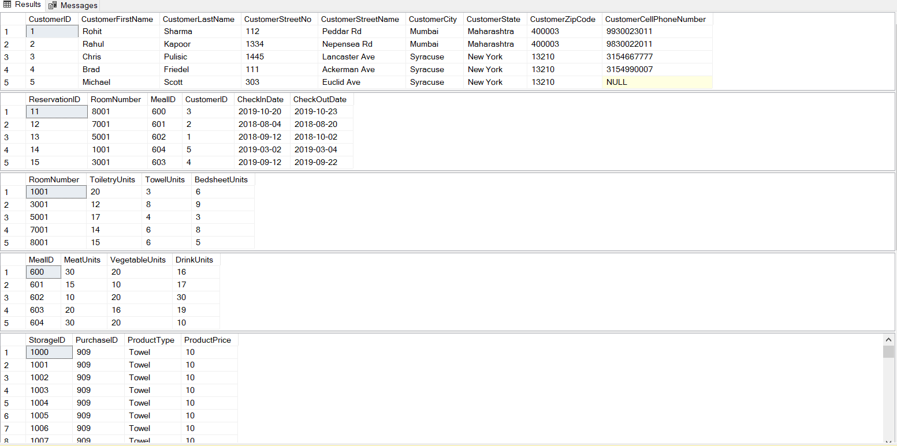

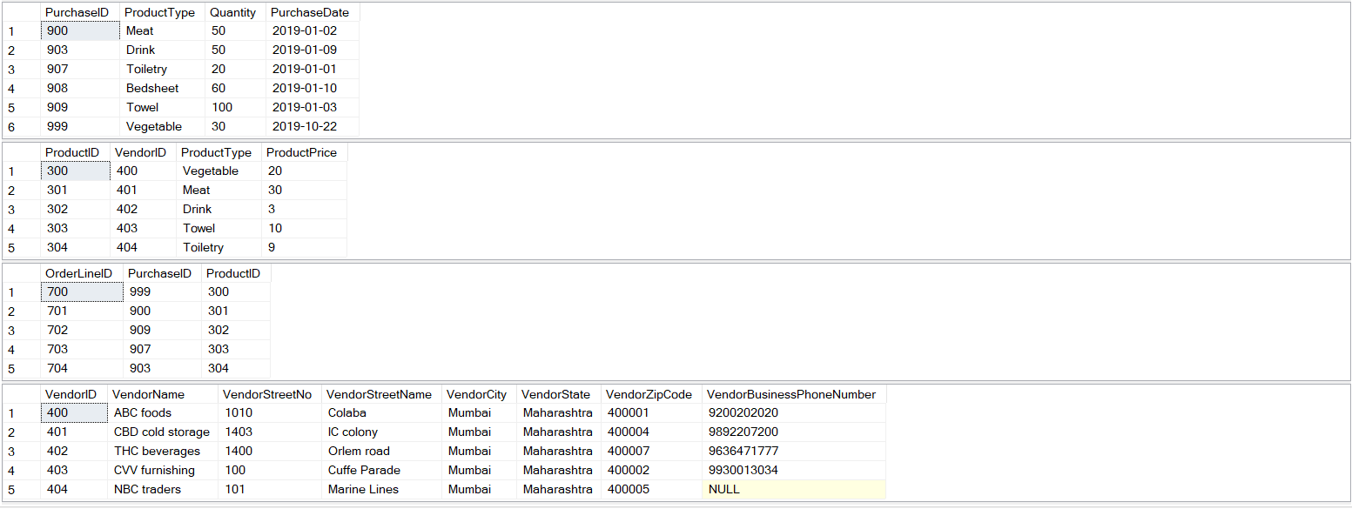

**Section VII: SQL Statements for Answering Major Data Questions.**

Major Data Questions**:**

1. How much room inventory is available for a reservation?

This question will aid the hotel manager in checking whether how much inventory (toiletries, towels and bedsheets) available in a room so that it can be allotted to a customer if the inventory levels are above the required level and if not then ask the room service staff to replenish them from the main inventory. This would help them in improving the customer satisfaction and keep a track as to how much inventory is used for a particular reservation. This information will then be rallied back to the purchase manager so that necessary purchases can be made if the inventory required for the rooms reaches a critical level in the main inventory. It would also aide the purchase manager in making bulk purchases as it would give an estimate as to how much room inventory is used up on an average in a particular month. This information is also useful to the sales head as it will help in the pricing analysis of the rooms.

1. How much restaurant inventory is available for a reservation?

This question will help the restaurant manager in ensuring that there is sufficient food inventory (vegetables, meat and drink products) left for a reservation for the complimentary breakfast and items ordered a la carte. It would help in ensuring that the restaurant never runs out of food items as it would negatively impact the customer satisfaction ratings if a particular food item isn’t available to the customer. If the inventory levels in the restaurant reaches a critical level then it can be replenished from the main inventory. The purchase manager would keep a track as to how much inventory is left in the main inventory. This data will also be useful to the sales head in the pricing analysis for the restaurant dishes and rooms.

1. What are the customer details for a reservation?

This would help the hotel manager in quickly pulling out the customer details. In cases when the customer details are required by the law agencies then it would aid in quickly pulling out the data. It could also be used to check whether the customer is a repeating customer at the time of the reservation so that better prices and special attention can be given as the hotel would want to keep their loyal customers satisfied.

1. What are the vendor details for a product?

This would aid the purchase manager in pulling out the vendor details for a particular product as it would be helpful at the time of reordering it. In cases when a product is defective it can be easily traced as to which vendor had supplied that product.

1. What are current inventory levels in storage?

This would aid the purchase manager in checking what are the current inventory levels so that if they reach a critical level then it could be reordered.

-- SQL Statements for Answering Major Data Questions.

--1) ---------- How much room inventory is there available for a reservation? ----------

SELECT re.ReservationID, ro.*

FROM Room ro

JOIN Reservation re

ON ro.RoomNumber = re.RoomNumber

--2) ---------- How much restaurant inventory is there available for a reservation? ----------

SELECT re.ReservationID, rm.*

FROM RestaurantMeal rm

JOIN Reservation re

ON rm.MealID = re.MealID

--3) ---------- What are the customer details for a reservation? ----------

SELECT re.ReservationID, c.*

FROM Customer c

JOIN Reservation re

ON c.CustomerID = re.CustomerID

--4) ---------- What are the vendor details for a product? ----------

SELECT p.ProductID, v.*

FROM Vendor v

JOIN Product p

ON v.VendorID = p.VendorID

--5) ---------- What are current inventory levels in storage? ----------

SELECT si.ProductType, COUNT(ProductType) 'Current Inventory'

FROM StorageInventory si

GROUP BY si.ProductType

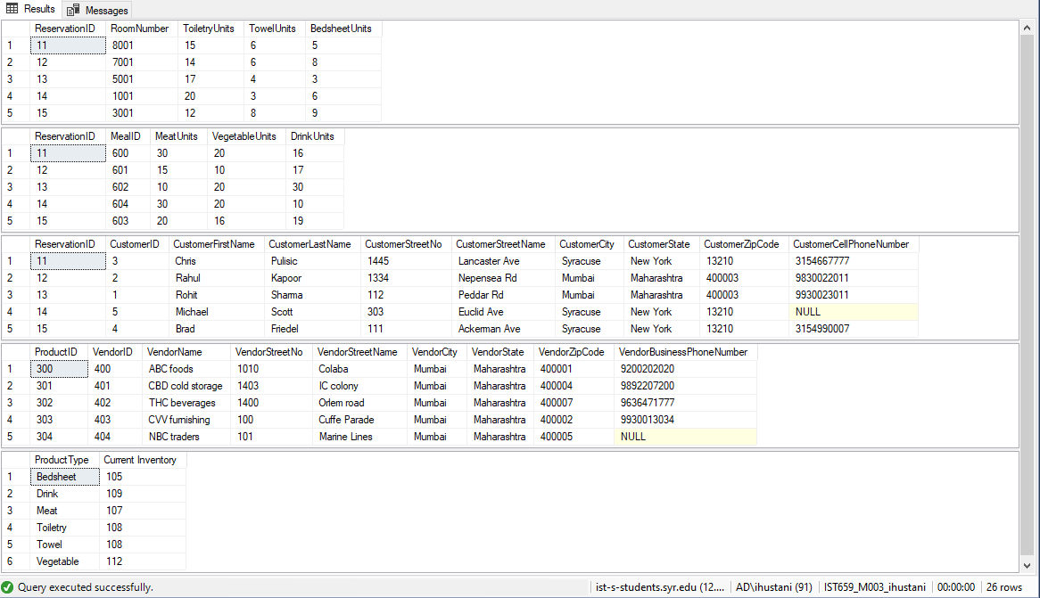

**PART 4 – INTERFACE IMPLEMENTATION**

**Section VIII: Forms**

1. **Customer**

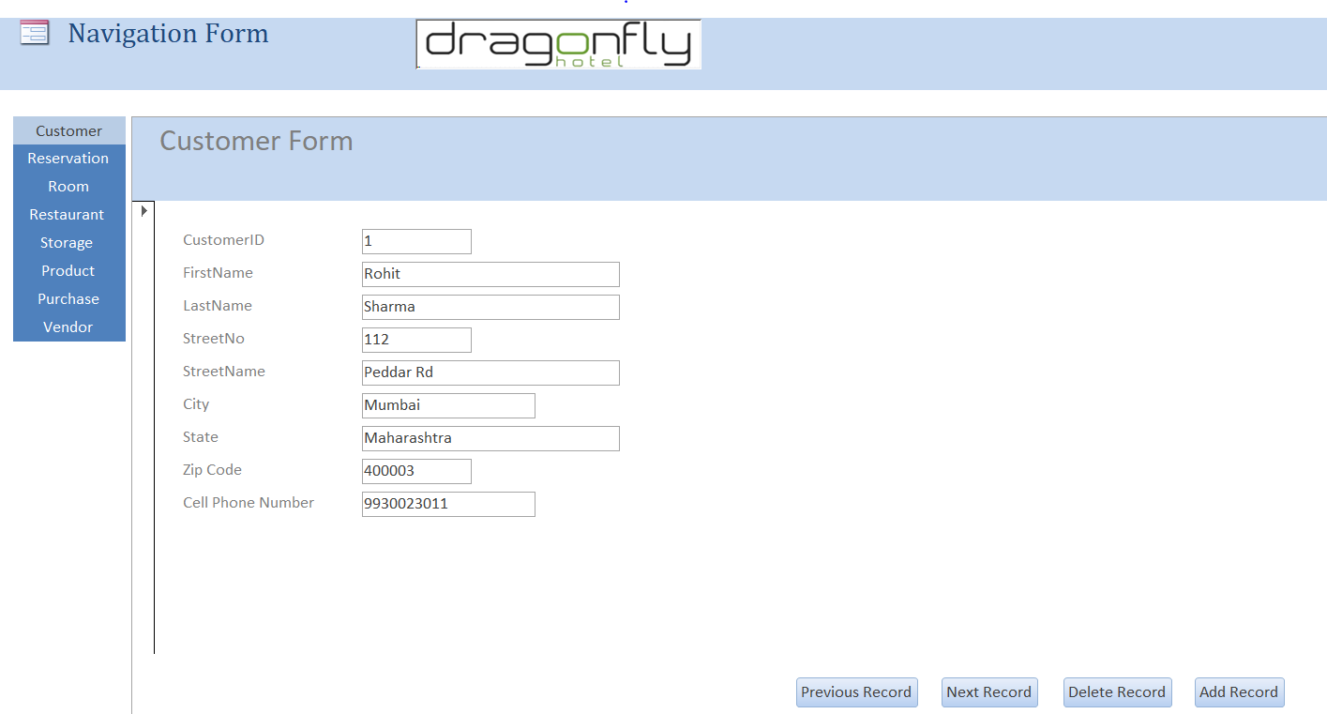

1. **Reservation**

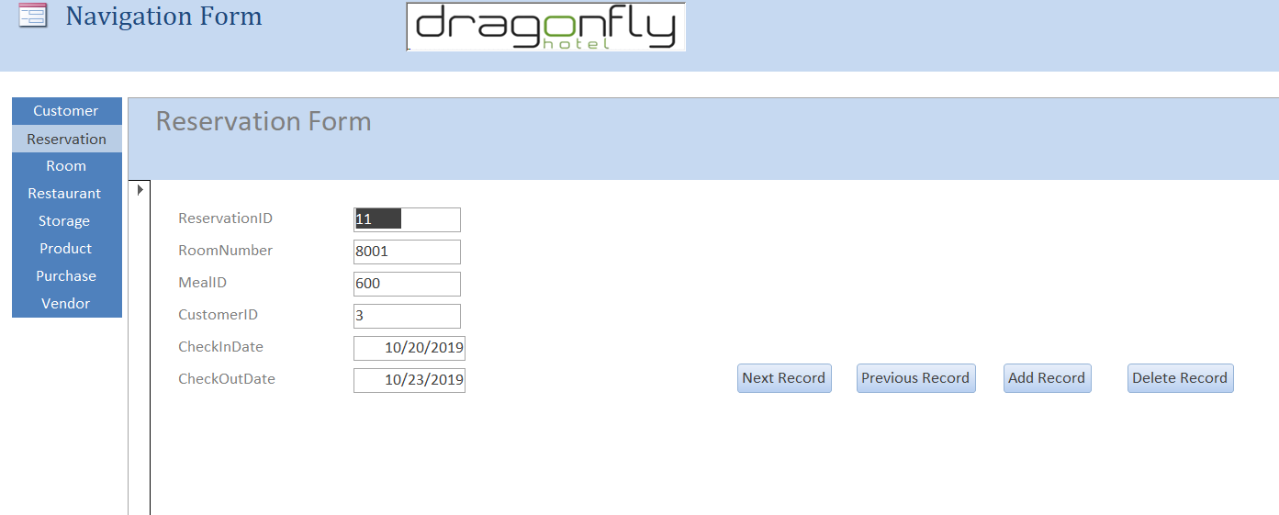

1. **Room**

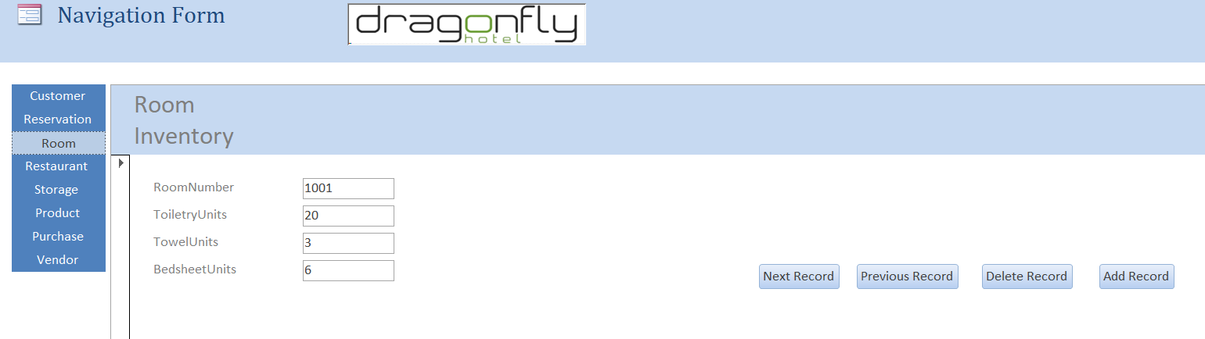

1. **Restaurant**

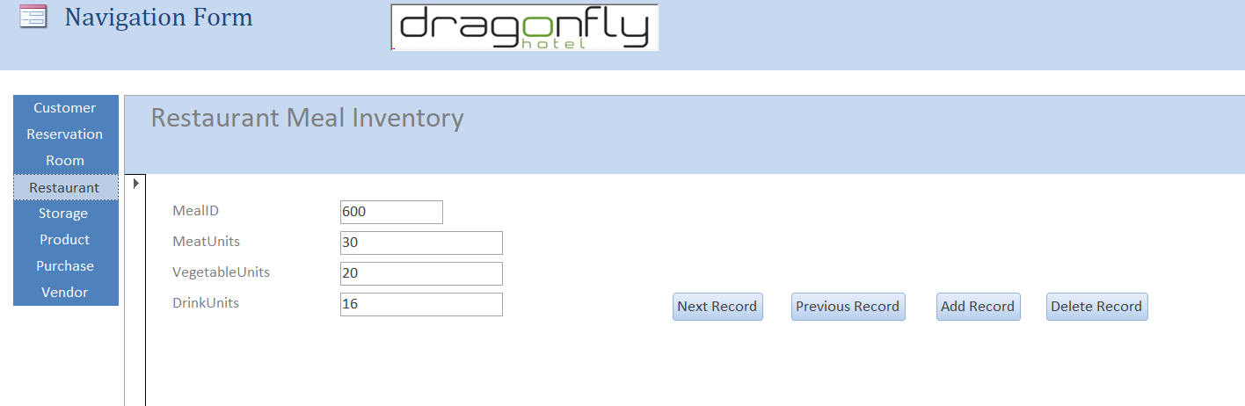

1. **Storage**

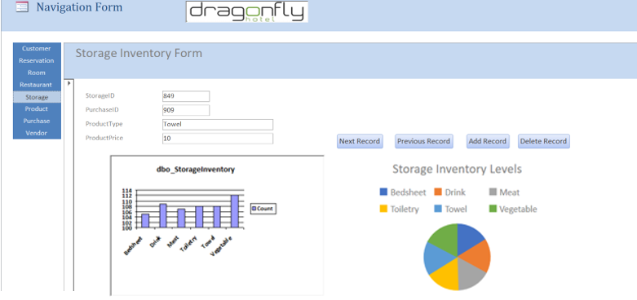

1. **Product**

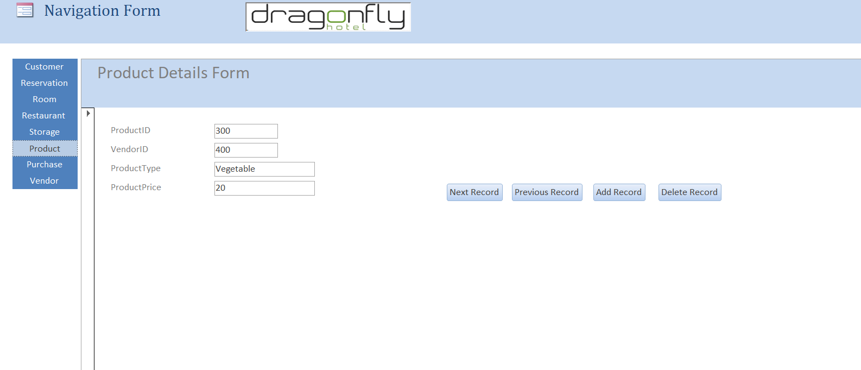

1. **Purchase**

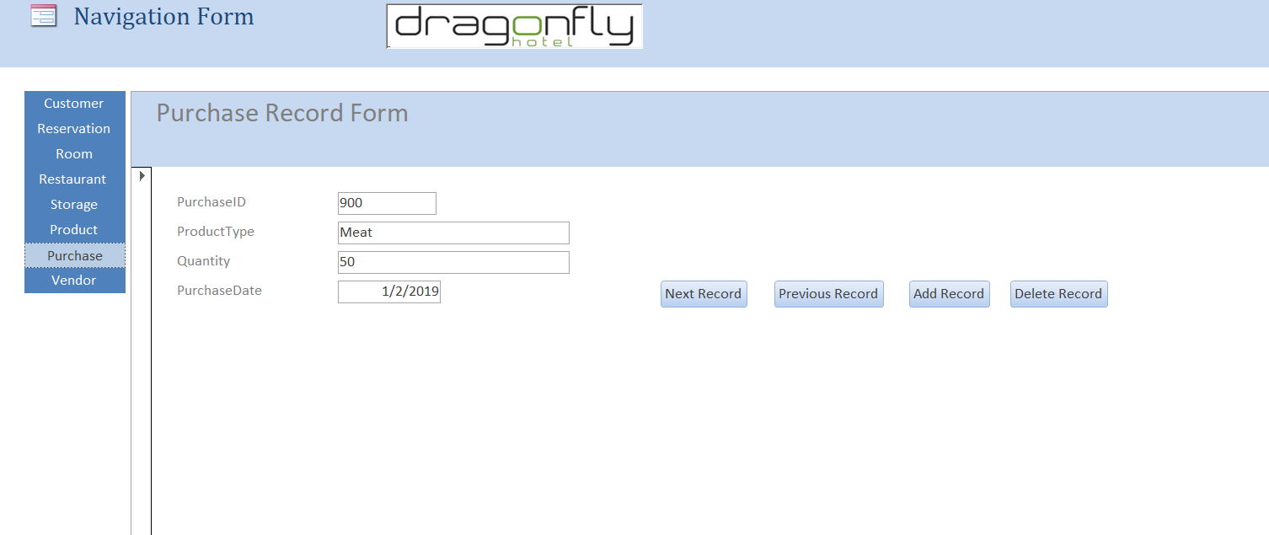

1. **Vendor**

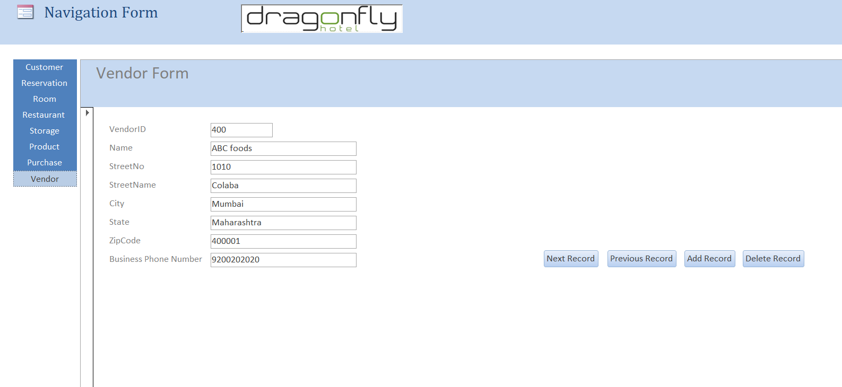

**Section IX: Reports**

1. How much room inventory is available for a reservation?

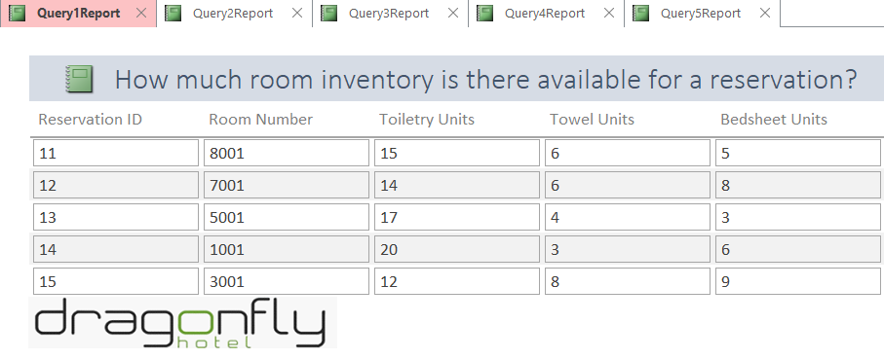

1. How much restaurant inventory is available for a reservation?

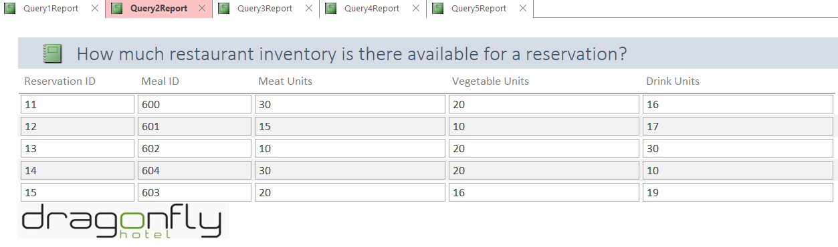

1. What are the customer details for a reservation?

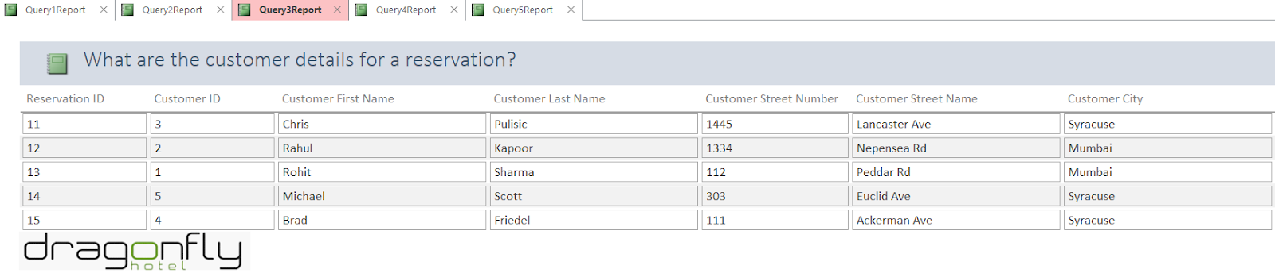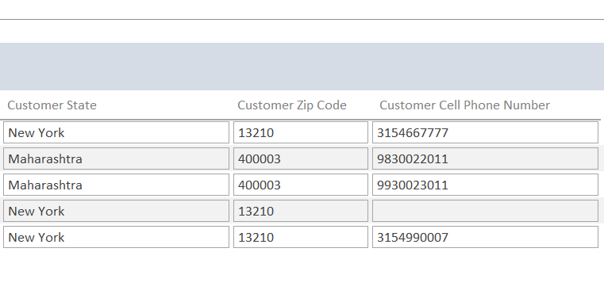

1. What are the vendor details for a product?

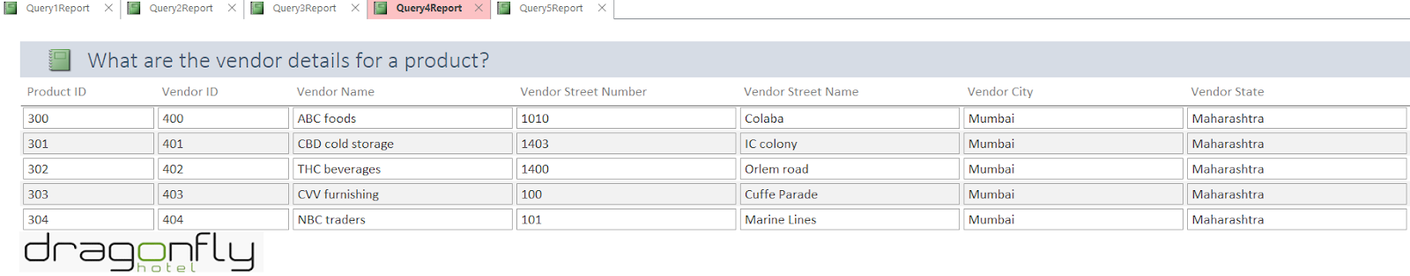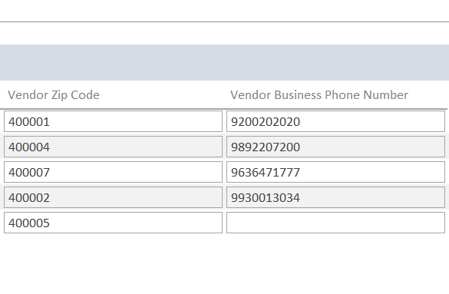

1. What are current inventory levels in storage?

