**Department of Electrical and Electronics Communication Engineering**

**Subject: Full Stack Development**

**Semester: VI AY 2025-26**

**Name: Rishabh Bajaj Class: T. Y. B. Tech.**

**Roll No: 1032221881 Batch:**

**Experiment No: 1**

**Name of the Experiment: Git and Version Control**

**Marks**

**Teacher’s Signature with date**

**Performed on: 10/01/25**

**Submitted on: 04/02/25**



**Aim:** Git repository and version control

**Objective:**

* To introduce the concepts and software behind version control, using the example of Git.
* To understand the use of 'version control' in the context of a coding project.
* To learn Git version control with Clone, commit to, and push, pull from a git repository.

**Platform:** Git, Git-Hub

**THEORY:**

Instructions: you are requested to write answer of following questions in A4 size pages.

1. What is Git? What is Version Control?

2. How to use Git for version controlling?

**Problem Statement:**

Create a public git repository for your team and submit the repo URL as a solution to this assignment, Learn Git concept of Local and Remote Repository, Push, Pull, Merge and Branch.

**Output:**

1. Screenshots of the output of problem statement to be attached.

2. Screenshots of execution of Git commands

**Conclusion:**

**Additional Links:**

<https://youtu.be/Ez8F0nW6S-w?si=chRvHv4k817yf-4d>

<https://youtu.be/q8EevlEpQ2A?si=NYoDbL1sZWgjVjTV>

**GitHub Link:**

<https://github.com/RishabhBajaj002/FSD_Lab/blob/main/Exp_1.docx>

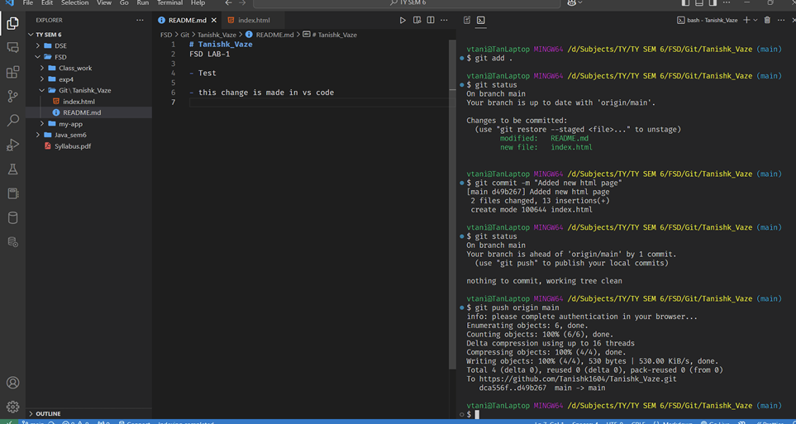

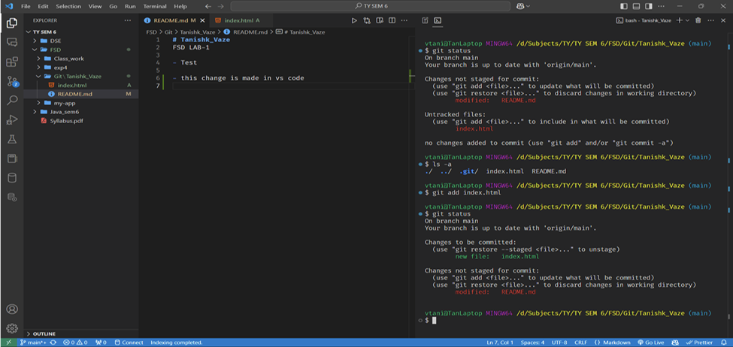

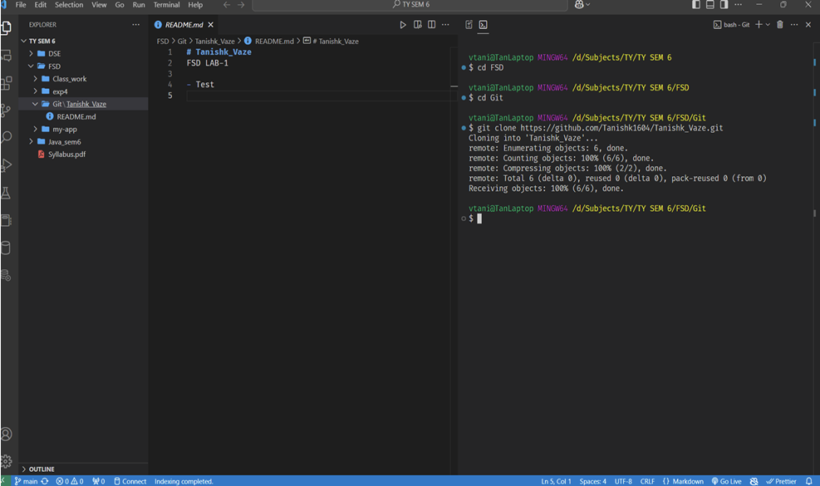

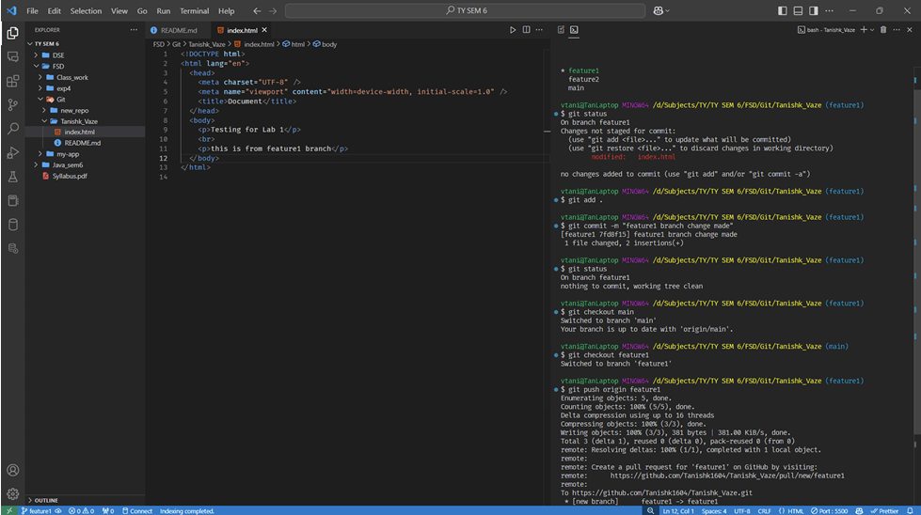

**Post lab question:**

1. What is branching in Git?
2. How to create and merge branches in Git? Write the commands used.
3. What is the difference between git reset, git revert, and git restore?

