**Department of Electrical and Electronics Communication Engineering**

**Subject: Full Stack Development**

**Semester: VI AY 2025-26**

**Name: Rishabh Bajaj Class: T. Y. B. Tech.**

**Roll No: 1032221881 Batch: G2**

**Experiment No: 2**

**Name of the Experiment: Responsive web design using HTML5 and BOOTSTRAP**

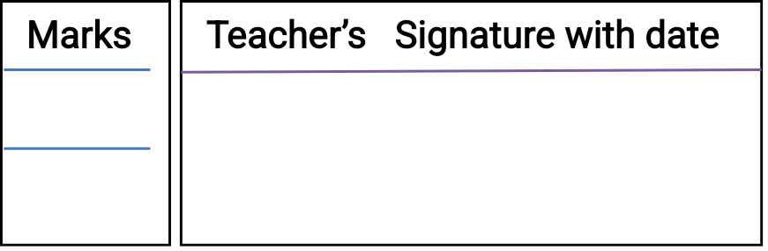

**Performed on: 9/01/2025**

**Submitted on: 5/02/2025**



**Aim:** Responsive web design using HTML5 and BOOTSTRAP

**Objective:**

* To understand HTML tags
* To learn the styling of web pages using CSS
* To learn Bootstrap Front End Framework.

**Platform:** HTML, CSS, BOOTSTRAP, VSCode

**THEORY:**

Instructions: you are requested to write answer of following questions in A4 size pages.

1. Name some new HTML5 elements useful for structuring a webpage.
2. Explain Bootstrap Grid System.
3. Explain in detail Bootstrap .container and .container-fluid class.
4. What are media queries in CSS?

**Problem Statement:**

Design and develop a responsive web page (For example student registration, course enrollment, library management system, online shopping system etc.) using Bootstrap front end framework. Web pages should contain HTML5 elements (Use all possible formatting for example font, colour etc.).

Web page should include various

* images,
* links within the page,
* tables
* lists
* form elements
* paragraphs
* links to other pages for navigation,
* new tabs.

Use Cascaded Style Sheets (CSS) to style the web pages designed. Make use of

* Three types of styles (Inline, Internal and External)
* border,
* margins,
* padding,
* navigation,
* dropdown list
* tag selector
* class selector
* id selector
* exploring background image and position property etc.

**Output:**

1. Screenshots of the output of problem statement to be attached.

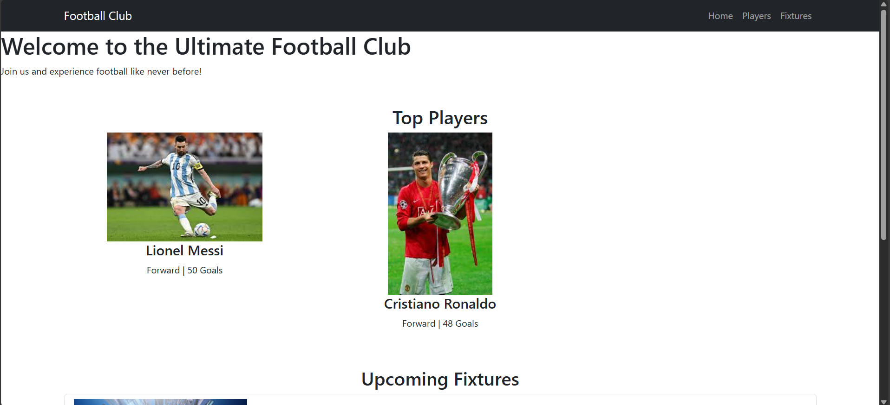

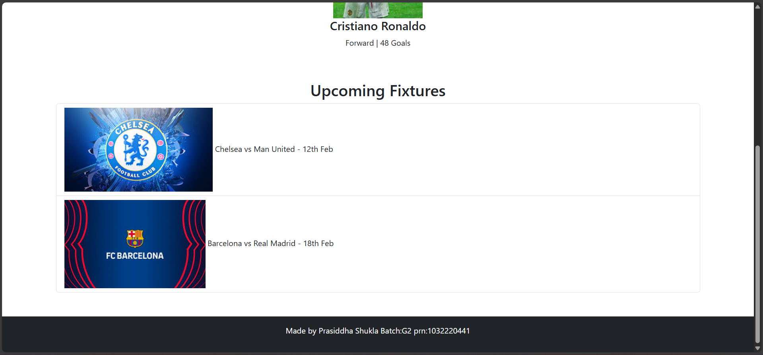

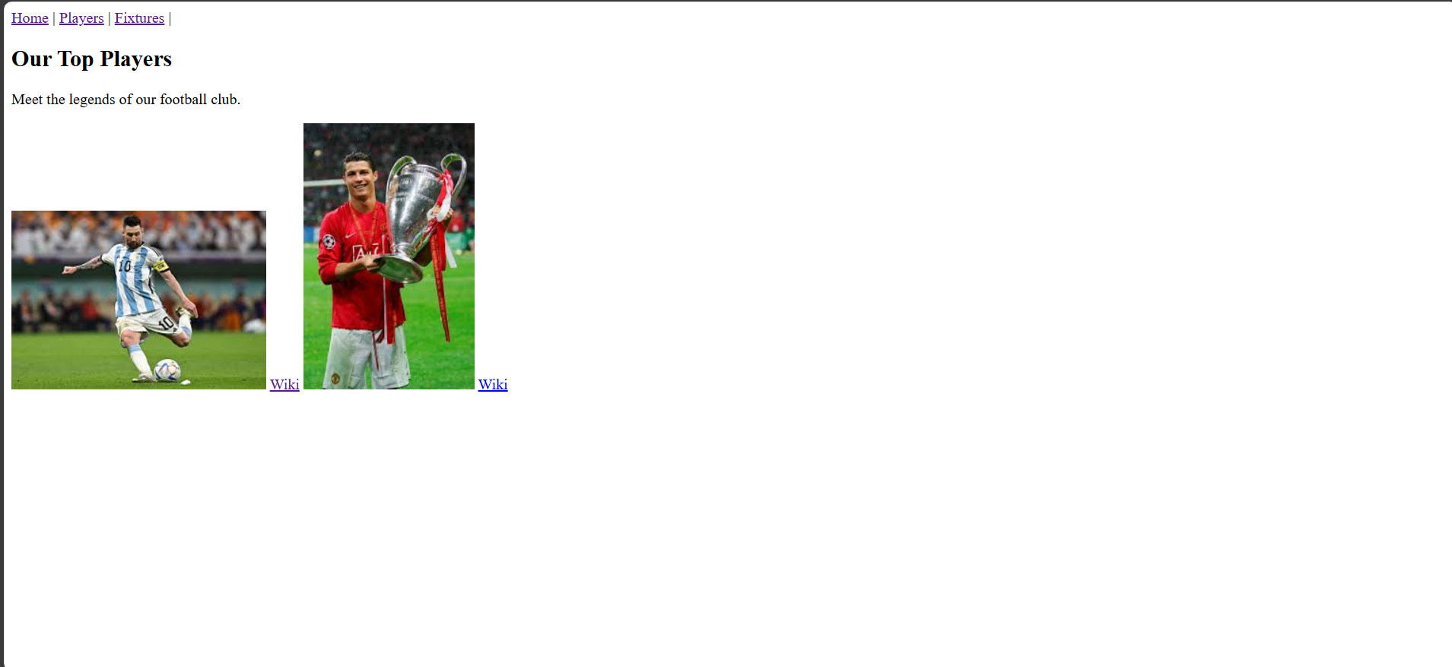



2. Share GitHub repository link of above project

<https://github.com/RishabhBajaj002/FSD_Lab/blob/main/Exp_2.docx>

**Conclusion:**

In this experiment, we successfully implemented responsive web design using HTML5 and Bootstrap, ensuring that the webpage adapts seamlessly to different screen sizes and devices. By utilizing Bootstrap’s grid system, responsive navigation bar, and pre-built components, we enhanced the layout, usability, and aesthetics of the website without extensive custom CSS. This approach simplifies development while maintaining a professional and user-friendly experience. Overall, the experiment demonstrated how Bootstrap efficiently streamlines web development, making modern, mobile-first designs more accessible and effective.

**Additional Links:**

<https://youtu.be/vpAJ0s5S2t0?si=r378S4khu8O4mPu2>

<https://youtu.be/_fBRGDxTnt4?si=EIIze6HhYXN0b6hk>

**Post lab question:**

1. What is a responsive website?
2. How Bootstrap helps to design a responsive website?
3. How does HTML5 improve accessibility in web design?

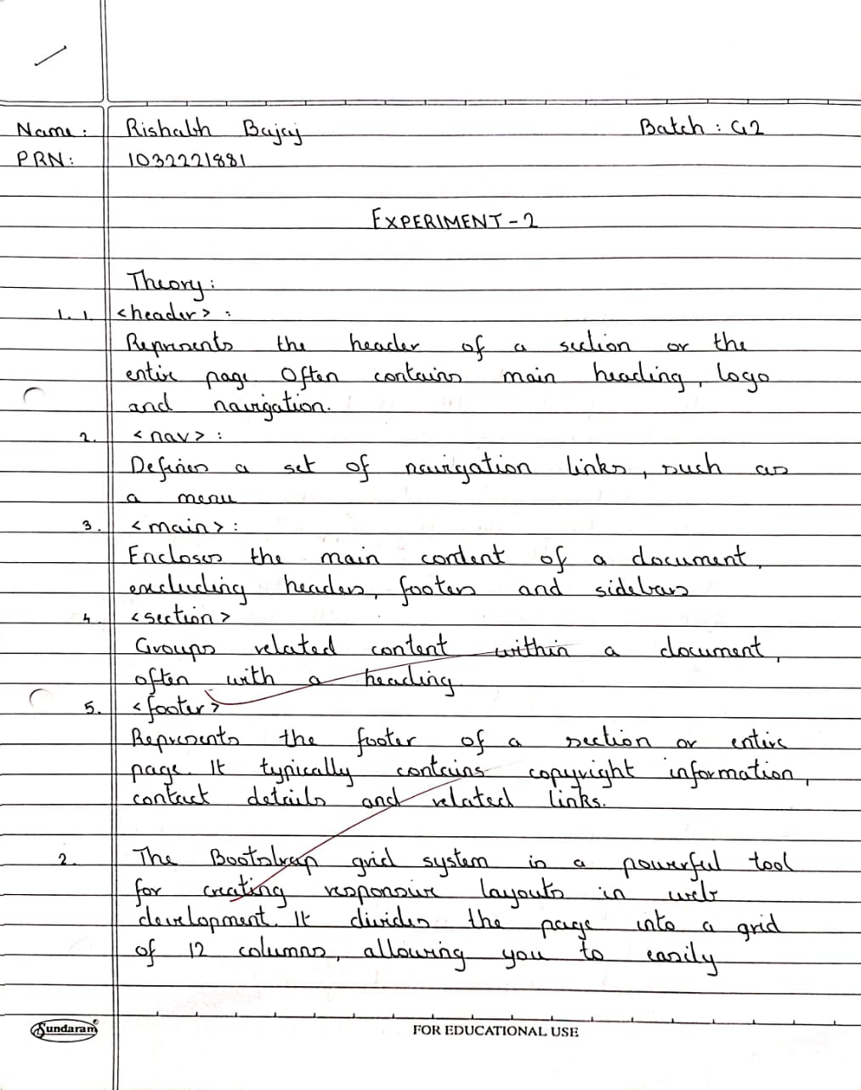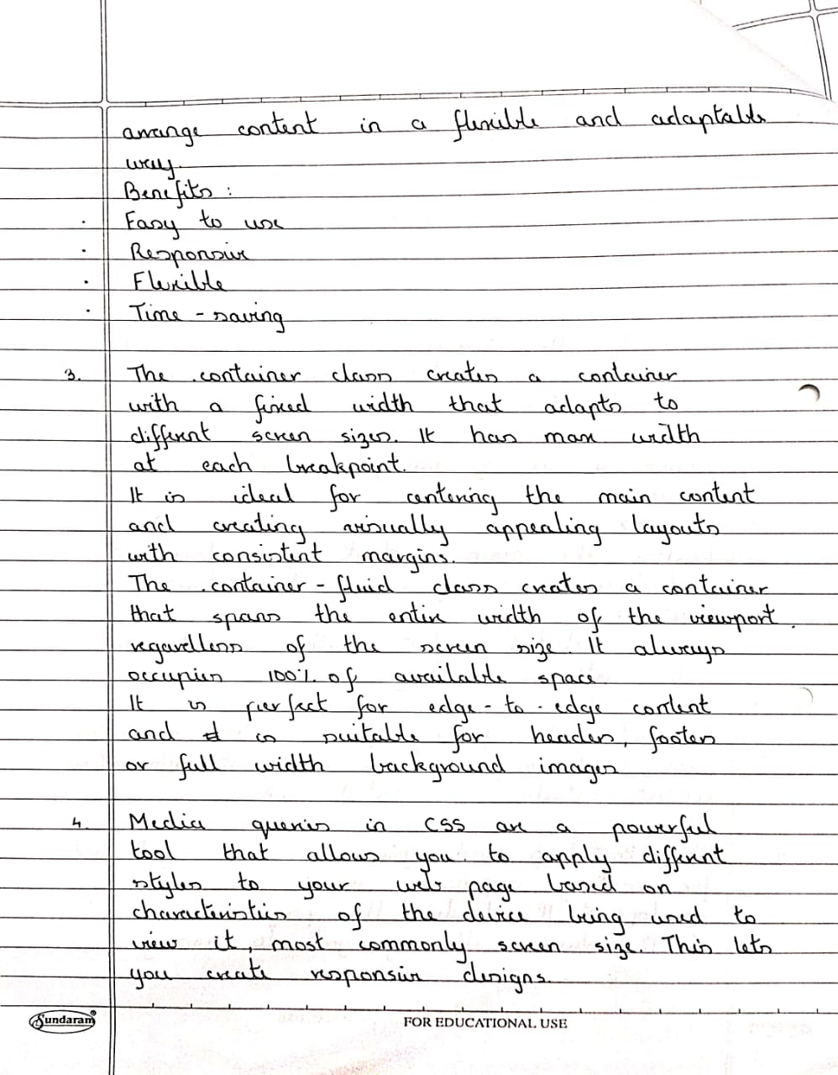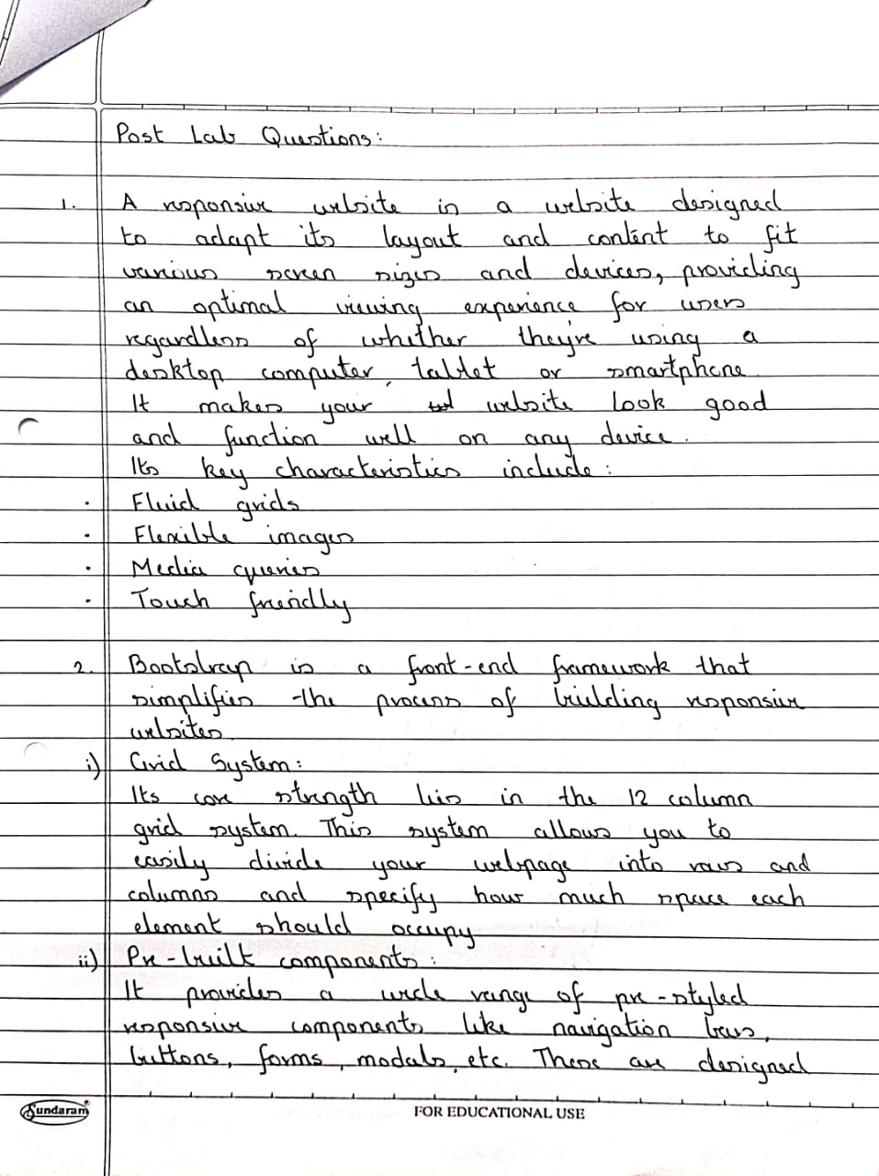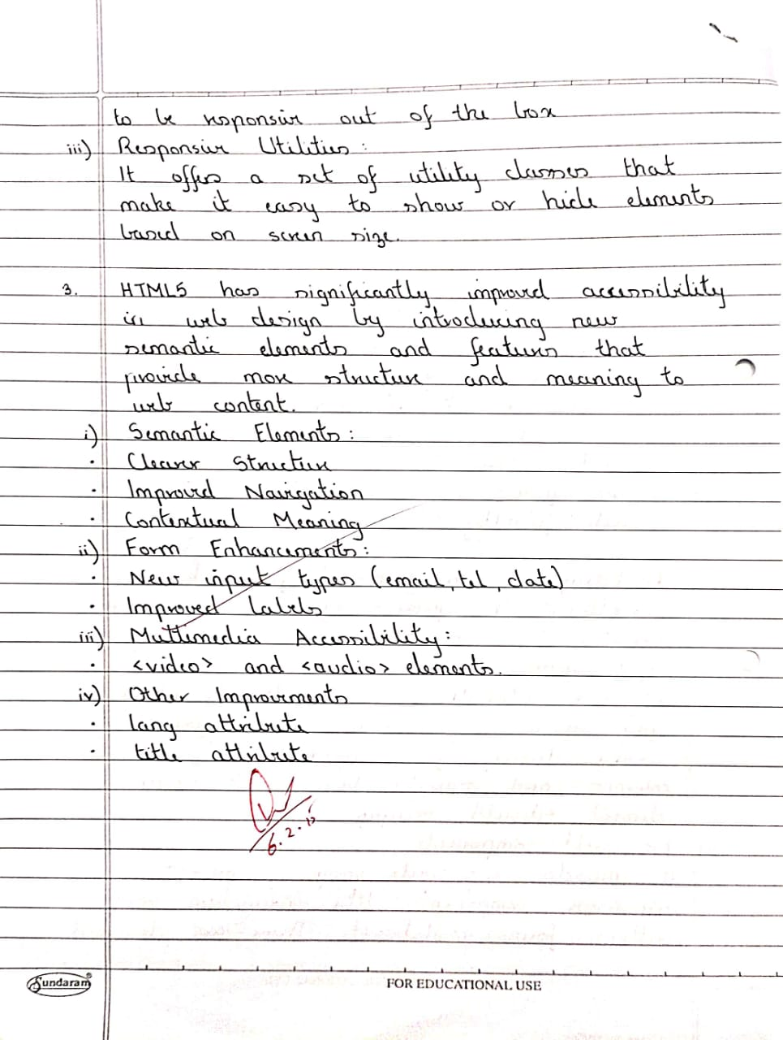x