GECO: Separating Delivery Evidence and Stop Authority in an Insulin-Pump Simulation Study
Author names, affiliations, contributions and corresponding-author information: pending the research team.

Abstract
Monitoring an automated insulin-delivery system requires distinguishing a permitted command from delivered fluid and accounting for the delivery withheld by containment. This paper evaluates GECO, an offline research method that separates requests, authorization, simulated emission, measurement reports and stop authority. A corrected causal estimator and forecast selector were evaluated on previously exposed internal test segments from 31 participants, comprising 77,110 matched 30-minute forecast pairs. Validation selected trend forecasting for 30 participants and persistence for one; selected forecasting reduced mean participant RMSE by 4.14 mg/dL relative to persistence, while the mechanistic forecast was worse for 28 participants. A prespecified comparison completed 4,608 fixed-request simulations and 576 feedback/stop sensitivity simulations with no execution failures. Under matched authority, the fuller detector increased stuck-on excess relative to a simpler detector by 0.137 research U in the original plant family and 0.085 research U in a Hovorka implementation. Overall, 2,108 main runs violated the physiological-domain screen, including 44 of 48 clean Hovorka runs per arm. A subsequent 2,048-run exploratory fasting supplement passed the declared domain screen but retained nuisance stops and condition-dependent excess/deficit tradeoffs. These findings support neither universal detector superiority nor clinical benefit. The contribution is a reproducible comparison that exposes containment tradeoffs and model limits, together with a proposed uncertainty-aware water/saline measurement protocol. IIT Patna physical measurements remain pending.
Index Terms— automated insulin delivery, runtime monitoring, delivery measurement, digital twin, causal forecasting, fault containment, simulation, metrology.

I. Introduction
An automated insulin-delivery loop converts glucose observations into pump commands. A command expresses an intended action; authorization determines whether that action is permitted; an endpoint acknowledgment reports message acceptance; and fluid delivery is a physical consequence. These quantities can diverge. An occluded outlet may deliver nothing after a valid command, while a malfunctioning actuator may emit more than authorized. A measurement report introduces another boundary because an instrument indication can be noisy, delayed or replaced in communication. A monitor must state which quantity it observes before its alarm can be interpreted.
Response introduces a second problem. Stopping future powered delivery can contain excess, but it also withholds subsequent requested delivery. A longer latch may improve one excess metric while increasing deficit, interruption or recovery time. Comparing a monitor that can stop an actuator with one that cannot conflates evidence quality with response authority. GECO investigates these distinctions through a shared-authority comparison and reports excess and deficit separately.
The relevant foundations already exist. GlucOS implements a BioKernel reference monitor and layered safeguards for automated insulin delivery [1]. KnowSafe studies prediction and mitigation of artificial-pancreas hazards, including consequences of intervention [2]. Pump calibration and Kalman-assisted delivery metrology also predate this work [3], [4]. GECO therefore makes no claim to invent a reference monitor, digital twin, insulin-pump measurement method or Kalman filter. Its contribution is a reproducible, outcome-neutral evaluation of an explicit evidence/authority model, including cases where a more elaborate detector performs worse.
Three questions organize the study. First, does the retained mechanistic estimator provide useful causal forecast evidence compared with simple baselines on supplied records? Second, how do detector and recovery policies change emitted delivery when requests and response authority are matched? Third, what measurements are still needed before a physical rig can supply a defensible virtual-patient input? The answers are separated because forecasting, fault discrimination, containment and physical measurement are different claims.
The completed contributions are: a corrected causal estimation and forecast-selection implementation with an internal retrospective evaluation; a prespecified simulation comparison using two structurally different plant families, matched exogenous inputs and complete outcome records; and an acquisition/reconstruction protocol that makes the missing physical evidence explicit. The main detector comparison is negative or mixed. The second plant also exposes substantial domain violations. These are central findings, not exclusions from the result denominator.

II. Prior Work and Scope
GlucOS places runtime checks around automated insulin delivery, while KnowSafe combines knowledge and data for hazard mitigation [1], [2]. Both limit any broad claim that an additional safety layer or predictive monitor is new. The present comparison asks a narrower question about authorization under separately represented delivery observations. It does not reproduce either system, execute a head-to-head benchmark against them, or show that their stated assumptions are invalid. Their experiments and threat models should not be replaced with the abstractions used here.
Bissig and colleagues examine insulin-pump calibration through discrete doses and their timing [3]. Girardot and colleagues describe Kalman-assisted pump-accuracy assessment [4]. These establish that delivery measurement requires more than command accounting. GECO borrows no numerical accuracy benchmark from those papers. Its simulated balance is an assumed observation model, and the conceptual bench remains unmeasured. JCGM 100 provides a framework for defining the measurand, corrections and uncertainty; it does not certify this apparatus [5].
Hovorka and colleagues provide the compartment equations and parameter means used for the independent plant implementation [6]. The original fasting-control study does not validate arbitrary meal/controller regimes in a derivative simulator. The UVA/Padova simulator has a separate model lineage and documented refinements [7]; it was not executed here, and no validation or regulatory history transfers to GECO. Unscented filtering is established [8], and personalized plasma-insulin estimation with Hovorka dynamics and a UKF has been studied [9]. GECO retains an extended Kalman implementation and reports no EKF–UKF experiment or universal filter ranking.
The literature review was bounded, with primary-source identities and claim locators recorded. Selected full-text sections supported GlucOS, KnowSafe, Hovorka and personalized-estimation comparisons. Pump-metrology access was partial or abstract-only, and the foundational UKF reference was checked bibliographically rather than reviewed in full during this update. These limits prevent unsupported performance comparisons. The distinct contribution is the executed matched study and its reproducible limitations, rather than an exhaustive novelty claim.

III. Quantities, Authority and Fault Model
At five-minute interval k, let $r_{k}$ denote the requested amount and $a_{k}$ the authorized amount, in research U. Let $m_{k}$ be latent emitted mass, $b_{k}$ the local cumulative balance indication, and $d_{k}$ the received interval-mass report. The simulator converts $m_{k}$ to plant input using the declared convention γ = 0.1005 g/research U. This mapping represents an offline water/saline abstraction. It is not a measured insulin concentration or a clinical dosing specification.
The main experiment generates one clean feedback request tape for each synthetic parameter unit and exogenous seed. Every paired arm receives that same $r_{k}$, meal sequence and noise arrays. A policy may inhibit or cap $a_{k}$; a simulated fault changes $m_{k}$; the measurement channel produces $b_{k}$ and $d_{k}$. Only $m_{k}$/γ drives the physiological plant. Neither noisy mass differences nor the potentially replaced network report can alter that evaluator input. The monitor receives reported CGM, available mass observations and prior authorized inputs, without evaluator glucose, emitted mass or fault-end labels.
Table I. Evidence quantities and access boundaries
Quantity | Meaning and access
Request $r_{k}$ | Clean controller intent shared across main-comparison arms
Authorization $a_{k}$ | Amount permitted by the detector/recovery policy
Emission $m_{k}$ | Latent actuator output; simulator and evaluator only
Local indication $b_{k}$ | Quantized, noisy cumulative observation available to every local guard
Received report $d_{k}$ | Interval report; may be replaced in one coordinated condition
Reported CGM $y_{k}$ | Sensor observation; may be biased or missing
Physical reconstruction | Future validated estimate with uncertainty; not available in this study
The controller uses a unit-specific equilibrium basal assumed known at setup. Above 150 mg/dL it adds 0.0025 research U per mg/dL above that threshold; it suspends below 100 mg/dL or a forecast below 90 mg/dL, with a 0.3 research-U interval cap. The 120 mg/dL value defines equilibrium initialization, not the implemented correction threshold. Its configuration is common across arms. Knowing equilibrium basal is a simulation setup assumption, not proof that the transferred twin identifies an individual physiology.
Eight conditions are evaluated: clean; a twofold powered actuator-input multiplier before quantization, gain, noise and offset; zero delivery from occlusion; a nominal stuck-on addition of 0.25 research U, scaled by 1.015 to 0.25375 emitted research U per powered interval; CGM bias of +40 mg/dL; missing CGM; the twofold input multiplier with +25 mg/dL CGM bias; and the latter combination with the received mass report replaced by authorized mass. Perturbations occupy intervals 144–167, corresponding to hours 12–14. They are numerical fault/compromise abstractions. No radio, packet, credential, firmware or live-device attack was performed.
The report-replacement condition retains the unmodified local balance guard in every arm. It consequently evaluates a specified remaining observation path, not successful detection after all physical witnesses are compromised. If two physical histories induce identical available observations and authority states, the practical monitor receives no additional truth from the simulation. The separately labelled oracle knows the physical-fault window and inhibits delivery during it; it is an explanatory privileged reference, not an achievable detector.

IV. Causal Estimation and Forecast Evidence

A. State, timing and covariance
The retained five-state research model contains plasma glucose G, remote insulin action X, insulin state I, gut carbohydrate Q and interstitial glucose $G_{i}$:
$\dot{G}=e_{gp}−p_{1}G−Xmax(G,30)+k_{c}k_{a}Q, \dot{X}=−p_{2}X+p_{3}(I−I_{b}),$
$\dot{I}=−k_{i}I+k_{u}u, \dot{Q}=−k_{a}Q+c, {\dot{G}}_{i}=(G−G_{i})/τ_{i}.$ (1)
Here u is research U/min and c is carbohydrate g/min. Five one-minute Euler substeps advance each observation interval. Numerical clamps retain G and $G_{i}$ within 20–600 mg/dL, X at or above −$p_{1}$/2, and I and Q nonnegative. The transition Jacobian includes these piecewise operations; active clamp rows have zero derivative. These are numerical rules, not independently validated biological boundaries.
The update at time k advances the model using $a_{k−1}$ and carbohydrate input from the previous interval, then assimilates the current CGM. Initialization uses the first current observation and a frozen basal steady-state approximation. Initializing and reset observations do not generate valid prediction errors. Missing data break trend/AR history, and a return after 60 minutes missing resets the filter. Hidden insulin and gut history are approximated on reset, which remains a limitation.
For $H=[0,0,0,0,1]$, the nominal innovation variance and gain are $s_{k}=HP_{k}^{−}H^{T}+R_{k}$ and $K_{k}=P_{k}^{−}H^{T}/s_{k}$. Covariance uses the Joseph form [10]:
$P_{k}^{+}=(I−K_{k}H)P_{k}^{−}(I−K_{k}H)^{T}+K_{k}R_{k}K_{k}^{T}.$ (2)
The same nominal $R_{k}$ enters gain and covariance. Its base value is 81 $(mg/dL)^{2}$, increased according to predicted low/high CGM; process-noise values remain declared heuristic settings. Symmetrization and finite/eigenvalue checks separate negligible roundoff projection from material covariance failure, which triggers a recorded reset. Numerical tests establish implementation properties under their fixtures; they do not establish clinical estimation accuracy.
A fitted scale α affects anomaly normalization only: $z_{k}^{raw}=(y_{k}−H{\hat{x}}_{k}^{−})/\sqrt{αs_{k}}$. It does not change gain, state or covariance. Adjacent valid fit innovations estimate ρ, clipped to [0,0.98], and the monitoring statistic is
$z_{k}=(z_{k}^{raw}−ρz_{k−1}^{raw})/\sqrt{1−ρ^{2}}.$ (3)
Initializing/reset observations remain invalid; the first valid innovation after a gap/reset is unwhitened. Let $w_{k}^{0}$ be the AR-whitened nominal innovation before α scaling. Then $α=max({10}^{−6},[q_{0.95}(|w^{0}|)/1.96]^{2})$. This calibration does not make observations independent or Gaussian; empirical coverage and alarm burden are reported separately.

B. Fitting, selection and internal evaluation
Supplied records were associated with HUPA-UCM version 1 and D1NAMO version 1.2.0 [11], [12]. The source repositories identify CC BY 4.0 and CC BY-SA 4.0, respectively. This analysis used the supplied local records and loader transformations, without obtaining new participant data. HUPA preprocessing can include interpolation, while D1NAMO carbohydrate conversion from calories and slow-insulin allocation are proxies rather than verified administration records. Forecasts are causal with respect to the supplied sample order, but upstream offline interpolation may not reproduce observations available in real time. Absence of future-array access does not establish that every preprocessed input was generated causally.
Chronological splits were floor(0.5N), floor(0.75N) and the remaining segment. Eligibility required at least 288 fit slots and 144 tune/test slots, at least 50% supplied finite CGM in each segment, and 50 forecast pairs after a 36-slot warmup. Four quantities—$e_{gp}$/$p_{1}$, $p_{1}$, $k_{c}$ and $p_{3}$—were fitted within prespecified log bounds using two deterministic least-squares starts. The objective used causal 30-minute mechanistic residuals at every sixth eligible fit origin. Basal hold came from the fit-window median supplied basal; no clinical sensitivity-rule prior constrained $p_{3}$. Optimizer convergence does not establish unique physiological identification.
Every eligible origin produced three predictions on the same target/mask. The mechanistic forecast repeated frozen basal and assumed no future meals; persistence retained current CGM; trend used up to four consecutive observations, an ordinary least-squares slope clipped to ±3 mg/dL/min, and 0.5 damping over 30 minutes. Future observations, meals and insulin records were unavailable to prediction. This conservative timing may leave contemporaneous information unused, but it is common to all policies. Lowest tune RMSE selected the runtime policy, with persistence preferred in ties.
The selected forecast’s fit errors ε provided the scale $σ_{6}=max(1,q_{0.95}(|ε|)/1.96)$ mg/dL. Each physiology channel received half a one-episode/day tune budget over thresholds from 4 to 128 in increments of 0.5. The alarm union was evaluated separately; meeting the tune budget did not guarantee test performance. Configuration was frozen before a separate test invocation. These segments had been exposed in earlier project work, so the final evaluation is an internal chronological test, not new external validation. Participant-level paired bootstrap intervals used 10,000 resamples, with equal participant weighting.

V. Shared-Authority Monitoring and Recovery
For authorized amount $a_{k}$, the expected mass accounts for simulated quantization and offset:
$μ(a_{k})=1.015γ round(200a_{k})/200+0.0015 (a_{k}>0),$ (4)
and μ(0)=0. Actual nominal emission has 0.0008 g Gaussian noise on positive quantized delivery and is bounded below by zero. The cumulative balance uses the median of five observations with 0.003 g Gaussian noise, then 0.01 g quantization. Signed interval differences are retained; they are not rectified into simulated plant input.
The simple score is $|d_{k}−μ(a_{k})|/σ_{m}$. The fuller detector maintains delivery and physiology two-sided CUSUMs. With standardized input v, positive and negative accumulators update as $C^{+}←max(0,C^{+}+clip(v,−6,6)−0.5)$ and $C^{−}←max(0,C^{−}−clip(v,−6,6)−0.5)$; $C=max(C^{+},C^{−})$. The physiology group selects the signed member with greatest absolute magnitude from the standardized innovation and due causal forecast residual. Both are transformations of the same CGM stream and count as one group. The fuller score is
$S_{k}=max(C_{m,k},\sqrt{C_{m,k}C_{g,k}}).$ (5)
Absent a current valid physiology input, only the delivery term is used. This heuristic score is not a calibrated probability. Full versus simple changes both temporal aggregation and physiology corroboration; it cannot isolate the physiology channel’s incremental contribution. Section VII-E examines that component-policy question in a narrower post-primary fasting supplement.
Both detectors share a 0.3 research-U cap, a local interval excess margin of 0.03 g, a 12-interval cumulative excess margin of 0.05 g, and a 1.05 authorized-mass factor. Six consecutive missing CGM samples also trigger containment. Separate thresholds strictly exceeded the maximum warmup-excluded statistic over 32 clean calibration runs: 7.44947 for full and 3.10096 for simple. Zero empirical statistical containment in these tuning runs is a finite-sample fitting result.
The six arms are full/manual, full/supervised, simple/manual, simple/supervised, sham/manual and oracle. Sham disables the statistical detector but retains local-budget and sensor-quality rules. All practical arms use identical local observations and stop authority. The study adapter imports the corrected estimator/controller components; it does not execute the complete legacy protocol, attestation or security-kernel stack.
Containment is observed at the end of an interval and inhibits subsequent powered delivery. Already emitted mass cannot be removed. A fixed operator authorization occurs every 120 minutes, independently of fault labels. Reset requires at least 30 minutes since the trip interval ended, six quiet local observations with absolute net change at most 0.01 g, and available current CGM. Manual emulation clears the latch. Supervised emulation enters three verification intervals capped at min($r_{k}$,0.08), requiring positive expected delivery and aggregate measured mass within 0.012 g of expectation, then six similarly capped probation intervals. Missing CGM during verification, or failure of its aggregate check, relatches. No missed amount is accumulated for catch-up.
For each interval k:
Read current reported CGM; update twin with prior authorized inputs.
Obtain shared clean request, or own feedback request in sensitivity runs.
If a scheduled operator slot satisfies cooldown and observed quiet rules:
clear latch manually, or enter bounded verification.
Authorize according to RUN / LATCHED / VERIFY / PROBATION state.
Simulate emission, local indication and received report separately.
Update delivery/physiology evidence and shared local/quality rules.
At interval end, latch on any applicable trigger.
Advance evaluator plant from emitted mass only; preserve complete record.
Quiet observations can be misleading, and zero-demand verification cannot confirm delivery. Operator availability and the selected schedule are assumptions. These rules emulate supervision; they are not evidence of autonomous, safe restart.

VI. Simulation Design and Analysis
Each plant family contains eight calibration and 24 locked test parameter units, with two repeated seeds per unit. The original family uses (1), while the second is a GECO implementation of Hovorka equations 1–7 and Tables 1–2 [6]. The Hovorka plant has accessible/remote glucose $Q_{1}$,$Q_{2}$, two subcutaneous insulin states $S_{1}$,$S_{2}$, plasma insulin I, three insulin-action states $x_{1}$,$x_{2}$,$x_{3}$, and two gut transit states. Its glucose dynamics are
${\dot{Q}}_{1}=−F_{01}^{c}−x_{1}Q_{1}+k_{12}Q_{2}−F_{R}+U_{G}+EGP_{0}(1−x_{3}),$
${\dot{Q}}_{2}=x_{1}Q_{1}−(k_{12}+x_{2})Q_{2}, G=Q_{1}/V_{G}.$ (6)
Insulin actions follow ${\dot{x}}_{i}=k_{ai}(S_{Ii}I−x_{i})$; subcutaneous insulin forms a two-stage transit chain. The two gut states implement the published meal impulse response for interval-constant input. Q is in mmol, S in mU, I in mU/L, $x_{1}$/$x_{2}$ in $\min^{−1}$ and $x_{3}$ dimensionless. Conversions are 1000 mU/U, 0.1801559 g glucose-equivalent carbohydrate/mmol and 18.01559 mg/dL per mmol/L glucose. The original Table 2 sensitivity means, visually verified in the primary paper, are $51.2×{10}^{−4}$ and $8.2×{10}^{−4}$ $\min^{−1}$ per mU/L and $520×{10}^{−4}$ per mU/L.
A nonnegative fasting equilibrium at 120 mg/dL supplies basal initialization; one-minute RK4 substeps integrate Hovorka dynamics. A nine-minute sensor lag is a separately disclosed extension. Body weight and family-specific parameter factors are synthetic engineering variations, not draws from a fitted patient distribution. Some original-family fields do not affect that model, so perturbation dimensions are not identical across families. The pooled twin uses coordinate-median fresh calibration parameters and the modal selected forecast policy, which was trend; it is a transfer configuration rather than a participant-specific synthetic twin. Unlike real-data initialization from current CGM, the synthetic twin resets to 120 mg/dL and does not assimilate the first sample.
The main matrix is 48 test units × 2 seeds × 8 conditions × 6 arms = 4,608 runs. Each contains 576 intervals, or 48 hours. Meals occur three times daily with paired timing/amplitude variation. CGM, pump and balance draws are paired by family/unit/seed. Statistical warmup is three hours. The independent unit is the synthetic parameter vector; seeds are repeated realizations within it.
The 576-run sensitivity uses the first six locked units per family, both seeds, four conditions and full/simple supervised policies. Each arm generates feedback-dependent requests and uses an arm/stop-matched clean reference. Three stop assumptions are evaluated: inhibit subsequent powered delivery; allow one additional five-minute powered interval; or add a residual tail of 0.02 research U for three intervals. These assumptions are not measured rig dynamics, and this feedback estimand is distinct from the main fixed-request comparison.
For actual emitted amounts $e_{k}=m_{k}/γ$ and paired clean reference $e_{k}^{0}$, delivery outcomes are
E+=k​max(ek−ek0,0), E−=k​max(ek0−ek,0), Enet=k​(ek−ek0). (7)
An interruption requires positive request and zero emission. Commanded latch exposure uses state before emission, avoiding an interval-boundary shift. Recovery is the first six-interval post-fault window without a latch and with authorization at least 95% of request, with some positive demand. Its onset and confirmation 30 minutes later are distinct; this measures authorization restoration, not physical or clinical recovery. Censoring is retained. First-trip latency is relative to scheduled onset and may be negative for an earlier nuisance trip.
All plant-domain failures remain in the denominator. In Hovorka, $x_{3}$>1 makes the published endogenous-production term negative; the equation is retained and separately flagged. Negative/nonfinite or other screened state violations are also recorded. Original-family plasma/interstitial/action boundary counts expose clipping beyond its plasma-domain screen. Neither a passing screen nor numerical boundedness establishes physiological validity. Glucose-band results on invalid trajectories are mathematical summaries.
Paired differences average the two seeds within each parameter unit, then use 4,096 percentile bootstrap resamples of units. Families, conditions, recovery policies and stop assumptions remain separate. Intervals describe this synthetic design; they are not patient uncertainty or multiplicity-adjusted superiority tests. Initial specification and three pre-outcome amendments preserve timing/domain corrections. Sources and configuration were frozen before execution, with complete attempts, failures and per-sample traces retained.

VII. Results

A. Internal forecast evaluation
Of 34 supplied participant records, 31 were evaluated: 24 HUPA and seven D1NAMO. D1NAMO 003 and 009 were excluded for insufficient length/coverage, and HUPA0017P failed input validation because supplied bolus values included −1 and −3 U. They were not silently repaired. An earlier packaging/import-order failure was retained as a separate attempt; the final frozen fit and test were separate invocations.
The 31 evaluations contained 77,110 matched forecast-origin/target pairs. HUPA0027P contributed 41,285 pairs, making pooled-pair accuracy strongly duration-weighted; equal-participant summaries were therefore used. Validation selected trend for 30 participants and persistence for one, with no mechanistic selection. The selected policy improved on persistence for 30 participants and tied for one. The mechanistic forecast was worse than persistence for 28 of 31 participants.
Table II. Internal participant forecast evaluation
Forecast | Median participant test RMSE (mg/dL) | Mean paired RMSE minus persistence, 95% interval (mg/dL)
Mechanistic | 25.77 | +3.73 [2.56, 4.91]
Persistence | 22.56 | Reference
Damped trend | 17.83 | −4.00 [−4.95, −3.03]
Tune-selected policy | 17.59 | −4.14 [−5.02, −3.33]
Median empirical nominal-95% coverage was 96.05% for innovations and 95.82% for selected forecasts, with participant ranges 86.12–98.73% and 87.50–98.92%. Near-nominal median coverage obscures participant variation. Thirteen participants exceeded one union alarm/day on test, with a maximum of 12/day; the median was 0.814/day. Twenty-four fits were near at least one parameter bound. Thus validation-selected causal forecasting improved this internal prediction comparison, but neither reliable physiological identification nor a uniformly low monitoring burden was demonstrated.
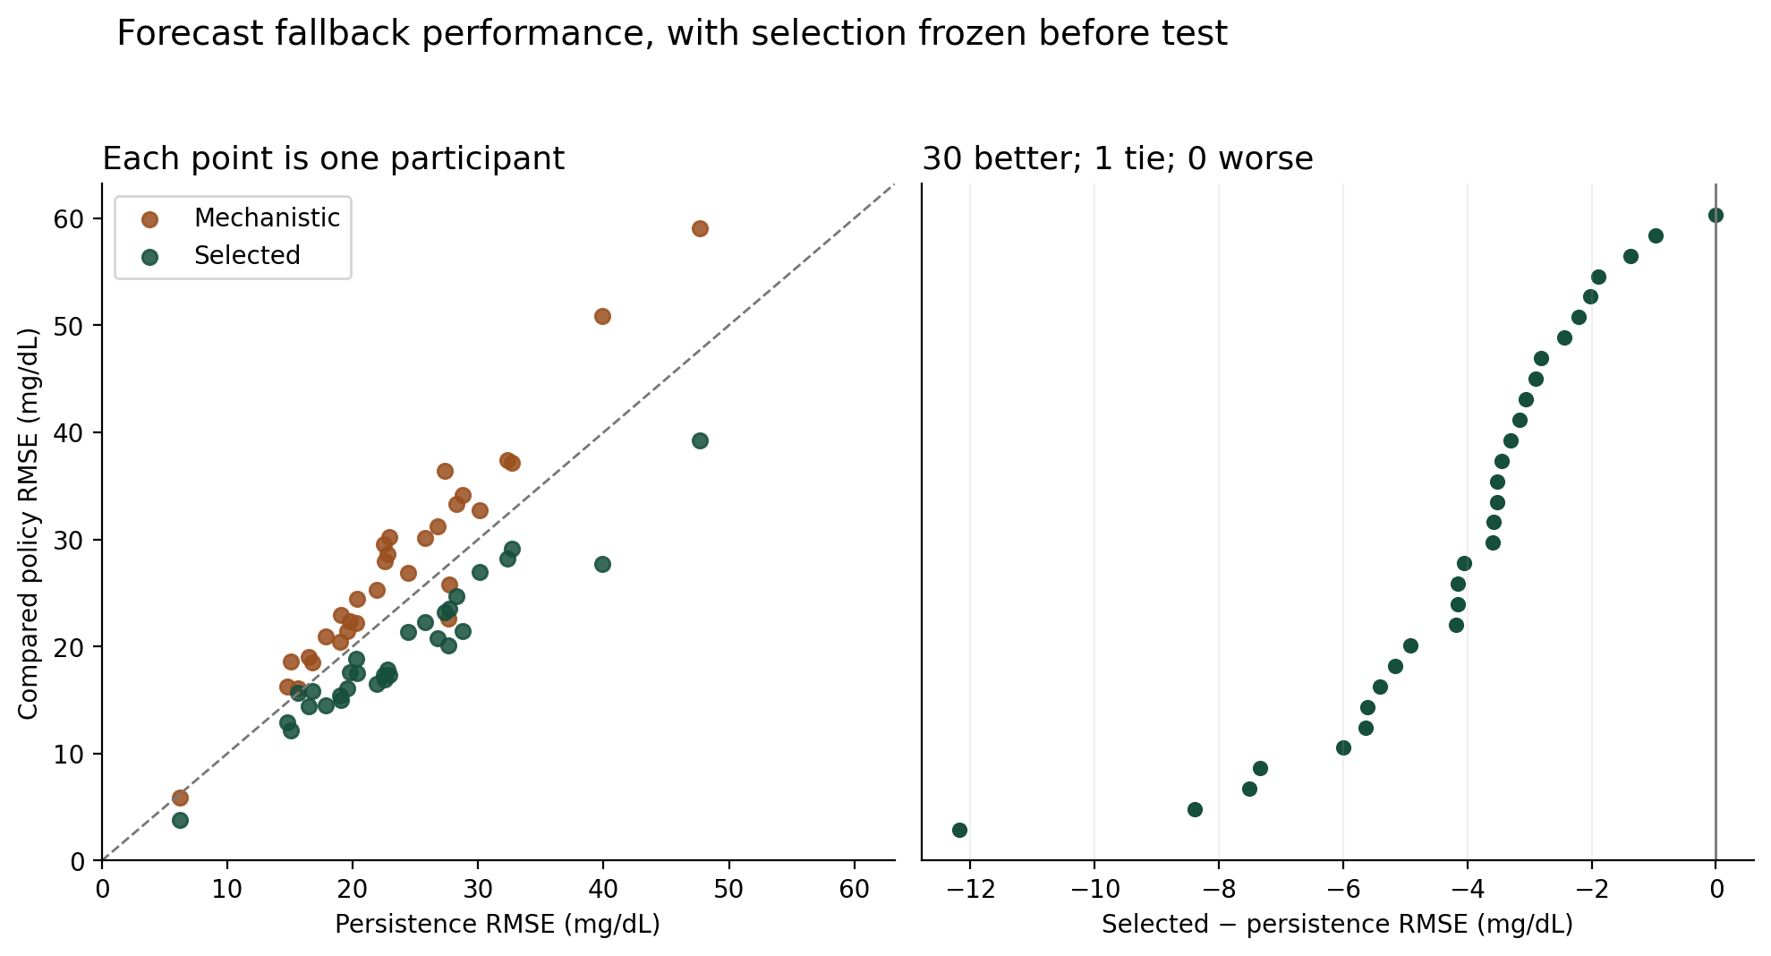
Fig. 1. Participant-level internal forecast comparison. The selected policy was chosen on tune data; each plotted point is one of 31 evaluated participants. Previously exposed test segments and upstream preprocessing limit prospective interpretation.
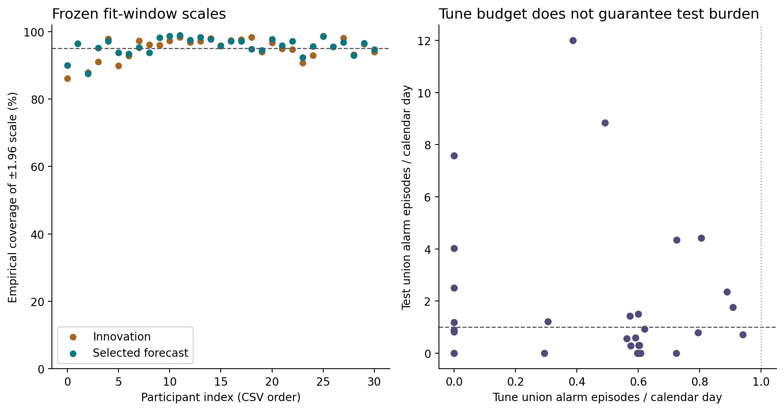
Fig. 2. Empirical test residual coverage and tune-to-test alarm burden. Near-nominal median coverage does not imply uniform participant coverage or a preserved alarm budget; 13 of 31 participants exceeded one test union alarm per day.

B. Completed comparison and model-domain findings
All 5,184 assigned simulations completed: 4,608 main and 576 feedback/stop runs, with zero final execution failures. Complete traces comprise 2,985,984 samples. No out-of-domain run was removed. Of the 4,608 main runs, 2,108 failed at least one physiological-domain screen; all were in the Hovorka family. In the clean condition, 44/48 Hovorka runs per arm had domain violations and negative endogenous production. The Hovorka main traces contained 138,103 invalid samples of 1,327,104, and 579 runs reached negative glucose, with a minimum of −20.91 mg/dL. This occurs before interpreting a fault response and limits the family as evidence of physiological robustness.
The original family had zero main runs failing its plasma-domain screen, but clipping still mattered: clean traces contained 100 remote-action boundary samples per arm. Across all original-family main runs there were 34,731 such samples. Absence of its coarse validity flag therefore cannot be described as independent model validation. Hovorka had 133,394 negative-EGP samples across main runs. No clinical glucose-benefit claim is made from either family.
Locked clean original-family runs had no trips in any arm. Hovorka clean full/manual and full/supervised each tripped in 2/48 runs, whereas simple, sham and oracle had none. These full-arm latches did not produce a nonzero aggregate delivery deficit relative to the reference under the requested tapes; a trip count and a withheld-delivery outcome are different quantities. The same benign calibration criterion therefore did not imply identical locked clean containment burden.

C. Matched delivery and recovery tradeoffs
Full/supervised minus simple/supervised delivery differences. Entries are mean paired research U [95% parameter-unit interval]; each row uses 24 units and 48 paired seed-runs. Positive values indicate greater excess or deficit for full. All eight conditions are retained.
Table III. Full minus simple supervised delivery differences
Plant | Condition | Excess difference (U) | Deficit difference (U)
Original | Clean | +0.000 [+0.000,+0.000] | +0.000 [+0.000,+0.000]
Original | 2× actuator input | +0.010 [+0.000,+0.025] | -0.011 [-0.028,+0.000]
Original | Occlusion | +0.000 [+0.000,+0.000] | -0.047 [-0.163,+0.015]
Original | Stuck-on addition | +0.137 [+0.100,+0.174] | -0.281 [-0.567,-0.042]
Original | CGM +40 | +0.000 [+0.000,+0.000] | +0.000 [+0.000,+0.000]
Original | CGM missing | +0.000 [+0.000,+0.000] | +0.000 [+0.000,+0.000]
Original | 2× input + CGM +25 | +0.010 [+0.000,+0.023] | -0.011 [-0.027,+0.000]
Original | 2× input + bias + report replacement | +0.000 [+0.000,+0.000] | +0.000 [+0.000,+0.000]
Hovorka | Clean | +0.000 [+0.000,+0.000] | +0.000 [+0.000,+0.000]
Hovorka | 2× actuator input | -0.003 [-0.019,+0.013] | +0.206 [+0.000,+0.479]
Hovorka | Occlusion | +0.000 [+0.000,+0.000] | +1.130 [+0.140,+2.378]
Hovorka | Stuck-on addition | +0.085 [+0.042,+0.127] | -0.452 [-1.436,+0.382]
Hovorka | CGM +40 | +0.000 [+0.000,+0.000] | +0.000 [+0.000,+0.000]
Hovorka | CGM missing | +0.000 [+0.000,+0.000] | +0.154 [-0.020,+0.387]
Hovorka | 2× input + CGM +25 | -0.003 [-0.019,+0.013] | +0.206 [+0.000,+0.470]
Hovorka | 2× input + bias + report replacement | +0.000 [+0.000,+0.000] | +0.049 [+0.000,+0.127]
Under stuck-on emission, full/supervised allowed more excess than simple/supervised in both families: +0.13745 research U [0.10044,0.17445] in the original model and +0.08458 [0.04229,0.12688] in Hovorka. Mean original-family excess was 0.39120 U for full versus 0.25375 U for simple, while deficits were 2.16130 and 2.44186 U, respectively. The fuller policy therefore traded greater excess for lower deficit in that condition; reporting only one side would reverse the apparent conclusion.
For Hovorka occlusion, full/supervised increased deficit by 1.13031 U [0.13982,2.37804] and longest interruption by 18.75 minutes [2.92,41.46] relative to simple/supervised. The original-family occlusion deficit difference was −0.04704 U [−0.16300,0.01522], compatible with a small effect in either direction. These findings do not support an overall advantage for the more elaborate detector. Hovorka-related quantities remain outcomes of the declared mathematical simulation, with the domain limitations above.
Supervised recovery also imposed delivery costs. Compared with full/manual, full/supervised increased stuck-on deficit by 0.03997 U [0.01713,0.06280] in the original family and 0.93603 U [0.61503,1.31483] in Hovorka. For occlusion, corresponding increases were 0.10286 U [0.03426,0.20218] and 0.40726 U [0.03204,0.88631]. Verification and probation restrict authorization by construction; their cost needs a demonstrated compensating benefit before they can be recommended. No main run was censored under the defined post-fault authorization-recovery endpoint. Sixteen main runs had a first trip before scheduled fault onset, which prevents treating every first-trip value as fault-detection delay.
Full and simple had identical main delivery contrasts for CGM-bias-only conditions in both families. This is consistent with the fixed-request estimand and a detector architecture requiring delivery evidence; it does not show that biased sensing is harmless in a feedback controller. In the report-replacement condition, shared local protection remained present. Oracle and sham results are retained in the complete tables; their differing information/protection assumptions prevent interpreting them as interchangeable practical baselines.

D. Feedback and stop assumptions
Feedback sensitivity changed both effect size and direction. For original-family stuck-on runs, full/supervised minus simple/supervised excess was +0.05321 U [−0.04055,0.18591] under baseline stopping, +0.45971 [0.08559,0.92228] with an additional powered interval, and +0.10619 [−0.01829,0.28867] with the residual tail. Under the additional-power assumption, deficit also increased by 0.54544 U [0.13031,0.96956]. Six parameter units per family support only a small sensitivity comparison. The result shows dependence on declared feedback/stop behavior, not a measured delay effect or universal ranking.

E. Post-primary exploratory fasting supplement
After the primary domain findings, a narrower fasting study was specified before its own calibration and outcomes. New vectors used four calibration and 16 locked test units per family, with two repeated seeds. Constant requests were selected from nominal actuator microsteps to approximate each plant’s known equilibrium basal, compensating the noise-free gain and offset without tuning glucose trajectories. No meals or feedback-dependent requests were used. The four supervised arms were full, matched mass-CUSUM-only, simple and sham, with common authority. Separate thresholds were fitted on 16 clean calibration runs; full versus mass-CUSUM therefore compares corroboration plus its independently calibrated threshold, not a validated physiological biomarker. Inference averaged seeds within 16 units per family and used 4,096 exploratory bootstrap resamples.
All 2,048 runs and 1,179,648 sample slots completed with no execution failure, declared domain violation or negative EGP. This does not establish normal or validated physiology: the original model retained 18,648 remote-action boundary samples, including 51 in clean runs. Hovorka clean glucose ranged 74.03–203.03 mg/dL. No compensated command was zero. Clean full-arm trips occurred in 3/32 runs in each family; mass-CUSUM/simple had 3/32 in the original family and 2/32 in Hovorka, while sham had none.
With twofold actuator input plus 25 mg/dL CGM bias, full minus mass-CUSUM excess was −0.07073 U [−0.09821,−0.04298] in the original family and −0.04187 U [−0.07946,−0.00952] in Hovorka. Under CGM bias alone, the same component comparison increased deficit by 1.33868 U [0.71855,2.10441] and 0.39818 U [0.20601,0.60903], respectively. These opposing outcomes prevent a uniform benefit claim. All eight conditions and six paired contrasts remain in the supplemental tables. The follow-on result is post-primary, exploratory and restricted to fixed fasting commands with known basal; it neither replaces the original outcomes nor validates their meal-excited physiological behavior.

VIII. Proposed IIT Patna Measurement Study
IIT Patna measurement pending. The rig is conceptual, components are unselected, and no team-measured delivery accuracy, uncertainty, stop latency, residual flow or recovery result exists. Simulated emitted mass is unavailable on a physical rig. Its virtual-patient input must come from a separately validated reconstruction with uncertainty and demonstrated zero-flow behavior. A balance indication or camera record is not automatically ground truth.
The concept comprises a syringe actuator, supported tubing and a defined free outlet above a balance receiver; a separate temperature sample vial avoids probe loading; reference masses are held on a separate tray; and a proposed camera/common event marker and logger support synchronization. Rendered geometry and dimensions are illustrative. Selection, assembly, ratings and mechanical fit require the laboratory’s actual records.
Figure 3 links the apparatus concept to the proposed measurement chain: a defined outlet and interval, signed native indications, and a validated reconstruction with uncertainty. Commands, acknowledgments and received reports are recorded separately. The final stage remains a required experiment, not an available input; the M01–M16 fields below identify the evidence needed to complete it.
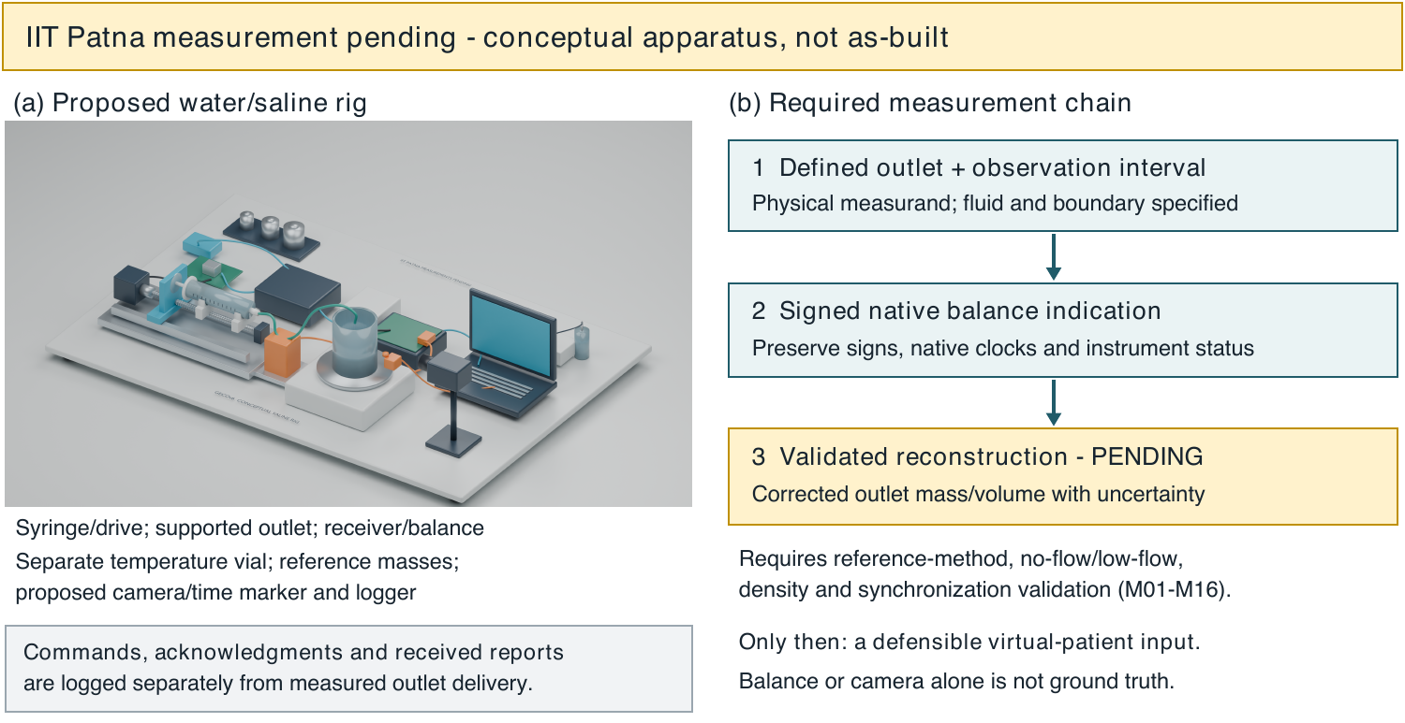
Fig. 3. IIT Patna measurement pending. Left: conceptual water/saline rig, not an as-built apparatus; components remain unselected. Right: proposed evidence chain from a defined outlet through signed native indications to a validated reconstruction with uncertainty. Commands and reports remain separate records. Balance and camera observations are not automatically ground truth. M01–M16 identify the required laboratory evidence.
The initial experiment should validate the measurand before connecting any reconstructed input to a virtual plant. Define the outlet, interval, fluid and hydraulic boundary. Record signed native indications, instrument status, calibration identifiers and original clocks. Characterize evaporation, drift, buoyancy where material, tubing contact, surface tension, vibration, settling and density/temperature uncertainty. Select a reference method with a documented calibration chain and independence assumptions. A camera can help locate events without automatically becoming a flow standard.
For an illustrative corrected mass difference $Δm_{c}=m_{end}−m_{start}−c_{blank}$ and volume $V=Δm_{c}/ρ$, uncertainty propagation must include density, correction and covariance terms [5]. Shared drift or calibration errors need not be independent. Negative corrected estimates near zero may arise from measurement noise; summing only positive increments produces an avoidable zero-flow bias. Reconstruction, filtering, latency and uncertainty must be validated against the chosen reference using no-flow and low-flow trials before a method is frozen.
Stopping requires separate times for the event, monitor decision, electrical command and a predefined flow-cessation criterion. Outlet passage, receiver arrival and balance settling are distinct. Post-stop mass needs a fixed follow-up and uncertainty; power removal does not automatically eliminate fluid motion. Restart testing must preserve withheld delivery, outstanding-command behavior and failed/absent-operator cases. Blank acquisition templates and an offline file validator enforce record structure only; a successful file check is not metrological validation.
IIT Patna measurement pending — replacement fields. M01: actual components/as-built record; M02: measurand/outlet; M03: traceable balance calibration; M04: fluid temperature/density; M05: environmental/no-flow corrections; M06: mechanical force isolation; M07: independent reference method; M08: reconstruction and zero-flow bias; M09: delivery accuracy/timing; M10: clock synchronization; M11: stop-event chain; M12: post-stop flow; M13: stop-path common modes; M14: nuisance alarms/misses; M15: restart/recovery; M16: locked trial design and complete immutable records. Replace a field only with raw-record identity, method/version, uncertainty, trial denominator and human review.
Table IV. IIT Patna physical results pending
Physical endpoint | Reference and unit | Result | Uncertainty | Status
Reconstructed outlet delivery | Validated reference; g or mL | Pending | Pending | IIT Patna measurement pending
Zero-flow cumulative bias | Matched blank; g or mL | Pending | Pending | IIT Patna measurement pending
Stop latency | Synchronized event chain; s | Pending | Pending | IIT Patna measurement pending
Post-stop delivery | Defined follow-up; g or mL | Pending | Pending | IIT Patna measurement pending
False-stop exposure | Benign trials; episodes/hour | Pending | Pending | IIT Patna measurement pending
Recovery deficit | Reference reconstruction; g or mL | Pending | Pending | IIT Patna measurement pending

IX. Discussion and Limitations
The main outcome is that complexity did not establish superiority. A fuller score can accumulate evidence differently, trip later for abrupt excess, or prolong authorization restrictions after recovery checks. Because temporal aggregation and physiology corroboration change together, the experiment cannot attribute a contrast solely to the twin. The post-primary fasting supplement adds a delivery-CUSUM-only arm with matched calibration exposure, while changing the operating regime; its bounded result does not resolve the main meal-regime comparison. Varying nuisance-stop budgets and reporting an excess/deficit frontier would be more informative than choosing a favorable threshold after outcomes.
The forecast study similarly favors a qualified conclusion. A causal selected baseline improved internal prediction relative to persistence, while the mechanistic forecast usually did not. The physiology channel still uses a corrected state estimator, but its selected future signal is predominantly trend. Calling this outcome a validated mechanistic digital twin would overstate the evidence. Near-bound parameters, proxy inputs, interpolation, uneven record duration and previous test exposure limit identifiability and generalization. Empirical residual coverage also failed to control test alarm burden for many participants.
The Hovorka result reveals an applicability failure in this implementation/regime, not a defect established in the original publication. Published prior means, synthetic variation, added observation lag and the selected controller were combined outside the original fasting experiment. Negative endogenous production in clean runs shows why a second equation family alone is insufficient evidence of physiological robustness. Future validity work should begin with declared operating regimes, equilibrium/response checks and pre-outcome acceptance criteria. It should retain these failed-regime results rather than replacing them with a favorable subgroup.
Several inference limits remain. Synthetic vectors are not patients; repeated seeds do not enlarge the number of independent parameter units. The fixed-request comparison estimates authorization effects for its generated tapes, while the feedback sensitivity answers a different question. The restricted conditions do not represent adaptive adversaries or complete cybersecurity execution. The remaining local measurement path and stop authority are assumed; common-mode compromise can remove their usefulness. No glucose statistic establishes treatment benefit, and no simulated research-U value should be interpreted as a patient dose.
Physical follow-up should first establish reconstruction accuracy and timing, then measure stop dynamics, then evaluate burden and recovery with frozen analysis. This order matters because an apparently precise comparator can be driven by biased delivery reconstruction. Water/saline results would characterize an apparatus under tested conditions; they would still not establish tissue absorption, clinical safety, deployment readiness or institutional endorsement. Team review, authorship and data-governance decisions remain required before submission.

X. Conclusion
GECO provides an explicit separation of delivery intent, authorization, emission, observation and response in a reproducible offline study. Causal forecast selection improved an internal retrospective baseline comparison, but the shared-authority simulation did not establish a fuller-detector advantage and exposed substantial physiological-domain limitations. The next substantive step is validated delivery reconstruction and measured stopping/recovery behavior on the proposed rig, with IIT Patna measurements still pending.

Data, Code and Supplementary Material
The working package retains the initial specification, amendments, frozen calibration/configuration identities, complete attempt/failure ledgers, participant metrics, paired synthetic contrasts and full traces. Real-data and simulation results are separate. Supplementary source access records distinguish full-text, partial and metadata-only support. The HUPA and D1NAMO repository licenses and attribution obligations apply to their material [11], [12]. Public deposition and redistribution have not occurred as part of this work; the team must select a release destination and confirm applicable permissions. No proprietary similarity service or detector-based authorship certification was used.

Author, Funding and AI-Use Statements — Team Completion Required
Author eligibility, names, affiliations, contributions, funding, conflicts, ethics/data-governance determination and final approval are pending the research team. No sample-paper author or institutional endorsement is carried into this manuscript. IEEE authorship and generated-content disclosure guidance will apply alongside the eventual venue’s instructions [13], [14], [15].
Proposed disclosure for team confirmation: OpenAI Codex assisted with literature organization and source checking, implementation and analysis drafting, figure/media preparation, and manuscript drafting and revision. Exact available tool/runtime information and verification records are retained in the accompanying package; unavailable model metadata are not inferred. Synthetic narration is identified in the video. The team must state the actual human verification, corrections, responsibility and final approval before submission. This pending statement does not assert that those approvals have already occurred.

References
[1] H. Venugopalan, S. M. A. Vijayanand, C. Stanford, S. Crossen, and S. T. King, “GlucOS: Security, correctness, and simplicity for automated insulin delivery,” in Proceedings of the 24th annual international conference on mobile systems, applications and services, 2026, pp. 185–201. doi: 10.1145/3745756.3809198.
[2] X. Zhou, M. Kouzel, C. Smith, and H. Alemzadeh, “KnowSafe: Combined Knowledge and Data Driven Hazard Mitigation in Artificial Pancreas Systems,” IEEE Transactions on Dependable and Secure Computing, 2025, doi: 10.1109/TDSC.2025.3584870.
[3] H. Bissig et al., “Calibration of insulin pumps based on discrete doses at given cycle times,” Biomedical Engineering / Biomedizinische Technik, vol. 68, no. 1, pp. 67–77, 2023, doi: 10.1515/bmt-2022-0040.
[4] S. Girardot, F. Mousin, J. Vezinet, P. Jacquemier, S. Hardy, and J.-P. Riveline, “Kalman Filter-Based Novel Methodology to Assess Insulin Pump Accuracy,” Diabetes Technology & Therapeutics, vol. 21, no. 10, pp. 557–565, 2019, doi: 10.1089/dia.2019.0147.
[5] Joint Committee for Guides in Metrology, “Evaluation of measurement data — Guide to the expression of uncertainty in measurement.” 2008. Available: https://www.bipm.org/documents/20126/2071204/JCGM_100_2008_E.pdf
[6] R. Hovorka et al., “Nonlinear model predictive control of glucose concentration in subjects with type 1 diabetes,” Physiological Measurement, vol. 25, no. 4, pp. 905–920, 2004, doi: 10.1088/0967-3334/25/4/010.
[7] C. Dalla Man, F. Micheletto, D. Lv, M. Breton, B. Kovatchev, and C. Cobelli, “The UVA/PADOVA Type 1 Diabetes Simulator,” Journal of Diabetes Science and Technology, vol. 8, no. 1, pp. 26–34, 2014, doi: 10.1177/1932296813514502.
[8] S. J. Julier and J. K. Uhlmann, “Unscented Filtering and Nonlinear Estimation,” Proceedings of the IEEE, vol. 92, no. 3, pp. 401–422, 2004, doi: 10.1109/jproc.2003.823141.
[9] I. Hajizadeh et al., “Adaptive and Personalized Plasma Insulin Concentration Estimation for Artificial Pancreas Systems,” Journal of Diabetes Science and Technology, vol. 12, no. 3, pp. 639–649, 2018, doi: 10.1177/1932296818763959.
[10] T. M. Chin, “Square-Root Formulas for Kalman Filter, Information Filter, and RTS Smoother: Links via Boomerang Prediction Residual,” Jet Propulsion Laboratory, IPN Progress Report 42-233, May 2023. Available: https://ipnpr.jpl.nasa.gov/progress_report/42-233/42-233A-orig.pdf
[11] J. I. Hidalgo, J. Alvarado, M. Botella, A. Aramendi, J. M. Velasco, and O. Garnica, “HUPA-UCM Diabetes Dataset.” Mendeley Data, 2024. doi: 10.17632/3hbcscwz44.1.
[12] F. Dubosson, J.-E. Ranvier, S. Bromuri, J.-P. Calbimonte, J. Ruiz, and M. Schumacher, “The open D1NAMO dataset: A multi-modal dataset for research on non-invasive type 1 diabetes management.” Zenodo, 2018. doi: 10.5281/zenodo.5651217.
[13] IEEE, “Submission and Peer Review Policies — AI-Generated Content.” Available: https://journals.ieeeauthorcenter.ieee.org/become-an-ieee-journal-author/publishing-ethics/guidelines-and-policies/submission-and-peer-review-policies/
[14] IEEE, “Ethical Requirements — Definition of Authorship.” Available: https://journals.ieeeauthorcenter.ieee.org/become-an-ieee-journal-author/publishing-ethics/ethical-requirements/
[15] IEEE, “IEEE Article Templates; Structure Your Article.” Available: https://journals.ieeeauthorcenter.ieee.org/create-your-ieee-journal-article/authoring-tools-and-templates/tools-for-ieee-authors/ieee-article-templates/

