School of Mathematics, Thapar University
Optimization Techniques (UMA-031)
Tutorial Sheet # 2
- Linearize the following objective function: Max 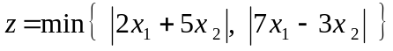
- Write the standard form of the LPP

(i) Max 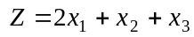
s. t. 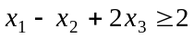, 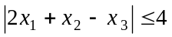 , 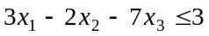
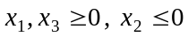

(ii) Max 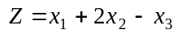
s. t. 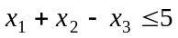, 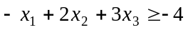, 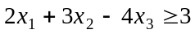, 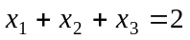, 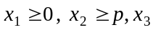is unrestricted in sign.

3. Examine graphically, whether the following sets are convex or not:
(a) 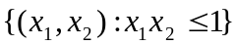 (b) 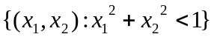 (c) 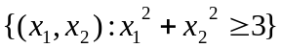
(d) 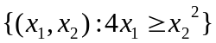 (e) 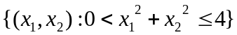 (f) 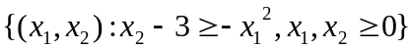
(g)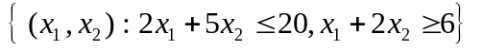 (h)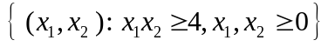
(i) (j) 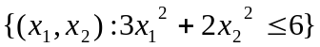

4. Find all the extreme points of the set and represent the
point (2, 3) as the convex combination of the extreme points of .

5. Solve the following linear programming problems graphically and state what your solution indicate.
(i)
(ii)
(iii)
(iv)
(v)
(vi)
(vii)

6. Consider the following LPP
Show graphically that the variable can be increased indefinitely while the optimal value of the objective function remains constant.

