Employee id- 109883998  
  
Name- Rishabh Manchanda

Database created for students and teacher

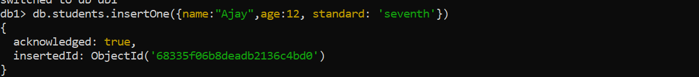

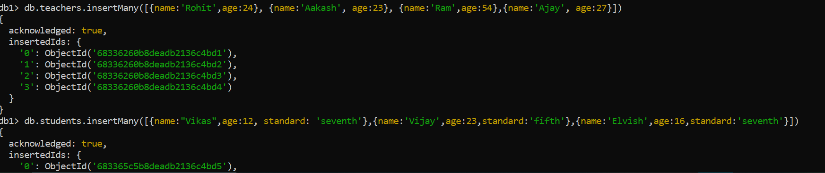

**Find value of teachers**

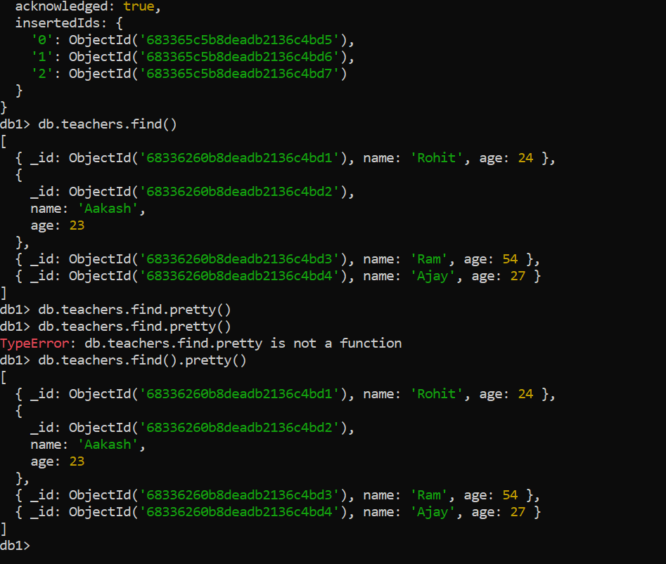

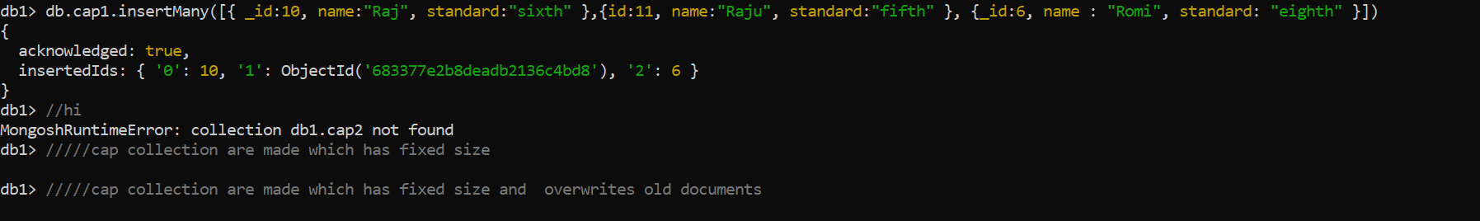

**Upserted new student data**

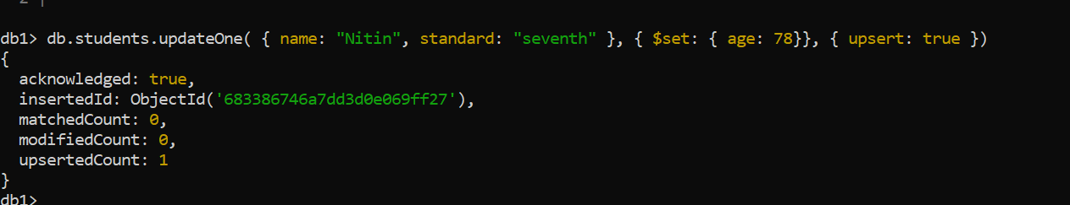

DB aggregation  
  
