Aligarh College of Engineering & Technology

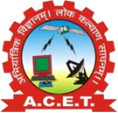

DATA MINING

AND

DATA WAREHOUSING FILE

SUBMITTED BY:

SARTHAK SHARMA

BTECH 3RD YEAR

DEPARTMENT

OF

COMPUTER SCIENCE & ENGINEERING