Why Learn Angular…? In 2020

# Overview Of Angular:-

Angular is a TypeScript-based open-source web application framework developed by Google’s Angular team along side a community of people’s and corporations.

When we developed Angular applications it involves writing the code using Typescript, a superset of Javascript, along with Hyper Text Markup Language(HTML), CSS, etc. Then the code written in Typescript compiles to Javascript and application is rendered in the browser.

It helps developers to make Single Page Applications (SPA’s) and it gives users very good experience of using web application .

This blog provides the basic knowledge of Angular Framework regarding the various versions and the mostly part of this blog contains the detailed explanation of Angular Architecture.

# Popularity and versions of Angular:-

Angular is the most widely used JavaScript framework which is used by developers for developing the Web, Mobile and Desktop based Applications .So far Angular team has released the following versions of Angular.

* Angular 2.0 – It was released in September 2016
* Angular 3.0 – It was not released because this Version was skipped due to mismatch between @angular/core,@angular/compiler and @angular/router libraries.
* Angular 4.0 – It was released in March 2017.
* Angular 5.0 – It was released in November 2017.
* Angular 6.0 – It was released in May 2018. It was also released with Angular CLI 6 and Material 6.
* Angular 7.0 – It was released in October 2018. It was released with Angular CLI 7 and Material 7.
* Angular 8.0 – It was released in May 2019. It was released with Angular CLI 8 and Material 8.
* Angular 9.0 – It was released in February 2020. It was released with Angular CLI 9 and Angular Material 9.It also come up with Ivy Compiler.
* Angular 10 – This is the latest version released in June 2020 with Angular CLI 10 and Angular Material 10.

# Performance and Speed of Angular:-

* Angular is universal because it furnishes the primary view of the application on .NET, Node.js, or PHP for near-instant and behavior driven interpretation in HTML documents.
* Angular supplements to show the templates part into code generation that are hugely reformed with today’s JavaScript virtual development tools.

# Architecture of Angular:-

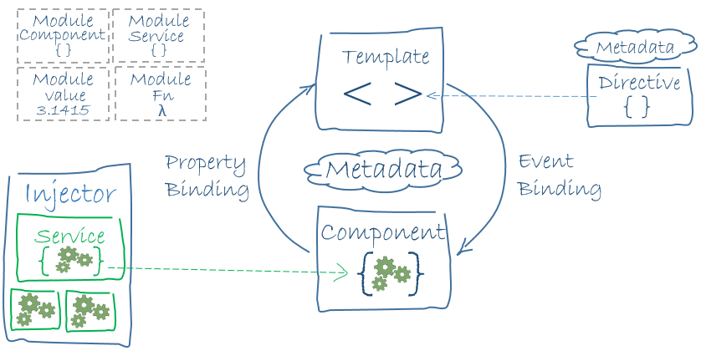

Eight main building blocks of an angular application which you see in above architecture:

* Modules
* Components
* Templates
* Meta Data
* Data Binding
* Directives
* Services
* Dependency Injection

# Modules in Angular:-

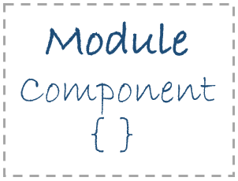

In Every Angular Application has a root module named as AppModule and the file name is app.module.ts.

If we want to use another custom module in angular application. So, we have to include that particular module in our app.module.ts file. Suppose I have to import FormsModule for using Angular Template Driven Forms so I include this particular module in our app.module.ts file which is shown in below figure.

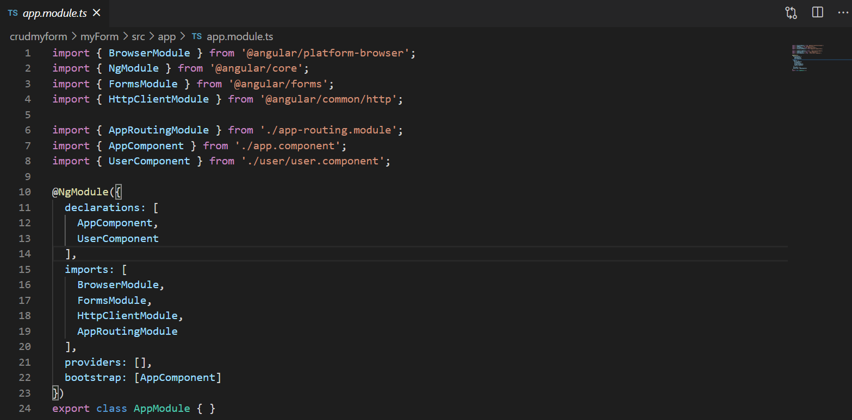

# Angular Library:-

Angular have Collection of Javascript Modules. You can think of them as Library Modules.

Every Angular library name starts with @angular Prefix. You can Install all modules by the help of npm package manager. If you want to import those modules so you have to use import statement for it. Like you have to import Component decorator from the @angular/core library like this:

Import { Component } from ‘@angular/core’;

# Components:-

Angular project contains atleast one component i.e root component (app.component.ts) file and this root component connects the component hierarchy with a webpage document object model (DOM). Each Component defines the class that contains application data and business logic and this component is associated with HTML template (app.component.html) file that defines the view to be displayed in the application.

//app.component.ts

@Component ({

Selector: ‘app-root’,

templateUrl: ‘./app.component.html’,

styleUrls: [‘./app.component.css’]

})

# Templates:-

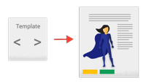

All the templates in angular are combination of HTML with Angular Markup that helps to modify HTML elements before they are displayed on web browser. Template directives provide program logic and a binding markup connects your application data and the DOM. There are two types of binding:

1. Event Binding:- It is basically used for bind events in your app and responds the user in the target environment by updating the data of your application.
2. Property Binding:- It is basically used for pass data from component class and ease you to interpolate values from data of your application into the HTML.

# Meta Data :-

Image for post

It tells Angular how to process a class. For a Component class the metadata associates it with a template that defines a view. A template combines simple HTML with Angular directives and binding markup that allow Angular to modify the HTML before rendering it for display on the web browser.

For a Service class the metadata provides the information Angular needs to make it available to components through dependency injection.

# Data Binding :-

Data Binding is the most powerful feature of Angular. Basically it is used for communication between a template and it’s Component.

It is necessary because when we write code in typescript, it is compiled in javascript and the result is shown to the user i.e HTML layout.

# From the Component to DOM :-

String Interpolation: {{ Value }} : String Interpolation add up the value of the property from the Component.

<p>Employee Name : {{ employee.name }}</p>

<p>Employee Designation: {{ employee.designation }}</p>

# Property Binding: [property]=”value” :-

In Property Binding, a value is passed from a component and setting the value of the given element in the user end.It is an example of one-way data binding.

<input type=”text” [value]=”employee.name” />

<input type=”text” [value]=”employee.designation” />

# Event Binding: (Event)=”myFunction($event)” :-

In Event Binding, a value is passed from a child component to parent component which can be a simple HTML attribute.

<input type=”text” (myEvent)=”onClick($event)” />

# Two-Way Binding: [(ngModel)]=”property”:-

It is the most important type of data binding which is combination of property and event binding in single notation by using the ngModel directive.

<input [(ngModel)]=”user.name” >

# Directives:-

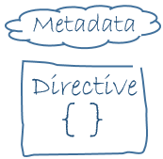

When we say that the components in the angular app are the building blocks of Angular Project. So, We are saying that directives are the building blocks of angular application. Let us discuss with an example of built in directive i.e ngClass

<p [ngClass]=”{‘blue’=true , ‘yellow’=false}”>

Hello World

</p>

<style>

.blue{color: blue}

.yellow{color: yellow}

</style>

In this example our text color is blue because it is true.

# Services:-

When we write code there is a situation when we need some code to be used everywhere on the page. So Services helps to achieve that. With Services we can access methods and properties across other components in the entire angular application. It distinguishes Components from Services to increase modularity and reusability.

# Dependency Injection:-



Dependency Injection keeps your Component Classes lean and efficient. It does not fetch data from the server. Basically it is the ability to add the functionality of components at run time.

Component Consumes the Services that is you can inject a service into a component by giving the component access to that service class i.e you import a particular service into that Component.

# Benefits:-

# Benefits Of Angular

|  |  |
| --- | --- |
| Individual Benefits | Organizational Benefits |
| Reduced Coding | Angular Support Single Page Applications |
| Angular Edge | Two-way Data Binding |
| Multiple Job Roles | Angular is Modular |
| Create with Ease | Typescript Ease |

# Conclusion:-

Angular is a outstanding flexible and customizable javascript framework. Due to its high popularity in the IT industry more Angular developers will be required in the future. The Angular web applications load faster as compared to the other frameworks .It provides several benefits to the developers which is basically the actual reason why some of the best companies around the world use this tool for their projects.