**Database:**

**1.What is Database?**

Database is collection of information, organized for easy to access and maintain.

Ex.

1.Telephone directory

[name, address, mobile number]

2.customer data

[customer name, number of item purchase, amount]

3.visitors’ registration

[name, house number, time, mobile number, sign]

**2.what is DBMS?**

**Database management system.**

DBMS is basically a software where you can store, retrieve, manage your data in a database.

**3.DBMS operation:**

1.Adding new files

2.Inserting data

3.Retrieving data (TO find information that has been stored)

4.Modifying data

5.Removing data

6.Removing files

**4.DBMS Advantages:**

1.Lots of techniques to store, manipulate and retrieve data.

2.Improve data sharing and data security

3.Enhanced security mechanism

4.Enhanced integrity constraints

5.Better transaction support

6.Backup and recovery features

**5.Types of DBMS?**

1.Hierarchical database

2.Relational database

3.Network database

4.Object oriented database

**1. Hierarchical database:**

A hierarchical database is a data model in which data is stored in the form of records and organized into a tree-like structure, or parent-child structure, in which one parent node can have many child nodes connected through links.

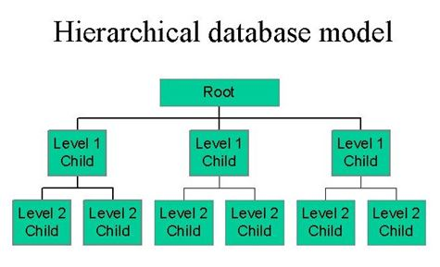

**2.Relational database:**

Data store in row and column (tabular). This is major use database because of flexibility and easy to implement.

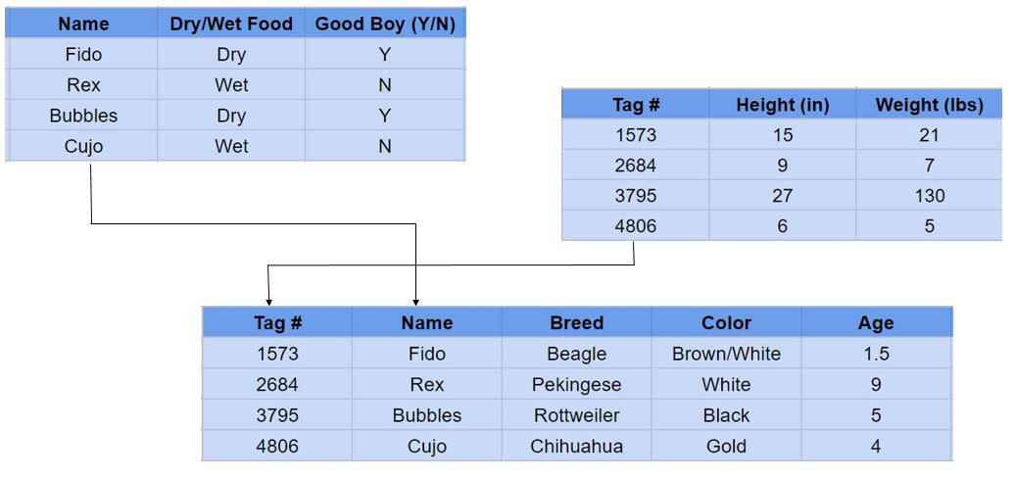

**3.Network database:**

Network database management systems (Network DBMSs) are based on a network data model that allows each record to have multiple parents and multiple child records. A network database allows flexible relationship model between entities.

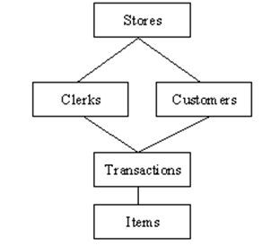

**4.Object oriented database:**

An object-oriented database (OOD) is a database system that can work with complex data objects. In object-oriented programming, data is stored in form of objects which are instance of classes.

Ex.

1.object

2.class

Flowers = [“a”,”b”,”c”]

**6.Features of RDMS?**

**(Relational database management system)**

1.Every information store in the form of tables.

2.Has primary key for unique identification of rows.

3.Has foreign keys for ensure data integrity.

4.Provide SQL for data access.

5.Use indexes for faster data retrieval.

**7. what is primary key?**

A primary key, also called a primary keyword, is a key in a relational database that is unique for each record. It is a unique identifier.

The table with the primary key is called parent table.

Ex.

Driver license number,

Telephone number (including area code),

Vehicle identification number (VIN).

A relational database must always have one and only one primary key.

|  |  |  |  |
| --- | --- | --- | --- |
| **Customer_id** | **First_name** | **Last_name** | **City** |
| 25 | Ajay | Sinha | Mumbai |
| 26 | Rohit | Verma | Mumbai |
| 27 | Akash | Sinha | Delhi |
| 28 | Rahul | Sharma | Kolkata |
| 29 | Vijay | Rathore | Bangalore |
| 30 | Rohit | Paul | Delhi |

**Syntax:**

create table customer(

customer_id int(10),

first_name varchar(10),

last_name varchar(10),

city varchar(10),

primary key(customer_id)

);

**8.What is foreign key?**

The foreign key is a column or set of columns that is used to link two tables together.

Foreign key is used to create links between tables.

The table with the foreign key is called child table.

**Table - 1**

|  |  |  |  |
| --- | --- | --- | --- |
| **Customer_id** | **First_name** | **Last_name** | **City** |
| 25 | Ajay | Sinha | 5 |
| 26 | Rohit | Verma | **2** |
| 27 | Akash | Sinha | 4 |
| 28 | Rahul | Sharma | 1 |
| 29 | Vijay | Rathore | 2 |
| 30 | Rohit | Paul | 3 |

**Table - 2**

|  |  |
| --- | --- |
| **City_id** | **City** |
| 1 | Bangalore |
| 2 | Chennai |
| 3 | Delhi |
| 4 | Hyderabad |
| 5 | Kolkata |
| 6 | Mumbai |

**9.D/F RDBMS and TRADITIONAL**

In the RDBMS store data in tabular form.

In TRADITIONAL store data as file.

**10.D/F RDBMS and DBMS**

In RDBMS here store data in in the form of collection of table.

DBMS like MYSQL, ORACLE, IBM DB2, MICROSOFT SQL SERVER,

Are based on RDBMS.