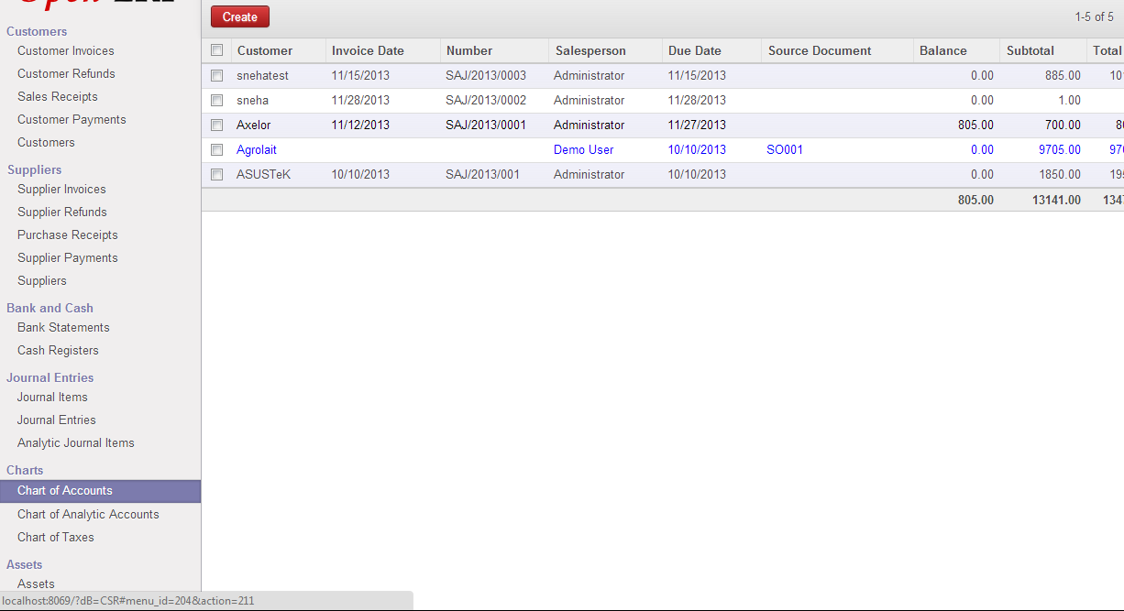

Goto Accounting.

In left panel select chart of accounts to view chart of accounts.

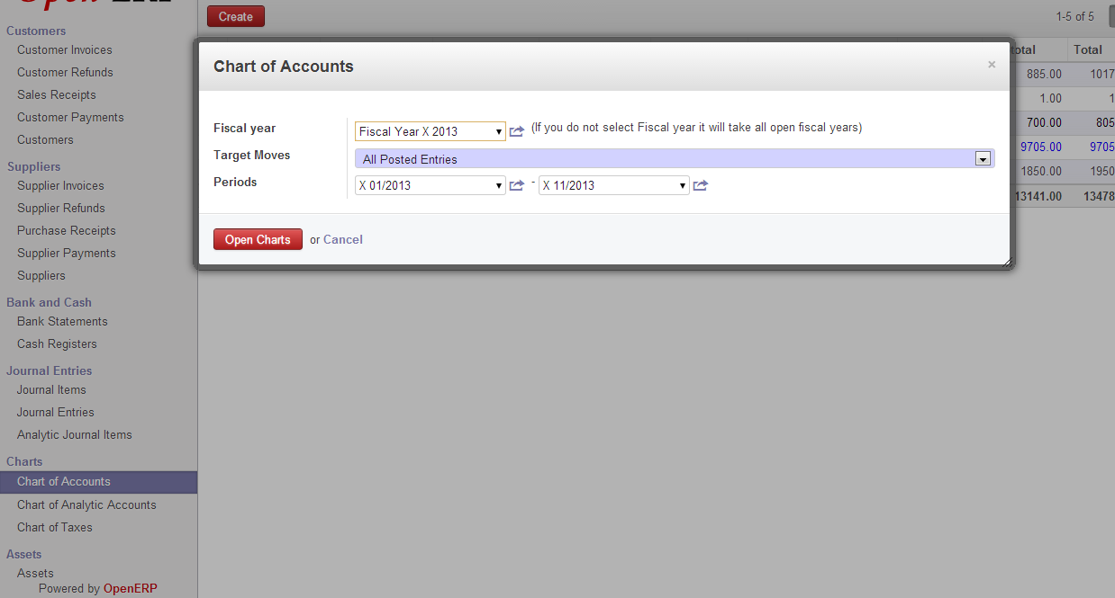

It will open a dialog box.

Select the fiscal year and period and click on Open Charts.

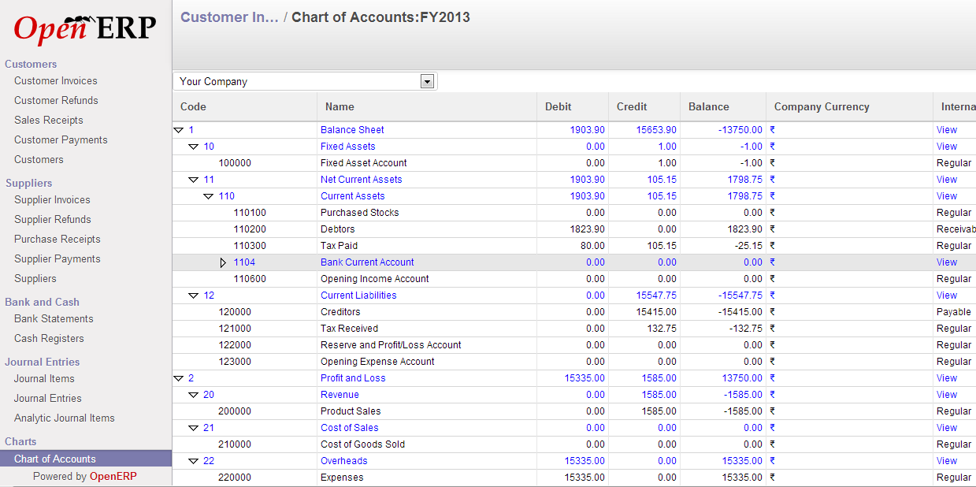

This will give you an hierarchy of chart of accounts.

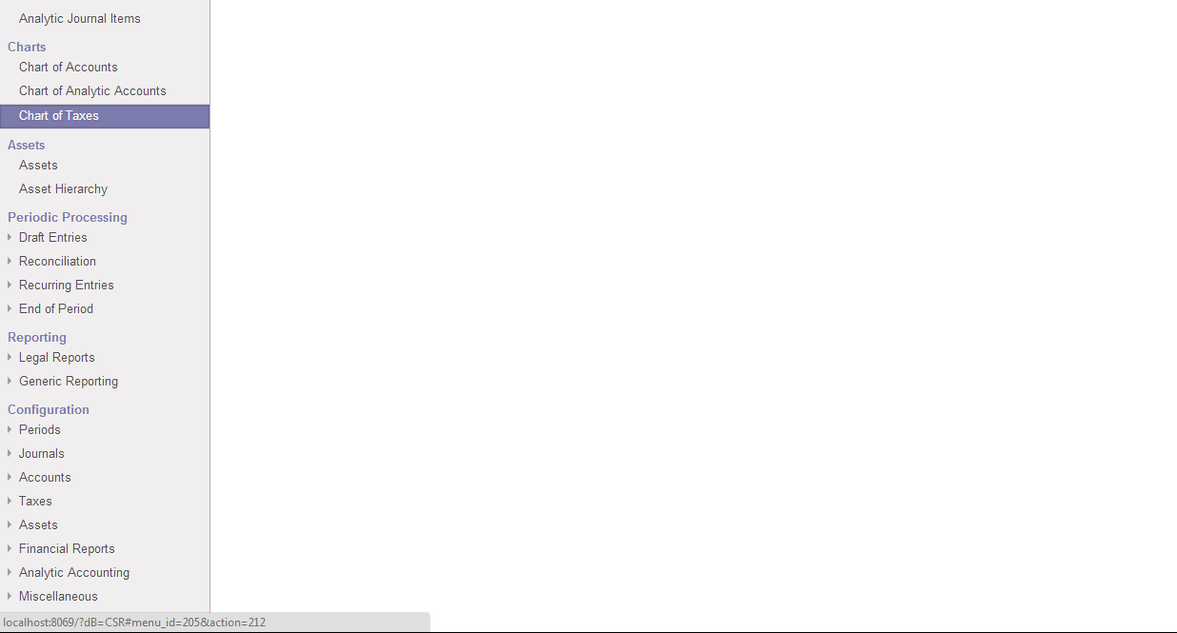

Similarly goto Accounting.

Select Chart Of Taxes.

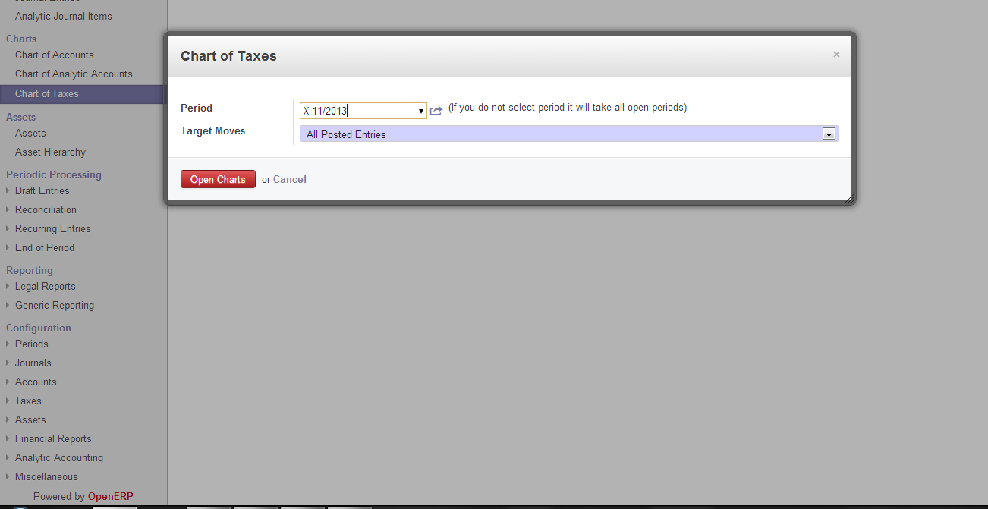

This will give you a dialog box.

Specify the Period and Click on Open Charts.

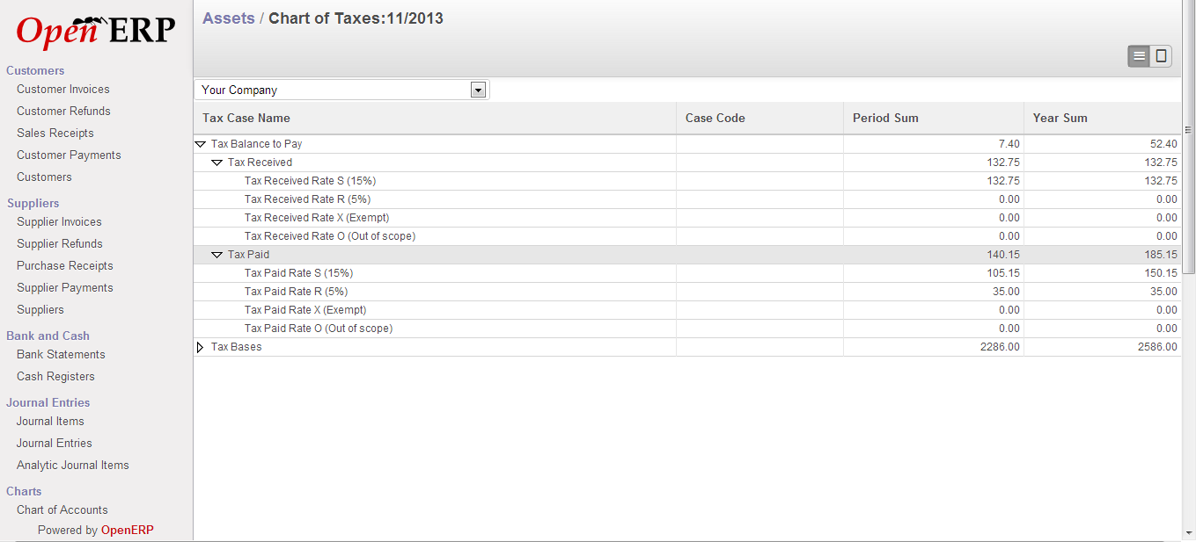

This will give you a hierarchy of chart of taxes.

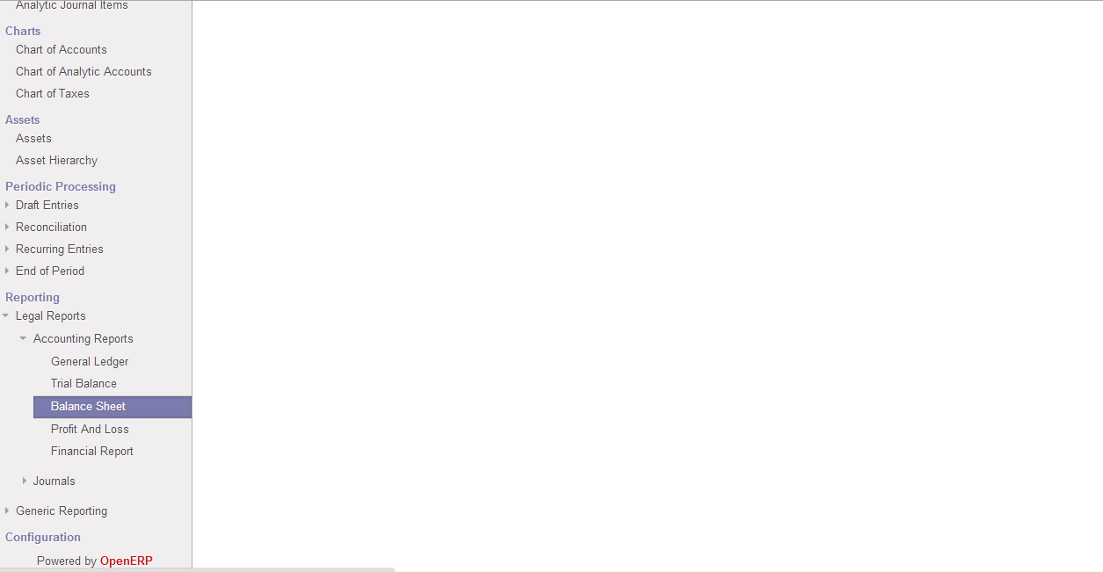

To view Balance Sheet click on Accounting in main menu.

Goto Reporting->Legal Reports->Balance Sheet.

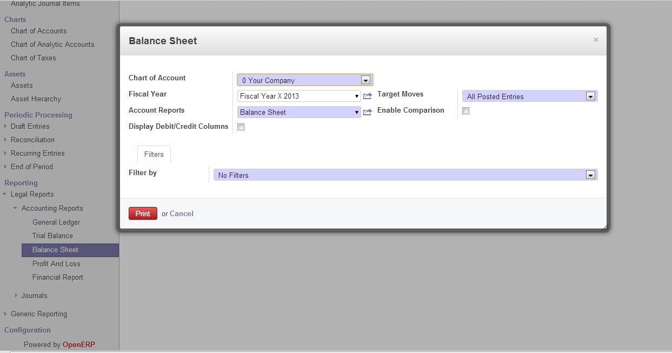

This will open a dialog box .

Specify the details and click on print.

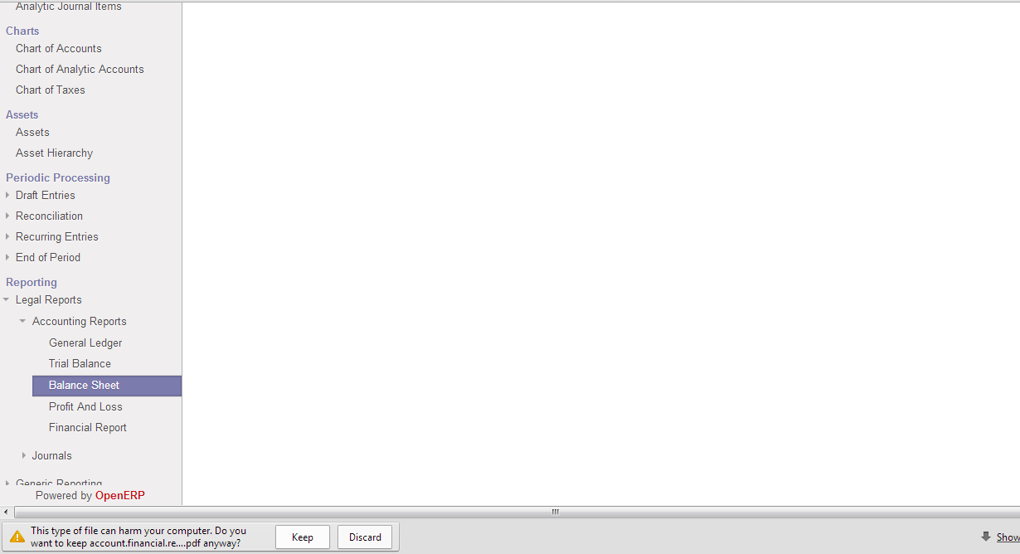

In the bottom of the page, it will ask you whether you want to keep the file or discard it.

Click on Keep.

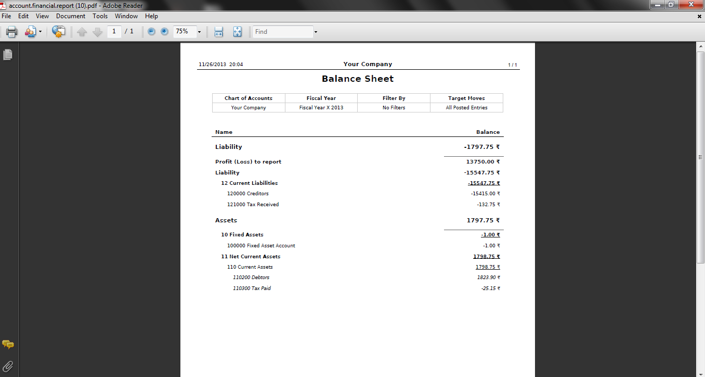

This will give you a pdf report of Balance Sheet.

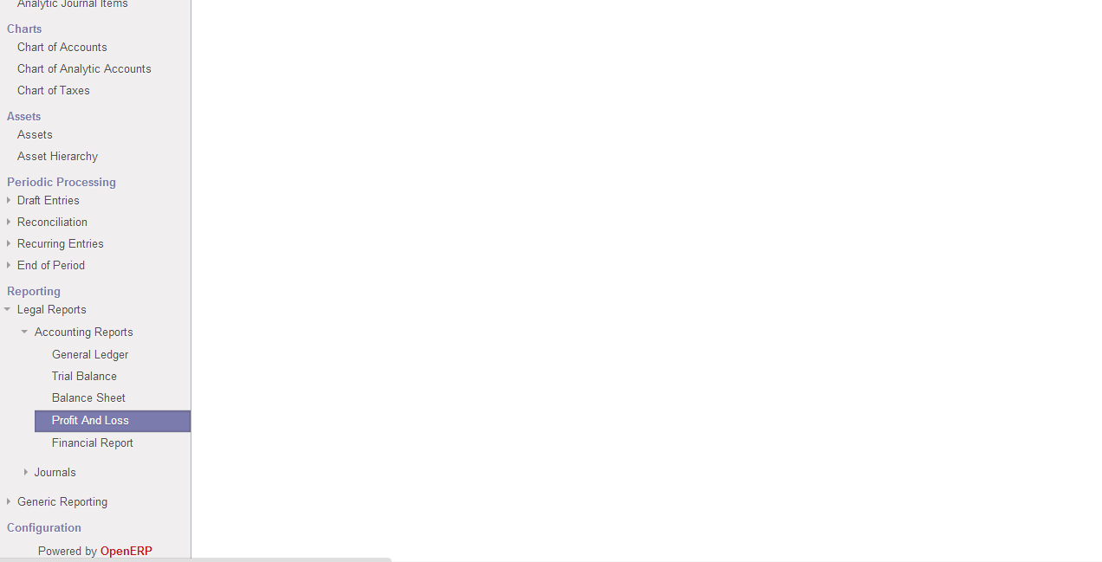

To view Profit and Loss Report click on Accounting in main menu.

Goto Reporting->Legal Reports-> Profit and Loss.

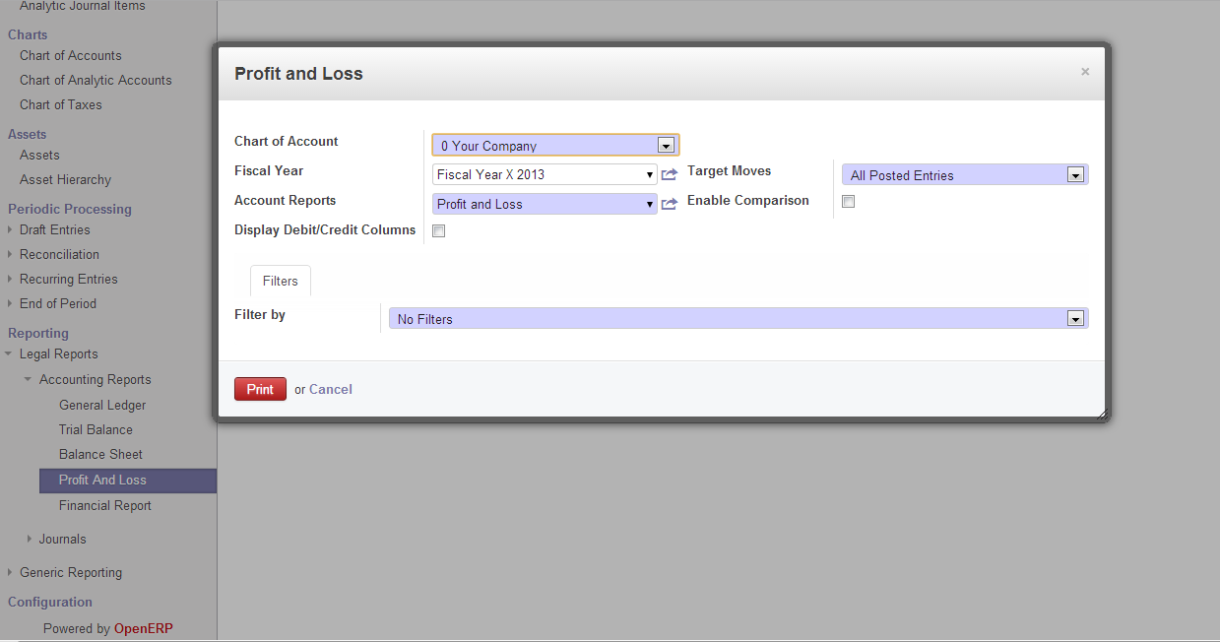

This will open a dialog box .

Specify the details and click on print.

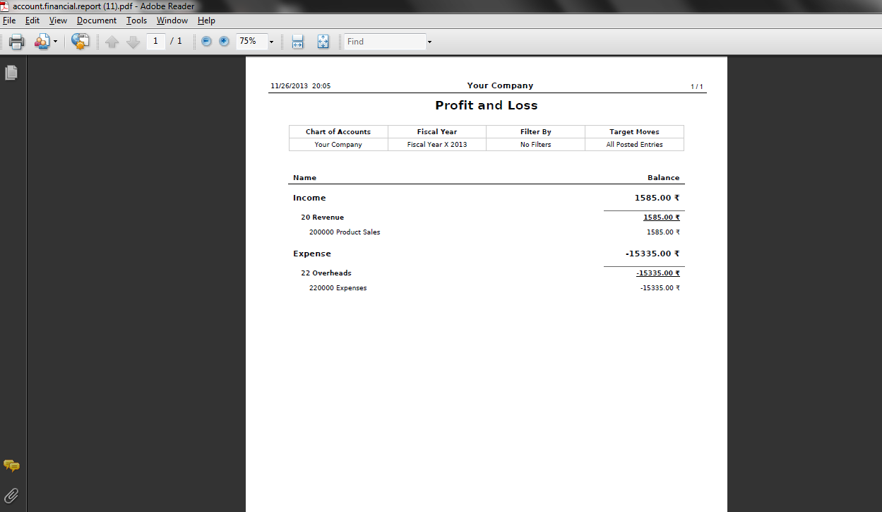

This will give you a pdf report of Profit and Loss.

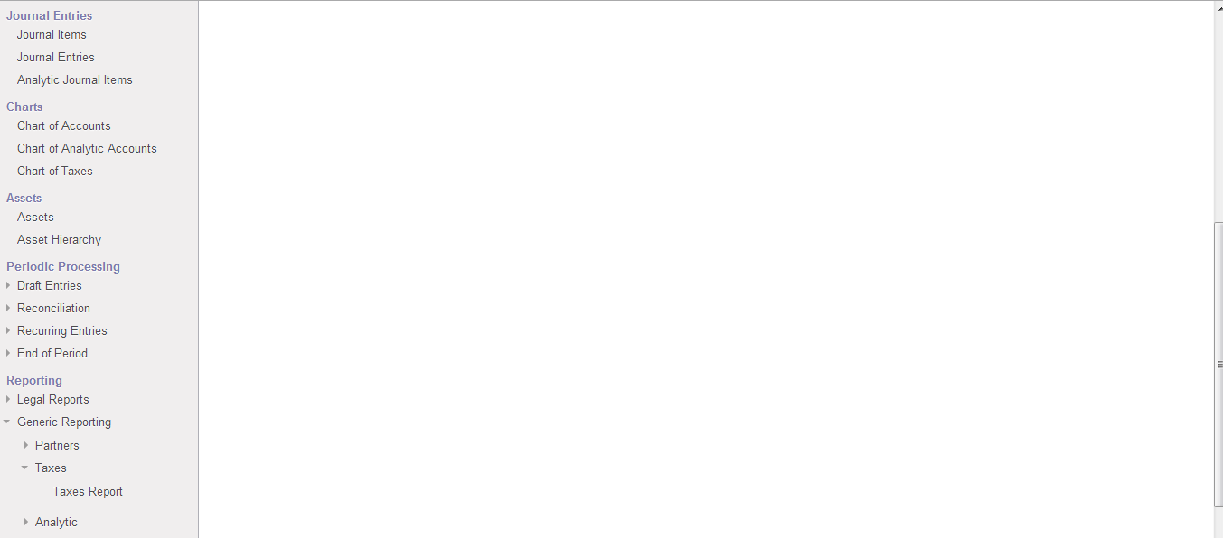

To view Taxes Report click on Accounting in main menu.

Goto Reporting->Generic Reporting-> Taxes Report.

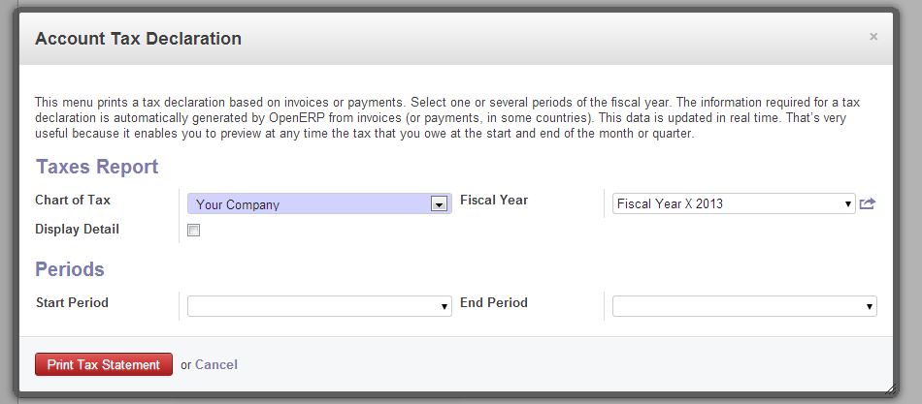

This will open a dialog box .

Specify the details and click on Print Tax Statement.

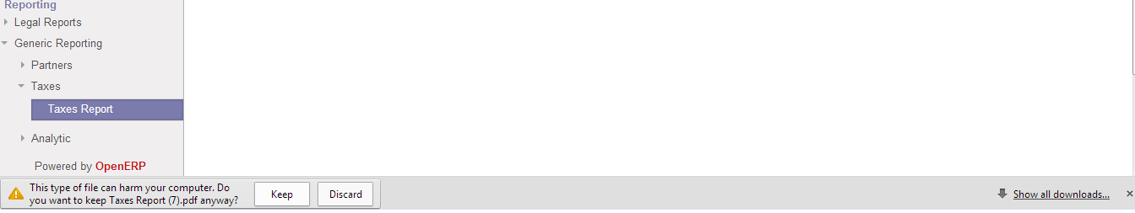

In the bottom of the page, it will ask you whether you want to keep the file or discard it.

Click on Keep.

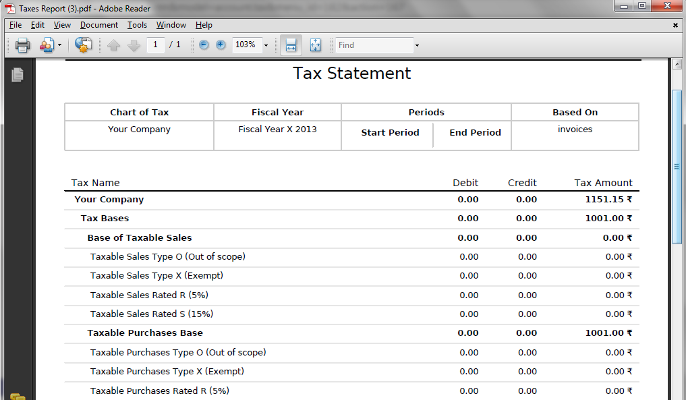

This will give you a pdf report of Tax Statement.