|  |  |  |
| --- | --- | --- |
|  |  |  |

Designing a report involves the following tasks. You do not have to perform all the tasks in the order in which they are presented here, but if you are new to BIRT Report Designer or learning how to design reports, you can use the following task list as a starting point:

|  |  |
| --- | --- |
| n | Plan the report. |
| n | Start a new report design. |

|  |  |
| --- | --- |
| n | Specify the data to use. |
| n | Lay out the report. |

|  |  |
| --- | --- |
| n | Format the report. |
| n | Design a master page. |

|  |  |
| --- | --- |
| n | Preview and test the report. |

For those who do not have report development expertise, it is important to understand that the process of creating a report is iterative rather than linear. You typically perform each task multiple times and in different orders. You might specify the data to use, lay out data, preview the report, then modify the data set, change the layout, preview the report again, and so on, until you are satisfied with the report’s contents and appearance.

## Connecting to a Data Source

Enterprise report data is frequently stored in a variety of systems and formats. BIRT Report Designer provides wizards to set up access to the following types of data sources:

|  |  |
| --- | --- |
| n | JDBC data sources |
| n | Text files |

|  |  |
| --- | --- |
| n | XML documents |
| n | Web services |

A report, however, is not limited to using data from these data sources. Developers can write JavaScript or Java scripts to get data from Java objects, such as Enterprise JavaBeans. Developers can also use BIRT’s Open Data Access (ODA) framework to write custom data drivers to access data from any source, including data stored in proprietary systems.

## About BIRT data sources

To access data for a BIRT report, you use a BIRT data source. A BIRT data source is an object that contains the information to connect to the database, text file, XML file, or web service. When you create a report, you use Data Explorer, as shown in [Figure 2‑1](http://help.eclipse.org/helios/topic/org.eclipse.birt.doc/birt/connecting.2.2.html#259056), to create and manage BIRT data sources.

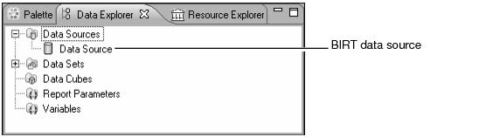

|  |  |
| --- | --- |
| ***Figure 2‑1*** | *Data source in the data explorer* |

You can create as many data sources as necessary for a report. The data sources can be of different types. For example, a report can use data from a database and data from a flat file repository.

#### How to specify the connection information for a database or other JDBC data source

|  |  |
| --- | --- |
| 1 | In Data Explorer, right-click Data Sources, then choose New Data Source. |
| 2 | On New Data Source, supply the following information: |

|  |  |
| --- | --- |
| 1 | Select JDBC Data Source from the list of data source types. |
| 2 | In Data Source Name, type a name for the data source. The name must be unique in the current report. [Figure 2‑2](http://help.eclipse.org/helios/topic/org.eclipse.birt.doc/birt/connecting.2.3.html#231195) shows a default data source name. |

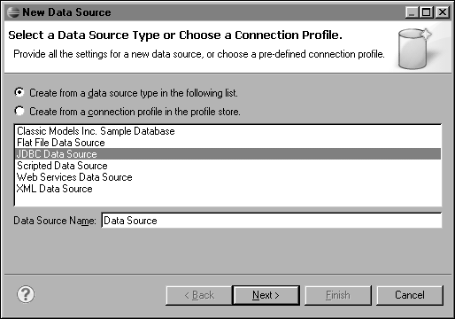

|  |  |  |  |
| --- | --- | --- | --- |
| ***Figure 2‑2*** | | *Creating a JDBC data source* | |
| 3 | Choose Next. | |

New JDBC Data Source Profile shows connection properties, as shown in [Figure 2‑3](http://help.eclipse.org/helios/topic/org.eclipse.birt.doc/birt/connecting.2.3.html#216722).

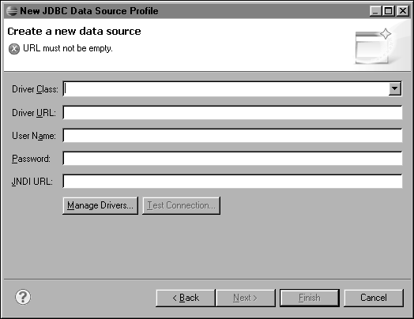

|  |  |  |  |
| --- | --- | --- | --- |
| ***Figure 2‑3*** | | *Defining JDBC connection information* | |
| 3 | Specify the connection information for the JDBC data source: | |

|  |  |
| --- | --- |
| 1 | In Driver Class, choose a driver class from the drop-down list. If you do not see the driver class that you want to use, add a driver as described later in this section. |
| 2 | In Database URL, type the database URL, using the syntax that the driver requires. Typically, BIRT Report Designer displays the necessary syntax in Database URL. For a Sun JDBC/ODBC bridge, for example, the syntax is |

jdbc:odbc:<data source name>

where <data source name> is the name of your data source. For example, the following URL identifies the sales database:

jdbc:odbc:sales

|  |  |
| --- | --- |
| 3 | In User Name, type the user name to use when connecting to the JDBC data source. This field can be left blank if your data source does not require a user name. |
| 4 | In Password, type the password to use when connecting to the JDBC data source. This field can be left blank if your data source does not require a password. |

|  |  |
| --- | --- |
| 5 | In JNDI URL, type the full path to the connection pooling service, if applicable. The following path is an example: |

java:comp/env/jdbc/MyDataSource

In the example, MyDataSource is the name of the JNDI database service.

|  |  |
| --- | --- |
| 4 | To ensure that the connection information is correct, choose Test Connection. If Test Connection returns an error, repeat the preceding steps to correct the error. Then, test the connection again. |
| 5 | Choose Finish. The new JDBC data source appears under Data Sources in Data Explorer. |

#### How to add a JDBC driver

This procedure assumes you are creating a new JDBC data source, and you need to install a new driver because the driver that your database requires is not available in the list of drivers.

|  |  |
| --- | --- |
| 1 | On New JDBC Data Source Profile, shown in [Figure 2‑4](http://help.eclipse.org/helios/topic/org.eclipse.birt.doc/birt/connecting.2.4.html" \l "260368" \o "How to add a JDBC driver), choose Manage Drivers. |

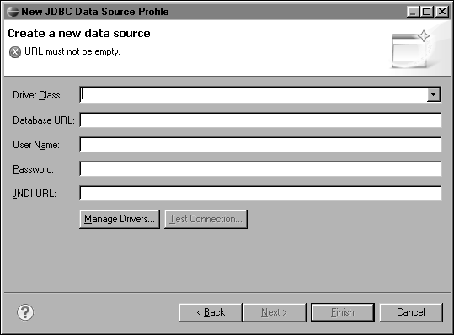

|  |  |  |  |
| --- | --- | --- | --- |
| ***Figure 2‑4*** | | *New JDBC Data Source Profile* | |
| 2 | On Manage JDBC Drivers, shown in [Figure 2‑5](http://help.eclipse.org/helios/topic/org.eclipse.birt.doc/birt/connecting.2.4.html" \l "216728" \o "How to add a JDBC driver), choose Add to install the JAR file that contains the driver. | |

|  |  |
| --- | --- |
| 3 | Navigate to the directory that contains the JAR file. Select the JAR file and choose Open. |

Manage JDBC Drivers shows the new JAR file.

|  |  |
| --- | --- |
| 4 | Choose Drivers to see the list of installed drivers, as shown in [Figure 2‑5](http://help.eclipse.org/helios/topic/org.eclipse.birt.doc/birt/connecting.2.4.html" \l "216730" \o "How to add a JDBC driver). |

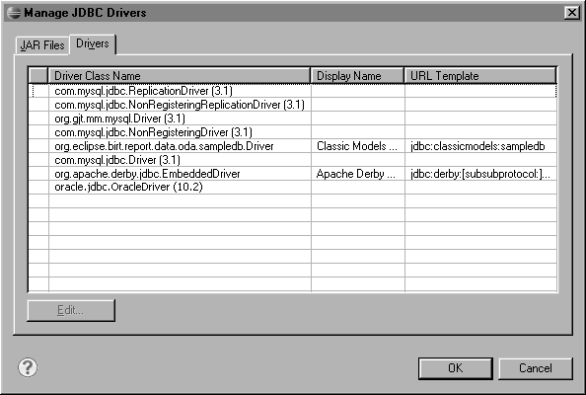

|  |  |  |  |
| --- | --- | --- | --- |
| ***Figure 2‑5*** | | *Viewing JDBC driver classes* | |
| 5 | Optionally, set the properties for a driver, using the following steps: | |

|  |  |
| --- | --- |
| 1 | Select the new driver, then choose Edit. Edit JDBC Driver appears. |

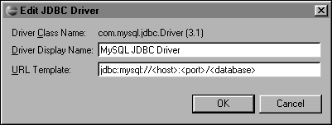

|  |  |  |  |
| --- | --- | --- | --- |
| ***Figure 2‑6*** | | *Editing a JDBC driver URL template* | |
| 2 | Specify settings for the JDBC driver. | |

|  |  |
| --- | --- |
| 1 | In Driver Display Name, type a name that appears in the Display Name column in Manage JDBC Drivers. |
| 2 | In URL Template, type the URL format that the driver requires. This URL format appears in Driver URL on New JDBC Data Source Profile, as shown in [Figure 2‑6](http://help.eclipse.org/helios/topic/org.eclipse.birt.doc/birt/connecting.2.4.html#216732). |

Choose OK. The driver manager displays the new display name and URL template syntax suggestion.

|  |  |
| --- | --- |
| 6 | On New JDBC Data Source Profile, specify the connection properties to connect to the JDBC data source. The Driver Class list displays the driver you just installed . |

#### How to create a SQL query to retrieve data from a JDBC data source

This procedure assumes you have already created the JDBC data source that this data set uses.

|  |  |
| --- | --- |
| 1 | In Data Explorer, right-click Data Sets, then choose New Data Set. |
| 2 | On New Data Set, specify the following information: |

|  |  |
| --- | --- |
| 1 | In Data Source Selection, under JDBC Data Source, select the data source to use. |
| 2 | In Data Set Type, select SQL Select Query. |

|  |  |
| --- | --- |
| 3 | In Data Set Name, type a name for the data set. |
| 4 | Choose Next. |

Query displays the information to help you create a SQL query. Available Items lists the items in the data source.

|  |  |
| --- | --- |
| 3 | To see the tables in a database, expand the database, as shown in [Figure 3‑1](http://help.eclipse.org/helios/topic/org.eclipse.birt.doc/birt/retrieving-data.3.3.html" \l "311301" \o "How to create a SQL query to retrieve data from a JDBC data source). |

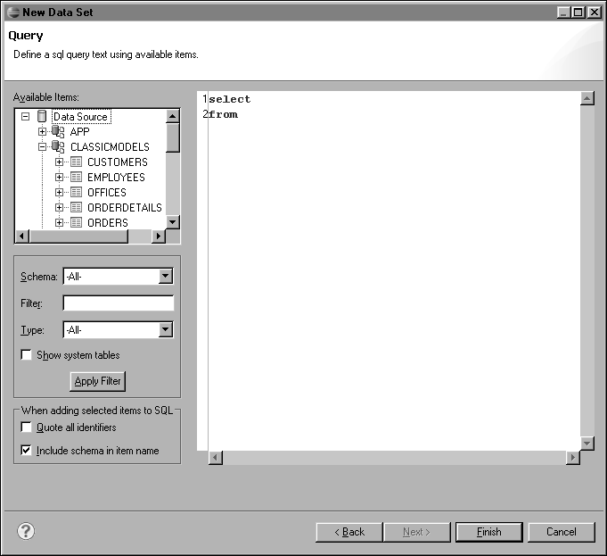

|  |  |
| --- | --- |
| ***Figure 3‑1*** | *Viewing a schema* |

You can use the filter options to specify specific schemas or objects to display.

|  |  |
| --- | --- |
| n | To see only views in the JDBC data source, in Type, select View, and choose Apply Filter. To see all tables, views, and stored procedures, select All, and choose Apply Filter. |
| n | If the data source has a large number of objects, you can limit the number of object names that are retrieved by typing one or more letters in the Filter field and choosing Apply Filter. Available Items displays the objects that have names that begin with the same letter or letters that you typed. You also can use SQL filter characters for the database that you are using. For example, on some databases, an underscore (_) matches any single character, and the percent sign (%) matches any sequence of characters. |

|  |  |
| --- | --- |
| n | If the database supports schemas, a Schema drop-down list is available. Select a schema to display only objects from that schema. |
| 4 | To display the columns in a table or view, click the plus sign (+) next to a table or view name. |

|  |  |
| --- | --- |
| 5 | In the text area, type a SQL statement that indicates what data to retrieve from the JDBC data source. Alternatively, drag tables, views, and columns from Available Items to the text area to insert their names in the SQL statement at the insertion point, as shown in [Figure 3‑2](http://help.eclipse.org/helios/topic/org.eclipse.birt.doc/birt/retrieving-data.3.3.html#215124). |

For some databases, if a table or column name contains spaces or SQL reserved words, you must enclose the name in quotation marks (" "). If you drag and drop tables and columns, and those items need to be enclosed in double quotation marks, select the Use identifier quoting option. When this option is selected, the data set editor inserts the quotation marks around a table or column name when you drop it in the text area.

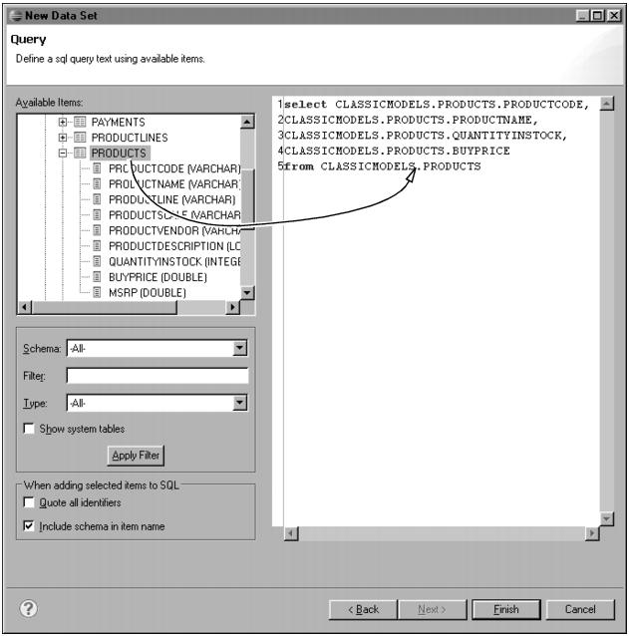

|  |  |  |  |
| --- | --- | --- | --- |
| ***Figure 3‑2*** | | *Adding a table to a SQL query* | |
| 6 | Choose Finish. Edit Data Set displays the columns specified in the query, and provides options for editing the data set. | |

## Test your Report

We're now ready to test the report layout. We verified the data set earlier, so now we want to verify that the report is presenting the data as we expect.

We preview the report by clicking on the Preview tab in the lower left corner of the report editor. This report has no parameters, but if it did, they could be modified by selecting the Show Report Parameters button.

The window that appears is an embedded web browser, which displays the report in HTML format. The report appears as a single page. This works best for smaller data sets. Since the sample database has quite a bit of data, we used a WHERE clause to limit the results. We could also use a report parameter or a data set filter to limit the amount of data displayed at any one time.

There are a number of ways we can improve the report's appearance:

* Add a title to the top of the report.
* Add some color to enhance the column headings.
* Shrink the size of the city and state columns.
* Add some color to make the state and city group headers stand out.
* Format the phone numbers.
* Sort customers by name.

Before we apply these aesthetic enhancements, let's look at other ways to preview the report.

## Preview as HTML

The Preview tab is handy for a quick review of your report. BIRT runs the report each time you switch to Preview. However, you can have either the Layout or the Preview tab open, but not both.

Instead, we can preview the report in a separate window. Find the Preview button in the toolbar. Use the little arrow next to it to open the pull-down. You can then Preview as HTML in a separate window. This allows you to switch back and forth between your layout editor and your preview without rerunning the report.

## Preview in Web Viewer

This option is similar to the one above. It allows the report to be previewed as HTML in a separate browser window using the BIRT Web Viewer. The viewer provides powerful navigation capabilities such as TOC, Previous Page, Next Page, Goto Page as well as search and export capabilities.

To preview the report in the Web Viewer use the toolbar Preview button and select the Web Viewer option or alternatively invoke File->Preview in Web Viewer.

## Preview as PDF

You can also choose Preview as PDF. This converts the layout to a multi-page PDF format