MICROCONTROLLER AND MICROPROCESSOR PROJECT

IIIT DHARWAD

3RD SEMESTER

TEAM MEMBERS
1. RISHABH DWIVEDI
2. PRABHDEEP SINGH PARMAR

IN SUPERIOR GUIDANCE OF
DR. PAVAN KUMAR C
(Asst. PROFESSOR IIIT DWD)

Microcontroller and Microprocessor
Project
Full Adder

Overview
Full adder takes 3 input say A , B and Cin where Cin is assumed to be previous carry and returns 2 output namely SUM and CARRY

SUM contains the sum of A,B and Cin and CARRY contains if any carry was generated durin sum

Black Box Diagram
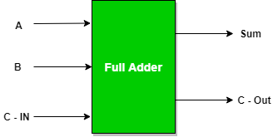

Truth Table
A | B | Cin | SUM | CARRY
0 | 0 | 0 | 0 | 0
0 | 0 | 1 | 1 | 0
0 | 1 | 0 | 1 | 0
0 | 1 | 1 | 0 | 1
1 | 0 | 0 | 1 | 0
1 | 0 | 1 | 0 | 1
1 | 1 | 0 | 0 | 1
1 | 1 | 1 | 1 | 1

Schematic
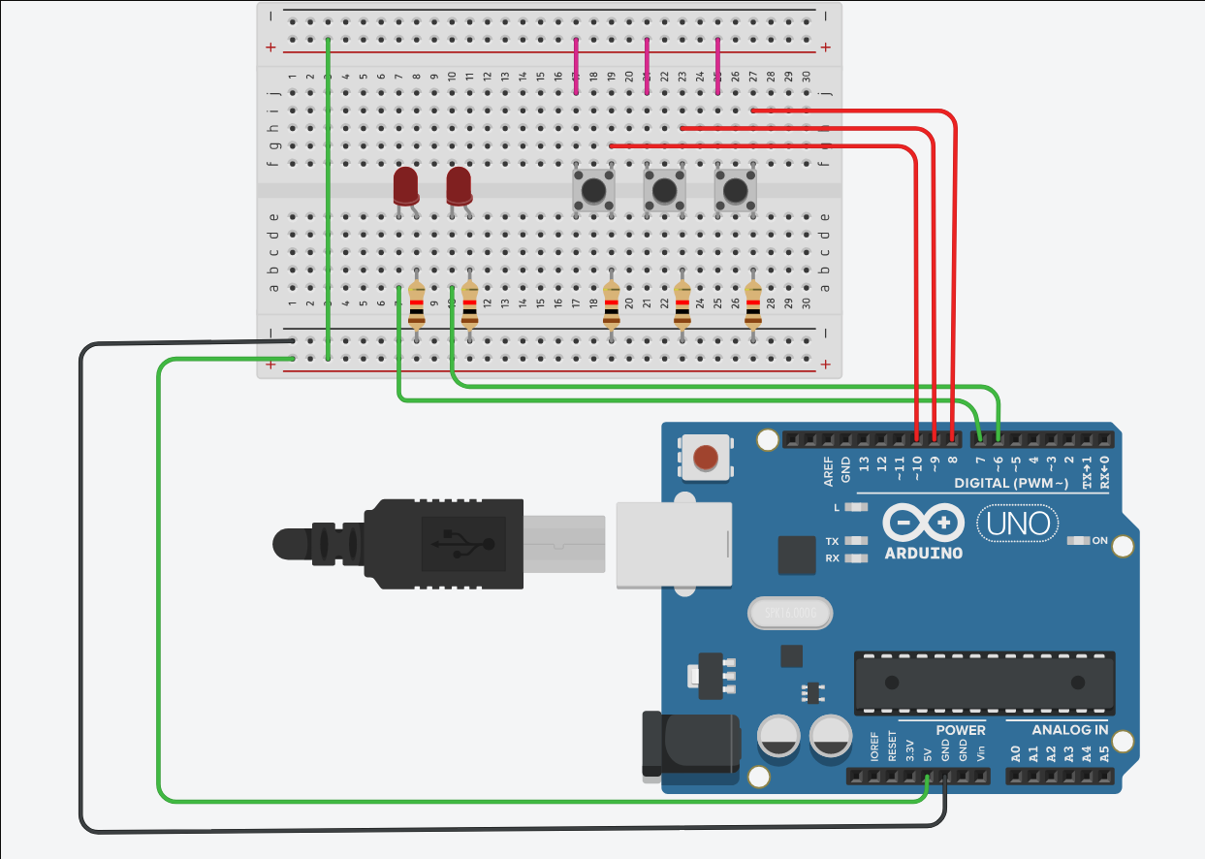
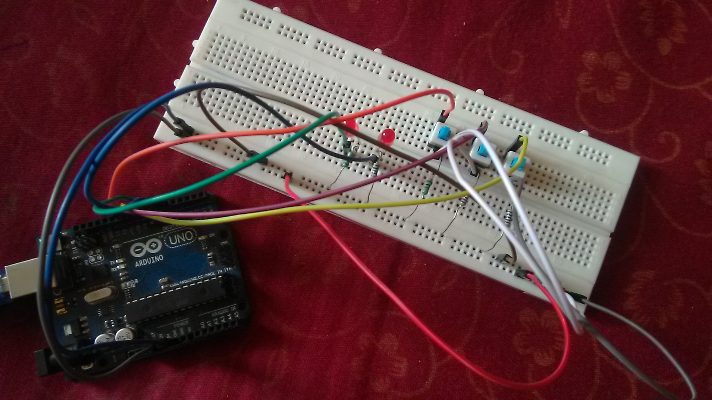
Actual circuit(A=0 B=0 Cin=0 SUM=0 CARRY=0)
Working
1. When A=1 B=0 Cin=0 SUM=1 CARRY=0
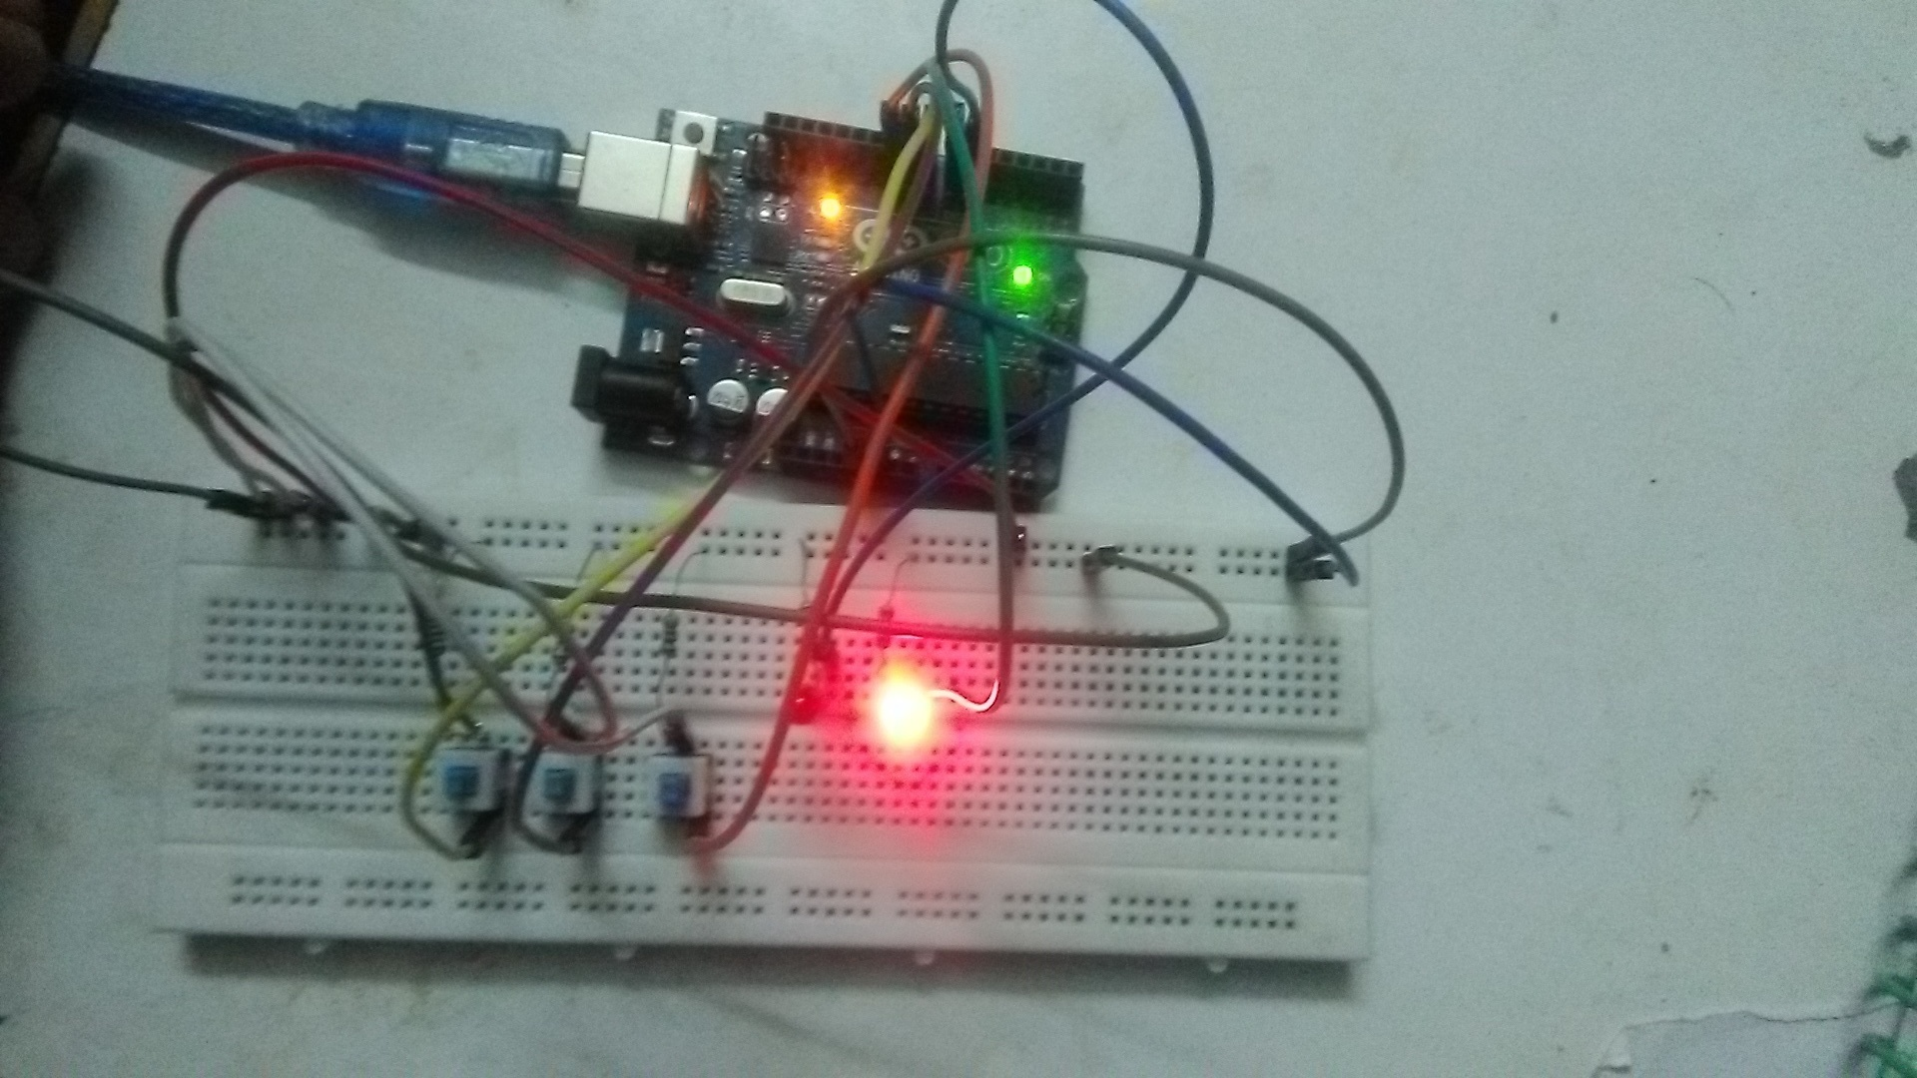
2. When A=0 B=1 Cin=0 SUM=1 CARRY=0
3. When A=0 B=0 Cin=1 SUM=1 CARRY=0
4. When A=1 B=1 Cin=0 SUM=0 CARRY=1
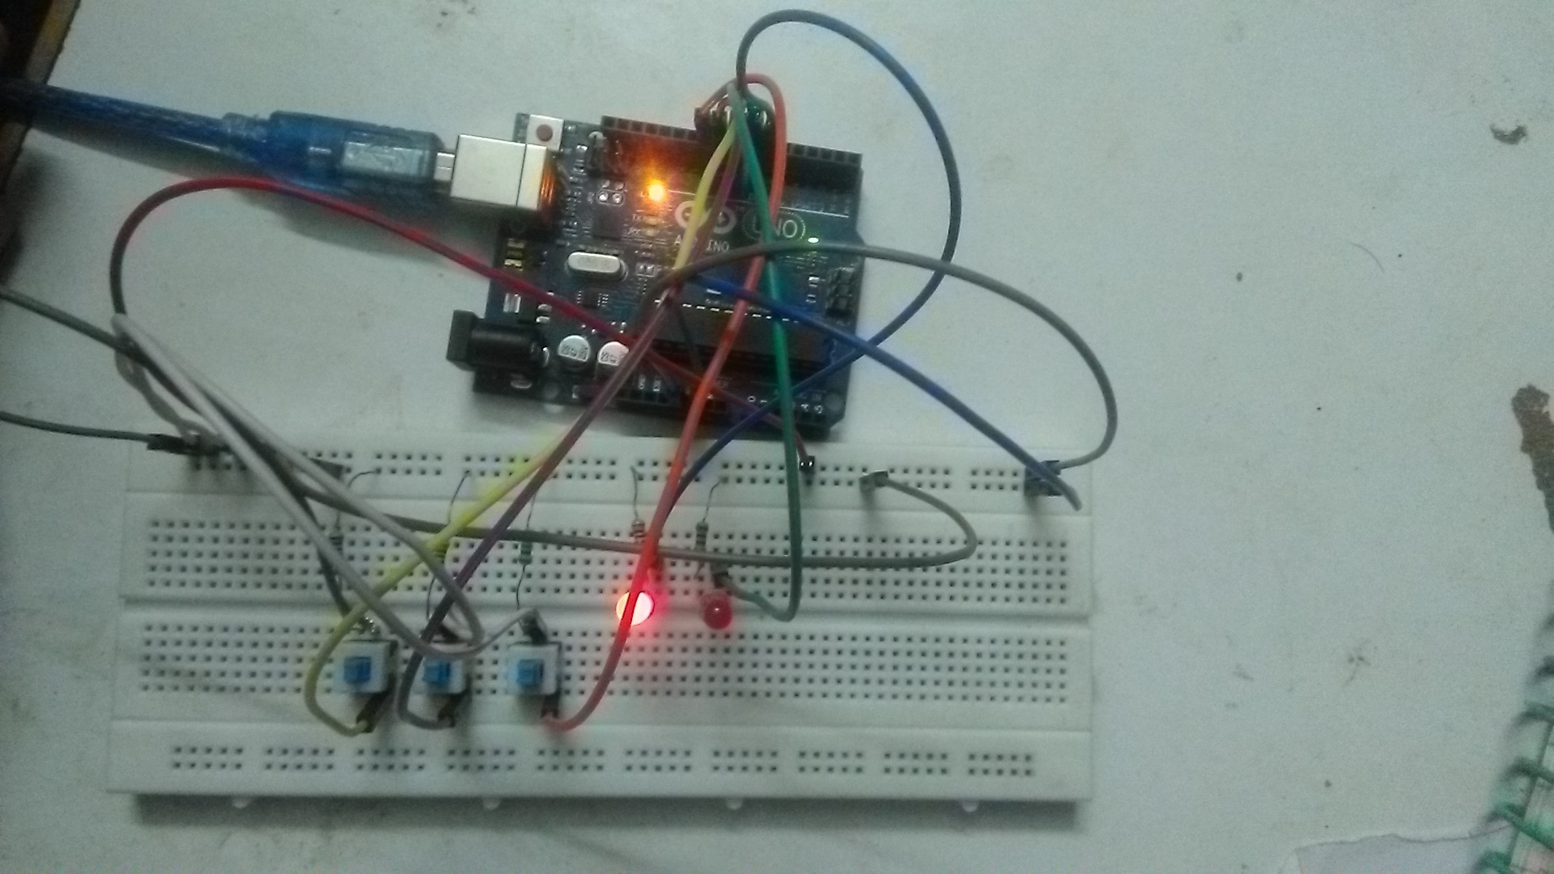

5. When A=0 B=1 Cin=1 SUM=0 CARRY=1
6. When A=1 B=0 Cin=1 SUM=0 CARRY=1

7. When A=1 B=1 Cin=1 SUM=1 CARRY=1
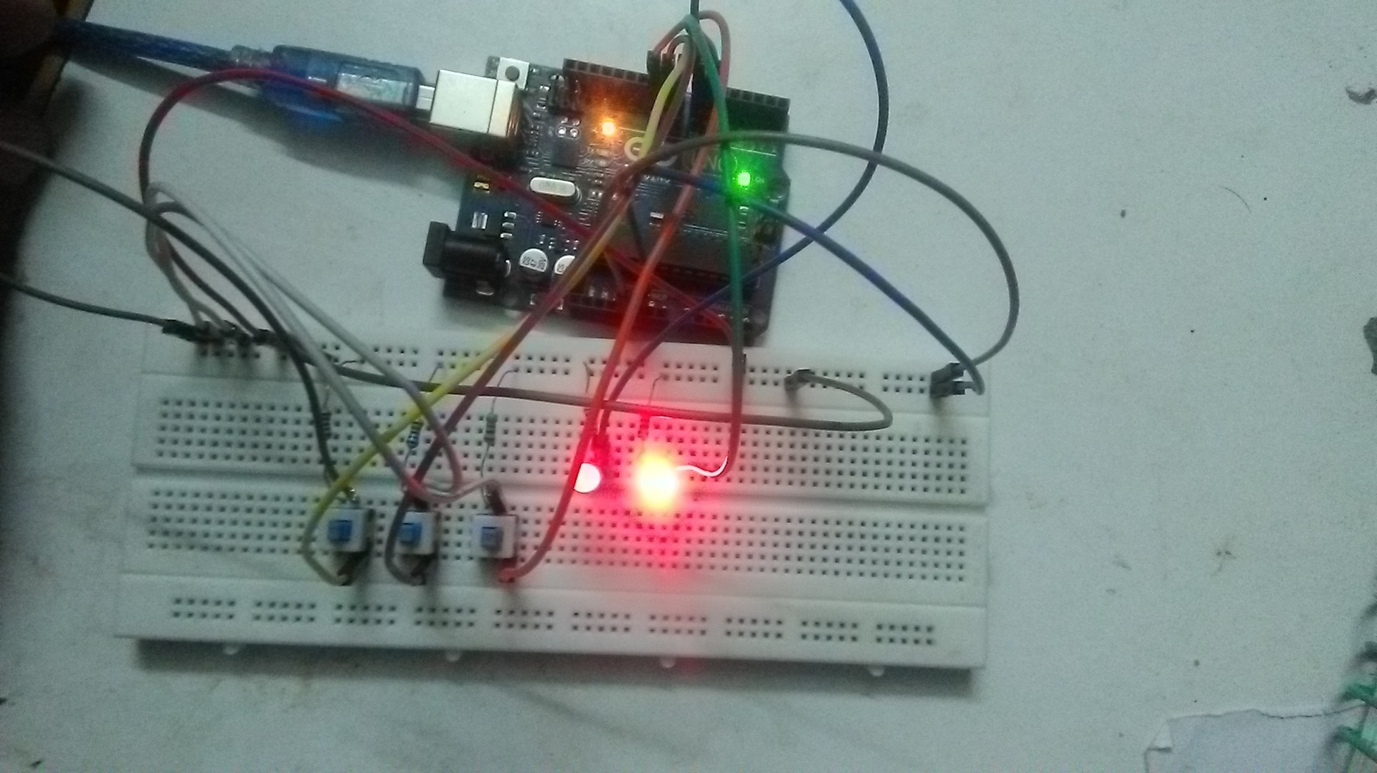

CODE:

.include "./m328Pdef.inc"
main:
ldi r16,0b11000000 ;for port d configuration for LED output
out ddrd,r16
ldi r16,0b00000000 ;for port b configuration for switches
out ddrb,r16
loop:
in r16,pinb
andi r16,0b00000111

ldi r23 ,0x00 ;real sum

;input from a
mov r22,r16
andi r22,0x01
add r23,r22

;input from b
mov r22,r16
andi r22,2
lsr r22
add r23 , r22

;input from c
mov r22,r16
andi r22,4
lsr r22
lsr r22
add r23 , r22

;write output
lsl r23
lsl r23
lsl r23
lsl r23
lsl r23
lsl r23
out portd,r23
rjmp loop

