prodDisruption — Production Architecture on Microsoft Azure

Contents
- Executive Summary
- Business Context
- Logical Architecture
- Component Responsibilities
- Runtime Flows
- Azure Service Inventory
- Network Architecture
- Identity & Access
- Data Architecture
- AI Architecture
- Multi-Tenancy Model
- Observability
- DevOps & Release Engineering
- Reliability & Disaster Recovery
- Performance & Scaling
- Security Controls
- Well-Architected Framework Alignment

1.Executive Summary

1.1 What is prodDisruption
prodDisruption is a multi-tenant, AI-driven SaaS platform that automates how an airline handles passenger experience the moment a flight is cancelled or delayed. It sits in front of the airline's existing CRM, Customer Data Platform (CDP) and flight inventory systems, and turns every disruption event into one of two outcomes:
- Recovery — when a flight is cancelled, an Azure AI Foundry agent selects the best alternate flight and the best available seat for that passenger, in under 30 seconds, using rules derived from the passenger's CDP persona (Student, Doctor, Defence, High Spender, General).
- Messaging — when a flight is delayed, an Azure AI Foundry agent selects the right message group and produces three personalised, channel-aware notifications (SMS, WhatsApp, Email) from the airline's approved template set, again driven by the passenger's persona.

1.2 Why this is needed
Flight disruptions are one of the largest unmanaged cost and CX problems in commercial aviation:
- Globally, irregular operations (IROPS) cost the aviation industry an estimated USD 30+ billion every year in operational recovery, compensation and lost loyalty (industry estimates).
- A single cancellation on a narrow-body aircraft produces roughly 180 individual rebooking conversations that today queue on contact-centre agents, with handle times in tens of minutes per passenger.
- Generic disruption SMS treats every passenger identically — a Defence traveller, a Doctor, a Student and a top-tier loyalist all receive the same template. Personalisation at scale is operationally impossible by hand.
- Airlines competing on customer experience need to scale empathy: every disrupted passenger needs an immediate, individually-relevant response — not a position in a phone queue.

1.3 Business outcomes
Lower IROPS cost↓ Contact-centre handle time and operational cost during disruption events
Higher NPSSub-minute, personalised responses replace 20-minute call queues
Loyalty retentionPersona-aware recovery protects high-value segments (High Spenders, Defence, Doctors)
Auditable playbookStandardised, logged disruption handling — every decision is traceable

1.4 How the platform works
Each disruption request follows the same four-step flow: (1) the platform ingests the disruption event from the airline's operational systems, (2) resolves the passenger's persona via the airline's CDP, (3) invokes the tenant-scoped Azure AI Foundry agent for either Recovery or Messaging, and (4) returns a deterministic, structured JSON response that the airline's downstream channels (web, mobile, contact centre, OTAs) consume directly.

1.5 Engineering posture
The platform is deployed entirely on managed Microsoft Azure services: three Azure Container Apps (api-prod, api-admin, mcp-server) behind Azure API Management, with an Azure Static Web Apps front-end for tenant administration. Azure Cache for Redis provides idempotency and hot-path caching; Azure Cosmos DB for MongoDB stores tenant configuration, AI agent registry, prompts and templates; Azure Key Vault holds all secrets with Managed Identity end-to-end; Microsoft Entra ID issues identities for admins and inter-tenant federation. Tenant configuration and the AI agent registry are hot-swappable — agent IDs, prompts and templates change at runtime without an application restart.
Multi-tenantLogical multi-tenant, partitioned by tenant_id at every layer
Deterministic AItemperature = 0.1, top_p = 0.1, structured JSON output with hallucination guard
Zero-trustManaged Identity, Key Vault references, private endpoints, no shared secrets
SaaS economicsPer-tenant metering, per-app autoscaling, per-tenant cost attribution

2.Business Context
Stakeholder | Outcome
Airline passengers | Sub-minute personalised recovery (alternate flight + seat) or proactive delay notifications
Airline operations | Automation of disruption recovery; reduction in contact-centre load
Airline marketing / CRM | Persona-aware messaging across Student, Doctor, Defence, High Spender, General segments
Airline IT | Drop-in SaaS — no on-premise AI infrastructure; standards-based REST API
AIONOS | Multi-tenant SaaS economics on Azure with per-tenant isolation and metering

Supported disruption flows
- Recovery flow — event_type = flight_cancelled. AI selects the best alternate flight + best seat based on CDP-derived priority rules.
- Messaging flow — event_type = flight_delayed. AI selects the best message group and personalises SMS / WhatsApp / Email content.

3.Logical Architecture
The platform is composed of three Azure Container Apps fronted by Azure API Management. The Admin Panel is delivered as a Static Web App. All data and identity services are accessed over private endpoints from inside the Container Apps VNET.
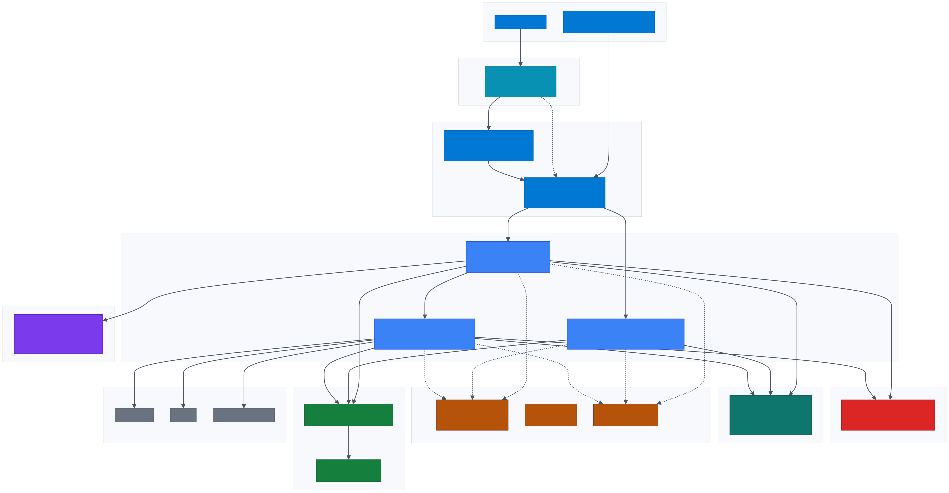

4.Component Responsibilities
Component | Azure Service | Responsibility | Ingress
Admin SPA | Azure Static Web Apps | Airline admin UI for tenant config, agent registry, prompt and template management | Public (HTTPS, custom domain)
APIM | API Management Standard v2 | Single ingress, JWT auth, tenant context injection (X-Tenant-Id), rate limiting, subscription keys, schema validation, request logging | Public (HTTPS)
api-prod | Azure Container Apps | Public REST API. Receives disruption requests, orchestrates the MCP call, executes the Azure AI Foundry agent and returns the structured response | External — via APIM only
api-admin | Azure Container Apps | Backend for the Admin SPA. CRUD on tenants, agents, prompts, templates. Writes audit logs to Cosmos DB | External — via APIM only
mcp-server | Azure Container Apps | Data orchestration plane. Parallel async fan-out to Disruption API, CDP API and Airline API. Resolves tenant base URLs from Cosmos DB | Internal — VNET only
AI Foundry | Azure AI Foundry (GPT-4.1) | Hosts the Recovery Agent and Messaging Agent. Per-tenant agent IDs resolved at runtime from Cosmos DB | Managed Identity authenticated
Redis Cache | Azure Cache for Redis | Hot-path caching: idempotency keys (de-dup repeated PNR requests), response cache for completed jobs, seat-map cache (30 min TTL), tenant-config and agent-config short-TTL cache, rate-limit counters | Private endpoint (Premium tier) / firewall + MI auth (Standard tier)
Cosmos DB | Cosmos DB for MongoDB | System of record for tenant config, agents, prompts, templates, settings, audit logs | Private endpoint
Entra ID | Microsoft Entra ID (P1) | Identity provider for airline admin users (SSO into the Admin SPA), JWT issuer for APIM validation, federation point for airline IdPs (B2B), service principals for CI/CD | Public OIDC / OAuth2 endpoints
Key Vault | Azure Key Vault | Centralised secret store. All Container Apps read via Key Vault references — no plaintext secrets in app config | Private endpoint
ACR | Azure Container Registry (Premium) | Signed, scanned container images for all three apps. Image pull via Managed Identity | Private endpoint
Application Insights / LAW | Azure Monitor | Distributed tracing, custom metrics, log aggregation, alerting | n/a

5.Runtime Flows

5.1 End-to-End Operational Flow — how an airline uses prodDisruption
The diagram below shows the full lifecycle of a single disruption — from detection in the airline's Operations Control Centre (OCC) through to passenger delivery and outcome capture in the airline's PSS / CRM. prodDisruption sits between the airline's operational data systems (disruption feed, CDP, flight inventory) and the airline's passenger channels (web, mobile, contact centre, OTA, push gateway). The platform produces decisions; the airline's existing systems remain the system of record for rebooking, notification dispatch and loyalty capture.
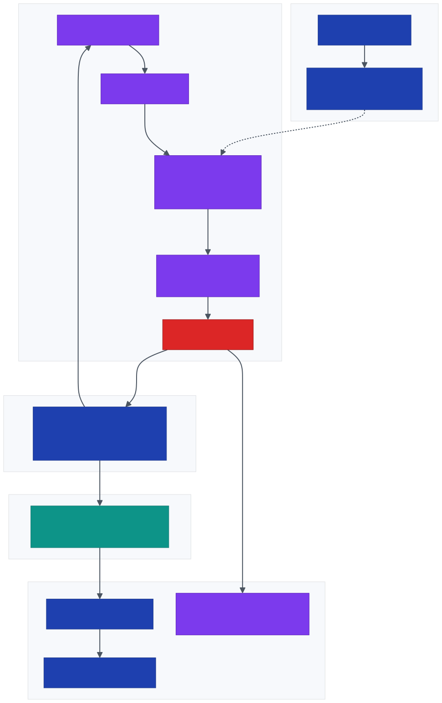

5.2 Data inputs and outputs per request
Each disruption request consumes a small, strictly-defined input set and produces a strictly-shaped JSON output. The platform itself is stateless on the request path — no passenger PII is persisted; only decision metadata (no personal data) is written to the audit log.
Direction | Field / payload | Source | Purpose
Inbound — request | pnr | Calling channel (Web / Mobile / IVR / OTA) | Lookup key for disruption event & CDP profile
 | last_name | Calling channel | Identity verification against the PNR
 | tenant_id | APIM (extracted from JWT claim) | Routes to correct airline tenant config + agent
Pulled — airline operational data | Disruption event | Airline Disruption API | Event type · segKey · delay / cancel context
 | CDP profile | Airline CDP | Persona signals — Student · Doctor · Defence · High Spender · General
 | Flight options + seat maps | Airline Flight Inventory API | Available alternates + assignable seats (recovery flow only)
Pulled — platform config | Active agent ID + admin prompts | Cosmos DB agents + prompts (per tenant + flow) | Hot-swappable AI configuration
 | Message templates | Cosmos DB templates | Approved base content for messaging flow
Outbound — recovery flow | selected_flight + flight_reasoning | Azure AI Foundry — Recovery Agent | Flight number · time · class · segKey · why this flight
 | selected_seat + seat_reasoning | Azure AI Foundry — Recovery Agent | Seat number · travel class · seat type · why this seat
Outbound — messaging flow | selected_group_id + reason | Azure AI Foundry — Messaging Agent | Persona-matched template group identifier
 | messages[SMS, WhatsApp, Email] | Azure AI Foundry — Messaging Agent | Personalised, channel-aware copy ready for dispatch
Side-effect | Audit log entry | Platform → Cosmos DB audit_logs | {tenant_id, pnr_hash, decision, agent_id, tokens_in/out, latency_ms, ts} — no PII

5.3 Decision contract — who owns what
prodDisruption is a decision service, not an execution service. It returns a JSON decision; existing airline systems remain responsible for the rebooking transaction, notification dispatch and loyalty capture. This separation keeps the integration non-disruptive to the airline's PSS and audit posture.
Step | Owner | System of record
Disruption detection | Airline OCC / NOC | Airline FOS / OCC tooling
Disruption event publishing | Airline IT | Airline Disruption API
Passenger persona | Airline marketing / data | Airline CDP
Flight options + seat maps | Airline IT | GDS / NDC / Airline inventory
Decision generation (AI) | prodDisruption | Azure AI Foundry agents
Delivery to passenger | Airline channel | Channel-owned (web / mobile / SMS gateway / agent app)
Rebooking commit | Airline reservations | Airline PSS (Amadeus / Sabre / Navitaire)
Loyalty & NPS capture | Airline CRM | Airline loyalty platform
Decision audit trail | prodDisruption | Cosmos DB audit_logs

5.4 Recovery flow — technical sequence (cancelled flight)
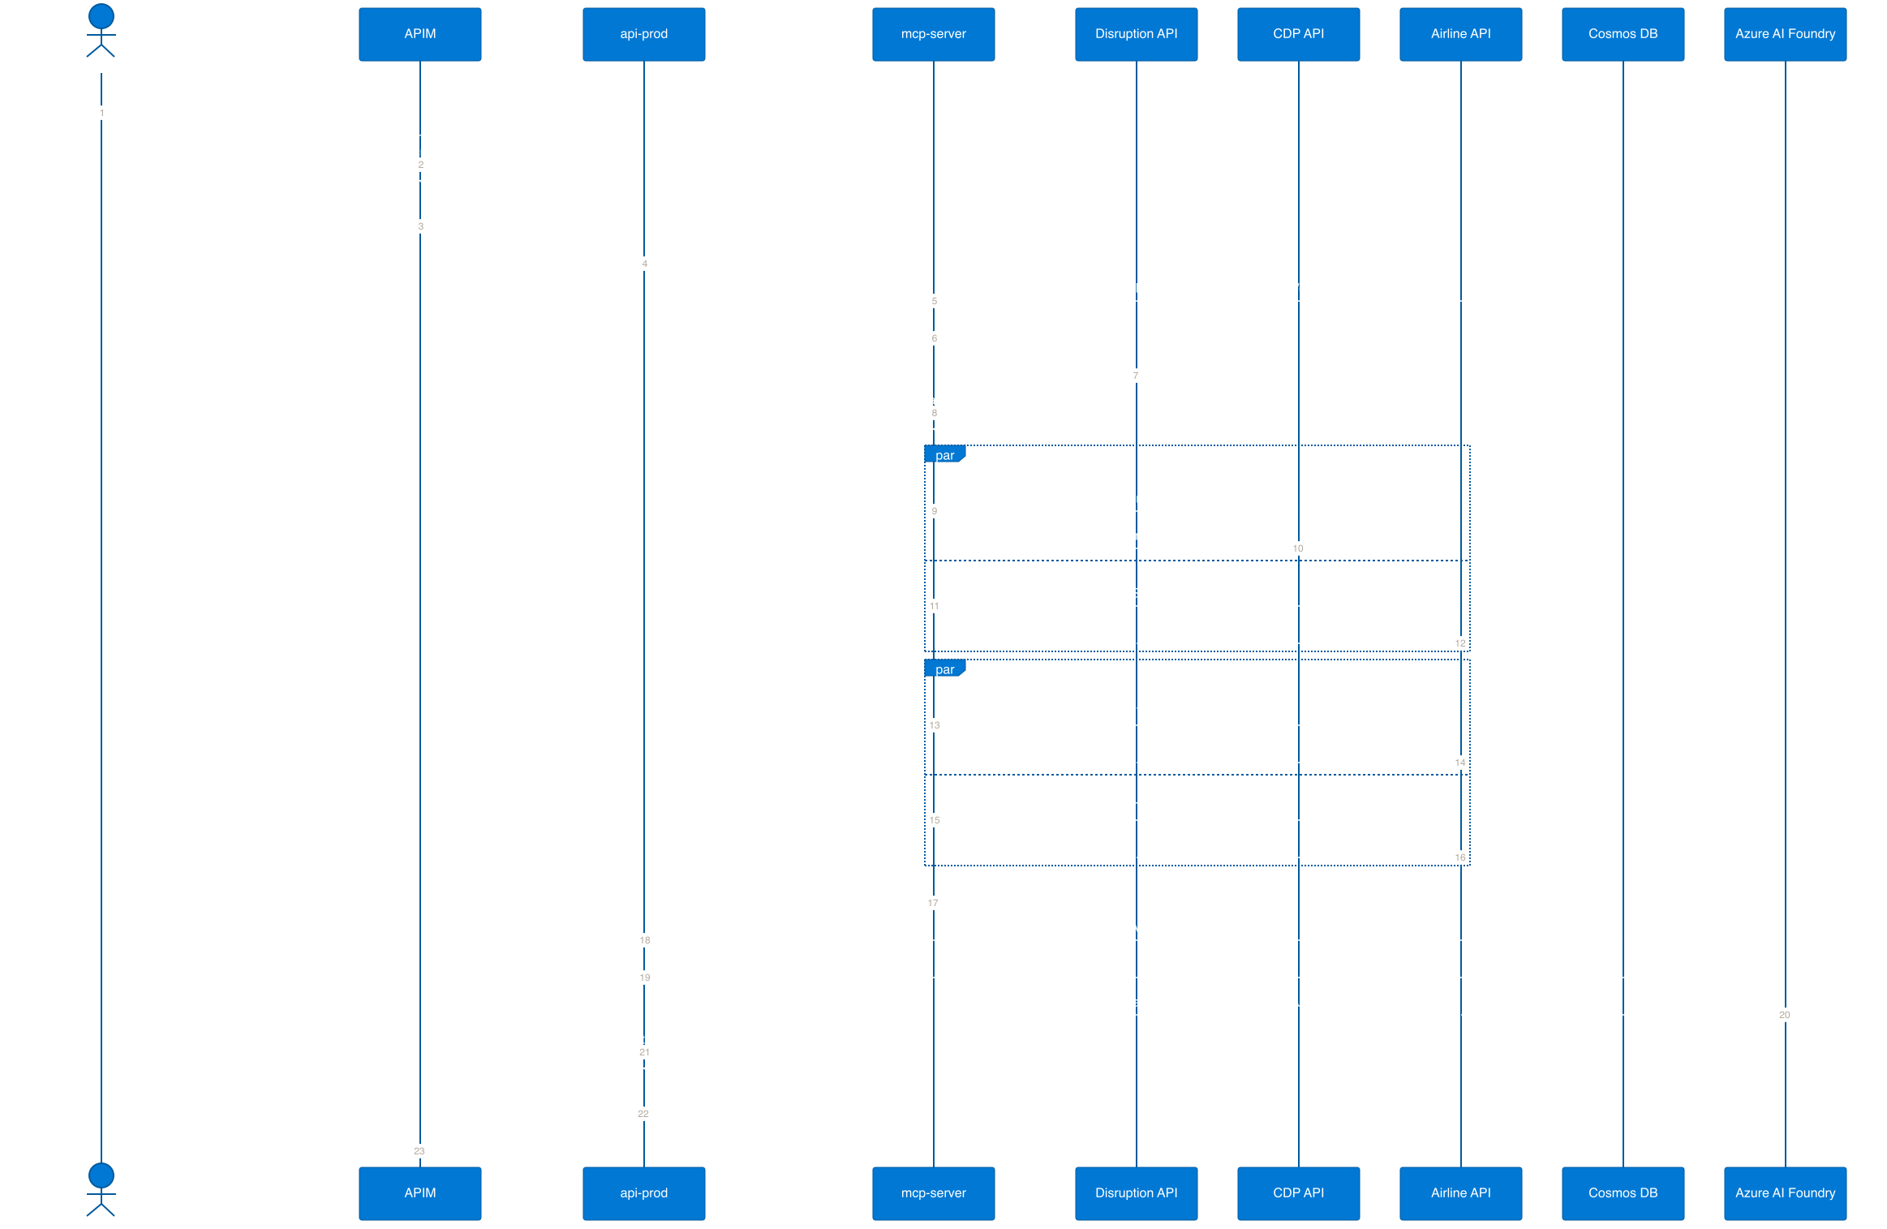

5.5 Messaging flow — technical sequence (delayed flight)
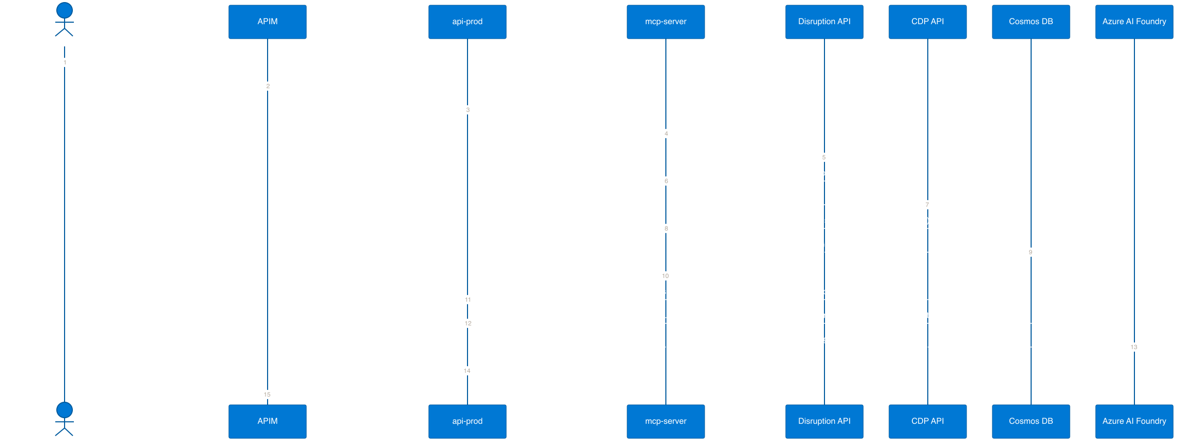

6.Azure Service Inventory
Service | SKU / Tier | Rationale
Azure API Management | Standard v2 (Stv2) | Production multi-tenant ingress, VNET integration, subscription keys, JWT validation
Azure Container Apps | Dedicated workload profile (D4) | Per-app autoscaling, VNET integration, predictable cost
Azure Static Web Apps | Standard | Custom domain, SSO with Entra ID, staging environments
Azure Cosmos DB for MongoDB | RU autoscale (1K–10K) | Predictable cost or true elastic; session consistency; per-tenant partition key
Azure Cache for Redis | Standard C1 (1 GB) — Premium P1 recommended | Idempotency, response cache, seat-map cache; Premium adds private endpoint and VNET injection
Azure AI Foundry | Standard project — model: GPT-4.1 | Hosts persistent assistants (Recovery + Messaging); per-tenant agent IDs
Microsoft Entra ID | Premium P1 | Admin SSO, JWT issuance for APIM, federation to airline IdPs, conditional access
Azure Key Vault | Standard | Secrets store; HSM tier upgrade available on enterprise contracts
Azure Container Registry | Premium | Geo-replication, content trust, private endpoint, Defender scanning
Application Insights | Workspace-based | Distributed tracing, custom metrics, KQL across all apps
Log Analytics Workspace | Pay-as-you-go | Central log sink + diagnostic settings for every resource
Microsoft Defender for Cloud | Defender for Containers, Key Vault, Cosmos DB | Posture management + runtime threat detection
Azure DDoS Protection | Network Protection (Standard) | Applied at the APIM public IP

7.Network Architecture
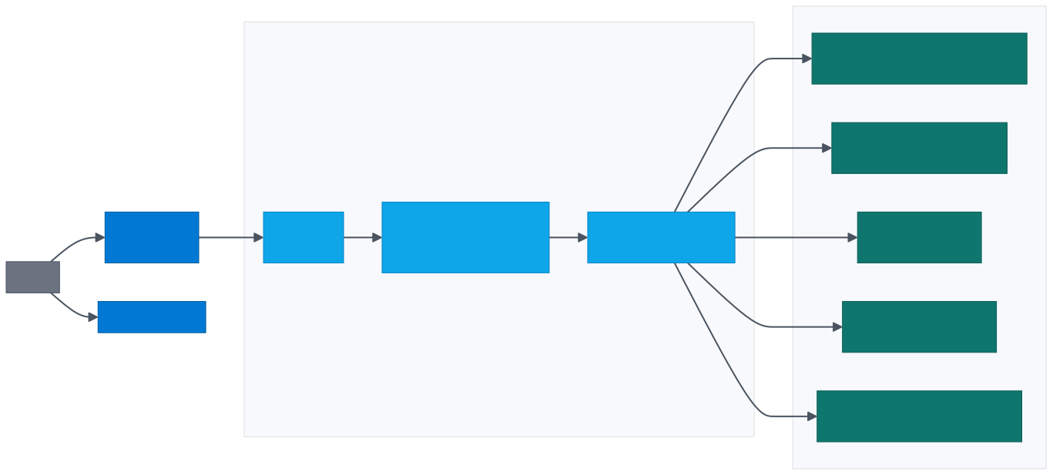
- APIM deployed in external mode in subnet-apim; egress permitted only to subnet-aca.
- Container Apps Environment is VNET-integrated. mcp-server uses internal-only ingress and is not addressable from the internet.
- All PaaS data services (Cosmos DB, Key Vault, ACR) are reached over Private Endpoints. Public network access is disabled on every account.
- Egress to tenant external APIs is routed through the Container Apps NAT — a fixed outbound public IP registered with each airline tenant for IP allow-listing.
- NSGs on each subnet enforce least-privilege L4 rules: APIM → ACA on 443 only; ACA → private endpoints on 443 (KV, ACR, AI Foundry), 10250 / 27017 (Cosmos), 6380 (Redis TLS).

8.Identity & Access

8.1 Identity providers and trust flow
Microsoft Entra ID is the identity authority for the platform. Two distinct identity flows are in use: human identities for airline admin users into the Admin Panel, and workload identities (system-assigned Managed Identity) for service-to-service authentication.
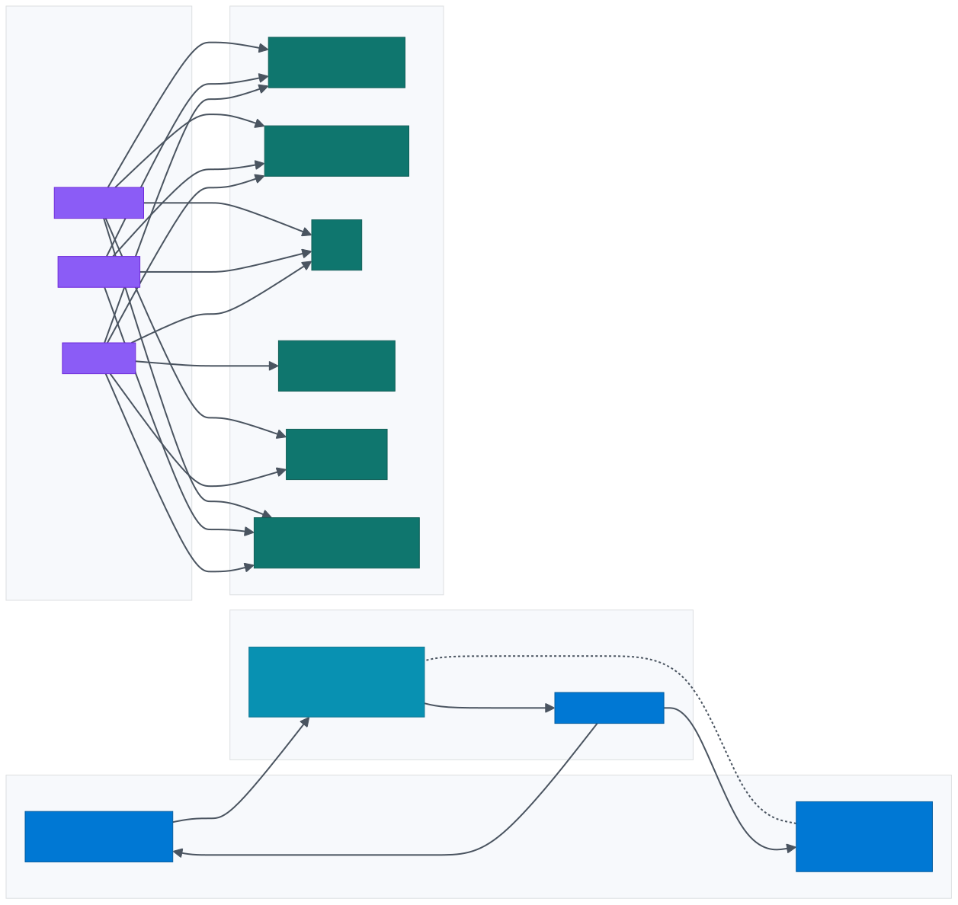

8.2 Zero-trust controls
Principle | Implementation
No secrets in code or env | Every secret is a Key Vault reference (secretref: in Container Apps). Rotated via Key Vault rotation policies.
Managed Identity everywhere | All inter-service calls authenticate via system-assigned MI. No SAS tokens, no connection strings.
RBAC, least privilege | Each MI holds the minimum role required — e.g. mcp-server is Cosmos Data Reader, not Contributor.
Human identity | Microsoft Entra ID (P1) — Conditional Access policies enforce MFA; airline tenants may federate their own IdP via B2B collaboration.
JWT at the edge | APIM validate-jwt policy verifies tokens against the Entra ID JWKS endpoint. Tenant claim drives X-Tenant-Id header injection.
Admin Panel SSO | Static Web Apps redirects unauthenticated users to Entra ID; admin roles enforced in SWA route config and in the api-admin backend.
Audit logging | Every admin write creates an audit log entry in Cosmos DB. Diagnostic settings on Key Vault and Cosmos DB stream to Log Analytics.

9.Data Architecture

9.1 Cosmos DB collections (database flight_operations)
Collection | Purpose | Partition key | Indexed fields
tenants | Per-tenant base URLs and metadata | tenant_id | tenant_id, is_active
agents | AI Foundry agent IDs per tenant per flow | tenant_id | tenant_id, flow, is_active
prompts | System/user prompt overrides per tenant per flow | tenant_id | tenant_id, flow, is_active
templates | Message templates (delay flow) | tenant_id | tenant_id, is_active
settings | Generic runtime settings | tenant_id | tenant_id
audit_logs | Admin write audit trail | tenant_id | tenant_id, timestamp

9.2 Data classification & residency
Class | Examples | Residency | Retention
Tenant configuration | Base URLs, agent IDs, prompts, templates | Primary Azure region (tenant-selected) | Lifetime of tenant
PII (transient) | PNR, last name, contact (request body only) | In-memory only, never persisted | None
Audit logs | Admin actions | Same region as tenant | 365 days (configurable)
Telemetry | Request traces, AI token counts | Same region as tenant | 30 days hot / 90 days archive
Key guarantee: the platform does not persist passenger PII. All PII flows through mcp-server in memory and is discarded after the response is returned.

9.3 Consistency & backup
- Consistency: Session consistency (per-tenant partition reads are read-your-writes).
- Backup: Continuous backup with 30-day point-in-time restore.
- Geo-replication: Available via secondary read region with auto-failover.

9.4 Redis cache key schema
Azure Cache for Redis sits on the hot path and is keyed strictly by tenant_id to enforce isolation. Keys, TTLs and use-cases:
Key pattern | TTL | Purpose
idem:{tenant_id}:{pnr} | 300 s | Idempotency — duplicate PNR requests within the window return the cached result instead of re-running the AI agent
result:{tenant_id}:{request_hash} | 3600 s | Response cache for completed disruption decisions
seatmap:{tenant_id}:{segKey} | 1800 s | Parsed seat map cache — avoids re-fetching the airline seat-map API for the same flight segment
agent_cfg:{tenant_id} | 60 s | Resolved agent IDs + active prompts from Cosmos — short-TTL to allow admin hot-swap to propagate quickly
tenant_cfg:{tenant_id} | 300 s | Tenant base URLs for external APIs — reduces Cosmos reads on the hot path
rl:{tenant_id}:{window} | 60 s sliding | Rate-limit counter — used by APIM and as a defensive secondary check in api-prod
Tier note: Standard C1 satisfies the cache workload at current volumes. Upgrading to Premium P1 enables private endpoint support, VNET injection and zone redundancy — recommended once contractual zero-trust requirements are signed with the first enterprise tenant.

10.AI Architecture
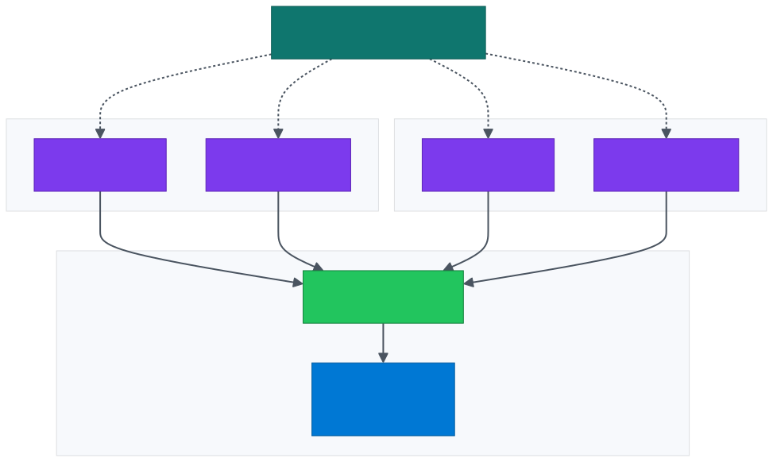
Property | Value
SDK | azure-ai-projects + azure-ai-agents
Authentication | DefaultAzureCredential — Managed Identity in production
Temperature / top_p | 0.1 / 0.1 (near-deterministic)
Thread lifecycle | Created per request, never reused
Timeout | 120 second polling window
Output parsing | safe_json_from_agent() strips markdown fences and validates JSON
Hot-swap | Activating a new agent ID in Cosmos DB applies on the next request — no app restart
Prompt layering | Base prompt → admin system prompt prepended → admin user prompt appended

11.Multi-Tenancy Model
Layer | Isolation mechanism | Shared infrastructure?
APIM | JWT tenant_id claim → X-Tenant-Id header injection; per-tenant rate limit and quota | Shared gateway
Container Apps | Tenant context flows in headers; no in-memory tenant state | Shared compute
MCP server | tenant_id resolves every external API base URL | Shared compute
Cosmos DB | Partition key = tenant_id on every collection | Shared account, isolated partitions
Key Vault | Per-tenant secret naming: tenants/{tenant_id}/{secret} | Shared vault
AI Foundry | Distinct agent_id per tenant per flow; thread isolation enforced by SDK | Shared project, isolated agents
External APIs | Per-tenant base URLs from tenants collection | Fully isolated per airline

Tenant onboarding workflow

12.Observability
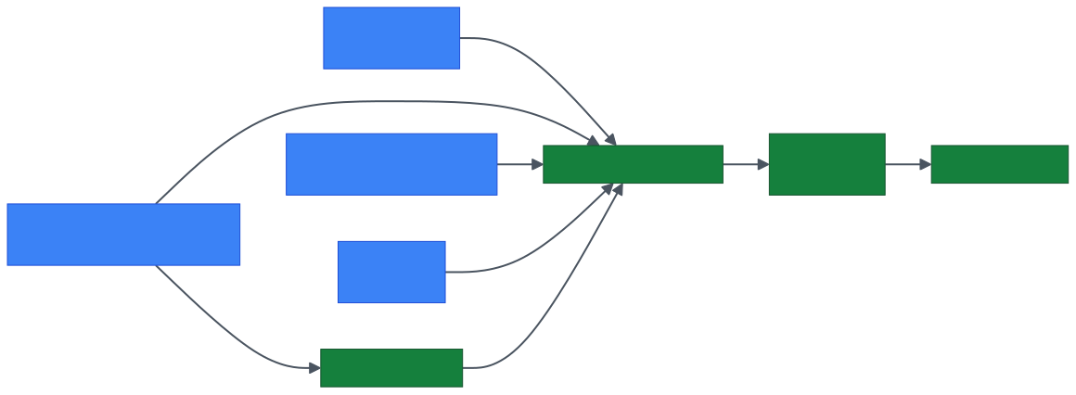

Custom telemetry
Metric | Dimensions | Purpose
disruption_request_latency_ms | tenant_id, flow, outcome | SLO tracking
ai_agent_run_latency_ms | tenant_id, flow, agent_id | AI performance
ai_tokens_consumed | tenant_id, flow, direction | Cost attribution
mcp_external_api_latency_ms | tenant_id, api_name | Airline-side performance
disruption_request_total | tenant_id, flow, status | Throughput & error rate

Production alert set
Severity | Condition | Action
Sev 1 | api-prod 5xx rate > 5% for 5 min | Page on-call
Sev 1 | AI Foundry timeout rate > 10% for 5 min | Page on-call
Sev 2 | p95 e2e latency > 30s for 10 min | Slack channel
Sev 2 | Cosmos DB throttling (429s) > 1% | Slack channel
Sev 3 | Key Vault auth failure > 0 | Email
Sev 3 | External tenant API error rate > 1% | Email tenant ops

13.DevOps & Release Engineering
- Blue/green via Container App revisions — new revision deployed with 0% traffic, smoke-tested, then progressively shifted.
- Auto-rollback — error-rate threshold of 1% on a new revision triggers automatic revert.
- Hot-reload of AI config — agent IDs, prompts and templates change in Cosmos DB without code deployment.
- Secret rotation — Key Vault policies rotate Cosmos DB keys (90 days) and tenant API keys. Container Apps reload Key Vault references on rotation.

14.Reliability & Disaster Recovery
The platform is deployed in a single Azure region (South India) with zone redundancy across all stateful services. Availability is achieved through Availability Zone distribution and Container Apps revision-level redundancy; durability is achieved through Cosmos DB continuous backup and ACR geo-replicated images.
Aspect | Configuration
Region | South India — primary and only deployed region
Availability Zones | Container Apps Environment, Cosmos DB, APIM and Redis are deployed across the AZs available in South India
HA within region | Container Apps revisions, min replicas ≥ 2 on every app, zone-redundant SKUs
Cosmos DB | Zone-redundant; continuous backup (30-day point-in-time restore)
APIM | Zone-redundant deployment
ACR | Premium with geo-replication — images are pre-staged in a paired region for fast cold-start during DR
Key Vault | Soft delete + purge protection enabled (90 days)
Redis | Standard C1 (in-region HA via primary/replica) — Premium upgrade adds zone redundancy and geo-replication
RTO target (in-region failure) | ≤ 5 minutes — AZ failover is automatic across managed services
RTO target (regional failure) | ≤ 4 hours — manual restore from Cosmos PITR + ACR replica + redeploy of Container Apps via IaC
RPO target | ≤ 5 minutes (Cosmos continuous backup)
Disaster recovery plan: Infrastructure is described as Bicep/Terraform; the platform can be re-provisioned in a paired Azure region from source control and Cosmos PITR in under 4 hours. A documented DR runbook covers failover steps, DNS update, tenant communication and data validation.

15.Performance & Scaling
Layer | Scaling rule | Min / Max
APIM | Fixed capacity units (Stv2) | 1 → 4 units
api-prod | HTTP concurrency (~50 / replica) | 2 → 20 replicas
api-admin | HTTP concurrency | 1 → 5 replicas
mcp-server | CPU + HTTP concurrency | 2 → 10 replicas
Cosmos DB (RU mode) | Autoscale 1K → 10K RU/s per collection | n/a
AI Foundry | Quota-bounded; per-region TPM / RPM monitored | Negotiated quota

Hot-path latency budget (recovery, p95)
Stage | Budget
APIM | < 50 ms
MCP fan-out (parallel) | < 4 s (dominated by airline APIs)
AI Foundry recovery run | < 15 s
Total end-to-end | < 20 s p95

16.Security Controls
Control family | Implementation
Network | VNET-integrated ACA, private endpoints for Cosmos / Key Vault / ACR; APIM is the only public ingress for the API; SWA is the only public ingress for the Admin UI
Identity | System-assigned Managed Identity per Container App; RBAC at minimum role; no SAS or connection strings
Secrets | Key Vault references only; soft delete + purge protection; rotation policies
Edge | APIM JWT validation, subscription keys, per-tenant rate limit and quota, schema validation, DDoS Network Protection on the public IP
Data in transit | TLS 1.2+ enforced; mTLS optional on internal ingress
Data at rest | AES-256 with Microsoft-managed keys; CMK upgrade path available
PII | No passenger PII persisted; in-memory only inside mcp-server
Threat detection | Microsoft Defender for Containers, Cosmos DB, Key Vault, CSPM
Vulnerability management | ACR + Defender for Containers; CI gate blocks HIGH / CRITICAL CVEs
Supply chain | Multi-stage builds, distroless base image, non-root runtime, signed images
Compliance posture | Aligned to ISO 27001 / SOC 2 controls inherited from Azure; per-tenant audit logs retained 365 days

17.Well-Architected Framework Alignment
ReliabilityZone-redundant SKUs · ACA min replicas ≥ 2 · Cosmos PITR · blue/green revisions · regional failover
SecurityManaged Identity everywhere · Key Vault references · private endpoints · JWT at the edge · Defender for Cloud
Cost OptimisationAutoscale on every Container App · Cosmos autoscale RU · per-tenant cost attribution tags · LAW sampling
Operational ExcellenceCI/CD with security gates · blue/green · custom telemetry · production alert set · audit logging
Performance EfficiencyAsync parallel fan-out in MCP · deterministic AI agents · parallel seat-map retrieval · concurrency-based autoscale

