COL 216

Assignment 3

Naman Nirwan(2021CS50593)

Rishabh Kumar(2021CS10103)

Things We have used:

1.)We have used a formula to calculate the penalty and regular times:

the formulae is:

total access time=(L1_read + L1_write) + (L2_read+L2_write)*20 + (L2Read_miss + L2write_miss + L2write_back)*200

1. Change in Block Size

Increase in the size of a Block will help the cache to use more spatial locality, i.e it will help cache to retrieve more data from memory in a single block.By fetching more data, we avoid fetching it again when needed later thus we can avoid misses, thus reducing the time. This can be interpreted from all 8 traces and more prominently from the first 4 traces (small data). For larger data files (last 4 traces) it can also be observed that after a minimum time, the average access time increases with block size. This is because the larger the block size is lesser will be the number of blocks the cache can hold at a time. This leads to more city misses and thus increases the time. The increasing slope (if the slope is considered with the sign) of the graph with increasing block size is also a result of these increasing capacity misses.

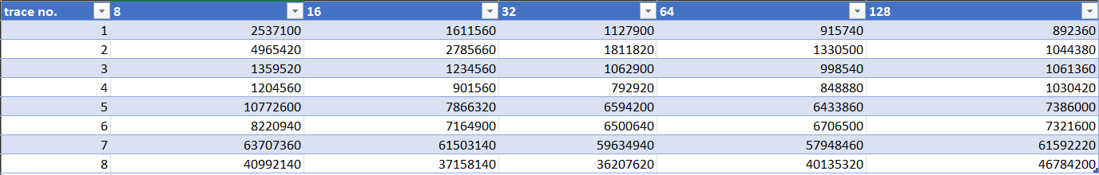

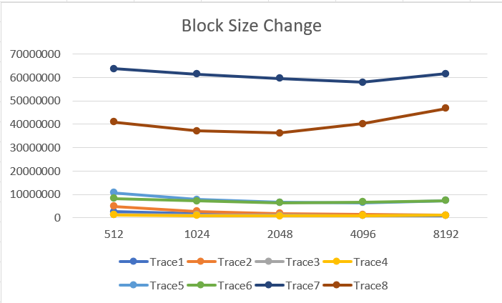

1. Change in Cache Size

As size of L1 increases, more data can be fetched from L2. Thus it will reduce the total number of capacity misses in L1 and hence the total access time. In reality as size of L1 increases, the memory access time for L1 also increases. But in our model the time is constant. Thus in our simulation there is no negative impact in increasing the size of L1. As larger files (last four traces) have more capacity misses, the reduction in their total time is most prominent as seen in the graph by large negative slopes.

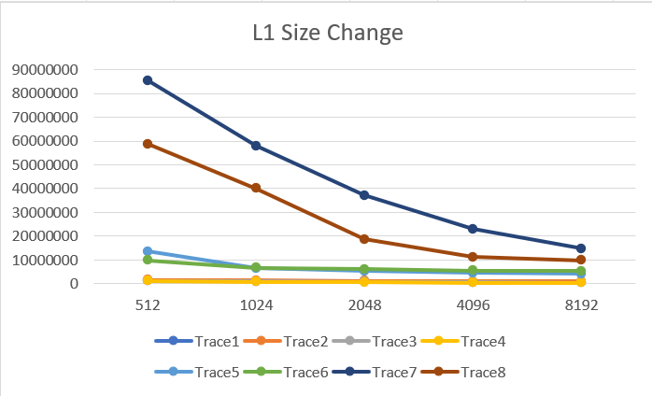

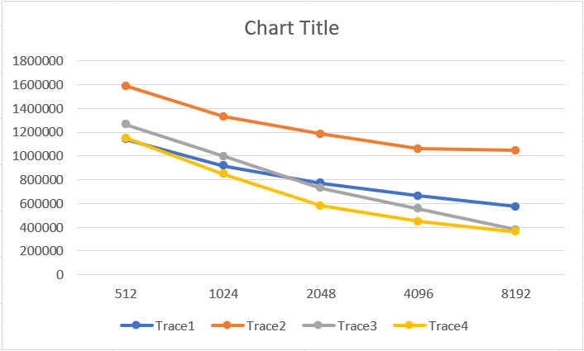

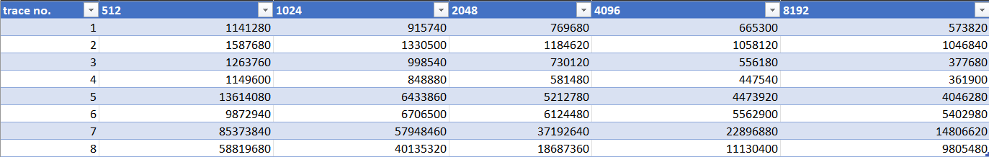

1. L1 Associativity Change:

As associativity of L1 increases, total number of conflict misses reduces. Thus total time also reduces. But conflict misses are quite less in number as compared to other types of misses in a large data set and even a slight increase in associativity can reduce these conflicts considerably. Hence, the time reduces as associativity increases from 1 to 2 and then it is almost constant. Same pattern is followed in all 8 trace files.

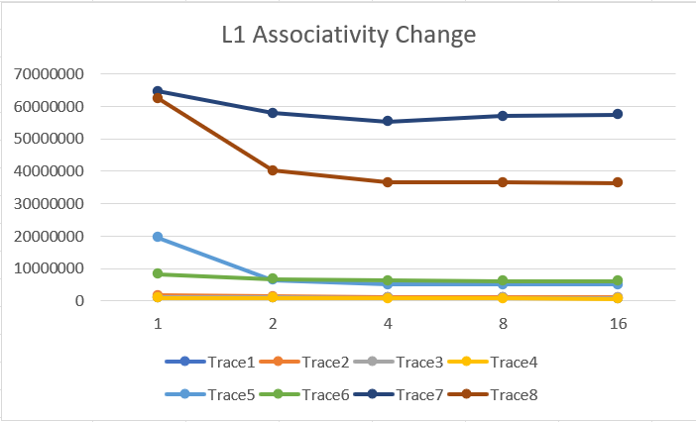  
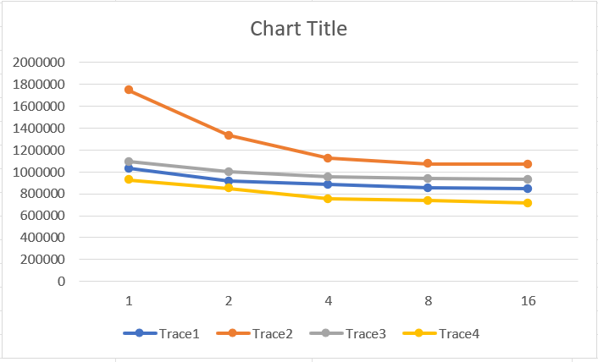

1. Change in Size of Cache L2

As size of L2 increases, more data can be fetched from DRAM. Thus it will reduce the total number of capacity misses in L2 and hence the total access time. In reality as size of L2 increases, the memory access time for L2 also increases. But in our model the time is constant. Thus in our simulation there is no negative impact in increasing the size of L2.

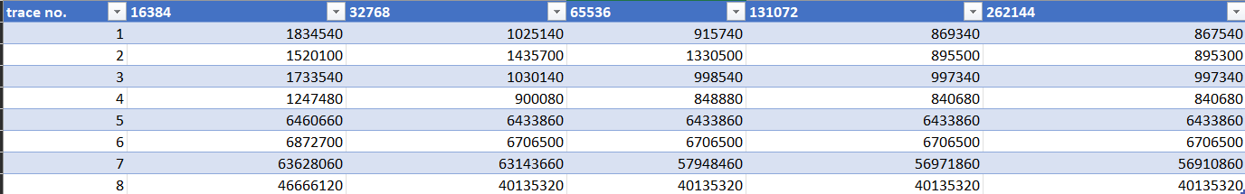

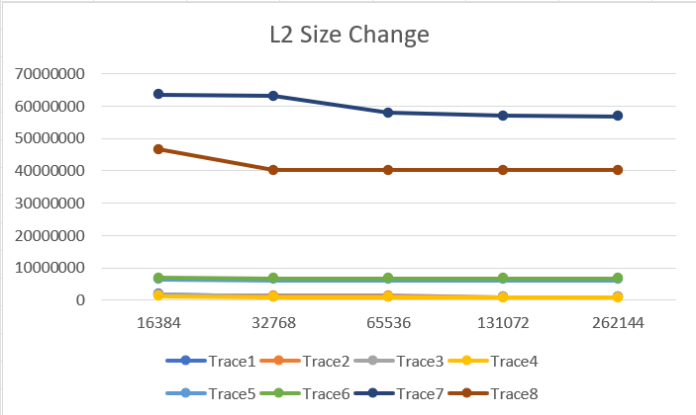

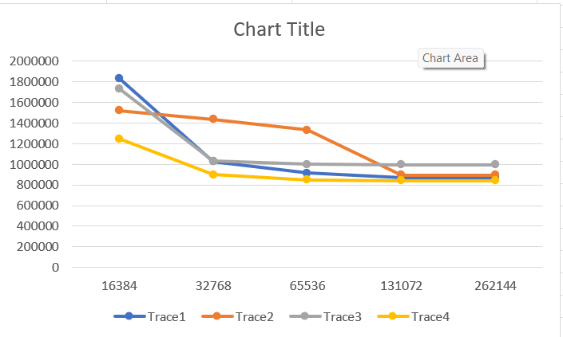

1. Change in Associativity of L2 Cache:

As associativity of L2 increases, total number of conflict misses reduces. Thus total time also reduces. But conflict misses are quite less in number as compared to other types of misses in a large data set and even a slight increase in associativity can reduce these conflicts considerably. Hence, the time reduces as associativity increases from 1 to 2 and then it is almost constant. Same pattern is followed in all 8 trace files.

