

**LAB PROBLEM 1: Class Diagram for Library System (Any Four)**

**Topic:** UML Class Diagram – Structure Overview

**Problem Statement:**

Draw a UML **Class Diagram** for a simple Library Management System with classes like Book, Member, and Librarian. Show relationships such as association and aggregation.

**Hints:**

● Use **attributes and methods** inside each class.

● Show **1-to-many** association between Member and Book.

● Mark the relationship direction using arrows.

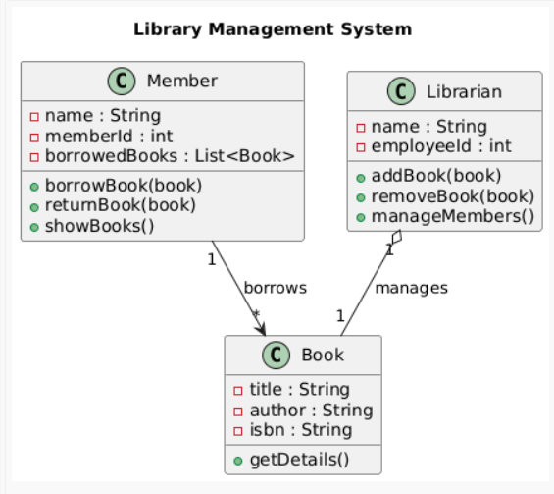

**LAB PROBLEM 2:**

**Object Diagram for Student-Teacher Relationship**

**Topic:** UML Object Diagram – Runtime Instances

**Problem Statement:**

Draw an **Object Diagram** representing real instances of classes Student and Teacher where each teacher guides two students.

**Hints:**

● Show object names (e.g., teacher1:Teacher, student1:Student). ● Indicate **object links** (runtime relationships).

● Keep attribute values simple (e.g., name = "Karthik").

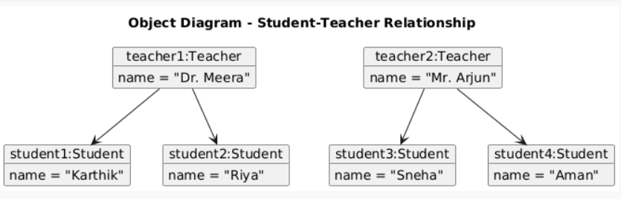

1



**LAB PROBLEM 3: Sequence Diagram for Online Order Process**

**Topic:** UML Sequence Diagram – Method Interaction Over Time

**Problem Statement:**

Draw a **Sequence Diagram** showing the process of placing an order on an e-commerce website. Include Customer, OrderService, PaymentGateway, and InventoryService.

**Hints:**

● Show the **flow of method calls** from customer to services.

● Include **return arrows** to indicate responses.

● Use **activation boxes** for ongoing operations.

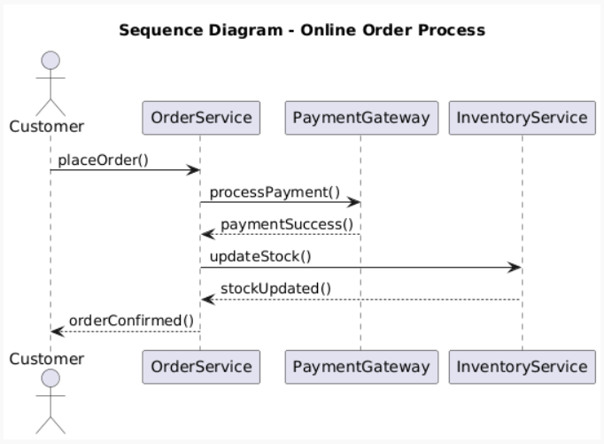

**LAB PROBLEM 4: Use Case Diagram for ATM System**

**Topic:** UML Use Case Diagram – User Interaction

**Problem Statement:**

Draw a **Use Case Diagram** showing the main user actions in an ATM system such as Withdraw Money, Check Balance, and Deposit Money.

**Hints:**

● Use **actor symbols** for users.

● Connect actors to use cases with lines.

● Optionally use **include** or **extend** relationships.

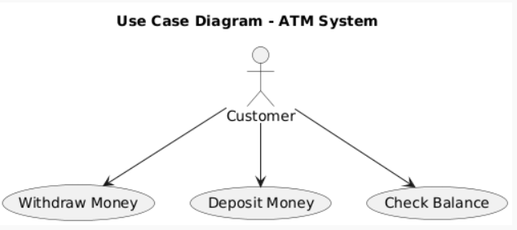

2

3