
Topic 1: Class Diagram – Structure Overview (Any 4)
Problem Statement 1:
Draw a Class Diagram for a simple Bank Account System with classes such as Account, Customer, and Bank. Show attributes and methods for each class, and represent the relationships between them.
Hints:
● Use association between Bank and Customer.
● Represent aggregation between Customer and Account.
● Include visibility symbols (+, -, #) for attributes and methods.

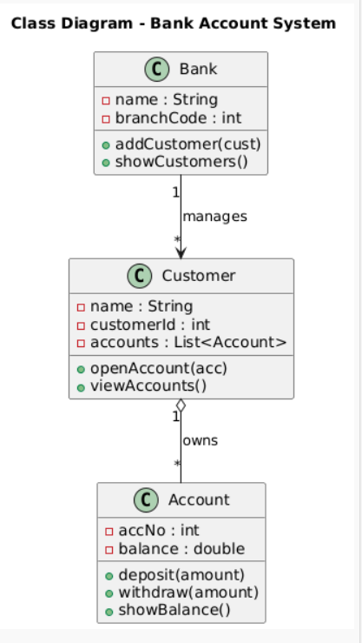
Topic 2: Object Diagram – Runtime Instances
Problem Statement 2:
Create an Object Diagram showing instances of Customer, Account, and Bank classes. Display how specific objects are linked during runtime (e.g., one bank has multiple customers, each with an account).
Hints:
● Show object names like cust1:Customer, acc1:Account.
● Include attribute values in objects (e.g., balance = 5000).
● Demonstrate links between instantiated objects.

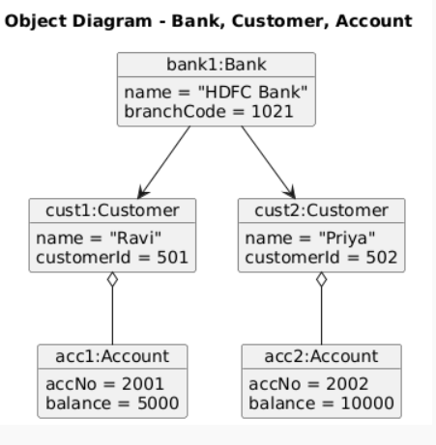
1

Topic 3: Sequence Diagram – Method Interaction Over Time
Problem Statement 3:
Draw a Sequence Diagram for an Online Shopping System showing interactions among Customer, Cart, PaymentService, and OrderService when a customer places an order.
Hints:
● Use lifelines for each participant.
● Show method calls (e.g., addItem(), makePayment(), confirmOrder()). ● Include return messages and activation boxes.

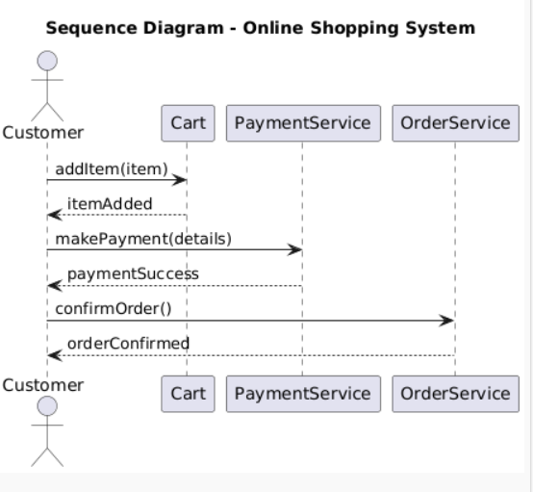
Topic 4: Use Case Diagram – Functional Overview
Problem Statement 4:
Create a Use Case Diagram for a Hospital Management System where an Admin, Doctor, and Patient interact with features like Manage Appointments, Update Records, and Generate Bills.
Hints:
● Use actor symbols for external users.
● Draw include and extend relationships between use cases.
● Label all relationships clearly.

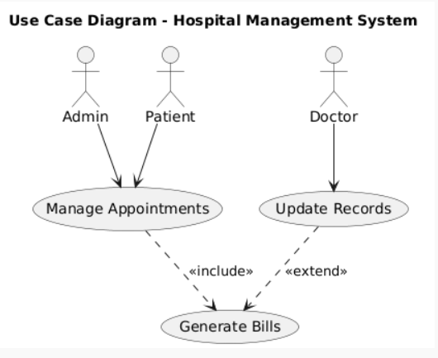
2

3

