
LAB PROBLEM 1: Class Diagram for Library System (Any Four)
Topic: UML Class Diagram – Structure Overview
Problem Statement:
Draw a UML Class Diagram for a simple Library Management System with classes like Book, Member, and Librarian. Show relationships such as association and aggregation.
Hints:
● Use attributes and methods inside each class.
● Show 1-to-many association between Member and Book.
● Mark the relationship direction using arrows.

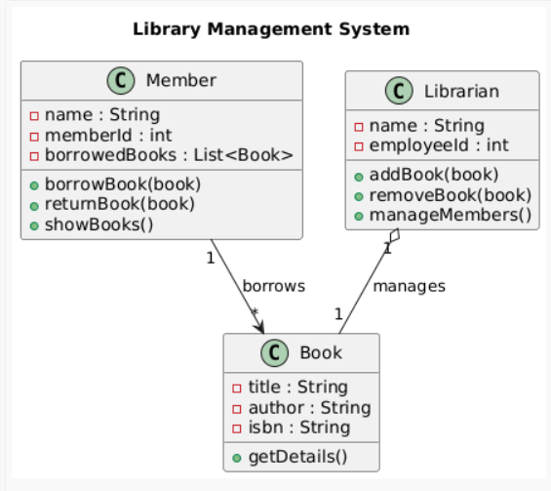

LAB PROBLEM 2:
Object Diagram for Student-Teacher Relationship
Topic: UML Object Diagram – Runtime Instances
Problem Statement:
Draw an Object Diagram representing real instances of classes Student and Teacher where each teacher guides two students.
Hints:
● Show object names (e.g., teacher1:Teacher, student1:Student). ● Indicate object links (runtime relationships).
● Keep attribute values simple (e.g., name = "Karthik").

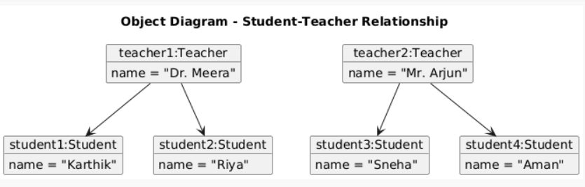

1

LAB PROBLEM 3: Sequence Diagram for Online Order Process
Topic: UML Sequence Diagram – Method Interaction Over Time
Problem Statement:
Draw a Sequence Diagram showing the process of placing an order on an e-commerce website. Include Customer, OrderService, PaymentGateway, and InventoryService.
Hints:
● Show the flow of method calls from customer to services.
● Include return arrows to indicate responses.
● Use activation boxes for ongoing operations.

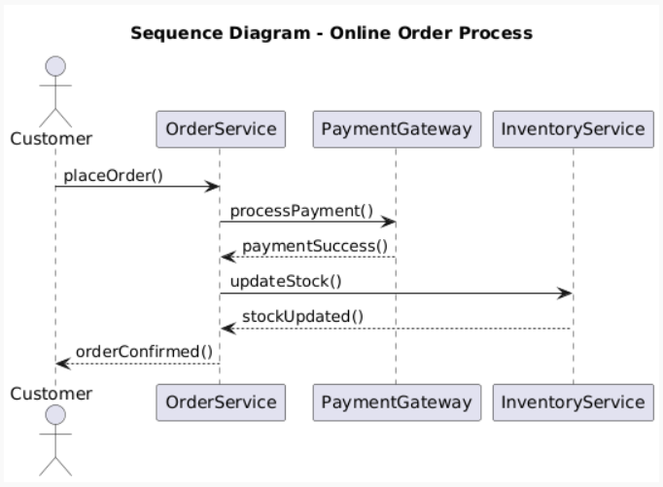
LAB PROBLEM 4: Use Case Diagram for ATM System
Topic: UML Use Case Diagram – User Interaction
Problem Statement:
Draw a Use Case Diagram showing the main user actions in an ATM system such as Withdraw Money, Check Balance, and Deposit Money.
Hints:
● Use actor symbols for users.
● Connect actors to use cases with lines.
● Optionally use include or extend relationships.

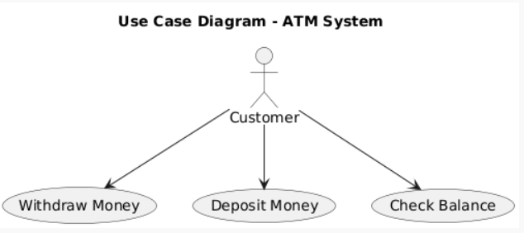
2

3

