
Practice Problem - UML with Java
Problem 1: Library Management System
Problem Statement: Design a simple Library Management System that tracks books and Members.
● A Library contains multiple Books.
● A Member can borrow multiple Books.
● If the Library is deleted, all its Books are also removed (Composition relationship).
import java.util.*;
// ==================== CLASS: Book ====================
class Book {
private String title;
private String author;
private String isbn;
public Book(String title, String author, String isbn) {
this.title = title;
this.author = author;
this.isbn = isbn;
}
public void showDetails() {
System.out.println("Title: " + title + ", Author: " + author + ", ISBN: " + isbn);
}
public String getTitle() {
return title;
}
}
// ==================== CLASS: Library ====================
class Library {
private String name;
private List<Book> books;
public Library(String name) {
this.name = name;
this.books = new ArrayList<>();
}
public void addBook(Book book) {
books.add(book);
System.out.println("Added book '" + book.getTitle() + "' to " + name + " Library");
}
public void showBooks() {
System.out.println("\nBooks in " + name + " Library:");
for (Book b : books) {
b.showDetails();
}
}
}
// ==================== CLASS: Member ====================
class Member {
private String name;
private List<Book> borrowedBooks;
public Member(String name) {
this.name = name;
this.borrowedBooks = new ArrayList<>();
}
public void borrowBook(Book book) {
borrowedBooks.add(book);
System.out.println(name + " borrowed book: " + book.getTitle());
}
public void showBorrowedBooks() {
System.out.println("\nBooks borrowed by " + name + ":");
for (Book b : borrowedBooks) {
b.showDetails();
}
}
}
// ==================== CLASS: LibraryDemo (Main) ====================
public class LibraryManagementSystem {
public static void main(String[] args) {
// Step 1 - Create a Library
Library lib = new Library("Central City");
// Step 2 - Create 3 Books
Book b1 = new Book("The Alchemist", "Paulo Coelho", "ISBN101");
Book b2 = new Book("Harry Potter", "J.K. Rowling", "ISBN102");
Book b3 = new Book("Rich Dad Poor Dad", "Robert Kiyosaki", "ISBN103");
// Step 3 - Add books to Library
lib.addBook(b1);
lib.addBook(b2);
lib.addBook(b3);
// Step 4 - Display all books
lib.showBooks();
// Step 5 - Create a Member
Member m1 = new Member("Ravi");
// Step 6 - Borrow 2 books
m1.borrowBook(b1);
m1.borrowBook(b3);
// Step 7 - Show borrowed books
m1.showBorrowedBooks();
}
}
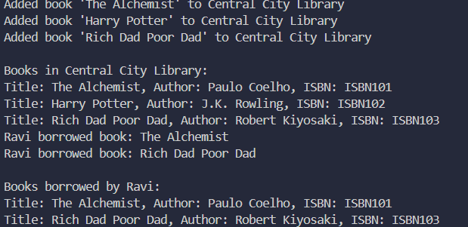
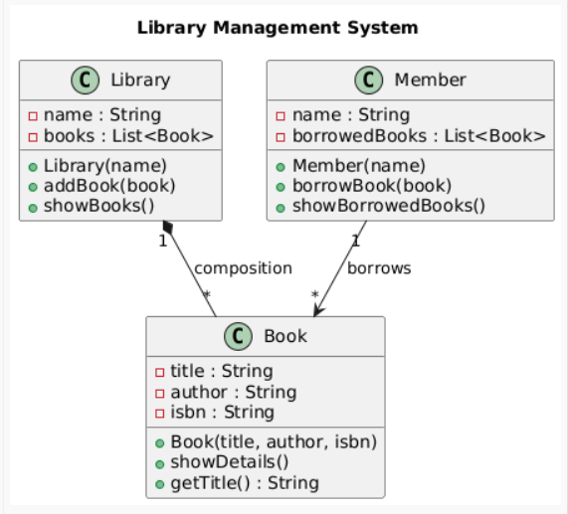

Problem 2: Object Diagram – Online Shopping System
Problem Statement: Design a simple Online Shopping System that represents the relationship between Customer, Order, and Product objects.
● A Customer can place multiple Orders.
● Each Order contains multiple Products.
● Each Product has a name and price.
● A Customer object has personal details like name and email.
The goal is to visualize specific object instances and their links at runtime using an Object Diagram.
import java.util.*;

// ==================== CLASS: Product ====================
class Product {
private String name;
private double price;
public Product(String name, double price) {
this.name = name;
this.price = price;
}
public void showDetails() {
System.out.println("Product: " + name + ", Price: ₹" + price);
}
public String getName() {
return name;
}
}
// ==================== CLASS: Order ====================
class Order {
private String orderId;
private List<Product> products;
public Order(String orderId) {
this.orderId = orderId;
this.products = new ArrayList<>();
}
public void addProduct(Product product) {
products.add(product);
System.out.println("Added product '" + product.getName() + "' to Order " + orderId);
}
public void showOrderDetails() {
System.out.println("\nOrder " + orderId + " contains:");
for (Product p : products) {
p.showDetails();
}
}
public String getOrderId() {
return orderId;
}
}
// ==================== CLASS: Customer ====================
class Customer {
private String name;
private String email;
private List<Order> orders;
public Customer(String name, String email) {
this.name = name;
this.email = email;
this.orders = new ArrayList<>();
}
public void placeOrder(Order order) {
orders.add(order);
System.out.println(name + " placed Order " + order.getOrderId());
}
public void showCustomerOrders() {
System.out.println("\nOrders placed by " + name + ":");
for (Order o : orders) {
o.showOrderDetails();
}
}
}
// ==================== CLASS: ShoppingDemo (Main) ====================
public class OnlineShoppingSystem {
public static void main(String[] args) {
// Step 1 - Create Customer
Customer customer1 = new Customer("Amit", "amit@gmail.com");
// Step 2 - Create Product objects
Product laptop = new Product("Laptop", 55000);
Product mobile = new Product("Mobile", 20000);
Product mouse = new Product("Mouse", 800);
// Step 3 - Create 2 Orders and add Products
Order order1 = new Order("O1001");
order1.addProduct(laptop);
order1.addProduct(mouse);
Order order2 = new Order("O1002");
order2.addProduct(mobile);
// Step 4 - Associate Orders with Customer
customer1.placeOrder(order1);
customer1.placeOrder(order2);
// Step 5 - Display Orders and their Products
customer1.showCustomerOrders();
}
}
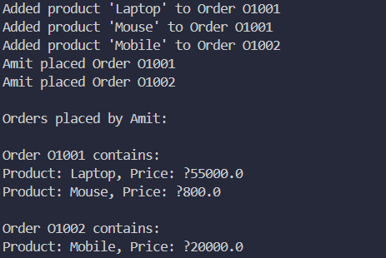
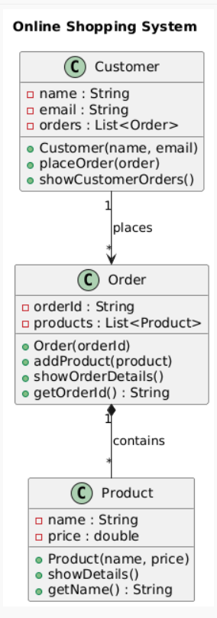
Problem 3: Sequence Diagram – ATM Transaction System �� Problem Statement:
Design a Sequence Diagram that models an ATM withdrawal process between a Customer, ATM, and BankAccount.
When a customer inserts a card and requests withdrawal:
1. The Customer sends a request to the ATM.
2. The ATM verifies the PIN with the BankAccount.
3. If successful, the BankAccount processes the withdrawal.
4. The ATM dispenses the cash.
5. The Customer receives confirmation.

import java.util.*;
// ==================== CLASS: BankAccount ====================
class BankAccount {
private String accountNumber;
private double balance;
private int pin;
public BankAccount(String accountNumber, double balance, int pin) {
this.accountNumber = accountNumber;
this.balance = balance;
this.pin = pin;
}
public boolean validatePin(int enteredPin) {
return this.pin == enteredPin;
}
public void deposit(double amount) {
balance += amount;
System.out.println("Deposited ₹" + amount + " | New Balance: ₹" + balance);
}
public void withdraw(double amount) {
if (amount > balance) {
System.out.println("❌ Insufficient balance!");
} else {
balance -= amount;
System.out.println("Withdrew ₹" + amount + " | Remaining Balance: ₹" + balance);
}
}
public void checkBalance() {
System.out.println("Current Balance: ₹" + balance);
}
public String getAccountNumber() {
return accountNumber;
}
}
// ==================== CLASS: Customer ====================
class Customer {
private String name;
private List<BankAccount> accounts;
public Customer(String name) {
this.name = name;
this.accounts = new ArrayList<>();
}
public void addAccount(BankAccount acc) {
accounts.add(acc);
System.out.println(name + " added Account " + acc.getAccountNumber());
}
public BankAccount getAccount(String accNum) {
for (BankAccount acc : accounts) {
if (acc.getAccountNumber().equals(accNum))
return acc;
}
return null;
}
public String getName() {
return name;
}
}
// ==================== CLASS: ATM ====================
class ATM {
public void startTransaction(Customer customer, String accNum, int enteredPin) {
BankAccount account = customer.getAccount(accNum);
if (account == null) {
System.out.println("Account not found!");
return;
}
if (!account.validatePin(enteredPin)) {
System.out.println("❌ Invalid PIN!");
return;
}
System.out.println("\nWelcome, " + customer.getName() + "! Access granted to Account " + accNum);
account.checkBalance();
// Example transactions
account.deposit(2000);
account.withdraw(1500);
account.checkBalance();
}
}
// ==================== MAIN CLASS ====================
public class ATMSystem {
public static void main(String[] args) {
Customer c1 = new Customer("Riya");
BankAccount acc1 = new BankAccount("ACC123", 5000, 1234);
BankAccount acc2 = new BankAccount("ACC456", 10000, 5678);
c1.addAccount(acc1);
c1.addAccount(acc2);
ATM atm = new ATM();
atm.startTransaction(c1, "ACC123", 1234); // correct PIN
atm.startTransaction(c1, "ACC456", 1111); // wrong PIN
}
}

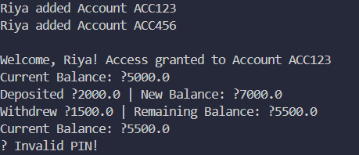
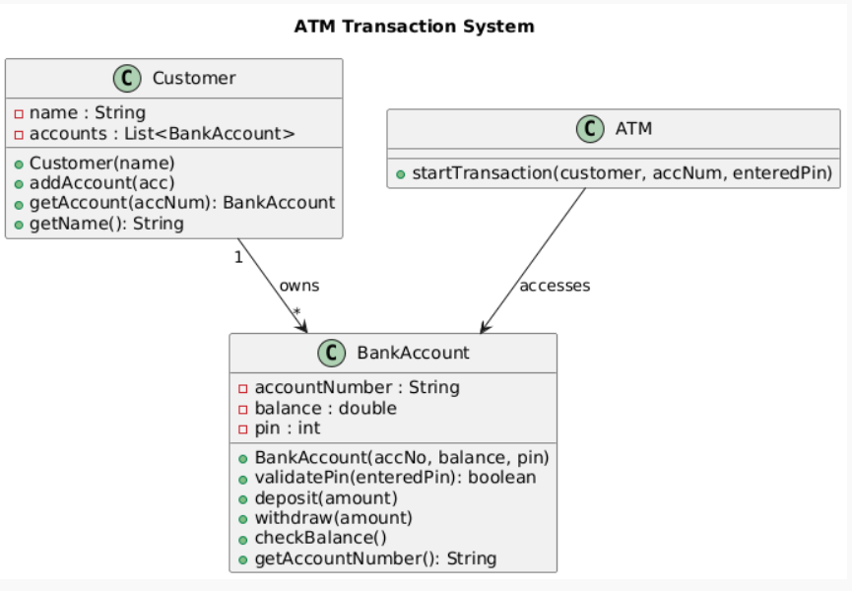
10

