PROJECT ON
“Hospital Appointment & Revenue Monitoring
System”



Submitted by: Submitted to:
Rishabh Singh PRN-24022141054 KPMG
Harshal Aman PRN-24022141025

Academic Year: 2024 – 2026
SECTION A – SQL TASKS
Q1. Data Storage & Loading
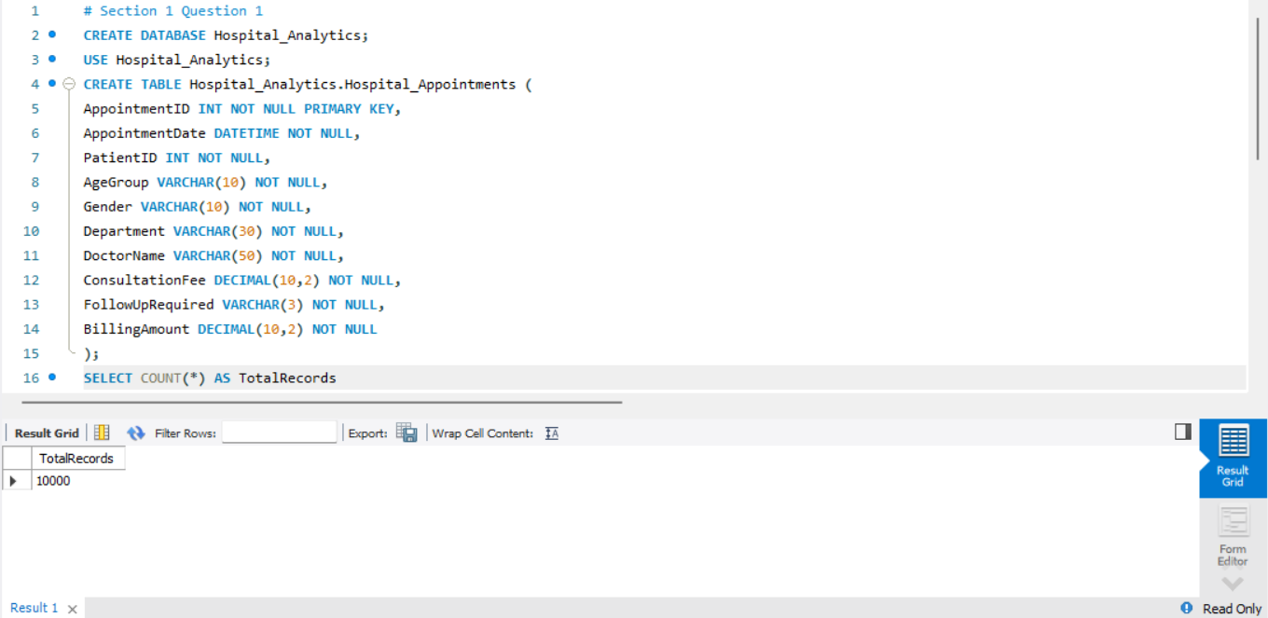
Q2. Hospital Data Analysis
The analysis revealed the following insights:
• Total number of appointments: 10,000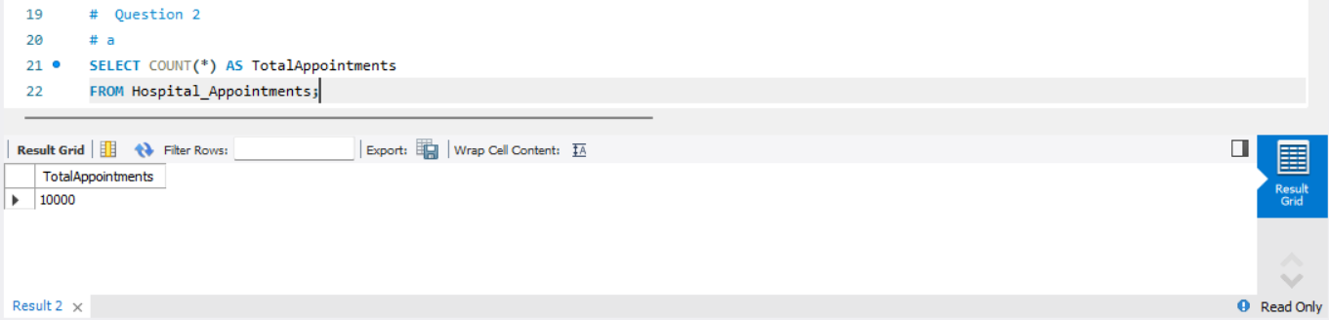
• Total billing amount generated by the hospital: ₹14,422,084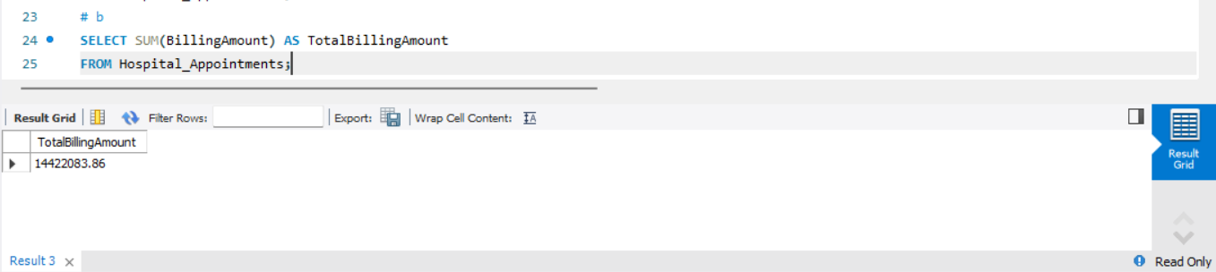
• Cardiology department generated the highest billing amount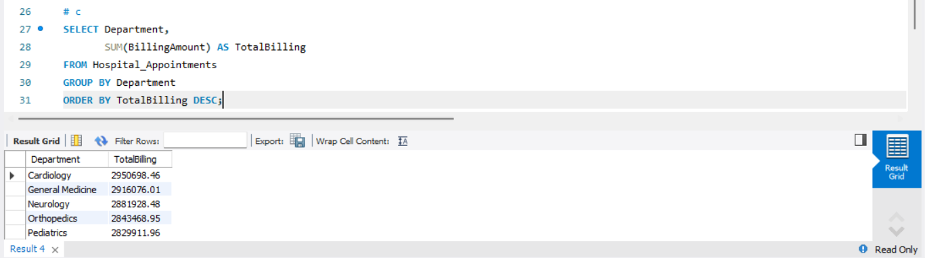
• Cardiology also recorded the highest number of appointments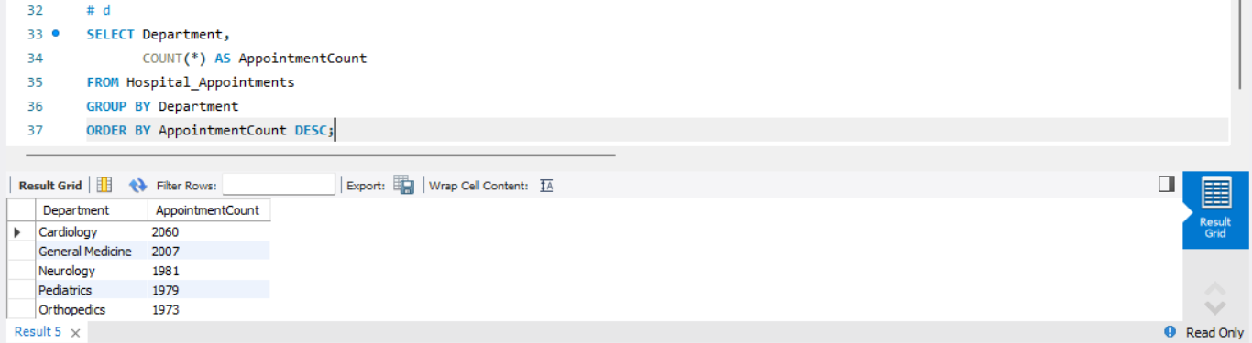
SECTION B – POWER BI DASHBOARD
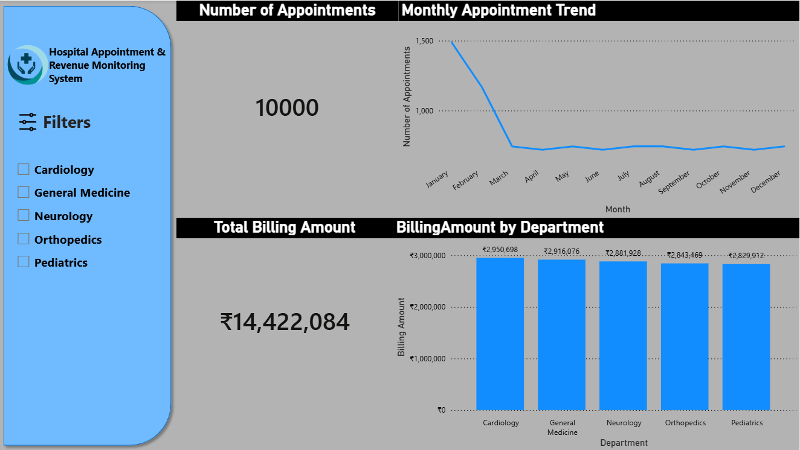
The Hospital Appointment & Revenue Monitoring Dashboard provides a clear overview of patient volume and revenue across departments. It displays total appointments and total billing amount for quick performance assessment. The monthly appointment trend helps identify peak and low-demand periods for better planning. Department-wise billing highlights revenue contribution, with Cardiology emerging as the top performer. An interactive department filter allows focused analysis. Overall, the dashboard supports informed, data-driven hospital management decisions.
SECTION C – BUSINESS INSIGHTS
Interpretation & Recommendations
- Dashboard analysis reveals that the Cardiology department brings in the largest billing amount of around Rs. 29.5 lakhs, which makes it clear that the department has high patient demand and percentage of revenue generation.

- The Orthopedics and Neurology departments are associated with greater billing values per appointment, which is explained by increase in the cost of consultation and the high rate of follow-up visits. Moreover, many of the appointments need follow-ups and this increases the number of repeat patients and resources.

Improvement Recommendation: The hospital management must consider establishing a program of structured follow up management and priorization particularly on high revenue and high follow up departments such as Orthopedics and Neurology. Hospital can decrease the congestion in the regular appointment slots by scheduling special follow-up slots, reminder systems, and allocate special staff or time blocks to do the follow-up.

Expected Impact:
- More efficient use of time of doctors.
- A shorter waiting time of the new patients.
- Better patient follow up experience.
- More revenue efficiency without raising costs of operation.

