**Cloud Assignment – Rishabh Singhla**

1. Create an AWS account.

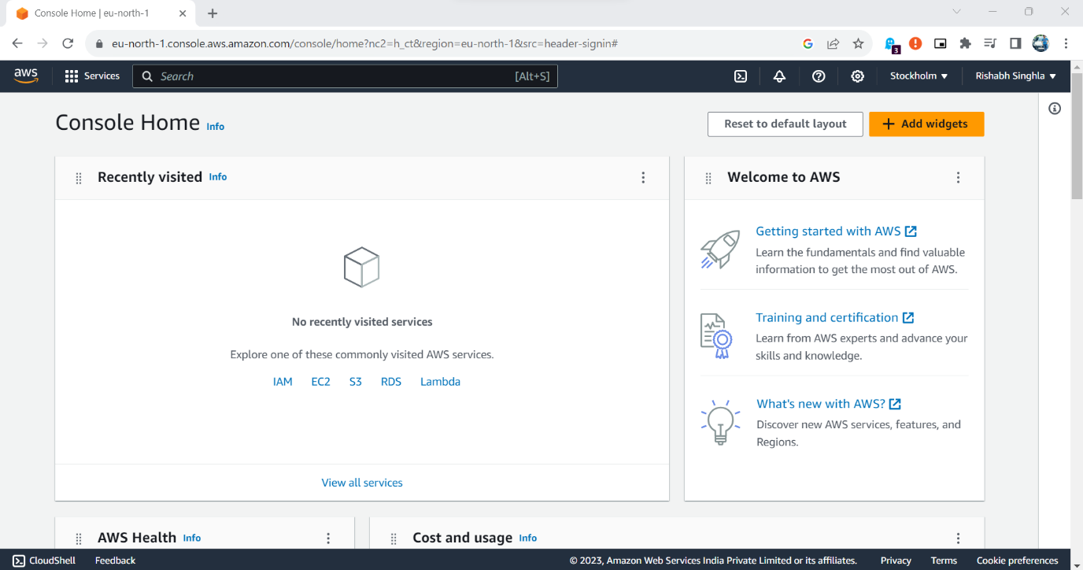

2.Create a virtual network with 2 subnets. Each subnet should have 16 IPs only.

3.One subnet should be public and other should be made private.

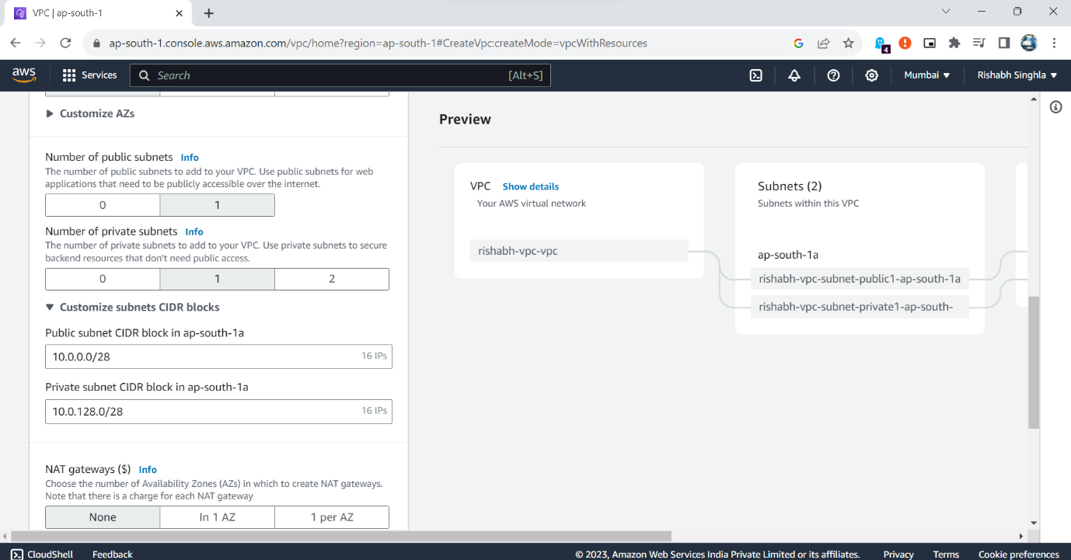

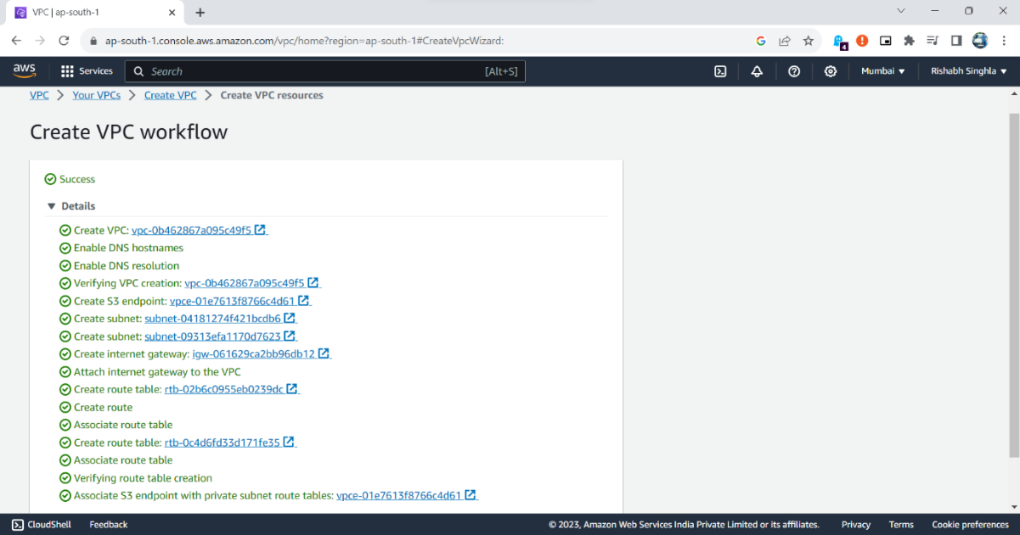

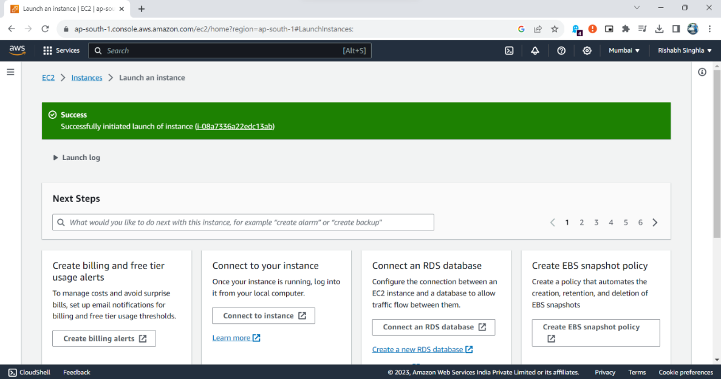

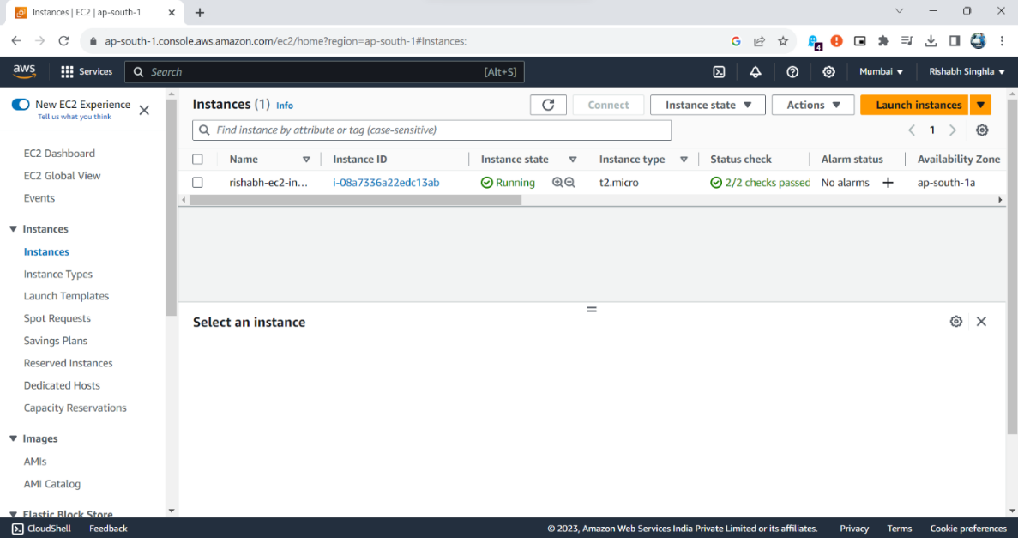

4. Inside one of the subnets, create a VM and deploy an application code inside it

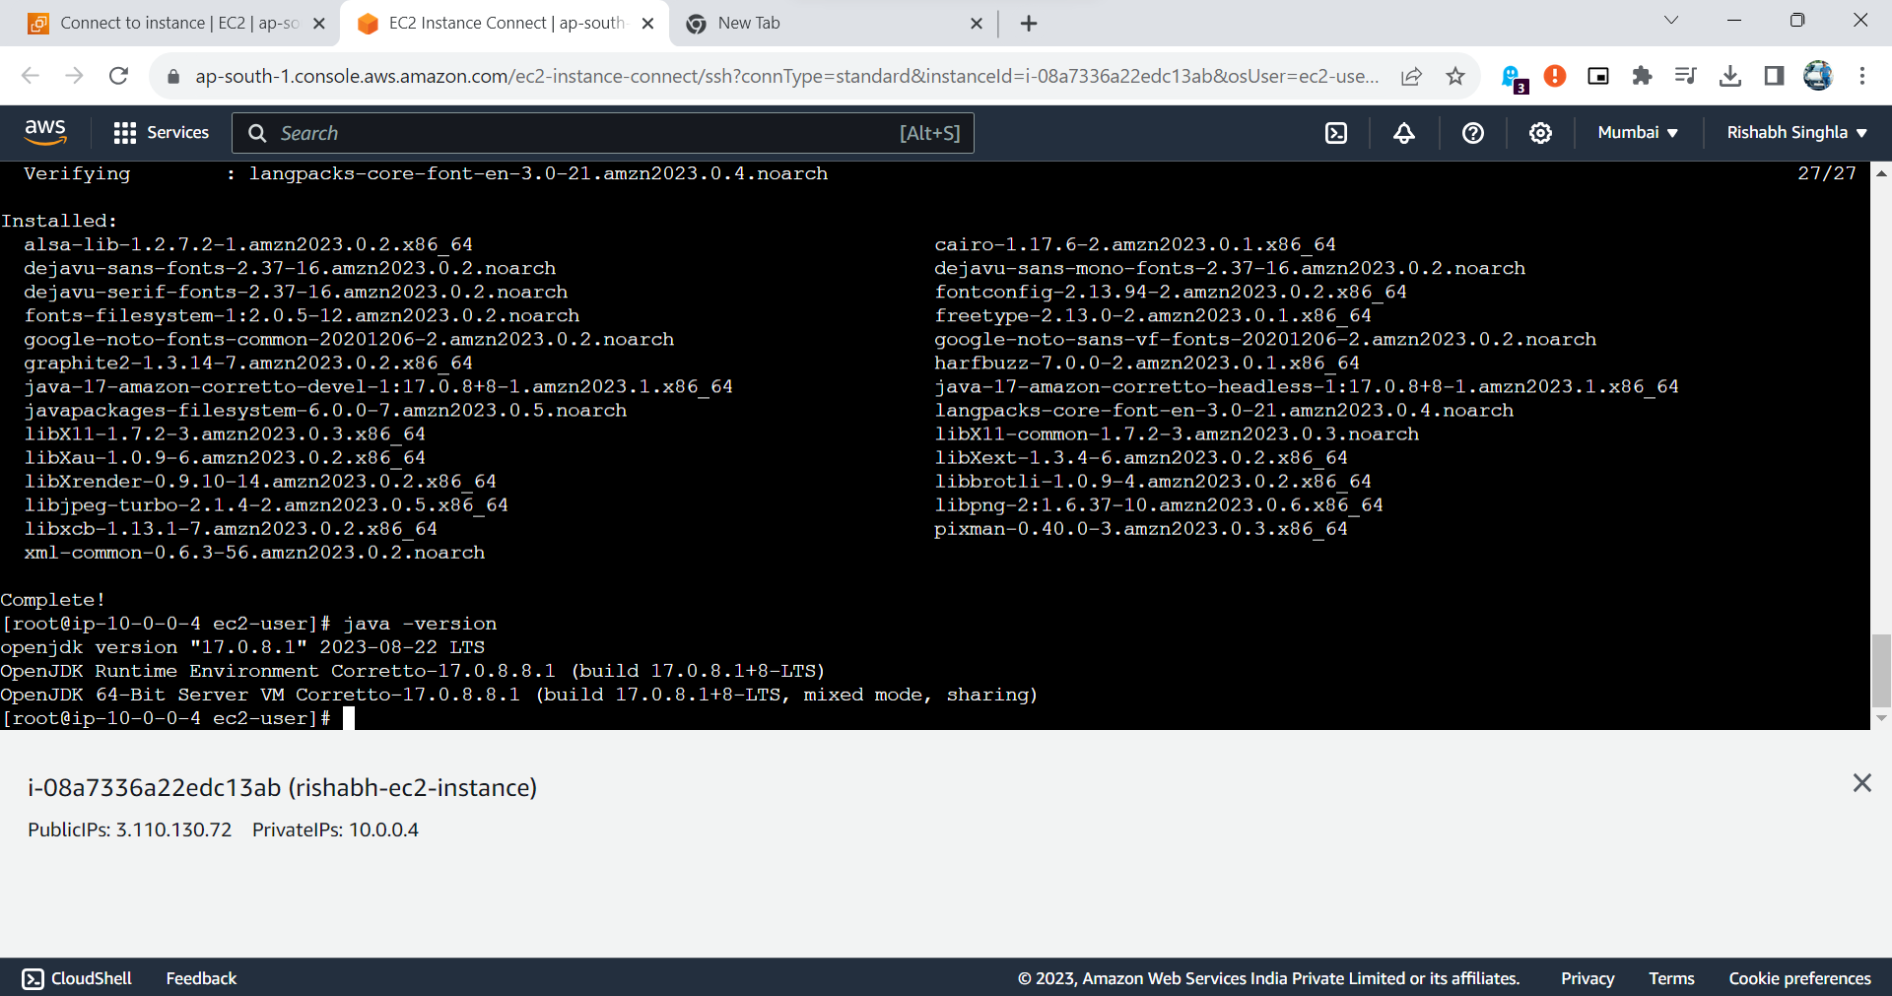

5.Make sure to use appropriate NACLs and SGs.

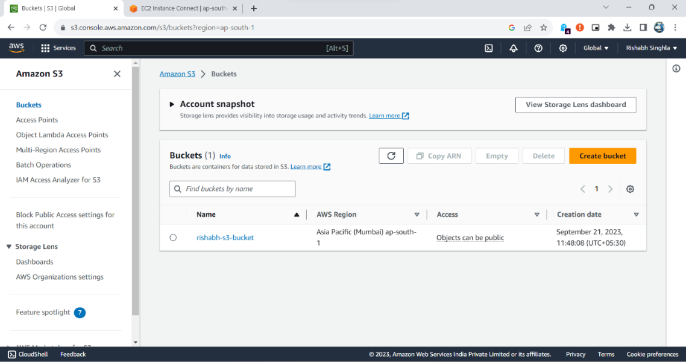

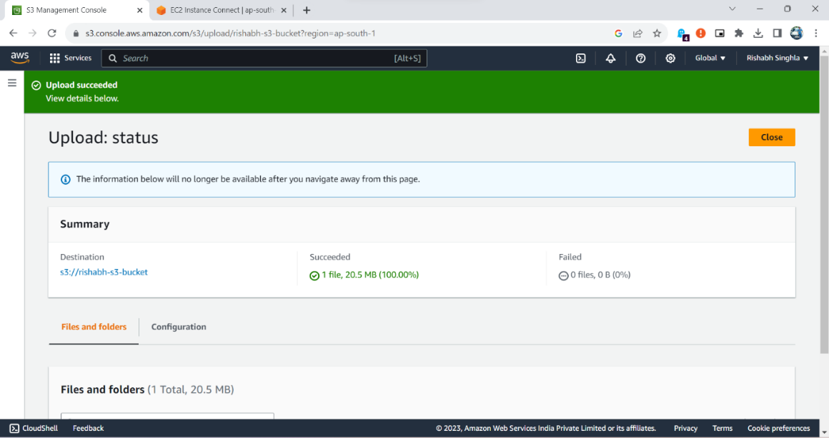

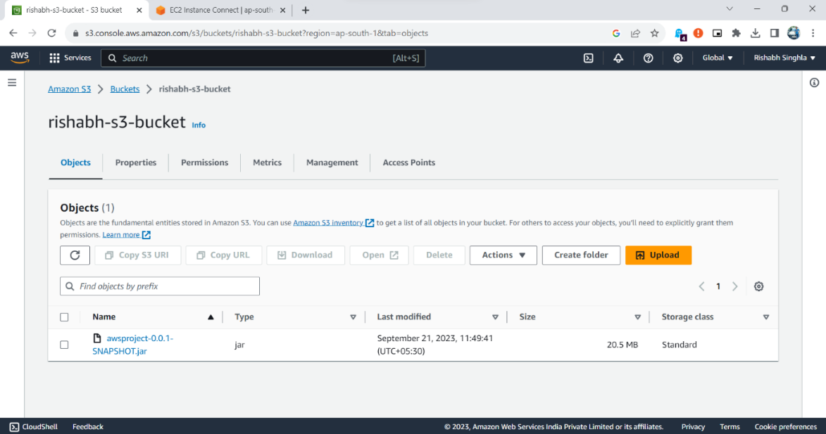

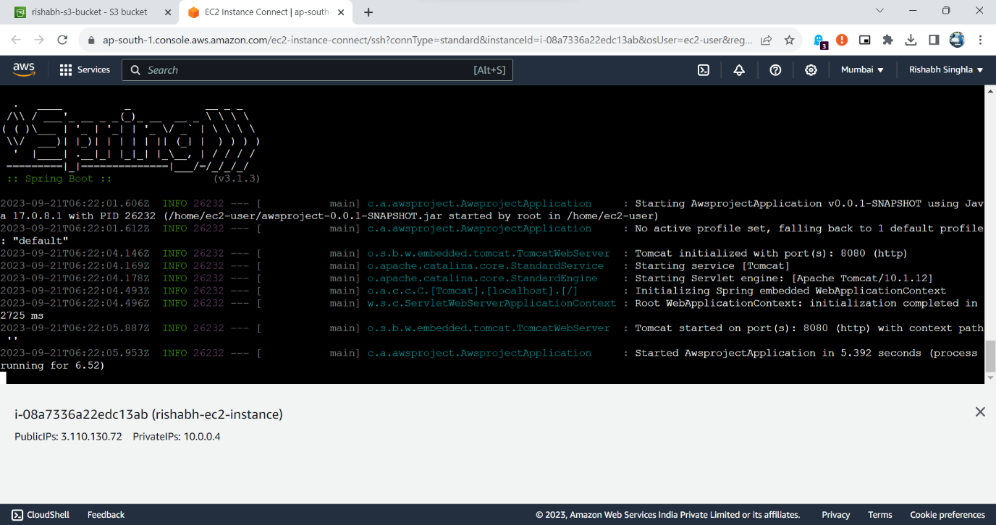

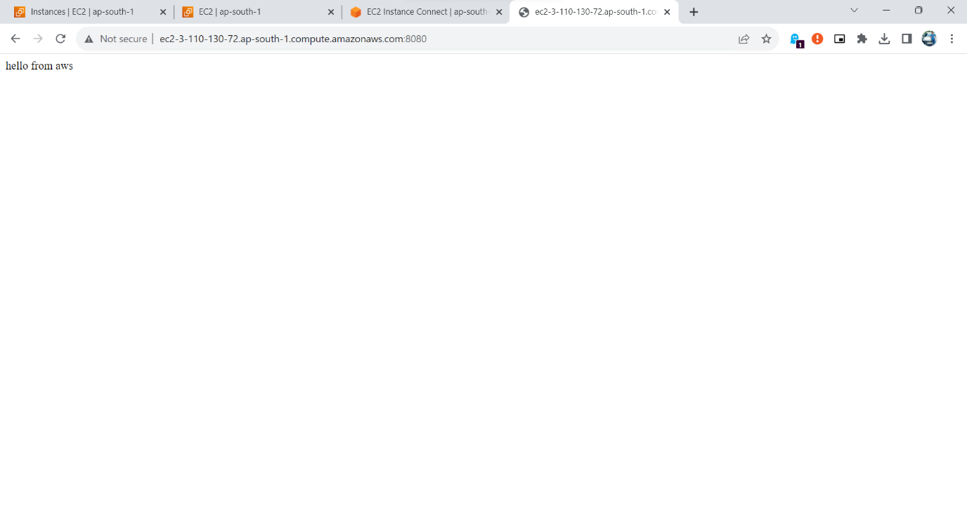

6.Code which is deployed on the VM must talk to the database (RDS) and ensure communication happens on the private channel.

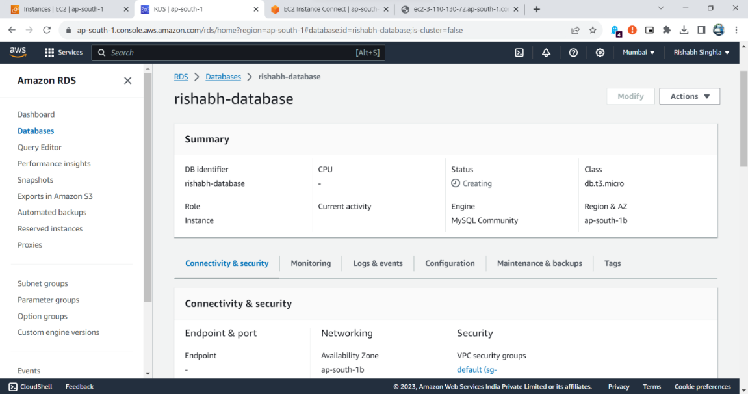

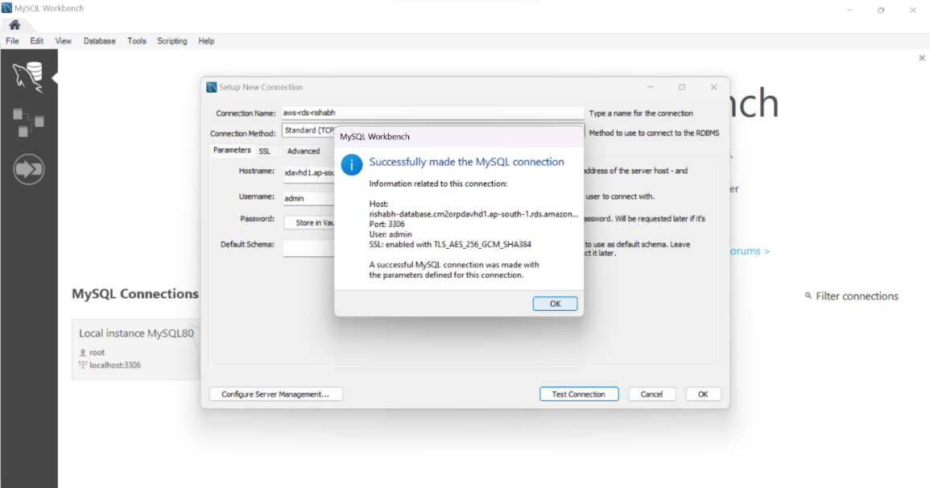

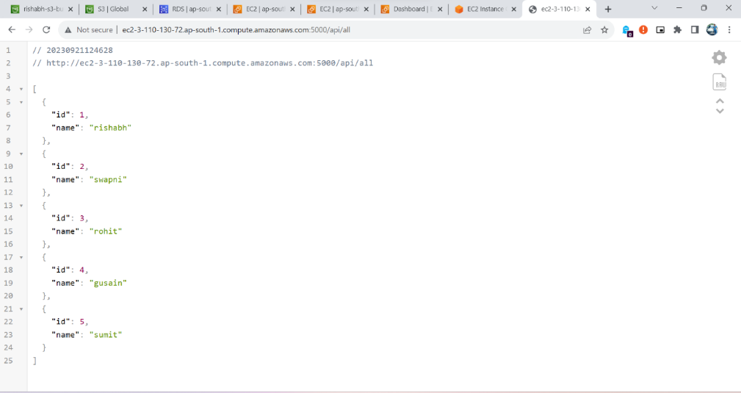

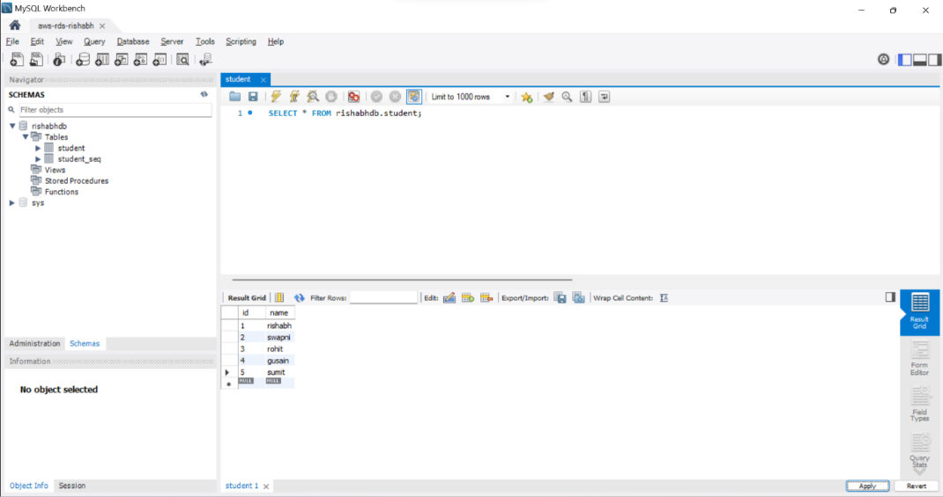

7.Deploy the same application to Elastic beanstalk Service.

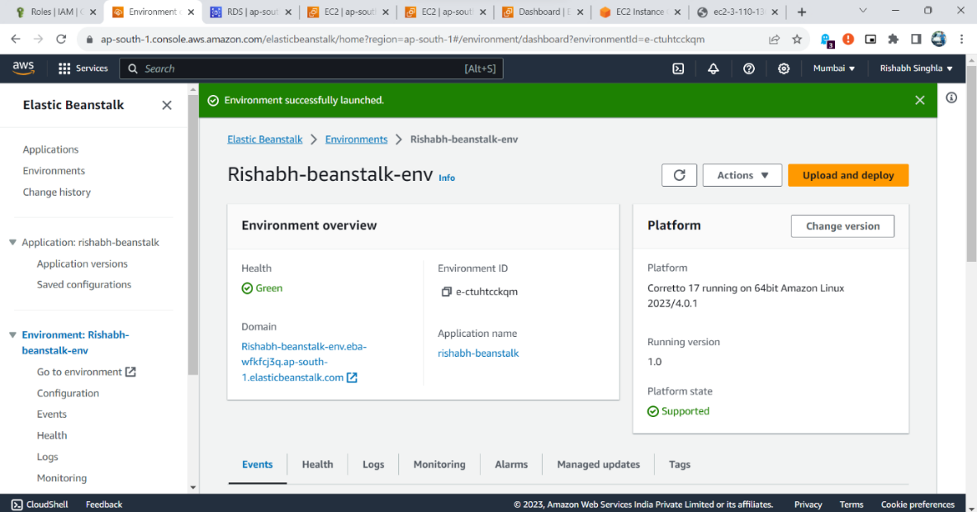

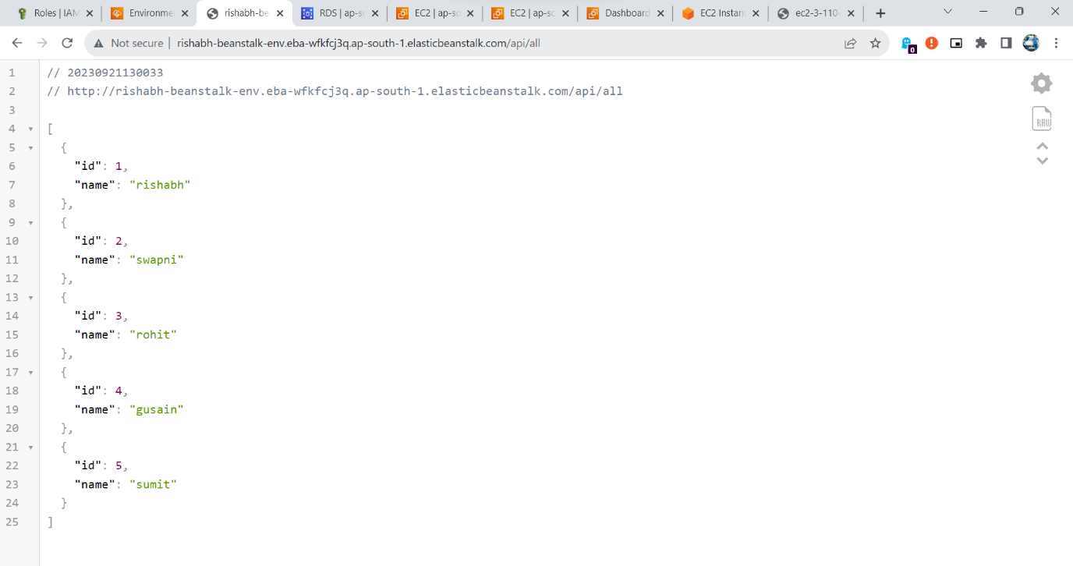

8.Create a Lambda that should trigger as soon as you upload a file in the S3 bucket.

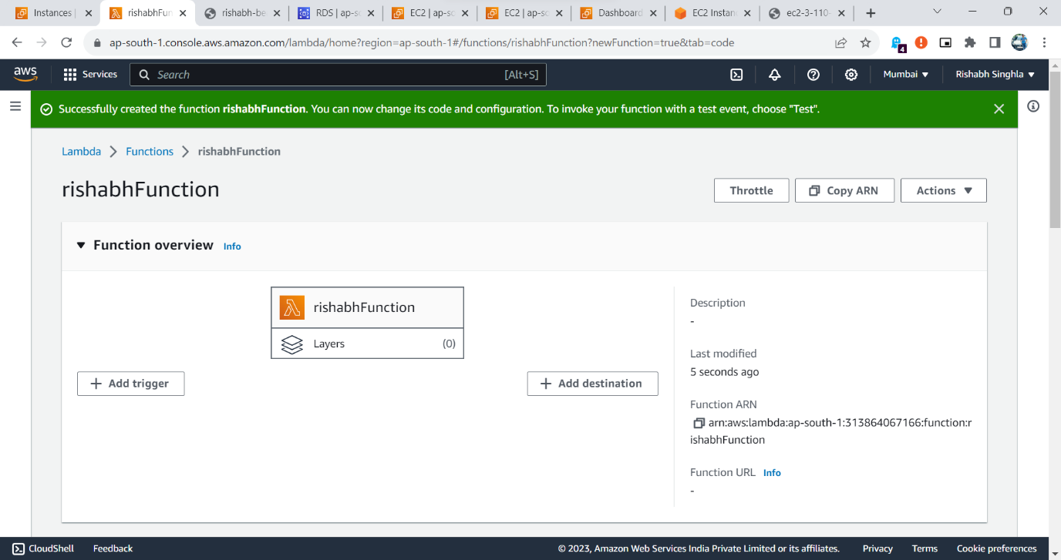

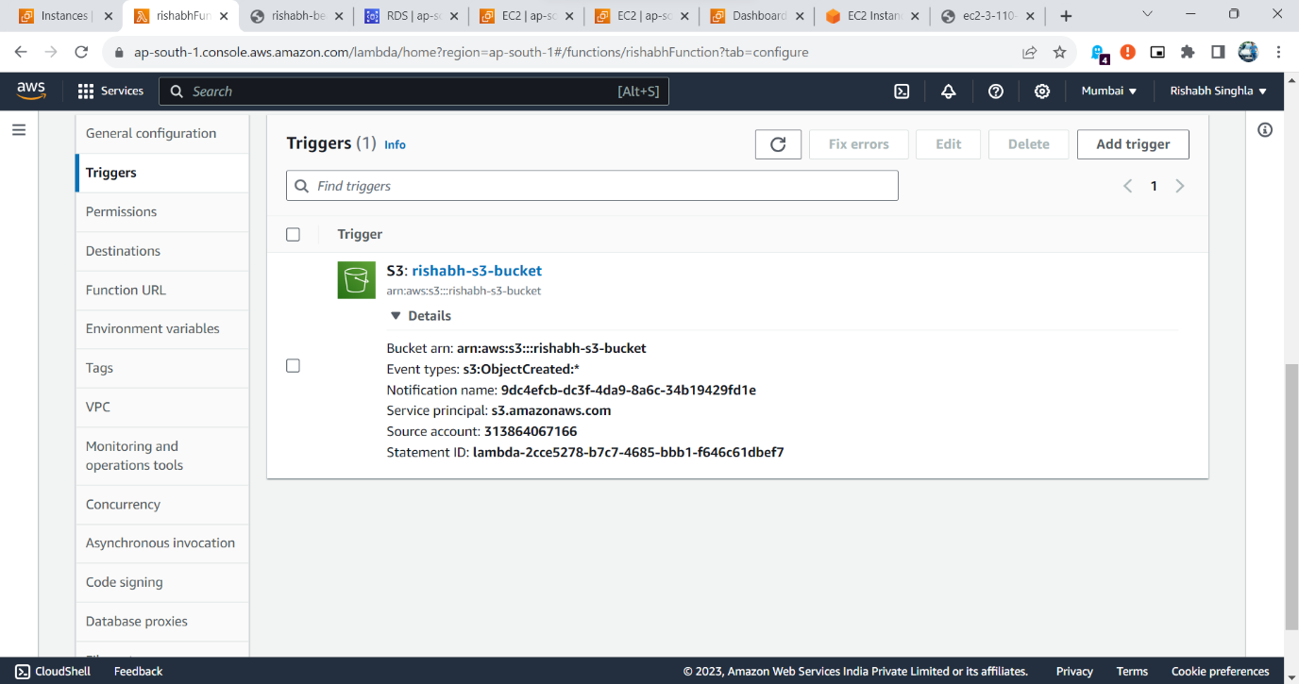

9.Function should be able to print the name of the file uploaded in the function.

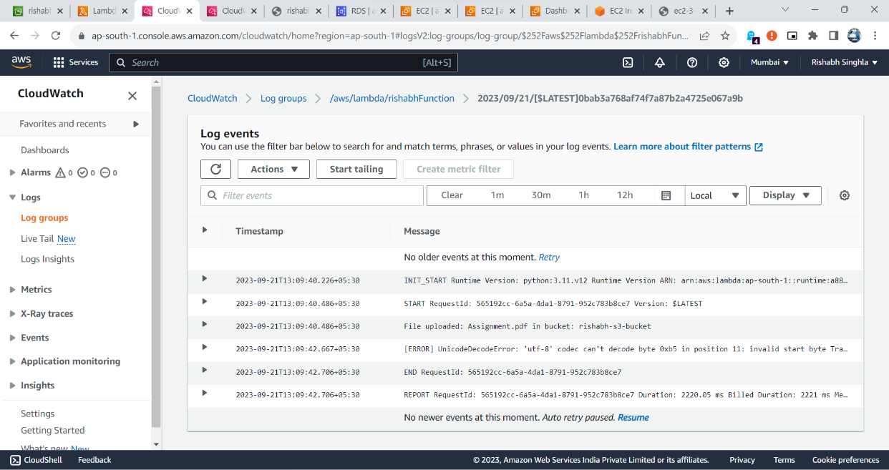

**Architecture Diagram**

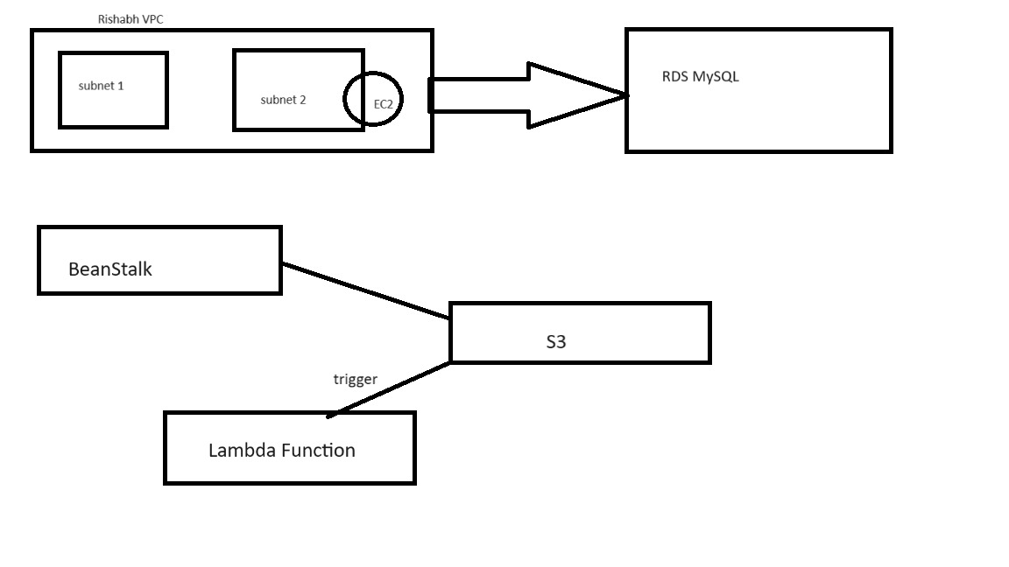

**Components of AWS**

Amazon Web Services (AWS) is a comprehensive cloud computing platform offered by Amazon that provides a wide range of services and tools for building, deploying, and managing applications and infrastructure in the cloud.

Here are some of the key components and concepts within AWS:

1.Compute Services:

* Amazon EC2 (Elastic Compute Cloud): This service provides resizable compute capacity in the cloud, allowing you to create and manage virtual machines (instances) for various purposes, such as running applications, hosting websites, or processing data.
* AWS Lambda: A serverless compute service that enables you to run code in response to events without managing servers. You pay only for the compute time consumed.

2.Storage Services:

* Amazon S3 (Simple Storage Service): A scalable object storage service that allows you to store and retrieve data, including files, images, and backups.
* Amazon EBS (Elastic Block Store): Provides persistent block-level storage volumes for use with EC2 instances.
* Amazon RDS (Relational Database Service): Managed database service that supports various database engines, including MySQL, PostgreSQL, and SQL Server.

3.Networking Services:

* Amazon VPC (Virtual Private Cloud): Allows you to create isolated networks within the AWS cloud, control inbound and outbound traffic, and connect to on-premises networks securely.

4.Developer Tools:

* AWS Code Deploy: Automates application deployments to various compute services, including EC2 instances and Lambda functions.

5.Security and Identity:

* AWS IAM (Identity and Access Management): Manages user and group permissions to control access to AWS resources.
* AWS Key Management Service (KMS): Manages encryption keys and integrates with various AWS services for data protection.

6.Management and Monitoring:

* AWS CloudWatch: Monitoring and observability service for collecting and tracking metrics, logs, and events from AWS resources.