**SUPERMARKET APPLICATION – CORE JAVA**

* **RISHABH SINGHLA**

**ADMIN SERVICES**

1. Login Screen for Admin and User

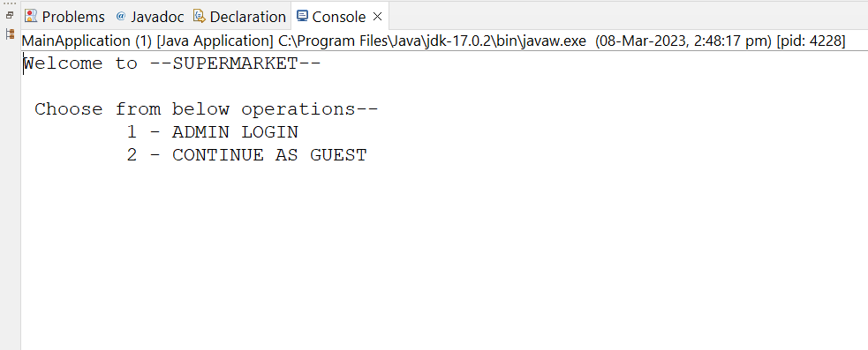

1. ADMIN password is authenticate and instructions are shown

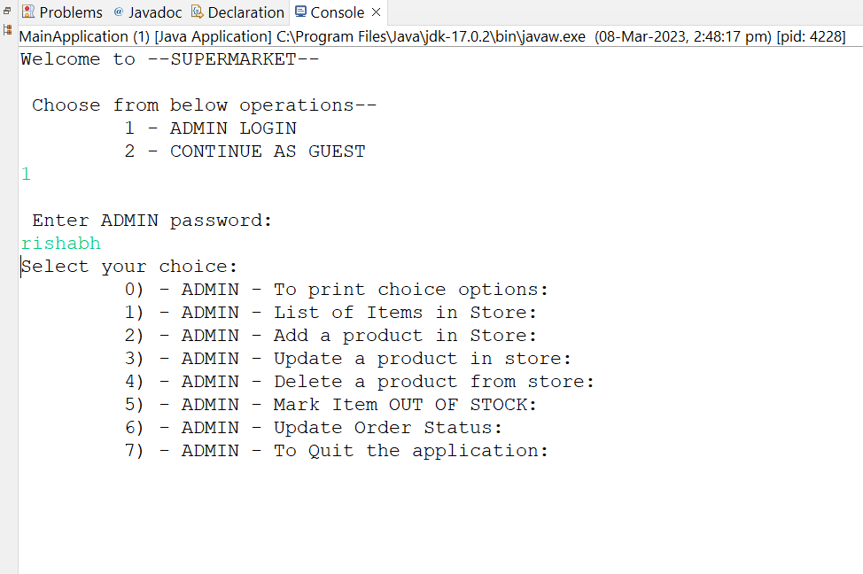

1. List of products shown to ADMIN in store

1. A new product 111 has been added by ADMIN in store

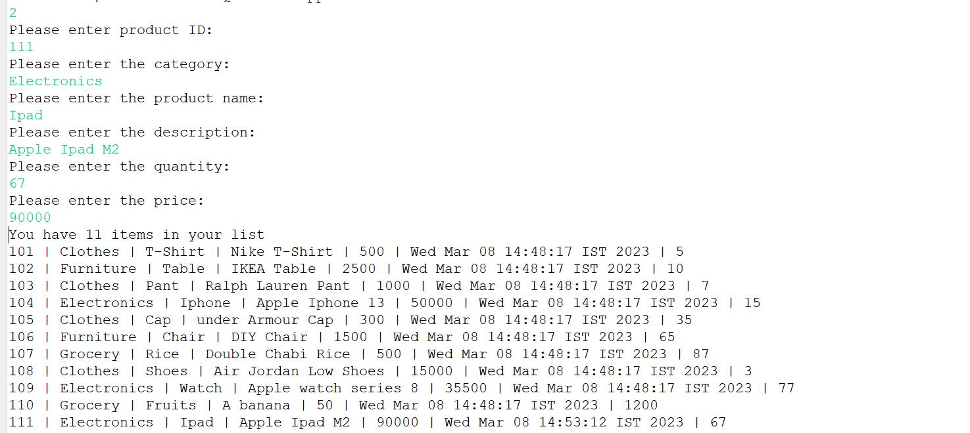

1. A product has been deleted by ADMIN by ID 106

1. A product has been UPDATE by ADMIN with ID 107

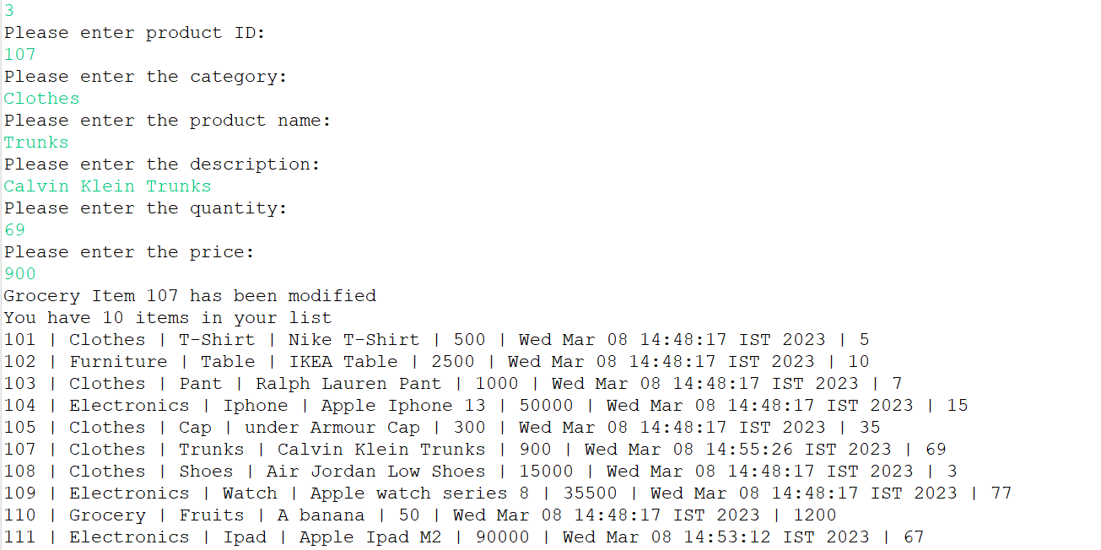

1. A product with product ID 111 has been marked OUT OF STOCK

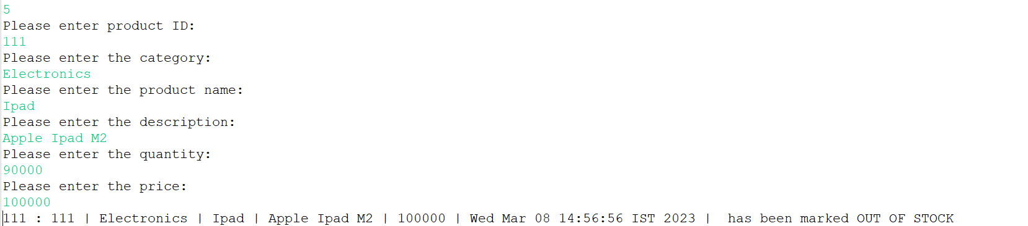

1. Order with Order ID 167 has been updated by ADMIN

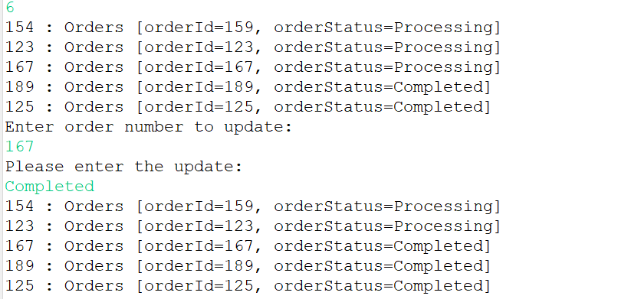

**USER SERVICES**

1. Printing the list of Items by Latest Arrival

1. Printing the List of items by Category

1. Searching Item by Category Clothes



1. Searching Item by Item Name



1. Searching Item by Description

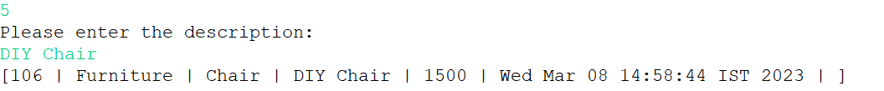

1. Searching Item by Unique Bar Code



1. Ordering and item and an Order Id is generated.

1. Tracking the Order using Order ID

