Optimizing Plane Design Using CFD Analysis
A parametric CFD study of CDF-62, a twin-jet transport-aircraft concept modelled at 1:100 scale. Three wing shapes, three fuselage shapes and three tail layouts were simulated one change at a time against a baseline, and the best option from each group was combined into a final design.
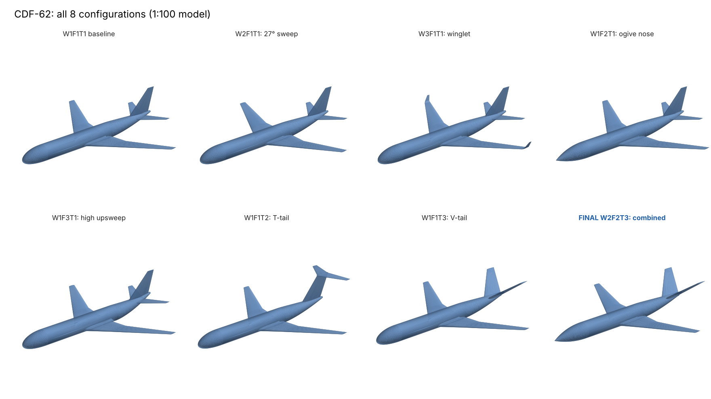
All eight configurations (1:100 model)

Result
The final design, W2F2T3 (27° wing sweep, ogive nose, V-tail), improved on the baseline in every headline metric:
Metric | Baseline W1F1T1 | Final W2F2T3 | Change
Maximum L/D | 9.0 | 9.7 | +7.8%
Minimum CD | 0.0341 | 0.0334 | −2.1%
Lift-curve slope CLα (per rad) | 4.08 | 4.24 | +3.9%
Pitch stability CMα (per rad) | −0.65 | −0.85 | 31% more stable
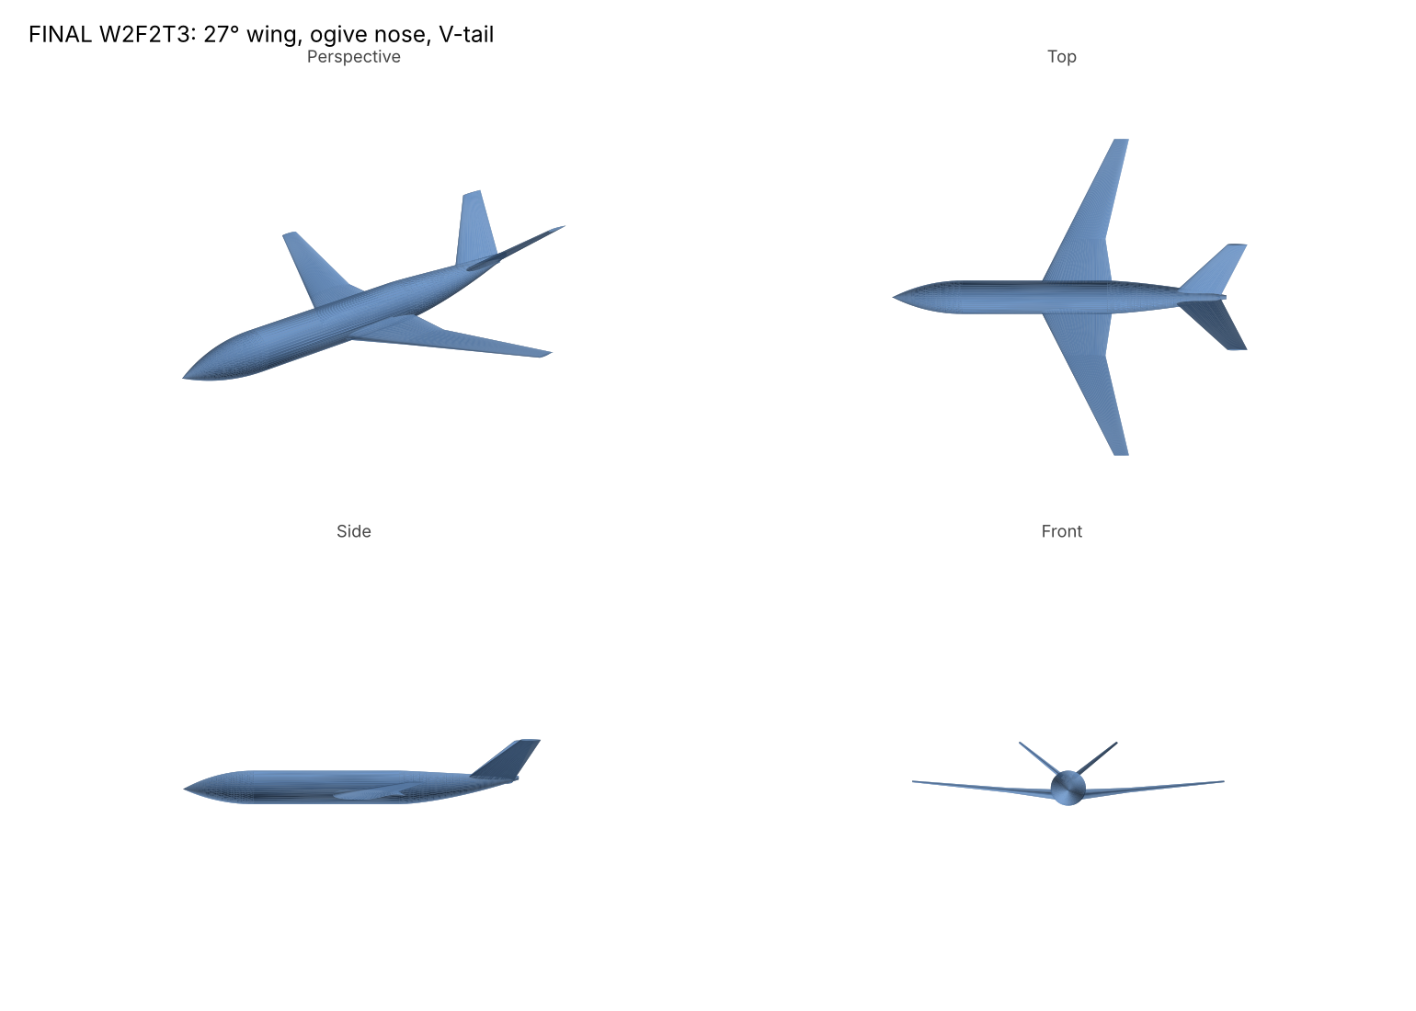
Final design W2F2T3: perspective, top, side and front views

Design variables
Each configuration is named W#F#T# (wing, fuselage, tail). The baseline is W1F1T1.
Code | Wing (W) | Fuselage (F) | Tail (T)
1 | 35° leading-edge sweep | Elliptical nose, 1.8 m tail upsweep | Conventional (fin + low tailplane)
2 | 27° leading-edge sweep | Tangent-ogive nose, 13 m long | T-tail
3 | 35° sweep + blended winglet | High tail upsweep (3.2 m), later tail-cone start | V-tail (38.6° dihedral)
Common geometry (full scale): 62 m fuselage, 6.2 m diameter, 58.76 m projected span, low wing with 5° dihedral, NASA SC(2) supercritical airfoils (14% root to 10% tip), NACA 0010 tail surfaces. Projected span and mean-chord position are held constant across wing variants so comparisons are like-for-like.

All configurations
Coarse mesh, U = 20 m/s, angle of attack −4° to 14°.
Config | Change from baseline | Max L/D | Min CD | CLα (/rad) | CMα (/rad)
W1F1T1 | Baseline | 9.0 | 0.0341 | 4.08 | −0.65
W2F1T1 | 27° sweep | 9.3 | 0.0348 | 4.18 | −0.57
W3F1T1 | Winglet | 8.9 | 0.0341 | 3.94 | −0.54
W1F2T1 | Ogive nose | 9.1 | 0.0336 | 4.09 | −0.70
W1F3T1 | High upsweep | 8.6 | 0.0362 | 4.06 | −0.61
W1F1T2 | T-tail | 8.9 | 0.0350 | 4.16 | −1.15
W1F1T3 | V-tail | 9.3 | 0.0331 | 4.16 | −0.87
W2F2T3 | Combined | 9.7 | 0.0334 | 4.24 | −0.85
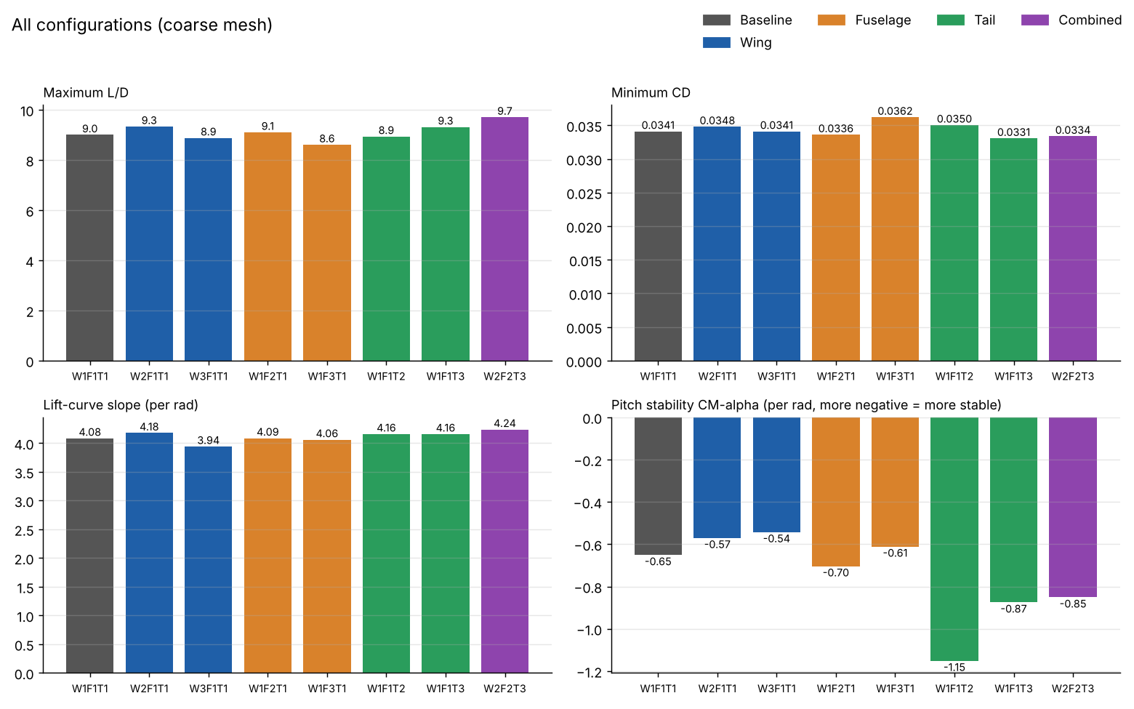
Summary of all configurations

Findings by group
- Wing. Reducing sweep to 27° gave the best L/D and lift slope. The winglet (W3) did not pay off at this Reynolds number: same minimum drag, lower lift slope.
- Fuselage. The ogive nose cut minimum drag and slightly improved stability. The high-upsweep tail cone added the most drag of any variant.
- Tail. The T-tail was by far the most stable (CMα −1.15) but cost L/D. The V-tail had the lowest drag of the whole study while still being much more stable than the baseline, so it was picked for the final design.

Combined design
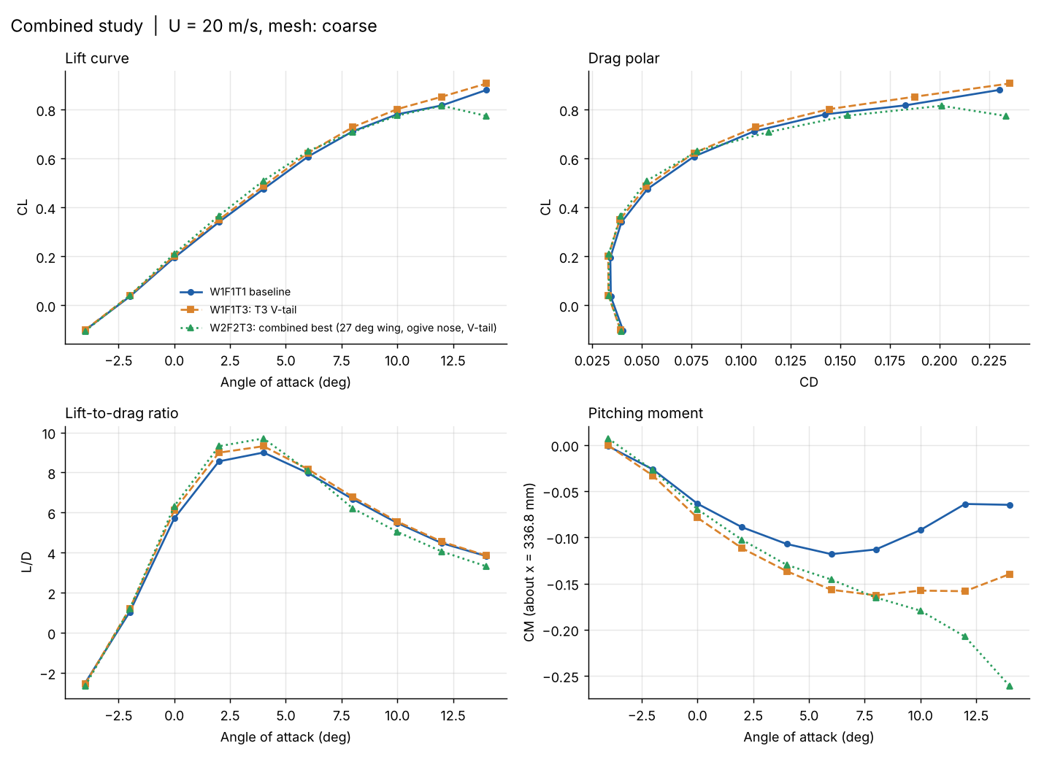
Combined study polars: baseline, V-tail only, and final design
The combined design has the highest L/D peak (around 4° AoA) and the steepest stable pitching-moment slope. One trade-off to note: above about 12° its lift curve flattens and drops earlier than the baseline, so its stall margin is smaller.
Polars for each group are in the plots folder (compare_wing.png, compare_fuselage.png, compare_tail.png). Pitching moment is taken about x = 336.8 mm on the 1:100 model.

Repository layout
models/scad/ Parametric OpenSCAD source, one file per configuration
models/stl/ Exported 1:100 meshes (millimetres)
plots/ Polars and summary charts from the CFD runs
docs/images/ Renders of the configurations

Using the models
The .scad files are all the same parametric model, each pre-set to one configuration with three switches at the top:
wing_type = 2; // 1 = 35° sweep, 2 = 27° sweep, 3 = winglet
fuse_type = 2; // 1 = baseline, 2 = ogive nose, 3 = high upsweep
tail_type = 3; // 1 = conventional, 2 = T-tail, 3 = V-tail

Other settings:
- units = 10 exports millimetres of the 1:100 model (for printing); units = 0.01 exports metres of the 1:100 model (for CFD meshing).
- part selects "assembly" or a printable part: "fuselage_shell", "wing_right", "wing_left", "tail", or "cutaway" (preview with internal components).
- te_min sets a minimum trailing-edge thickness. Keep 0 for CFD; use 0.05 (0.5 mm on the print) for FDM printing.
Open in OpenSCAD 2021.01 or newer, render with F6, then File > Export > STL. Fusion 360 can't open .scad files directly, so import the STL instead.
The printable layout is sized for a 1:100 flying model: 1.2 mm skin, a 6 mm carbon spar tube from root to kink, a top hatch, and space for a 3S 850 mAh LiPo, 30 A ESC, receiver, tail servo and 40 mm EDF.

Limitations
- All results are from a coarse mesh; a mesh-independence study is still needed before quoting absolute values.
- Runs are at U = 20 m/s on a 1:100 model, so the Reynolds number is far below full scale. Trends between configurations are more reliable than absolute coefficients.
- Each group was varied with the other two held at baseline; interaction effects were only checked for the one combined design.

