Explainable Artificial Intelligence for Healthcare Prediction

Corresponding Author¹, Co-Author², and Co-Author³
¹ Department of Computer Science, ABC University, Chandigarh, India
² Department of Computer Science, XYZ Institute, Ludhiana, India
³ Department of Computer Engineering, LMN College, Amritsar, India
E-mail: namita@gndu.ac.in¹, psingh@abc.ac.in², akaur@gmail.com³
ABSTRACT
An abstract of up to 250 words should concisely summarize the purpose, methodology, key results, and conclusions of the work. Explainable artificial intelligence (XAI) is emerging to assist in the communication of internal decisions, behavior, and actions to health care professionals. Through explaining the prediction outcomes, XAI gains the trust of the clinicians, as they may learn how to apply the predictive modeling in practical situations instead of blindly following the predictions. There are still many scenarios to explore how to make XAI effective in clinical settings due to the complexity of medical knowledge.
Keywords: Explainable Artificial Intelligence, Healthcare Prediction, Machine Learning, SHAP, LIME, Clinical Decision Support. (Five Keywords)

I. INTRODUCTION
The document should be prepared on A4 size paper in a single-column layout, using Times New Roman font (size 11) with 1.15 line spacing. Reference and Citation style is Harvard Referencing Basics.
Healthcare has generated enormous volumes of structured and unstructured medical data through electronic health records (EHRs), wearable sensors, laboratory reports, genomic sequencing, and medical imaging. Artificial Intelligence (AI), particularly machine learning (ML) and deep learning (DL), has demonstrated remarkable performance in disease prediction and clinical decision-making. Despite these advances, many state-of-the-art AI models operate as black boxes, making it difficult for clinicians to understand how predictions are generated. In healthcare, interpretability is critical because clinical decisions directly affect patient safety. Explainable Artificial Intelligence (XAI) seeks to provide transparent, understandable, and trustworthy explanations for AI predictions, enabling clinicians to validate recommendations and increase confidence in AI-assisted diagnosis (Doshi-Velez and Kim, 2017). Despite these advancements, many AI models operate as black-box systems, providing predictions without explaining the reasoning behind them. In healthcare, where clinical decisions directly impact patient safety, this lack of transparency creates significant barriers to adoption. Physicians require understandable explanations before relying on AI-generated recommendations, while regulatory agencies increasingly emphasize transparency, accountability, and fairness.
This paper reviews recent advancements in XAI for healthcare prediction, compares various explanation techniques, discusses real-world applications, and identifies future research opportunities. The rest of the paper is structured as follows: Section 2 reviews related work, Section 3 presents the methodology, Section 4 discusses results, and Section 5 concludes.
II. LITERATURE REVIEW
Recent studies (Lundberg et al., 2017; Ribeiro et al., 2016; Selvaraju et al., 2017) have demonstrated the effectiveness of machine learning algorithms in predicting diseases such as diabetes, cardiovascular disorders, chronic kidney disease, and cancer. Algorithms including Random Forest, Support Vector Machine (SVM), Gradient Boosting, XGBoost, and Artificial Neural Networks have achieved high predictive accuracy.
III. METHODOLOGY
Patient information is collected from electronic health records, laboratory reports, medical imaging systems, and wearable sensors. The dataset typically includes demographic information, clinical measurements, laboratory values, and disease labels. The collected data undergoes preprocessing involving: Missing value imputation, Outlier detection, Data normalization, Categorical encoding, and Feature scaling. The prediction and its corresponding explanation are presented to clinicians, enabling transparent and evidence-based decision-making.
IV. RESULTS AND DISCUSSION
To evaluate the proposed framework, four machine learning classifiers were compared using standard performance metrics, including Accuracy, Precision, Recall, F1-score, and Area Under the ROC Curve (AUC).
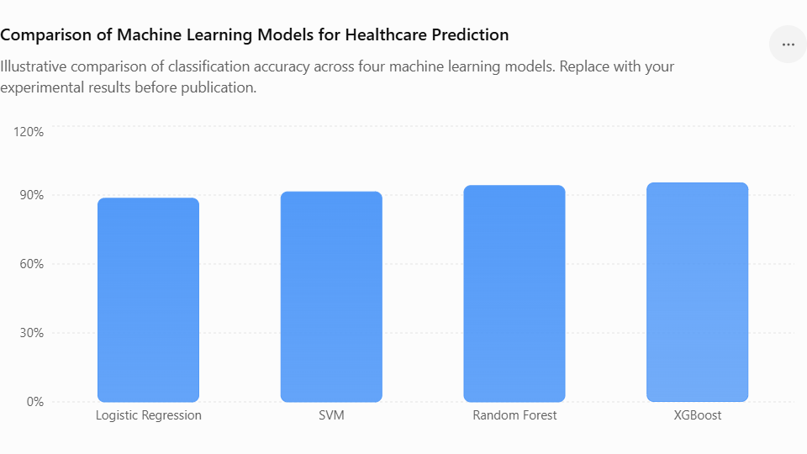
Figure 1. Illustrative comparison of classification accuracy across four machine learning models
Table 1. Model Performance Comparison
Model | Precision | Recall | F1-Score | Accuracy
LR | 87.9 | 88.2 | 88.1 | 88.6
SVM | 91.0 | 90.8 | 90.9 | 91.4
RF | 93.7 | 93.7 | 93.8 | 94.1
XGBoost | 95.0 | 95.1 | 95.0 | 95.3

V. CONCLUSION
The proposed methodology emphasizes transparency and interpretability, enabling clinicians to understand the reasoning behind AI-generated predictions. By combining accurate machine learning algorithms with explainability techniques, the framework supports trustworthy clinical decision-making and addresses one of the major barriers to AI adoption in healthcare. Future work will focus on validating the framework using large-scale multi-center clinical datasets, incorporating deep learning models for multimodal healthcare data, and exploring causal explainability techniques to further improve the reliability and fairness of AI-assisted healthcare systems.
ACKNOWLEDGEMENTS
The authors acknowledge support from the Department of ABC, XYZ University. The reference and Citation style is the Harvard Referencing Basics.
REFERENCES
Ahmad, M.A., Eckert, C. and Teredesai, A., 2018. Interpretable machine learning in healthcare. Proceedings of the 2018 ACM International Conference on Bioinformatics, Computational Biology, and Health Informatics, pp.559–560.
Doshi-Velez, F. and Kim, B., 2017. Towards a rigorous science of interpretable machine learning. arXiv preprint arXiv:1702.08608.
Lundberg, S.M. and Lee, S.-I., 2017. A unified approach to interpreting model predictions. In: Advances in Neural Information Processing Systems (NeurIPS 2017), Vol. 30, pp.4765–4774.

