PROJECT TOPIC: Campus Connect – Junior Senior Interaction Platform

Group No.: 74

Project Group Members:
- Basant Bhargav (Sec-Roll No. B-17 / Univ Roll No. 2315000591)
- Harsh Chahar (Sec-Roll No. C-31 / Univ Roll No. 2315000896)
- Rajat Agrawal (Sec-Roll No. B-53 / Univ Roll No. 2315001786)
- Rishabh Kumar (Sec-Roll No B-55 / Univ Roll No. 2315001830)
5. Rudra Agrawal (Sec-Roll No. B-57 / Univ Roll No. 2315001892)

Project Supervisor: Ms. Ruchi Gupta, Master Trainer

About the Project:
Students often struggle to find the right guidance, career advice, and practical insights needed to navigate their academic and professional journeys. The lack of meaningful interaction between juniors and seniors creates a gap in knowledge sharing, leaving many students uncertain about internships, placements, interviews, and career opportunities.
To address this challenge, the proposed “Junior–Senior Interaction Platform” aims to build a collaborative student community that connects learners with experienced peers. The platform will enable juniors to explore senior profiles, review their achievements, and identify suitable mentors based on their interests and career goals. Integrated real-time chat will facilitate personalized guidance, doubt resolution, and meaningful connections. Additionally, a dedicated community space will allow students to share interview experiences, placement journeys, preparation strategies, and valuable resources, making practical knowledge accessible to everyone.
Motivation:
This project aims to bridge the communication gap between junior and senior students by creating a collaborative platform for mentorship and knowledge sharing. As a major final-year project, it integrates full-stack development, database management, authentication, and real-time communication using the MERN stack. It promotes peer learning, career awareness, and professional development. The platform benefits society by making student guidance more accessible and fostering a supportive academic community.
Innovation:
- Achievement-Based Matching: Juniors can explore senior profiles and achievements to find suitable mentors based on their interests and career goals.
- Real-Time Interaction: Direct chatting enables personalized guidance, doubt resolution, and experience sharing.
- Interview Experience Hub: A dedicated space for students to share interview questions, placement experiences, and preparation strategies.
- Centralized Student Community: Combines mentorship, networking, and knowledge sharing on a single platform.
- Peer-to-Peer Learning: Encourages students to exchange resources, learn from real experiences, and support each other's growth.
Project Planning:
For Junior–Senior Interaction Platform, below provided the following project planning schedule. It starts in September 2026 and finishes in March 2027.

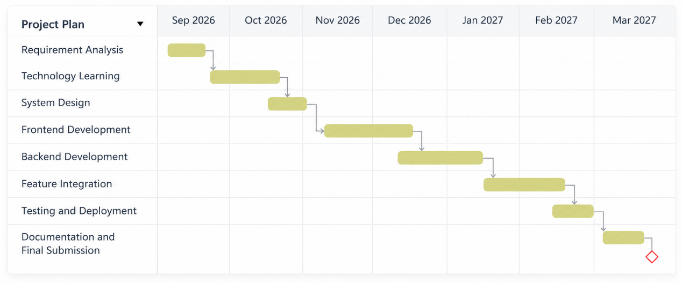

Tools required:
- Hardware Requirements:
- Computer or laptop with Intel Core i3 or equivalent processor.
- Minimum 8 GB RAM.
- Minimum 256 GB storage.
- Stable internet connection.

- Software Requirements:
- Frontend: React.js, HTML, CSS, JavaScript.
- Backend: Node.js and Express.js.
- Database: MongoDB Atlas.
- Code Editor: Visual Studio Code.
- Browser: Google Chrome
- Version Control: Git and GitHub.
- API Testing: Postman.
- Additional Tools: npm and Socket.IO for real-time chatting.

Signature of Project Supervisor: _____________________

