Calculate Object Size using Single Camera Vision

Using Standard reference object in frame.

Assuming both the target and reference object is in same plane
Plane should be at 90 degree with repect to camera line of sight.
RO
TO
PRW
PRH
PTW
PTH
Drawing 2: Width
Drawing 1: Height

RO : Reference Object
PRH : Pixel height of Reference object in frame
PRW : pixel width of target object in frame
TO : Target Object
PTH : pixel height of target obejctin frame
PTW :Pixel width of target object in frame

pixels_per_metric = PRW / Known _width

original_target_object_height = PTH / pixels_per_metric
riginal_target_object_width = PTW / pixels_per_metric

https://de.mathworks.com/help/vision/examples/measuring-planar-objects-with-a-calibrated-camera.html
https://www.pyimagesearch.com/2015/01/19/find-distance-camera-objectmarker-using-python-opencv/
How to determine whether the object is on same plane or not :

using single camera we can not determine , because camera always gives 2d frame as output
If object is tilted or placed in different angle then in that case size of object will be different in different-different position.

if the object is not parallel to plane then one properties could be useful for this -

original_height/original_width = measured_height / measured_width

To do size and or distance calculations without a reference object
a) the lens and focus information and
b) two or more images of the same scene from different angles so as to use parallax calculations.
https://ijirae.com/volumes/Vol4/iss11/05.NVAE10087.pdf
https://www.ijert.org/research/distance-measurement-system-using-binocular-stereo-vision-approach-IJERTV2IS121134.pdf
https://en.wikipedia.org/wiki/Parallax

As long as you know the focal length and the object distance, both of which some lenses return to the camera you can calculate the real size of an item in the image. The focal length will give you the lens field of view in terms of degrees.

For example, a 100mm lens has a vertical field of view of 14 degrees on a full frame camera. Something that fills half your frame vertically therefore uses 7 degrees of field of view.
If you no the distance, you can now build a right angled triangle with internal angles of 7, 90 and 83 degrees (cos the internal angles of a triangle add up to 180 degrees.
At this point you have enough information to use the law of tangents (you need two angles and a length or two lengths and an angle) to calculate the remaining sides of the triangle and hence the size of the object.

You need to perform some sort of camera calibration. That can be done offline before the script is deployed (provided you’re using the same camera sensors) or you can include the reference object in the image. In either case, the system must be calibrated first.
How to get object position :
As per use case the idea is to calculate the lenth of necklace and earings .
Here is the main problem to get the position of target feature object from image because if we opencv to get the required object . It is very difficult to take decision about object .
The opencv uses edge detection method to determine the contour point on image :
for example :
image and predicion using opencv it is very difficult to identify the necklace as a target object among all other object . Every close curve treated as object here.

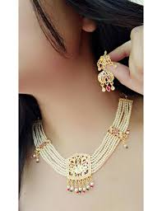
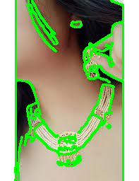
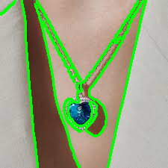
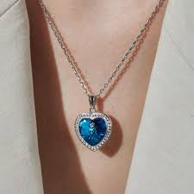

Solution : if we could be crop the image and able to seperate the object from image .To do so and
get the feature from image we can use face detection and after some math we can calculate the approximate position for necklace and earings.

If we have only one or two object in a frame then we can use the opencv function .
