BRAIN
AI-Native Commerce Operating System
Solution Architecture & End-to-End Technical Design
Direct-to-Consumer Commerce · India · UAE · GCC
Version 1.0 · Document Status: Source-of-truth technical architecture

Table of Contents

1. Introduction
Brain is the operating system that sits above a Direct-to-Consumer (DTC) brand's fragmented commerce stack.
A typical DTC operator works across a storefront, two ad managers, a payments dashboard, a logistics panel, a WhatsApp inbox, an inventory sheet, and a finance file. Each tool shows one slice of the business, none of them agree, and the most expensive decisions get made on platform ROAS while contribution margin and cash quietly erode through returns, RTO, refunds, and wasted spend. Brain removes that fragmentation. It connects the entire stack, unifies the data, computes one honest picture of revenue and profit, attributes outcomes truthfully, tells the operator what changed and why it matters, recommends the highest-value next action, executes the safe ones within guardrails, and remembers every outcome so each decision sharpens the next.
This document describes the complete technical architecture of Brain as an end-to-end flow: how data enters the platform, how it is processed and made trustworthy, how intelligence is produced on top of it, how actions are taken safely, and how the whole system is deployed, secured, scaled, and operated. It is written to be read start to finish as a single technical narrative.

1.1 Architectural objective
Brain must satisfy two demands at once. It must be fast enough to be the high-frequency surface an operator opens first every morning, and it must be deterministic and auditable enough to bill on realized margin and to execute money-moving actions automatically. Every design decision in this document serves both demands simultaneously.

1.2 Guiding principles
- Event-driven by default. Every state change is an event on a streaming backbone, enabling real-time freshness, replay, and a complete audit trail. Money-moving actions run on a separate synchronous, idempotent path.
- Deterministic numbers, probabilistic advice. A single deterministic metric engine computes every figure. AI may explain or narrate an approved number but can never invent one.
- Structural tenant isolation. A brand's data is walled off by a mandatory workspace key enforced at the data-access layer, so one brand can never reach another's data.
- Region adapters, never forks. One core engine serves all regions; India and GCC rules for tax, consent, logistics, and calendars plug in as configuration, with data pinned to its region.
- Realized over placed. Decisions and billing rest on revenue that actually survives cancellation, RTO, refund, and settlement — not placed or platform-reported revenue.
- Safe by construction. Guardrails, caps, confidence gates, reversibility, and a kill switch are platform services that every automated action passes through.
- Compounding memory. Every recommendation, action, and outcome is recorded permanently, so the platform becomes more valuable every week it runs.

2. High-Level Architecture
Brain is an event-driven, multi-tenant, cloud-native platform built on AWS. It is organized as a streaming data foundation, a deterministic computation core, an agentic decision-and-execution layer, and a set of operator-facing surfaces — all bound together by a canonical data model and a permanent decision log.
At the highest level the platform runs two coupled loops. The data loop continuously senses, normalizes, attributes, and detects. The decision loop decides, acts, logs, and learns. The two loops are deployed separately so the data foundation can scale on data throughput while the decision layer scales on reasoning cost and safety, and they are unified through two shared assets: the canonical data model and the Decision Log.

2.1 System context
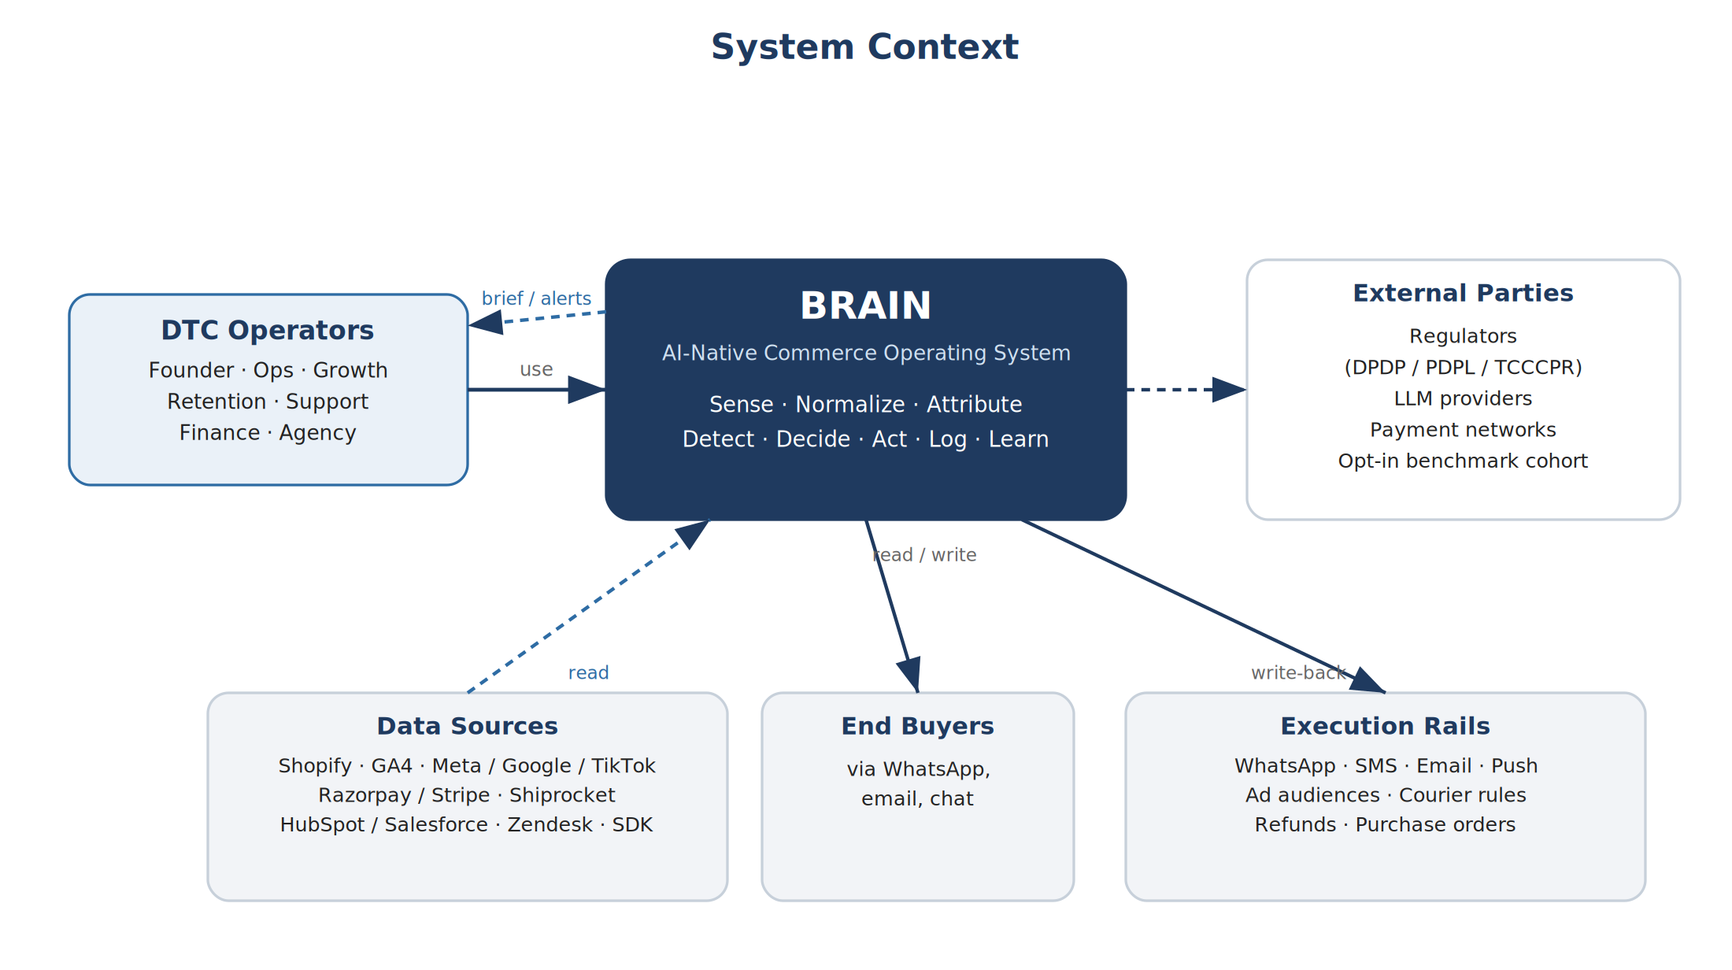
Figure 1. Brain in context — operators, data sources, end buyers, execution rails, and external parties.

2.2 Logical layers
The platform is organized into six logical layers, each described in detail in the sections that follow:
Layer | Responsibility
Ingestion | Collect first-party data and events from all sources; write back approved actions to execution rails.
Streaming & processing | Normalize, resolve identity, attribute outcomes, and detect meaningful movement in real time.
Storage & serving | Persist data across hot, warm, and cold tiers; serve real-time and historical reads.
Computation core | The deterministic metric engine and the realized-revenue ledger that produce every trusted number.
Intelligence & execution | Agents that reason and recommend; guardrails and the execution engine that act safely.
Experience | Operator surfaces, dashboards, briefs, and the natural-language assistant.

3. End-to-End Data and Decision Flow
This section traces a single piece of activity — for example, a new order — through the entire platform, from the moment it is captured to the moment it produces a recommendation, an action, and a recorded outcome. Subsequent sections expand each stage in detail.

3.1 The flow at a glance
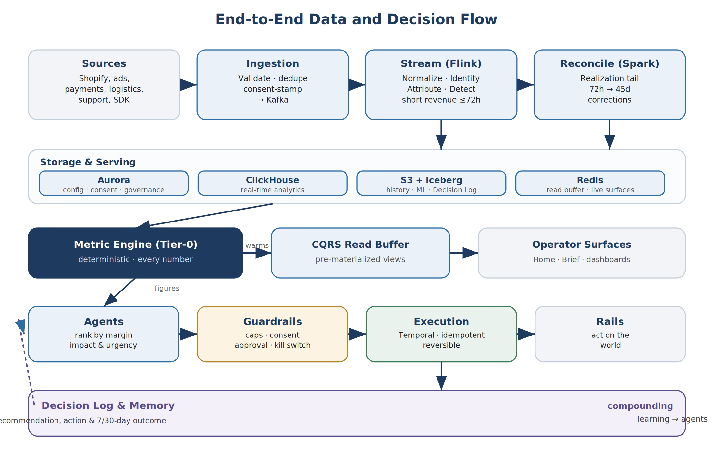
Figure 2. The end-to-end flow — from sources through ingestion, streaming, reconciliation, and the deterministic core, into the guardrailed decision loop and the compounding Decision Log.

3.2 The flow in words
- Capture. An order webhook from the storefront, a spend update from an ad platform, or an event from the tracking SDK arrives at the Ingestion layer. It is validated, de-duplicated, stamped with consent and region metadata, and published to a raw Kafka topic keyed by the brand's workspace.
- Normalize and resolve. Stream processors translate the source-specific shape into Brain's canonical model, apply the brand's region rules (currency, tax, timezone), and resolve the customer identity across anonymous and known identifiers.
- Attribute. The processor links touchpoints to the order, applies the configured attribution models, and reconciles the result against the realized-revenue ledger so credit is never double-counted across ad platforms.
- Realize. The order enters the revenue state machine. Short-lived states are tracked in the stream; the slow realization tail — cancellation, RTO, refund, settlement, over up to 45 days — is owned by a reconciliation job that issues corrections to closed periods.
- Detect. A complex-event-processing stage compares live movement against the brand's learned baseline and emits signals — a margin drop, an RTO spike, an approaching stockout, creative fatigue.
- Compute. The deterministic metric engine turns stored data into trusted figures — contribution margin, MER, RTO cost, COD realization — each carrying its formula version, filters, freshness, and lineage. These figures warm the read buffer so operator screens are instant.
- Decide. Agents read the figures, the signals, and the brand's memory, rank the highest-value actions by expected margin impact and urgency, and produce recommendations with evidence, confidence, and risk.
- Act. Each candidate action passes through the guardrail layer — caps, confidence thresholds, consent checks, approval matrix. Approved or pre-authorized actions are executed as durable, idempotent, reversible workflows.
- Log and learn. The condition, recommendation, decision, execution, and the 7-day and 30-day outcomes are written to the Decision Log. That memory feeds the agents, so the next recommendation is better.

4. Microservice Architecture
Brain is implemented as a set of independently deployable services aligned to bounded contexts. Each service owns its own data, exposes a versioned contract, enforces the workspace isolation key, and scales independently. Services communicate asynchronously through Kafka by default, and synchronously through gRPC or REST only where an immediate answer is required. The landscape below is the target state; the platform is delivered to it progressively, so that early phases run a lean core and the finer-grained decompositions are introduced as scale and ownership justify them.

4.1 Service landscape
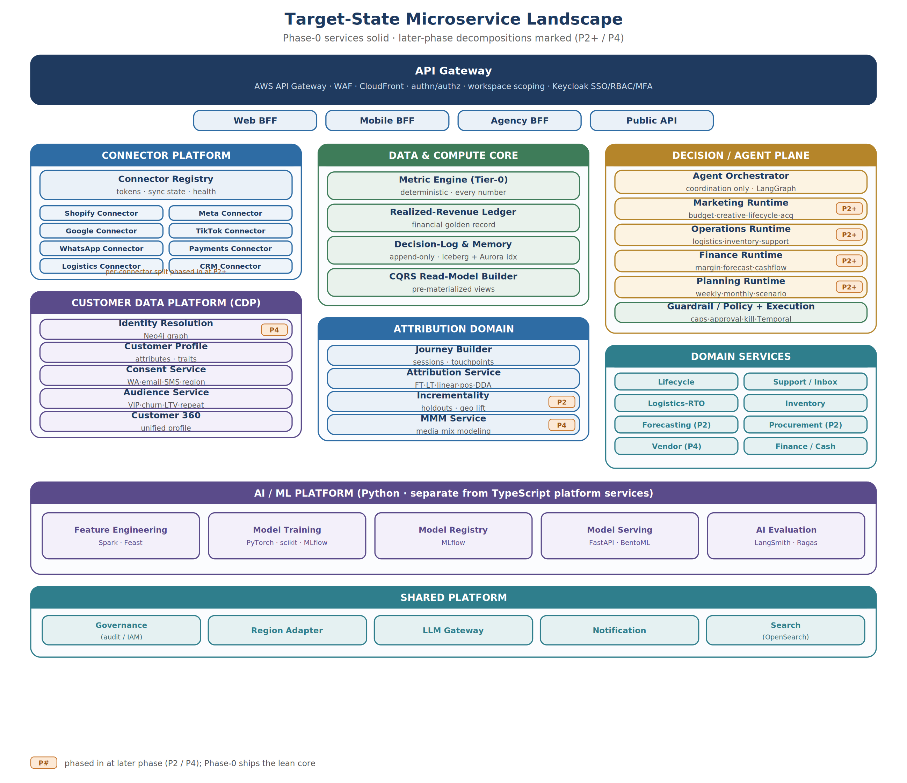
Figure 3. Target-state microservice landscape. Phase-0 services are part of the lean core; items marked P2 or P4 are decomposed in later phases.
Phasing. Phase 0 ships a lean core: a single ingestion service, a combined identity and customer service, a single attribution service, the deterministic core, a single agent service, and the domain services. The per-connector split, the dedicated graph database for identity, media-mix modelling, and the separate per-discipline agent runtimes are introduced from Phase 2 onward, so the team is never operating the full target footprint before the load requires it.

4.2 Domains and services

Connector Platform
Ingestion is organized as a connector platform rather than one service. A Connector Registry owns configuration, OAuth tokens, synchronization state, retry state, and health for every integration. Each integration then runs as its own connector service so that a single provider's outage or rate limit affects only its own deployment.
Service | Owns / Responsibility | Phase
Connector Registry | Connector configuration, OAuth tokens, sync and retry state, connector health. | 0
Per-connector services | One independently deployable service per provider (Shopify, Meta, Google, TikTok, WhatsApp, Payments, Logistics, CRM, and others); fetch, normalize, and write back for that provider. | 2+

Customer Data Platform (CDP)
A dedicated customer-data layer sits between identity resolution and attribution, so that Brain is a customer-intelligence platform as well as an operational one. It consolidates capabilities that would otherwise be scattered — consent and audiences in particular — into one clearly-owned domain.
Service | Owns / Responsibility | Phase
Identity Resolution | Email, phone, device, and anonymous matching into one customer; deterministic-first with a labelled probabilistic overlay. Backed by a graph database (Neo4j) at target state. | 0 (graph: 4)
Customer Profile | Customer attributes, demographics, behavioural traits, and commerce profile. | 1
Consent Service | WhatsApp, email, SMS, and regional consent state and withdrawal. | 0
Audience Service | Reusable audiences — VIP, churn-risk, high-LTV, repeat-buyer — built once and activated across channels. | 1
Customer 360 | Unified customer profile assembled from the above for surfaces, agents, and lifecycle. | 2

Data & Compute Core
Service | Owns / Responsibility | Phase
Metric Engine (Tier-0) | Deterministic calculation of every metric; versioned formula registry. Called by agents and the read-model builder, never by surfaces directly. | 0
Realized-Revenue Ledger | The financial golden record; short-horizon stream state plus long-horizon reconciliation of the realization tail. | 0
Decision-Log & Memory | Append-only record of every recommendation, action, and outcome; Brand Fingerprint; condition-outcome memory. | 0
CQRS Read-Model Builder | Pre-materialize Home, Brief, and dashboard payloads so surfaces read instantly and never call the metric engine synchronously. | 0

Attribution Domain
Service | Owns / Responsibility | Phase
Journey Builder | Sessions, touchpoints, and ordered customer journeys. | 1
Attribution Service | First-touch, last-touch, linear, position-based, and data-driven attribution, reconciled to realized revenue. | 0
Incrementality | Holdout tests, lift studies, and geo experiments. | 2
MMM Service | Media-mix modelling for blended channel planning. | 4

Decision & Agent Plane
The agent orchestrator coordinates execution only and holds no business logic. The reasoning itself runs in per-discipline runtimes, so each can scale and evolve independently. Agent orchestration uses LangGraph for state, memory, and human-approval flows; the resulting actions are carried out by the guardrail and execution services.
Service | Owns / Responsibility | Phase
Agent Orchestrator | Coordinates agent execution; ranks recommendations by margin impact, urgency, confidence, and risk. LangGraph-based. | 0
Marketing / Operations / Finance / Planning runtimes | Per-discipline agent runtimes (budget, creative, lifecycle, acquisition; logistics, inventory, support; margin, forecasting, cashflow; weekly, monthly, scenario planning). | 2+
Guardrail / Policy | Enforce caps, confidence thresholds, consent, approval matrix, and the kill switch on every action. | 0
Execution | Perform actions as durable, idempotent, reversible workflows (Temporal); track 7-day and 30-day outcomes. | 0

Domain Services
Service | Owns / Responsibility | Phase
Lifecycle | Margin-gated campaigns and WhatsApp journeys; offer governance. | 1
Support / Inbox | Classify, enrich, resolve, and route tickets; feed insights back to other domains. | 2
Logistics-RTO | NDR, courier, and pincode intelligence; RTO cost and courier-switch actions. | 1
Inventory | Real-time stock cover and days-of-cover tracking. | 1
Forecasting | Demand prediction adjusted for campaigns, festivals, and seasonality. | 2
Procurement | Reorder and purchase-order generation. | 2
Vendor | Supplier and vendor management. | 4
Finance / Cash | P&L, settlement timing, refund liability, cash conversion, scenario planning. | 1

Shared Platform
Service | Owns / Responsibility | Phase
Governance | Audit log, IAM, role and approval enforcement (consent lives in the CDP). | 0
Region Adapter | Inject regional tax, consent, logistics, calendar, and provider rules into every service. | 0
LLM Gateway | Route prompts to models by task complexity; enforce that AI quotes computed figures only. | 0
Notification | Severity-routed alerts to in-product, mobile, and email with quiet-hours and override. | 0
Search | Customer, order, and ticket search (OpenSearch). | 2

4.3 Communication model
Asynchronous (Kafka) is the default. A new order flows without any service blocking another: a connector publishes to a raw topic, identity enriches, attribution and the ledger consume, the domain services react, and the read-model builder refreshes the operator buffer.
Synchronous (gRPC / REST) is used only where an immediate answer is required: a BFF reading a pre-materialized view, an agent or the read-model builder requesting a number from the metric engine, and any action passing through the guardrail and execution gate.
Two invariants keep the service mesh honest. First, only the metric engine produces numbers; every other service calls it rather than computing its own, which guarantees a single definition of every figure. Second, every action passes through the guardrail, then execution, then the Decision Log, which guarantees safety and auditability across the entire platform.

4.4 Language and per-service standards
Platform services are built in TypeScript on NestJS; the AI and machine-learning services are built in Python. Standardizing on two languages — one for platform, one for data science — keeps hiring and operations simple while giving each domain the ecosystem it needs.
- Each service owns its own data; no shared tables across services.
- The workspace isolation key is enforced at the data-access layer of every service, not in hand-written queries, with database row-level security behind it.
- Each service is independently deployable with its own pipeline and runs as a container on the shared cluster.
- Each service exposes a versioned contract and emits distributed traces tagged with the workspace and decision identifiers.
- Each service autoscales independently based on its own load profile.

4.5 AI and Machine-Learning Platform
The revenue-critical models — RTO-risk, lifetime-value, churn, demand forecasting, creative-fatigue, data-driven attribution, and recommendation ranking — run on a dedicated AI and data-science platform, kept separate from the TypeScript platform services and built in Python. This separation lets the data-science discipline use its own tooling and release cadence without coupling to the operational services, while every prediction is still tracked as an outcome in the Decision Log.
Service | Responsibility | Technology
Feature Engineering | Feature generation, validation, and transformation. | Python · Spark · Feast
Model Training | Training, retraining, and experimentation; challenger models in shadow. | Python · PyTorch · scikit-learn · MLflow
Model Registry | Versioning and promotion of models. | MLflow
Model Serving | Prediction APIs and online inference. | Python · FastAPI · BentoML
AI Evaluation | Agent, prompt, and retrieval evaluation and model benchmarking. | LangSmith · Ragas
Each revenue-critical model runs against a monitored accuracy and calibration band; on drift it falls back automatically to a deterministic heuristic and raises an alert, and any prediction that feeds a money-moving action below a confidence floor is routed to a human. This keeps the machine-learning layer powerful but always subordinate to the deterministic core and the guardrails.

5. Ingestion Layer
The ingestion layer is the single doorway through which all first-party data enters Brain and through which all approved actions leave it. It hosts the connectors for roughly forty providers across twelve categories — storefront and marketplace, ads, payments, logistics, messaging, support, CRM, analytics, OMS and ERP, reviews and loyalty, and finance — and the first-party tracking SDK.

5.1 Ingestion modes
Connectors operate in one of four modes according to the quality and reliability of the underlying source:
Mode | Used for | Behaviour
Webhook / change-data-capture | Orders, payment events, support messages | Near-real-time; validated and de-duplicated on arrival. Orders are fresh within 5–15 minutes.
Polling | Ad spend and creatives, logistics status, settlements | Scheduled pulls with per-connector backoff and rate budgets; hourly where the API permits.
Tracking SDK / server-side | Web and app behavioural events | First-party, server-side capture resilient to cookie loss; consent-stamped at capture; queryable within a minute.
Import / parse | Finance sheets and exports | Clearly labelled as brittle, monitored closely, never hidden from the operator.

5.2 Reliability and quality
Every connector exposes its connected state, last successful sync, current lag, error type, and a data-completeness score. Connectors are protected by circuit breakers, exponential backoff, and dead-letter queues, and are probed by synthetic health checks. When a source is stale or broken, the affected metrics are labelled accordingly and high-risk recommendations that depend on that source are withheld until it recovers. Token-refresh failures and rate-limit exhaustion surface on the integration-health surface and in the audit trail.

5.3 Write-back
Ingestion is bidirectional. Approved actions — a lifecycle send, an ad budget change, a courier-rule update, a refund — are written back to the relevant rail through the same connector framework, always as idempotent operations so that a retry can never act twice.

6. Streaming and Real-Time Processing
All ingested data lands on a Kafka streaming backbone. Kafka is chosen because it allows the platform to replay history to rebuild any derived store, to process events exactly once, to preserve per-brand ordering through workspace-keyed partitions, and to absorb large spikes without back-pressuring the sources. Topics are organized by stage — raw, normalized, attributed, signals, and decisions — and every topic is keyed by the workspace so isolation and ordering hold throughout.

6.1 Stream processing pipelines
Apache Flink processes the streams. It is chosen for true event-time processing with watermarks, rich windowing, complex-event processing, and durable exactly-once state. The pipelines are:
- Normalizer — maps each source's shape onto Brain's canonical model and applies region rules for currency, timezone, and tax.
- Identity resolver — joins anonymous and known identifiers into one customer using deterministic keys first, with an optional, clearly-labelled probabilistic overlay that any brand can disable entirely.
- Journey and attribution builder — sequences touchpoints into journeys, applies the attribution models, and reconciles credit to the realized-revenue ledger.
- Anomaly detector — compares live movement against the brand's learned baseline and emits signals for margin, RTO, fatigue, and stockout conditions.
- Sale and event mode — a tighter-window pipeline that tracks hourly pace against forecast and raises alerts within a minute during sale events.

6.2 The realized-revenue ledger
Revenue is the most important number in Brain, and it is not known at the moment an order is placed. An order travels through placed, confirmed, shipped, delivered, and settled states, and may be cancelled, returned, or refunded along the way, over a window of up to 45 days. To handle this without burdening the stream, the ledger is split. The stream tracks only the short-horizon states, keeping its state small so checkpoints are fast and recovery is quick. A separate reconciliation job, running on a schedule and triggered by realization events, owns the slow tail: it finalizes delivered and settled revenue, applies returns and refunds, and emits corrections to already-closed periods. The result is one authoritative realized-revenue figure that decisions and billing both rely on.

7. Storage and Serving
Brain uses a polyglot, tiered storage strategy so that each kind of data lives in the store best suited to it, and so that cost falls as data ages.
Store | Technology | Holds
Operational (OLTP) | Aurora PostgreSQL | Configuration, cost setup, consent, goals, users and roles, governance and audit, and the recent index of the Decision Log. One cluster per region for data residency.
Hot serving | Redis | The read buffer for operator surfaces, the live revenue strip, queues, idempotency keys, and rate limits.
Analytical (OLAP) | ClickHouse | Real-time metrics, journeys, RTO and pincode cubes, event analytics, and the serving copy of the realized-revenue ledger.
Lakehouse | S3 with Apache Iceberg | Full history, raw and normalized data, machine-learning training sets, backfill source, the cold tier, and the Decision Log system of record.
Memory | pgvector | Decision, brand, and creative memory; knowledge retrieval for the natural-language assistant.
Features | Feast | Online and offline features for the risk, lifetime-value, fatigue, and churn models.
Identity graph | Neo4j | The identity graph for resolving anonymous and known identifiers into one customer (introduced at target state).
Search | OpenSearch | Customer, order, and ticket search.

7.1 Tiering and retention
Data moves automatically from hot to warm to cold as it ages. Raw events are held for thirteen months in the hot analytical store and a further twenty-four months in the cold lakehouse before being purged, which preserves two full festival cycles for machine learning while bounding cost and privacy exposure. Derived metrics are retained for the life of the brand, so the numbers are never lost even after raw data is purged. The Decision Log is retained for the life of the brand. Erasure requests purge a customer across every tier, including backups.

7.2 The read path
Operator surfaces never compute their own numbers and never call the metric engine on page load. Instead, a read-model builder pre-materializes the Home, Brief, and dashboard payloads into the hot and analytical stores whenever the underlying data changes and on a freshness schedule. Surfaces read these ready-made views, which keeps screens instant and ensures the computation core can be scaled or updated without affecting the daily operator experience.

8. The Computation Core: Metric Engine
The metric engine is the heart of Brain and the source of its trustworthiness. It is the only component permitted to produce a business figure. Every dashboard, every agent, and every automated decision quotes a number that originates here. Because the entire product depends on it for both correctness and availability, it is operated as the most redundant and most rigorously tested service on the platform, deployed with multiple replicas and zero-downtime, multi-version releases, and kept off the synchronous read path by the read-model builder.

8.1 What it computes
The engine computes the full contribution-margin waterfall — revenue net of tax, then CM1, CM2, CM3, and operating profit — at the grain of an order, SKU, customer, cohort, campaign, day, week, month, channel, or workspace. It applies each SKU's own tax slab rather than a blended rate, resolves landed costs and variable costs, and produces True CM2 after RTO cost and refund and payment provisions. It computes the marketing and attribution metrics — MER, aMER, CAC, lifetime-value-to-CAC, attributed and incremental return on ad spend — and the logistics metrics including RTO rate and cost, COD realization, and the break-even COD return rate.

8.2 How every number is trustworthy
The engine holds one canonical, versioned formula per metric in a definition registry. Every value it returns is accompanied by its formula version, the filters and period applied, its data freshness, a confidence indicator, a lineage handle that resolves to the source rows, and a flag if it is an estimate because cost or data coverage is incomplete. This is what allows any figure on any screen to be explained down to its formula and its source, and what allows the platform to bill honestly on margin.

9. Intelligence and Safe Execution
On top of the trusted figures sits the intelligence layer that turns numbers into decisions, and the execution layer that carries them out safely.

9.1 Agents
Brain organizes its intelligence into three agent groups — a marketing group, an operations group, and a finance group — supported by specialist agents for the morning brief, anomaly detection, budget, creative, lifecycle, support, logistics, inventory, planning, pricing, and attribution. Each agent reads computed figures from the metric engine, signals from the stream, and the brand's memory, and produces ranked recommendations. Every recommendation carries its evidence, the metrics it used, its expected revenue and margin impact, a confidence score, a risk level, its reversibility, the approval level required, and the plan for measuring its outcome. Recommendations are ranked by expected margin impact, urgency, confidence, risk, and reversibility.

9.2 Machine learning under governance
Several models are load-bearing for the product's promise — in particular the RTO-risk model and the data-driven attribution model. These are treated as product-critical rather than advisory. Each runs against a continuously monitored accuracy and calibration band; if it drifts outside that band it automatically falls back to a deterministic heuristic and raises an alert. Challenger models run in shadow and are promoted only on measured outperformance. Any prediction that feeds a money-moving action below a confidence floor is routed to a human regardless of agent confidence, and every such prediction is outcome-tracked to close the calibration loop.

9.3 Guardrails and execution
No service performs an action directly. Every candidate action passes through the guardrail layer, which enforces owner-set caps, confidence thresholds, consent checks, the approval matrix, and the global kill switch. Approved or pre-authorized actions are then carried out by the execution engine as durable, idempotent, reversible workflows. Because the workflows are idempotent, a retry can never act twice; because they are durable, an action approved before an outage still completes and the operator is told what did and did not run. The execution engine also schedules the 7-day and 30-day outcome measurements for every action.

9.4 Auto-execution and the kill switch
Automation begins with the low-risk, high-frequency, reversible actions: pausing an underperforming ad, reducing a fatiguing budget, applying an approved abandoned-cart discount, sending an approved lifecycle message, or switching a courier rule for a high-RTO pincode within a cap. Higher-risk actions such as refunds remain assisted, drafted for human approval, until outcome data justifies more autonomy. The owner can pause all automation within sixty seconds through a global kill switch; the platform itself reduces autonomy back toward recommend-only if the reversal rate crosses a threshold.

10. Decision Log and Compounding Memory
The Decision Log is the platform's permanent operating memory and its most durable competitive asset. Every recommendation, every approval, rejection, or edit, every executed and reversed action, every lifecycle send and support resolution, and every 7-day and 30-day outcome is written to it. It is held as an append-only, immutable record in the lakehouse — the system of record — with a hot index of the most recent activity in the operational store for fast audit and decision-ROI queries. Outcomes are appended as new records rather than mutating existing ones, preserving immutability.
From this log Brain derives two further memories. The Brand Fingerprint summarizes the brand's operating patterns over time — revenue rhythms, margin trends, channel efficiency curves, RTO and COD baselines, creative fatigue half-life, discount sensitivity, and festival multipliers. The condition-outcome memory stores what was true, what Brain recommended, what was done, and what happened, so that recommendations and attribution improve with every week of operation. Cross-brand benchmarks are produced only from aggregated, anonymized data above strict privacy thresholds, and only for brands that opt in.

11. Operator Experience
All of the platform's intelligence reaches the operator through a small set of focused surfaces, each served instantly from the read buffer.
- Home / Command Center — the current-day answer: live revenue and profit, revenue quality, the top three actions ranked by margin impact, the operational queues, decision ROI, and integration health.
- Executive dashboards — role-specific views for the chief executive, marketing, operations, finance, and technology leaders, all built on the same trusted dataset so no one argues over whose number is right.
- Morning Brief — delivered at the local morning time, at most three actions, each with problem, evidence, recommendation, expected impact, risk, and confidence.
- Evening Pulse, Weekly Review, and Month-End Compound Report — the daily, weekly, and monthly rhythm of pace, accountability, and learning.
- Sale and Event Mode — high-frequency monitoring of pace, margin, inventory, and risk during festivals and campaigns.
- Natural-language assistant — plain-language questions answered with the exact figures and formulas used, the period and filters, a confidence caveat where data is incomplete, and a suggested next action. The assistant narrates figures from the metric engine and never invents them.

12. Cross-Cutting Concerns

12.1 Multi-region and data residency
Brain is multi-region by design. India data is stored in the India region by default, and GCC data in a GCC region, consistent with local data-protection law. Compute is stateless and can run across regions, but raw and personal data is pinned to its region at the storage tier. Where a multi-brand group needs a portfolio view across regions, only aggregated and anonymized figures cross the regional boundary, through a governed aggregation zone, and only with the appropriate legal basis. Enterprise customers can tighten residency further or disable cross-region rollups entirely.
Residency for the operational store is achieved by running one Aurora PostgreSQL cluster per region — a dedicated India cluster and dedicated UAE and KSA clusters — so that a region's operational, configuration, consent, and governance data, together with the recent index of its Decision Log, never leaves its region. The analytical store, lakehouse, and caches are likewise region-pinned. This per-region cluster model maps directly onto the region-adapter pattern: the core engine is identical everywhere, while each region's data lives in its own isolated cluster.

12.2 Scalability and performance
Stateless services autoscale on load; the stream processors autoscale on backlog; the analytical store scales by sharding and read replicas. Reactive autoscaling is the default, and because the festival and sale calendar is known in advance, the platform also pre-warms capacity ahead of predictable peaks. During a spike, non-critical analytics are shed before alerts or execution, and the read buffer absorbs read spikes without touching the computation core. The platform is sized to sustain millions of events a day with an order of magnitude of headroom for sale days.

12.3 Reliability and disaster recovery
Every tier runs across multiple availability zones, with asynchronous cross-region replication within the same regulatory zone. The recovery-point objective is five minutes and the recovery-time objective for core services is one hour; because the streaming log is retained, derived stores can be rebuilt by replay after a disruption. Stream processing checkpoints continuously, connectors are protected by circuit breakers and dead-letter queues, and all write-backs are idempotent.

12.4 Security and compliance
Brain holds card, bank, and other payment secrets nowhere; it reads only fees, settlements, and refund status, and performs refunds through the gateway, which keeps it out of payment-card-data scope. Personal data is hashed or pseudonymized by default, never written to logs, and analyzed at pincode or city level rather than full address wherever possible. Data is encrypted in transit and at rest with managed keys, with per-tenant keys for enterprise customers. Access is governed by single sign-on with multi-factor authentication and by role- and attribute-based controls.
Tenant isolation is enforced structurally: the workspace key is injected automatically at the data-access layer so that no hand-written query can bypass it, every query result is asserted to belong to the requesting workspace, and automated isolation tests block any release that could leak across brands. Postgres row-level security provides an additional, database-level line of defence behind these application controls. The platform complies with India's DPDP framework and telecom communication rules, and with the UAE and KSA data-protection laws, with consent tracked by customer, channel, purpose, source, and region, and enforced on every outbound message. A SOC 2 control framework operates from early in the build so that an independent assessment is available when enterprise customers require it.

12.5 Observability
Every service emits logs, metrics, and traces tagged with the workspace and decision identifiers, which doubles as the backbone for explaining any figure or action. Service-level objectives and error budgets are tracked for every target in this document, with burn-rate alerts. Data-quality signals — freshness, de-duplication, identity-match, schema conformance, and completeness — feed the integration-health surface and gate recommendations. Reversal rates, model calibration, and outcome accuracy are monitored and drive the automatic return to recommend-only mode when needed.

12.6 Cost management
Because Brain is priced as a share of the realized margin it helps a brand keep, its own cost to serve is metered per brand across compute, storage, model usage, and messaging, and surfaced on a margin-safety dashboard. The model gateway routes each task to the least costly model that can serve it and never calls a model for a figure the metric engine can return. Storage tiering, columnar compression, cost-efficient compute for batch work, and reserved capacity for steady serving keep the platform margin-safe.
The operational store deliberately carries only a bounded workload. Analytical queries run on the columnar store, full history and the high-write Decision Log record live in the lakehouse, hot reads are served from the cache, and the Aurora tier holds only operational, configuration, governance, and the Decision-Log hot index. Keeping Aurora off the high-volume read and write paths means the database is never the platform's scaling bottleneck while still providing the high availability, fast failover, read-replica headroom, and enterprise readiness that larger customers expect. Connection pooling is used from the outset so that the full set of microservices shares database connections efficiently. The main cost driver to plan for is the per-region cluster model, since each region carries its own Aurora baseline; this is metered explicitly in the FinOps view, alongside the option of Aurora Serverless for lower-traffic regions during early rollout.

13. Technology Stack
Layer | Technology
Cloud | AWS — India and GCC regions, data pinned per region
Web frontend | Next.js · React · TypeScript · Tailwind CSS · ShadCN · TanStack Query
Mobile frontend | React Native · Expo
Platform services | NestJS · TypeScript (all business microservices)
AI / ML services | Python (feature engineering, training, serving, evaluation)
API and edge | AWS API Gateway · AWS WAF · CloudFront, in front of the BFF layer
Authentication | Keycloak — SSO, RBAC, MFA, enterprise identity
Streaming backbone | Apache Kafka (MSK) with Schema Registry
Stream processing | Apache Flink (real-time enrichment, attribution, identity, signals, revenue)
Batch processing | Apache Spark (model training, reconciliation, historical rebuilds, backfills)
Operational database | Aurora PostgreSQL — one cluster per region (India, UAE, KSA)
Graph database | Neo4j — identity graph and customer identity resolution (target state)
Analytical store | ClickHouse — analytics, dashboards, attribution, journeys, metrics serving
Lakehouse | Amazon S3 with Apache Iceberg — raw and historical events, Decision Log, ML datasets
Cache layer | Redis — CQRS read models, rate limiting, idempotency, hot serving
Search | OpenSearch — customer, order, and ticket search
Vector store | pgvector — decision, brand, and creative memory; knowledge retrieval
Feature store | Feast
AI framework | LangGraph — agent orchestration, state, memory, human-approval workflows
ML tooling | MLflow (registry) · PyTorch / scikit-learn (training) · FastAPI / BentoML (serving) · LangSmith / Ragas (evaluation)
Model access | Custom LLM gateway routing across providers by task complexity
Workflow engine | Temporal — approvals, execution workflows, reversible actions
Container platform | Amazon EKS with automatic node scaling
Infrastructure as code | Terraform
GitOps / CI-CD | ArgoCD · GitHub Actions
Observability | OpenTelemetry · Prometheus · Grafana · Loki · Tempo
Secrets and keys | Managed key service and secrets vault

14. Delivery Roadmap
The platform is delivered in five phases, each building on a trustworthy foundation and each ending in a clear, demonstrable capability.
Phase | Delivers | Outcome
Foundation | Multi-tenant model and isolation; streaming spine; tracking SDK; core connectors; identity basics; cost setup; metric engine and read buffer; contribution-margin waterfall; store analytics; baseline attribution; Decision Log; integration health; India region adapter; security baseline. | A brand connects its stack, sees true contribution margin and attributed revenue, receives top actions, and logs decisions.
Operator Wedge | High-frequency Home; acquisition and attribution analytics; RTO, COD, and pincode intelligence; customer segmentation; first WhatsApp recovery workflows; weekly review; support classification; GCC adapter foundations; enterprise-control groundwork. | Brain becomes the daily operating surface with at least one measured revenue-recovery workflow.
Lifecycle and AI CX | Shared audiences and activation; WhatsApp marketing; replenishment, winback, and VIP retention; AI ticket resolution; support-to-commerce feedback; inventory and logistics queues; creative and budget recommendations; planning and scenarios. | Recovered revenue and protected margin are demonstrable across lifecycle and support.
Agentic Execution | Owner-configured auto-execution of the reversible low-cost actions; guardrail engine; kill switch; reversal workflows; outcome-accuracy dashboard; action API. | Brain safely executes low-risk actions with measurable outcomes and a low reversal rate.
Scale and Enterprise | Portfolio rollups through the aggregation zone; enterprise data controls and residency options; advanced benchmarking; custom integration framework; advanced approval matrices; light retail and point-of-sale ingestion; mature GCC coverage. | Brain supports multi-brand groups, agencies, and enterprises without compromising isolation.

15. Summary
Brain is an event-driven, multi-tenant platform whose architecture mirrors its business promise. Data enters through a resilient ingestion layer, is normalized and attributed in a real-time stream, and is reconciled into one realized-revenue truth. A deterministic metric engine turns that data into figures that can be explained and billed on, and a read buffer serves them to operators instantly. On top of those figures, governed intelligence produces ranked recommendations, and a guardrailed, idempotent execution engine carries out the safe ones, recording every outcome into a permanent decision memory that makes the platform sharper each week. The whole system is multi-region by design, isolated by construction, observable end to end, and built to scale from the first connected brand to a multi-region enterprise portfolio.

