**Face Emotion Recognition**

**Introduction**

Project uses Image enhancement techniques like contrast stretching and denoising to process an image so that the result is more suitable than the original image for specific application. The project classifies emotion on a person’s face into one of seven categories- happy, sad, fear, disgust, angry, neutral and surprise. We have used a pretrained model ("model_v6_23. hdf5") in our code. We use the predict () method of load_model class which belongs to keras.models library to predict the emotions of the detected face.

**Requirements**

* OpenCV 3.2+
* Tensorflow 1.7+
* Python 3.6+
* Matplotlib

### 

### **Installation:**

#### **Installing Tensorflow in Windows-**

#### When installing TensorFlow, you can choose either the CPU-only or GPU-supported version.

Installing Tensorflow-cpu:

Run this command on windows terminal(powershell or command prompt)

pip3 install --upgrade tensorflow

Installing Tensorflow-gpu:

GPU supported TensorFlow requires you to install a number of libraries and drivers. It supports NVIDIA GPU card, with support for CUDA Compute 3.5 or higher.

You must install the following software in order to run the GPU version of TensorFlow:

* NVIDIA GPU drivers
* CUDA Toolkit: CUDA 9.0.
* NCCL 2.2 (optional)
* cuDNN SDK (7.2 or higher)
* TensorRT for improved latency and throughput.

You can install TensorFlow with GPU support as follows:

Run this command on windows terminal(powershell or command prompt)

pip3 install tensorflow-gpu

#### **Installing OpenCV in Windows-**

Run this command on windows terminal(powershell or command prompt)

pip install opencv-contrib-python

**Installing Matplotlib in Windows-**

Run this command on windows terminal(powershell or command prompt)

pip install matplotlib

## **Basic Usage:**

After installation of all the libraries and tools listed above in requirements, unzip the 21_FaceEmotionRecognition on your system and open the Project Code .

* Final_code.py(file)

The following files containing datasets will need to be downloaded and put in same folder as code file to make the code work.

* haarcascade_frontalface_default.xml (file)
* model_v6_23.hdf5(file)

from

<https://www.datacamp.com/community/tutorials/face-detection-python-opencv>

and

<https://github.com/opencv/opencv/blob/master/data/haarcascades/haarcascade_frontalface_default.xml>

Open Final_code.py(file) with python, windows command prompt will open and the program will be successfully executed on your system.

This implementation by default first enhances your image by applying image enhancement techniques like denoising and contrast stretching, then it detects a person’s face in the picture and then it detects emotions on a person’s face. With a 6 layered CNN, the pretrained model was able to achieve 61.3% of validation accuracy.

**SEQUENCE OF IMPLEMENTATION OF THE PROJECT**

Our application works in a series of steps that are enlisted below:

1.Image Selection

2 Image Enhancement

3.Face Detection

4. Facial Emotion Recognition

Each step description is provided in 21_Facial_Emotion_Recognizer.docx(file)

## **Example Output:**

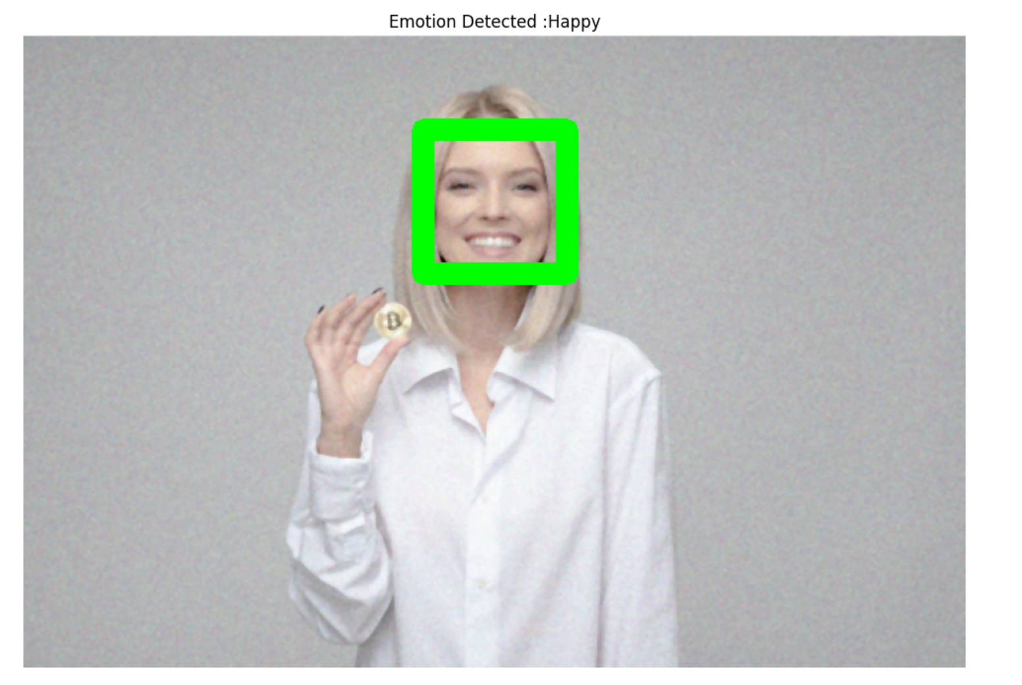

Happy Emotion is detected for the image

## **References:**

1. Dwivedi, P. (2019, April 4). *Face Detection, Recognition and Emotion Detection in 8 lines of code!* Medium. https://towardsdatascience.com/face-detection-recognition-and-emotion-detection-in-8-lines-of-code-b2ce32d4d5de

*2. Use the dialog box to open an image file and display the picture - Programmer Sought*. (n.d.). ProgrammerSought. Retrieved March 1, 2021, from<https://programmersought.com/article/80784886101/>

3. *OpenCV: Smoothing Images*. (n.d.). OpenCV. Retrieved March 1, 2021, from https://docs.opencv.org/master/d4/d13/tutorial_py_filtering.html