Resume of
 | ASADUZZAMAN (MUKUL) | 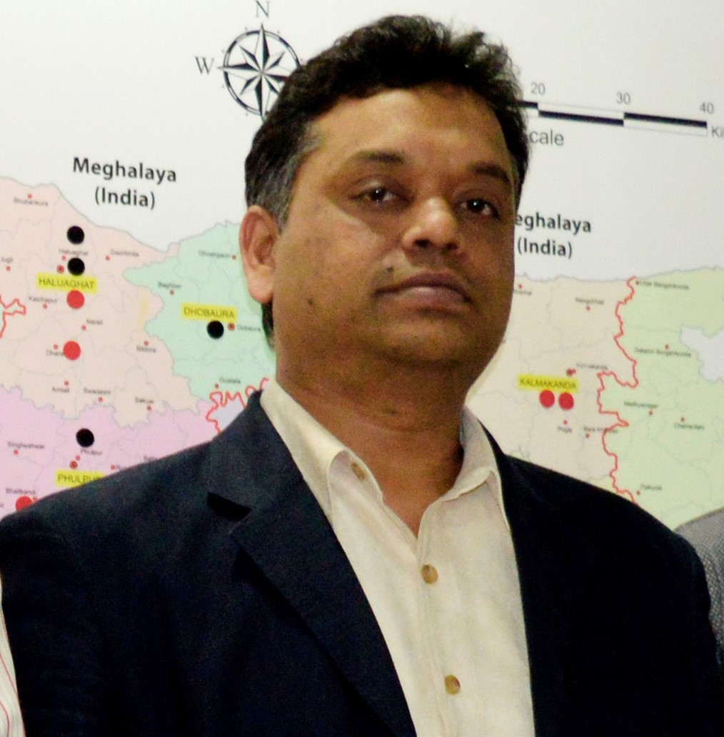
 | Cell: 01715551987 | Email: azmukul32@gmail.com
 | Address: 190/2 Uposhahor, Rajshahi.

Looking for : Top Level Position
Preferred Job Category : Business Development/ Sales Management / Operation Management

Profile:
Accomplished Sales Representative with a Positive, Passionate and Persistent Attitude. With an Experience of 19+ Years working in the sales environment coupled with the exposure to Abul Khair Group (CGD), Transcom Beverages Ltd. (PEPSI) and Berger Paints BD Ltd.’s sales in the Consumer Goods industry has widened my knowledge and skills as a sales person, and sets me apart for success. I believe Confidence and Commonsense helps me to connect people.

Areas of Experience:
Territory/Area Business Plan, Business Development Review, Strategic Planning, Profit Responsibilities, Accounts Management, Vendor Management, Dealer/Distributor Management, Business Networking Plan, Depot and Distribution Management, Demand Planning, Customer Relationship and development, People management- Recruiting, Training and Motivation, Rural Operation Planning, Budgeting – Expenses and Sales, Customer Care etc.

Career History 1
- Branch Manager (Regional Business Head), Berger Paints Bangladesh limited (BPBL)
- November, 2012 – to -Present—(Worked: Mymensingh Division, Dhaka North region, now at Rajshahi and part of Khulna Division)

Achievement:
- Best performer of the year 2012 and 2013 and 2 other award in 2012 and 3 other award 2013, Remarkable performance in 2014, especially in Distribution reach, again best performer award in 2015. Special performance Award-2016. From 2017 conference pending but last four years business growth 15% (CAGR).

Career History 2
- Area Manager: Transcom Beverages Limited (PEPSI)
- January 2008 – 30 October, 2012 ( Worked at Dhaka, Rajshahi and Sylhet Division)

Achievement:
- Ring of Honor 2010 for best performer by PEPSICO International. Best New comer award in 2008.

Career History 3
- Regional Sales officer: Abul khair group (Consumer goods).
- November 2003 to December 2007 ( Worked at: Chittagong, Khulna and Dhaka Division)

Achievement:
- Promoted as “Management Trainee” to “Regional Sales In-Charge” within one year.

Academic Competence:
- MBA, CGPA- 3.28 out of 4.00, Major in Management, Year of 2000, University of Rajshahi.
- BBS, First Class (63%), Major in Management, Year of 1998, and University of Rajshahi.
- HSC, First Division (68%), Commerce Group, Year of 1995, Dhaka City College Dhaka Board.
- SSC, First Division (76%), Commerce Group, Year of 1993, Dhaka Board.

Professional Training:
- Sales leadership 1 on 1, 3 days session, December 2018 (Coaching, Mentoring and situational Leadership)
- Strategic and Design Thinking- By- SAPIEN ( 17-18 January-2017)
- Values - by, Mind Mapper /BERGER ( 16 November 2016)
- Lead SPEAK - by, Mind Mapper /BERGER ( 30 July 2016)
- Emotional Intelligence - by, Mind Mapper /BERGER ( Duration 15-16 March 2015)
- Discover the Leader Within –Aspire- Perspire- Inspire - by, Mind Mapper /BERGER ( 20 February 2015)
- Project Management by, Mind Mapper /BERGER ( 11-13 November 2014)
- Performance Coaching and Mentoring Excellence program by, HR Kites/BERGER ( Duration 19-09-2014 to 21-09-2014)
- Talent pipeline @ Growth, by, HR Kites /BERGER( Duration 01-05-2013 to 03-05-2013)
- Effective Negotiation Skills by, prothom Alo Jobs/ BERGER (20 June 2014)
- Professional training on “ B to B (2 Days) Nov.2008 by PEPSICO,
- Territory University Feb,2009 (3 Days)by PEPSICO,
- Activity of Dabba Wala in India Oct.2009 (1 Day) and Field Forces Management” by PEPSICO
- “Training for the Trainers” Aug.2010 (3 Days) by PEPSICO.
- Training on “In-Store marketing”( BAT module) by Abul Khair & Com. Mar.2006 (Duration 7 days)
- Certificate course on “Marketing and Sales Management” from BIM (Bangladesh Institute of Management), duration three months Feb 2008 (3 Months).
- Interns on “Over All management” of USHA Silk Industry Rajshahi, duration (3 months)

Communication Skills:
- Communication skills in both Bengali and English.
- Special course on English Language from English department of Rajshahi University, duration three months (72 hours)
- Sp. Training on “general English” from British Council, duration three month (32 hours)

Computer Proficiency:
- Operating System: Windows 3.1, 95, 98, 2000, Millennium and Windows XP.
- Database Programming: MS Access.
- Internet: Familiar with available famous Internet Browser and E-mail software.
- Application: Almost available all application packages special in MS Excel & MS Word.
- Hardware: Basic knowledge and very much familiar with assembling a Personal Computer.

Extra-Curricular Activities & Country Visit:
- Played as a member of cricket, Football and playing cards teen in School, College and University.
- Country Visit: India, Nepal, Malaysia and Thailand

Personal Profile:
- Date of Birth : 31 July, 1977
- Place of Birth : Manikgonj
- Father’s Name : Nuruzzaman
- Mothers Name : Hazera Begum
- Marital Status : Married
- Blood Group : A Positive (A1 +ve)
- Religion : Islam
- Nationality : Bangladeshi (By Birth)
- Current Location : Rajshahi

Postal Address:
Present Address | Permanent Address
Asaduzzaman (Mukul)  190, Sector-2, Uposhohor,  Rajshahi | C/O: Nuruzzaman  Vill: Bathimury  Post: Ramdianaly  Thana: Ghior  Manikgonj, Dhaka  Bangladesh

Reference:
- Mr. SYED SALAHUDDIN ABU NASER. Director Akzonobel (Dulux)Bangladesh- Mob-01713-435858
- Mr. Asrar Alam- Head Operation- Coca-Cola – 01799-990006

Yours truly

Asaduzzaman

