
Md. Mahabubul Kabir

Address: Tongi, Gazipur Sadar, Gazipur
Mobile: (+88) 01994048899, 01750504843 (WhatsApp)
E-mail: mahabub.eee.pu@gmail.com
LinkedIn: md-mahabubul-kabir-085b6113a/

Career Summary:
- Working as a Shift In-charge (Plant Operation) at Kallol Group of Companies & have 5.3 years’ experience in Production & Maintenance, Project Management and Automation process Development.
- I am a B.Sc Engineer with 5.3 years of work experience within the industry. I am looking for a position in a small to midsized growing company or industry where I can use my skills to their full.

Career Objective:
To work as a Technical professional & add value to the organizational growth. Communication skills, technical skills, leadership skills, knowledge can be solely utilized for the career & organizational development.

Key Proficiencies:

- PLC and CNC Machineries
- Operation & Maintenance
- Production and Quality
- Electrical Maintenance
- Project Management

- Circuit Designing
- Electrical Measurements
- Power Distribution
- Panel Board Connection
- Generator and Sub-Station


Working Experience:
- Organization Name: Kallol Group of Companies (Manufacturing and Packaging Plant)
Website: kallolgroup.com

Designation: Shift In-charge (Plant Operation) Duration: From Dec ’17 to till now
Job Responsibility:

- Machine maintenance, operators handling, follow up production and delay production.
- Planning and organizing maintenance and production schedules.
- Overseeing production processes and determining quality control standards.
- Assessing project and resource requirements.
- Organizing the repair and routine maintenance of production equipment.
- Supervising the work of junior staff and organizing relevant training sessions.
- Maximize efficiency on productivity ensured hourly production monitoring and maintain production.
- Ensuring that health and safety regulations are met.
- Assist with the development of electrical knowledge and skills for the technical knowledge.
- Assist in interpret and review of design, drawing of electro-mechanical system of the plant.
- Well working experience in Packaging and Poly pouch Bag Making Machine.
- Well maintenance experience in Injection Molding and Extruder Blow Molding Machine.

Key Contributions are:
- Installed a new manufacturing plant in Kallol Group of Companies that value is 15,300$.
- Improved the manufacturing plant, resulting in increasing production of 3.5 Metric Tons (MT).
- Installed new packaging machine which has reduced the packing cost of taka 10corer of every year.
- Completed Fire Detection System and ISO training 3 months worked as an Electrical Engineer
- Selected the highest producing in-charge in 2019 at Kallo Group manufacturing plant.
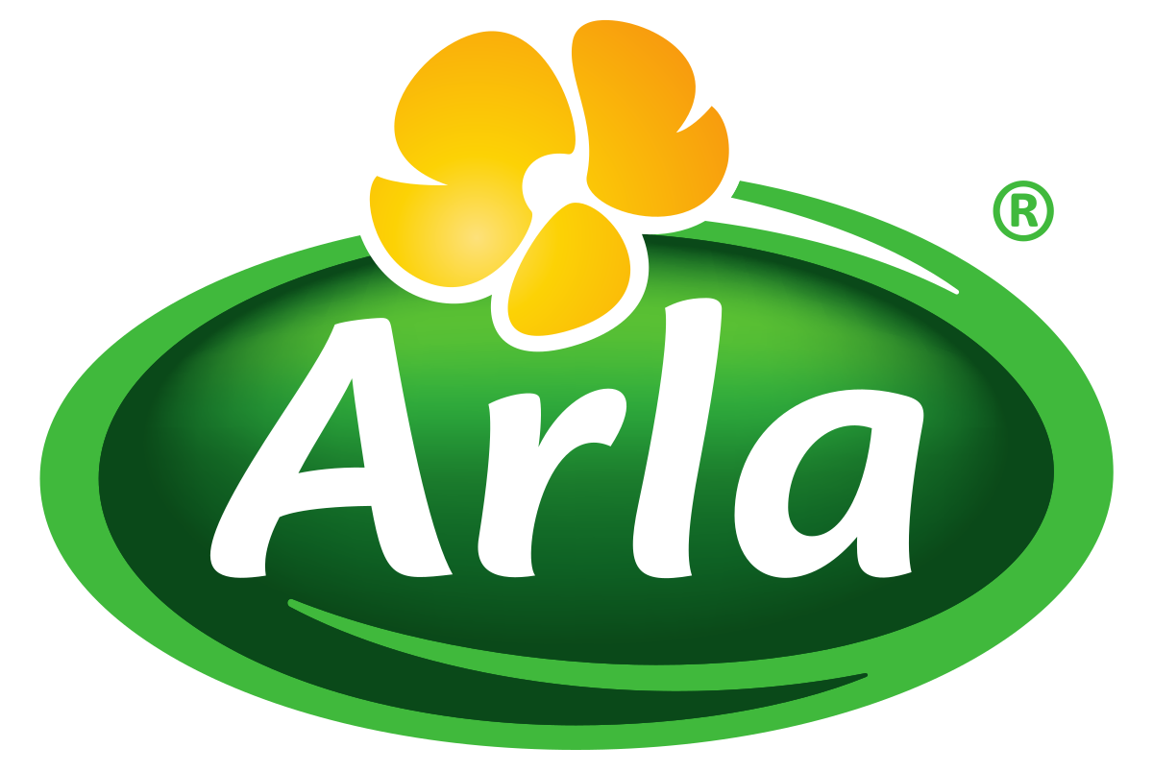
- Organization Name: Arla Foods Bangladesh Ltd (DANO Milk) Dealer of Arla (Denmark).
Website: www.arlafoods.com.bd

Designation: Production Engineer (Maintenance and Operation) Duration: From Mar’15 to Dec ’17
Job Responsibility:
- Maintain all machineries of the factory in proper working condition to ensure optimum production.
- Participated in installing Transformer, PFI Panel, and Motor controlling unit.
- Conduct the performance check of all mechanical fittings to ensure the safety at the workplace.
- Plan method or sequence of operations for developing or testing experimental electrical equipment.
- Carry out planning of new electrical installation & maintaining the existing ones.
- Check electrical and hydraulic systems of buildings to ensure functionality
- Plan and oversee all repair and installation activities

Professional Qualification:
- Electrical Machine Operation and Maintenance (PLC ) from
North Bengal Engineering Training Center in 2015 (04 months)


Academic Qualification:
- Bachelor in Engineering in Electrical & Electronic Engineering (EEE) from
Prime University, Dhaka in 2020
- Diploma in Engineering Electronic from
Rangpur Polytechnic Institute, Rangpur with CGPA 3.17 out of 4 in 2015
- SSC in Science from Dimla Fazil (Degree) Madrasah with CGPA 5.00 out of 5.00 in 2010

Training:
- 06 months long “Industrial Attachment” from Smart Technology in 2014
- I have successfully completed online training of Project Management, Digital Security Essentials, Career Planning, MS Word and Basic Teacher Training Course in MuktoPaath.
- Visit BTCL and Betar station to take knowledge about signal distribution system.
- Visited 11 KV substation sites to take knowledge about power distribution system.
- Assembly of Electrical Safety Training, ISO Training, Fire Fighting, and PLC etc Training
Soft Skill: Teamwork, convincing, inspiring, influencing, negotiation, leadership skill.
Computer Skill: Sound in Microsoft word, excel, & power point presentation

Software Skill: Auto CAD Designing, MATLAB, Pspice, Circuit Maker Software etc.
Language: Fluent in Bangla and English

Personal Information:
Date of Birth: 05th February, 1995 Nationality: Bangladeshi NID NO: 4155672936 Marital Status: Single Religion: Islam Permanent Address: Dimla, Dimla(5350), Nilphamari.
References

- Md. Nokibor Rahman, Rangpur Polytechnic Institute, Chief Instructor, Mobile: (+88) 01550003000
- Md. Asfarul Islam, Kallol Group of Companies, Technical Manager, Mobile: (+88) 01521466498

Signature:

Date:

