
Hossain Mohammad Moinuddin
Contact Number : 01793261006
E-mail : hmmoinuddin46@gmail.com
Current Address : Mahmudabad Residential Area, Shayestanagar, Habiganj, Sylhet

Career Objective
I want to pursue my career in a dynamic work environment with a nice corporate culture. I wish to furnish my career through my knowledge and skill which I want to utilize properly. I will try my best to use both my talent and performance for the development of the organization.

Self Assessment
- Adapted to hard-working situation
- A self-driven attitude and willingness to learn and a strong presence of mind
- Energetic, devoted, sincere and hard-working
- Impressive interpersonal and communication skill
- Able to persuade and influence others
- Highly organized and dedicated in performing tasks with positive attitude

Experiences

- At present working in “Berger Paints Bangladesh Limited” (From June 22, 2019) In the position of “Territory Manager (Sales, Trade)”
- Worked in “Abul Khair Group” (From December 1, 2016 to June 20, 2019) in the position of “Marketing Executive (Sales, Flat Steel Division)” (Duration: More than 2 years and 6 months)
- Completed Internship at United Commercial Bank Limited (UCBL), Anderkilla Branch, Chittagong, from 19th June, 2016 to 19th September, 2016 (Duration: 3 months)

Professional Trainings
- Successfully attended and participated in the training on “Bangladesh Export Processing Zone (EPZ) Labour Act, 2019” { Organized by: “Advocatesbd Associates”, Trainer: Advocate Khandokar Tomal Ahmed, Venue: Bangladesh Institute of Management (BIM), Chattogram Campus, Date: 8th March, 2019 }
- Successfully completed training on “Art of Selling” and “Product Knowledge” from 3 August, 2019 to 5 August, 2019 (Organized by: Berger Paints Bangladesh Limited, Venue: Sylhet Sale Office, Berger Paints Bangladesh limited, Duration: 3 days)
- Successfully completed course on “Basic Technical Analysis” [Organized by: Bangladesh Institute of Capital Market (BICM) On 16 November, 2019]

Literary work
- In BBA, completed a Thesis Paper titled “ Sahara’s Sponsorship Effect Upon the Bagladesh Cricket Team in the Area of Faculty of Busines Studies, University of Dhaka”

Educational Qualification
The Institute of Cost and Management Accountants of Bangladesh (ICMAB)
Level: Operational Level, Level 3 (At present Studying)
Admission Session: July – December, 2018

Master of Business Administration (MBA) 2015
CGPA: 3.23 (In the scale of 4.00)
Department of Marketing
University of Dhaka

Bachelor of Business Administration (BBA) 2014 CGPA : 3.17 (In the scale of 4.00)
Department of Marketing
University of Dhaka
Higher Secondary Certificate (H.S.C) 2010
G.P.A - 4.80 (In the scale of 5.00)
Group: Business Studies
Govt Commerce College, Chittagong

Secondary School Certificate (S.S.C) 2008
G.P.A. - 5.00 (In the scale of 5.00)
Group: Business Studies Railway Public High School, Chittagong

Computer Skills

- Microsoft Office ( Microsoft Word, Microsoft Excel, Microsoft powerPoint)
- Bangla Typing (Avro)
- Image editing

Personal Details

- Name : Hossain Mohammad Moinuddin
- Father’s Name : Mohammad Shahab Uddin
- Mother’s Name : Shamem Ara Begum
- Date of Birth : 30th September , 1993
- Religion : Islam
- Nationality : Bangladeshi.
- NID Number : 328 526 9373
- Marital Status : Unmarried
- Permanent Address: Village: Ghagra, Post Office: Sharishadi,
Thana: Feni, District: Feni

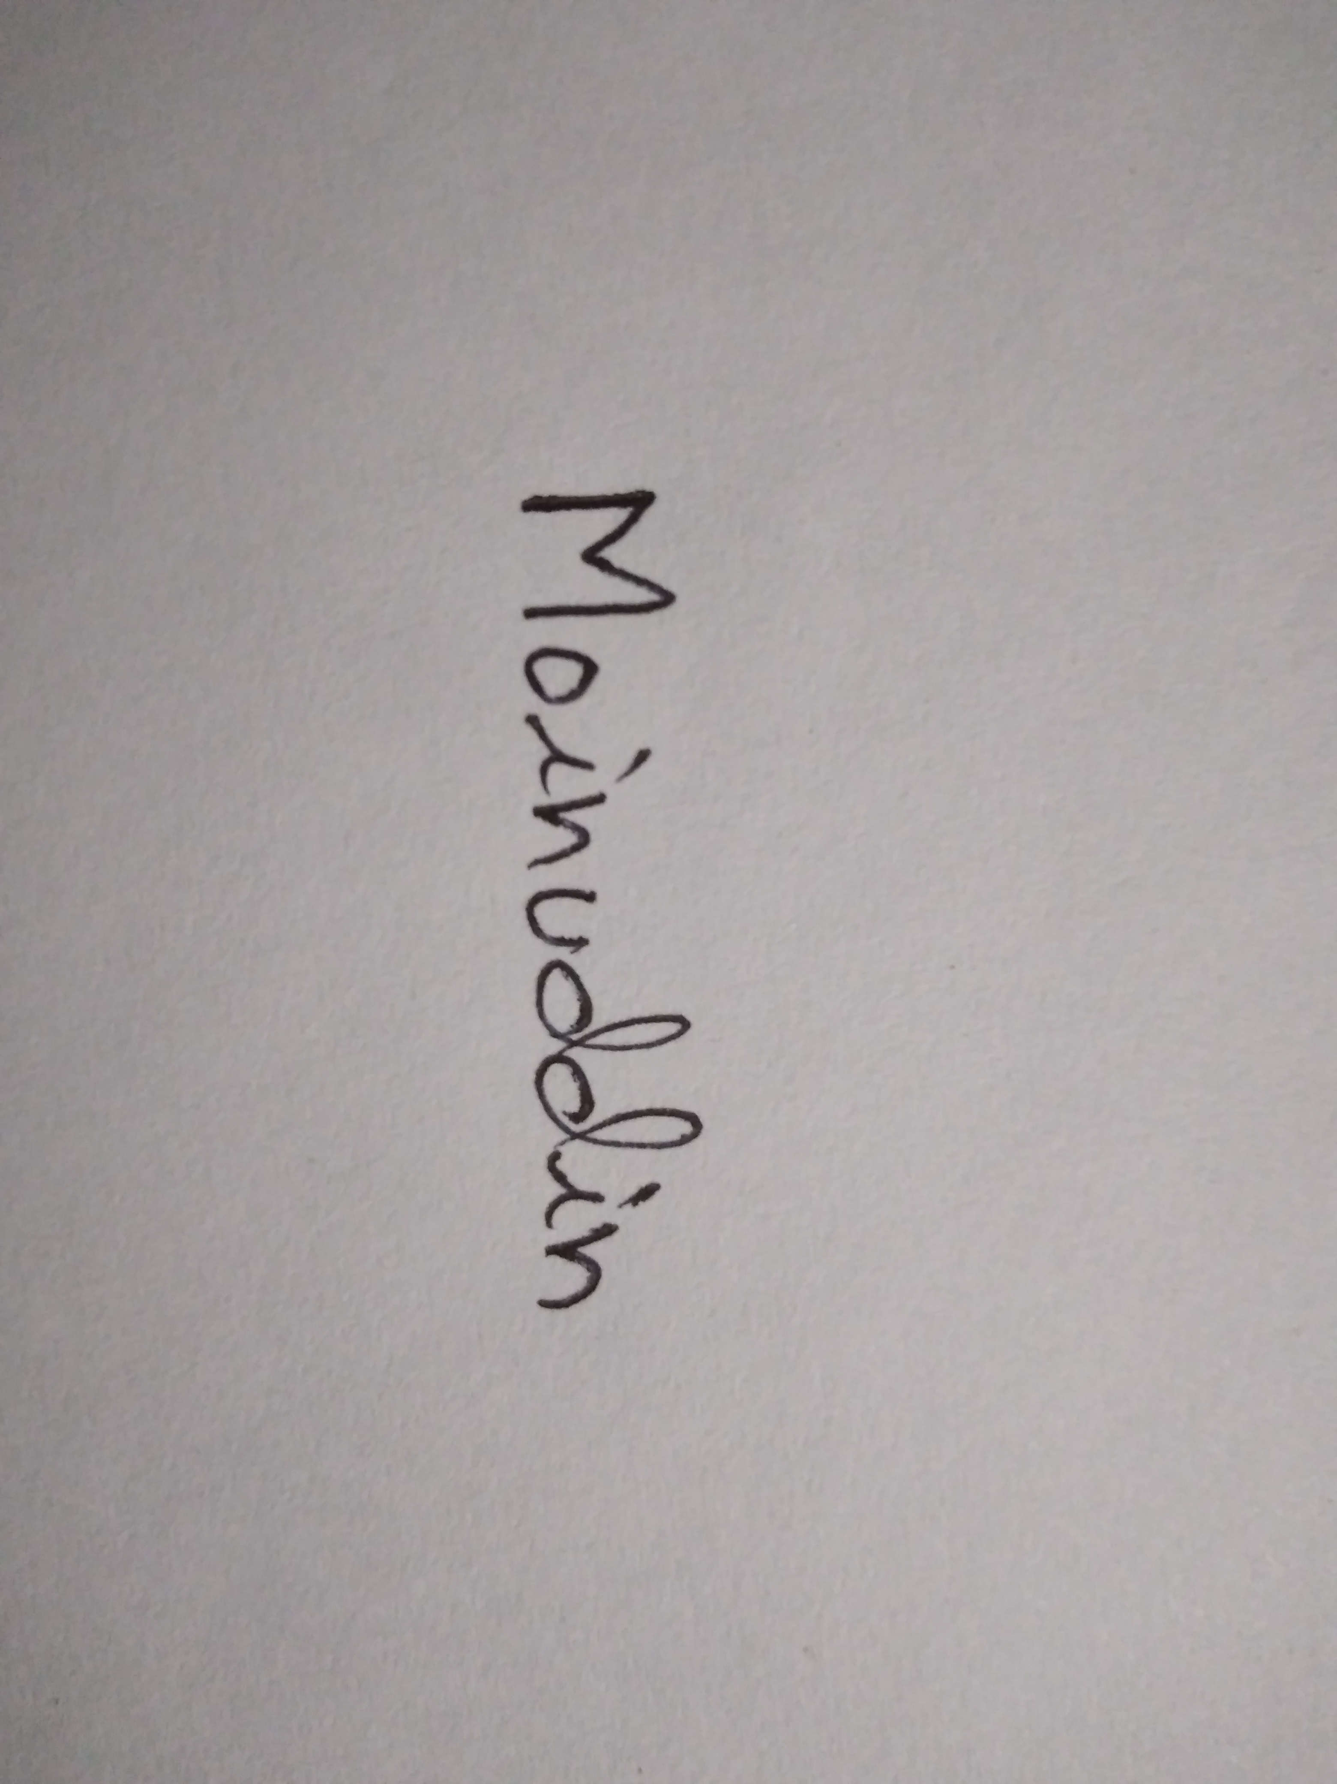
Signature
References
- Md. Faruk Hasan
Deputy Manager (Transport)
Abul Khair Group
D. T. Road, Pahartali, Chittagong.
Contact: 01926670988

- Aleya Begum
Assistant General Manager (AGM)
Janata Bank Limited
Divisional Office, Chittagong
Contact : 01714409288

