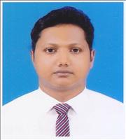

MD.MAHBUBUR RAHMAN

Mobile: +88 01795 948 798
Email: pappu_uiu@yahoo.com

Career Goals:
My goal is to become a sales executive where I can use my qualities. I always try to provide the best to my customer and make them satisfied. I will endeavor to provide the best quality to the customer so that he/she will bookmark my product as a quality product. As a result of this, the product which I am selling will gain fame as well as capture the market also.

Experiences:
Maxwell Services Limited
Sr. Executive (HR and Admin)
From February 01, 2016 to continue
House # 71, Road # 04, Block - C
Banani, Dhaka-1213.
Responsibilities:

- Preparing or updating employment records related to hiring, transferring, promoting, and terminating
- Explaining human resources policies, procedures, laws, and standards to new and existing employees
- Ensuring new hire paperwork is completed and processed
- Informing job applicants of job duties, responsibilities, benefits, schedules, working conditions, promotion opportunities, etc.
- Addressing any employment relations issues, such as work complaints and harassment allegations
- Processing all personnel action forms and ensuring proper approval
- Overseeing hiring process, which includes coordinating job posts, reviewing resumes, and performing reference checks

Metro Homes Limited
Executive (Marketing and Sales)
April 01, 2015 to January 31, 2016
4th Floor, House No.1, Road No.12 (New),
Mirpur Road, Dhanmondi, Dhaka.

Responsibilities:

- Maintains relationships with clients by providing support, information, and guidance.
- Researching and recommending new opportunities.
- Identifies product improvements and new products by remaining current on market activities, and competitors.
- Maintains quality service by establishing and enforcing organization standards.
- Contributes to team effort by accomplishing related results as needed.
- By using spreadsheet (Microsoft Excel) preparing the monthly forecast of collection data from clients.
- Reporting to Marketing General Manager the monthly forecast, clients (Both existing and potential) information to take necessity action by the management.
- Accompany buyers during visits to and inspections of property, advising them on the suitability and value of the homes they are visiting.

Education:

Degree | Institute | Passing year | Reward | Major
MBA | London School of Commerce (Dhaka Campus) | 2018 | 2:2 (Second Class in UK Standard Grade) | Bisiness  Management
BBA | Cardiff Metropolitan University, United Kingdom | 2014 | 2:2 (Second Class in UK Standard Grade) | Business Management
HSC | Dhaka Commerce College, Dhaka | 2006 | Grade : A  CGPA: 4.50 | Business Studies
SSC | Kalamata Purbo Bashaboo High School | 2004 | Grade : A-  CGPA: 3.69 | Business Studies

Computer Skills:
A good user of Microsoft Office Software’s (MS WORD, MS EXCEL, MS POWER POINT, MS OUTLOOK)
A good user of Adobe Photoshop and illustrators. (Design Business card and flyers)

Personal Skills:
✦ Good Communicational Skills
✦ Leadership Skills
✦ Ability to work under pressure
✦ Time Management
✦ Self motivated
✦ Adaptability
✦ Teamwork

Hobby:
Reading Books, watching movies, Playing indoor and outdoor games.

Personal Information:

Father : MD. Abdul Malik
Mother : Mahbuba Akhter
Date of Birth : 15 March, 1989.

Present Address : 59/3 Dakkhingaon, Sahibagh, Bashaboo, Dhaka-1214.

Permanent Address:
Vill: Charkakra.
P/S: Companigonj.
P/O: Basurhat
Dis: Noakhali.

Nationality : Bangladeshi (By Birth)
Religion : ISLAM
Marital Status : Married

References:

1. Rashidul Hassan 2. Yeasir Al MArzan
BSM & Officer Chief Executive Officer
One Bank Limited Maxwell Services
Mandari Branch Road# 04, House# 71
Laxmipur Banani
Noakhali Dhaka
Mobile: 01811150688 Mobile: 01775999900

I MD. MAHBUBUR RAHMAN hereby declare that all the information stated above is true to best of my knowledge and belief. I will take the responsibility of any mistakes in data if occur in future.
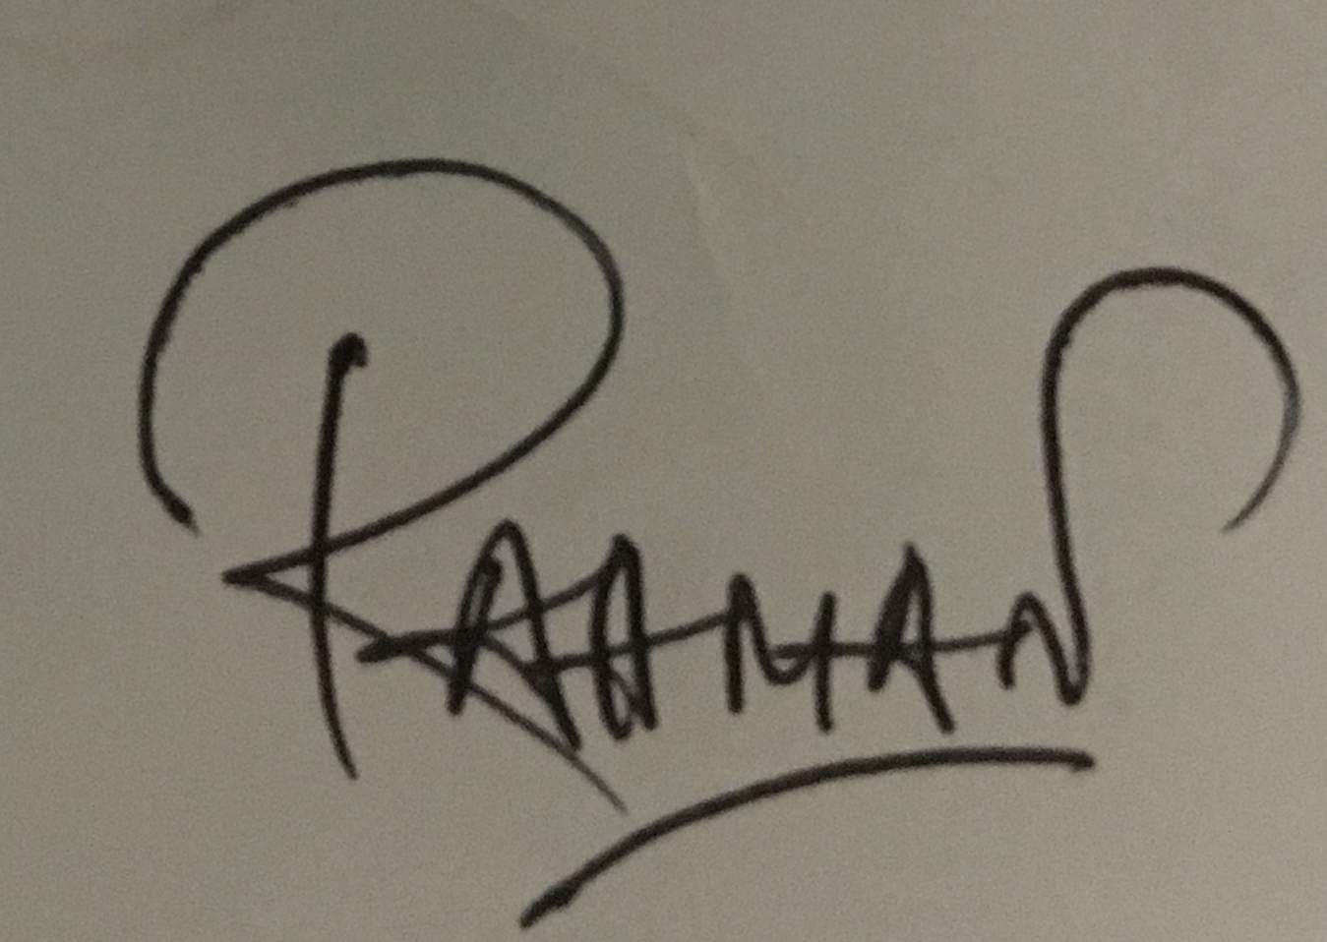

————————————
(Signature)

