
NAKIB ULLAH NASIM
56/C, South Mugda Para
DHAKA-1214
Contact No: 01794545649
E-mail:nakibullahnasim3@gmail.com

Career Objective:

To be an employee in a well-reputed organization where I can contribute, continuously learn and gain a rewarding experience. I believe if I get the chance I will be capable to get the viewers’ attention.

Employment History:

Total Year of Experiences: 1 Year

Office Executive (February 01,2020- Present)
Koboj.com (online business shop)
Company Location: Anarkoli Super Market, 4th floor, 77/1 Siddeshwari Road,
Malibag, Dhaka-1217.

Duties/Responsibilities:
1. Managed front desk operations.
2. Handled incoming and outgoing calls.
3. Dispatched courier mails and maintained record.
4. Distributed inwards documents received.
5. Made and ensured payments of bills on time.
6. Managed company’s petty cash.

Educational Qualification:

Bachelor of Science (B.Sc.)

Graduation : C.S.E (computer science & engineering)
GPA : Running
Department : C.S.E
University : DHAKA CITY COLLEGE

Higher Secondary Certificate (H.S.C)

College : DHAKA CITY COLLEGE
Department : Science
Passing year : 2015
Board : Dhaka
Result : 5.00

Secondary School Certificate (S.S.C)

School : Mugda Para Kazi Jafor High School
Department : Science
Passing year : 2013
Board : Dhaka
Result : 5.00

Language Proficiency:

Language | Reading | Writing | Speaking
Bangla | High | High | High
English | High | High | Medium

Computer Knowledge:

Graphics Design : Adobe Illustrator, Adobe Photoshop.
Office Application : MS Word, Ms Excel, Ms Power Point.

Networking & Internet : Basic networking knowledge, browsing,

sending & receiving e-mails, download

different staffs.

Personal Information:

Name : Nakib Ullah Nasim
Father Name : Nur-Novi
Mother’s Name : Sufia Begum
Date of Birth : 24 April 1997
Permanent Address : 56/C,South Mugdapara, Dhaka-1214
E-mail : nakibullahnasim3@gmail.com
Mobile : 01794545649
Marital Status : Unmarried
Gender : Male
Religion : Islam
Nationality : Bangladeshi
Height : 5'11"
Blood Group : AB+
Hobbies : Badminton

Declaration:

I do hereby declare that the above information is true and correct. To the best of my knowledge if required and where applicable, this document can be supported by authentic certificate/papers.

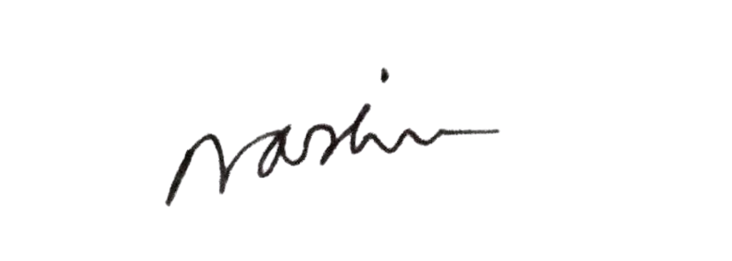

Signature

