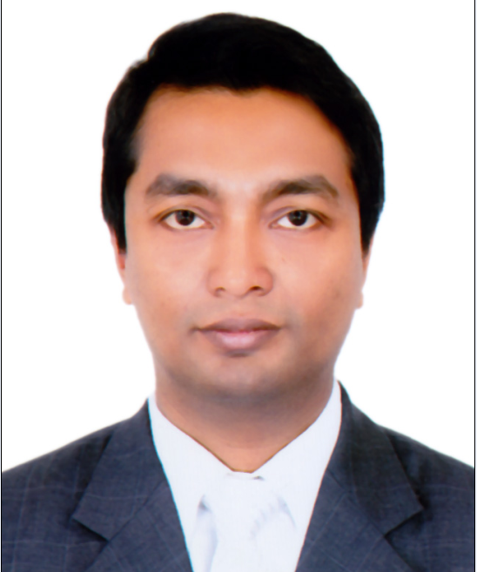

Md. Kausar
Address: 205/2 New Paltan Lane, Azimpur Dhaka-1205.
Mobile: 01717038374, 01977036508
` E-mail: md.qaysar@hotmail.com

Career Objective:
To work in the Sales and Marketing Department of any fast-growing local large or multinational company with immense responsibility so that my influential and situational leadership style, knowledge and experience of more than 8 years in Sales, marketing, branding, promotion and Strategic Business Planning can be solely utilized for the organizational development.

Working Experience:

- Company Name: BTI ( Building Technology & Ideas Ltd)
Designation : Deputy Manager ( Team Leader, Sales ) Duration: From July ’16 to till

Job Responsibility:
- Prepared sales reports (Monthly report,Sales report, Weekly report etc).
- Contact with existing client and new client.
- Data analyzing.
- Market survey for new product.
- New client hunting.
- Prepared a marketing planning.
- Implementation and execute guidelines for improvement of Customer data base.
- Implement a Customer relationship management.
- Find out the customer needs & wants to solve them.
- Implement a Customer relationship management.
- Marketing planning of respective products.
- Competitive market analyzing.
- Internal & External meeting with customer.
- Solve request of customer.
- Contact with existing client and new client.
- Cold calling up qualified sales prospects.
- Negotiating the terms of a sales agreement and closing sales.
- Find out the customer needs & wants to solve them.

Achievement:
- Introduced about 100 new clients.
- Ensured 95.8% money from client.
- Achieved 96.96% of company quarterly target.
- Commercial project at Dhanmondi, Banani, Shymoli & Gulshan sold 75% of the Commercial space by convincing clients.
- Branding work of the running projects of the company.
- Communication with different customer and ensured discounted offer to clients.

- Company Name: Rangs Properties Limited
Designation: Asst. Manager ( Sales ) Duration: From Feb ’15 to June ’17

Job Responsibility:
- Communicating with existing client and finding new client.
- Forecasting, making material requirement planning, Sales and marketing of the products.
- Implementation and execute guidelines for improvement of Customer data base.
- Implement a Customer relationship management.
- Find out the customer needs & wants to solve them.
- Communication with customer.
- Marketing planning of respective products.
- Prepared the entire database of the company.
- Relationship with all land owners.
- Solving different problems raised from the Customer.
- Competitive market analyzing.
- Internal & External meeting with customer.

Achievement:
- Achieved 105% of company target in every year.
- Introduced about 250 new clients within 1 years.
- Ensured 100% money from client after handover of the apartment.
- Commercial project at Dhanmondi, Tejgaon, Banani, Baridhara & Gulshan sold 85% of the apartments & Commercial space by convincing clients.

- Company Name: Navana Real Estate Ltd.
Designation 1: Senior Executive-Sales Duration: From March ’10 to Jan ’15
Job Responsibility:
- Sales and marketing of the products.
- Implementation and execute guidelines for improvement of Customer data base.
- Implement a Customer relationship management.
- Find out the customer needs & wants to solve them.
- Contact with existing client and new client.
- Cold calling up qualified sales prospects.
- Negotiating the terms of a sales agreement and closing sales

Achievement:
- Sold about 20Nos of apartment to new clients.
- Worked in a commercial project at Dhanmondi, Banani & Gulshan sold 65% of the apartments & Commercial space by convincing clients.
- Conducted survey and prepared comparative statement
- Accomplished the branding work of the running projects of the company.
- Assisted clients to source materials from other sister concern of Navana.
- Kept Communication with different merchants and ensured discounted offer to clients.

Academic Qualification:
- Pursuing MBA in Marketing Management from North South University
- BBA in Marketing Management from
University Of Development Alternative with a CGPA of 2.75 out of 4.00.
- H.S.C ( Dip In Commerce ) in Dhaka Commercial College with a 2nd division.
- S.S.C in Mohammadpur Govt. High School with a 2nd division

Training:

- Participated in 6 months long SEO course organized by BASIS.
- A.C.B.C ( Advanced Certificate of Business Course ) course organized by Dhaka University.
- Digital Marketing Certified by Google.
- S.E.O Certified by E-Marketing Institutes.
Soft Skill: Teamwork, convincing, inspiring, influencing, negotiation, leadership skill.

Computer Skill: Sound in Microsoft word, excel, Microsoft project & power point presentation.
Language: Bangla, English, German & French.

References:

- Md. Ashsan Parvez, Citibank N.A, Head Of Internal Control. Mobile No: (+88) 01711 975 496
- Mohammad Sami Al Hafiz, Group Chief Communication Officer Mutual Trust Bank Ltd.

“I CERTIFY THAT ALL INFORMATION STATED IN THIS RESUME IS TRUE AND COMPLETE TO THE BEST OF MY KNOWLEDGE, I AUTHORIZE THE RECEIVER OF THIS RESUME TO VERIFY THE INFORMATION PROVIDED IN THIS RESUME”

Yours Truly,

Md. Kausar

