MD. ABDUL AZIZ | 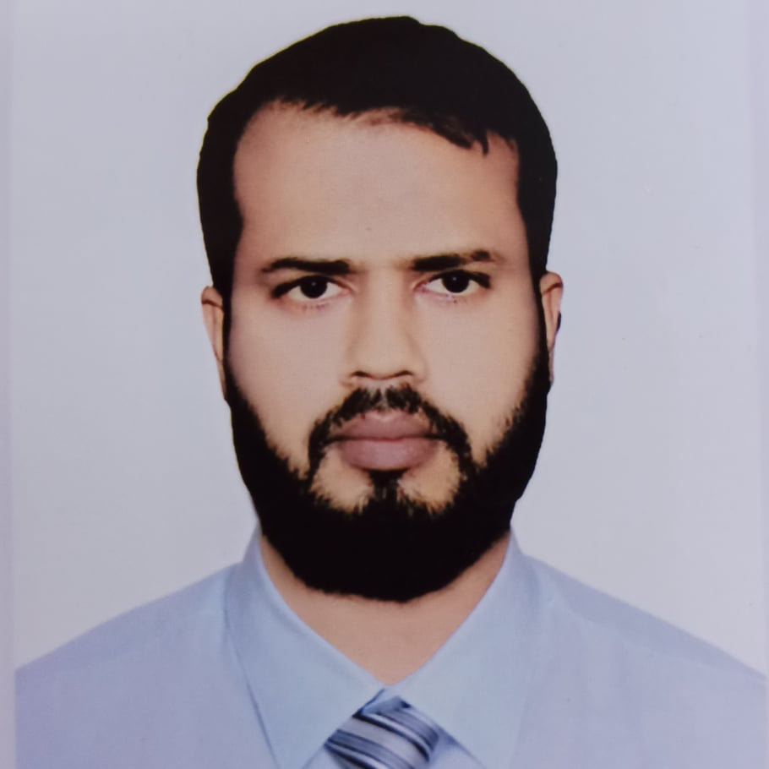
Address: Vill: Orba palace 5th Floor (6-B) Modhumeta Road Tongi, Gazipur Sadar, Gazipur
Mobile No 1: 01739671765
Mobile No 2 :+8801713222404
e-mail : azizprojen@gmail.com

Career Objective:
I am a professional Engineer we started my career through the department of transportation & Logistics. As a person who is committed to professionalism, appreciated challenges, seeking an opportunity in a reputed organization.

Career Summary:
I am a professional Engineer we started my career through the department of transportation. I have made many hardships and sacrifices and have found a way to succeed in my professional life. We have ability to apply repair, team handling and advanced technologies. If you get chance at your organization, I can prove my eligibility.

Special Qualification:
Export- Import forwarder, port customs authorities and C&F agents Operation
distribution at factory Control Delivery schedule/ Logistics.
shipment factory to port
All type vehicle maintenance
I have practical knowledge about SAP, ERP software

Employment History:
Total Year of Experience : 9.6 Year(s)
1. | Manager Logistics & Transport ( June 30, 2019 - Continuing)
Crown Cement Group
Company Location : Delta Life Tower (3 &, 6 floor )Rd 90, Gulshan-2 Dhaka 1212,
Department: Logistics
Duties/Responsibilities:
Work out Transport requirement for corporate office, Export- Import, etc. Adequate knowledge on shipment procedure through LCL & FCL mode.
Enough communication skills among forwarder, port customs authorities and C&F agents for smoothly shipment.
Enough knowledge on shipment procedure from factory to port (loading point to unloading point).
Enough knowledge on shipment documents i.e. packing list, gate pass, commercial invoice etc
Compliance requirements relating to shipment procedure.
Responsible for the entire process starting from preparation of Delivery Orders to delivery of to the customer.
Over all responsible of distribution at factory Control Delivery schedule/ Logistics.
Coordination with dealers & sales for planning the delivery as per the schedule.
Strategically planning and managing logistics, warehouse, transportation and customer services.
Managing direct inbound or outbound logistics operations, such as transportation or warehouse activities, safety performance or logistics quality management.
Liaoning with external agencies (police/ municipalities/corporation/premise security agencies/Premises Co-op Society) and Coordinating with Travel Agencies for Airlines, Railway bookings and transport arrangement for employees & guest.
Manage Transportation budget and monthly costs analysis. monthly statement of vehicle.
Ensure timely operation of Transport section. Maintain and up to date log book for all Transports.
Brief all drivers on regular basis about their responsibility.
Ensure/renewal/update of all vehicle related documents i.e. Tax Token, Fitness, Insurance, route permit etc. of all company vehicle.
Supervise and monitor activities of transport staff. Maintain Duty Roster of Driver/ Helper.
Manage Vendor/ Suppliers/ Service providers.
Recruiting deficient drivers, mechanics and helper with the help of HR & Admin department. To ensure proper action regarding all documents, calls, mails & faxes related to factory/ head office/ foreigner/ Pick & Drop
To assist and provide full support to the Administration Department for appropriate vehicle, hotel and Greet service arrangements
Ensure consistent vehicle management, work and route allocation within the transport team
Preparing monthly budget, monthly Expenditure Report, and other Reports as and when required by the Management.
Test drive of vehicles to find out the problems before raising requisition for repairing and checking the repairing works after completion of work by the workshops.
Planning and executing vehicles` maintenance schedule in coordination with
Maintain up to date accountability and maintenance of vehicle and their records.
Strictly act upon the CNG/petrol/diesel filling mechanism approved by the management.
Plan and prepare budget and implement accordingly to reduce operational cost
Perform/supervise / monitor maintenance of vehicles (Forklifts /Pay loader /Dump Truck /Tractor & Light vehicles).
Other task assigns by the management.
2. | Manager-Transport ( March 30, 2017 - June 29, 2019)
Best Electronics ltd. concern of Zaman Group
Company Location : City Centre ( Level 11 & Level 16 ) floor 90/1, Motijheel Dhaka.
Department: Logistic
3. | Asst. Manager Transport & Workshop Operations ( February 3, 2011 - March 29, 2017)
Dekko Group
Company Location : Suvastu Zenim Plaza House # 37 (4th Floor), Road # 16 (Old 27), Dhanmondi R/A, Dhaka-1209
Department: Transport Management

Academic Qualification:
Exam Title | Concentration/Major | Institute | Result | Pas.Year | Duration
Bachelor in Engineering (BEngg) | Mechatronics | World university of Bangladesh | Appeared | 2020 | 4 year
Diploma in Engineering | Automobile | Bangladesh Polytechnic Institute Bogura | CGPA:3.5  out of 4 | 2012 | 4 years
SSC | Humanities | Uchal Baria High School | CGPA:3.88  out of 5 | 2008 | 2 years

Training Summary:
Training Title | Topic | Institute | Country | Location | Year | Duration
Diploma in Computer science | Computer Basic Training | Institute of ict | Bangladesh | Bogra | 2010 | 6 Month

Professional Qualification:
Certification | Institute | Location | From | To
Services Training | Projen Motors (BD) Co Ltd. | Dhaka | May 6, 2017 | May 18, 2017
professional and Personal Etiquettes & Safety at work | Dekko Group Learning Center | Dhaka | April 13, 2016 | April 16, 2016
Basic Training (Transport Operations) | Nitol Motors Ltd | Nilphamari | February 1, 2012 | February 29, 2012

Career and Application Information:
Looking For | : | Mid Level Job
Available For | : | Full Time
Present Salary | : | Tk. 48000
Expected Salary | : | Tk. 75000
Preferred Job Category | : | Engineer/Architect, General Management/Admin, Driving/Motor Technician
Preferred District | : | Chattogram, Dhaka, Gazipur, Khulna, Narayanganj, Rajshahi
Preferred Country | : | American Samoa, Australia, Canada, China, India, New Zealand
Preferred Organization Types | : | Manufacturing (FMCG), Multinational Companies, Garments, Textile, Pharmaceutical/Medicine Companies, Food (Packaged)/Beverage, Agro based firms (incl. Agro Processing/Seed/GM), Electronic Equipment/Home Appliances, Plastic/ Polymer Industry, Cement Industry, Transport Service

Specialization:
Fields of Specialization
- Export/ Import through L/C
- logistic management
- Transport Management
- Vehicle Repairing
- Distribution/ Supply Chain Management
- Transport/ Airline/ Travel
- Business Development
- Relationship Management/ Key Account Management
- Customer Service
- Purchase/ Procurement

Language Proficiency:
Language | Reading | Writing | Speaking
Bangla (mother tongue) | High | High | High
English | Medium | Medium | Medium

Personal Details :
Father's Name | : | Md. Shahidur Rahman
Mother's Name | : | Mst.Rehena Akter
Date of Birth | : | November 18, 1990
Gender | : | Male
Marital Status | : | Married
Nationality | : | Bangladeshi
National Id No. | : | 19901015485000048
Religion | : | Islam
Passport No | : | BL0653002
Passport Issue Date | : | 8/21/2016
Permanent Address | : | vill: Malegaca ( Uchal Baria Hat ) P/O-Paikor, Kahalu, Bogura
Current Location | : | Gazipur

Reference (s):
 |  | Reference: 01 | Reference: 02
Name | : | Md. Farid Ahmed | Md. kayum khan Razu
Organization | : | Department of Inspection for Factories and Estbs. | Apollo Hospital Dhaka
Designation | : | Deputy Chief Inspector (General) | Manager Hr & Admin
Address | : | Dhaka | Plot: 81, Block: E, Bashundhara R/A,Dhaka -1229
Phone (Off.) | : |  | +8801704166890
Phone (Res.) | : |  | +88027313317
Mobile | : | +8801715-098383 | +8801819196548
E-Mail | : | engr.farid@gmail.com | razu.protocal@gmail.com
Relation | : | Family Friend | Professional

