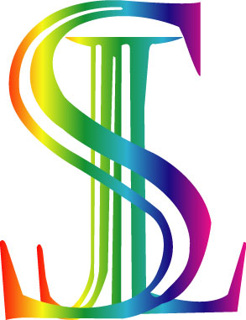 SHAMS JACQUARD LTD.
(100% Export Oriented Knit & Sweaters Factory.)

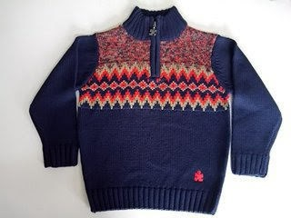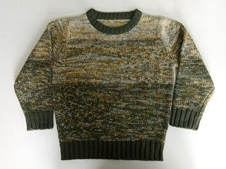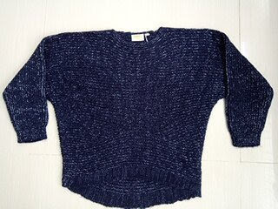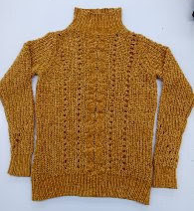
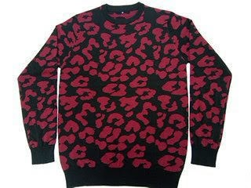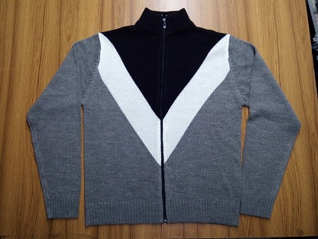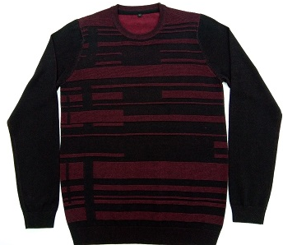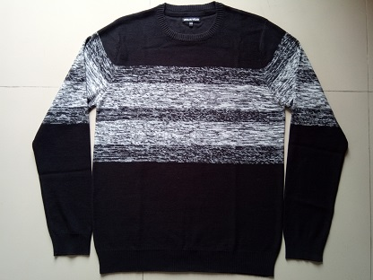
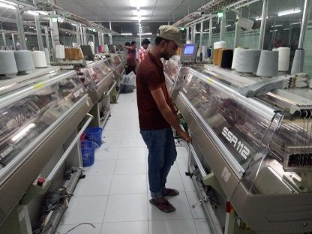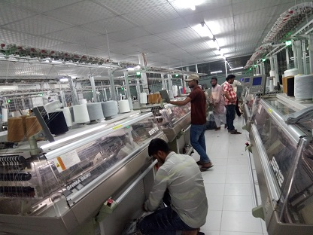

Head Office: House # 6, Road # 10, Sector # 04, Uttara, Dhaka-1230, Bangladesh.

Company Profile
Name of Company: Shams Jacquard Ltd.
Type of Company : 100% Export Oriented Knit & Sweaters Factory.
Factory Location : Shams Jacquard Ltd.
South Salna, P.O.- Salna Bazar,
Gazipur Sodor, Gazipur-1703, Bangladesh.
Contact Person : Manirul Haque (Managing Director)

: Kamrul Ahsan. (Merchandising manager)
Mobile: +8801711848308
E-mail: shamsmerchandiser@gmail.com

License : Trade,VAT: 18011072587, Bank, BGMEA:6021, ERC: Ra-0122124, GSP, TIN: 639925275451, VAT no: 18011072587, Incorporation no: C-117640/14, Etc.

Buyer : Lahelle – France, COFEMEL-SOCIEDADE DE VETUARIO S.A.Portugal. Mister* lady GmbH - GERMAN, Ovs – Italy,
Floor Space : 25,500 Sq.Ft.
Year of Establishment: 2015.

Name of Bank : Social Islami Bank Limited.
Latif Emporium,Plot#27,Road#7,Sector#3,
Uttara Branch. Dhaka -1230, Bangladesh.
Ph:+8802 8959731-33
E-mail: fex.uttara@sibl-bd.com
SWIFT: SOIVBDDHUTR
A/c no: 0241330016956,

Production Capacity: 67,000 pcs monthly.
Product : All types of Sweater, Knit,
Pullover, Cardigans and Vests.
Yarn Source : Local, Like that-Acrylic, Cotton,
Wool, Viscose, Nylon and Fancy yarn.
Total Man Power : 150 People(+).
Detail of Machineries:
Sl. no | Name of Machineries | Quantity
01. | Auto Jacquard Machine (SHIMA SEIKI) Japan | 50 Set
02. | Flat knitting Machine(42”-36”Bed) | 150 Set
04. | Composer M/C | 01 Set
05. | Dial Linking Machine | 30 Set
06. | Over Look Machine | 02 Set
08. | Light Cheek M/C | 02 Set
09. | Washing Machine | 02 Set
10. | Hydro –Extractor | 01 Set
11. | Dryer | 02 Set
12. | Vacuum Iron Table & Iron | 10 Set
13. | Plain Sewing Machine | 08 Set
14. | Steam Boiler | 01 Set
15. | Diesel Generator | 01 Set
16. | C N G Convection | 03 Set
17. | Ad Just Fan | 07 Set
18. | Winding Machine | 06 Set

(100%Export Oriented Sweater Industry)

CODE OF CONTDUCT:

LABOUR- Shams Jacquard Ltd. Complies fully with the legal requirements of the countries in which they operate
- . Child Labor: Shams Jacquard Ltd. strictly complies with the minimum employment age limit defined by national law or by International Labor Organization (ILO) Convention 138.
- Wages, Benefits, Working Hours and Transparent Record Keeping: Shams Jacquard Ltd. complies with all laws pertaining to working hour, local wages, overtime compensation and legally mandated benefits. Our wage and benefit policies satisfy all applicable laws and regulations.
- Forced/Bonded Labor: Shams Jacquard Ltd. does not use any type of forced labor, which means any work or service performed involuntarily under threat of physical or other penalty, such as prison, indentured or bonded labor. Further, we respect the freedom of movement of our workers.
- Discrimination: Shams Jacquard Ltd. ensures that all conditions of employment must be based on an individual's ability to do the job, not on the basis of personal characteristics, such as gender, ethnic origin, religion, or personal beliefs.
- Harassment and Abuse: At Shams Jacquard Ltd. we have zero tolerance for harassment, which can take many forms, including physical, sexual, verbal or visual behavior that creates an offensive, hostile, or intimidating environment.
- Freedom of Association: Shams Jacquard Ltd. respects the rights of employees to lawfully associate or not to associate with groups of their choosing, as long as such groups are legal in the country where the merchandise is manufactured.
- Health and Safety: Shams Jacquard Ltd. ensure the condition that all production facilities must be safe, clean and consistent with all applicable laws and regulations or industry best practices, whichever is higher in order to avoid preventable work related accidents, injuries and diseases.

ENVIRONMENT
Shams Jacquard Ltd. as a LEED registered green factory, meets all relevant local and national environmental protection laws, and is striving to comply with international environment protection standards.

BUSINESS INTEGRITY
Shams Jacquard Ltd. demonstrates a high degree of professionalism and always upholds business ethics in all respects.

COMPLIANCE WITH THE LAW
Shams Jacquard Ltd. complies fully with the legal requirements of the countries in which they operate.

(100% Export Oriented Sweater Factory)

FEATURES:
- Design, Construction and Operation and Maintenance of the building have been made in line with LEED and ACCORD Consultant’s guideline with a view to make it resource efficient, high performing , healthy and cost effective
- Air blowing and air exhausting system as per LEED guidelines
- Sustainable Site
- Adequate Open Area
- Rainwater Harvesting
- Use of Recyclable Contents in Construction Materials
- CO2 Monitoring System
- Using Maximum Day Lighting
- Efficient Water Fixtures to reduce the use of water
- Certified Woods and Paints to minimize impact on environment
- Installation of Sophisticated Fire Fighting Protection System
- Modern Child Care Center
- Modern Medical Facility
- Dining Hall
- Locker Facility
- Training Center for enhancing workers’ efficiency
- Modern Store Management System
- LEED Certified Sophisticated Single Stage End Suction Fire Pump
- LEED Certified Busser Trucking System
- Energy Efficient Shema Shaki and Sewing Machineries (Zuki and Kansai Brand) as per LEED guideline
- Modern Quality Assurance System
- 24 hours close circuit camera surveillance

COMPLINCE and CERTIFICATON:

  - Already we have applied for Gold Certification with USGBC. The process for certification is going on.

  - The process for Social Audit is going on.

3. The building structure, fire and electrical safety have been made as per the guideline of ACCORD Consultants. The process for audit is going on.

(100% Export Oriented Green Sweater Factory)
Quality ıı Commitment ıı Great Value

